**ICP3**

**700756561**

**TEJENDRA KONDURU**

**Program1:**

**import numpy as np**

**from keras.models import Sequential**

**from keras.layers import Dense**

**from sklearn.model_selection import train_test_split**

**from sklearn.datasets import load_breast_cancer**

**from sklearn.preprocessing import StandardScaler**

**# Load dataset**

**from google.colab import files**

**uploaded = files.upload()**

**dataset = pd.read_csv("diabetes.csv", header=None).values**

**# Split the dataset into training and testing sets**

**X_train, X_test, Y_train, Y_test = train_test_split(dataset[:, 0:8], dataset[:, 8], test_size=0.25, random_state=87)**

**# Set random seed for reproducibility**

**np.random.seed(155)**

**# Create the model with additional Dense layers**

**model = Sequential()**

**model.add(Dense(20, input_dim=8, activation='relu'))  # Hidden layer**

**model.add(Dense(15, activation='relu'))  # Additional layer**

**model.add(Dense(2, activation='relu'))  # Additional layer**

**model.add(Dense(1, activation='sigmoid'))  # Output layer**

**# Compile the model**

**model.compile(loss='binary_crossentropy', optimizer='adam', metrics=['accuracy'])**

**# Fit the model**

**model.fit(X_train, Y_train, epochs=100, initial_epoch=0, verbose=1)**

**# Print the model summary**

**print(model.summary())**

**evaluation = model.evaluate(X_test, Y_test)**

**print(f"Loss: {evaluation[0]}, Accuracy: {evaluation[1]}")**

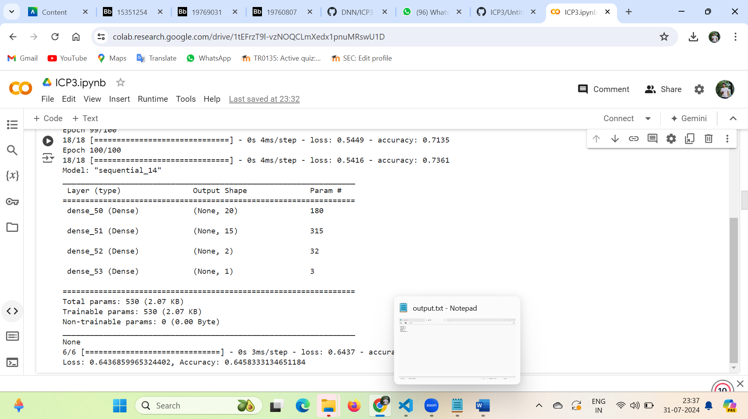

**Program2:**

**import numpy as np**

**import matplotlib.pyplot as plt**

**from keras.datasets import mnist**

**from keras.models import Sequential**

**from keras.layers import Dense**

**from keras.utils import to_categorical**

**# Load the MNIST dataset**

**(train_images, train_labels), (test_images, test_labels) = mnist.load_data()**

**# Process the data**

**dimData = np.prod(train_images.shape[1:])**

**train_data = train_images.reshape(train_images.shape[0], dimData)**

**test_data = test_images.reshape(test_images.shape[0], dimData)**

**# Convert data to float and scale values between 0 and 1**

**train_data = train_data.astype('float32')**

**test_data = test_data.astype('float32')**

**train_data /= 255.0**

**test_data /= 255.0**

**# Change the labels from integer to one-hot encoding**

**train_labels_one_hot = to_categorical(train_labels)**

**test_labels_one_hot = to_categorical(test_labels)**

**# Creating the network**

**model = Sequential()**

**model.add(Dense(512, activation='relu', input_shape=(dimData,)))**

**model.add(Dense(512, activation='relu'))**

**model.add(Dense(10, activation='softmax'))**

**model.compile(optimizer='rmsprop', loss='categorical_crossentropy', metrics=['accuracy'])**

**# Train the model**

**history = model.fit(train_data, train_labels_one_hot, batch_size=256, epochs=10, verbose=1,**

**validation_data=(test_data, test_labels_one_hot))**

**# Task 1: Plot the loss and accuracy for both training data and validation data**

**def plot_history(history):**

**plt.figure(figsize=(12, 4))**

**plt.subplot(1, 2, 1)**

**plt.plot(history.history['loss'], label='Training Loss')**

**plt.plot(history.history['val_loss'], label='Validation Loss')**

**plt.title('Loss')**

**plt.xlabel('Epochs')**

**plt.ylabel('Loss')**

**plt.legend()**

**plt.subplot(1, 2, 2)**

**plt.plot(history.history['accuracy'], label='Training Accuracy')**

**plt.plot(history.history['val_accuracy'], label='Validation Accuracy')**

**plt.title('Accuracy')**

**plt.xlabel('Epochs')**

**plt.ylabel('Accuracy')**

**plt.legend()**

**plt.show()**

**plot_history(history)**

**# Task 2: Plot one of the images in the test data and predict**

**def plot_image_and_predict(index):**

**plt.imshow(test_images[index], cmap='gray')**

**plt.title(f"True Label: {test_labels[index]}")**

**plt.show()**

**# Preprocess the image**

**img = test_images[index].reshape(1, dimData).astype('float32') / 255.0**

**# Predict the class**

**prediction = model.predict(img)**

**predicted_class = np.argmax(prediction)**

**print(f"Predicted Label: {predicted_class}")**

**plot_image_and_predict(0)**

**# Task 3: Change the number of hidden layers and activation function to tanh or sigmoid**

**def build_and_train_model(layers, activation):**

**model = Sequential()**

**model.add(Dense(512, activation=activation, input_shape=(dimData,)))**

**for _ in range(layers - 1):**

**model.add(Dense(512, activation=activation))**

**model.add(Dense(10, activation='softmax'))**

**model.compile(optimizer='rmsprop', loss='categorical_crossentropy', metrics=['accuracy'])**

**history = model.fit(train_data, train_labels_one_hot, batch_size=256, epochs=10, verbose=1,**

**validation_data=(test_data, test_labels_one_hot))**

**return history**

**# Example with 3 hidden layers and 'tanh' activation**

**history_tanh = build_and_train_model(3, 'tanh')**

**plot_history(history_tanh)**

**# Example with 3 hidden layers and 'sigmoid' activation**

**history_sigmoid = build_and_train_model(3, 'sigmoid')**

**plot_history(history_sigmoid)**

**# Task 4: Run the same code without scaling the images and check the performance**

**train_data_no_scale = train_images.reshape(train_images.shape[0], dimData).astype('float32')**

**test_data_no_scale = test_images.reshape(test_images.shape[0], dimData).astype('float32')**

**model_no_scale = Sequential()**

**model_no_scale.add(Dense(512, activation='relu', input_shape=(dimData,)))**

**model_no_scale.add(Dense(512, activation='relu'))**

**model_no_scale.add(Dense(10, activation='softmax'))**

**model_no_scale.compile(optimizer='rmsprop', loss='categorical_crossentropy', metrics=['accuracy'])**

**history_no_scale = model_no_scale.fit(train_data_no_scale, train_labels_one_hot, batch_size=256, epochs=10, verbose=1,**

**validation_data=(test_data_no_scale, test_labels_one_hot))**

**plot_history(history_no_scale)**

**GitHub Link:**

<https://github.com/teja375/DNN/tree/main/ICP3>