ICP5

Tejendra konduru

700756561

Program1:

from keras.layers import Input, Dense

from keras.models import Model

from keras.datasets import fashion_mnist

import numpy as np

import matplotlib.pyplot as plt

from keras.optimizers import Adadelta

# Load Fashion MNIST data

(x_train, _), (x_test, _) = fashion_mnist.load_data()

# Normalize and reshape the data

x_train = x_train.astype('float32') / 255.

x_test = x_test.astype('float32') / 255.

x_train = x_train.reshape((len(x_train), np.prod(x_train.shape[1:])))

x_test = x_test.reshape((len(x_test), np.prod(x_test.shape[1:])))

# Define hyperparameters

encoding_dim = 32

input_dim = x_train.shape[1]

noise_factor = 0.5

learning_rate = 1.0

batch_size = 128

epochs = 10

# Define the denoising autoencoder model

input_img = Input(shape=(input_dim,))

encoded = Dense(128, activation='relu')(input_img)

encoded = Dense(encoding_dim, activation='relu')(encoded)

decoded = Dense(128, activation='relu')(encoded)

decoded = Dense(input_dim, activation='sigmoid')(decoded)

denoising_autoencoder = Model(input_img, decoded)

optimizer = Adadelta(learning_rate=learning_rate)

denoising_autoencoder.compile(optimizer=optimizer, loss='binary_crossentropy')

# Introducing noise to the input data

x_train_noisy = x_train + noise_factor * np.random.normal(loc=0.0, scale=1.0, size=x_train.shape)

x_test_noisy = x_test + noise_factor * np.random.normal(loc=0.0, scale=1.0, size=x_test.shape)

x_train_noisy = np.clip(x_train_noisy, 0., 1.)

x_test_noisy = np.clip(x_test_noisy, 0., 1.)

# Train the denoising autoencoder

history = denoising_autoencoder.fit(x_train_noisy, x_train,

                                    epochs=epochs,

                                    batch_size=batch_size,

                                    shuffle=True,

                                    validation_data=(x_test_noisy, x_test_noisy))

# Predict on test data

decoded_imgs = denoising_autoencoder.predict(x_test_noisy)

# Visualize one original and reconstructed image

plt.figure(figsize=(10, 4))

# Original image

plt.subplot(1, 2, 1)

plt.imshow(x_test_noisy[0].reshape(28, 28), cmap='gray')

plt.title('Original Noisy Image')

plt.axis('off')

# Reconstructed image

plt.subplot(1, 2, 2)

plt.imshow(decoded_imgs[0].reshape(28, 28), cmap='gray')

plt.title('Reconstructed Image')

plt.axis('off')

plt.show()

# Plot training & validation loss values

plt.plot(history.history['loss'])

plt.plot(history.history['val_loss'])

plt.title('Model Loss')

plt.ylabel('Loss')

plt.xlabel('Epoch')

plt.legend(['Train', 'Validation'], loc='upper right')

plt.show()

Output:

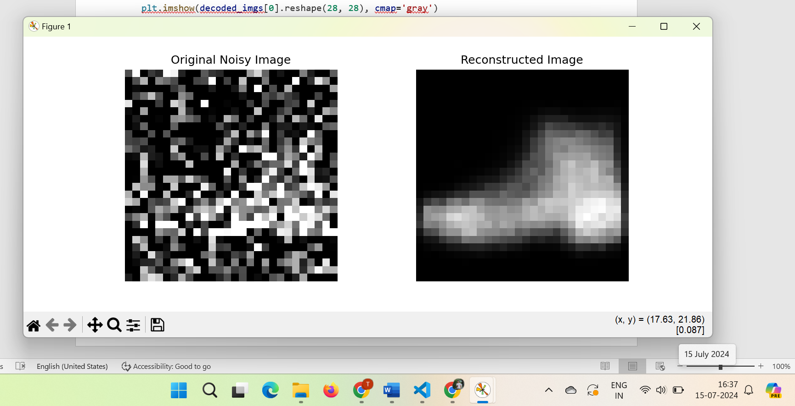

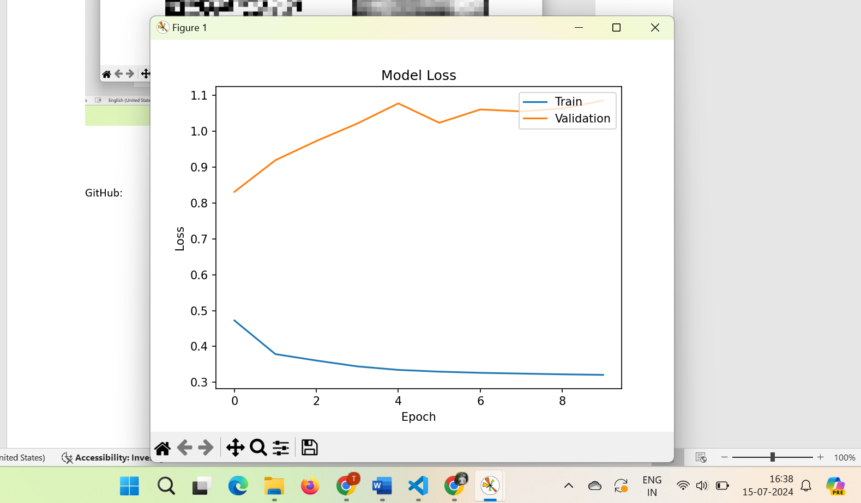

GitHub:

<https://github.com/teja375/DNN/tree/main/ICP5>