**ICP- 6**

**Tejendra konduru**

**700756561**

Save the model and use the saved model to predict on new text data (ex, “A lot of good things are happening. We are respected again throughout the world, and that's a great [thing.@realDonaldTrump”)](mailto:thing.@realDonaldTrump”)\)

!pip uninstall -y tensorflow keras pandas matplotlib scikit-learn

!pip install tensorflow==2.15.0 keras==2.15.0 pandas==2.0.3 matplotlib==3.9.1 scikit-learn==1.5.1

import pandas as pd # Basic packages for creating dataframes and loading dataset

import numpy as np

import matplotlib.pyplot as plt # Package for visualization

import re # importing package for Regular expression operations

from sklearn.model_selection import train_test_split # Package for splitting the data

from sklearn.preprocessing import LabelEncoder # Package for conversion of categorical to Numerical

from tensorflow.keras.preprocessing.text import Tokenizer # Tokenization

from tensorflow.keras.preprocessing.sequence import pad_sequences # Add zeros or crop based on the length

from tensorflow.keras.models import Sequential # Sequential Neural Network

from tensorflow.keras.layers import Dense, Embedding, LSTM, SpatialDropout1D # For layers in Neural Network

from tensorflow.keras.utils import to_categorical

from tensorflow.keras.models import load_model

# Load the dataset as a Pandas DataFrame

path_to_csv = '/content/sample_data/Sentiment.csv'

dataset = pd.read_csv(path_to_csv, header=0)

# Select only the necessary columns 'text' and 'sentiment'

mask = dataset.columns.isin(['text', 'sentiment'])

data = dataset.loc[:, mask]

# Keeping only the necessary columns

data['text'] = data['text'].apply(lambda x: x.lower())

data['text'] = data['text'].apply(lambda x: re.sub('[^a-zA-Z0-9\s]', '', x))

for idx, row in data.iterrows():

    row[0] = row[0].replace('rt', ' ') # Removing Retweets

max_features = 2000

tokenizer = Tokenizer(num_words=max_features, split=' ') # Maximum words is 2000 to tokenize sentence

tokenizer.fit_on_texts(data['text'].values)

X = tokenizer.texts_to_sequences(data['text'].values) # Taking values to feature matrix

X = pad_sequences(X) # Padding the feature matrix

embed_dim = 128 # Dimension of the Embedded layer

lstm_out = 196 # Long short-term memory (LSTM) layer neurons

def createmodel():

    model = Sequential() # Sequential Neural Network

    model.add(Embedding(max_features, embed_dim, input_length = X.shape[1])) # input dimension 2000 Neurons, output dimension 128 Neurons

    model.add(LSTM(lstm_out, dropout=0.2, recurrent_dropout=0.2)) # Drop out 20%, 196 output Neurons, recurrent dropout 20%

    model.add(Dense(3, activation='softmax')) # 3 output neurons[positive, Neutral, Negative], softmax as activation

    model.compile(loss = 'categorical_crossentropy', optimizer='adam', metrics = ['accuracy']) # Compiling the model

    return model

labelencoder = LabelEncoder() # Applying label Encoding on the label matrix

integer_encoded = labelencoder.fit_transform(data['sentiment']) # Fitting the model

y = to_categorical(integer_encoded)

X_train, X_test, Y_train, Y_test = train_test_split(X, y, test_size=0.33, random_state=42) # 67% training data, 33% test data split

batch_size = 32 # Batch size 32

model = createmodel() # Function call to Sequential Neural Network

model.fit(X_train, Y_train, epochs=1, batch_size=batch_size, verbose=2) # verbose the higher, the more messages

score, acc = model.evaluate(X_test, Y_test, verbose=2, batch_size=batch_size) # evaluating the model

print(score)

print(acc)

print(model.metrics_names) # metrics of the model

print(integer_encoded)

print(data['sentiment'])

# Predicting on the text data

sentence = ['A lot of good things are happening. We are respected again throughout the world, and that is a great thing.@realDonaldTrump']

sentence = tokenizer.texts_to_sequences(sentence) # Tokenizing the sentence

sentence = pad_sequences(sentence, maxlen=X.shape[1], dtype='int32', value=0) # Padding the sentence

sentiment_probs = model.predict(sentence, batch_size=1, verbose=2)[0] # Predicting the sentence text

sentiment = np.argmax(sentiment_probs)

print(sentiment_probs)

if sentiment == 0:

    print("Neutral")

elif sentiment == 1:

    print("Negative")

else:

    print("Positive")

# Custom wrapper for Keras model

from sklearn.base import BaseEstimator, ClassifierMixin

class CustomKerasClassifier(BaseEstimator, ClassifierMixin):

    def __init__(self, build_fn=None, epochs=1, batch_size=32, verbose=1, **sk_params):

        self.build_fn = build_fn

        self.epochs = epochs

        self.batch_size = batch_size

        self.verbose = verbose

        self.sk_params = sk_params

        self.model = None

    def fit(self, X, y, **kwargs):

        self.model = self.build_fn()

        return self.model.fit(X, y, epochs=self.epochs, batch_size=self.batch_size, verbose=self.verbose, **kwargs)

    def predict(self, X, **kwargs):

        return self.model.predict(X, **kwargs)

    def predict_proba(self, X, **kwargs):

        return self.model.predict(X, **kwargs)

    def score(self, X, y, **kwargs):

        _, accuracy = self.model.evaluate(X, y, verbose=0)

        return accuracy

# Use the custom Keras classifier

model = CustomKerasClassifier(build_fn=createmodel, verbose=2)

batch_size = [10, 20, 40]

epochs = [1, 2]

param_grid = {'batch_size': batch_size, 'epochs': epochs}

grid = GridSearchCV(estimator=model, param_grid=param_grid)

grid_result = grid.fit(X_train, Y_train)

# Summarize results

print("Best: %f using %s" % (grid_result.best_score_, grid_result.best_params_))

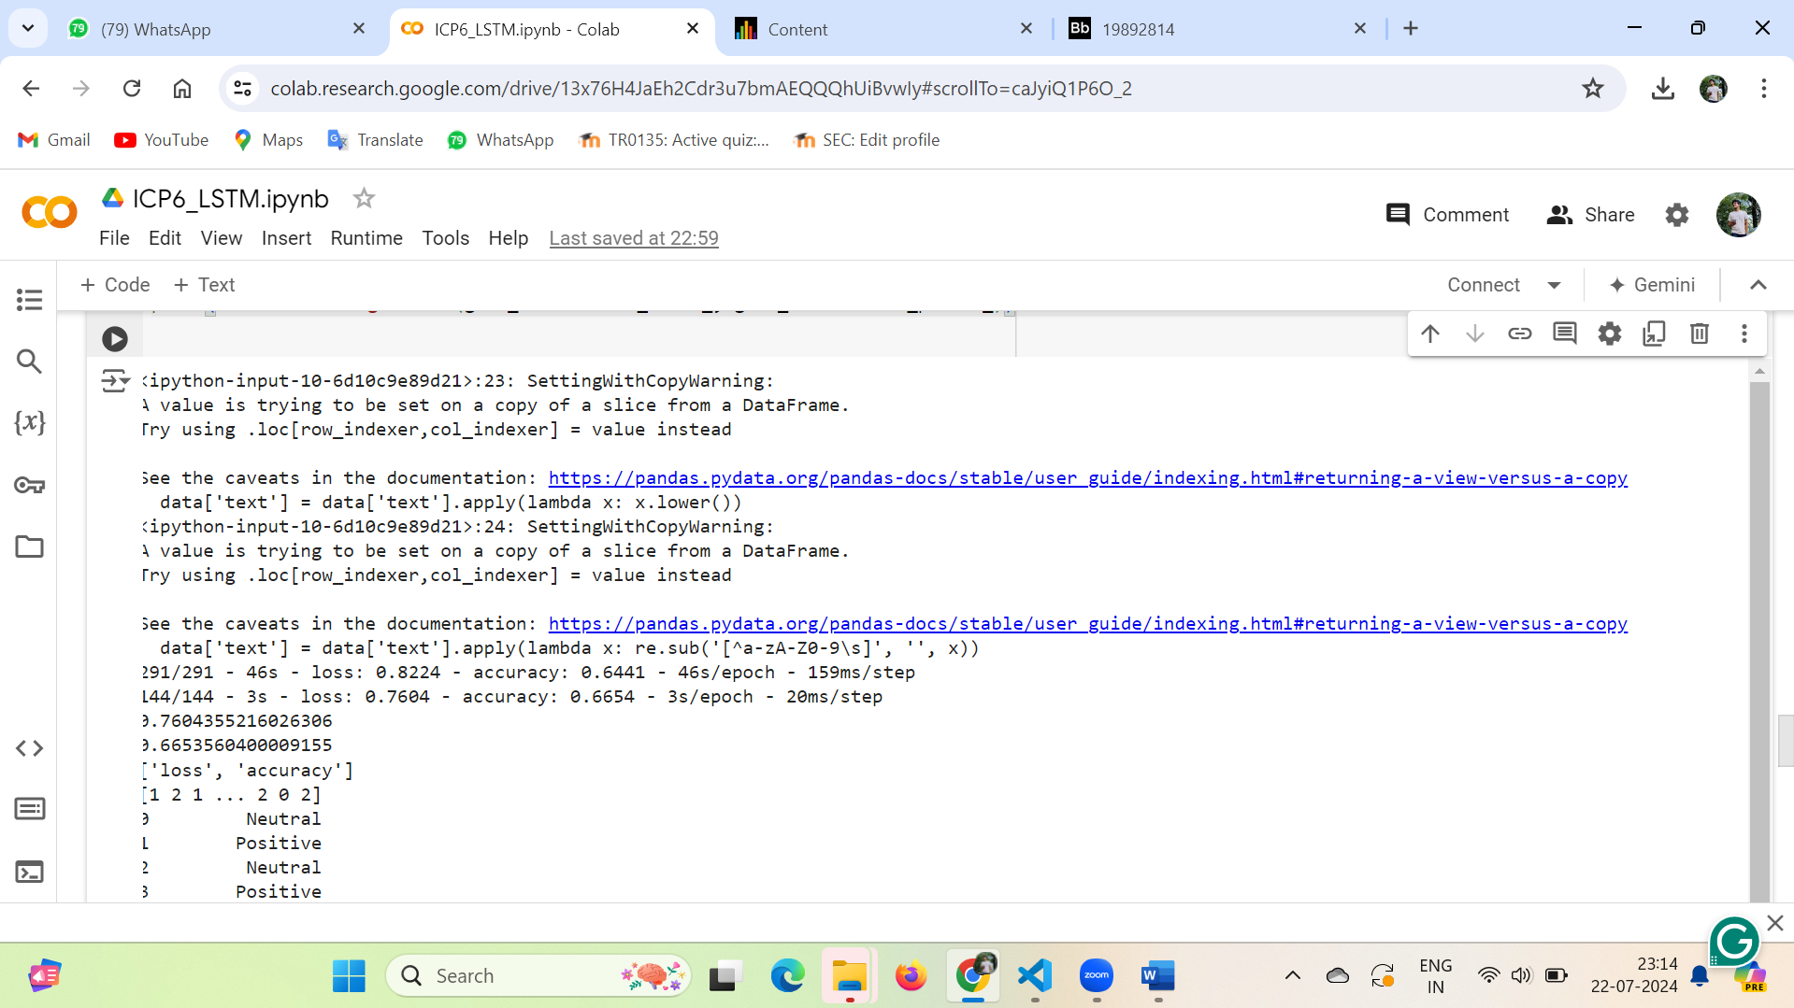

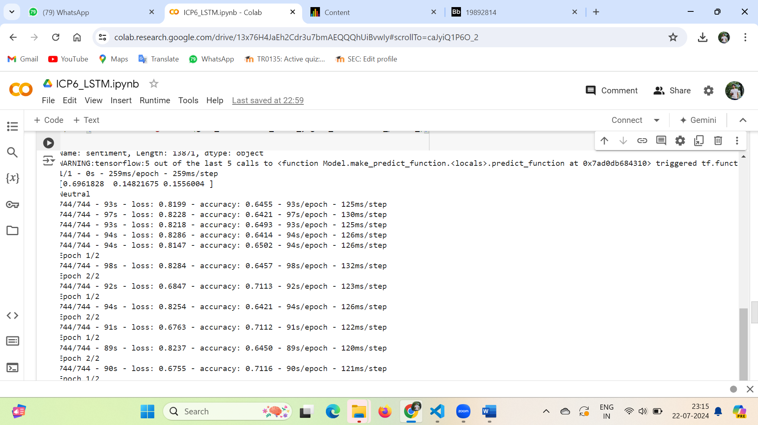

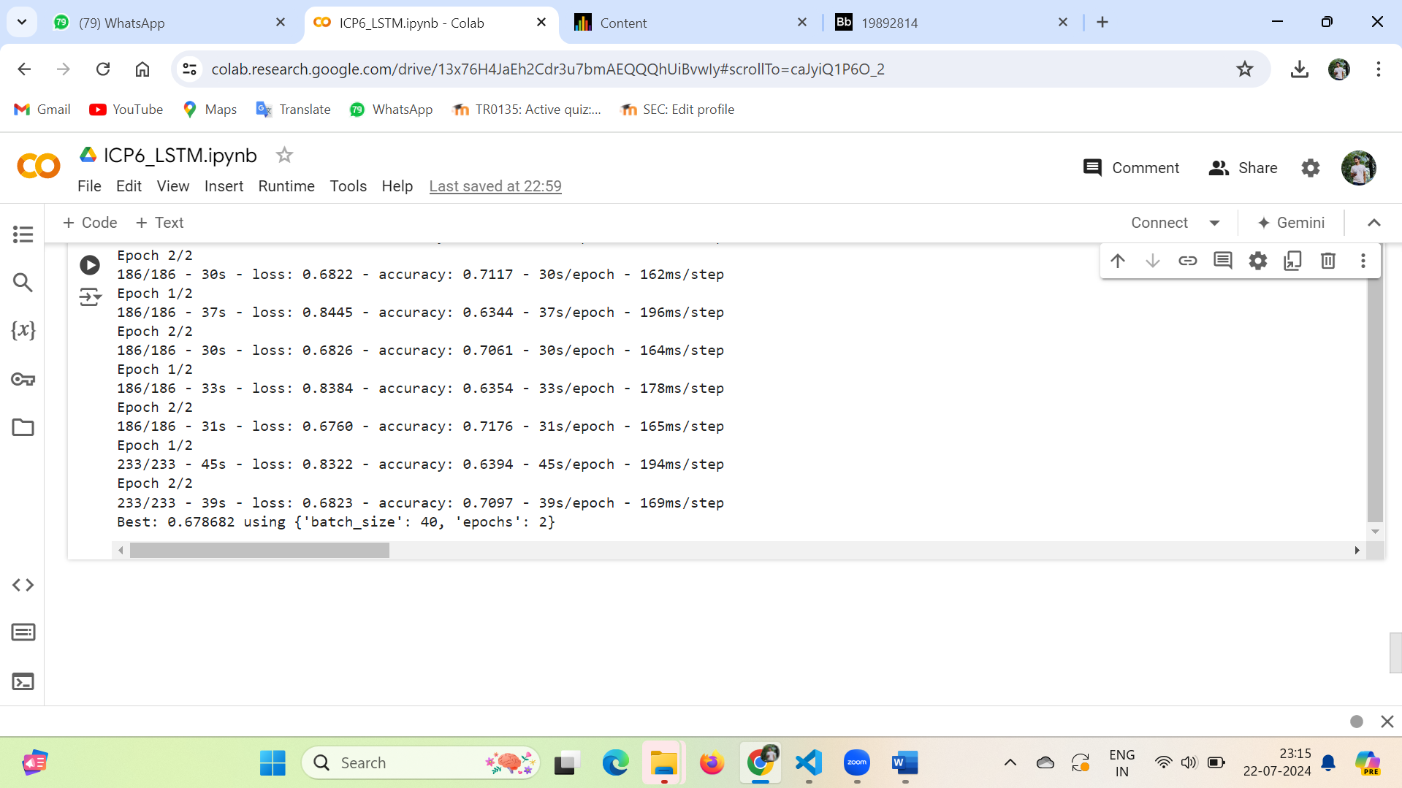

GitHub:

<https://github.com/teja375/DNN/tree/main/ICP6>