Please read the instructions before running the application.

For this application, **MEAN** stack framework has been used along with HTML, CSS, JavaScript, JQuery and Bootstrap.

Node JS modules require

1. Express
2. Body-parser
3. MongoDB

Node JS Server will run on 8080 port number

**Mongo DB**

Mongo DB server will run in 27017 port. If for any changes on the port number, configuration changes are to be made from dbconnect.js file.

**POC Details**

This POC has been developed based upon the Facebook feed fetching and storing in the database.

The Facebook feeds have been implemented by using the Access Token from Facebook Graph API.

The following are the steps to be followed in order to get feeds from any of the pages in Facebook.

P.S: Facebook feeds has been implemented

**Steps to get the access key:**

1. Please login to your Facebook account.
2. Please go to developers.facebook.com and under Tools & Support tab, click on Graph API Explorer
3. Click on Get Access Key button and select all the checkboxes on the pop-up that appears
4. Click on OK, if asked to give the permissions from Facebook.
5. The access key will be populated in the access key input field.
6. Copy the access key and paste against the **variable** accessToken in feedFactory.js file.

**Steps to be followed to get the page ID:**

1. Go to your Facebook account and search for the pages you’ve liked earlier to get the RSS feeds and copy the page URL.
2. Go to http://findmyfbid.com/ and paste the URL in the input field and click OK.
3. Then a unique ID will be populated Copy the ID.
4. Paste the ID against pageId in feedFactory.js file.

Now, the application is ready to receive the feeds from Facebook.

Please search the feeds and on click on Save Feeds button, the feeds will be saved into Mongo DB and will and will be populated in the right pane from Mongo DB.

ScreenShot:

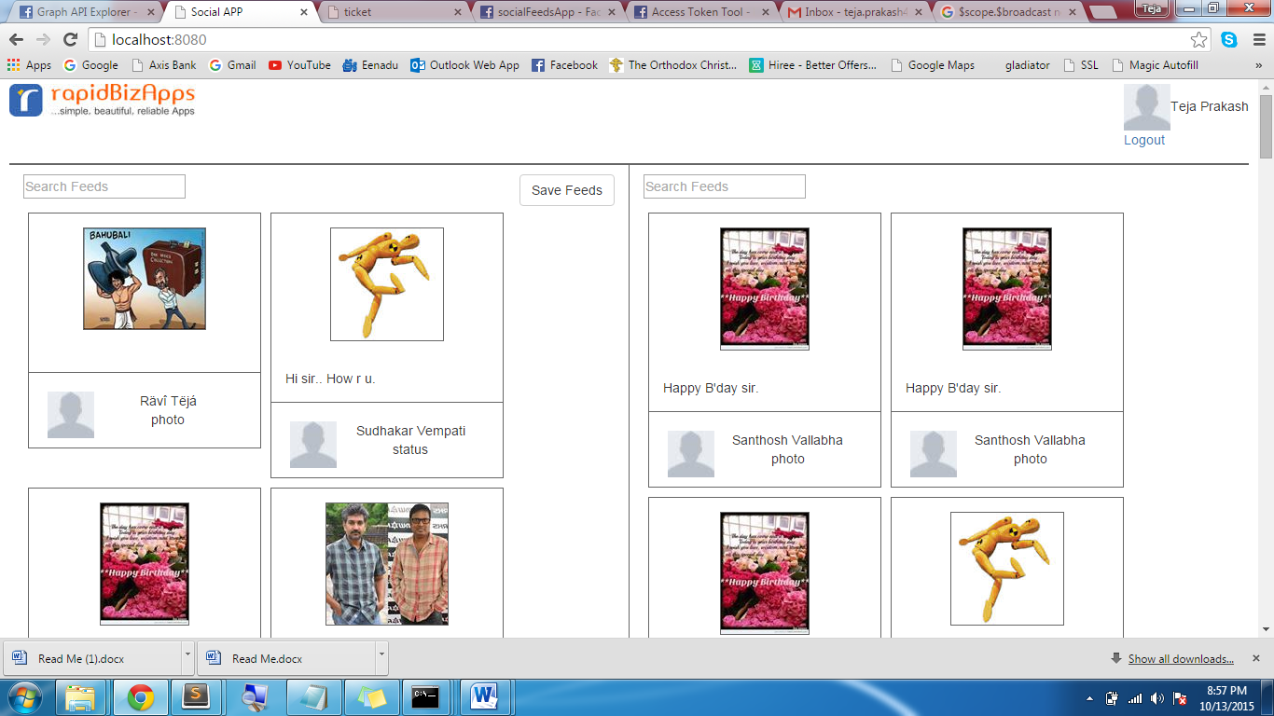

Please find below the following sites which have been referred for working on this project.

* <https://developers.facebook.com>
* Search key in <http://google.com> using: Filtering by multiple specific model properties , how to create facebook app id for localhost, facebook login in javascript
* Pluralsight offline node videos and mongo DB videos
* Never-expire access token for Facebook, but was failed to achieve it due to constraints in time as well as the change in Facebook Graph API protocols
* <http://www.tutorialspoint.com/mongodb> for Mongo DB related information and usage guidelines
* <http://www.tutorialspoint.com/nodejs/>
* <http://stackoverflow.com/questions/5133075/running-facebook-application-on-localhost>