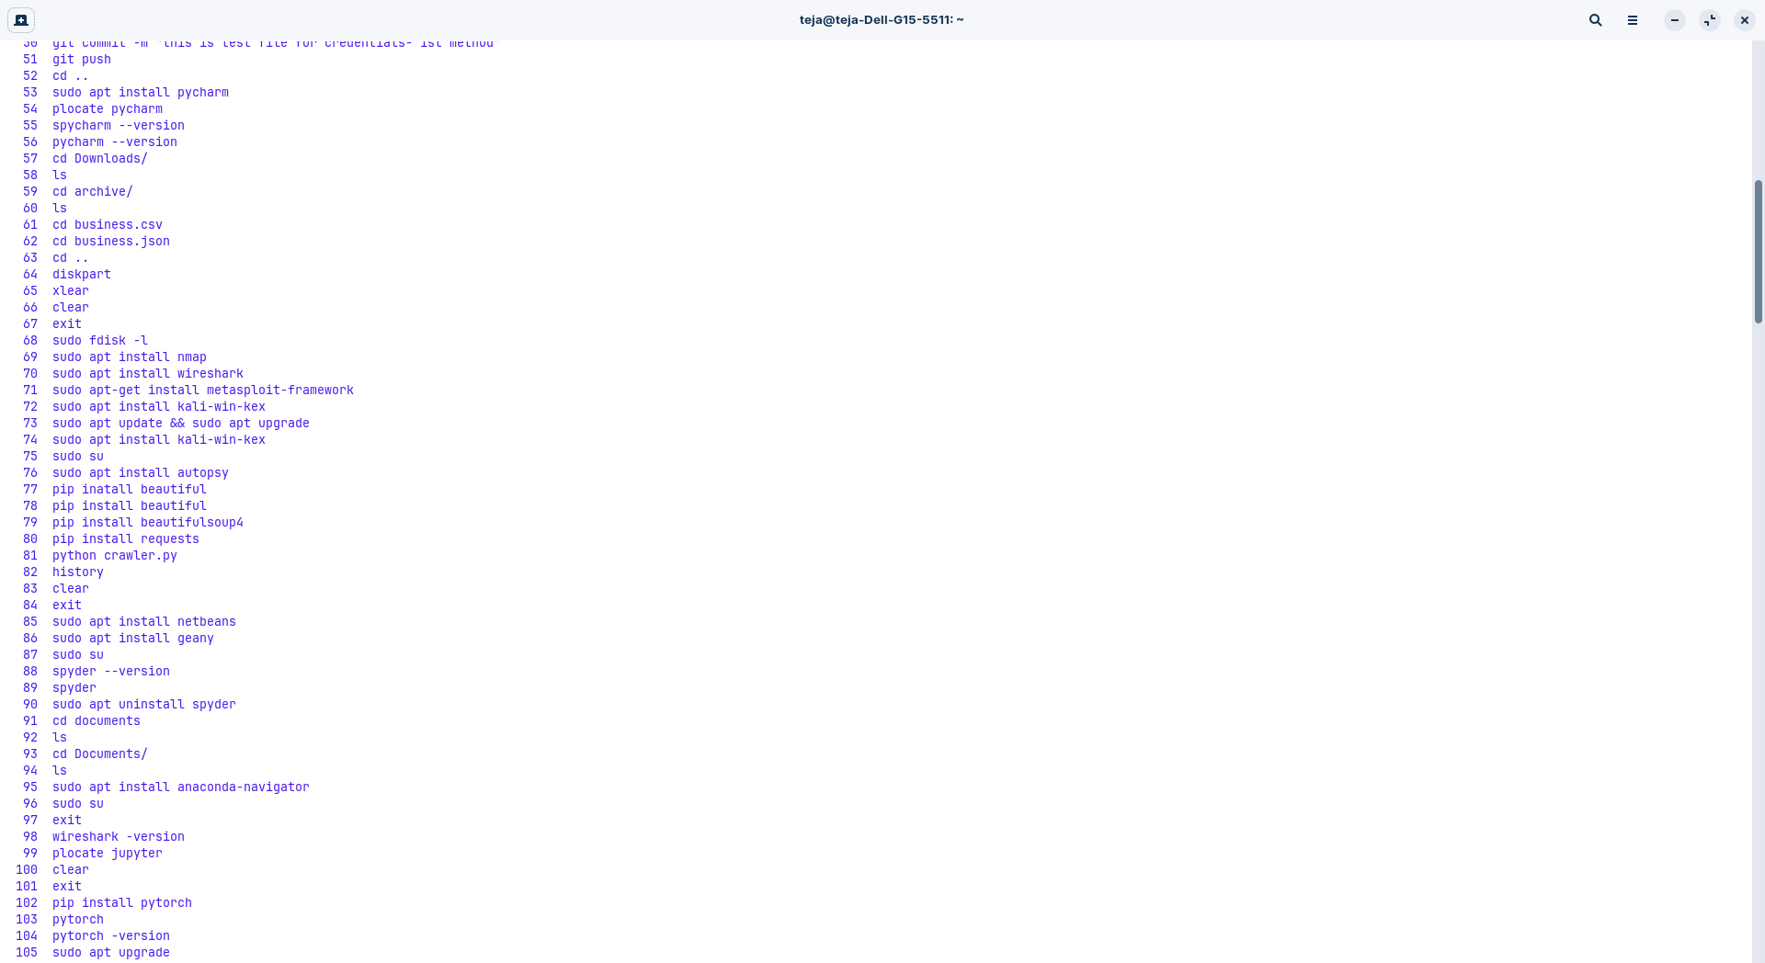
Instalation of tools
nmap
wireshark
metasploit
autopsy

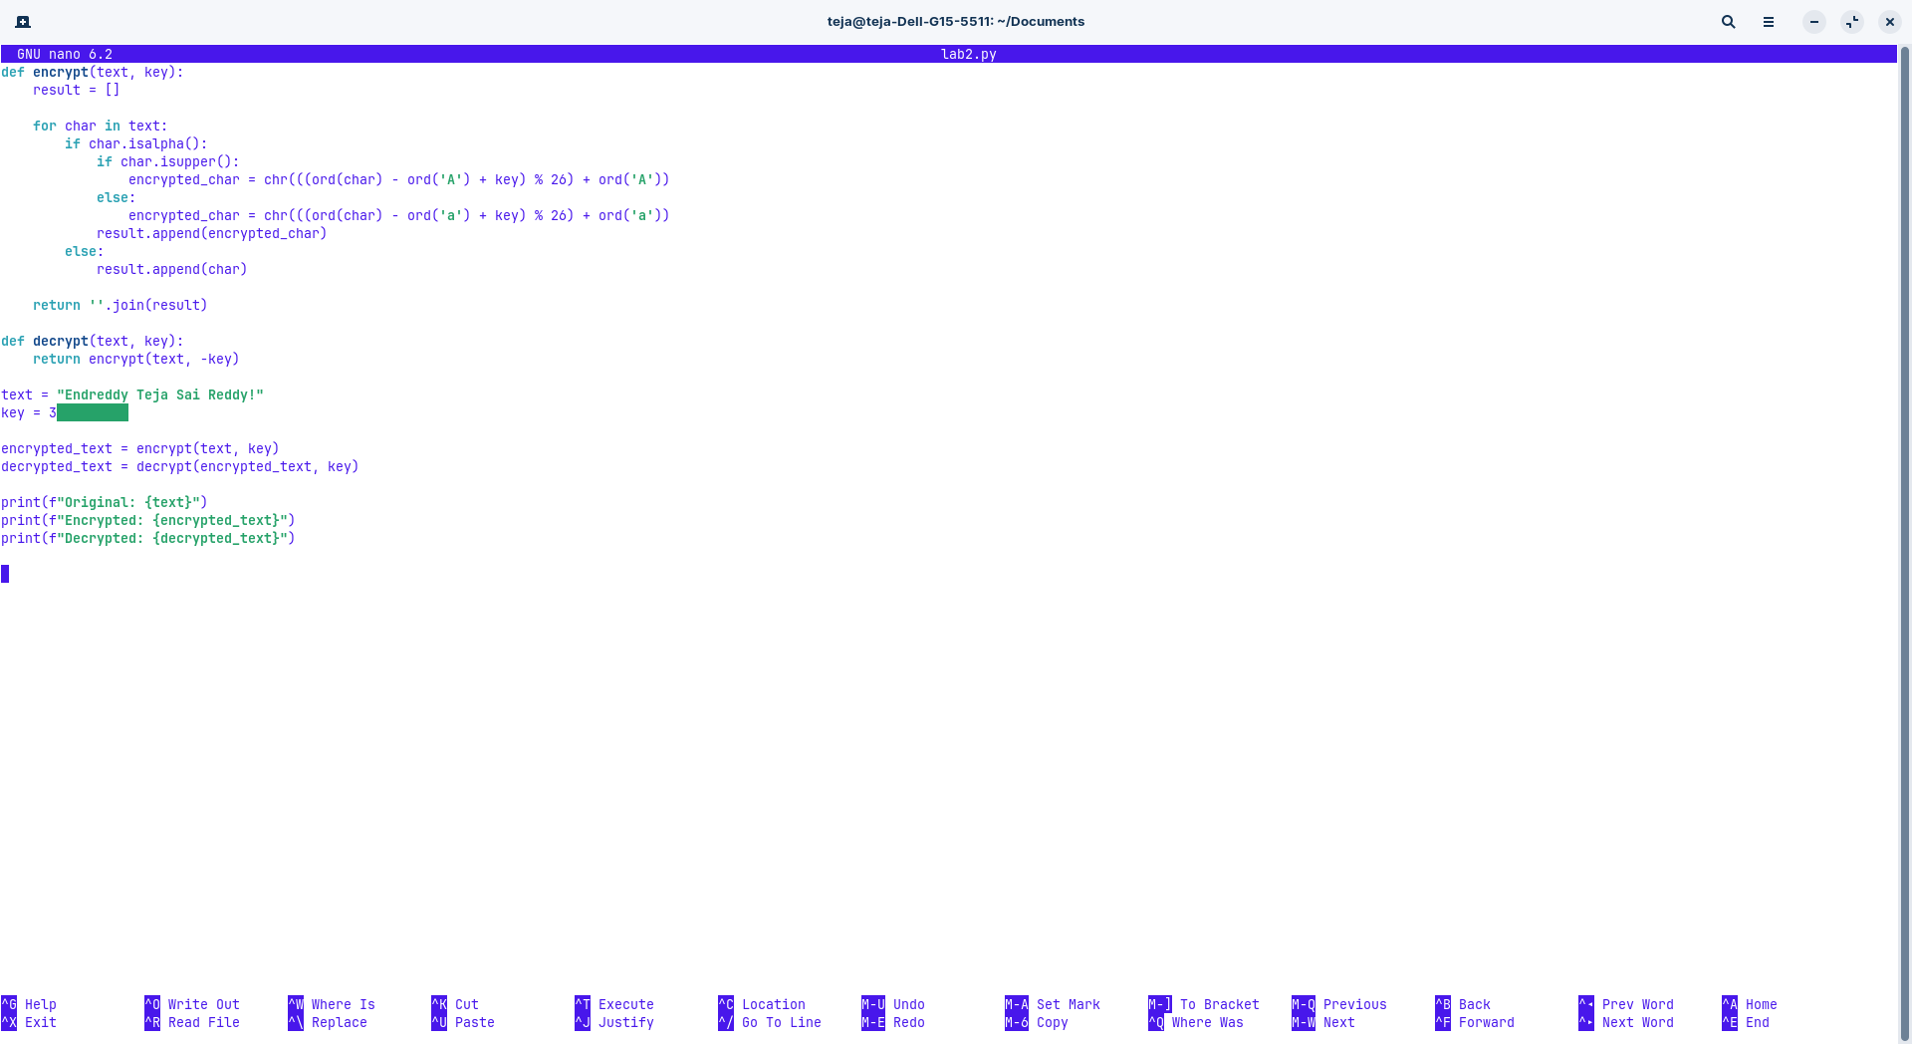
OUT PUT:-

Original: Endreddy Teja Sai Reddy!
Encrypted: Hqguhggb Whmd Vdl Uhggb!
Decrypted: Endreddy Teja Sai Reddy!

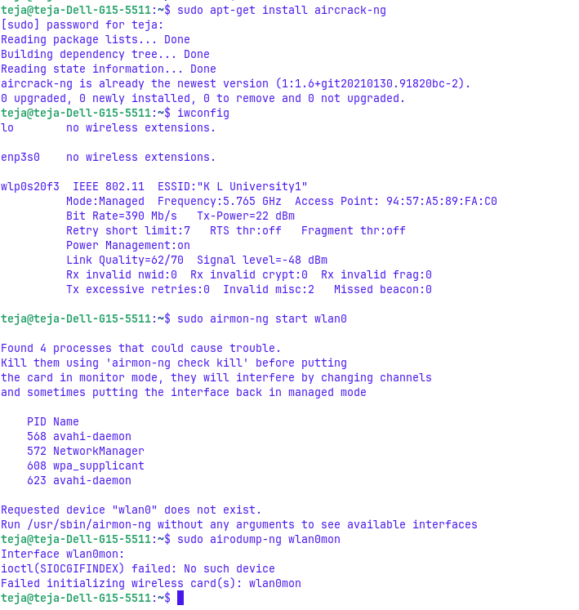
Install aircrack-ng
command sudo apt get install aircrack-ng

packet capturing:-
capture raw packages for analysis

network discovery:-
shows the information about the wireless networks

clint tracking:-

we can the clints and therir mac address
here we can se which clints are connected to which access points

