Real-World Phishing Awareness Example
This document demonstrates a real-world phishing email example used for cybersecurity awareness training.
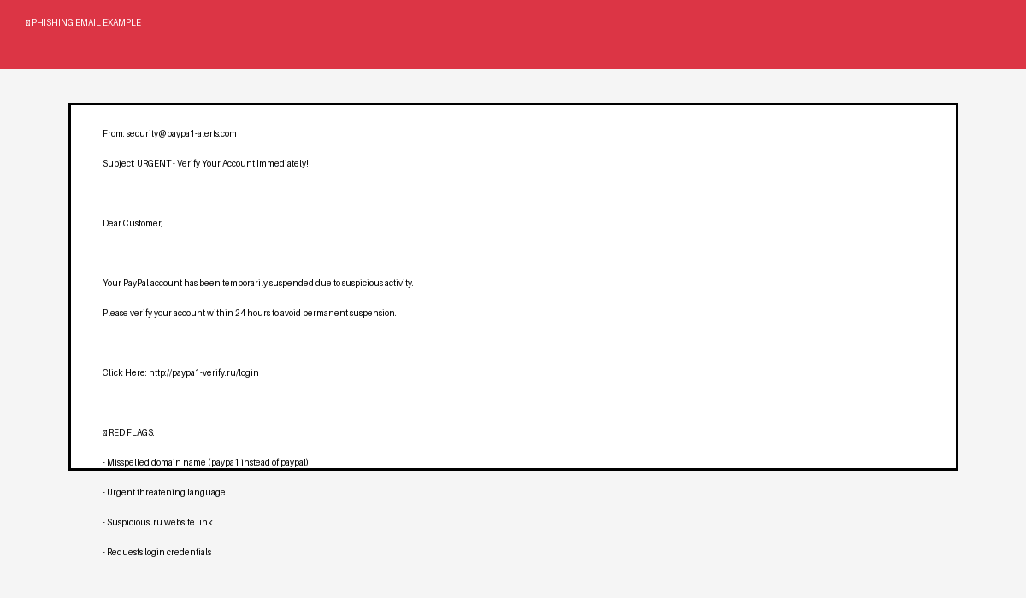

Key Warning Signs
- Misspelled domain names
- Urgent or threatening messages
- Suspicious external links
- Requests for passwords or OTPs
- Grammar and formatting mistakes

Cybersecurity Best Practices
- Always verify the sender email address
- Do not click suspicious links
- Enable multi-factor authentication
- Report phishing emails immediately
- Use strong and unique passwords

