Exercise- 2 B191143CS Panasa Teja

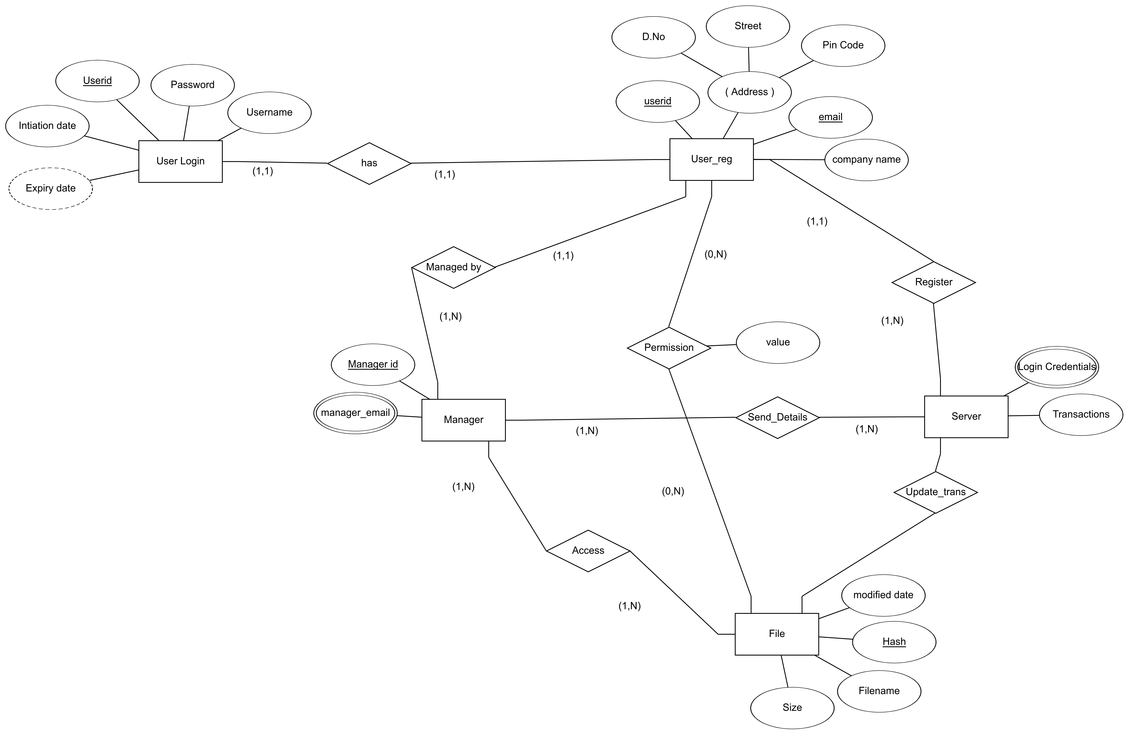
ENTITIES:
1. User login
2. User
3. file
4. manager
5. server

Relationships:
1. has- User has account for login purpose
2. managed by- User has a manager it’s relationship is represtend by this(N to 1)
3. access- User has an access to files given by the manager.
4. register- after creating an account it will save into server its shown ny this relationship
5. send_details- manager can access the details of user from the server.
6. permissions- user send request to manager for file access this can be shown by this.
7. update_transactions- after accessing files it will update the usage of file.

