***Networks Lab Experiment-1***

Singam Sai Bala Subrahmanyam

B180522CS

1. **Ping**

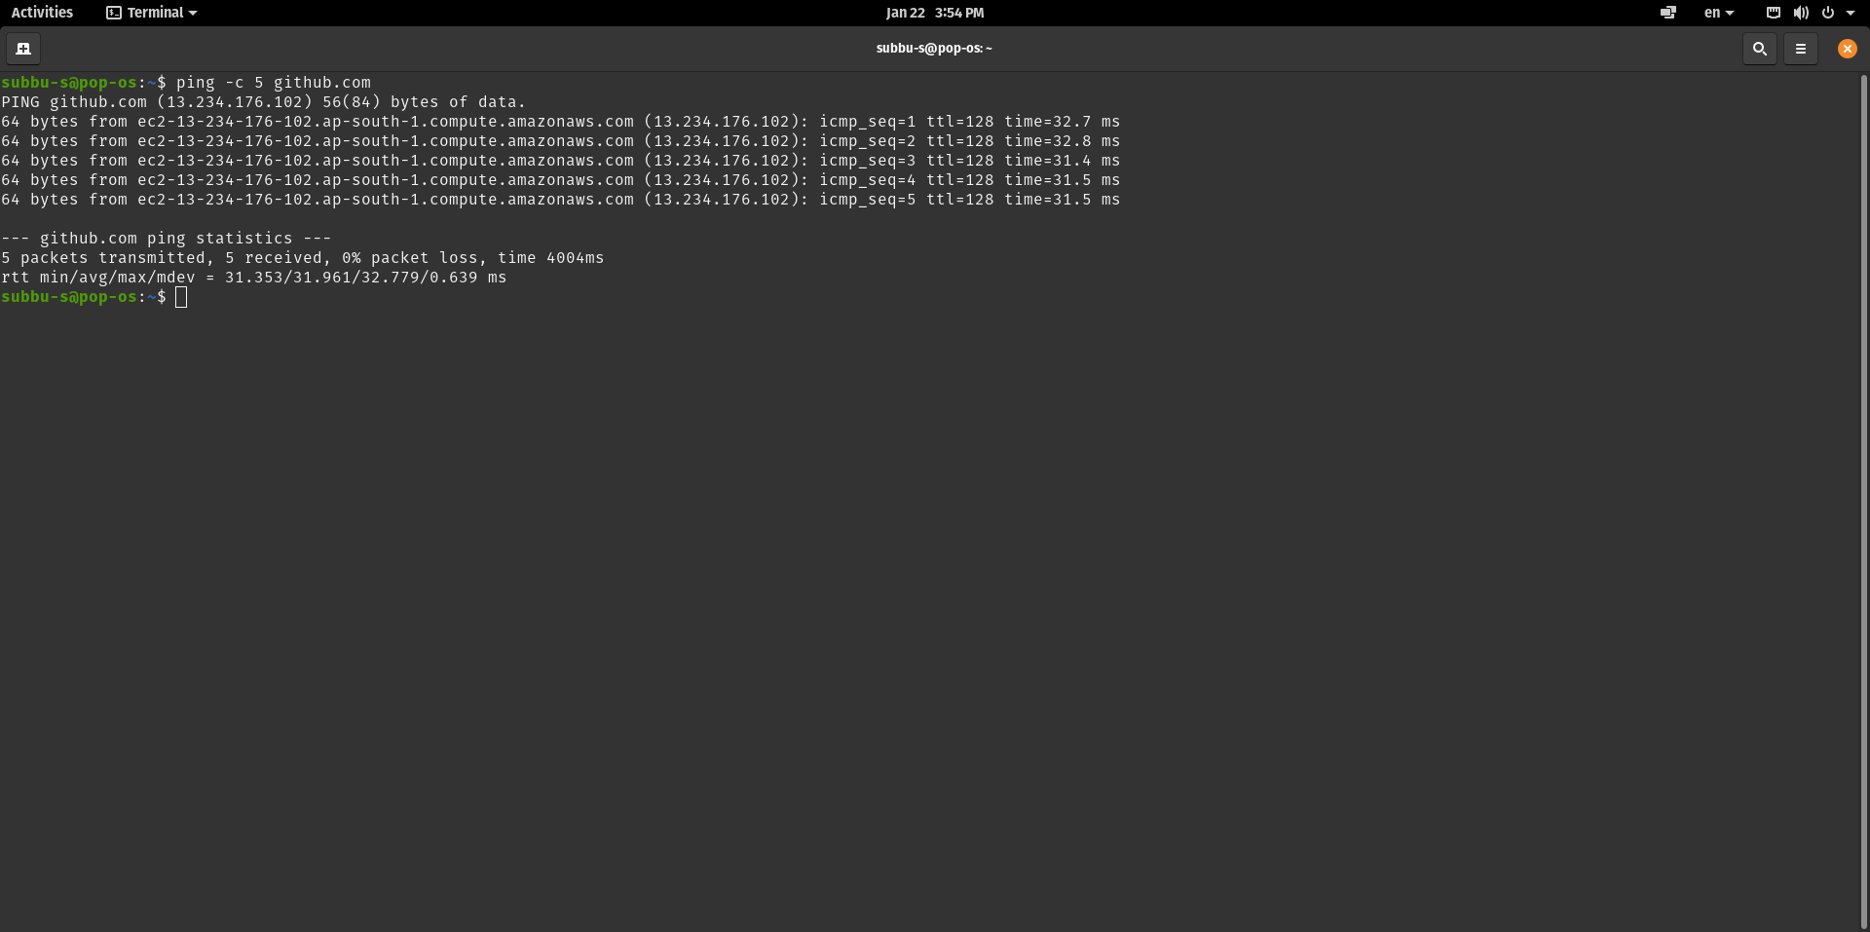

Ping command is used to test if a networked device is reachable. It sends ICMP ( Internet Control Message Protocol) request packets to the target host and waits for its reply.

-c flag is count which determines the number of packets to be sent. Ping also provides the statistics of results and reports packets loss and errors if any. TTL (time to live) is a mechanism that limits the lifetime of packets.

1. **Traceroute**

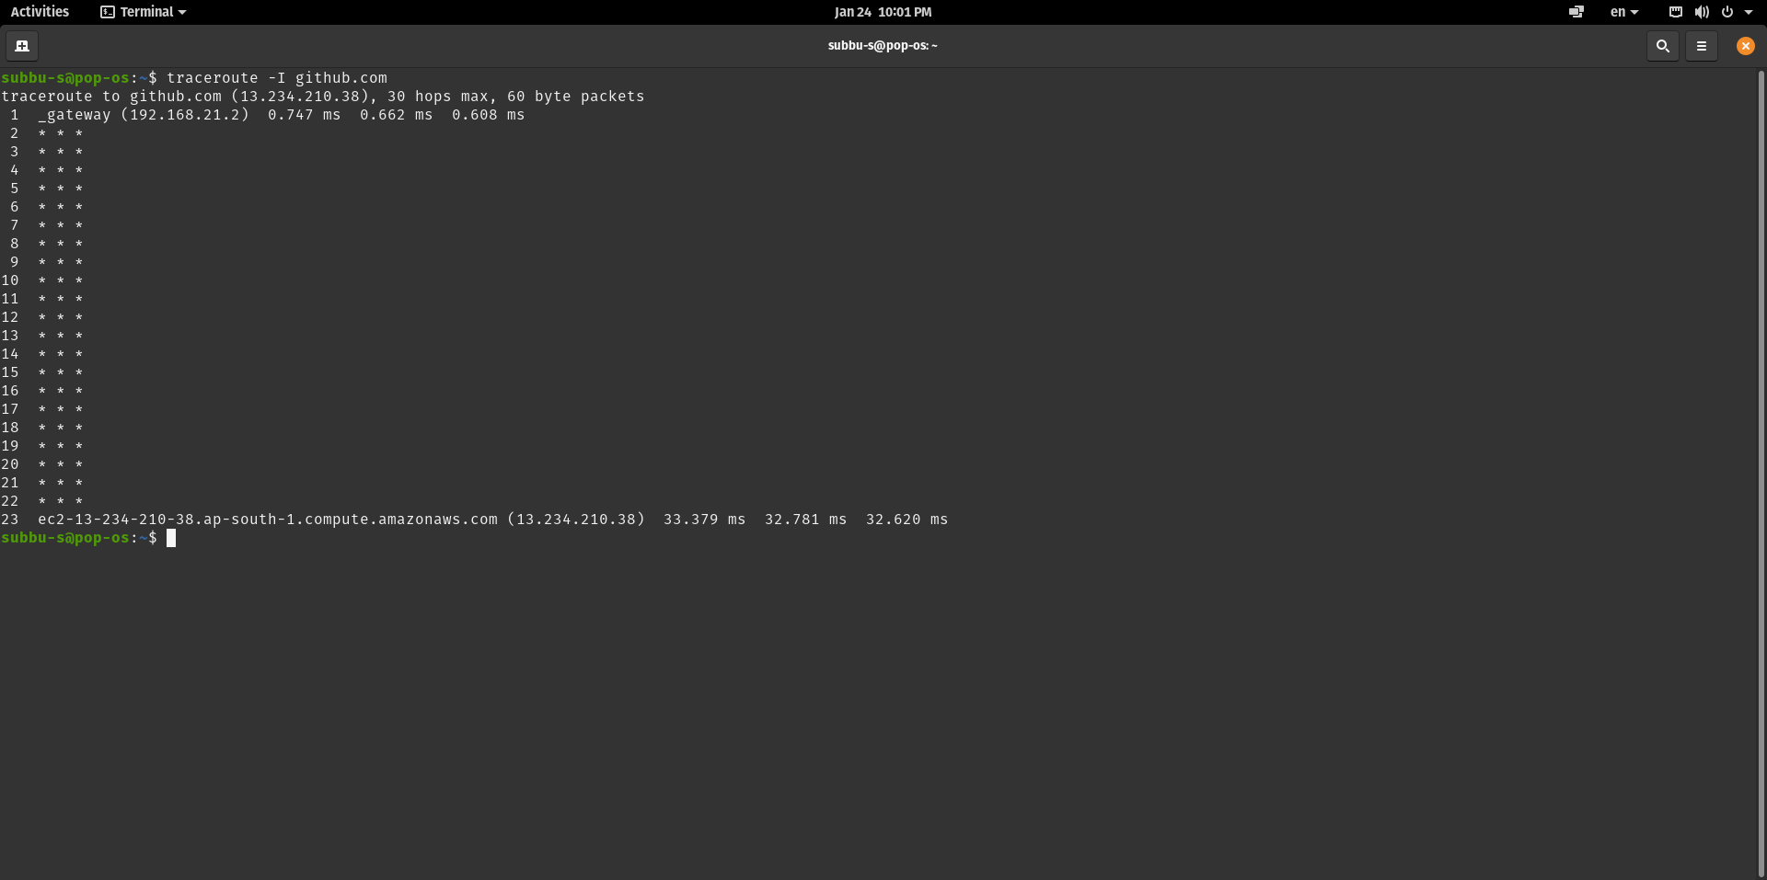

Traceroute tracks the path taken by the packets from the IP network to the network host given as an argument. It sends probe packets with small TTL and draws out an “time exceeded” reply from the gateway.

-I flag is used to select ICMP trace out method which uses ICMP echo packets for probes. The asterisk “ * “ are printed for a probe if there are no responses from probes within a certain time out.

1. **Ifconfig**

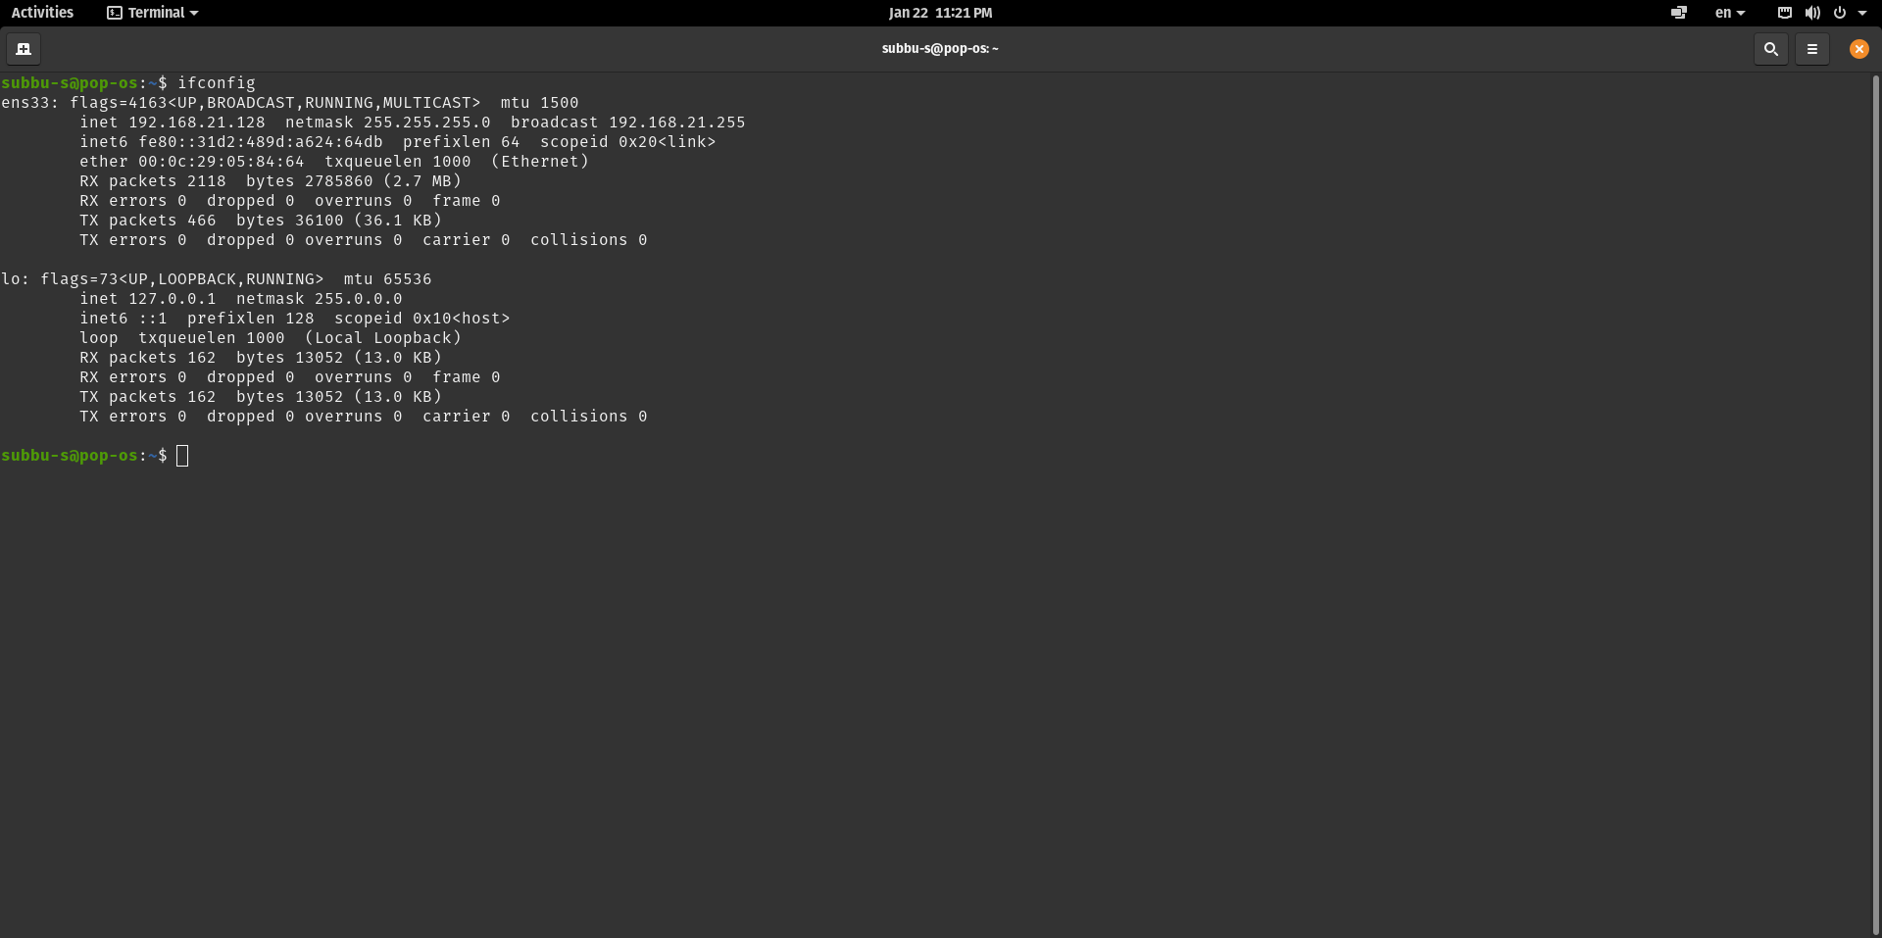

Ifconfig means interface configuration. It is used to display current configurations information and is also used to configure network interfaces.

An ifconfig command with no flags will display all the active interfaces details and is also used to check assigned IP address for an server.

1. **dig/nslookup/host**

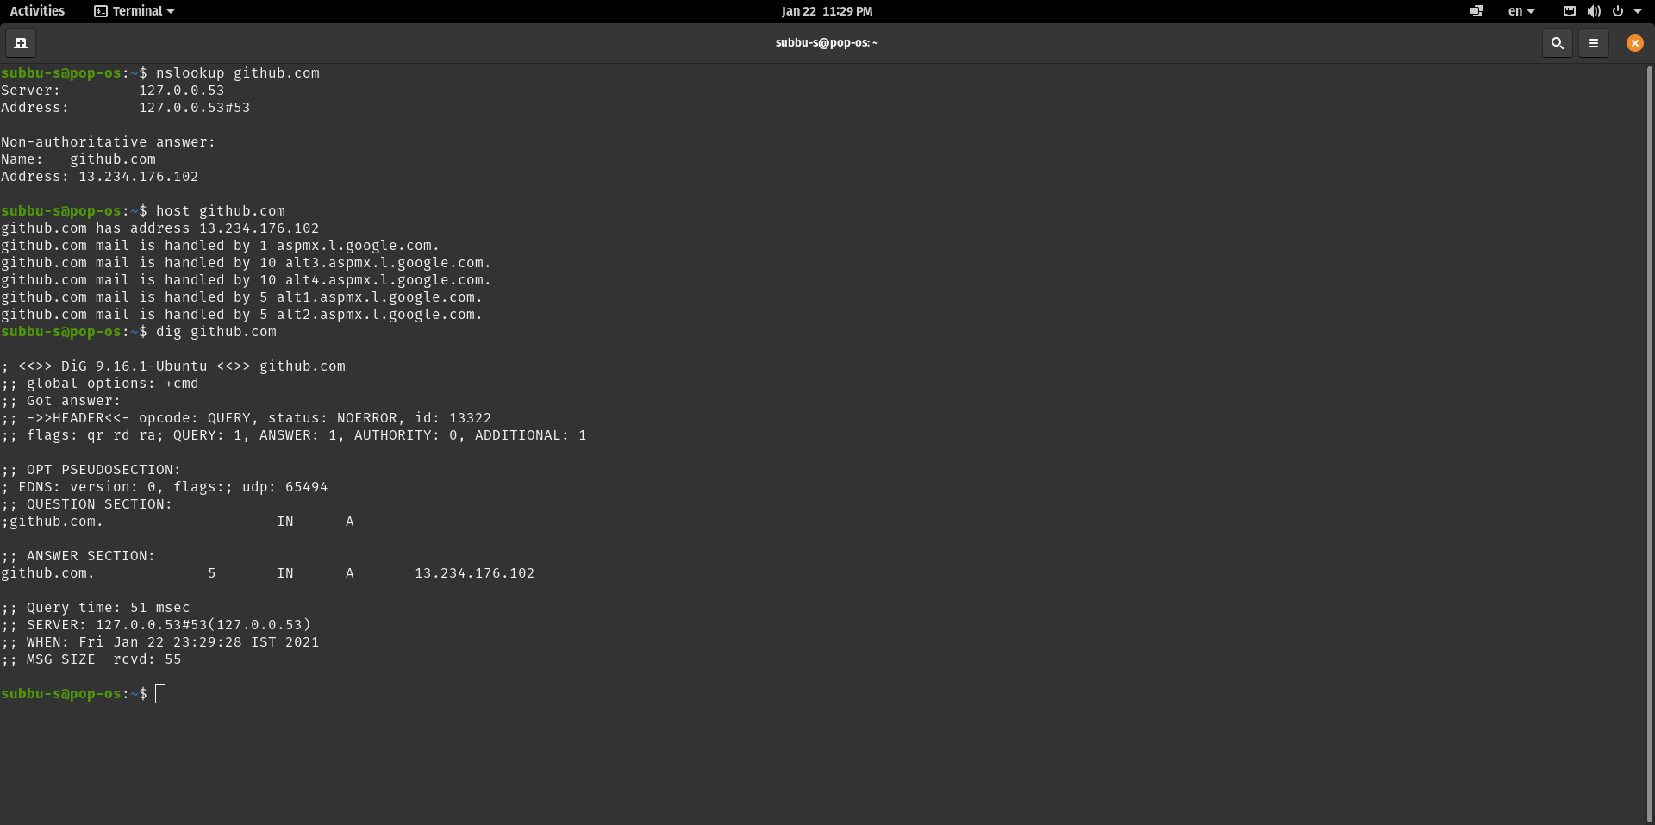

dig / nslookup / host commands are used as DNS (Domain Name System) lookup utilities. When provided with a domain name as arguments these commands will print the IP address for the corresponding domain names.

1. **whois**

When provided with a domain name as argument, whois fetches the information about the domain, its owner, owner’s contact information, company that registers domain for the owner, servers that control domains DNS, creation and expiration dates etc

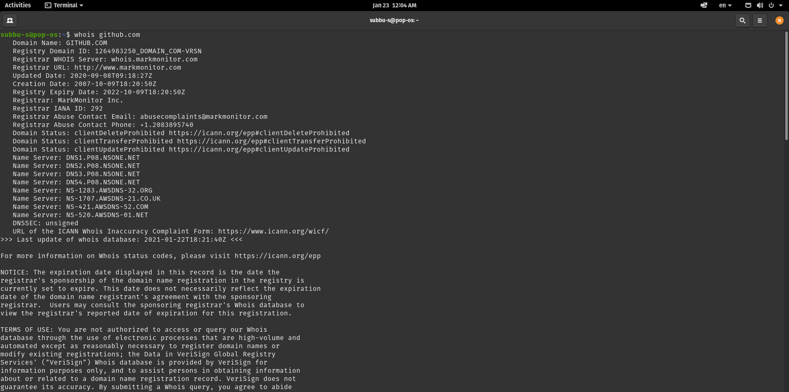

1. **route**

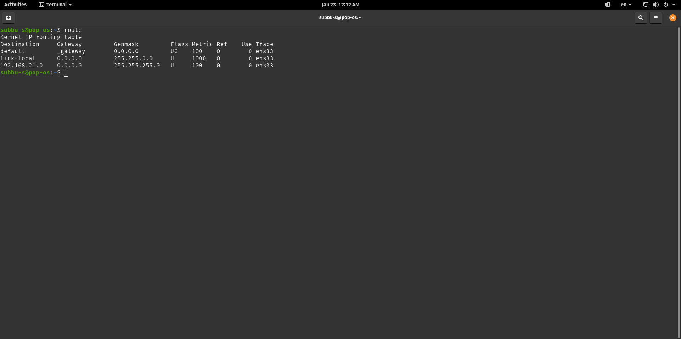

route command is used to show or modify the IP routing tables of the kernel. Simple route command without any arguments will display IP routing tables.

Routing table is a data table stored in a network host that contains routes to particular network destinations, distances associated with those routes.

1. **tcpdump**

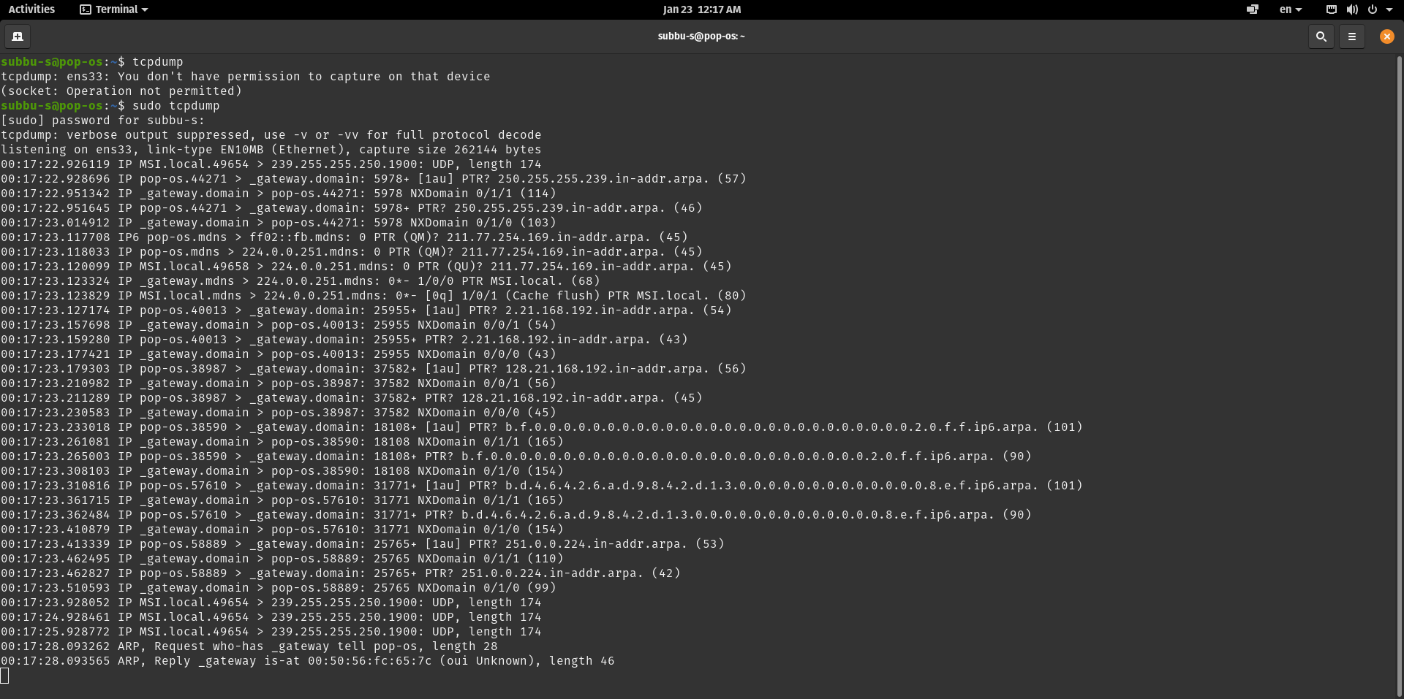

Tcpdump is a command-line packet analyser used to dump the traffic on a network. It prints the description of the packets on a network interface along with a time stamp. After completing capturing packets it prints out the report consisting of count of captured, received, dropped packets.

1. **netstat**

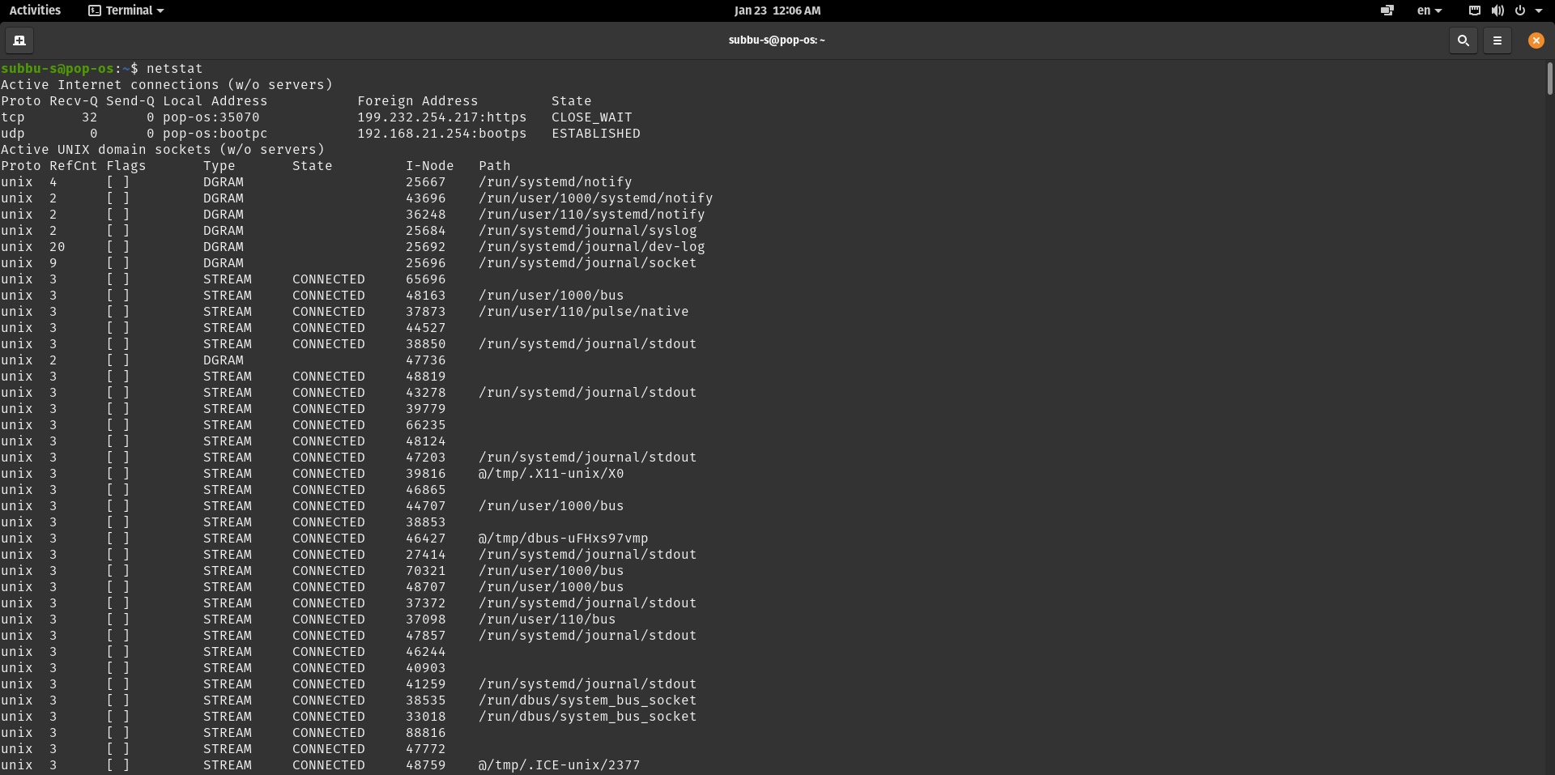

It is a networking tool that serves as a monitoring tool for connections over a network. It prints routing tables, interface statistics, incoming and outgoing connections, port listening etc

1. **dstat**

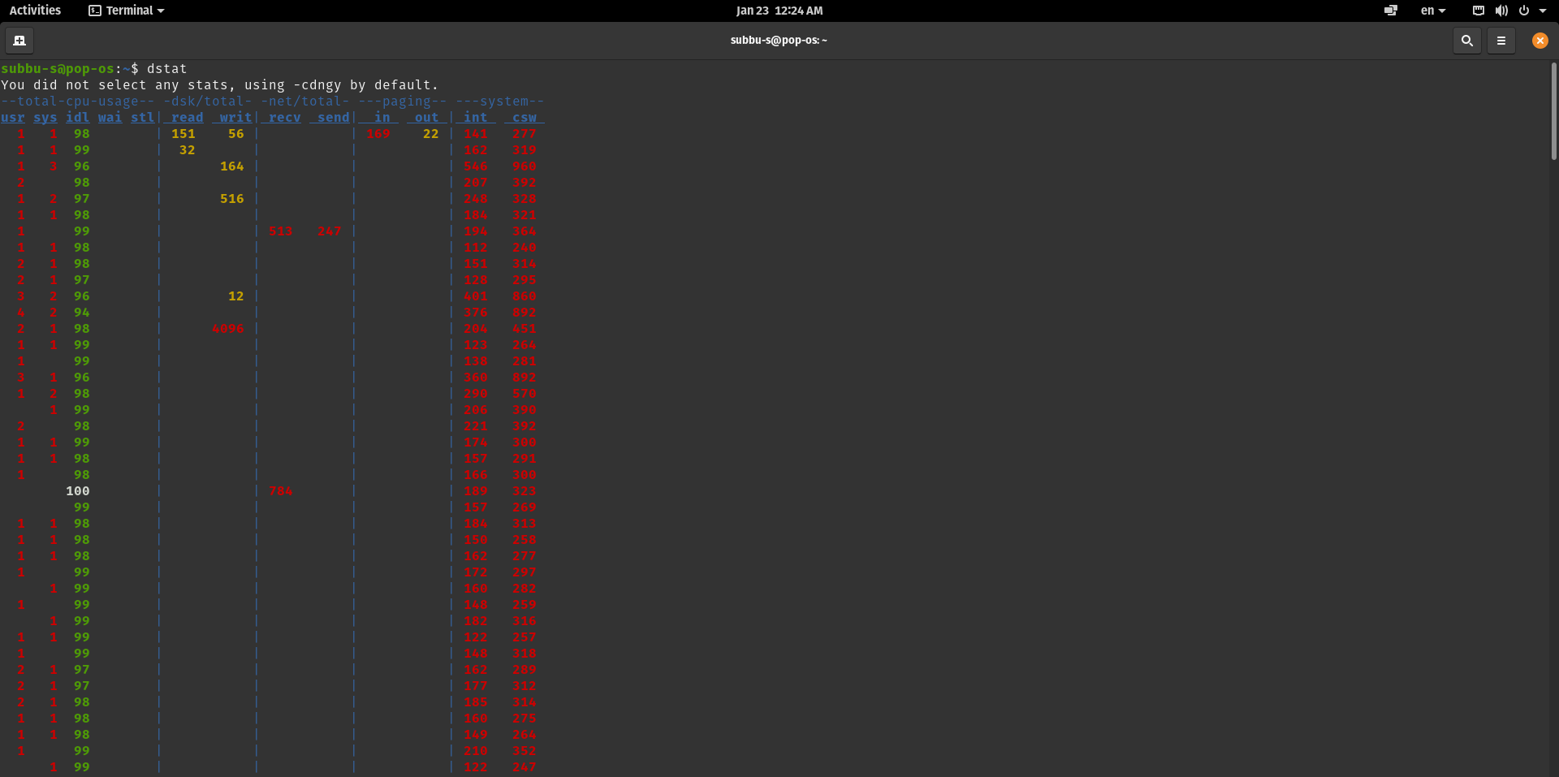

dstat is a tool used to generate statistics from system resources such as CPU, I/O devices, Networks etc

dstat without any arguments displays statistics of major OS components: CPU, Disk, Network, Paging, System stats in the same order

1. **Ifstat**

Ifstat is used to report network interface statistics and displays network’s bandwidth consumption and speed at regular intervals of time.

Acts similar to iostat / vmstat which reports io and virtual memory statistics respectively.

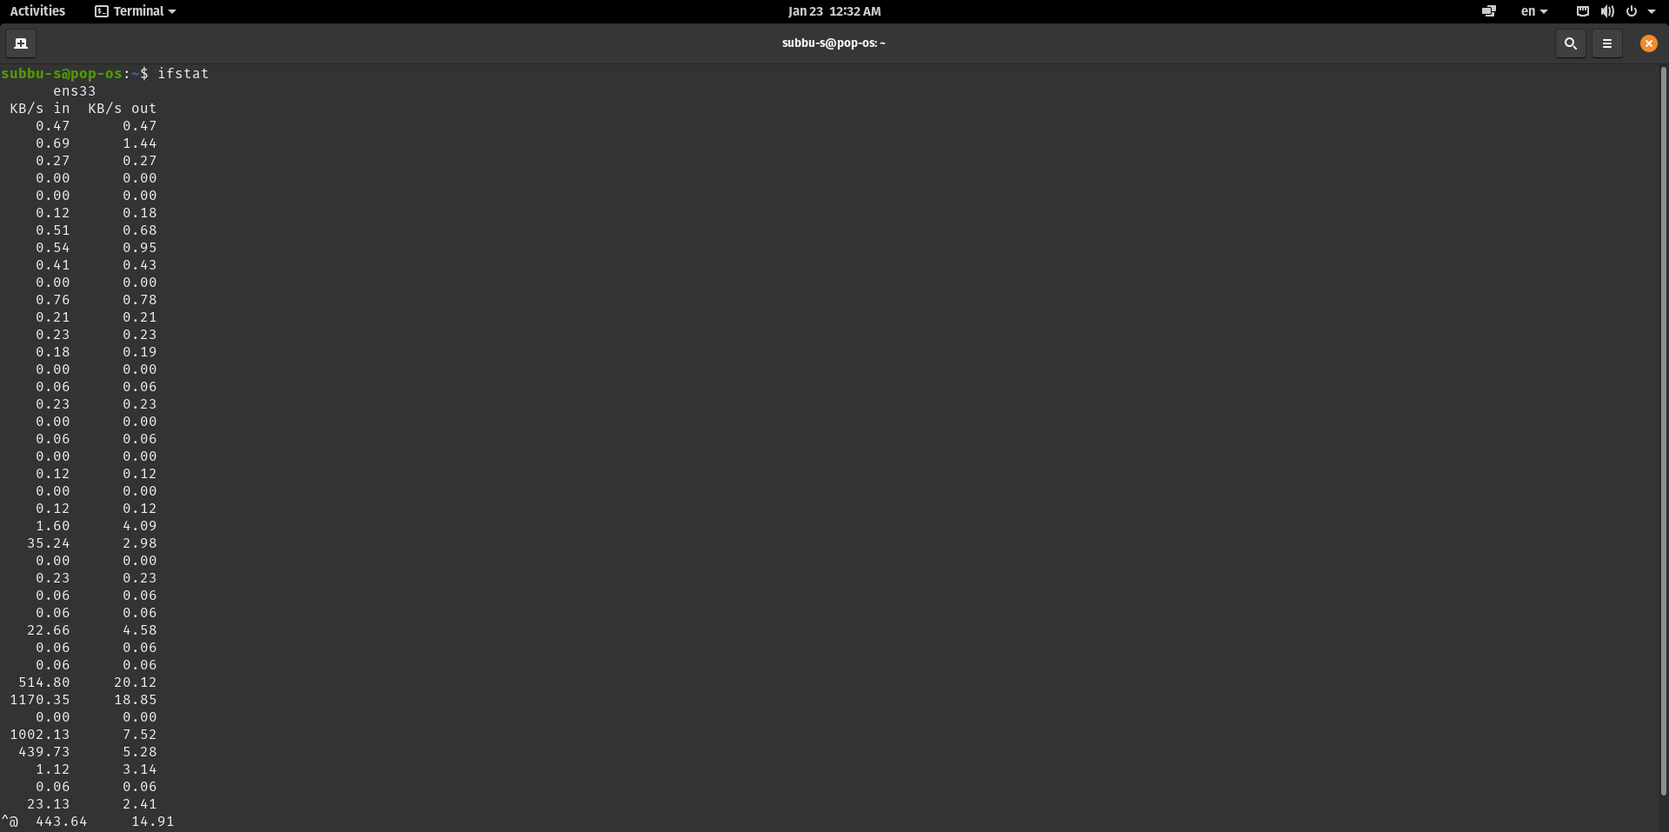

1. **Wget**

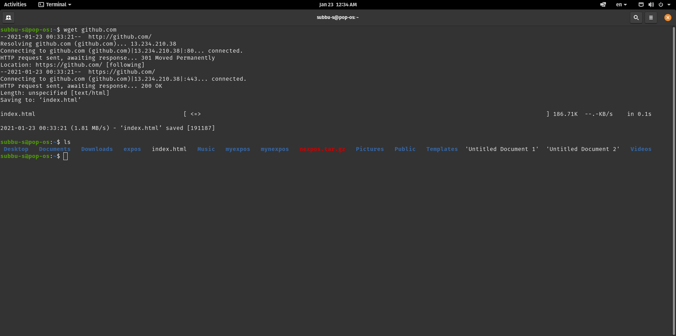

Wget utility helps us to download files from the web when provided with an url or domain name as argument. It retrieves files using HTTP, HTTPS, FTP and FTPS protocols which are widely used.

If download fails it keeps on trying until it retrieves the whole file which is suitable over slow and unstable connections.