Scope: take fivetran etl ui as reference and create lighter version:
Front end React
Backend Java
Side bar
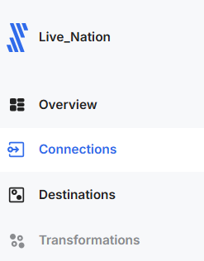

Connections section
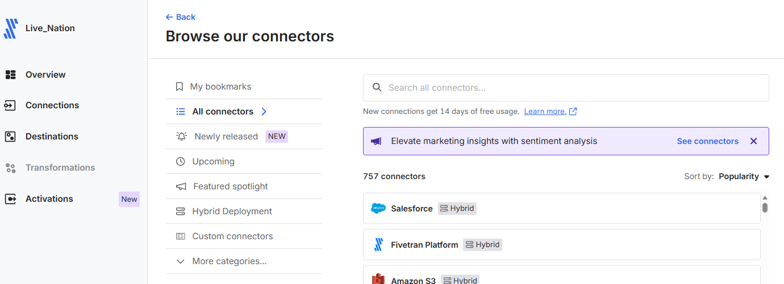

Create destinations in the same way as connections

For now, add below connection sources:
- Quick books
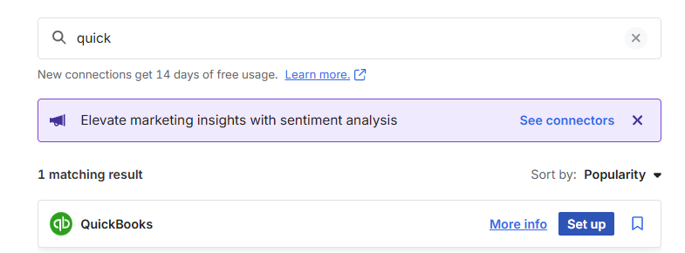
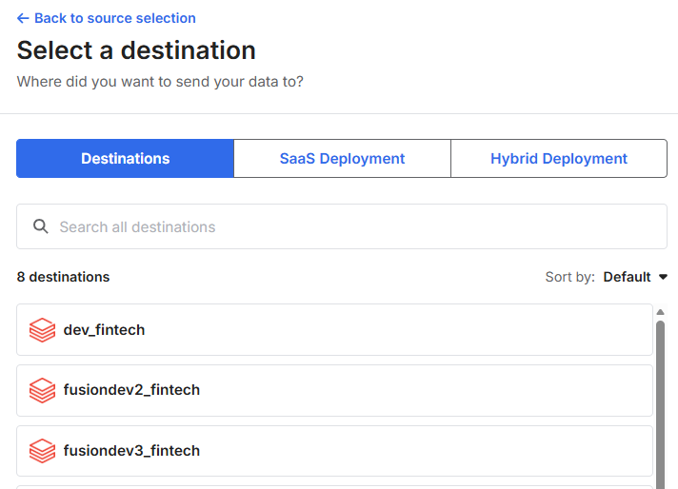
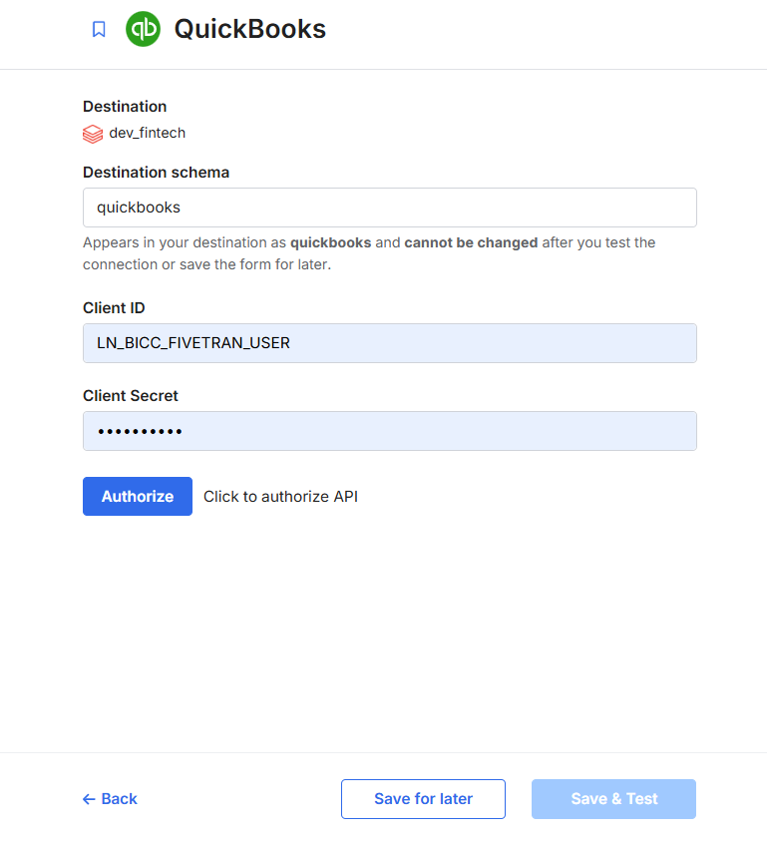

- Mysql
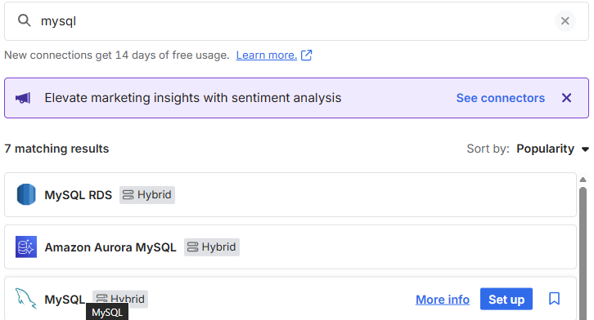

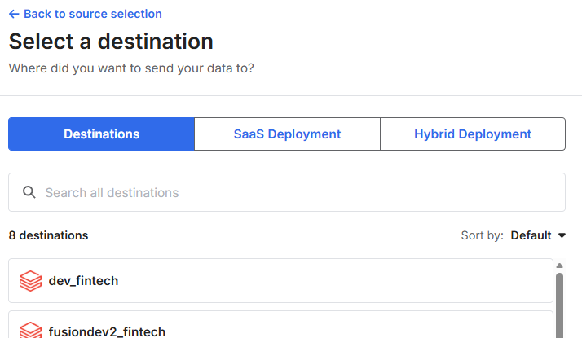

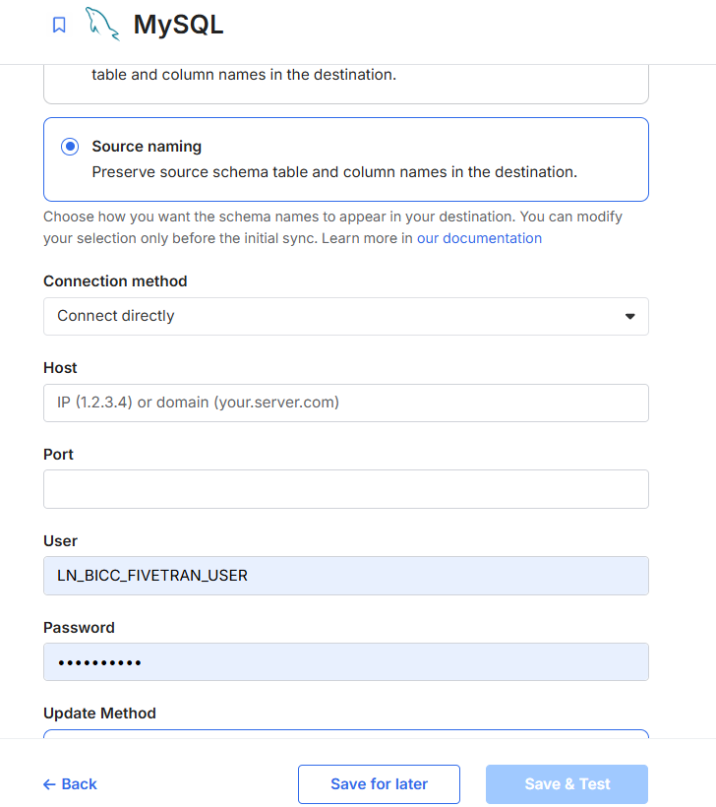

Destinations as :
- Azure SQL (create destination ui that takes parameters accordingly)
- Azure blob (create destination ui that takes parameters accordingly)

