ANALYSIS OF WORLD BANK DATA W.R.T CLIMATE CHANGE

**Brief about Data:** Obtained the data regarding various indictors corresponding to climate change from the world bank website. It contains data spanning from years 1960 to 2020 for different countries as well as the world. This data can be used to identify trends in various indictors, and compare the statistical factors between each country or the world.

**Observing patterns in given data**

* The urban population throughout the world has been on a continuous increase till date. (Fig1.)
* Over the past 2 decades we can see a steady rise in the increase in greenhouse gases emissions. (Fig2.)
* We observe that most of the countries with min access to electricity belong to African continent. (Fig3.)
* So, the developing countries increasing urbanisation unconsciously increase the greenhouse gas emissions, while the underdeveloped countries still strive for electricity.

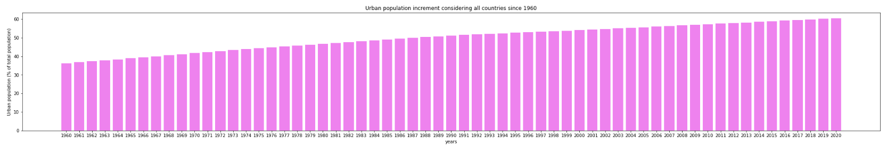

Fig1. Growth of urban population

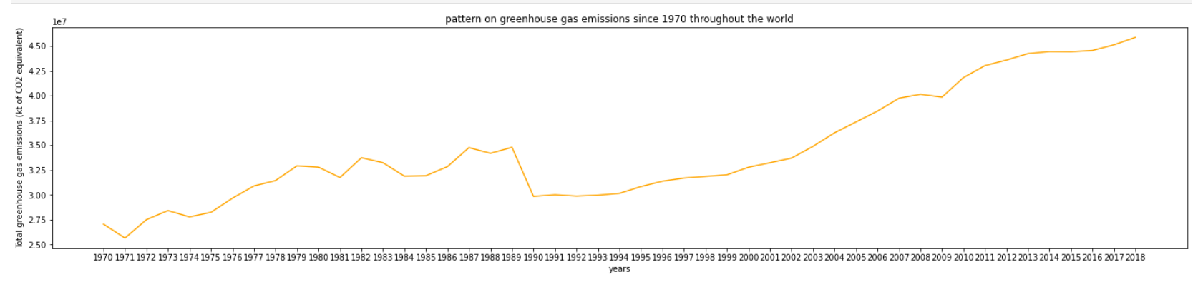

Fig2. Growth of emission of greenhouse gases

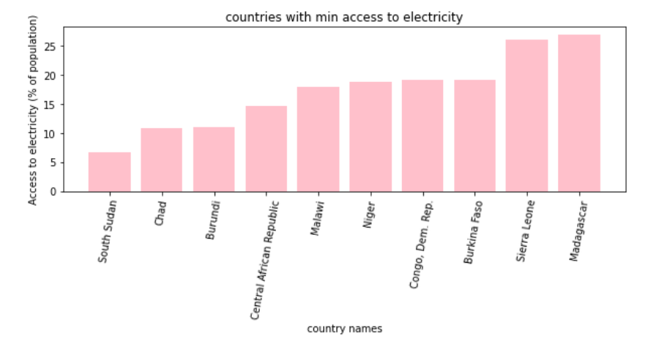

Fig3. Countries with least access to electricity

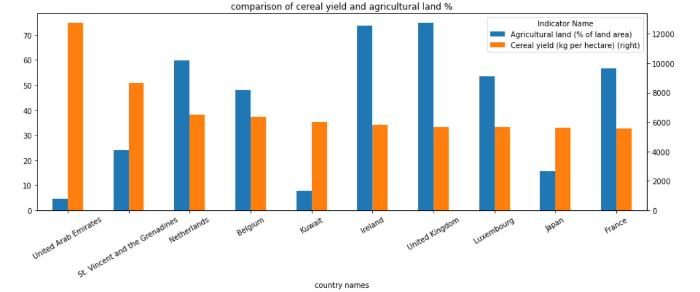

Fig4. Countries with high cereal yield and their agricultural land%

**Statistical Values Summary**

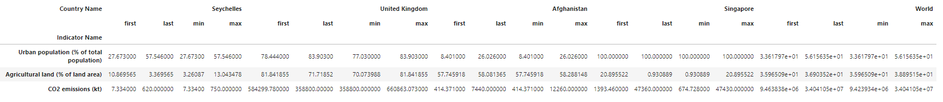

In the above summary we observe few interesting patterns:

1. In case of Singapore, which belongs to High Income group is East Asian and Pacific Region, has an absolute urban population % since 1960.
2. Seychelles has observed a 20% increase in the urban population % since 1960, on the other hand Agricultural Land % has been decreasing almost continuously with least values of only 3% in 2020.
3. Comparing different income groups we see that high income countries (UK, Singapore) have greater percentages of urban population, when compared to low income countries (Afghanistan).

**Correlation between indicators**

For exploring correlations between indicators, we have considered the indicators urban population %, electricity consumption, CO2 emissions. Between countries of different income levels and with the world.

The comparison and the analysis is done using scatter plots which help us identify the relation between 2 features. The different plots below are:

1. CO2 emissions vs urban population%
2. Agricultural Land vs Agricultural GDP %
3. Urban population vs Electricity consumption

Case1: China – High Income country, Asia

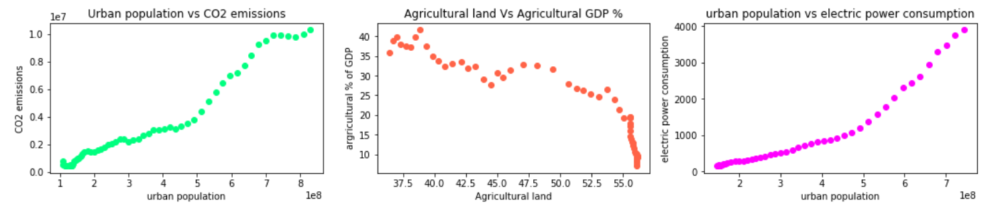

We see a linear relation in the increase of urbanisation and CO2 emissions as well as electricity consumption. This can be accounted to increase in electrical appliances and vehicles with urbanisation, which contribute to electric consumption increase and CO2 emissions. Although agricultural land is increasing the GDP seems to be decreasing, this may be because the agriculture results have not been fruitful or not drawing comparative amount of income compared to other sectors.

Case2: Tanzania – Low Income, Africa

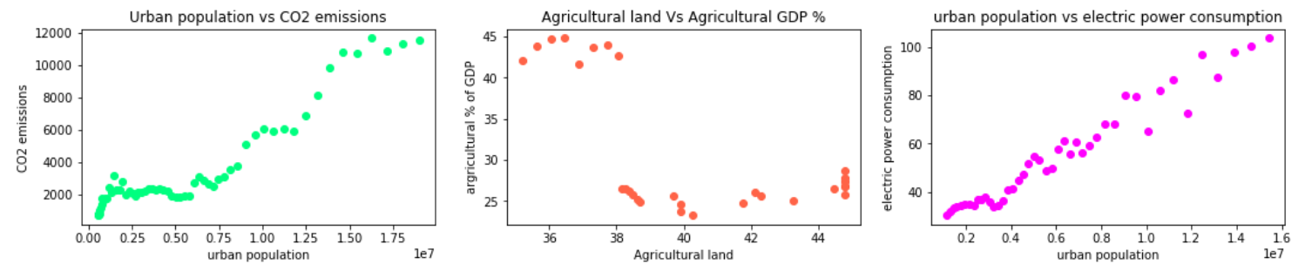

Although the scale of increasing of urban population is comparatively very less with that of China, we can see similar trends with respect to CO2 emissions and electricity consumption. No particular correlation has been observed here with respect to second plot.

Case3: United Kingdom – High Income, Europe

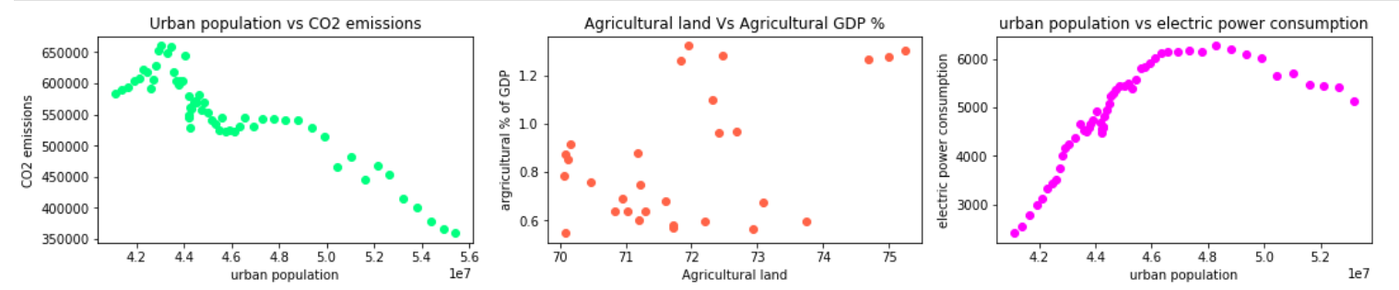

Interestingly we see that as the urban population is increasing the CO2 emissions have been decreasing, this might be because the state is employing for a cleaner environment by cutting down elements cause CO2 emissions. If we see the consumption of electricity it has been following an upward curve till some point but then seems to be reducing, we can’t conclusively say why this happened. In case of Agricultural GCP increment w.r.t land increment we don’t see any pattern here as well.

Case4: Singapore – High Income, Asia

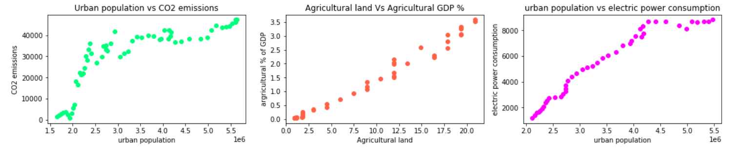

Similar patterns with respect to china and Tanzania can be observed with respect to plots 1 and 3. But the agricultural GDP % seems to be increasing hand in hand with the increase in agricultural land. We may also speculate that agriculture maybe contributing to a greater part of GDP of the country.

Case5: Patterns throughout the world