TIME SERIES ANALYSIS OF COVID19 DATA

Brief about Data: Obtained the time series data related to confirmed cases, deaths and recoveries from a Git hub page maintained by John Hopkins University. Reference: <https://github.com/CSSEGISandData/COVID-19>

**Context**: COVID-19 is a contagious disease caused by SARS-CoV-2. It emerged in December 2019 from Wuhan. In this analysis we are going to discover various trends and facts regarding the covid19 throughout the world.

**Time Series Trends:**

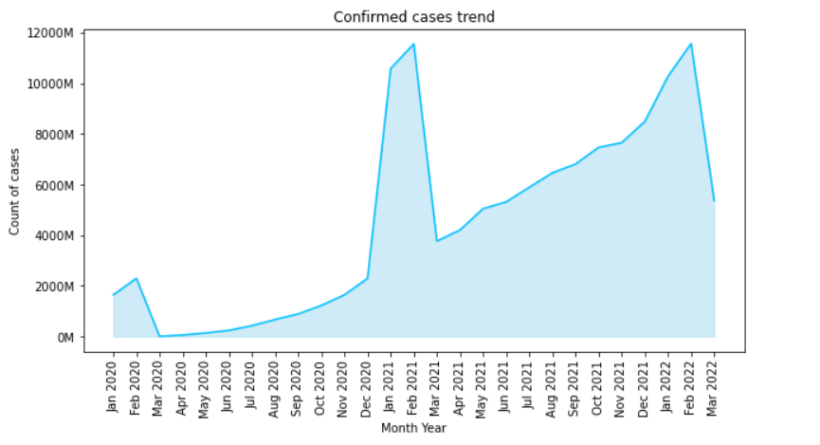

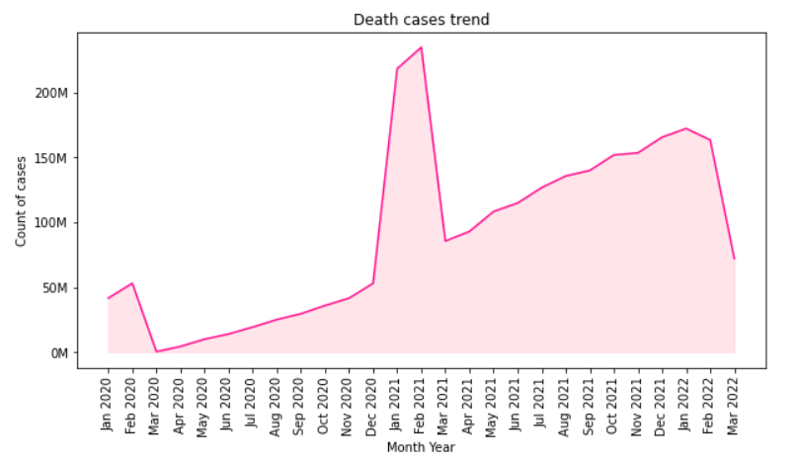

The above plots represent the time trend of the COVID positive cases throughout the world over the past 2 years. Interesting observation we can notice here is although the trend is increasing throughout, there seems to be a surge around December2020 to February2021, where the cases touched a high of 12000M and the casualties reached the all-time high of over 200M.

One more observation here is that there seems to be a one-on-one correlation between the cases and deaths recorded but around December2021 to Feb2022, we see that even though there is a spike in the cases observed, similar behaviour is not observed in the deaths count.

Other methods tried: Tried plotting the data as bar chart but the trends were not continuous so changed to line plot which had continuous lines which is more interpretable wrt trends.

If we investigate this further we see that the first date when the vaccination was started is