**Command to run the code should be like:**

**Python train.py 0.0001 32 1 c:\project**

**Plot of training loss & validation loss:**

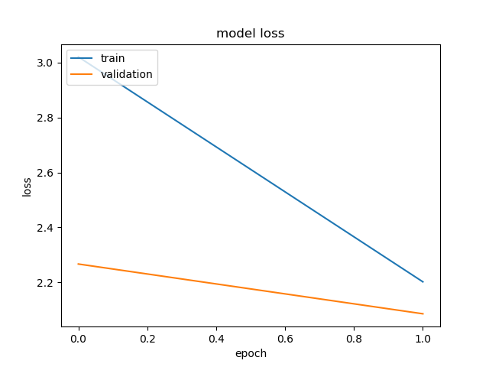

**Best performance parameters:**

* Model gives 91% accuracy after training to 100 epochs.
* Learning rate should be 0.0001 to get best results.

**The dimensions of the layers:**

* Layer (type) Output Shape Param
* =================================================================
* conv2d_1 (Conv2D) (None, 32, 32, 64) 1792
* _________________________________________________________________
* activation_1 (Activation) (None, 32, 32, 64) 0
* _________________________________________________________________
* max_pooling2d_1 (MaxPooling2 (None, 16, 16, 64) 0
* _________________________________________________________________
* dropout_1 (Dropout) (None, 16, 16, 64) 0
* _________________________________________________________________
* conv2d_2 (Conv2D) (None, 14, 14, 128) 73856
* _________________________________________________________________
* activation_2 (Activation) (None, 14, 14, 128) 0
* _________________________________________________________________
* max_pooling2d_2 (MaxPooling2 (None, 7, 7, 128) 0
* _________________________________________________________________
* dropout_2 (Dropout) (None, 7, 7, 128) 0
* _________________________________________________________________
* conv2d_3 (Conv2D) (None, 5, 5, 256) 295168
* _________________________________________________________________
* activation_3 (Activation) (None, 5, 5, 256) 0
* _________________________________________________________________
* conv2d_4 (Conv2D) (None, 3, 3, 256) 590080
* _________________________________________________________________
* activation_4 (Activation) (None, 3, 3, 256) 0
* _________________________________________________________________
* max_pooling2d_3 (MaxPooling2 (None, 1, 1, 256) 0
* _________________________________________________________________
* dropout_3 (Dropout) (None, 1, 1, 256) 0
* _________________________________________________________________
* flatten_1 (Flatten) (None, 256) 0
* _________________________________________________________________
* dense_1 (Dense) (None, 1024) 263168
* _________________________________________________________________
* activation_5 (Activation) (None, 1024) 0
* _________________________________________________________________
* dropout_4 (Dropout) (None, 1024) 0
* _________________________________________________________________
* dense_2 (Dense) (None, 1024) 1049600
* _________________________________________________________________
* activation_6 (Activation) (None, 1024) 0
* _________________________________________________________________
* dropout_5 (Dropout) (None, 1024) 0
* _________________________________________________________________
* dense_3 (Dense) (None, 10) 10250
* _________________________________________________________________
* activation_7 (Activation) (None, 10) 0
* =================================================================

**Parameters in the network:**

* Total params: 2,283,914
* Trainable params: 2,283,914
* Non-trainable params: 0

**The number of neurons:**

* The convolution layers have 723968 neurons.
* The hidden layers have 1058816 neurons.

**Batch normalization effect:**

Batch normalization potentially helps in two ways: faster learning and higher overall accuracy. The improved method also allows you to use a higher learning rate, potentially providing another boost in speed.