

Name:

Teja Ganesh

Allam



Date:



0

1



-



10



-



2024



•



Executive Summary



•



Introduction



•



Methodology



•



Results



•



Visualization



–



Charts



•



Dashboard



•



Conclusion



•



Appendix



Outline



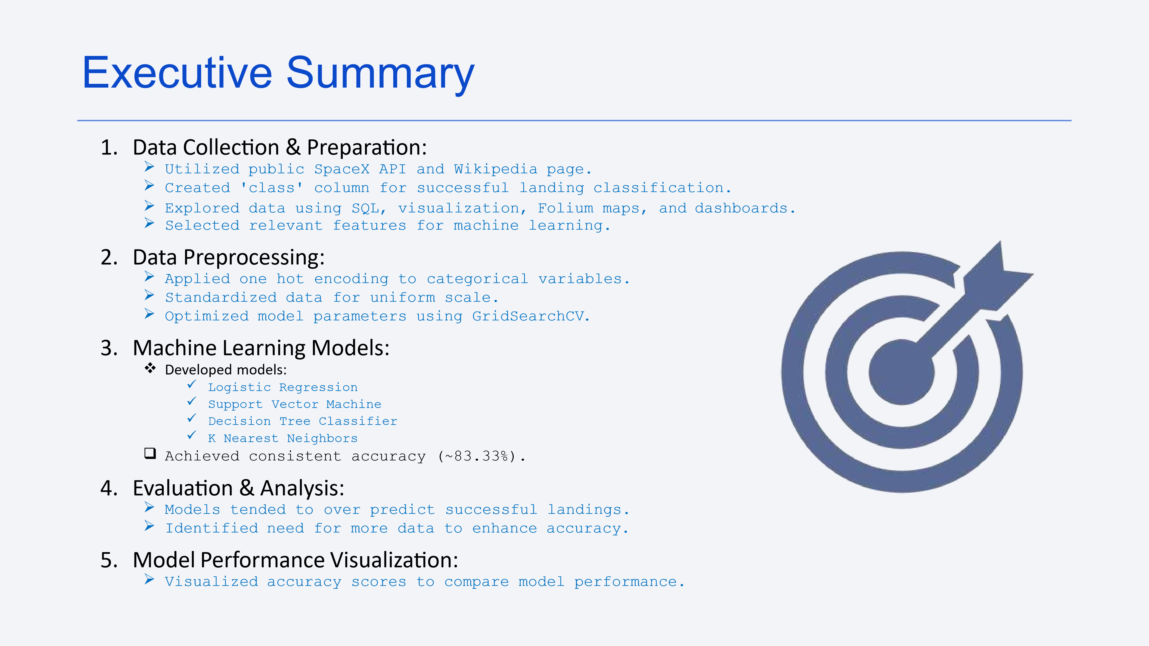

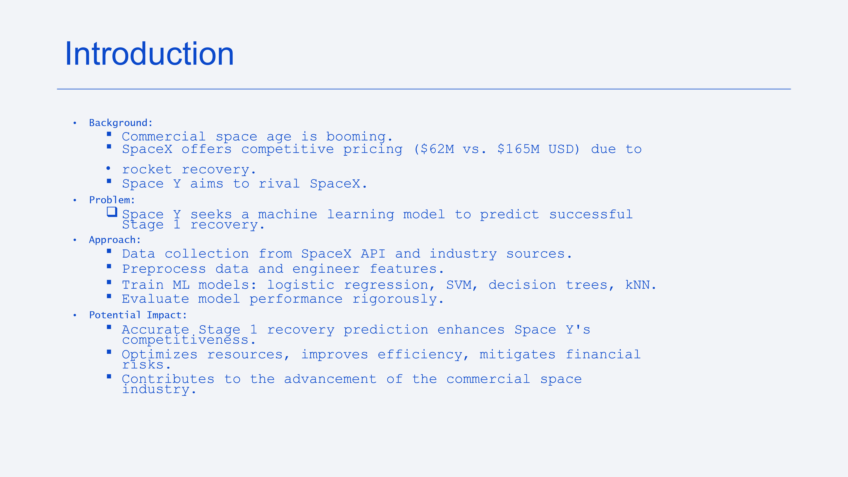



1



.Data Collection:



➢



Combined data from SpaceX API and Wikipedia.



2



. Data Wrangling:



➢



Cleaned and organized collected data.



3



. Classification:



➢



Identified successful and unsuccessful landings.



4



. Exploratory Data Analysis (EDA):



➢



Used visualization and SQL for insights.



➢



Visualized data distribution.



➢



Extracted insights with SQL.



5



. Interactive Visual Analytics:



➢



Employed Folium and



Plotly



Dash.



Methodology



Data Collection

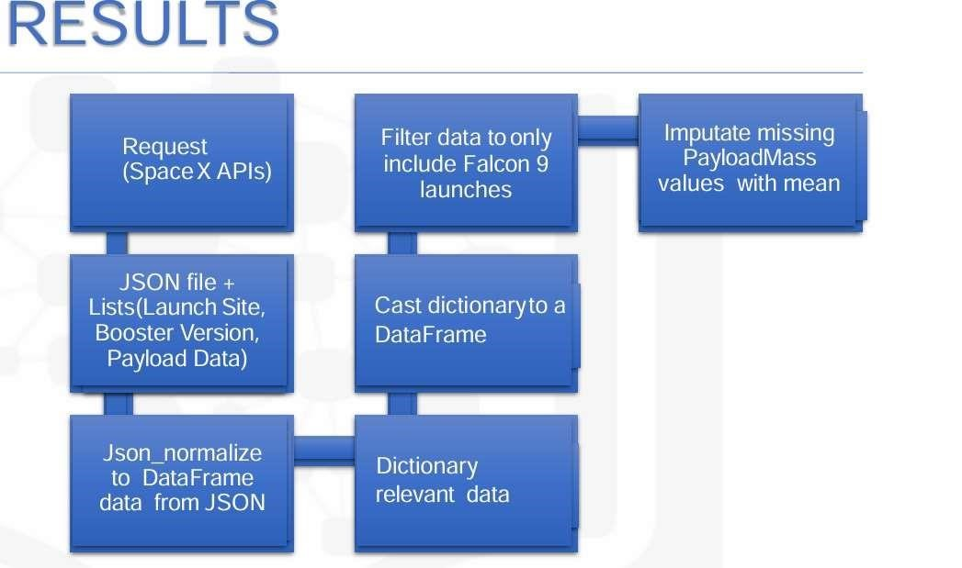

Data Collection



–



SpaceX API

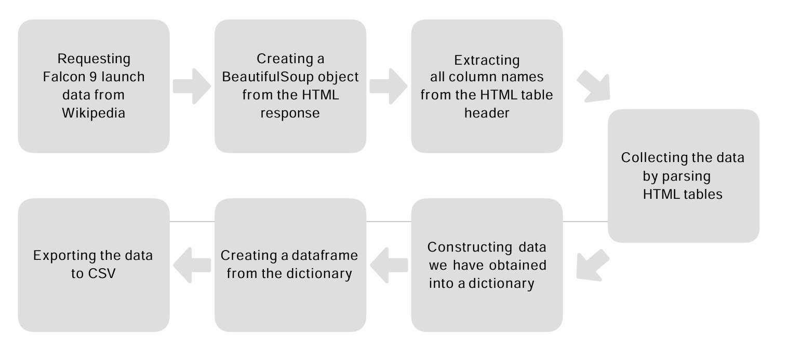

•



EDA with visualization offers insights into data characteristics,



aiding in decision



-



making and hypothesis generation.



•



Visualizations help identify patterns, trends, outliers, and



dependencies, enhancing data understanding.



•



Findings guide subsequent analysis and



modeling



,



interpretability and robustness of results.



•



GitHub Link:



EDA with Data Visualization

[ED](https://github.com/tejaganesh23/DataScience-and-MachineLearning-CapstoneProject/blob/main/jupyter-labs-EDA-with-Visualization-lab.ipynb)

[A](https://github.com/tejaganesh23/DataScience-and-MachineLearning-CapstoneProject/blob/main/jupyter-labs-EDA-with-Visualization-lab.ipynb)

[-](https://github.com/tejaganesh23/DataScience-and-MachineLearning-CapstoneProject/blob/main/jupyter-labs-EDA-with-Visualization-lab.ipynb)

[wit](https://github.com/tejaganesh23/DataScience-and-MachineLearning-CapstoneProject/blob/main/jupyter-labs-EDA-with-Visualization-lab.ipynb)

[h](https://github.com/tejaganesh23/DataScience-and-MachineLearning-CapstoneProject/blob/main/jupyter-labs-EDA-with-Visualization-lab.ipynb)

[-](https://github.com/tejaganesh23/DataScience-and-MachineLearning-CapstoneProject/blob/main/jupyter-labs-EDA-with-Visualization-lab.ipynb)

[Visualizatio](https://github.com/tejaganesh23/DataScience-and-MachineLearning-CapstoneProject/blob/main/jupyter-labs-EDA-with-Visualization-lab.ipynb)

[n](https://github.com/tejaganesh23/DataScience-and-MachineLearning-CapstoneProject/blob/main/jupyter-labs-EDA-with-Visualization-lab.ipynb)

[-](https://github.com/tejaganesh23/DataScience-and-MachineLearning-CapstoneProject/blob/main/jupyter-labs-EDA-with-Visualization-lab.ipynb)

[la](https://github.com/tejaganesh23/DataScience-and-MachineLearning-CapstoneProject/blob/main/jupyter-labs-EDA-with-Visualization-lab.ipynb)

[b](https://github.com/tejaganesh23/DataScience-and-MachineLearning-CapstoneProject/blob/main/jupyter-labs-EDA-with-Visualization-lab.ipynb)

EDA with SQL

* Utilized SQL queries to perform comprehensive exploratory data analysis (EDA), extracting valuable insights directly from the dataset.
* SQL facilitated efficient querying, aggregation, and manipulation of data, enabling in-depth analysis of various aspects such as distribution, relationships, trends, and outliers.
* The EDAwith SQL provided a solid foundation for understanding the dataset's characteristics and informing subsequent analytical decisions.
* GitHub Link:[EDA with SQL](https://github.com/tejaganesh23/DataScience-and-MachineLearning-CapstoneProject/blob/main/jupyter-labs-eda-sql-edx_sqllite.ipynb)



Build an Interactive Map with Folium

•

Utilized Folium, a Python library for creating interactive maps, to

perform geospatial analysis and visualization of data. Popup

information windows were incorporated to display additional details

when users interacted with map markers, enhancing data expl

oration.

Interactive features such as zooming, panning, and toggling layers were

integrated to provide users with a dynamic and

•

GitHub Findings:

•

Map Generation

•

Marker Clustering

•

Popup Information

* Github Link:-

[Build an Interactive map with Folium](https://github.com/tejaganesh23/DataScience-and-MachineLearning-CapstoneProject/blob/main/jupyter-labs-Interactive-Visual-Analytics-with-Folium-lab.ipynb)



•



The Interactive Dashboard built with



Plotly



Dash offers a dynamic and user



-



friendly



interface for exploring and visualizing data.



•



Data Visualization:



•



Implemented interactive charts and graphs using



Plotly



to visualize key insights and



trends. User Interaction:



•



Included line charts, bar charts, scatter plots, and heat maps to represent different



aspects of the data.



•



Integrated dropdown menus, sliders, and date pickers to enable users to filter and



customize the displayed data dynamically.



•



GitHub Link:



-



Build a Dashboard with



Plotly



Dash

[Build a Dashboard with Plotl](https://github.com/tejaganesh23/DataScience-and-MachineLearning-CapstoneProject/blob/main/Hands-on%20Lab_%20Build%20an%20Interactive%20Dashboard%20with%20Ploty%20Dash.ipynb)

[y](https://github.com/tejaganesh23/DataScience-and-MachineLearning-CapstoneProject/blob/main/Hands-on%20Lab_%20Build%20an%20Interactive%20Dashboard%20with%20Ploty%20Dash.ipynb)



•



The Machine Learning Prediction Lab is dedicated to developing



and evaluating predictive models using advanced machine



learning techniques.



•



Model Evaluation:



•



Employed cross



-



validation techniques to assess model



generalization and robustness.



•



Identified key factors influencing the target variable based on



feature importance analysis.



•



GitHub Link



[:](https://github.com/SaiRamKumar70/DataScience-and-MachineLearning-CapstoneProject/blob/main/SpaceX_Machine_Learning_Prediction_Part_5.jupyterlite.ipynb)



[-](https://github.com/SaiRamKumar70/DataScience-and-MachineLearning-CapstoneProject/blob/main/SpaceX_Machine_Learning_Prediction_Part_5.jupyterlite.ipynb)



Predictive Analysis (Classification)

[Predictive Analysi](https://github.com/tejaganesh23/DataScience-and-MachineLearning-CapstoneProject/blob/main/SpaceX_Machine_Learning_Prediction_Part_5.jupyterlite.ipynb)

[s](https://github.com/tejaganesh23/DataScience-and-MachineLearning-CapstoneProject/blob/main/SpaceX_Machine_Learning_Prediction_Part_5.jupyterlite.ipynb)



Results

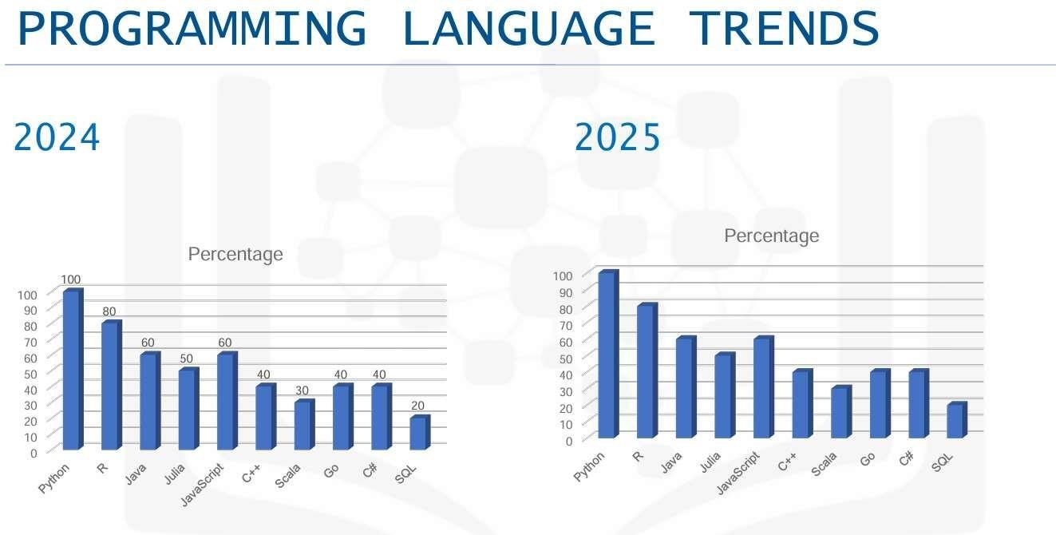

Flight Number vs. Launch



Site

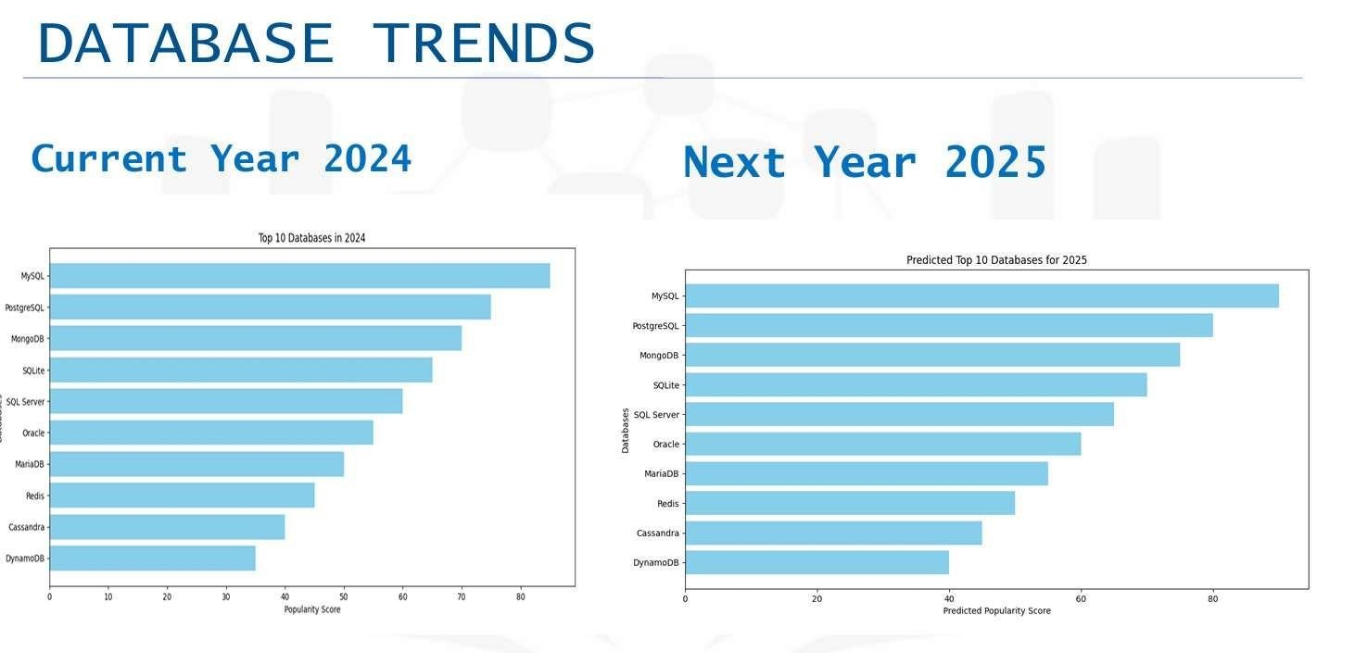

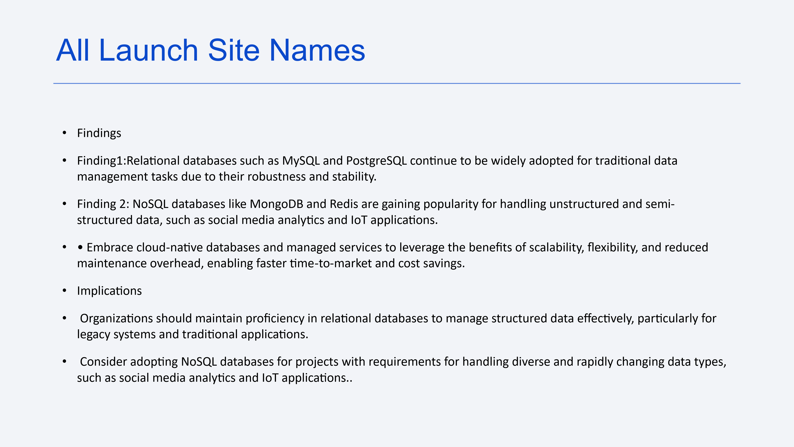



•



User



-



friendly interface and intuitive design enable easy creation and customization



of dashboards, reducing the learning curve for users.



•



Seamless data integration capabilities ensure access to comprehensive data from



diverse sources, enhancing data analysis and decision



-



making.



•



Interactive visualization features empower users to explore data dynamically,



uncovering insights and trends that drive business outcomes.



•



Robust collaboration and sharing functionalities facilitate teamwork and



communication, fostering a data



-



driven culture within the organization and driving



collective intelligence



Conclusions

