**A PROJECT REPORT ON**

**FABRICATION AND ANALYSIS OF**

**ABRASIVE JET MACHINING**

Submitted in partial fulfillment of the requirements for the award of the degree

of

**BACHELOR OF TECHNOLOGY**

In

**MECHANICAL ENGINEERING**

Under the guidance of

**Mr. P. GNANA PRAKASH., M.Tech,**

**Assistant Professor / Mechanical Engineering**



**BY**

**A. THIRUMALESH 14751A0301**

**G. PAVAN KUMAR 14751A0320**

**M. LAVA KUMAR 14751A0330**

**P. JAYA PRAKASH 14751A0338**

**SREENIVASA INSTITUTE OF TECHNOLOGY AND**

**MANAGEMENT STUDIES, CHITTOOR-517127, A.P.**

**(Autonomous – NAAC Accredited)**

**(Approved by AICTE, New Delhi & Permanently Affiliated to JNTUA, Ananthapur)**

**DEPARTMENT OF MECHANICAL ENGINEERING**

**(2014-2018)**

**SREENIVASA INSTITUTE OF TECHNOLOGY AND MANAGEMENT STUDIES, CHITTOOR-517127, A.P.**

**(Autonomous – NAAC Accredited)**

**(Approved by AICTE, New Delhi & Permanently Affiliated to JNTUA, Ananthapur)**



This is to certify that the project work entitled “**FABRICATION AND ANALASIS OF ABRASIVE JET MACHINING**”is a genuine work of

**A. THIRUMALESH 14751A0301**

**G. PAVAN KUMAR 14751A0320**

**M. LAVA KUMAR 14751A0330**

**P. JAYA PRAKASH 14751A0338**

Submitted to the department of Mechanical Engineering, in partial fulfillment of the requirements for the award of the degree of BACHELOR OF TECHNOLOGYin MECHANICAL ENGINEERING from Jawaharlal Nehru Technological University Ananthapur, Ananthapur.

|  |  |
| --- | --- |
| Signature of the Supervisor | Signature of the Head of Department |
| **Mr. P. GNANA PRAKASH., M.Tech.,**  Assistant Professor ,  Department of Mechanical Engineering,  Sreenivasa Institute of Technology and  Management Studies, Chittoor, A.P. | **Dr. S. RAJESH, M.E., Ph.D.,**  Associate Professor & HOD,  Department of Mechanical Engineering,  Sreenivasa Institute of Technology and  Management Studies, Chittoor, A.P. |

Submitted for University Examination (Viva-Voce) held on……………………

**INTERNAL EXAMINER EXTERNAL EXAMINER**

**ACKNOWLEDGEMENT**

A Project of this magnitude would have not been possible without the guidance and co-ordination of many people. We are fortune in having top quality people to help, support and guide us in every step towards our goal.

Our team is very much grateful to the Chairperson **Smt. D. A. Sathya Prabha** Garu for her encouragement and stalwart support.

Further, we would like to express our profound gratitude to our principal **Dr. P. Ramesh Kumar., M.E., Ph.D.,**for providing all possible facilities throughout the completion of our project work.

We express our sincere thanks to our Head of Department **Dr. S. Rajesh., M.E., Ph.D.,** for his co-operation and valuable suggestions towards the completion of project work.

We express our sincere thanks to our guide **Mr. P. Gnana Prakash., M.Tech.,**for offering us the opportunity to do this work under his guidance.

We express our sincere salutation to all other teaching and non-teaching staff of our department for their direct and indirect support given during our project work. Last but not the least, we dedicate this work to our parents and the Almighty who have been with us throughout and helped us to overcome the hard times.

**A. THIRUMALESH 14751A0301**

**G. PAVAN KUMAR 14751A0320**

**M. LAVA KUMAR 14751A0330**

**P. JAYA PRAKASH 14751A0338**

**CONTENTS**

1. INTRODUCTION 1

1.1 ABRASIVE JET MACHINING PRINCIPLE: 1

1.2 EQUIPMENT: 1

1.3 VARIABLES IN ABRASIVE JET MACHINE: 2

1.4 CHARACTERISTICS OF DIFFERENT VARIABLES: 3

1.5 OPERATING CHARACTERISTICS: 4

1.6 ADVANTAGES AND DISADVANTAGES: 6

1.7 APPLICATIONS: 7

2. LITERATURE SURVEY 9

3. PROJECT DESCRIPTION 13

3.1 DESIGN PROCEDURE: 13

3.2. AIR COMPRESSOR: 13

3.3 NOZZLES: 15

3.4 BOROSILICATE GLASS: 18

3.4 PROPERTIES OF BOROSILICATE GLASS: 18

3.6: APPLICATIONS: 19

3.7: ABRASIVE PARTICLES: 20

3.8 FABRICATION PROCEDURE 24

3.8.1 Frame and Platform: 24

3.8.2 Mixing Chamber: 25

3.8.3 Main Chamber: 26

3.8.4 Nozzle Holder: 27

3.9: PIPING SYSTEMS: 27

3.10. TOTAL SETUP OF AJM: 28

4. RESULTS & DISCUSSIONS 31

4.1 PARAMETRIC SETTINGS: 31

4.2: Experimental Procedure: 31

4.2.1 Formulae: 32

4.2.2: Sample Calculations: 34

4.2.4: Sample Calculations: 37

4.2.5: Sample Calculations: 40

5. CONCLUSION 42

REFERENCES 43

**FIGURES**

Fig: 1.1: Schematic layout of Abrasive Jet Machining 2

Fig: 1.2: Effect on abrasive flow rate and mixing ratio on MRR 4

Fig: 1.3: Effect on abrasive flow rate and gas pressure on MRR 4

Fig 1.4: SOD vs. MRR 5

Fig: 3.1: design procedure 13

Fig: 3.2: Air compressor 15

Fig .3.3: Abrasive nozzle operation 16

Fig.3.4: nozzle mild steel(4mm) 17

Fig.3.5: nozzle mild steel (5mm) 17

Fig: 3.6: Borosilicate glass 18

Fig: 3.7: Different Types of Abrasive Particles 22

Fig.3.8: Silicon Carbide 23

Fig: 3.9: frame 24

Fig: 3.10: Mixing chamber 25

Fig: 3.11: Main chamber 26

Fig: 3.12: Nozzle holder 27

Fig: 3.13: hose pipe Structure 27

Fig: 3.15: Schematic layout of dust collection 30

Fig:4.1: Formulae 32

Fig: 4.2: Machined Work Piece with Nozzle (4mm) & T=20sec 35

Fig: 4.3: Machined Work Piece with Nozzle (5mm) & T=20sec 38

Fig: 4.4: Machined Work Piece with Nozzle (5.5mm) & T=20sec 41

**TABLES**

Table1.1: Parameters of AJM 3

Table 3.1: Typical properties of borosilicate glass 19

Table: 3.2: Abrasive Particle Sizes and Their Applications 21

Table 3.3 - Miscellaneous Used for Preparation of Abrasive Jet Machine 29

Table 4.1: Symbols and levels of operations for parameters considered 31

Table 4.2: Parameters for Nozzle (4mm) 33

Table 4.3: Parameters for Nozzle (5mm) 36

Table 4.4: Parameters for Nozzle (5.5mm) 39

**GRAPHS**

Graph 4.1: SOD & Pressure Vs Angle 4(mm) 34

Graph 4.2: SOD & Pressure Vs Angle 5 (mm) 37

Graph 4.3: SOD & Pressure Vs Angle 5.5(mm) 40

**ABSTRACT**

It is very difficult to produce hole in brittle material like glass with conventional machining process, therefore the non-conventional machining process such as Abrasive Jet Machining (AJM) has been used for overcome this problem. AJM process parameters were varied i.e. pressure, nozzle tip distance, and nozzle diameter.

The objective of this paper is to optimize the process parameters of AJM on borosilicate glass along which focused type of abrasive particle, particle size, carrier gas pressure, stand of distance, to increase the MRR and dimensional accuracy.

Due to the flow of abrasive particles in the atmosphere due to the pressure of air, it is hazardous to health and environment gets polluted. In order to reduce the pollution, we used dust collection setup, in which the work piece is submerged in water so that if particles strike the work piece some of the particles adher in the water it won’t fly into the atmosphere. So that we can reduce the atmospheric pollution.

By using Taughi Method, the results are plotted in the form of graphs.

# 1.INTRODUCTION

## 1.1 ABRASIVE JET MACHINING PRINCIPLE:

Abrasive Jet Machining (AJM) is the removal of material from a workpiece by the application of a high-speed stream of abrasive particles carried in gas medium from a nozzle. The AJM process differs from conventional sand blasting in that the abrasive is much finer and the process parameters and cutting action are carefully controlled.

The process is used chiefly to cut intricate shapes in hard and brittle materials which are sensitive to heat and have a tendency to chip easily. The process is also used for deburring and cleaning operations. AJM is inherently free from chatter and vibration problems. The cutting action is cool because the carrier gas serves as a coolant.

## 1.2 EQUIPMENT:

A schematic layout of AJM is shown in Fig1.1. The filtered gas, supplied under pressure to the mixing chamber containing the abrasive powder and vibrating at 50 c/s, entrains the abrasive particle and is the passed into a connecting hose. This abrasive and gas mixture emerges from a small nozzle at high velocity. The abrasive powder feed rate is controlled by the amplitude of vibration of the mixing chamber. A pressure regulator controls the gas flow and pressure.

The nozzle is mounted on a fixture. Either the workpiece or the nozzle is moved bycams pantograph or other suitable mechanisms to control the size and shape of the cut. Hand operation is sometimes adequate to remove surface contaminations or in cutting where accuracy is not very critical. Dust removal equipment is necessary to protect the environment. Commercial bench mounted units including all controls, motion producing devices, and dust control equipment are available.

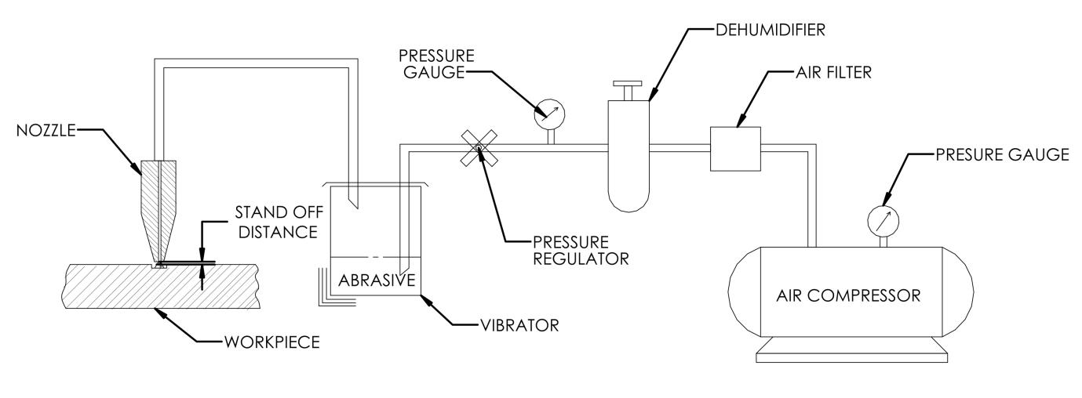Fig: 1.1: Schematic layout of Abrasive Jet Machining

The major components are:

1. Air compressor.
2. Air filter.
3. Dehumidifier.
4. Pressure Gauge.
5. Pressure Regulator.
6. Vibrator or Mixer.
7. Nozzle.
8. Horizontal and Vertical motion module (for xyz motion).
9. Arrangement to hold the workpiece.

## 1.3 VARIABLES IN ABRASIVE JET MACHINE:

The variables that influence the rate of metal removal and accuracy of machining in this process is:

1. Carrier gas
2. Types of abrasive
3. Size of abrasive grain
4. Velocity of abrasive jet
5. Flow rate of abrasive
6. Work material
7. Geometry, composition and material of nozzle
8. Nozzle work distance (standoff distance)
9. Shape of cut and operation type

## 1.4 CHARACTERISTICS OF DIFFERENT VARIABLES:

###### Table1.1: Parameters of AJM

|  |  |
| --- | --- |
| Medium | Air , CO2 ,N2 |
| Abrasive | SiC, Al2O3 (of size 20µ to 50µ ) |
| Flow rate of abrasive | 3 to 20 gram/min |
| Velocity | 150 to 300 m/min |
| Pressure | 2 to 8 kg/cm2 |
| Nozzle size | 0.07 to 0.40 mm |
| Material of nozzle | Mild Steel |
| Nozzle life | 12 to 300 hrs |
| Standoff distance | 0.25 to 15 mm (8mm generally) |
| Work material | Non Metals like glass, ceramics, and granites. Metals and alloys of hard materials like germanium, silicon etc |
| Part application | Drilling, cutting, deburring, cleaning |

## 1.5 OPERATING CHARACTERISTICS:

The main performance measuring parameters of AJM are as follows

1. The material removal rate in gm/mm3

2. The accuracy and surface finish of the machined surface

3. The Nozzle wear rate

Effect of abrasive flow rate on MRR is shown in figure.1.2, Kinetic energy of abrasive particles is responsible for removal of material by erosion process. Abrasive must impinge on the work surface with a certain minimum velocity so that the erosion can take place.

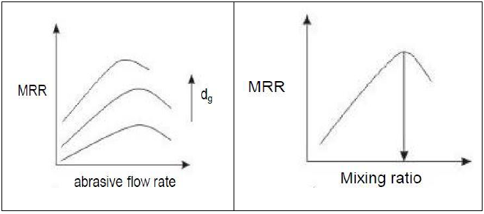

Fig: 1.2: Effect on abrasive flow rate and mixing ratio on MRR

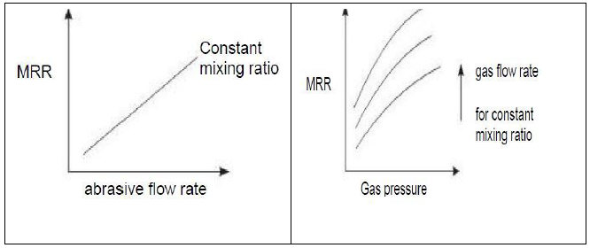

Fig: 1.3: Effect on abrasive flow rate and gas pressure on MRR

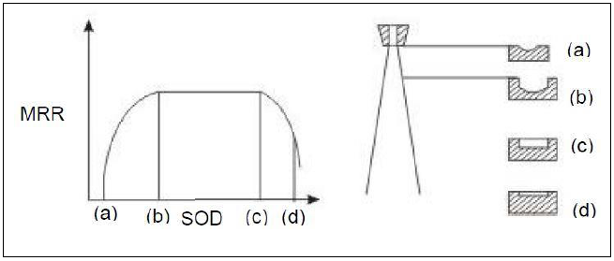

#### Fig 1.4: SOD vs. MRR

As seen in the fig 1.3 MRR increases with increase in abrasive flow rate due to greater number of particles striking per unit time. Also MRR increases with increase in mixing ratio which is the ratio of weight of particles to that of the weight of air. But further increase in mixing ratio decreases MRR due to the fact that the volume of carries gas which is responsible for the high velocity is reduced.

MRR increases with increase in abrasive flow rate when mixing ratio is constant. The MRR increases with increase in gas pressure as the particles will strike with greater velocity with higher pressure. Another important parameter is the stand-off distance which is the distance between the nozzle tip and work piece.

As seen in the fig.1.4 MRR first increase with increase in SOD then remains constant for a period of time and then decrease. This is due to the fact that flaring of jet occurs at a large distance from the nozzle tip. Also the shape of the cavity becomes less accurate as the nozzle tip distance increases.

## 

## 1.6 ADVANTAGES AND DISADVANTAGES:

***The main advantages are listed as follows:***

1. It has the ability to cut intricate holes shape in materials of having any hardness.
2. Also, it can cut fragile and heat sensitive material without damage as physical toolis absent.
3. No alteration in microstructure of materials, as no heat is generated.
4. Capital cost is low.
5. Machining can be performed easily for brittle materials of thin sections.
6. Heat generated in this process is very less.

***The major disadvantages include:***

1. Also, it can cut fragile and heat sensitive material without damage as physical tool is absent.
2. Stray strings can occur and so its application is limited.
3. Embedding of the abrasive particles in the work piece surface may occur while machiningsofter material.
4. The abrasive material may accumulate at nozzle and fail the process if moisture is contained in the air.
5. Tapping is about 7° angle if the nozzle top distance is 15 mm.
6. It cannot be used to drill blind holes.
7. Tapering occurs due to flaring of the jet
8. Risk to environment is higher
9. Abrasive Jet Machining is not applicable for ductile materials and also poor machining accuracy.
10. Abrasive powder can’t be recycled.

## 

## 1.7 APPLICATIONS:

***Metalworking:***

* + 1. Deburr critical areas of machined parts.
    2. Drill/cut thin, hardened metal sections.
    3. Apply trade names, markings to parts.
    4. Remove chrome or anodizing.
    5. Remove machine marks and flaws.
    6. Remove corrosion or contaminants.
    7. Prepare surfaces for bonding.

***Medical:***

* + - 1. Removal of Laser Slag from Nitinol Components.
      2. Deburring, Drilling & Surface Modification of stents, implantable and IV components.
      3. Cleaning and deburring of surgical instruments.
      4. Removal of coatings from catheters and guide wires.

***Electronics:***

* + - * 1. Strip fine, critical wiring without damage.
        2. Adjust resistors and capacitors.
        3. Create conductive paths in micro modules.
        4. Prepare ceramic element plates.
        5. Machine semiconductors and substrates.
        6. Machine fragile quartz and crystalline parts.

***Grinding:***

* + - 1. Expose grit on CBN resin bond wheels.
      2. Clean residue from diamond wheels.
      3. Dress wheels of any size or shape.
      4. Clean/dress during grinding cycles.
      5. Automatic-no operator needed.
      6. Induce cleaning by amperage control.
      7. Reduce heat, minimize burned parts.

***Glass:***

* + - 1. Cut optical fibers without altering wavelength.
      2. Cut, drill and frost precision optical lenses.
      3. Cut extremely thin sections of glass.
      4. Cut intricate, curved patterns.
      5. Cut, etch normally inaccessible internal areas.
      6. Clean/dress glass grinding wheels.

***Plastics:***

* + - 1. Adjust critical, internal mold surfaces.
      2. Remove flashing from finished, molded parts.

The major area of application of AJM process is in the machining of brittle materials and heat sensitive materials like quartz glass, sapphire, mica and ceramics semiconductor materials. It is also used in countering, drilling, cutting slot, thin sections, de-burring, for producing integrate shapes in hard and brittle materials.

It is often used for cleaning and polishing of plastics like nylon. Delicate cleaning, such as removal of smudges from antique documents, is also possible with this method. Micro machining is possible in brittle materials by this method.

# 2. LITERATURE SURVEY

The literature study of Abrasive Jet Machine reveals that the machining process was started a few decades ago. Till date there has been a complete and detailed experiment and theoretical study on this process. Most of the studies argue over the hydrodynamic characteristics of abrasive jets, hence determining the influence of all operational variables on the process usefulness including abrasive size, kinds and concentration, impact speed and angle of strike. Other papers found new problems concerning carrier gas typologies, nozzle shape, size and wear rate, jet velocity and pressure, standoff distance (SOD).

These papers state the overall process performance in terms of material removal rate(MRR), geometrical tolerances and surface finish of work pieces, as well as in terms of nozzle wear rate or nozzle life. Finally, there are several significant and important papers which focus on either leading process mechanisms in machining of both ductile and brittle materials, or on the development of systematic experimental statistical approaches and artificial neural networks to predict the relationship between the settings of operational variables and the machining rate and accuracy in surface finishing. Some researchers have also done the CFD simulation of machining process.

**1. El-Domiaty et al (2009)** is conducted the experimentation on drilling of Glass with AJM. The abrasive grits (sand) were mixed with air stream a head of the nozzle and the abrasive flow rate was kept constant throughout the machining process. The Results was represented with Graphs.

**2. Bhaskar Chandra Kandpal et al (2011)** conducted Experimentation on machining of Glass and Ceramics with various types of Abrasives by changing pressure, nozzle tip distance on different thickness of glass plates and ceramic plates. The effect of process parameters of compared with theoretical results.

**3. Stephen Wan et al. (2010)** present simple deterministic process models for the prediction of the evolution of the cross-sectional profile of glass channels generated by erosive wear in micro air abrasive jet machining using a round nozzle. Experiments were carried out on soda lime and borosilicate glass to verify the process models. Predicted model results show fairly good agreement with experimental results.

**4. Lingyin et al (2001)** investigated the abrasive jet machining characteristics of a glass-infiltrated alumina used for fabrication of all-ceramic dental crowns were investigated using a high-speed dental hand piece and diamond burs with different grit sizes.

**5. Dr. A. K. Paul et al** carried out the effect of the carrier fluid (air) pressure on the MRR and the material removal factor (MRF) have been investigated experimentally on an indigenous AJM set-up developed in the laboratory. Experiments are conducted on Porcelain with silicon carbide as abrasive particles at various air pressures. It was observed that MRR has increased with increase in grain size and increase in nozzle diameter. The dependence of MRR on stand-off distance reveals that MRR increases with increase in SOD at a particular pressure.

**6. Dr. M. Sreenevasa Rao (1967)** reviewed that Ingulli was the first to explain the effect of abrasive flow rate on material removal rate in AJM.

**7. Sarkar and Pandey (1976)** concluded that the standoff distance increases the MRR and penetration rate increase and on reaching an optimum value it start decreasing.

**8. J. Wolak (1977) and K. N. Murthy (1987)** investigated that after a threshold pressure, the MRR and penetration rate increase with nozzle pressure. The maximum MRR for brittle and ductile materials are obtained at different impingement angles. For ductile material impingement angle of 15-20 results in maximum MRR and for brittle material normal to surface results maximum MRR.

**9. X. P. Li et al**  stated that during cutting of work piece, reinforcement particles made impact on surface of the work which causes wear of work specimen. These particles get dislodged in material surface. It is reported that pressured air approach minimizes the tool wear and also prevent of particles from being embedded in work piece .Experimental tests for cutting of SiC-Al has been carried out with tungsten carbide tool with or without the aid of the pressured air jet are conducted. It shows that pressured air jet method significantly minimize the wear of work piece.

**10. Manabu Wakuda et al (2003)** reported that the material response to the abrasive impacts indicates a ductile behavior, which may be due to the elevated temperature during machining. Chipping at the peripheral region of the dimples was found for coarse-grained alumina samples. The use of synthetic diamond abrasive is a possible choice if high machining efficiency is desired. However, the machined surface reveals a relatively rough appearance as a result of large-scale inter granular cracking and subsequent crushing

**11. Ghobeity et al** have experimented on process repeatability in abrasive jet machining. They mentioned that many applications have several problems inherent with traditional abrasive jet equipment. Poor repeatability in pressure feed AJM system was traced to uncontrolled variation in abrasive particle mass flux caused by particle packing and local cavity formation in reservoir. Use of mixing chamber improved the process repeatability. For finding out process repeatability they measured depth of machined channel.

**12. R. H. M. Jafar et al (2013)** presented experimental data on the effect of particle size, velocity, and angle of attack on the Surface roughness of unmasked channels machined in borosilicate glass using AJM. Single impact experiments were conducted to quantify the damage due to the individual alumina particles. Based on these observations, the assumed location of lateral crack initiation in a relatively simple analytical model from the literature was modified, and used to predict the roughness and erosion rate.

**13. N. S. Pawar et al (2013)** presented Experimental analysis of AJM with sea sand as abrasive material and considering Silicon Carbide, mild steel as nozzle material with a vibrating cylindrical mixing chamber. The experiments conducted on glass sheet by varying the pressure &Sod. Graphs are plotted with variation in parameters.

**14. V. C. Venkatesh, T. N. Goh et al (1989)** reported a study of the results of machining under various conditions. A commercial AJM machine was used, with nozzles of diameter ranging from 0.45 to 0.65 mm, the nozzle materials being either tungsten carbide or sapphire, both of which have high tool lives. Silicon carbide and aluminum oxide were the two abrasives used. The materials machined were glass, ceramics, and electro-discharge machined (EDM) dies steel.

**15. Manabu Wakuda, Yukihiko et al (2003)** presented a paper attempts to identify the material response of alumina ceramics to the abrasive particle impact in the AJM process. They used three kinds of commercial abrasive particles to dimple the sintered alumina samples, aluminum oxide (WA), silicon carbide (GC) abrasive, and synthetic diamond (SD) abrasive.

**16. D.S. Robinson Smart (2011)** designed and fabricated a set up in order to investigate the effect of Standoff Distance (SOD), horizontal and vertical angle between the work piece and abrasive jet nozzle and the exit diameter of abrasive jet nozzle on coating removal rate.

**17. Shanmugam and Masood (2009)** presented an investigation on the kerf taper angle generated by abrasive water jet (AWJ) technique to machine two types of composites: epoxy pre-impregnated graphite woven fabric and glass epoxy. Comprehensive factorial design of experiments was carried out in varying the traverse speed, abrasive flow rate, standoff distance and water pressure.

**18. Ghobeity, H. Gateau et al (2007)** Explained Poor repeatability of the erosion rate in a pressure feed AJM system was traced to uncontrolled variation in the abrasive particle mass flux caused by particle packing and local cavity formation in the reservoir.

# 3. PROJECT DESCRIPTION

## 3.1 DESIGN PROCEDURE:

As per the data collected from various references we came to a final drawing lay out of our project which is attached along with this project work. First we concentrated on the main powder feeding mechanism, i.e. hoppers (powder mixing chambers). From calculations we considered GI pipe so as to withstand pneumatic pressure as high as 14 kg/cm2, considering it as closed vessel. The shows the fig.3.1 design procedure of AJM.

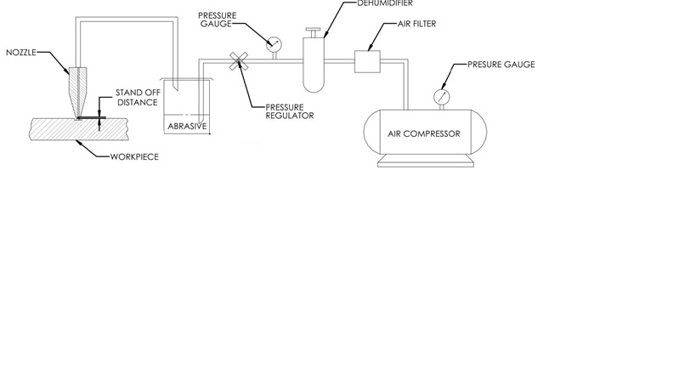

#### Fig: 3.1: design procedure

## 3.2. AIR COMPRESSOR:

(Two Stage Reciprocating Air Compressor)

Air compressors compress the air to high pressure taking input energy from electric motor or internal combustion engine. In abrasive jet machining high pressure air jet is required so that the suspended particles in it can strike the work piece at high velocity. Positive-displacement air compressors work by forcing air into a chamber whose volume is reduced to compress the air.

Piston type compressors use this principle by pumping air into an air chamber through the use of the motion of pistons. They use one-way valves to direct air into a chamber, where the air is compressed. Reciprocating single acting compressors are generally of one-stage or two-stage design. Compressors can be of a lubricated, non-lubricated or oil-less design. In the single-stage compressor, air is drawn in from the atmosphere and compressed to final pressure in a single stroke.

Rotary screw compressors also use positive-displacement compression by mating two helical screws that, when turned, send air into a chamber, whose volume is reduced as the screws turn gradually. Vane compressors use a slotted rotor with varied blade placement to lead air into a chamber compressing the volume.

The applications of compressors are to supply high-pressure air to fill gas cylinders, to supply moderate-pressure air to a submerged surface supplied driver, to supply moderate-pressure air for driving some school building pneumatic HVAC control system valves, to supply a large amount of moderate-pressure air to power pneumatic tools, to fill tires, to produce large volumes of moderate-pressure air for large-scale industrial use such as oxidation for petroleum coking or cement plant bag house purge systems. For this purpose a compressor with capacity 14bar powered by electric motor is used.

The volume of compressed air delivered by an air compressor at its discharge pressure normally is stated in terms of prevailing atmospheric inlet conditions. The corresponding flow rate in Standard cubic feet per minute will depend upon both the Standard used and the prevailing atmospheric inlet conditions.

Varying flow rates for more than one discharge pressure simply reflect the reduction in compressor volumetric efficiency that occurs with increased system pressure (psig). For this reason, the maximum operating pressure of a compressor should be chosen carefully, shown in fig.3.2.

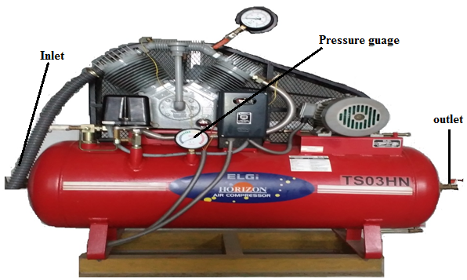

#### Fig: 3.2: Air compressor

## 3.3 NOZZLES:

Nozzles are the mechanical devices which increase the velocity of fluid in exchange of pressure drop. They are commonly used in internal combustion engines, space rockets, missiles, fire extinguishers etc. In abrasive jet machining the high velocity jet is created by the nozzle action. As the abrasive particles strike the nozzle they may erode the nozzle surface. So very high wear resistant materials used.

Mild steel nozzles are used for circular cross‐sections in the range of 0.5‐3 mm diameter, for rectangular sections of size 0.08 x 0.05 to 0.18 x 3.8 mm and for square sections of size up to 2 mm. Sapphire nozzles are made only for circular cross‐sections only. The size varies from 0.2 to 0.7 mm in diameter. Nozzles are made with an external taper to minimize secondary effects due to ricocheting of abrasive particles coming out, as shown in fig.3.3

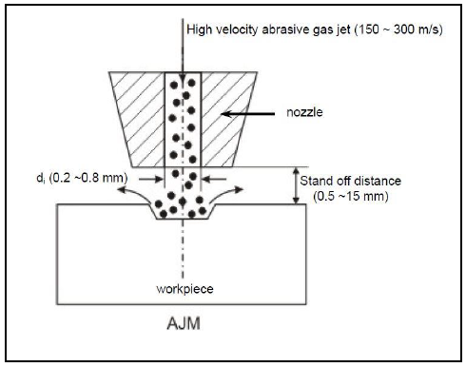

#### Fig .3.3:Abrasive nozzle operation

Nozzles made of have an average life of 12 hours whereas nozzles of sapphire last for about 30 hours of operation. The rate of material removal and the size of machined area are influenced by the distance of the tip nozzle from the work piece. The abrasive particles from the nozzle follow a parallel path only for a short distance and then the jet of particles flares resulting in the over sizing of the hole. It is observed that the jet stream is initially in the form of a cylindrical shape for about 1.6 mm and then it flares into a cone of 7° included angle.

The material removal rate initially increases with increase in the distance of the nozzle from the work piece because of the acceleration of particles leaving nozzle. This increase is maximum up to a distance about 8 mm and then it steadily drops off because of increase in machining area for the same amount of abrasive and decrease in velocity of abrasive stream due to drag. Despite their simple design, abrasive jet nozzles can be troublesome at times. The main drawbacks are short life of expensive parts, clogging of orifice due to dirt or moisture, wear, miss alignment and damage to the jewel, as shown in fig.3.4 for nozzle 4mm & fig.3.5 for nozzle 5mm.

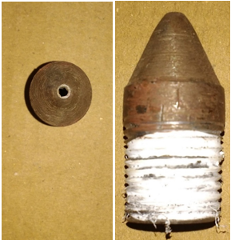

#### Fig.3.4: nozzle mild steel(4mm)

Length = 44mm

Internal diameter = 4mm

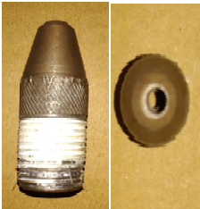

#### 

#### Fig.3.5: nozzle mild steel (5mm)

Length = 55mm

Internal diameter = 5mm

## 3.4 BOROSILICATE GLASS:

Borosilicate glass is a type of [glass](https://en.wikipedia.org/wiki/Glass) with [silica](https://en.wikipedia.org/wiki/Silicon_dioxide) and [boron trioxide](https://en.wikipedia.org/wiki/Boron_trioxide) as the main glass-forming constituents. Borosilicate glasses are known for having very low [coefficients of thermal expansion](https://en.wikipedia.org/wiki/Coefficient_of_thermal_expansion) (~3 × 10−6 K−1 at 20 °C), making them resistant to [thermal shock](https://en.wikipedia.org/wiki/Thermal_shock), more so than any other common glass. Such glass is less subject to [thermal stress](https://en.wikipedia.org/wiki/Thermal_stress) and is commonly used for the construction of [reagent bottles](https://en.wikipedia.org/wiki/Reagent_bottle).as shown in fig.3.6

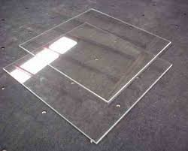

#### Fig: 3.6: Borosilicate glass

## 3.4 PROPERTIES OF BOROSILICATE GLASS:

[Borosilicate glass](http://www.azom.com/ads/abmc.aspx?b=4937) is chemically resistant, has a low thermal expansion coefficient and can be used at relatively high temperatures. It is available in many forms and sizes such as rod, tube, plate and as machined or hot formed components.

|  |  |  |  |
| --- | --- | --- | --- |
|  | **Property** | **Units** | **Value** |
| General | Density | g/cm3 | 2.23 |
| Mechanical | Young's Modulus | GPa | 64 |
| Thermal | Max. Use Temperature | °C | 500 |
| Thermal Conductivity | W/m.K | 1.14 |
| Co-Efficient of Linear Expansion | 10-6/°C | 3.3 |
| Electrical | Volume Resistance | Ù.cm | 1015 |
| Dielectric Constant |  | 4.6 |
| Dielectric Strength |  |  |

Table 3.1: Typical properties of borosilicate glass

## 

## 3.6: APPLICATIONS:

1. Due to its chemical and thermal resistance and good optical clarity it is used in modern laboratory glassware.
2. It is used in electronics.
3. Glass cookware is another common usage.
4. Many high-quality flashlights use borosilicate glass for the lens.
5. Most astronomical [reflecting telescope](https://en.wikipedia.org/wiki/Reflecting_telescope) use glass mirror components made of borosilicate glass because of its low coefficient of thermal expansion.

## 3.7**: ABRASIVE PARTICLES:**

Abrasives generally rely upon a difference in hardness between the abrasive and the material being worked upon, the abrasive being the harder of the two substances. Typically, materials used as abrasives are hard minerals or synthetic stones, some of which may be chemically and physically identical to naturally occurring minerals but which cannot be called minerals as they did not arise naturally.

These minerals are either crushed or are already of a sufficiently small size (anywhere from macroscopic grains as large as about 2 mm to microscopic grains about 0.001 mm in diameter) to permit their use as an abrasive. These grains, commonly called grit, have rough edges, often terminating in points which will decrease the surface area in contact and increase the localized contact pressure.

The abrasive and the material to be worked are brought into contact while in relative motion to each other. Force applied through the grains causes fragments of the worked material to break away while simultaneously smoothing the abrasive grain and/or causing the grain to work loose from the rest of the abrasive.

Some factors which will affect how quickly a substance is abraded include:

* Difference in hardness between the two substances: a much harder abrasive will cut faster and deeper
* Grain size (grit size): larger grains will cut faster as they also cut deeper
* Adhesion between grains, between grains and backing, between grains and matrix: determines how quickly grains are lost from the abrasive and how soon fresh grains, if present, are exposed
* Contact force: more force will cause faster abrasion
* Loading: worn abrasive and cast off work material tends to fill spaces between abrasive grains so reducing cutting efficiency while increasing friction

Aluminum oxide (Al2O3) Silicon carbide (Sic) Glass beads, crushed glass and sodium bicarbonate are some of abrasives used in AJM. Selection of abrasives depends on MRR, type of work material, machining accuracy.

|  |  |  |
| --- | --- | --- |
| **Abrasives** | **Grain Sizes** | **Application** |
| Aluminum oxide(Al2O3) | 12, 20, 50 microns | Good for cleaning, cutting and deburring |
| Silicon carbide (SiC) | 25,40 micron | Used for similar application but for hard material |
| Glass beads | 0.635 to 1.27mm | Gives matte finish |
| Dolomite | 200 mesh | Etching and polishing |
| Sodium bi carbonate | 27 micros | Cleaning, deburring and cutting of soft material Light finishing below 500C |

###### Table: 3.2: Abrasive Particle Sizes and Their Applications

This are the different types of abrasives shown in below figure 3.7.

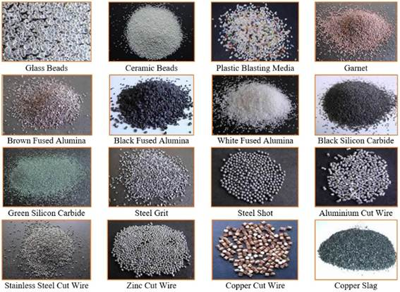

#### Fig: 3.7: Different Types of Abrasive Particles

The abrasive particles used in our experiment is shown in the below fig 3.8

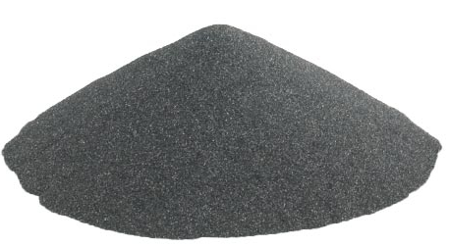

#### Fig.3.8: Silicon Carbide

## 3.8FABRICATION PROCEDURE

### 3.8.1Frame and Platform:

First we prepare a frame of dimensions 700x700x750and platform of size 700x700x350 has been fabricated and welded it on the frame. The below fig 3.9 is frame of AJM we used.

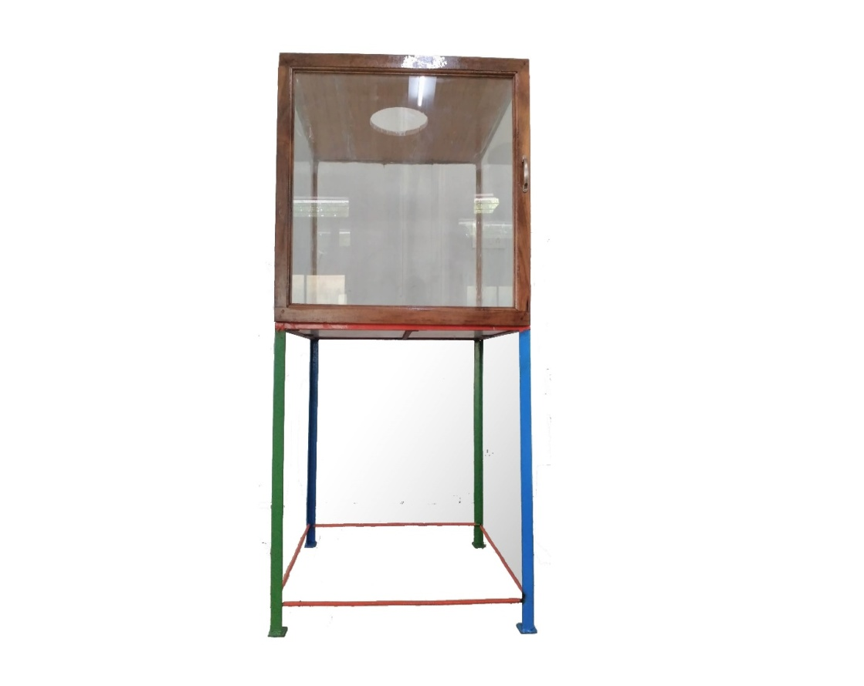

#### Fig: 3.9: frame

The frame is prepared with the help of angular rods in such a way that it is capable of bearing the total weight of the machine and should not create any kind of vibrations during the process. The stand is covered with the help of glass to avoid the escape of high pressure abrasive particles during the process.

### 3.8.2 Mixing Chamber:

The Mixing chamber consists of two inlets and two outlets.Where it has two inlets at the top one for connecting the hose pipe andother is for abrasive particles.

The high-pressure air from the compressor is passed through inlet of abrasive chamber and other for abrasive feeding

Here mixing of both air and abrasive particles will be exit from outlet of chamber to the inlet of main chamber.as shown in fig.3.10

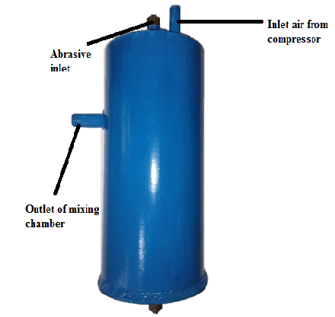

#### Fig: 3.10:Mixing chamber

### 3.8.3Main Chamber:

Mainchamber which has one inlet for the outlet i.e. mixture of air and abrasive particles goes to the abrasive chamber to main chamber for better mixing of air and abrasive particles. The chamber is of cylindrical shape and a cone made up of mild steel.

The diameter and length of the main chamber is 200mm&300mm and it is tapered in the bottom so as to collect the abrasive particles in the bottom and tapered in order to fix the nozzle. As shown in fig.3.11.

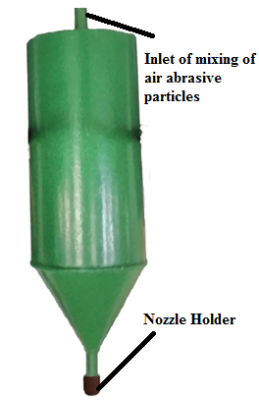

#### Fig: 3.11: Main chamber

### 3.8.4Nozzle Holder:

Holder is used to hold the nozzle rigidly and main chamber. It is made of mild steel and is designed in such a way that then nozzle fits exactly inside the nozzle holder.

As shown in fig.3.12.

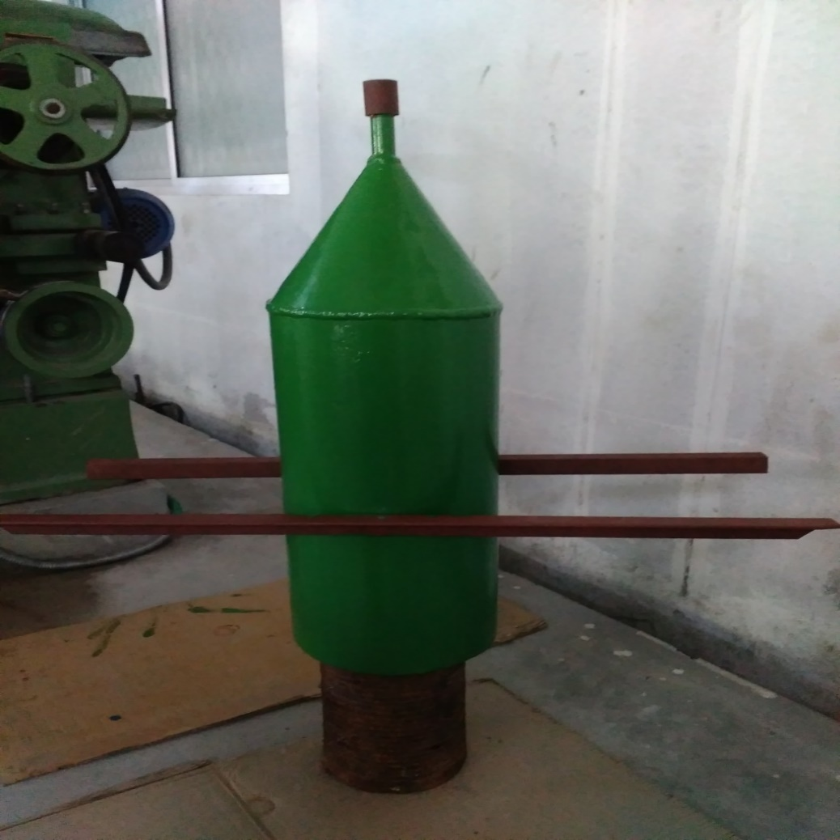

#### Fig: 3.12: Nozzle holder

## 3.9:PIPING SYSTEMS:

The piping systems shown in fig.3.13 are required for carrying the compressed air from the compressor to the mixing chamber and from the mixing chamber to the nozzle orifice via the filter regulator. It is required to maintain the pressure in the line without eroding the pipe. Here nylon braided hoses having 12 mm internal dia. is provided. This is used because of long life, light weight, durability and easy availability. Also the head loss is very small when it occurs a bend. The hose is composed of reinforcement of synthetic yarn in between two or more layers of soft PVC. The yarn is reinforced in longitudinal directions as well as crosswise so as to increase the strength.

|  |  |  |  |
| --- | --- | --- | --- |
| |  | | --- | | PVC layers | | |  |
|  | Reinforcement |
|  |

#### 

#### Fig: 3.13: hose pipe Structure

## 3.10. TOTAL SETUP OF AJM:

The mixing chamber is connected to the pressure gauge which is further connected to the compressor. And the mixing chamber is next connected to main chamber the end of the main chamber is fitted with the nozzle by means of a nozzle holder made of mild steel. The total setup of the Abrasive jet machining is shown in the fig.3.14

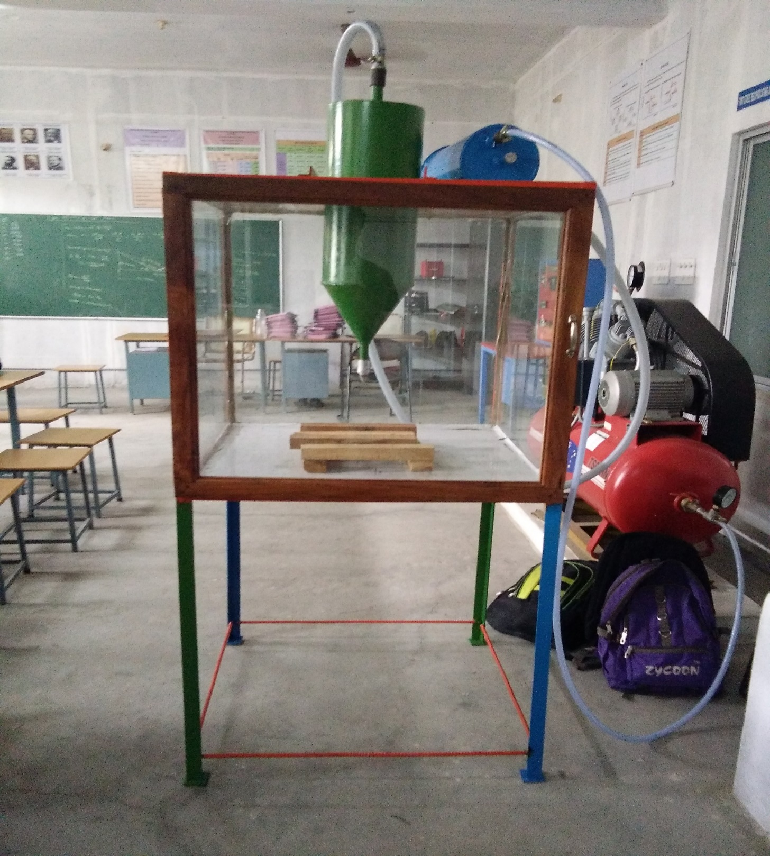

Fig: 3.14: AJM setup

The main chamber is welded to the stand by means of angular rods. The nozzle holder is fixed to the bottom of the main chamber. The stand is covered with the help of glass to eliminate the escape of the abrasive particles and for the protection.The opening for the abrasive Particles was arranged with in mixing chamber air tight and leak proof system. The total setup is fixed properly such that there will be no loss of compressed air and particles.

###### Table 3.3: Miscellaneous Used for Preparation of Abrasive Jet Machine

|  |  |  |
| --- | --- | --- |
| **S. No** | **Part Name** | **Material** |
| 1 | Hopper | Mild steel |
| 2 | Ball valve | Stainless steel |
| 3 | Nozzle | Mild steel |
| 4 | Frame | Mild steel |
| 5 | Nipple | Mild steel |
| 6 | Hose pipe | Plastic |
| 7 | Control valve | Brass |
| 8 | Bolts and nuts | Mild steel |

**3.11.DUST COLLECTION SETUP:**

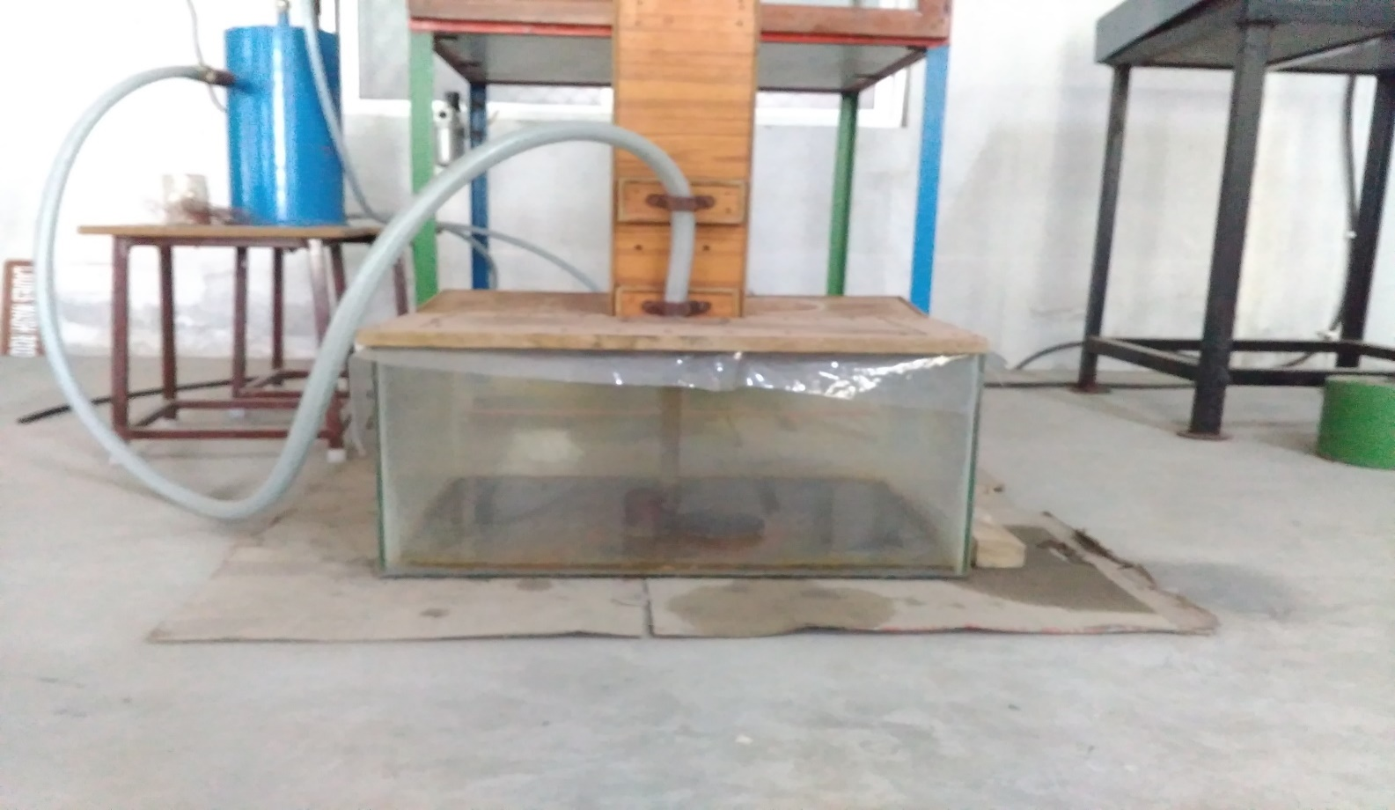

#### Fig:3.15: Schematic layout of dust collection

While machining process in AJM the abrasive particles are mixed in the atmosphere and slowly deposit on surrounding. Due to these particles which is present in atmosphere is more hazardous to human beings which leads some disease. To control this we used a dust collector technic as shown in above fig:3.15. Water is filled in the tank by using this technic the particles which comes out from the nozzle and strikes the workpiece will adhere on the surface of water. So,it reduces pollution.

# 4. RESULTS & DISCUSSIONS

## 4.1 PARAMETRIC SETTINGS:

The process parameters are identified based on literature survey such as gas Pressure, nozzle Tip Distance and nozzle diameter are effect the MRR and the product quality produced by AJM. In finding how the output parameters varies with the variation in the input parameter, three set of experiments as shown in Table 3 have been studied. All experiments were performed in same abrasive particle as SiC and same size of 20 microns. The selection of factors was based on the journals, preliminary result and the suggestion from the handbook recommended by the machine manufacturer.

###### Table 4.1: Symbols and levels of operations for parameters considered

|  |  |  |  |  |  |  |
| --- | --- | --- | --- | --- | --- | --- |
| **S. No** | **Symbols** | **Machining parameters** |  | **Levels** | | **Units** |
| **1** | **2** | **3** |
| 1 | A | Air Pressure | 5 | 6 | 7 | Bar |
| 2 | B | Nozzle Diameter | 4 | 5 | 5.5 | Mm |
| 3 | C | Standoff distance | 2 | 4 | 6 | Mm |

## 4.2: Experimental Procedure:

Work piece material is selected as Borosilicate glass and the specimens were cut into rectangular shape which having the dimensions of 100×100and having thickness of 3 mm for machining on AJM . Before placing the specimen, first measure initial weight of the specimen with the help of digital weighing machine. After measuring the weight of the specimen then clamp below the AJM. Before starting the experiment first check the all connections of air compressor. Abrasive particles are feed in to the mixing chamber before the starting of the compressor.

As the Compressor was switched on and maintain required pressure of the gas, abrasive grains were mixed with air jet coming from the compressor and focused on the specimen with help of nozzle and after finishing of the machining turn off the compressor. calculate the taper angle by using formulae by shown in fig.4.1.

### 4.2.1Formulae:

* Taper: =

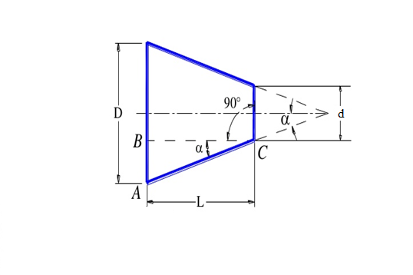

#### Fig:4.1: Formulae

D = larger diameter of tapered in mm,

d = smaller diameter of tapered in mm,

L = length of tapered part in mm,

2α= angle of tapered and

α = angle of tapper or half tapper angle.

###### Table 4.2: Parameters for Nozzle (4mm)

|  |  |  |  |  |
| --- | --- | --- | --- | --- |
| **Column** | **Factors** | | | **Angle** |
| **Trail No** | **A**  **Air Pressure (bar)** | **B**  **Stand**  **Off**  **Distance**  **(mm)** | **C**  **Nozzle Diameter (mm)** | **Tapper angle** |
| 1 | 5 | 2 | 4 | 14.11 |
| 2 | 6 | 2 | 4 | 14.22 |
| 3 | 7 | 2 | 4 | 14.28 |
| 4 | 5 | 4 | 4 | 16.84 |
| 5 | 6 | 4 | 4 | 16 |
| 6 | 7 | 4 | 4 | 15.12 |
| 7 | 5 | 6 | 4 | 19.18 |
| 8 | 6 | 6 | 4 | 19.43 |
| 9 | 7 | 6 | 4 | 19.34 |

### 4.2.2: Sample Calculations:

α= tan-1 ((D1-D2)/2l)

D1= larger diameter of the hole = 5.25 mm

D2= smaller diameter of the hole = 2 mm

l= thickness of glass = 3 mm

2α= tan-1 ((5.25-2)/2*3)

α = 14.220

The graph 5.1 shows the effect of SOD and Pressure on Angle



Graph 4.1: SOD & Pressure Vs Angle 4(mm)

The below figure 4.2 shows the machined work piece.

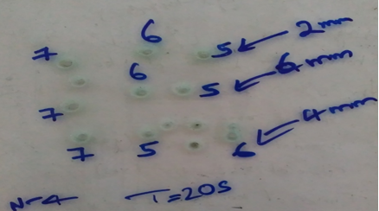

#### Fig: 4.2: Machined Work Piece with Nozzle (4mm)& T=20sec

###### Table 4.3: Parameters for Nozzle (5mm)

|  |  |  |  |  |
| --- | --- | --- | --- | --- |
| **Column** | **Factors** | | | **Angle** |
| **Trail No** | **A**  **Air Pressure (bar)** | **B**  **Stand**  **Off**  **Distance**  **(mm)** | **C**  **Nozzle Diameter (mm)** | **Tapper angle** |
| 1 | 5 | 2 | 5 | 16 |
| 2 | 6 | 2 | 5 | 14.2 |
| 3 | 7 | 2 | 5 | 13.28 |
| 4 | 5 | 4 | 5 | 17.65 |
| 5 | 6 | 4 | 5 | 16.84 |
| 6 | 7 | 4 | 5 | 14.22 |
| 7 | 5 | 6 | 5 | 16.84 |
| 8 | 6 | 6 | 5 | 14.22 |
| 9 | 7 | 6 | 5 | 12.50 |

### 4.2.4: Sample Calculations:

α= tan-1 ((D1-D2)/2l)

D1= larger diameter of the hole = 7 mm

D2= smaller diameter of the hole = 3mm

l= thickness of glass = 3mm

α= tan-1((7-3)/2*6)

α= 16.840

The graph 4.2 shows the effect of SOD and Pressure on Angle



Graph 4.2: SOD & Pressure Vs Angle 5 (mm)

The below figure 4.3 shows the machined work piece.

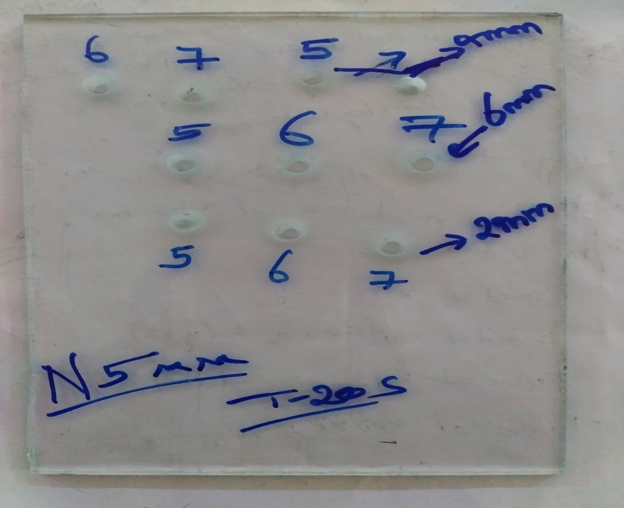

#### Fig: 4.3: Machined Work Piece with Nozzle (5mm) & T=20sec

###### Table 4.4: Parameters for Nozzle (5.5mm)

|  |  |  |  |  |
| --- | --- | --- | --- | --- |
| **Column** | **Factors** | | | **Angle** |
| **Trail No** | **A**  **Air Pressure (bar)** | **B**  **Stand**  **Off**  **Distance**  **(mm)** | **C**  **Nozzle Diameter (mm)** | **Tapper angle** |
| 1 | 5 | 2 | 5.5 | 15.12 |
| 2 | 6 | 2 | 5.5 | 16 |
| 3 | 7 | 2 | 5.5 | 16.84 |
| 4 | 5 | 4 | 5.5 | 16.84 |
| 5 | 6 | 4 | 5.5 | 16 |
| 6 | 7 | 4 | 5.5 | 15.12 |
| 7 | 5 | 6 | 5.5 | 14.22 |
| 8 | 6 | 6 | 5.5 | 16 |
| 9 | 7 | 6 | 5.5 | 12.31 |

### 4.2.5: Sample Calculations:

α= tan-1 ((D1-D2)/2l)

D1= larger diameter of the hole =6.75 mm

D2= smaller diameter of the hole = 3 mm

l= thickness of glass = 3mm

α= tan-1((6.75-3)/2*3)

α= 160

The graph 4.3 shows the effect of SOD and Pressure on Angle



Graph 4.3: SOD & Pressure Vs Angle 5.5(mm)

The below figure 4.4 shows the machined work piece.

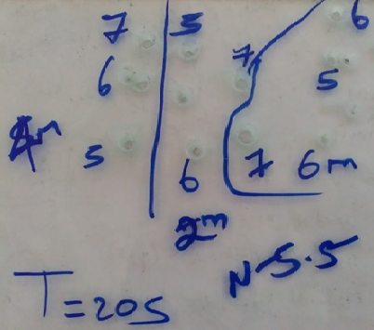

#### Fig: 4.4: Machined Work Piece with Nozzle (5.5mm) & T=20sec

# 5. CONCLUSION

1. Borosilicate glass is successfully machined on abrasive jet machine and effect of their process parameters on the Tapper Angle is analyzed by using DOE.
2. By using DOE, we find the most influencing parameter on Tapper Angle is pressure, next nozzle diameter and standoff distance.
3. From the practical results we found the better Tapper Angle is obtained at Air pressure(7 bar), SOD(6mm), Nozzle diameter(5.5mm).

# REFERENCES

1. **Bhaskar Chandra Kandpal1 (2011)** conducted experiment on “Machining Of Glass And Ceramic With Alumina And Silicon Carbide In Abrasive Jet Machining” International Journal of Advanced Engineering Technology, IJAET/Vol. II/ Issue IV/October-December, 2011/251-256. 12.
2. **El-Domiaty (2009)** conducted experiment on “Drilling of Glass Sheets by Abrasive Jet Machining” World Academy of Science, Engineering and Technology 32 2009.
3. **Lingyin et al (2001)** conducted experiment on **“**Abrasive Machining Of Glass-Infiltrated Alumina with Diamond Burs Machining Science and Technology” An International Journal Volume 5, Issue 1, 2001 pages 43-61.
4. **V. C. Venkatesh, T. N. Goh et al (1989)** conducted experiment on **“**an empirical study of parameters in Abrasive Jet Machining 1989” International Journal of Machine Tools and Mfg.
5. **Dr. A. K. Paul et al (1987)** “some studies on Abrasive jet machining” the Journal of the Institution of Engineers (India) Volume 68 part PE 2 November 1987.
6. **Sarkar and Pandey (1976)** “Some Investigations on the Abrasive Jet Machining” Journal of the Institution of Engineers (India), Volume 56, ME 6, 1976
7. **R. H. M. Jafar et al (2013)** conducted experiment on “Surface roughness and erosion rate of abrasive jet micro machined channels” Experiments and analytical model, -2013-Elsevier
8. **Shanmugam and Masood (2009)** investigate on “kerf characteristics in abrasive water jet cutting of layered composites” International Journal of Material Processing Technology
9. **Manabu Wakuda, Yukihiko et al (2003)** conducted experiment on “Material response to particle impact during abrasive jet machining of alumina ceramics” Journal of Materials Processing Technology, Volume 132, issue 1-3 (January 10, 2003), p. 177-183.
10. **D.S. Robinson Smart (2011)** investigates on “Effect of Abrasive Jet Nozzle Position and Angle on Coating Removal Rate” International Journal of Manufacturing Systems, 1: 57-64