**CS 6301.004**

**Association Rule Analysis**

**Team Members:**

Prathyusha Kanmanth Reddy(pxk166230)

Teja Kiran Chunduri(txc163430)

Shree Charan Varma Enugandla(sxe170530)

Srinivasa Rajesh Ayachitula(sxa172830)

**Data Description**

The dataset for this competition is a relational set of files describing customers' orders over time. The dataset is anonymized and contains a sample of over 3 million grocery orders from more than 200,000 Instacart users. For each user, we provide between 4 and 100 of their orders, with the sequence of products purchased in each order.

**File descriptions**

Each entity (customer, product, order, aisle, etc.) has an associated unique id. Most of the files and variable names should be self-explanatory.

order_products__prior.csv

These files specify which products were purchased in each order. order_products__prior.csv contains previous order contents for all customers. 'reordered' indicates that the customer has a previous order that contains the product. Note that some orders will have no reordered items. You may predict an explicit 'None' value for orders with no reordered items. See the evaluation page for full details.

order_id,product_id,add_to_cart_order,reordered

1,49302,1,1

1,11109,2,1

1,10246,3,0

...

### departments.csv

department_id,department

1,frozen

2,other

3,bakery

...

products.csv

product_id,product_name,aisle_id,department_id

1,Chocolate Sandwich Cookies,61,19

2,All-Seasons Salt,104,13

3,Robust Golden Unsweetened Oolong Tea,94,7

...

**Results- Products**

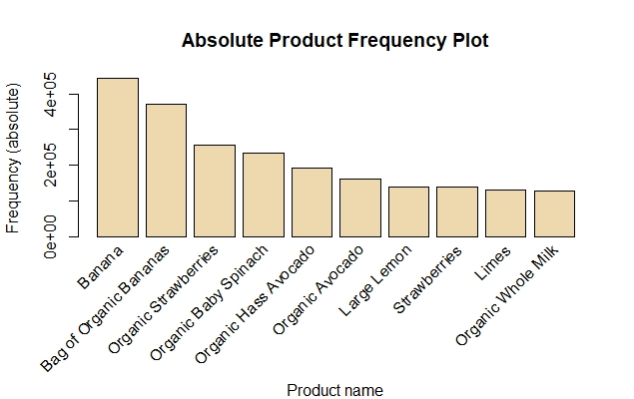

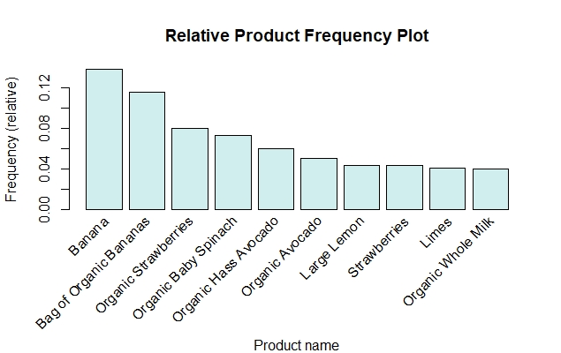

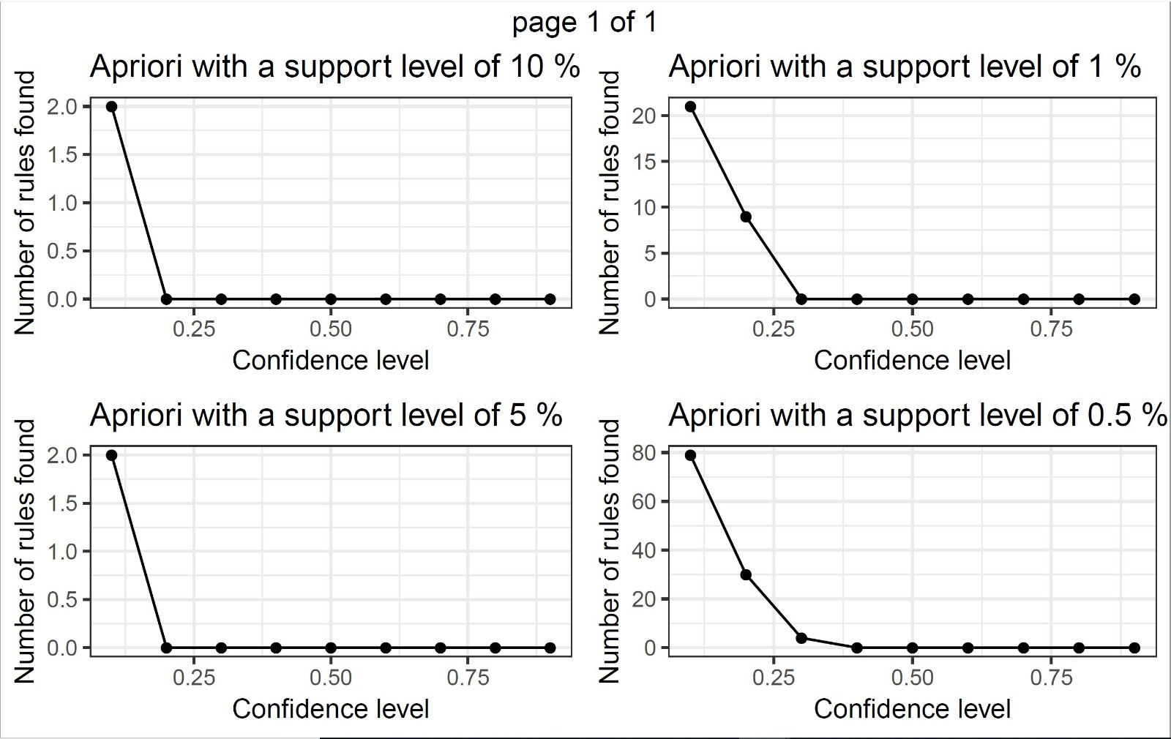

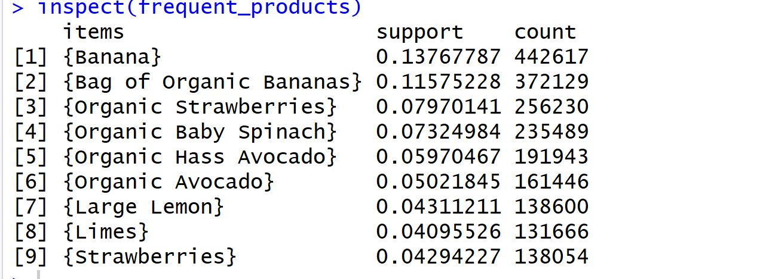

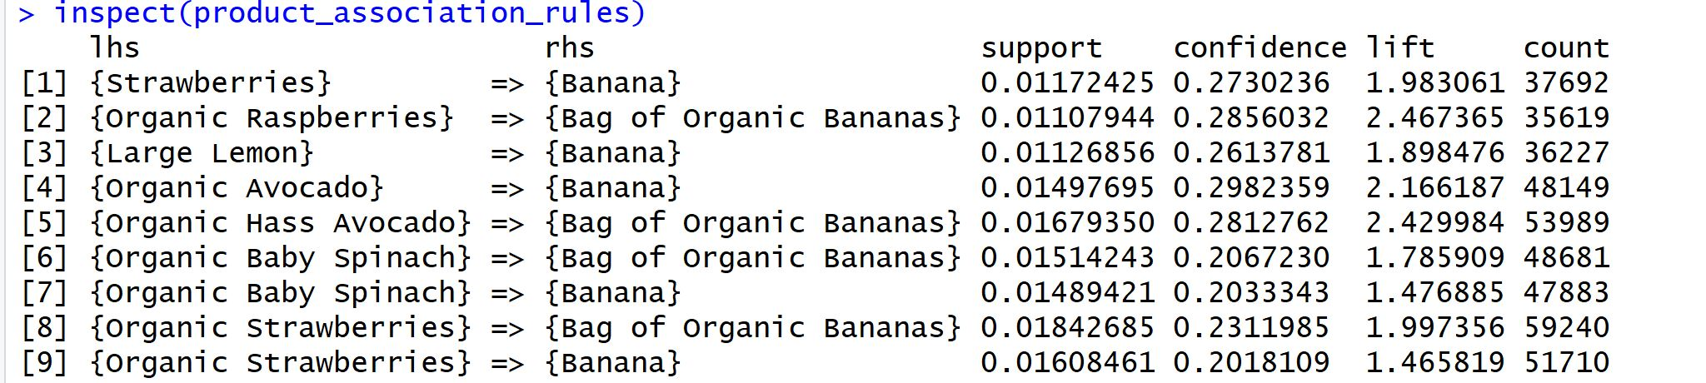

**Results- Departments**

