Introduction to Machine Learning

Machine Learning (ML) is a subset of artificial intelligence (AI) that enables systems to learn from data, identify patterns, and make decisions with minimal human intervention. Instead of explicitly programming a computer to perform a specific task, ML algorithms allow computers to improve their performance through experience.

History of Machine Learning
The concept of machine learning dates back to the 1950s when Arthur Samuel developed one of the first self-learning computer programs for playing checkers. Over the decades, advancements in computing power, algorithms, and data availability have accelerated the development of ML.

Types of Machine Learning
Machine learning is broadly categorized into three types:
- Supervised Learning: In this approach, the model is trained on a labelled dataset, where each input is associated with a corresponding output. The algorithm learns from this data and makes predictions based on new inputs. Examples include classification (e.g., spam detection) and regression (e.g., predicting house prices).
- Unsupervised Learning: In unsupervised learning, the model is given an unlabeled dataset and must find patterns or relationships within the data. Common techniques include clustering (e.g., customer segmentation) and dimensionality reduction (e.g., principal component analysis).
- Reinforcement Learning: This type of learning involves an agent interacting with an environment and learning by receiving rewards or penalties. Reinforcement learning is widely used in robotics, gaming, and autonomous systems.
Key Components of Machine Learning
Several fundamental components play a crucial role in building and deploying ML models:
- Dataset: A collection of data used to train and test the model.
- Features: The input variables that influence the predictions.
- Model: The mathematical representation that learns from the data.
- Training: The process of optimizing the model by adjusting its parameters based on data.
- Evaluation: Assessing the model's performance using metrics like accuracy, precision, recall, and F1-score.

Applications of Machine Learning
Machine learning has a wide range of applications across industries:
- Healthcare: Disease prediction, medical image analysis, and personalized treatment recommendations.
- Finance: Fraud detection, stock market prediction, and risk assessment.
- E-commerce: Recommendation systems and customer behaviour analysis.
- Autonomous Vehicles: Object detection, navigation, and collision avoidance.
- Natural Language Processing (NLP): Used in chatbots, sentiment analysis, and speech recognition.
Challenges in Machine Learning
- Data Dependency: High-quality and large amounts of data are required for accurate predictions.
- Computational Cost: Training complex models can be resource-intensive.
- Interpretability: Some models, like deep learning, function as black boxes, making them hard to interpret.
- Overfitting: Models may perform well on training data but fail on unseen data.
- Bias and Fairness Issues: Biased data can lead to unethical and unfair decisions.
- Security Vulnerabilities: ML models can be manipulated by adversarial attacks, leading to incorrect outcomes.

Future of Machine Learning
Machine learning is continuously evolving with advancements in deep learning, reinforcement learning, and AI ethics. The integration of ML with cloud computing, edge computing, and quantum computing will further enhance its capabilities, leading to new innovations in various domains.

Data Collection
Data collection is the process of gathering relevant information from various sources. It serves as the foundation for building and training machine learning models. The quality, quantity, and diversity of the collected data significantly impact the performance and accuracy of machine learning algorithms.
Types of Data Collection

- Primary Data Collection
  - Data is collected directly from sources through surveys, experiments, or real-time sensors.
  - Examples: Customer feedback, IoT sensor data, and experimental results.
- Secondary Data Collection
  - Data is obtained from existing sources such as public datasets, databases, or third-party APIs.
  - Examples: Government databases, Kaggle datasets, and social media analytics.
Methods of Data Collection
- Manual Entry: Collecting data manually through human effort (e.g., survey responses).
- Web Scraping: Extracting data from websites using automated scripts.
- APIs (Application Programming Interfaces): Fetching real-time data from online platforms.
- IoT Devices and Sensors: Gathering real-time data from smart devices.
- Databases and Logs: Extracting data from structured databases and server logs.
Importance of Data Collection
- Improves Model Accuracy: High-quality data leads to better predictions and decision-making.
- Reduces Bias: Diverse and well-balanced data helps in reducing bias in machine learning models.
- Enhances Generalization: Proper data collection ensures models perform well on new, unseen data.
- Supports Data-Driven Decisions: Enables businesses and researchers to make informed decisions based on insights from data.

Challenges in Data Collection
- Data Privacy and Security: Ensuring sensitive information is protected and compliant with regulations.
- Incomplete or Noisy Data: Handling missing values, inconsistencies, and errors in collected data.
- High Costs and Time Consumption: Collecting high-quality data can be resource-intensive.
- Data Integration Issues: Combining data from multiple sources while maintaining consistency.

Data Preprocessing
Data preprocessing is a critical step in machine learning that involves cleaning, transforming, and organizing raw data to improve its quality and usability. Since real-world data often contains inconsistencies, missing values, and noise, preprocessing ensures that the dataset is optimized for analysis and model training.
Steps in Data Preprocessing
- Data Cleaning
  - Handling missing values (e.g., removing or imputing missing data).
  - Removing duplicate entries.
  - Identifying and correcting errors or inconsistencies.
- Data Transformation
  - Normalization and standardization to bring all features to a common scale.
  - Encoding categorical data (e.g., converting text labels into numerical format using one-hot encoding).
  - Feature engineering to create new meaningful variables from existing data.
- Data Reduction
  - Feature selection to remove irrelevant or redundant features.
  - Principal Component Analysis (PCA) to reduce dimensionality.
  - Sampling techniques to balance dataset proportions.
- Data Splitting
  - Dividing the dataset into training, validation, and testing sets.
  - Ensuring a balanced representation of classes in classification problems.
Importance of Data Preprocessing
- Enhances Model Accuracy: Well-Preprocessed data improves the performance of machine learning models.
- Reduces Overfitting: Proper feature selection and normalization prevent models from learning noise.
- Speeds Up Training: Cleaning and reducing data help optimize computational efficiency.
- Ensures Better Interpretability: Preprocessed data provides meaningful insights for analysis and decision-making.

Example for Data Preprocessing :
Data Set:
The dataset contains 4 columns and 10 rows, with some missing values.
- Country: Represents the country of the individual (France, Spain, or Germany).
- Age: Represents the age of the individual, with some missing values.
- Salary: Represents the salary of the individual, with some missing values.
- Purchased: A categorical variable ("Yes" or "No") indicating whether the individual made a purchase.
Data.csv
Country | Age | Salary | Purchased
France | 44 | 72000 | No
Spain | 27 | 48000 | Yes
Germany | 30 | 54000 | No
Spain | 38 | 61000 | No
Germany | 40 |  | Yes
France | 35 | 58000 | Yes
Spain |  | 52000 | No
France | 48 | 79000 | Yes
Germany | 50 | 83000 | No
France | 37 | 67000 | Yes

Code:
# Importing the libraries
import numpy as np
import matplotlib.pyplot as plt
import pandas as pd
# Importing the dataset
dataset = pd.read_csv('Data.csv')
X = dataset.iloc[:, :-1].values
y = dataset.iloc[:, -1].values
print(X)
#OutPut
[['France' 44.0 72000.0]
['Spain' 27.0 48000.0]
['Germany' 30.0 54000.0]
['Spain' 38.0 61000.0]
['Germany' 40.0 nan]
['France' 35.0 58000.0]
['Spain' nan 52000.0]
['France' 48.0 79000.0]
['Germany' 50.0 83000.0]
['France' 37.0 67000.0]]

print(y)
#Output
['No' 'Yes' 'No' 'No' 'Yes' 'Yes' 'No' 'Yes' 'No' 'Yes']
# *Taking care of missing data
from sklearn.impute import SimpleImputer
imputer = SimpleImputer(missing_values=np.nan, strategy='mean')
imputer.fit(X[:, 1:3])
X[:, 1:3] = imputer.transform(X[:, 1:3])
print(X)
#Output
[['France' 44.0 72000.0]
['Spain' 27.0 48000.0]
['Germany' 30.0 54000.0]
['Spain' 38.0 61000.0]
['Germany' 40.0 63777.77777777778]
['France' 35.0 58000.0]
['Spain' 38.77777777777778 52000.0]
['France' 48.0 79000.0]
['Germany' 50.0 83000.0]
['France' 37.0 67000.0]]
# *Encoding categorical data
# Encoding the Independent Variable
from sklearn.compose import ColumnTransformer
from sklearn.preprocessing import OneHotEncoder
ct = ColumnTransformer(transformers=[('encoder', OneHotEncoder(), [0])], remainder='passthrough')
X = np.array(ct.fit_transform(X))
print(X)
#Output
[[1.0 0.0 0.0 44.0 72000.0]
[0.0 0.0 1.0 27.0 48000.0]
[0.0 1.0 0.0 30.0 54000.0]
[0.0 0.0 1.0 38.0 61000.0]
[0.0 1.0 0.0 40.0 63777.77777777778]
[1.0 0.0 0.0 35.0 58000.0]
[0.0 0.0 1.0 38.77777777777778 52000.0]
[1.0 0.0 0.0 48.0 79000.0]
[0.0 1.0 0.0 50.0 83000.0]
[1.0 0.0 0.0 37.0 67000.0]]
# Encoding the Dependent Variable
from sklearn.preprocessing import LabelEncoder
le = LabelEncoder()
y = le.fit_transform(y)
print(y)
#Output
[0 1 0 0 1 1 0 1 0 1]

#*Splitting the dataset into the Training set and Test set
from sklearn.model_selection import train_test_split
X_train, X_test, y_train, y_test = train_test_split(X, y, test_size = 0.2, random_state = 1)
print(X_train)
#Output
[[0.0 0.0 1.0 38.77777777777778 52000.0]
[0.0 1.0 0.0 40.0 63777.77777777778]
[1.0 0.0 0.0 44.0 72000.0]
[0.0 0.0 1.0 38.0 61000.0]
[0.0 0.0 1.0 27.0 48000.0]
[1.0 0.0 0.0 48.0 79000.0]
[0.0 1.0 0.0 50.0 83000.0]
[1.0 0.0 0.0 35.0 58000.0]]
print(X_test)
#Output
[[0.0 1.0 0.0 30.0 54000.0]
[1.0 0.0 0.0 37.0 67000.0]]
print(y_train)
#Output
[0 1 0 0 1 1 0 1]
print(y_test)
#Ouput
[0 1]
# *Feature Scaling
from sklearn.preprocessing import StandardScaler
sc = StandardScaler()
X_train = sc.fit_transform(X_train)
X_test = sc.transform(X_test)
print(X_train)
#Output
[[-0.77459667 -0.57735027 1.29099445 -0.19159184 -1.07812594]
[-0.77459667 1.73205081 -0.77459667 -0.01411729 -0.07013168]
[ 1.29099445 -0.57735027 -0.77459667 0.56670851 0.63356243]
[-0.77459667 -0.57735027 1.29099445 -0.30453019 -0.30786617]
[-0.77459667 -0.57735027 1.29099445 -1.90180114 -1.42046362]
[ 1.29099445 -0.57735027 -0.77459667 1.14753431 1.23265336]
[-0.77459667 1.73205081 -0.77459667 1.43794721 1.57499104]
[ 1.29099445 -0.57735027 -0.77459667 -0.74014954 -0.56461943]]
print(X_test)
#Output
[[-0.77459667 1.73205081 -0.77459667 -1.46618179 -0.9069571 ]
[ 1.29099445 -0.57735027 -0.77459667 -0.44973664 0.20564034]]

Experiment – 1

Aim : Write a program to implement the Linear Regression algorithm in order to predict the required data point. Select appropriate data set for the experience and draw graphs.

LINEAR REGRESSION
Description :

Linear Regression is a supervised learning algorithm that predicts a continuous output variable based on one or more input features.

Linear Regression Equation
y = β0 + β1x + ε

y: Dependent Variable (Target)
x: Independent Variable (Feature)
β0: Intercept or Constant Term
β1: Coefficient (Weight) of the feature
ε: Error Term (Residual)

Algorithm for Linear Regression
- Import Libraries and Load Data
  - Import necessary libraries like NumPy, Pandas, and Matplotlib.
  - Load the dataset and preprocess it (handle missing values, split data).
- Define the Hypothesis (Linear Equation)
  - Assume a straight-line relationship between input (X) and output (Y):
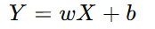
Here, w is the slope (weight), and b is the intercept (bias).
- Compute the Cost Function
  - Use Mean Squared Error (MSE) to measure the error:
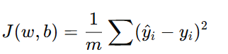
  - Where:
    - m = Number of data points
    - yᵢ = Actual value
    - ŷᵢ = Predicted value

- Minimize the Cost Function using Gradient Descent
Update w and b to reduce error
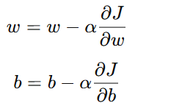
  - α (alpha) is the learning rate, which controls step size.
- Train the Model
  - Run multiple iterations of Gradient Descent until the error is minimized.
- Make Predictions
  - Use the trained model to predict new values of Y for given X.
- Evaluate the Model
  - Use performance metrics like MSE (Mean Squared Error) and R² Score to check accuracy.

Data Set:

The dataset contains two columns: YearsExperience and Salary, with 30 observations. YearsExperience represents the number of years an employee has worked, while Salary indicates the corresponding salary. The values for experience range from 1.1 to 10.5 years, and salaries range from 37,731 to 122,391.

Salary_Data.csv
YearsExperience | Salary
1.1 | 39343
1.3 | 46205
1.5 | 37731
2 | 43525
2.2 | 39891
2.9 | 56642
3 | 60150
3.2 | 54445
3.2 | 64445
3.7 | 57189
3.9 | 63218
4 | 55794
4 | 56957
4.1 | 57081
4.5 | 61111
4.9 | 67938
5.1 | 66029
5.3 | 83088
5.9 | 81363
6 | 93940
6.8 | 91738
7.1 | 98273
7.9 | 101302
8.2 | 113812
8.7 | 109431
9 | 105582
9.5 | 116969
9.6 | 112635
10.3 | 122391

Code:

# Importing the libraries

import numpy as np
import matplotlib.pyplot as plt
import pandas as pd

# Importing the dataset

dataset = pd.read_csv('Salary_Data.csv')
X = dataset.iloc[:, :-1].values
y = dataset.iloc[:, -1].values

# Splitting the dataset into the Training set and Test set

from sklearn.model_selection import train_test_split
X_train, X_test, y_train, y_test = train_test_split(X, y, test_size = 1/3, random_state = 0)

# Training the Linear Regression model on the Training set

from sklearn.linear_model import LinearRegression
regressor = LinearRegression()
regressor.fit(X_train, y_train)

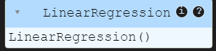

# Predicting the Test set results
y_pred = regressor.predict(X_test)
# Visualising the Training set results

plt.scatter(X_train, y_train, color = 'red')
plt.plot(X_train, regressor.predict(X_train), color = 'blue')
plt.title('Salary vs Experience (Training set) 22B01A4638')
plt.xlabel('Years of Experience')
plt.ylabel('Salary')
plt.show()

OUTPUT

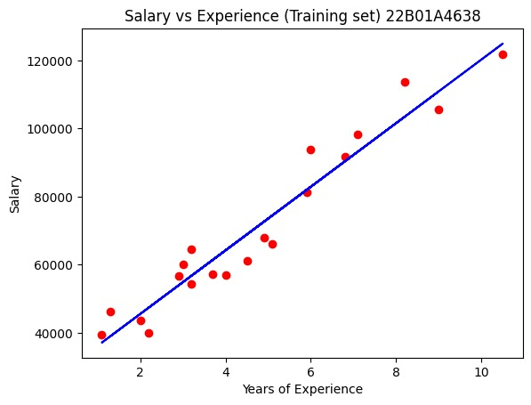

# Visualising the Test set results
plt.scatter(X_test, y_test, color = 'red')
plt.plot(X_train, regressor.predict(X_train), color = 'blue')
plt.title('Salary vs Experience (Test set) 22B01A4638')
plt.xlabel('Years of Experience')
plt.ylabel('Salary')
plt.show()

OUTPUT

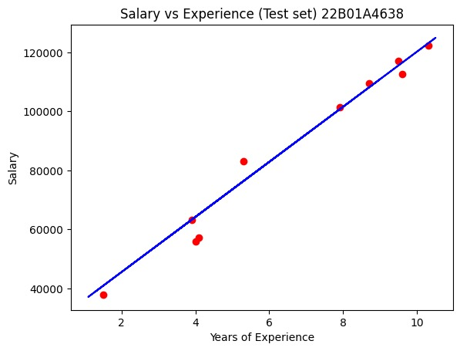

Experiment – 2

Aim : Write a program to implement a two-class regression model on the given dataset to classify the data points in the dataset.

LOGISTIC REGRESSION

Description:
Logistic Regression is a statistical method used for binary classification, where the dependent variable has two possible outcomes (e.g., yes/no, pass/fail). It models the relationship between independent variables and the probability of a specific outcome using the sigmoid function, which maps values between 0 and 1.
The logistic regression equation is:
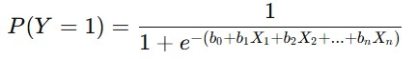
where:
- P(Y=1) is the probability of the positive class,
- b₀ is the intercept,
- b₁, b₂, ..., bₙ are the coefficients,
- X₁, X₂, ..., Xₙ are the independent variables.

Algorithm for Logistic Regression
- Import Libraries and Load Data
  - Import necessary libraries like NumPy, Pandas, and Matplotlib.
  - Load the dataset and preprocess it (handle missing values, encode categorical variables, and split data).
- Define the Hypothesis (Logistic Function)
  - Unlike Linear Regression, Logistic Regression uses the Sigmoid function to map predictions between 0 and 1:
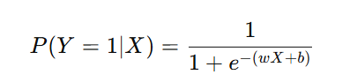
  - Here, w is the weight (coefficient), b is the bias (intercept), and e is Euler’s number (~2.718).

- Compute the Cost Function (Log Loss)
  - Since Logistic Regression is used for classification, we use the Log-Loss function (Binary Cross-Entropy) to measure error:
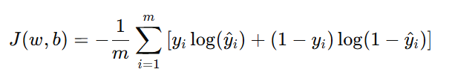
  - Where:
    - m = Number of data points
    - yᵢ = Actual label (0 or 1)
    - ŷᵢ = Predicted probability
- Minimize the Cost Function using Gradient Descent
  - Update w and b iteratively to reduce error:
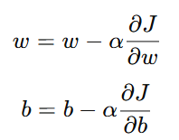
  - α (alpha) is the learning rate, which controls the step size.
- Train the Model
  - Perform multiple iterations of Gradient Descent until the cost function converges to a minimum.
- Make Predictions
  - Compute the probability using the Sigmoid function.
  - If ŷ ≥ 0.5, classify as 1 (positive class), otherwise classify as 0 (negative class).
- Evaluate the Model
  - Use performance metrics like:
    - Accuracy
    - Precision, Recall, and F1-score
    - ROC-AUC Curve

Data Set:
The dataset contains three columns:
- Age: Represents the age of individuals, ranging from 18 to 60 years.
- EstimatedSalary: Represents the estimated salary of individuals, ranging from 15,000 to 150,000.
- Purchased: A binary variable (0 or 1) indicating whether the individual made a purchase (1) or not (0).
The dataset consists of 400 observations, with no missing values.
Social_Network_Ads.csv:
Age | EstimatedSalary | Purchased
19 | 19000 | 0
35 | 20000 | 0
26 | 43000 | 0
27 | 57000 | 0
19 | 76000 | 0
27 | 58000 | 0
27 | 84000 | 0
32 | 150000 | 1
25 | 33000 | 0
35 | 65000 | 0
… | … | ..
… | … | ..
36 | 33000 | 0
49 | 36000 | 1

Code:
# Importing the libraries

import numpy as np
import matplotlib.pyplot as plt
import pandas as pd

# Importing the dataset

dataset = pd.read_csv('Social_Network_Ads.csv')

X = dataset.iloc[:, :-1].values
y = dataset.iloc[:, -1].values

# Splitting the dataset into the Training set and Test set

from sklearn.model_selection import train_test_split
X_train, X_test, y_train, y_test = train_test_split(X, y, test_size = 0.25, random_state = 0)

print(X_train)

#Output:
[[ 44 39000]
[ 32 120000]
[ 38 50000]
[ 32 135000]
…..
[ 27 54000]
[ 26 118000]]
print(y_train)

#OutPut:
[0 1 0 1 1 1 0 0 0 0 0 0 1 1 1 0 1 0 0 1 0 1 0 1 0 0 1 1 1 1 0 1 0 1 0 0 1
0 0 1 0 0 0 0 0 1 1 1 1 0 0 0 1 0 1 0 1 0 0 1 0 0 0 1 0 0 0 1 1 0 0 1 0 1
1 1 0 0 1 1 0 0 1 1 0 1 0 0 1 1 0 1 1 1 0 0 0 0 0 1 0 0 1 1 1 1 1 0 1 1 0
1 0 0 0 0 0 0 0 1 1 0 0 1 0 0 1 0 0 0 1 0 1 1 0 1 0 0 0 0 1 0 0 0 1 1 0 0
0 0 1 0 1 0 0 0 1 0 0 0 0 1 1 1 0 0 0 0 0 0 1 1 1 1 1 0 1 0 0 0 0 0 1 0 0
0 0 0 0 1 1 0 1 0 1 0 0 1 0 0 0 1 0 0 0 0 0 1 0 0 0 0 0 1 0 1 1 0 0 0 0 0
0 1 1 0 0 0 0 1 0 0 0 0 1 0 1 0 1 0 0 0 1 0 0 0 1 0 1 0 0 0 0 0 1 1 0 0 0
0 0 1 0 1 1 0 0 0 0 0 1 0 1 0 0 1 0 0 1 0 1 0 0 0 0 0 0 1 1 1 1 0 0 0 0 1
0 0 0 0]

print(X_test)

#Output:
[[ 30 87000]
[ 38 50000]
[ 35 75000]
[ 30 79000]
…………….
[ 23 63000]
[ 48 33000]
[ 48 90000]
[ 42 104000]]

print(y_test)

#Output:
[0 0 0 0 0 0 0 1 0 0 0 0 0 0 0 0 0 0 1 0 0 1 0 1 0 1 0 0 0 0 0 1 1 0 0 0 0
0 0 1 0 0 0 0 1 0 0 1 0 1 1 0 0 0 1 1 0 0 1 0 0 1 0 1 0 1 0 0 0 0 1 0 0 1
0 0 0 0 1 1 1 0 0 0 1 1 0 1 1 0 0 1 0 0 0 1 0 1 1 1]

# Feature Scaling

from sklearn.preprocessing import StandardScaler
sc = StandardScaler()
X_train = sc.fit_transform(X_train)
X_test = sc.transform(X_test)

print(X_train)

#Output:
[[ 0.58164944 -0.88670699]
[-0.60673761 1.46173768]
[-0.01254409 -0.5677824 ]
...
[-0.21060859 -0.50979612]
[-1.10189888 -0.45180983]
[-1.20093113 1.40375139]]
print(X_test)

#Output:
[[-0.80480212 0.50496393]
[-0.01254409 -0.5677824 ]
[-0.30964085 0.1570462 ]
[-0.80480212 0.27301877]
[-0.30964085 -0.5677824 ]
...
[-1.49802789 -0.19087153]
[ 0.97777845 -1.06066585]
[ 0.97777845 0.59194336]
[ 0.38358493 0.99784738]]

# Training the Logistic Regression model on the Training set

from sklearn.linear_model import LogisticRegression
classifier = LogisticRegression(random_state = 0)
classifier.fit(X_train, y_train)

#Output:

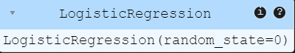

# Predicting a new result

print(classifier.predict(sc.transform([[30,87000]])))

#Output:
[0]

# Predicting the Test set results

y_pred = classifier.predict(X_test)
print(np.concatenate((y_pred.reshape(len(y_pred),1), y_test.reshape(len(y_test),1)),1))

#Output:
[[0 0]
[0 0]
[0 0]
[0 0]
...
[0 0]
[0 1]
[1 1]
[1 1]]

# Making the Confusion Matrix

from sklearn.metrics import confusion_matrix, accuracy_score
cm = confusion_matrix(y_test, y_pred)
print(cm)
accuracy_score(y_test, y_pred)

#Output:
[[65 3]
[ 8 24]]

0.89

# Visualising the Training set results

from matplotlib.colors import ListedColormap
import numpy as np
import matplotlib.pyplot as plt

# Ensure `X_set` and `y_set` are properly defined
X_set, y_set = sc.inverse_transform(X_train), y_train

# Create a mesh grid for the plot
X1, X2 = np.meshgrid(
np.arange(start=X_set[:, 0].min() - 10, stop=X_set[:, 0].max() + 10, step=0.25),
# Fine grid for smoother boundary
np.arange(start=X_set[:, 1].min() - 1000, stop=X_set[:, 1].max() + 1000, step=0.25)
)

# Predict over the grid and reshape to fit X1 and X2
Z = classifier.predict(sc.transform(np.array([X1.ravel(), X2.ravel()]).T))
Z = Z.reshape(X1.shape)

# Plot the decision boundary
plt.contourf(X1, X2, Z, alpha=0.75, cmap=ListedColormap(['salmon', 'dodgerblue']))
plt.xlim(X1.min(), X1.max())
plt.ylim(X2.min(), X2.max())

# Plot data points with distinct colors for each class
for i, j in enumerate(np.unique(y_set)):
plt.scatter(
X_set[y_set == j, 0],
X_set[y_set == j, 1],
c=np.array(ListedColormap(['red', 'purple'])(i)).reshape(1, -1), # Ensure color mapping is correct
label=j
)

# Add titles and labels
plt.title('Logistic Regression Classification (Training set) 22B01A4638')
plt.xlabel('Age')
plt.ylabel('Estimated Salary')
plt.legend()
plt.show()

#Output:

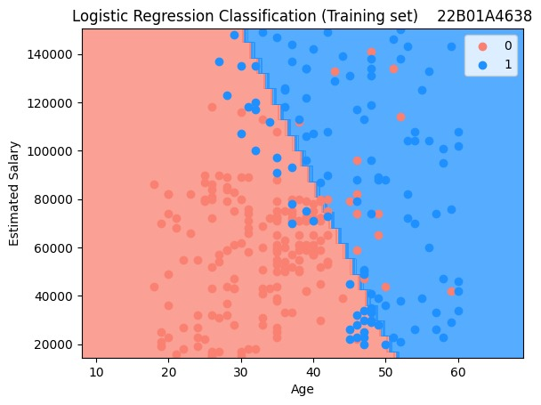

#Visualising the Test set results

from matplotlib.colors import ListedColormap
import numpy as np
import matplotlib.pyplot as plt

# Ensure `X_set` and `y_set` are properly defined
X_set, y_set = sc.inverse_transform(X_test), y_test

# Use a coarser grid to reduce memory usage
X1, X2 = np.meshgrid(
np.arange(start=X_set[:, 0].min() - 5, stop=X_set[:, 0].max() + 5, step=1),
# Adjusted step size
np.arange(start=X_set[:, 1].min() - 500, stop=X_set[:, 1].max() + 500, step=1)
)

# Predict over the reduced grid and reshape to fit X1 and X2
Z = classifier.predict(sc.transform(np.array([X1.ravel(), X2.ravel()]).T))
Z = Z.reshape(X1.shape)

# Plot the decision boundary
plt.contourf(X1, X2, Z, alpha=0.75, cmap=ListedColormap(['salmon', 'dodgerblue']))
plt.xlim(X1.min(), X1.max())
plt.ylim(X2.min(), X2.max())

# Plot data points with distinct colors for each class
for i, j in enumerate(np.unique(y_set)):
plt.scatter(
X_set[y_set == j, 0],
X_set[y_set == j, 1],
c=np.array(ListedColormap(['red', 'purple'])(i)).reshape(1, -1),
label=j
)

# Add titles and labels
plt.title('Logistic Regression Classification (Test set) 22B01A4638’)
plt.xlabel('Age')
plt.ylabel('Estimated Salary')
plt.legend()
plt.show()

#OutPut:

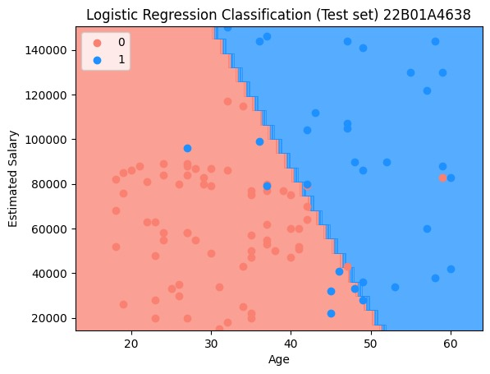

Experiment – 3

Aim : Write program to demonstrate the working of the Decision Tree algorithm. Use appropriate data set for building the decision tree apply this knowledge to classify a new sample.

DECISION TREE
Description :
A Decision Tree is a supervised learning algorithm used for classification and regression tasks. It works by splitting the dataset into smaller subsets based on feature conditions, forming a tree-like structure where:
- Each internal node represents a decision based on a feature.
- Each branch represents an outcome of the decision.
- Each leaf node represents the final output (class label or numerical value).

Algorithm for Decision Tree
- Import Libraries and Load Data
  - Import necessary libraries like NumPy, Pandas, Matplotlib, and Scikit-Learn.
  - Load and preprocess the dataset (handle missing values, encode categorical variables, and split data).
- Select the Best Feature to Split (Root Node Selection)
  - Calculate impurity using:
    - Gini Index (for classification):
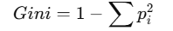
    - Entropy (Information Gain) (for classification):
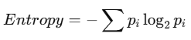
    - Mean Squared Error (MSE) (for regression).
  - Choose the feature that best splits the data by maximizing Information Gain or reducing Gini impurity.
- Split the Data into Branches
  - Divide the dataset based on the selected feature’s threshold.
  - Repeat the process recursively for each child node.

- Stop Splitting (Stopping Criteria)
  - Stop when one of the following conditions is met:
    - A node contains only one class (pure node).
    - Maximum depth of the tree is reached.
    - Minimum number of samples in a node is too small.
- Make Predictions
  - For classification, return the most frequent class in the leaf node.
  - For regression, return the average of target values in the leaf node.
- Evaluate the Model
  - Use metrics like:
    - Accuracy, Precision, Recall, and F1-score (for classification).
    - Mean Squared Error (MSE) or R² score (for regression).
Data Set:
The dataset contains three columns:
- Age: Represents the age of individuals, ranging from 18 to 60 years.
- EstimatedSalary: Represents the estimated salary of individuals, ranging from 15,000 to 150,000.
- Purchased: A binary variable (0 or 1) indicating whether the individual made a purchase (1) or not (0).
The dataset consists of 400 observations, with no missing values.
Social_Network_Ads.csv:
Age | EstimatedSalary | Purchased
19 | 19000 | 0
35 | 20000 | 0
26 | 43000 | 0
27 | 57000 | 0
19 | 76000 | 0
27 | 58000 | 0
27 | 84000 | 0
32 | 150000 | 1
25 | 33000 | 0
35 | 65000 | 0
… | … | ...
… | … | ..
36 | 33000 | 0
49 | 36000 | 1
Code for Decision Tree Classification:
# Importing the libraries
import numpy as np
import matplotlib.pyplot as plt
import pandas as pd
# importing data set
dataset = pd.read_csv('Social_Network_Ads.csv')
X = dataset.iloc[:, :-1].values
y = dataset.iloc[:, -1].values
# Splitting the dataset into the Training set and Test set
from sklearn.model_selection import train_test_split
X_train, X_test, y_train, y_test = train_test_split(X, y, test_size = 0.25, random_state = 0)

print(X_train
#Output
[[ 44 39000]
[ 32 120000]
[ 38 50000]
...
[ 29 43000]
[ 36 52000]
[ 27 54000]
[ 26 118000]]

print(y_train)
#Output
[0 1 0 1 1 1 0 0 0 0 0 0 1 1 1 0 1 0 0 1 0 1 0 1 0 0 1 1 1 1 0 1 0 1 0 0 1
0 0 1 0 0 0 0 0 1 1 1 1 0 0 0 1 0 1 0 1 0 0 1 0 0 0 1 0 0 0 1 1 0 0 1 0 1
1 1 0 0 1 1 0 0 1 1 0 1 0 0 1 1 0 1 1 1 0 0 0 0 0 1 0 0 1 1 1 1 1 0 1 1 0
1 0 0 0 0 0 0 0 1 1 0 0 1 0 0 1 0 0 0 1 0 1 1 0 1 0 0 0 0 1 0 0 0 1 1 0 0
0 0 1 0 1 0 0 0 1 0 0 0 0 1 1 1 0 0 0 0 0 0 1 1 1 1 1 0 1 0 0 0 0 0 1 0 0
0 0 0 0 1 1 0 1 0 1 0 0 1 0 0 0 1 0 0 0 0 0 1 0 0 0 0 0 1 0 1 1 0 0 0 0 0
0 1 1 0 0 0 0 1 0 0 0 0 1 0 1 0 1 0 0 0 1 0 0 0 1 0 1 0 0 0 0 0 1 1 0 0 0
0 0 1 0 1 1 0 0 0 0 0 1 0 1 0 0 1 0 0 1 0 1 0 0 0 0 0 0 1 1 1 1 0 0 0 0 1
0 0 0 0]
print(X_test)
# Output
[[ 30 87000]
[ 38 50000]
[ 35 75000]
[ 30 79000]
...
[ 23 63000]
[ 48 33000]
[ 48 90000]
[ 42 104000]]
print(y_test)
[0 0 0 0 0 0 0 1 0 0 0 0 0 0 0 0 0 0 1 0 0 1 0 1 0 1 0 0 0 0 0 1 1 0 0 0 0
0 0 1 0 0 0 0 1 0 0 1 0 1 1 0 0 0 1 1 0 0 1 0 0 1 0 1 0 1 0 0 0 0 1 0 0 1
0 0 0 0 1 1 1 0 0 0 1 1 0 1 1 0 0 1 0 0 0 1 0 1 1 1]
# Feature Scaling
from sklearn.preprocessing import StandardScaler
sc = StandardScaler()
X_train = sc.fit_transform(X_train)
X_test = sc.transform(X_test)
print(X_train)
#Output
[[ 0.58164944 -0.88670699]
[-0.60673761 1.46173768]
[-0.01254409 -0.5677824 ]
…. [-0.21060859 -0.50979612]
[-1.10189888 -0.45180983]
[-1.20093113 1.40375139]]
print(X_test)
#Output
[[-0.80480212 0.50496393]
[-0.01254409 -0.5677824 ]
...
[ 0.97777845 -1.06066585]
[ 0.97777845 0.59194336]
[ 0.38358493 0.99784738]]
# Training the Decision Tree Classification model on the Training set
from sklearn.tree import DecisionTreeClassifier
classifier = DecisionTreeClassifier(criterion = 'entropy', random_state = 0)
classifier.fit(X_train, y_train)
#Output
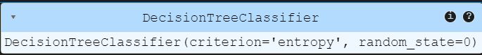
# Predicting a new result
print(classifier.predict(sc.transform([[30,87000]])))
#Output
[0]
# Predicting the Test set results
y_pred = classifier.predict(X_test)
print(np.concatenate((y_pred.reshape(len(y_pred),1), y_test.reshape(len(y_test),1)),1))
#Output
[[0 0]
[0 0]
[0 0]
….
[0 0]
[1 1]
[1 1]
[1 1]]

# Making the Confusion Matrix
from sklearn.metrics import confusion_matrix, accuracy_score
cm = confusion_matrix(y_test, y_pred)
print(cm)
accuracy_score(y_test, y_pred)
#Output
[[62 6]
[ 3 29]]
0.91
# Visualising the Training set results
from matplotlib.colors import ListedColormap
import numpy as np
import matplotlib.pyplot as plt

# Ensure `X_set` and `y_set` are properly defined
X_set, y_set = sc.inverse_transform(X_train), y_train

# Create a mesh grid for the plot
X1, X2 = np.meshgrid(
np.arange(start=X_set[:, 0].min() - 10, stop=X_set[:, 0].max() + 10, step=1), # step adjusted for better resolution
np.arange(start=X_set[:, 1].min() - 1000, stop=X_set[:, 1].max() + 1000, step=1)
)

# Predict over the grid and reshape to fit X1 and X2
Z = classifier.predict(sc.transform(np.array([X1.ravel(), X2.ravel()]).T))
Z = Z.reshape(X1.shape)

# Plot the decision boundary
plt.contourf(X1, X2, Z, alpha=0.75, cmap=ListedColormap(['orange', 'palegreen']))
plt.xlim(X1.min(), X1.max())
plt.ylim(X2.min(), X2.max())

# Plot data points with distinct colors for each class
for i, j in enumerate(np.unique(y_set)):
plt.scatter(
X_set[y_set == j, 0],
X_set[y_set == j, 1],
c=np.array(ListedColormap(['magenta', 'purple'])(i)).reshape(1, -1), # Ensure color mapping is correct
label=j
)

# Add titles and labels
plt.title('Decision Tree Classification (Training set) 22B01A4638')
plt.xlabel('Age')
plt.ylabel('Estimated Salary')
plt.legend()
plt.show()
#Output
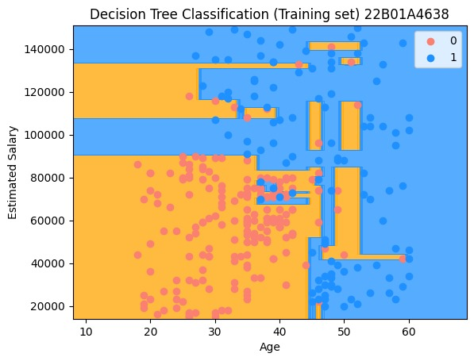

# Visualising the Test set results
from matplotlib.colors import ListedColormap
import numpy as np
import matplotlib.pyplot as plt

# Ensure `X_set` and `y_set` are properly defined
X_set, y_set = sc.inverse_transform(X_test), y_test

# Create a mesh grid for the plot
X1, X2 = np.meshgrid(
np.arange(start=X_set[:, 0].min() - 10, stop=X_set[:, 0].max() + 10, step=1), # Adjusted step size for better resolution
np.arange(start=X_set[:, 1].min() - 1000, stop=X_set[:, 1].max() + 1000, step=1)
)

# Predict over the grid and reshape to fit X1 and X2
Z = classifier.predict(sc.transform(np.array([X1.ravel(), X2.ravel()]).T))
Z = Z.reshape(X1.shape)

# Plot the decision boundary
plt.contourf(X1, X2, Z, alpha=0.75, cmap=ListedColormap(['salmon', 'palegreen']))
plt.xlim(X1.min(), X1.max())
plt.ylim(X2.min(), X2.max())

# Plot data points with distinct colors for each class
for i, j in enumerate(np.unique(y_set)):
plt.scatter(
X_set[y_set == j, 0],
X_set[y_set == j, 1],
c=np.array(ListedColormap(['chocolate', 'dodgerblue'])(i)).reshape(1, -1), # Ensure color mapping is correct
label=j
)

# Add titles and labels
plt.title('Decision Tree Classification (Test set) 22B01A4638')
plt.xlabel('Age')
plt.ylabel('Estimated Salary')
plt.legend()
plt.show()
#Output
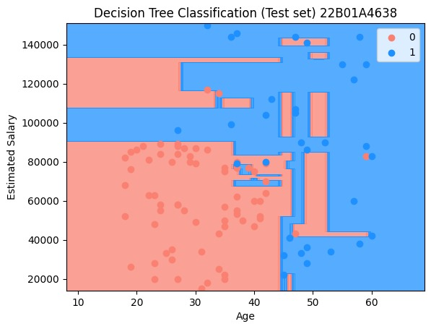

Experiment – 4
Aim: Write a program to implement Support Vector Machine algorithm on the given dataset to classify the data points in the dataset.
Support Vector Machine (SVM)
Description :
Support Vector Machine (SVM) is a supervised learning algorithm used for classification and regression tasks. It works by finding the best decision boundary (hyperplane) that maximizes the margin between different classes.
- For classification, SVM finds a hyperplane that best separates different classes.
- For regression, it tries to fit a function that predicts values with minimal error.
SVM can use different kernel functions (Linear, Polynomial, RBF, Sigmoid) to transform data into higher dimensions and make it easier to separate non-linearly separable data.

Algorithm for SVM :
1. Import Libraries and Load Data
- Import necessary libraries like NumPy, Pandas, Matplotlib, and Scikit-Learn.
- Load and preprocess the dataset (handle missing values, encode categorical variables, and split data).
2. Select the Kernel Type
- Linear Kernel: Used for linearly separable data.
- Polynomial Kernel: Used when data is non-linearly separable.
- Radial Basis Function (RBF) Kernel: Most commonly used for complex non-linear data.
- Sigmoid Kernel: Works like a neural network activation function.
3. Find the Optimal Hyperplane
- Compute the decision boundary that maximizes the margin between classes.
- Solve the optimization problem to minimize classification error.

4. Introduce Slack Variables (Soft Margin SVM)
- If data is not perfectly separable, allow some misclassification by introducing a penalty parameter (C).
- Higher C → Less margin but lower misclassification.
- Lower C → More margin but higher misclassification.
5. Use the Kernel Trick (for Non-Linear Data)
- Transform data into a higher-dimensional space using kernel functions.
- This makes non-linearly separable data easier to classify.
6. Classify New Data Points
- Use the trained SVM model to predict the class of new data.
7. Evaluate the Model
- Use metrics like:
  - Accuracy, Precision, Recall, F1-score (for classification).
  - Mean Squared Error (MSE) or R² score (for regression).

Data Set:
The dataset contains three columns:
- Age: Represents the age of individuals, ranging from 18 to 60 years.
- EstimatedSalary: Represents the estimated salary of individuals, ranging from 15,000 to 150,000.
- Purchased: A binary variable (0 or 1) indicating whether the individual made a purchase (1) or not (0).
The dataset consists of 400 observations, with no missing values.

Social_Network_Ads.csv:
Age | EstimatedSalary | Purchased
19 | 19000 | 0
35 | 20000 | 0
26 | 43000 | 0
27 | 57000 | 0
19 | 76000 | 0
27 | 58000 | 0
27 | 84000 | 0
32 | 150000 | 1
25 | 33000 | 0
35 | 65000 | 0
… | ... | ..
… | … | ..
36 | 33000 | 0
49 | 36000 | 1

Code:
# Importing the libraries
import numpy as np
import matplotlib.pyplot as plt
import pandas as pd
# Importing the dataset
dataset = pd.read_csv('Social_Network_Ads.csv')

X = dataset.iloc[:, :-1].values
y = dataset.iloc[:, -1].values
# Splitting the dataset into the Training set and Test set
from sklearn.model_selection import train_test_split
X_train, X_test, y_train, y_test = train_test_split(X, y, test_size = 0.25, random_state = 0)
print(X_train)
#Output
[[ 44 39000]
[ 32 120000]
[ 38 50000]
….
[ 27 54000]
[ 26 118000]]
print(y_train)
#Output
[0 1 0 1 1 1 0 0 0 0 0 0 1 1 1 0 1 0 0 1 0 1 0 1 0 0 1 1 1 1 0 1 0 1 0 0 1
0 0 1 0 0 0 0 0 1 1 1 1 0 0 0 1 0 1 0 1 0 0 1 0 0 0 1 0 0 0 1 1 0 0 1 0 1
1 1 0 0 1 1 0 0 1 1 0 1 0 0 1 1 0 1 1 1 0 0 0 0 0 1 0 0 1 1 1 1 1 0 1 1 0
1 0 0 0 0 0 0 0 1 1 0 0 1 0 0 1 0 0 0 1 0 1 1 0 1 0 0 0 0 1 0 0 0 1 1 0 0
0 0 1 0 1 0 0 0 1 0 0 0 0 1 1 1 0 0 0 0 0 0 1 1 1 1 1 0 1 0 0 0 0 0 1 0 0
0 0 0 0 1 1 0 1 0 1 0 0 1 0 0 0 1 0 0 0 0 0 1 0 0 0 0 0 1 0 1 1 0 0 0 0 0
0 1 1 0 0 0 0 1 0 0 0 0 1 0 1 0 1 0 0 0 1 0 0 0 1 0 1 0 0 0 0 0 1 1 0 0 0
0 0 1 0 1 1 0 0 0 0 0 1 0 1 0 0 1 0 0 1 0 1 0 0 0 0 0 0 1 1 1 1 0 0 0 0 1
0 0 0 0]
print(X_test)
#Output
[[ 30 87000]
[ 38 50000]
[ 35 75000]
...
[ 23 63000]
[ 48 33000]
[ 48 90000]
[ 42 104000]]
print(y_test)
#Output
[0 0 0 0 0 0 0 1 0 0 0 0 0 0 0 0 0 0 1 0 0 1 0 1 0 1 0 0 0 0 0 1 1 0 0 0 0
0 0 1 0 0 0 0 1 0 0 1 0 1 1 0 0 0 1 1 0 0 1 0 0 1 0 1 0 1 0 0 0 0 1 0 0 1
0 0 0 0 1 1 1 0 0 0 1 1 0 1 1 0 0 1 0 0 0 1 0 1 1 1]
# Feature Scaling
from sklearn.preprocessing import StandardScaler
sc = StandardScaler()
X_train = sc.fit_transform(X_train)
X_test = sc.transform(X_test)
print(X_train)
#Output
[[ 0.58164944 -0.88670699]
[-0.60673761 1.46173768]
[-0.01254409 -0.5677824 ]
….
[-1.10189888 -0.45180983]
[-1.20093113 1.40375139]]
print(X_test)
#Output
[[-0.80480212 0.50496393]
[-0.01254409 -0.5677824 ]
[-0.30964085 0.1570462 ]
…
[-1.49802789 -0.19087153]
[ 0.97777845 -1.06066585]
[ 0.97777845 0.59194336]
[ 0.38358493 0.99784738]]
# Training the SVM model on the Training set
from sklearn.svm import SVC
classifier = SVC(kernel = 'linear', random_state = 0)
classifier.fit(X_train, y_train)
#Output
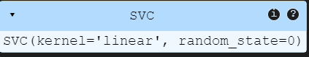
# Predicting a new result
print(classifier.predict(sc.transform([[30,87000]])))
#Output
[0]
# Predicting the Test set results
y_pred = classifier.predict(X_test)
print(np.concatenate((y_pred.reshape(len(y_pred),1), y_test.reshape(len(y_test),1)),1))
#Output
[[0 0]
[0 0]
[0 0]
…
[1 1]
[1 1]]

# Making the Confusion Matrix
from sklearn.metrics import confusion_matrix, accuracy_score
cm = confusion_matrix(y_test, y_pred)
print(cm)
accuracy_score(y_test, y_pred)
#Output
[[66 2]
[ 8 24]]
0.9
# Visualising the Training set results
from matplotlib.colors import ListedColormap
import numpy as np
import matplotlib.pyplot as plt

# Inverse transform X_train to the original scale and assign y_train
X_set, y_set = sc.inverse_transform(X_train), y_train

# Create a mesh grid for decision boundary visualization
X1, X2 = np.meshgrid(
np.arange(start=X_set[:, 0].min() - 10, stop=X_set[:, 0].max() + 10, step=0.25),
np.arange(start=X_set[:, 1].min() - 1000, stop=X_set[:, 1].max() + 1000, step=0.25)
)

# Predict outcomes for each grid point
Z = classifier.predict(sc.transform(np.array([X1.ravel(), X2.ravel()]).T))
Z = Z.reshape(X1.shape)

# Plot the decision boundary
plt.contourf(X1, X2, Z, alpha=0.75, cmap=ListedColormap(['aliceblue', 'brown']))

# Set plot limits
plt.xlim(X1.min(), X1.max())
plt.ylim(X2.min(), X2.max())

# Scatter plot for data points with class-specific colors
for i, j in enumerate(np.unique(y_set)):
plt.scatter(
X_set[y_set == j, 0],
X_set[y_set == j, 1],
c=np.array(ListedColormap(['salmon', 'dodgerblue'])(i)).reshape(1, -1),
label=j
)

# Add title and axis labels
plt.title('SVM (Training set) 22B01A4638')
plt.xlabel('Age')
plt.ylabel('Estimated Salary')
plt.legend()
plt.show()
#Output
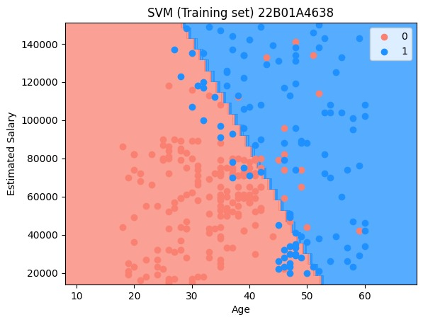

# Visualising the Test set results
from matplotlib.colors import ListedColormap
import numpy as np
import matplotlib.pyplot as plt

# Ensure `X_set` and `y_set` are properly defined
X_set, y_set = sc.inverse_transform(X_test), y_test

# Define grid limits and density
grid_density = 100 # Adjust grid density for efficiency
x_min, x_max = X_set[:, 0].min() - 10, X_set[:, 0].max() + 10
y_min, y_max = X_set[:, 1].min() - 1000, X_set[:, 1].max() + 1000

# Create mesh grid using linspace for efficient memory usage
X1, X2 = np.meshgrid(
np.linspace(x_min, x_max, grid_density),
np.linspace(y_min, y_max, grid_density)
)

# Predict outcomes for each grid point
grid_points = np.c_[X1.ravel(), X2.ravel()]
Z = classifier.predict(sc.transform(grid_points)).reshape(X1.shape)

# Plot decision boundary
plt.contourf(X1, X2, Z, alpha=0.75, cmap=ListedColormap(['silver', 'dodgerblue']))
plt.xlim(x_min, x_max)
plt.ylim(y_min, y_max)
# Scatter plot for data points with class-specific colors
for i, j in enumerate(np.unique(y_set)):
plt.scatter(
X_set[y_set == j, 0],
X_set[y_set == j, 1],
c=ListedColormap(['maroon', 'violet'])(i),
label=j
)

# Add titles and labels
plt.title('SVM (Test set) 22B01A4638')
plt.xlabel('Age')
plt.ylabel('Estimated Salary')
plt.legend()
plt.show()
#Output
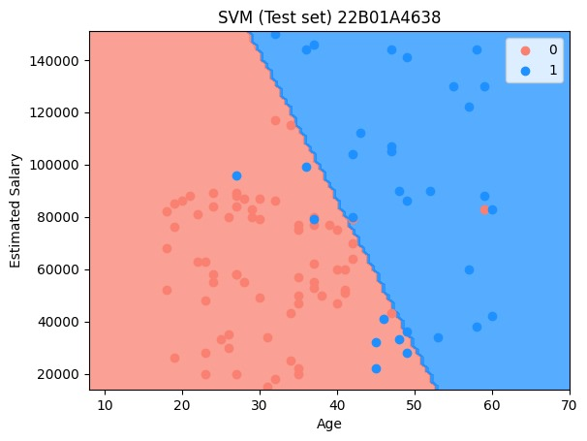

Experiment – 5
Aim : Write a program to implement K – Nearest Neighbor algorithm to classify the given data set. Print both correct and wrong prediction.

K-Nearest Neighbors (KNN)
Description :
K-Nearest Neighbors (KNN) is a supervised learning algorithm used for classification and regression tasks. It is a lazy learning algorithm that makes predictions based on the majority class (for classification) or average value (for regression) of the K nearest data points.
- For classification, KNN assigns a class based on the most common class among its K nearest neighbors.
- For regression, KNN predicts the output by averaging the values of its K nearest neighbors.
Algorithm for KNN:
1. Import Libraries and Load Data
- Import necessary libraries like NumPy, Pandas, Matplotlib, and Scikit-Learn.
- Load and preprocess the dataset (handle missing values, encode categorical variables, and split data).
2. Choose the Value of K
- Select an appropriate K value (number of neighbors).
- A small K (e.g., 1 or 3) → Sensitive to noise, may lead to overfitting.
- A large K (e.g., 10 or 20) → More stable but may underfit the data.
- Common practice: Choose K = sqrt(n) (where n is the number of data points).
3. Calculate the Distance Between Data Points
- Compute the distance between the new data point and all other points using:
  - Euclidean Distance (most commonly used):
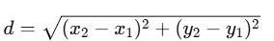
  - Manhattan Distance
  - Minkowski Distance
  - Hamming Distance (for categorical data).
4. Find the K Nearest Neighbors
- Select the K closest points to the new data point based on the calculated distances.

5. Make Predictions
- For classification: Assign the most frequent class among the K neighbors.
- For regression: Compute the average value of the K neighbors.
6. Evaluate the Model
- Use metrics like:
  - Accuracy, Precision, Recall, F1-score (for classification).
  - Mean Squared Error (MSE) or R² score (for regression).
Data Set:
The dataset contains three columns:
- Age: Represents the age of individuals, ranging from 18 to 60 years.
- EstimatedSalary: Represents the estimated salary of individuals, ranging from 15,000 to 150,000.
- Purchased: A binary variable (0 or 1) indicating whether the individual made a purchase (1) or not (0).
The dataset consists of 400 observations, with no missing values.

Social_Network_Ads.csv:
Age | EstimatedSalary | Purchased
19 | 19000 | 0
35 | 20000 | 0
26 | 43000 | 0
27 | 57000 | 0
19 | 76000 | 0
27 | 58000 | 0
27 | 84000 | 0
32 | 150000 | 1
25 | 33000 | 0
35 | 65000 | 0
… | … | ..
… | … | ..
36 | 33000 | 0
49 | 36000 | 1

Code:
# Importing the libraries
import numpy as np
import matplotlib.pyplot as plt
import pandas as pd
# Importing the dataset
dataset = pd.read_csv('Social_Network_Ads.csv')

X = dataset.iloc[:, :-1].values
y = dataset.iloc[:, -1].values
# Splitting the dataset into the Training set and Test set
from sklearn.model_selection import train_test_split
X_train, X_test, y_train, y_test = train_test_split(X, y, test_size = 0.25, random_state = 0)
print(X_train)
#Output
[[ 44 39000]
[ 32 120000]
[ 38 50000]
….
[ 27 54000]
[ 26 118000]]
print(y_train)
#Output
[0 1 0 1 1 1 0 0 0 0 0 0 1 1 1 0 1 0 0 1 0 1 0 1 0 0 1 1 1 1 0 1 0 1 0 0 1
0 0 1 0 0 0 0 0 1 1 1 1 0 0 0 1 0 1 0 1 0 0 1 0 0 0 1 0 0 0 1 1 0 0 1 0 1
1 1 0 0 1 1 0 0 1 1 0 1 0 0 1 1 0 1 1 1 0 0 0 0 0 1 0 0 1 1 1 1 1 0 1 1 0
1 0 0 0 0 0 0 0 1 1 0 0 1 0 0 1 0 0 0 1 0 1 1 0 1 0 0 0 0 1 0 0 0 1 1 0 0
0 0 1 0 1 0 0 0 1 0 0 0 0 1 1 1 0 0 0 0 0 0 1 1 1 1 1 0 1 0 0 0 0 0 1 0 0
0 0 0 0 1 1 0 1 0 1 0 0 1 0 0 0 1 0 0 0 0 0 1 0 0 0 0 0 1 0 1 1 0 0 0 0 0
0 1 1 0 0 0 0 1 0 0 0 0 1 0 1 0 1 0 0 0 1 0 0 0 1 0 1 0 0 0 0 0 1 1 0 0 0
0 0 1 0 1 1 0 0 0 0 0 1 0 1 0 0 1 0 0 1 0 1 0 0 0 0 0 0 1 1 1 1 0 0 0 0 1
0 0 0 0]
print(X_test)
#Output
[[ 30 87000]
[ 38 50000]
[ 35 75000]
...
[ 23 63000]
[ 48 33000]
[ 48 90000]
[ 42 104000]]
print(y_test)
#Output
[0 0 0 0 0 0 0 1 0 0 0 0 0 0 0 0 0 0 1 0 0 1 0 1 0 1 0 0 0 0 0 1 1 0 0 0 0
0 0 1 0 0 0 0 1 0 0 1 0 1 1 0 0 0 1 1 0 0 1 0 0 1 0 1 0 1 0 0 0 0 1 0 0 1
0 0 0 0 1 1 1 0 0 0 1 1 0 1 1 0 0 1 0 0 0 1 0 1 1 1]
# Feature Scaling
from sklearn.preprocessing import StandardScaler
sc = StandardScaler()
X_train = sc.fit_transform(X_train)
X_test = sc.transform(X_test)
print(X_train)
#Output
[[ 0.58164944 -0.88670699]
[-0.60673761 1.46173768]
[-0.01254409 -0.5677824 ]
….
[-1.10189888 -0.45180983]
[-1.20093113 1.40375139]]
print(X_test)
#Output
[[-0.80480212 0.50496393]
[-0.01254409 -0.5677824 ]
[-0.30964085 0.1570462 ]
…
[-1.49802789 -0.19087153]
[ 0.97777845 -1.06066585]
[ 0.97777845 0.59194336]
[ 0.38358493 0.99784738]]
# Training the K-NN model on the Training set
from sklearn.neighbors import KNeighborsClassifier
classifier = KNeighborsClassifier(n_neighbors = 5, metric = 'minkowski', p = 2)
classifier.fit(X_train, y_train)
#Output
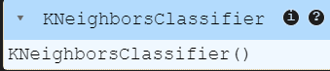
# Predicting a new result
print(classifier.predict(sc.transform([[30,87000]])))
#Output
[0]
# Predicting the Test set results
y_pred = classifier.predict(X_test)
print(np.concatenate((y_pred.reshape(len(y_pred),1), y_test.reshape(len(y_test),1)),1))
#Output
[[0 0]
[0 0]
[0 0]
….
[1 1]
[1 1]
[1 1]]
# Making the Confusion Matrix
from sklearn.metrics import confusion_matrix, accuracy_score
cm = confusion_matrix(y_test, y_pred)
print(cm)
accuracy_score(y_test, y_pred)
#Output
[[64 4]
[ 3 29]]
0.93
# Visualising the Training set results
from matplotlib.colors import ListedColormap
import numpy as np
import matplotlib.pyplot as plt

# Ensure `X_set` and `y_set` are properly defined
X_set, y_set = sc.inverse_transform(X_train), y_train

# Create a mesh grid for the plot
X1, X2 = np.meshgrid(
np.arange(start=X_set[:, 0].min() - 10, stop=X_set[:, 0].max() + 10, step=1), # Adjusted step size for better resolution
np.arange(start=X_set[:, 1].min() - 1000, stop=X_set[:, 1].max() + 1000, step=1)
)

# Predict over the grid and reshape to fit X1 and X2
Z = classifier.predict(sc.transform(np.array([X1.ravel(), X2.ravel()]).T))
Z = Z.reshape(X1.shape)

# Plot the decision boundary
plt.contourf(X1, X2, Z, alpha=0.75, cmap=ListedColormap(['rosybrown', 'dodgerblue']))
plt.xlim(X1.min(), X1.max())
plt.ylim(X2.min(), X2.max())

# Plot data points with distinct colors for each class
for i, j in enumerate(np.unique(y_set)):
plt.scatter(
X_set[y_set == j, 0],
X_set[y_set == j, 1],
c=np.array(ListedColormap(['salmon', 'violet'])(i)).reshape(1, -1), # Ensure color mapping is correct
label=j
)

# Add titles and labels
plt.title('K-NN Classification (Training set) 22B01A4638')
plt.xlabel('Age')
plt.ylabel('Estimated Salary')
plt.legend()
plt.show()
#Output
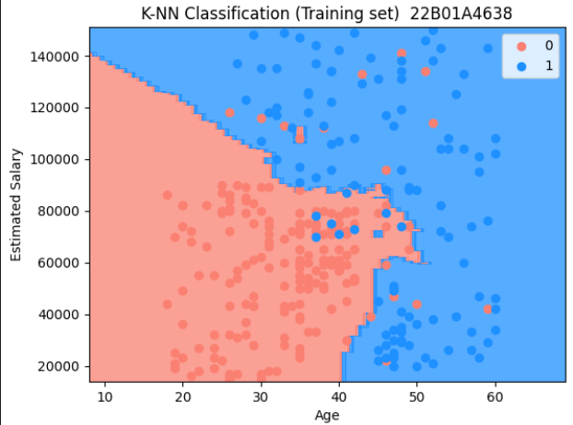

# Visualising the Test set results
from matplotlib.colors import ListedColormap
import numpy as np
import matplotlib.pyplot as plt

# Ensure `X_set` and `y_set` are properly defined
X_set, y_set = sc.inverse_transform(X_test), y_test

# Create a mesh grid for the plot
X1, X2 = np.meshgrid(
np.arange(start=X_set[:, 0].min() - 10, stop=X_set[:, 0].max() + 10, step=1), # Adjusted step size for better resolution
np.arange(start=X_set[:, 1].min() - 1000, stop=X_set[:, 1].max() + 1000, step=1)
)

# Predict over the grid and reshape to fit X1 and X2
Z = classifier.predict(sc.transform(np.array([X1.ravel(), X2.ravel()]).T))
Z = Z.reshape(X1.shape)

# Plot the decision boundary
plt.contourf(X1, X2, Z, alpha=0.75, cmap=ListedColormap(['pink', 'dodgerblue']))
plt.xlim(X1.min(), X1.max())
plt.ylim(X2.min(), X2.max())

# Plot data points with distinct colors for each class
for i, j in enumerate(np.unique(y_set)):
plt.scatter(
X_set[y_set == j, 0],
X_set[y_set == j, 1],
c=np.array(ListedColormap(['coral', 'aquamarine'])(i)).reshape(1, -1), # Ensure color mapping is correct
label=j
)

# Add titles and labels
plt.title('K-NN Classification(Test set) 22B01A4638')
plt.xlabel('Age')
plt.ylabel('Estimated Salary')
plt.legend()
plt.show()
#Output
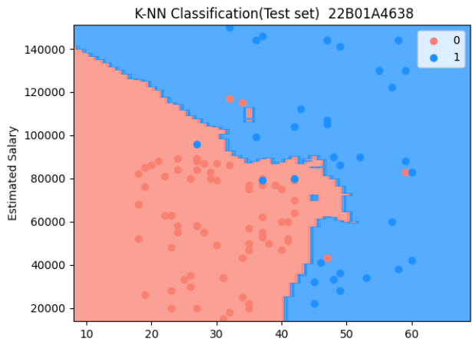

Experiment – 6
Aim: Write a program to implement the Naïve Bayesian classifier for a sample training data set stored as a .csv file. Compute the accuracy of the classifier ,considering few test data sets.
Naïve Bayes
Description:
Naïve Bayes is a probabilistic classification algorithm based on Bayes’ Theorem. It assumes that all features are independent (hence "naïve") and calculates the probability of a class given the input features.
It is widely used for text classification (spam detection, sentiment analysis), medical diagnosis, and recommendation systems.
Algorithm for Naïve Bayes
1. Import Libraries and Load Data
- Import necessary libraries like NumPy, Pandas, and Scikit-Learn.
- Load and preprocess the dataset (handle missing values, encode categorical variables, and split data).
2. Apply Bayes' Theorem
Bayes' Theorem calculates the probability of a class C given the features X:
P(C∣X)=P(X∣C)⋅P(C)P(X)P(C|X) = \frac{P(X|C) \cdot P(C)}{P(X)}
Where:
- P(C|X) → Posterior probability (probability of class C given feature X).
- P(X|C) → Likelihood (probability of feature X given class C).
- P(C) → Prior probability (probability of class C occurring).
- P(X) → Evidence (probability of feature X occurring).
3. Compute Class Probabilities
- Calculate P(C) (prior probability of each class).
- Calculate P(X|C) (probability of each feature given the class).
- Assume feature independence and compute the combined probability.
4. Classify New Data Points
- For a new input X, compute P(C|X) for each class C.
- Assign the class with the highest probability as the prediction.
5. Evaluate the Model
- Use metrics like:
  - Accuracy, Precision, Recall, F1-score (for classification).

Data Set:
The dataset contains three columns:
- Age: Represents the age of individuals, ranging from 18 to 60 years.
- EstimatedSalary: Represents the estimated salary of individuals, ranging from 15,000 to 150,000.
- Purchased: A binary variable (0 or 1) indicating whether the individual made a purchase (1) or not (0).
The dataset consists of 400 observations, with no missing values.
Social_Network_Ads.csv:
Age | EstimatedSalary | Purchased
19 | 19000 | 0
35 | 20000 | 0
26 | 43000 | 0
27 | 57000 | 0
19 | 76000 | 0
27 | 58000 | 0
27 | 84000 | 0
32 | 150000 | 1
25 | 33000 | 0
35 | 65000 | 0
. | . | .
. | . | .
36 | 33000 | 0
49 | 36000 | 1

Code:
# Importing the libraries
import numpy as np
import matplotlib.pyplot as plt
import pandas as pd
# Importing the dataset
dataset = pd.read_csv('Social_Network_Ads.csv')

X = dataset.iloc[:, :-1].values
y = dataset.iloc[:, -1].values
# Splitting the dataset into the Training set and Test set
from sklearn.model_selection import train_test_split
X_train, X_test, y_train, y_test = train_test_split(X, y, test_size = 0.25, random_state = 0)
print(X_train)
#Output
[[ 44 39000]
[ 32 120000]
[ 38 50000]
….
[ 27 54000]
[ 26 118000]]
print(y_train)
#Output
[0 1 0 1 1 1 0 0 0 0 0 0 1 1 1 0 1 0 0 1 0 1 0 1 0 0 1 1 1 1 0 1 0 1 0 0 1
0 0 1 0 0 0 0 0 1 1 1 1 0 0 0 1 0 1 0 1 0 0 1 0 0 0 1 0 0 0 1 1 0 0 1 0 1
1 1 0 0 1 1 0 0 1 1 0 1 0 0 1 1 0 1 1 1 0 0 0 0 0 1 0 0 1 1 1 1 1 0 1 1 0
1 0 0 0 0 0 0 0 1 1 0 0 1 0 0 1 0 0 0 1 0 1 1 0 1 0 0 0 0 1 0 0 0 1 1 0 0
0 0 1 0 1 0 0 0 1 0 0 0 0 1 1 1 0 0 0 0 0 0 1 1 1 1 1 0 1 0 0 0 0 0 1 0 0
0 0 0 0 1 1 0 1 0 1 0 0 1 0 0 0 1 0 0 0 0 0 1 0 0 0 0 0 1 0 1 1 0 0 0 0 0
0 1 1 0 0 0 0 1 0 0 0 0 1 0 1 0 1 0 0 0 1 0 0 0 1 0 1 0 0 0 0 0 1 1 0 0 0
0 0 1 0 1 1 0 0 0 0 0 1 0 1 0 0 1 0 0 1 0 1 0 0 0 0 0 0 1 1 1 1 0 0 0 0 1
0 0 0 0]
print(X_test)
#Output
[[ 30 87000]
[ 38 50000]
[ 35 75000]
...
[ 23 63000]
[ 48 33000]
[ 48 90000]
[ 42 104000]]
print(y_test)
#Output
[0 0 0 0 0 0 0 1 0 0 0 0 0 0 0 0 0 0 1 0 0 1 0 1 0 1 0 0 0 0 0 1 1 0 0 0 0
0 0 1 0 0 0 0 1 0 0 1 0 1 1 0 0 0 1 1 0 0 1 0 0 1 0 1 0 1 0 0 0 0 1 0 0 1
0 0 0 0 1 1 1 0 0 0 1 1 0 1 1 0 0 1 0 0 0 1 0 1 1 1]
# Feature Scaling
from sklearn.preprocessing import StandardScaler
sc = StandardScaler()
X_train = sc.fit_transform(X_train)
X_test = sc.transform(X_test)
print(X_train)
#Output
[[ 0.58164944 -0.88670699]
[-0.60673761 1.46173768]
[-0.01254409 -0.5677824 ]
….
[-1.10189888 -0.45180983]
[-1.20093113 1.40375139]]
print(X_test)
#Output
[[-0.80480212 0.50496393]
[-0.01254409 -0.5677824 ]
[-0.30964085 0.1570462 ]
…
[-1.49802789 -0.19087153]
[ 0.97777845 -1.06066585]
[ 0.97777845 0.59194336]
[ 0.38358493 0.99784738]]

# Training the Naive Bayes model on the Training set
from sklearn.naive_bayes import GaussianNB
classifier = GaussianNB()
classifier.fit(X_train, y_train)
#Output
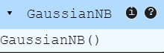
# Predicting a new result
print(classifier.predict(sc.transform([[30,87000]])))
#Output
[0]
# Predicting the Test set results
y_pred = classifier.predict(X_test)
print(np.concatenate((y_pred.reshape(len(y_pred),1), y_test.reshape(len(y_test),1)),1))
#Output
[[0 0]
[0 0]
[0 0]
...
[0 0]
[1 1]
[1 1]
[1 1]]
# Making the Confusion Matrix
from sklearn.metrics import confusion_matrix, accuracy_score
cm = confusion_matrix(y_test, y_pred)
print(cm)
accuracy_score(y_test, y_pred)
[[65 3]
[ 7 25]]
0.9
# Visualising the Training set results
from matplotlib.colors import ListedColormap
import numpy as np
import matplotlib.pyplot as plt

# Ensure `X_set` and `y_set` are properly defined
X_set, y_set = sc.inverse_transform(X_train), y_train

# Create a mesh grid for the plot
X1, X2 = np.meshgrid(
np.arange(start=X_set[:, 0].min() - 10, stop=X_set[:, 0].max() + 10, step=0.25), # Fine grid for smoother boundary
np.arange(start=X_set[:, 1].min() - 1000, stop=X_set[:, 1].max() + 1000, step=0.25)
)

# Predict over the grid and reshape to fit X1 and X2
Z = classifier.predict(sc.transform(np.array([X1.ravel(), X2.ravel()]).T))
Z = Z.reshape(X1.shape)

# Plot the decision boundary
plt.contourf(X1, X2, Z, alpha=0.75, cmap=ListedColormap(['fuchsia', 'gainsboro']))
plt.xlim(X1.min(), X1.max())
plt.ylim(X2.min(), X2.max())

# Plot data points with distinct colors for each class
for i, j in enumerate(np.unique(y_set)):
plt.scatter(
X_set[y_set == j, 0],
X_set[y_set == j, 1],
c=np.array(ListedColormap(['forestgreen', 'lime'])(i)).reshape(1, -1), # Ensure color mapping is correct
label=j
)

# Add titles and labels
plt.title('Naive Bayes Classification (Training set) 22B01A4638')
plt.xlabel('Age')
plt.ylabel('Estimated Salary')
plt.legend()
plt.show()
#Output
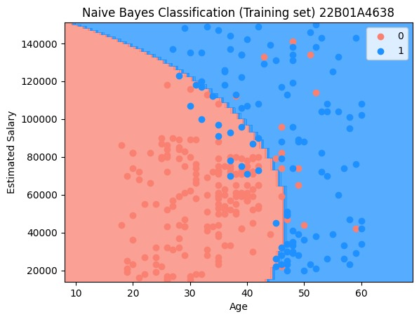

# Visualising the Test set results
from matplotlib.colors import ListedColormap
import numpy as np
import matplotlib.pyplot as plt

# Ensure `X_set` and `y_set` are properly defined
X_set, y_set = sc.inverse_transform(X_test), y_test

# Create a mesh grid for the plot
X1, X2 = np.meshgrid(
np.arange(start=X_set[:, 0].min() - 10, stop=X_set[:, 0].max() + 10, step=0.25), # Fine grid resolution
np.arange(start=X_set[:, 1].min() - 1000, stop=X_set[:, 1].max() + 1000, step=0.25)
)

# Predict over the grid and reshape to fit X1 and X2
Z = classifier.predict(sc.transform(np.array([X1.ravel(), X2.ravel()]).T))
Z = Z.reshape(X1.shape)

# Plot the decision boundary
plt.contourf(X1, X2, Z, alpha=0.75, cmap=ListedColormap(['lime', 'dodgerblue']))
plt.xlim(X1.min(), X1.max())
plt.ylim(X2.min(), X2.max())

# Plot data points with distinct colors for each class
for i, j in enumerate(np.unique(y_set)):
plt.scatter(
X_set[y_set == j, 0],
X_set[y_set == j, 1],
c=np.array(ListedColormap(['salmon', 'grey'])(i)).reshape(1, -1), # Ensure color mapping is correct
label=j
)

# Add titles and labels
plt.title('Naive Bayes Classification (Test set) 22B01A4638')
plt.xlabel('Age')
plt.ylabel('Estimated Salary')
plt.legend()
plt.show()
#Output
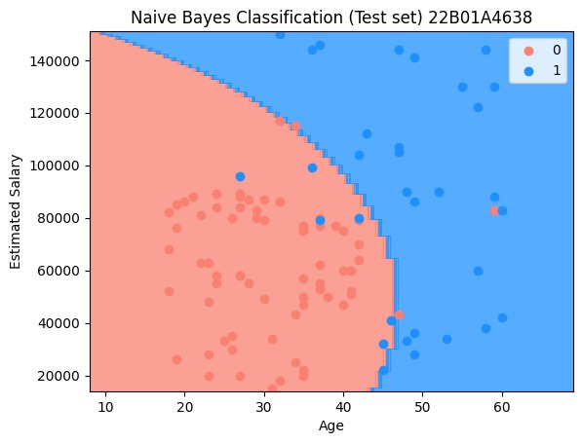

Experiment -7
Aim: Write an application to apply K – Means Algorithm to cluster a set of data stored in a .csv file.
K-Means Clustering
Description:
K-Means is an unsupervised learning algorithm used for clustering. It groups similar data points into K clusters by minimizing the variance within each cluster. The number of clusters (K) is predefined by the user.
It is widely used in customer segmentation, image compression, anomaly detection, and recommendation systems.

Algorithm for K-Means
1. Import Libraries and Load Data
- Import necessary libraries like NumPy, Pandas, Matplotlib, and Scikit-Learn.
- Load and preprocess the dataset (handle missing values, normalize data, and remove outliers).
2. Choose the Number of Clusters (K)
- K is predefined but can be optimized using:
  - Elbow Method (plot within-cluster variance vs. K and find the "elbow" point).
  - Silhouette Score (measures how similar points are within their cluster).
3. Initialize Cluster Centroids
- Select K random points as initial cluster centers (centroids).
- Can use K-Means++ for better initialization.
4. Assign Data Points to Nearest Centroid
- Calculate the Euclidean distance between each data point and all centroids.
- Assign each data point to the closest centroid.
5. Recalculate Cluster Centroids
- Compute the mean of all points in each cluster.
- Update the centroid locations.
6. Repeat Until Convergence
- Repeat steps 4 and 5 until centroids no longer change or a maximum number of iterations is reached.
7. Evaluate the Model
- Use metrics like:
  - Inertia (Within-Cluster Sum of Squares - WCSS) (lower is better).
  - Silhouette Score (higher is better).
Data Set:
The dataset contains five columns:
- CustomerID: A unique identifier assigned to each customer.
- Genre: Represents the gender of the customer (Male/Female).
- Age: Represents the age of customers, ranging from 18 to 70 years.
- Annual Income (k$): Represents the annual income of customers, ranging from 15,000 to 137,000 (in thousands).
- Spending Score (1-100): A score assigned to customers based on their spending behavior and purchasing patterns.
The dataset consists of 200 observations, with no missing values.
Mall_Customers.csv
CustomerID | Genre | Age | Annual Income (k$) | Spending Score (1-100)
1 | Male | 19 | 15 | 39
2 | Male | 21 | 15 | 81
3 | Female | 20 | 16 | 6
4 | Female | 23 | 16 | 77
5 | Female | 31 | 17 | 40
6 | Female | 22 | 17 | 76
7 | Female | 35 | 18 | 6
8 | Female | 23 | 18 | 94
9 | Male | 64 | 19 | 3
10 | Female | 30 | 19 | 72
11 | Male | 67 | 19 | 14
12 | Female | 35 | 19 | 99
13 | Female | 58 | 20 | 15
…… | …… | …… | ….. | ……
195 | Female | 47 | 120 | 16
196 | Female | 35 | 120 | 79
197 | Female | 45 | 126 | 28
198 | Male | 32 | 126 | 74
199 | Male | 32 | 137 | 18
200 | Male | 30 | 137 | 83

Code:
# Importing the libraries
import numpy as np
import matplotlib.pyplot as plt
import pandas as pd

# Importing the dataset
dataset = pd.read_csv('Mall_Customers.csv')
X = dataset.iloc[:, [3, 4]].values

# Using the elbow method to find the optimal number of clusters
from sklearn.cluster import KMeans
wcss = []
for i in range(1, 11):
kmeans = KMeans(n_clusters = i, init = 'k-means++', random_state = 42)
kmeans.fit(X)
wcss.append(kmeans.inertia_)
plt.plot(range(1, 11), wcss)
plt.title('The Elbow Method 22B01A4638')
plt.xlabel('Number of clusters')
plt.ylabel('WCSS')
plt.show()

#Output
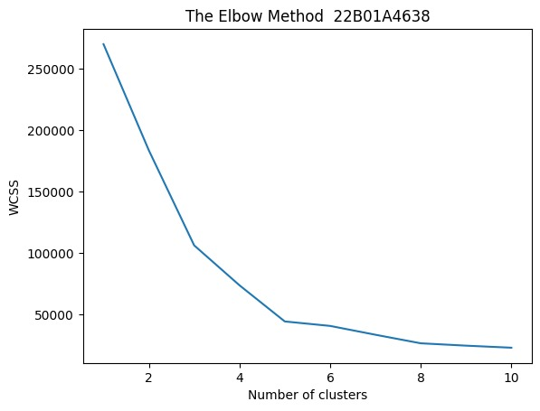
# Training the K-Means model on the dataset
kmeans = KMeans(n_clusters = 5, init = 'k-means++', random_state = 42)
y_kmeans = kmeans.fit_predict(X)
# Visualising the clusters
plt.scatter(X[y_kmeans == 0, 0], X[y_kmeans == 0, 1], s = 100, c = 'pink', label = 'Cluster 1')
plt.scatter(X[y_kmeans == 1, 0], X[y_kmeans == 1, 1], s = 100, c = 'blue', label = 'Cluster 2')
plt.scatter(X[y_kmeans == 2, 0], X[y_kmeans == 2, 1], s = 100, c = 'green', label = 'Cluster 3')
plt.scatter(X[y_kmeans == 3, 0], X[y_kmeans == 3, 1], s = 100, c = 'cyan', label = 'Cluster 4')
plt.scatter(X[y_kmeans == 4, 0], X[y_kmeans == 4, 1], s = 100, c = 'magenta', label = 'Cluster 5')
plt.scatter(kmeans.cluster_centers_[:, 0], kmeans.cluster_centers_[:, 1], s = 300, c = 'yellow', label = 'Centroids')
plt.title('Clusters of customers 22B01A4638')
plt.xlabel('Annual Income (k$)')
plt.ylabel('Spending Score (1-100)')
plt.legend()
plt.show()
#Output
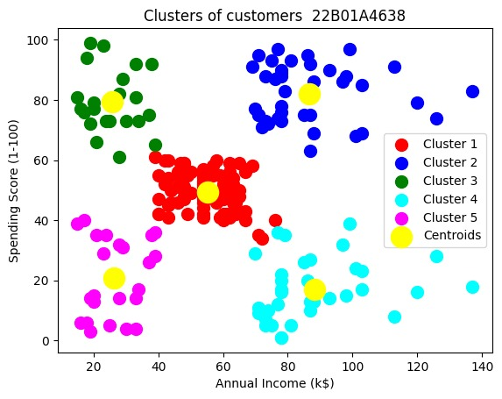

Beyond Syllabus
Experiment -8
Multiple Regression
Description
A Multiple Regression Model is an extension of simple linear regression that predicts a dependent variable (Y) based on multiple independent variables (_{X1,X2,X3,…,Xn)}. It is commonly used in statistical modeling and machine learning for understanding relationships between variables and making predictions.
Mathematical Representation
The general form of a multiple regression model is:
where:
- Y = Dependent (target) variable
- _{X1,X2,X3,…, Xn} = Independent (predictor) variables
- _{β0}= Intercept (constant term)
- _{β1,β2,…,βn} = Regression coefficients (indicating the impact of each independent variable on Y
- ϵ = Error term (captures variability not explained by the predictors)
Data Set:
The dataset contains five columns:
- R&D Spend: Represents the amount spent on research and development.
- Administration: Represents the amount spent on administrative expenses.
- Marketing Spend: Represents the amount spent on marketing activities.
- State: Categorical variable indicating the state where the startup operates.
- Profit: Represents the profit earned by the startup.
The dataset consists of 50 observations, with no missing values.

50_Startups.csv
R&D Spend | Administration | Marketing Spend | State | Profit
165349.2 | 136897.8 | 471784.1 | New York | 192261.8
162597.7 | 151377.6 | 443898.5 | California | 191792.1
153441.51 | 101145.6 | 407934.5 | Florida | 191050.4
144372.41 | 118671.9 | 383199.6 | New York | 182902
142107.34 | 91391.77 | 366168.4 | Florida | 166187.9
131876.9 | 99814.71 | 362861.4 | New York | 156991.1
134615.46 | 147198.9 | 127716.8 | California | 156122.5
130298.13 | 145530.1 | 323876.7 | Florida | 155752.6
120542.52 | 148719 | 311613.3 | New York | 152211.8
… | … | ... | … | ...
… | ... | … | ... | …
1315.46 | 115816.2 | 297114.5 | Florida | 49490.75
0 | 135426.9 | 0 | California | 42559.73
542.05 | 51743.15 | 0 | New York | 35673.41
0 | 116983.8 | 45173.06 | California | 14681.4

Code:
# Importing the libraries
import numpy as np
import matplotlib.pyplot as plt
import pandas as pd
# Importing the dataset
ataset = pd.read_csv('50_Startups.csv')

X = dataset.iloc[:, :-1].values
y = dataset.iloc[:, -1].values
print(X)
#Output
[[165349.2 136897.8 471784.1 'New York']
[162597.7 151377.59 443898.53 'California']
[153441.51 101145.55 407934.54 'Florida']
[144372.41 118671.85 383199.62 'New York']
…..
[1315.46 115816.21 297114.46 'Florida']
[0.0 135426.92 0.0 'California']
[542.05 51743.15 0.0 'New York']
[0.0 116983.8 45173.06 'California']]
# Encoding categorical data
from sklearn.compose import ColumnTransformer
from sklearn.preprocessing import OneHotEncoder
ct = ColumnTransformer(transformers=[('encoder', OneHotEncoder(), [3])], remainder='passthrough')
X = np.array(ct.fit_transform(X))
print(X)
#output
[[0.0 0.0 1.0 165349.2 136897.8 471784.1]
[1.0 0.0 0.0 162597.7 151377.59 443898.53]
[0.0 1.0 0.0 153441.51 101145.55 407934.54]
….
[0.0 1.0 0.0 1315.46 115816.21 297114.46]
[1.0 0.0 0.0 0.0 135426.92 0.0]
[0.0 0.0 1.0 542.05 51743.15 0.0]
[1.0 0.0 0.0 0.0 116983.8 45173.06]]
# Splitting the dataset into the Training set and Test set
from sklearn.model_selection import train_test_split
X_train, X_test, y_train, y_test = train_test_split(X, y, test_size = 0.2, random_state = 0)
# Training the Multiple Linear Regression model on the Training set
from sklearn.linear_model import LinearRegression
regressor = LinearRegression()
regressor.fit(X_train, y_train)
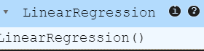
# Predicting the Test set results
y_pred = regressor.predict(X_test)
np.set_printoptions(precision=2)
print(np.concatenate((y_pred.reshape(len(y_pred),1), y_test.reshape(len(y_test),1)),1))
#Output
[[103015.2 103282.38]
[132582.28 144259.4 ]
[132447.74 146121.95]
[ 71976.1 77798.83]
[178537.48 191050.39]
[116161.24 105008.31]
[ 67851.69 81229.06]
[ 98791.73 97483.56]
[113969.44 110352.25]
[167921.07 166187.94]]

Experiment – 9
Polynomial Regression
Description
Polynomial Regression is an extension of linear regression that models the relationship between the dependent variable (Y) and independent variable (X) as an n-degree polynomial. It is useful when data exhibits a nonlinear relationship.
Mathematical Representation
The polynomial regression equation of degree n is:
where:
- Y= Dependent (target) variable
- X= Independent (predictor) variable
- _{β0 , β1, β2 , . . . ,βn} = Coefficients
- ϵ = Error term
Data set:
The dataset contains three columns:
- Position: Represents the job title in a company hierarchy.
- Level: Represents the hierarchical level of the position as an integer.
- Salary: Represents the corresponding salary for each position.
The dataset consists of 10 observations, with no missing values
Position_Salaries.csv
Position | Level | Salary
Business Analyst | 1 | 45000
Junior Consultant | 2 | 50000
Senior Consultant | 3 | 60000
Manager | 4 | 80000
Country Manager | 5 | 110000
Region Manager | 6 | 150000
Partner | 7 | 200000
Senior Partner | 8 | 300000
C-level | 9 | 500000
CEO | 10 | 1000000

Code:
# Importing the libraries
import numpy as np
import matplotlib.pyplot as plt
import pandas as pd

# Importing the dataset
dataset = pd.read_csv('Position_Salaries.csv')
X = dataset.iloc[:, 1:-1].values
y = dataset.iloc[:, -1].values

# Training the Linear Regression model on the whole dataset
from sklearn.linear_model import LinearRegression
lin_reg = LinearRegression()
lin_reg.fit(X, y)

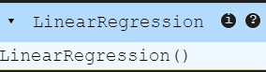

# Training the Polynomial Regression model on the whole dataset
from sklearn.preprocessing import PolynomialFeatures
poly_reg = PolynomialFeatures(degree = 4)
X_poly = poly_reg.fit_transform(X)
lin_reg_2 = LinearRegression()
lin_reg_2.fit(X_poly, y)

# Visualising the Linear Regression results
lt.scatter(X, y, color = 'red')
plt.plot(X, lin_reg.predict(X), color = 'purple')
plt.title('Truth or Bluff (Linear Regression)')
plt.xlabel('Position Level')
plt.ylabel('Salary')
plt.show()

#Output
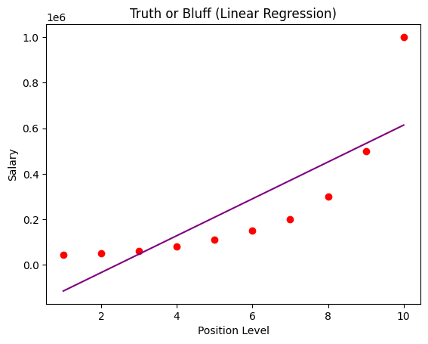

# Visualising the Polynomial Regression results
plt.scatter(X, y, color = 'red')
plt.plot(X, lin_reg_2.predict(poly_reg.fit_transform(X)), color = 'blue')
plt.title('Truth or Bluff (Polynomial Regression)')
plt.xlabel('Position level')
plt.ylabel('Salary')
plt.show()
#Output

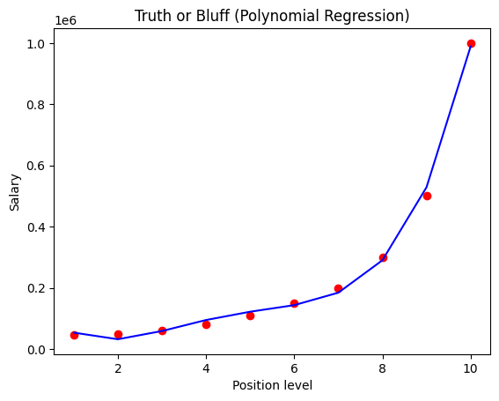
# Visualising the Polynomial Regression results (for higher resolution and smoother curve)
X_grid = np.arange(min(X), max(X), 0.1)
X_grid = X_grid.reshape((len(X_grid), 1))
plt.scatter(X, y, color = 'red')
plt.plot(X_grid, lin_reg_2.predict(poly_reg.fit_transform(X_grid)), color = 'blue')
plt.title('Truth or Bluff (Polynomial Regression)')
plt.xlabel('Position level')
plt.ylabel('Salary')
plt.show()
#Ouput
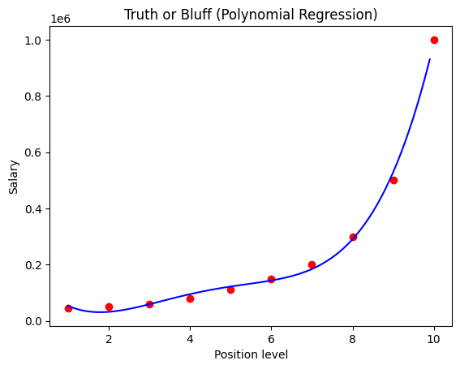

# Predicting a new result with Linear Regression
lin_reg.predict([[6.5]])
#Output
array([330378.78787879])
# Predicting a new result with Polynomial Regression
lin_reg_2.predict(poly_reg.fit_transform([[6.5]]))
#Output
array([158862.4526515])
Experiment – 10
Support Vector Regression (SVR)
Description:
Support Vector Regression (SVR) is a regression algorithm based on Support Vector Machines (SVMs). It aims to find a function that best fits the data while maintaining a margin of tolerance (ϵ\epsilon) around the predicted values.
Mathematical Representation
SVR attempts to minimize the following function:
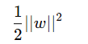
subject to:
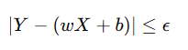
where:
- Y= Actual target variable
- X = Feature set (independent variables)
- w ,b = Model parameters (weights and bias)
- ϵ = Tolerance margin (defines how much error is acceptable)
Data set:
The dataset contains three columns:
- Position: Represents the job title in a company hierarchy.
- Level: Represents the hierarchical level of the position as an integer.
- Salary: Represents the corresponding salary for each position.
The dataset consists of 10 observations, with no missing values
Position_Salaries.csv
Position | Level | Salary
Business Analyst | 1 | 45000
Junior Consultant | 2 | 50000
Senior Consultant | 3 | 60000
Manager | 4 | 80000
Country Manager | 5 | 110000
Region Manager | 6 | 150000
Partner | 7 | 200000
Senior Partner | 8 | 300000
C-level | 9 | 500000
CEO | 10 | 1000000
Code
# Importing the libraries
import numpy as np
import matplotlib.pyplot as plt
import pandas as pd
# Importing the dataset
dataset = pd.read_csv('Position_Salaries.csv')

X = dataset.iloc[:, 1:-1].values
y = dataset.iloc[:, -1].values
print(X)
#Output [[ 1]
[ 2]
[ 3]
[ 4]
[ 5]
[ 6]
[ 7]
[ 8]
[ 9]
[10]]

print(y)
#Output
[ 45000 50000 60000 80000 110000 150000 200000 300000 500000
1000000]
y = y.reshape(len(y),1)
print(y)
[[ 45000]
[ 50000]
[ 60000]
[ 80000]
[ 110000]
[ 150000]
[ 200000]
[ 300000]
[ 500000]
[1000000]]
# Feature Scaling
from sklearn.preprocessing import StandardScaler
sc_X = StandardScaler()
sc_y = StandardScaler()
X = sc_X.fit_transform(X)
y = sc_y.fit_transform(y)
print(X)
[[-1.5666989 ]
[-1.21854359]
[-0.87038828]
[-0.52223297]
[-0.17407766]
[ 0.17407766]
[ 0.52223297]
[ 0.87038828]
[ 1.21854359]
[ 1.5666989 ]]
print(y)
[[-0.72004253]
[-0.70243757]
[-0.66722767]
[-0.59680786]
[-0.49117815]
[-0.35033854]
[-0.17428902]
[ 0.17781001]
[ 0.88200808]
[ 2.64250325]]
# Training the SVR model on the whole dataset
from sklearn.svm import SVR
regressor = SVR(kernel = 'rbf')
regressor.fit(X, y)
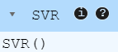
## Predicting a new result
sc_y.inverse_transform(regressor.predict(sc_X.transform([[6.5]])).reshape(-1,1))
#Output
array([[170370.0204065]])
# Visualising the SVR results
plt.scatter(sc_X.inverse_transform(X), sc_y.inverse_transform(y), color = 'red')
plt.plot(sc_X.inverse_transform(X), sc_y.inverse_transform(regressor.predict(X).reshape(-1,1)), color = 'blue')
plt.title('Truth or Bluff (SVR)')
plt.xlabel('Position level')
plt.ylabel('Salary')
plt.show()
#Ouput
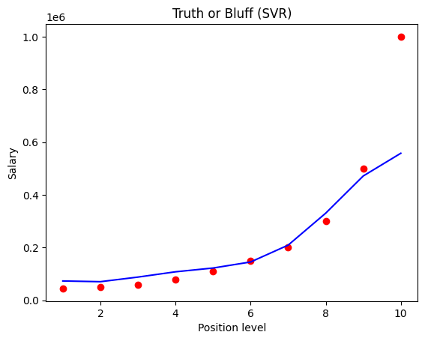
# Visualising the SVR results (for higher resolution and smoother curve)
X_grid = np.arange(min(sc_X.inverse_transform(X)), max(sc_X.inverse_transform(X)), 0.1)
X_grid = X_grid.reshape((len(X_grid), 1))
plt.scatter(sc_X.inverse_transform(X), sc_y.inverse_transform(y), color = 'red')
plt.plot(X_grid, sc_y.inverse_transform(regressor.predict(sc_X.transform(X_grid)).reshape(-1,1)), color = 'blue')
plt.title('Truth or Bluff (SVR)')
plt.xlabel('Position level')
plt.ylabel('Salary')
plt.show()

#Output

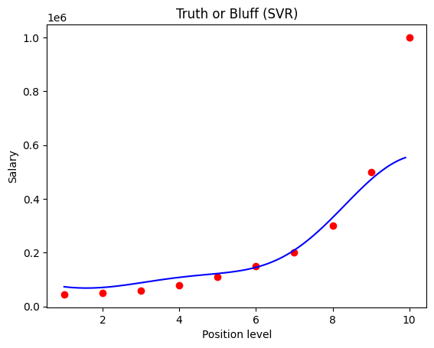
Experiment- 11
Kernel SVM
Description:
Kernel SVM (Support Vector Machine) is an advanced form of SVM that uses kernel functions to transform non-linearly separable data into a higher-dimensional space where it becomes linearly separable. This helps in handling complex classification problems.
Mathematical Representation
The decision function for Kernel SVM is:
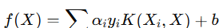
where:
- X = Input features
- _{yi =} Class labels (+1 or -1)
- _{αi} = Lagrange multipliers
- K (X_{i} , X) = Kernel function (transforms data into higher-dimensional space)
- b = Bias term
Data Set:
The dataset contains three columns:
- Age: Represents the age of individuals, ranging from 18 to 60 years.
- EstimatedSalary: Represents the estimated salary of individuals, ranging from 15,000 to 150,000.
- Purchased: A binary variable (0 or 1) indicating whether the individual made a purchase (1) or not (0).
The dataset consists of 400 observations, with no missing values.
Social_Network_Ads.csv:
Age | EstimatedSalary | Purchased
19 | 19000 | 0
35 | 20000 | 0
26 | 43000 | 0
27 | 57000 | 0
19 | 76000 | 0
27 | 58000 | 0
27 | 84000 | 0
32 | 150000 | 1
25 | 33000 | 0
35 | 65000 | 0
… | … | …
… | ... | ...
36 | 33000 | 0
49 | 36000 | 1

Code
# Importing the libraries
import numpy as np
import matplotlib.pyplot as plt
import pandas as pd
# Importing the dataset
dataset = pd.read_csv('Social_Network_Ads.csv')
X = dataset.iloc[:, :-1].values
y = dataset.iloc[:, -1].values
# Splitting the dataset into the Training set and Test set
from sklearn.model_selection import train_test_split
X_train, X_test, y_train, y_test = train_test_split(X, y, test_size = 0.25, random_state = 0)
print(X_train)
#Output
[[ 44 39000]
[ 32 120000]
[ 38 50000]
…
[ 29 43000]
[ 36 52000]
[ 27 54000]
[ 26 118000]]

print(y_train)
#Ouput
[0 1 0 1 1 1 0 0 0 0 0 0 1 1 1 0 1 0 0 1 0 1 0 1 0 0 1 1 1 1 0 1 0 1 0 0 1
0 0 1 0 0 0 0 0 1 1 1 1 0 0 0 1 0 1 0 1 0 0 1 0 0 0 1 0 0 0 1 1 0 0 1 0 1
1 1 0 0 1 1 0 0 1 1 0 1 0 0 1 1 0 1 1 1 0 0 0 0 0 1 0 0 1 1 1 1 1 0 1 1 0
1 0 0 0 0 0 0 0 1 1 0 0 1 0 0 1 0 0 0 1 0 1 1 0 1 0 0 0 0 1 0 0 0 1 1 0 0
0 0 1 0 1 0 0 0 1 0 0 0 0 1 1 1 0 0 0 0 0 0 1 1 1 1 1 0 1 0 0 0 0 0 1 0 0
0 0 0 0 1 1 0 1 0 1 0 0 1 0 0 0 1 0 0 0 0 0 1 0 0 0 0 0 1 0 1 1 0 0 0 0 0
0 1 1 0 0 0 0 1 0 0 0 0 1 0 1 0 1 0 0 0 1 0 0 0 1 0 1 0 0 0 0 0 1 1 0 0 0
0 0 1 0 1 1 0 0 0 0 0 1 0 1 0 0 1 0 0 1 0 1 0 0 0 0 0 0 1 1 1 1 0 0 0 0 1
0 0 0 0]
print(X_test)
#Ouput
[[ 30 87000]
[ 38 50000]
[ 35 75000]
[ 30 79000]
…
[ 23 63000]
[ 48 33000]
[ 48 90000]
[ 42 104000]]
print(y_test)
#Output
[0 0 0 0 0 0 0 1 0 0 0 0 0 0 0 0 0 0 1 0 0 1 0 1 0 1 0 0 0 0 0 1 1 0 0 0 0
0 0 1 0 0 0 0 1 0 0 1 0 1 1 0 0 0 1 1 0 0 1 0 0 1 0 1 0 1 0 0 0 0 1 0 0 1
0 0 0 0 1 1 1 0 0 0 1 1 0 1 1 0 0 1 0 0 0 1 0 1 1 1]
# Feature Scaling
from sklearn.preprocessing import StandardScaler
sc = StandardScaler()
X_train = sc.fit_transform(X_train)
X_test = sc.transform(X_test)
print(X_train)
#Output
[[ 0.58164944 -0.88670699]
[-0.60673761 1.46173768]
[-0.01254409 -0.5677824 ]
[-0.60673761 1.89663484]
…
[-0.90383437 -0.77073441]
[-0.21060859 -0.50979612]
[-1.10189888 -0.45180983]
[-1.20093113 1.40375139]]
print(X_test)
#Output
[[-0.80480212 0.50496393]
[-0.01254409 -0.5677824 ]
[-0.30964085 0.1570462 ]
…
[-1.49802789 -0.19087153]
[ 0.97777845 -1.06066585]
[ 0.97777845 0.59194336]
[ 0.38358493 0.99784738]]
#Training the Kernel SVM model on the Training set
from sklearn.svm import SVC
classifier = SVC(kernel = 'rbf', random_state = 0)
classifier.fit(X_train, y_train)

#Output
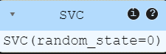
# Predicting a new result
print(classifier.predict(sc.transform([[30,87000]])))
#Output
[0]
# Predicting the Test set results
y_pred = classifier.predict(X_test)
print(np.concatenate((y_pred.reshape(len(y_pred),1), y_test.reshape(len(y_test),1)),1))
#Output
[[0 0]
[0 0]
[0 0]
…
[0 0]
[1 1]
[1 1]
[1 1]]
#Making the Confusion Matrix
from sklearn.metrics import confusion_matrix, accuracy_score
cm = confusion_matrix(y_test, y_pred)
print(cm)
accuracy_score(y_test, y_pred)
0.93
# Visualising the Training set results
from matplotlib.colors import ListedColormap
import numpy as np
import matplotlib.pyplot as plt
# Ensure `X_set` and `y_set` are properly defined
X_set, y_set = sc.inverse_transform(X_train), y_train
# Define grid limits and density
grid_density = 100 # Adjust grid density for memory efficiency
x_min, x_max = X_set[:, 0].min() - 10, X_set[:, 0].max() + 10
y_min, y_max = X_set[:, 1].min() - 1000, X_set[:, 1].max() + 1000
# Create mesh grid using linspace for efficient memory usage
X1, X2 = np.meshgrid(
np.linspace(x_min, x_max, grid_density),
np.linspace(y_min, y_max, grid_density)
)
# Predict outcomes for each grid point
grid_points = np.c_[X1.ravel(), X2.ravel()]
Z = classifier.predict(sc.transform(grid_points)).reshape(X1.shape)

# Plot decision boundary
plt.contourf(X1, X2, Z, alpha=0.75, cmap=ListedColormap(['salmon', 'dodgerblue']))
plt.xlim(x_min, x_max)
plt.ylim(y_min, y_max)

# Scatter plot for data points with class-specific colors
colors = ListedColormap(['salmon', 'dodgerblue'])
for i, j in enumerate(np.unique(y_set)):
plt.scatter(
X_set[y_set == j, 0],
X_set[y_set == j, 1],
c=colors(i),
label=j
)

# Add titles and labels
plt.title('Kernel SVM (Training set)')
plt.xlabel('Age')
plt.ylabel('Estimated Salary')
plt.legend()
plt.show()
#Output
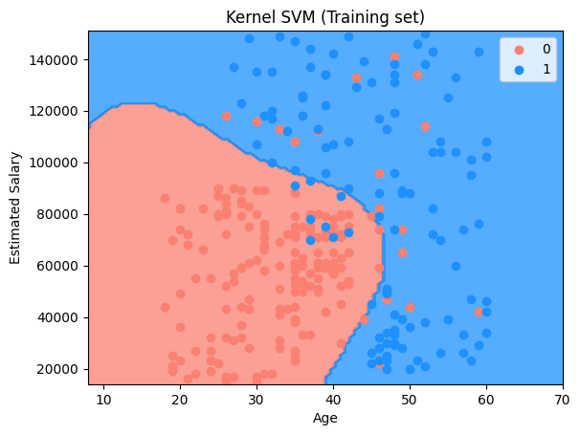

## Visualising the Test set results
from matplotlib.colors import ListedColormap
import numpy as np
import matplotlib.pyplot as plt

# Ensure `X_set` and `y_set` are properly defined
X_set, y_set = sc.inverse_transform(X_test), y_test

# Define grid limits and density
grid_density = 100 # Adjust grid density for efficiency
x_min, x_max = X_set[:, 0].min() - 10, X_set[:, 0].max() + 10
y_min, y_max = X_set[:, 1].min() - 1000, X_set[:, 1].max() + 1000

# Create mesh grid using linspace for efficient memory usage
X1, X2 = np.meshgrid(
np.linspace(x_min, x_max, grid_density),
np.linspace(y_min, y_max, grid_density)
)

# Predict outcomes for each grid point
grid_points = np.c_[X1.ravel(), X2.ravel()]
Z = classifier.predict(sc.transform(grid_points)).reshape(X1.shape)

# Plot decision boundary
plt.contourf(X1, X2, Z, alpha=0.75, cmap=ListedColormap(['salmon', 'dodgerblue']))
plt.xlim(x_min, x_max)
plt.ylim(y_min, y_max)

# Scatter plot for data points with class-specific colors
colors = ListedColormap(['salmon', 'dodgerblue'])
for i, j in enumerate(np.unique(y_set)):
plt.scatter(
X_set[y_set == j, 0],
X_set[y_set == j, 1],
c=colors(i),
label=j
)

# Add titles and labels
plt.title('Kernel SVM (Test set)')
plt.xlabel('Age')
plt.ylabel('Estimated Salary')
plt.legend()
plt.show()
#Output
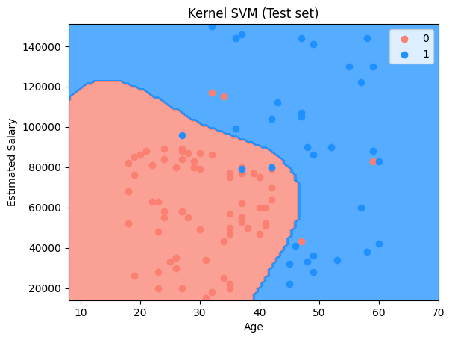

Experiment – 12
Hierarchical Clustering
Description:
Hierarchical Clustering is an unsupervised machine learning algorithm used to group data points into clusters based on similarity. It builds a hierarchy of clusters using either a bottom-up (agglomerative) or top-down (divisive) approach.
Types of Hierarchical Clustering
- Agglomerative Clustering (Bottom-Up Approach):
  - Starts with each data point as its own cluster.
  - Iteratively merges the closest clusters until only one remains.
- Divisive Clustering (Top-Down Approach):
  - Starts with all data points in one cluster.
  - Recursively splits clusters until each data point is its own cluster.
Key Steps in Hierarchical Clustering
- Compute Distance Matrix: Measure similarity (e.g., Euclidean distance).
- Merge or Split Clusters: Based on chosen method (agglomerative or divisive).
- Create Dendrogram: A tree-like diagram showing the clustering hierarchy.
- Select Optimal Clusters: Cut the dendrogram at an appropriate level.

Data Set:
The dataset contains five columns:
- CustomerID: A unique identifier assigned to each customer.
- Genre: Represents the gender of the customer (Male/Female).
- Age: Represents the age of customers, ranging from 18 to 70 years.
- Annual Income (k$): Represents the annual income of customers, ranging from 15,000 to 137,000 (in thousands).
- Spending Score (1-100): A score assigned to customers based on their spending behavior and purchasing patterns.
The dataset consists of 200 observations, with no missing values.
Mall_Customers.csv
CustomerID | Genre | Age | Annual Income (k$) | Spending Score (1-100)
1 | Male | 19 | 15 | 39
2 | Male | 21 | 15 | 81
3 | Female | 20 | 16 | 6
4 | Female | 23 | 16 | 77
5 | Female | 31 | 17 | 40
6 | Female | 22 | 17 | 76
7 | Female | 35 | 18 | 6
8 | Female | 23 | 18 | 94
9 | Male | 64 | 19 | 3
10 | Female | 30 | 19 | 72
11 | Male | 67 | 19 | 14
12 | Female | 35 | 19 | 99
13 | Female | 58 | 20 | 15
…… | …… | …… | ….. | ……
195 | Female | 47 | 120 | 16
196 | Female | 35 | 120 | 79
197 | Female | 45 | 126 | 28
198 | Male | 32 | 126 | 74
199 | Male | 32 | 137 | 18
200 | Male | 30 | 137 | 83

Code:
# Importing the libraries
import numpy as np
import matplotlib.pyplot as plt
import pandas as pd
# Importing the dataset
dataset = pd.read_csv('Mall_Customers.csv')
X = dataset.iloc[:, [3, 4]].values
# Using the dendrogram to find the optimal number of clusters
import scipy.cluster.hierarchy as sch
dendrogram = sch.dendrogram(sch.linkage(X, method = 'ward'))
plt.title('Dendrogram')
plt.xlabel('Customers')
plt.ylabel('Euclidean distances')
plt.show()
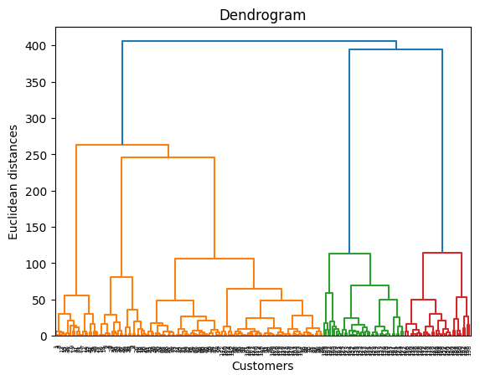
# Training the Hierarchical Clustering model on the dataset
from sklearn.cluster import AgglomerativeClustering
# Create the AgglomerativeClustering model
hc = AgglomerativeClustering(n_clusters=5, linkage='ward') # 'metric' is not needed for 'ward' linkage
# Fit and predict the clusters
y_hc = hc.fit_predict(X)

# Visualising the clusters
plt.scatter(X[y_hc == 0, 0], X[y_hc == 0, 1], s = 100, c = 'red', label = 'Cluster 1')
plt.scatter(X[y_hc == 1, 0], X[y_hc == 1, 1], s = 100, c = 'blue', label = 'Cluster 2')
plt.scatter(X[y_hc == 2, 0], X[y_hc == 2, 1], s = 100, c = 'green', label = 'Cluster 3')
plt.scatter(X[y_hc == 3, 0], X[y_hc == 3, 1], s = 100, c = 'cyan', label = 'Cluster 4')
plt.scatter(X[y_hc == 4, 0], X[y_hc == 4, 1], s = 100, c = 'magenta', label = 'Cluster 5')
plt.title('Clusters of customers')
plt.xlabel('Annual Income (k$)')
plt.ylabel('Spending Score (1-100)')
plt.legend()
plt.show()
#Output
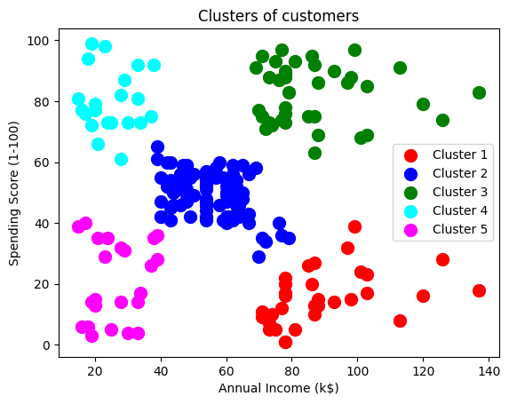
Experiment – 13
Principal Component Analysis (PCA)
Description:
Principal Component Analysis (PCA) is a dimensionality reduction technique used to transform high-dimensional data into a lower-dimensional space while preserving as much variance as possible. It helps in reducing computational complexity and avoiding overfitting.
Mathematical Representation
PCA transforms data by finding new axes (principal components) that maximize variance:
Z = XW
where:
- X= Original dataset
- W = Matrix of principal components (eigenvectors of covariance matrix)
- Z = Transformed dataset in the new coordinate system
Key Steps in PCA
- Standardize the Data: Ensure all features have mean = 0 and variance = 1.
- Compute the Covariance Matrix: Understand feature relationships.
- Calculate Eigenvalues and Eigenvectors: Identify principal components.
- Select Top Principal Components: Choose components that explain the most variance.
- Transform the Data: Project onto the selected principal components.
Data set:
The dataset contains 14 columns:
- Alcohol: Represents the alcohol content in wine.
- Malic_Acid: Amount of malic acid present.
- Ash: Measure of ash content in the wine.
- Ash_Alcanity: Alkalinity of ash.
- Magnesium: Magnesium concentration in the wine.
- Total_Phenols: Total amount of phenolic compounds.
- Flavanoids: Flavonoid content, affecting taste and quality.
- Nonflavanoid_Phenols: Non-flavonoid phenol content.
- Proanthocyanins: Type of phenolic compound in wine.
- Color_Intensity: Intensity of the wine's color.
- Hue: Color tone of the wine.
- OD280: Optical density at 280nm, indicating protein and polyphenol content.
- Proline: Amino acid concentration in wine.
- Customer_Segment: Categorical variable indicating wine class.
The dataset consists of 178 observations, with no missing values.
Wine.csv
Alcohol | Malic_Acid | Ash | Ash_Alcanity | Magnesium | ……. | Proline | Customer_Segment
14.23 | 1.71 | 2.43 | 15.6 | 127 | …. | 1065 | 1
13.2 | 1.78 | 2.14 | 11.2 | 100 | …. | 1050 | 1
13.16 | 2.36 | 2.67 | 18.6 | 101 | …. | 1185 | 1
14.37 | 1.95 | 2.5 | 16.8 | 113 | …. | 1480 | 1
13.24 | 2.59 | 2.87 | 21 | 118 | …. | 735 | 1
14.2 | 1.76 | 2.45 | 15.2 | 112 | …. | 1450 | 1
14.39 | 1.87 | 2.45 | 14.6 | 96 | …. | 1290 | 1
14.06 | 2.15 | 2.61 | 17.6 | 121 | …. | 1295 | 1
14.83 | 1.64 | 2.17 | 14 | 97 | …. | 1045 | 1
13.86 | 1.35 | 2.3 | 16 | 98 | …. | 1045 | 1
14.1 | 2.16 | 2.32 | 18 | 105 | …. | 1510 | 1
….. | ….. | … | …. | …. | …. | …. | ….
….. | ….. | … | …. | ….. | …. | …. | ….
13.17 | 2.59 | 2.37 | 20 | 120 | …. | 840 | 3
14.13 | 4.1 | 2.74 | 24.5 | 96 | ….. | 560 | 3

Code:
# Importing the libraries
import numpy as np
import matplotlib.pyplot as plt
import pandas as pd
# Importing the dataset
dataset = pd.read_csv('Wine.csv')
X = dataset.iloc[:, :-1].values
y = dataset.iloc[:, -1].values

# Splitting the dataset into the Training set and Test set
from sklearn.model_selection import train_test_split
X_train, X_test, y_train, y_test = train_test_split(X, y, test_size = 0.2, random_state = 0)
# Feature Scaling
from sklearn.preprocessing import StandardScaler
sc = StandardScaler()
X_train = sc.fit_transform(X_train)
X_test = sc.transform(X_test)
#Applying PCA
from sklearn.decomposition import PCA
pca = PCA(n_components = 2)
X_train = pca.fit_transform(X_train)
X_test = pca.transform(X_test)
# Training the Logistic Regression model on the Training set
from sklearn.linear_model import LogisticRegression
classifier = LogisticRegression(random_state = 0)
classifier.fit(X_train, y_train)
#Output
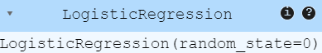
# Making the Confusion Matrix
from sklearn.metrics import confusion_matrix, accuracy_score
y_pred = classifier.predict(X_test)
cm = confusion_matrix(y_test, y_pred)
print(cm)
accuracy_score(y_test, y_pred)
#Output
[[14 0 0]
[ 1 15 0]
[ 0 0 6]]
0.9722222222222222
# Visualising the Training set results
from matplotlib.colors import ListedColormap
import numpy as np
import matplotlib.pyplot as plt
# Define the dataset and labels
X_set, y_set = X_train, y_train
# Define grid limits and density
grid_density = 100 # Adjust grid density for efficient memory usage
x_min, x_max = X_set[:, 0].min() - 1, X_set[:, 0].max() + 1
y_min, y_max = X_set[:, 1].min() - 1, X_set[:, 1].max() + 1
# Create the mesh grid
X1, X2 = np.meshgrid(
np.linspace(x_min, x_max, grid_density),
np.linspace(y_min, y_max, grid_density)
)
# Predict outcomes for grid points
grid_points = np.c_[X1.ravel(), X2.ravel()]
Z = classifier.predict(grid_points).reshape(X1.shape)
# Plot decision boundary
plt.contourf(X1, X2, Z, alpha=0.75, cmap=ListedColormap(['red', 'green', 'blue']))
plt.xlim(x_min, x_max)
plt.ylim(y_min, y_max)
# Plot the data points with distinct colors for each class
colors = ListedColormap(['red', 'green', 'blue'])
for i, j in enumerate(np.unique(y_set)):
plt.scatter(
X_set[y_set == j, 0],
X_set[y_set == j, 1],
c=colors(i),
label=j
)
# Add titles and labels
plt.title('Logistic Regression (Training set)')
plt.xlabel('PC1')
plt.ylabel('PC2')
plt.legend()
plt.show()
#Output
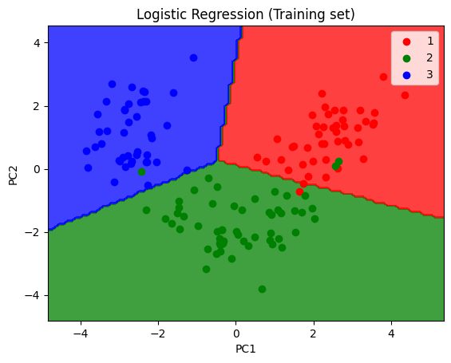
# Visualising the Test set results
from matplotlib.colors import ListedColormap
import numpy as np
import matplotlib.pyplot as plt
# Define the dataset and labels
X_set, y_set = X_test, y_test
# Define grid limits and density
grid_density = 100 # Adjust grid density for memory efficiency
x_min, x_max = X_set[:, 0].min() - 1, X_set[:, 0].max() + 1
y_min, y_max = X_set[:, 1].min() - 1, X_set[:, 1].max() + 1

# Create the mesh grid
X1, X2 = np.meshgrid(
np.linspace(x_min, x_max, grid_density),
np.linspace(y_min, y_max, grid_density)
)
# Predict outcomes for grid points
grid_points = np.c_[X1.ravel(), X2.ravel()]
Z = classifier.predict(grid_points).reshape(X1.shape)
# Plot decision boundary
plt.contourf(X1, X2, Z, alpha=0.75, cmap=ListedColormap(['red', 'green', 'blue']))
plt.xlim(x_min, x_max)
plt.ylim(y_min, y_max)
# Plot the data points with distinct colors for each class
colors = ListedColormap(['red', 'green', 'blue'])
for i, j in enumerate(np.unique(y_set)):
plt.scatter(
X_set[y_set == j, 0],
X_set[y_set == j, 1],
c=colors(i),
label=j
)

# Add titles and labels
plt.title('Logistic Regression (Test set)')
plt.xlabel('PC1')
plt.ylabel('PC2')
plt.legend()
plt.show()
#Output
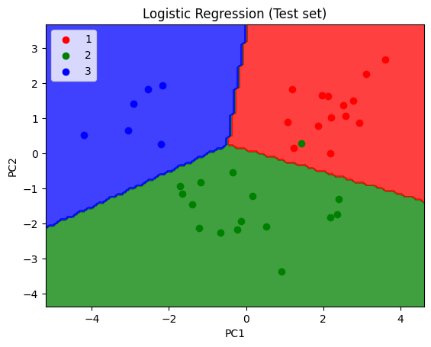
Experiment – 14
Kernel Principal Component Analysis (KPCA)
Description:
Kernel Principal Component Analysis (KPCA) is a non-linear extension of Principal Component Analysis (PCA) that uses kernel functions to map data into a higher-dimensional space before performing dimensionality reduction.
Purpose: It is used when data exhibits non-linear patterns that traditional PCA cannot capture, making it effective for complex datasets.
Common Kernels Used:
- Linear Kernel: Equivalent to standard PCA.
- Polynomial Kernel: Captures polynomial relationships.
- Radial Basis Function (RBF) Kernel: Effective for highly non-linear data.
Data set:
The dataset contains 14 columns:
- Alcohol: Represents the alcohol content in wine.
- Malic_Acid: Amount of malic acid present.
- Ash: Measure of ash content in the wine.
- Ash_Alcanity: Alkalinity of ash.
- Magnesium: Magnesium concentration in the wine.
- Total_Phenols: Total amount of phenolic compounds.
- Flavanoids: Flavonoid content, affecting taste and quality.
- Nonflavanoid_Phenols: Non-flavonoid phenol content.
- Proanthocyanins: Type of phenolic compound in wine.
- Color_Intensity: Intensity of the wine's color.
- Hue: Color tone of the wine.
- OD280: Optical density at 280nm, indicating protein and polyphenol content.
- Proline: Amino acid concentration in wine.
- Customer_Segment: Categorical variable indicating wine class.
The dataset consists of 178 observations, with no missing values.
Wine.csv
Alcohol | Malic_Acid | Ash | Ash_Alcanity | Magnesium | ……. | Proline | Customer_Segment
14.23 | 1.71 | 2.43 | 15.6 | 127 | …. | 1065 | 1
13.2 | 1.78 | 2.14 | 11.2 | 100 | …. | 1050 | 1
13.16 | 2.36 | 2.67 | 18.6 | 101 | …. | 1185 | 1
14.37 | 1.95 | 2.5 | 16.8 | 113 | …. | 1480 | 1
13.24 | 2.59 | 2.87 | 21 | 118 | …. | 735 | 1
14.2 | 1.76 | 2.45 | 15.2 | 112 | …. | 1450 | 1
14.39 | 1.87 | 2.45 | 14.6 | 96 | …. | 1290 | 1
14.06 | 2.15 | 2.61 | 17.6 | 121 | …. | 1295 | 1
14.83 | 1.64 | 2.17 | 14 | 97 | …. | 1045 | 1
13.86 | 1.35 | 2.3 | 16 | 98 | …. | 1045 | 1
14.1 | 2.16 | 2.32 | 18 | 105 | …. | 1510 | 1
….. | ….. | … | …. | …. | …. | …. | ….
….. | ….. | … | …. | ….. | …. | …. | ….
13.17 | 2.59 | 2.37 | 20 | 120 | …. | 840 | 3
14.13 | 4.1 | 2.74 | 24.5 | 96 | ….. | 560 | 3

Code:
# Importing the libraries
import numpy as np
import matplotlib.pyplot as plt
import pandas as pd
# Importing the dataset
dataset = pd.read_csv('Wine.csv')
X = dataset.iloc[:, :-1].values
y = dataset.iloc[:, -1].values
# Splitting the dataset into the Training set and Test set
from sklearn.model_selection import train_test_split
X_train, X_test, y_train, y_test = train_test_split(X, y, test_size = 0.2, random_state = 0)
# Feature Scaling
from sklearn.preprocessing import StandardScaler
sc = StandardScaler()
X_train = sc.fit_transform(X_train)
X_test = sc.transform(X_test)
#Applying Kernel PCA
from sklearn.decomposition import KernelPCA
kpca = KernelPCA(n_components = 2, kernel = 'rbf')
X_train = kpca.fit_transform(X_train)
X_test = kpca.transform(X_test)
# Training the Logistic Regression model on the Training set
from sklearn.linear_model import LogisticRegression
classifier = LogisticRegression(random_state = 0)
classifier.fit(X_train, y_train)
#Output
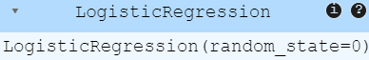
# Making the Confusion Matrix
from sklearn.metrics import confusion_matrix, accuracy_score
y_pred = classifier.predict(X_test)
cm = confusion_matrix(y_test, y_pred)
print(cm)
accuracy_score(y_test, y_pred)
#Output
[[14 0 0]
[ 0 16 0]
[ 0 0 6]]
1.0
# Visualising the Training set results
from matplotlib.colors import ListedColormap
import numpy as np
import matplotlib.pyplot as plt
# Set up test data
X_set, y_set = X_test, y_test
# Create a mesh grid for plotting
X1, X2 = np.meshgrid(
np.arange(start=X_set[:, 0].min() - 1, stop=X_set[:, 0].max() + 1, step=0.01),
np.arange(start=X_set[:, 1].min() - 1, stop=X_set[:, 1].max() + 1, step=0.01)
)
# Predict on the grid and reshape to fit the mesh grid
Z = classifier.predict(np.array([X1.ravel(), X2.ravel()]).T)
Z = Z.reshape(X1.shape)
# Set up color mapping for the plot
# Use a specific colormap and assign distinct colors for each class
num_classes = len(np.unique(y_set))
cmap = plt.cm.get_cmap('coolwarm', num_classes)
# Plot the decision boundary
plt.contourf(X1, X2, Z, alpha=0.75, cmap=cmap)
plt.xlim(X1.min(), X1.max())
plt.ylim(X2.min(), X2.max())
# Plot the data points with distinct colors for each class
for i, j in enumerate(np.unique(y_set)):
plt.scatter(X_set[y_set == j, 0], X_set[y_set == j, 1],
c=cmap(i), label=f'Class {j}')
# Add titles and labels
plt.title('Logistic Regression (Test set)')
plt.xlabel('PC1')
plt.ylabel('PC2')
plt.legend()
plt.show()

#Output
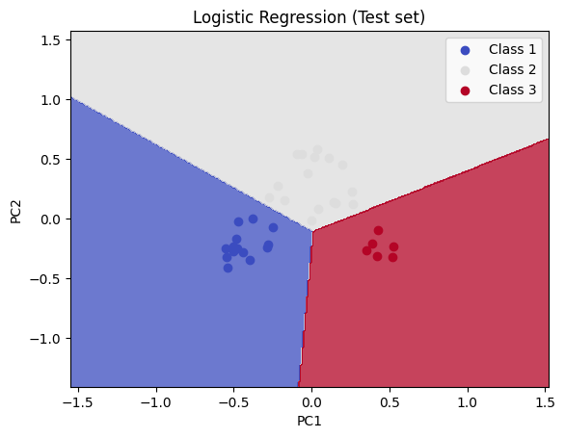
# Visualising the Test set results
from matplotlib.colors import ListedColormap
import numpy as np
import matplotlib.pyplot as plt
# Set up test data
X_set, y_set = X_test, y_test
# Create a mesh grid for plotting
X1, X2 = np.meshgrid(
np.arange(start=X_set[:, 0].min() - 1, stop=X_set[:, 0].max() + 1, step=0.01),
np.arange(start=X_set[:, 1].min() - 1, stop=X_set[:, 1].max() + 1, step=0.01)
)

# Predict on the grid and reshape to fit the mesh grid
Z = classifier.predict(np.array([X1.ravel(), X2.ravel()]).T)
Z = Z.reshape(X1.shape)
# Set up color mapping for the plot dynamically based on the number of unique classes
num_classes = len(np.unique(y_set))
cmap = plt.cm.coolwarm # Directly use the colormap
# Plot the decision boundary
plt.contourf(X1, X2, Z, alpha=0.75, cmap=cmap)
plt.xlim(X1.min(), X1.max())
plt.ylim(X2.min(), X2.max())
# Plot the data points with distinct colors for each class
for i, j in enumerate(np.unique(y_set)):
plt.scatter(X_set[y_set == j, 0], X_set[y_set == j, 1],
c=[cmap(i / num_classes)], label=f'Class {j}')
# Add titles and labels
plt.title('Logistic Regression (Test set)')
plt.xlabel('PC1')
plt.ylabel('PC2')
plt.legend()
plt.show()
#Output
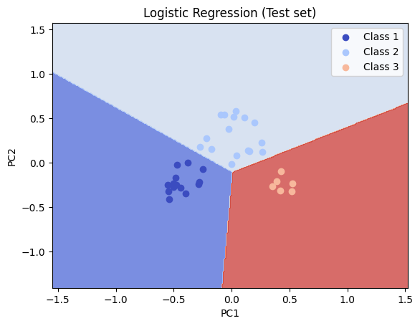
Experiment – 15
Partitioning Around Medoids (PAM) & K-Medoids Clustering
Description:
Partitioning Around Medoids (PAM) is a clustering algorithm that selects actual data points (medoids) as cluster centers. Unlike K-Means, it minimizes dissimilarities within clusters and is more robust to outliers. K-Medoids, a generalization of PAM, iteratively refines medoid selection for better clustering. It is widely used in market segmentation, anomaly detection, and image processing.
Code:
k_medoids.py
'''
Light Weight K-Medoids Implementation
'''
import numpy as np
import matplotlib.pyplot as plt
from copy import deepcopy
from IPython import embed
import time

def _get_init_centers(n_clusters, n_samples):
'''return random points as initial centers'''
init_ids = []
while len(init_ids) < n_clusters:
_ = np.random.randint(0,n_samples)
if not _ in init_ids:
init_ids.append(_)
return init_ids

def _get_distance(data1, data2):
'''example distance function'''
return np.sqrt(np.sum((data1 - data2)**2))

def _get_cost(X, centers_id, dist_func):
'''return total cost and cost of each cluster'''
st = time.time()
dist_mat = np.zeros((len(X),len(centers_id)))
# compute distance matrix
for j in range(len(centers_id)):
center = X[centers_id[j],:]
for i in range(len(X)):
if i == centers_id[j]:
dist_mat[i,j] = 0.
else:
dist_mat[i,j] = dist_func(X[i,:], center)
#print 'cost ', -st+time.time()
mask = np.argmin(dist_mat,axis=1)
members = np.zeros(len(X))
costs = np.zeros(len(centers_id))
for i in range(len(centers_id)):
mem_id = np.where(mask==i)
members[mem_id] = i
costs[i] = np.sum(dist_mat[mem_id,i])
return members, costs, np.sum(costs), dist_mat

def _kmedoids_run(X, n_clusters, dist_func, max_iter=1000, tol=0.001, verbose=True):
'''run algorithm return centers, members, and etc.'''
# Get initial centers
n_samples, n_features = X.shape
init_ids = _get_init_centers(n_clusters,n_samples)
if verbose:
print ('Initial centers are ', init_ids)
centers = init_ids
members, costs, tot_cost, dist_mat = _get_cost(X, init_ids,dist_func)
cc,SWAPED = 0, True
while True:
SWAPED = False
for i in range(n_samples):
if not i in centers:
for j in range(len(centers)):
centers_ = deepcopy(centers)
centers_[j] = i
members_, costs_, tot_cost_, dist_mat_ = _get_cost(X, centers_,dist_func)
if tot_cost_-tot_cost < tol:
members, costs, tot_cost, dist_mat = members_, costs_, tot_cost_, dist_mat_
centers = centers_
SWAPED = True
if verbose:
print ('Change centers to ', centers)
if cc > max_iter:
if verbose:
print ('End Searching by reaching maximum iteration', max_iter)
break
if not SWAPED:
if verbose:
print ('End Searching by no swaps')
break
cc += 1
return centers,members, costs, tot_cost, dist_mat

class KMedoids(object):
‘ ‘ ‘
Main API of KMedoids Clustering

Parameters
--------
n_clusters: number of clusters
dist_func : distance function
max_iter: maximum number of iterations
tol: tolerance

Attributes
--------
labels_ : cluster labels for each data item
centers_ : cluster centers id
costs_ : array of costs for each cluster
n_iter_ : number of iterations for the best trail

Methods
-------
fit(X): fit the model
- X: 2-D numpy array, size = (n_sample, n_features)

predict(X): predict cluster id given a test dataset.
’ ’ ’
def __init__(self, n_clusters, dist_func=_get_distance, max_iter=10000, tol=0.0001):
self.n_clusters = n_clusters
self.dist_func = dist_func
self.max_iter = max_iter
self.tol = tol

def fit(self, X,plotit=True, verbose=True):
centers,members, costs,tot_cost, dist_mat = _kmedoids_run(
X,self.n_clusters, self.dist_func, max_iter=self.max_iter, tol=self.tol,verbose=verbose)
if plotit:
fig, ax = plt.subplots(1,1)
colors = ['b','g','r','c','m','y','k']
if self.n_clusters > len(colors):
raise ValueError('we need more colors')

for i in range(len(centers)):
X_c = X[members==i,:]
ax.scatter(X_c[:,0],X_c[:,1],c=colors[i],alpha=0.5,s=30)
ax.scatter(X[centers[i],0],X[centers[i],1],c=colors[i],alpha=1., s=250,marker='*')
return

def predict(self,X):
raise NotImplementedError()
example.py
from k_medoids import KMedoids
import numpy as np
import matplotlib.pyplot as plt

def example_distance_func(data1, data2):
'''example distance function'''
return np.sqrt(np.sum((data1 - data2)**2))

if __name__ == '__main__':
X = np.random.normal(0,3,(500,2))
model = KMedoids(n_clusters=5, dist_func=example_distance_func)
model.fit(X, plotit=True, verbose=True)
plt.show()
Output
Initial centers are [241, 162, 316, 143, 209]
Change centers to [0, 162, 316, 143, 209]
Change centers to [1, 162, 316, 143, 209]
Change centers to [1, 2, 316, 143, 209]
Change centers to [1, 2, 3, 143, 209]
Change centers to [1, 2, 3, 143, 7]
Change centers to [1, 2, 9, 143, 7]
Change centers to [12, 2, 9, 143, 7]
Change centers to [12, 2, 22, 143, 7]
Change centers to [12, 2, 23, 143, 7]
Change centers to [12, 2, 23, 27, 7]
Change centers to [29, 2, 23, 27, 7]
Change centers to [29, 38, 23, 27, 7]
Change centers to [29, 38, 39, 27, 7]
Change centers to [29, 38, 39, 41, 7]
Change centers to [29, 38, 39, 41, 53]
Change centers to [29, 38, 39, 74, 53]
Change centers to [83, 38, 39, 74, 53]
Change centers to [83, 38, 39, 144, 53]
Change centers to [83, 38, 39, 144, 154]
Change centers to [83, 38, 39, 171, 154]
Change centers to [83, 38, 39, 221, 154]
End Searching by no swaps
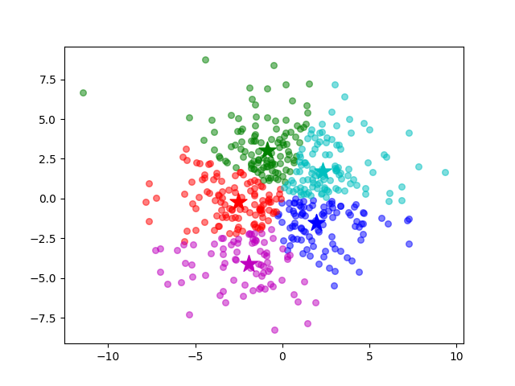
Experiment – 16
XGBoost (Extreme Gradient Boosting)
Description:
XGBoost is a powerful machine learning algorithm based on gradient boosting, designed for speed and performance. It uses an ensemble of decision trees with boosting to minimize errors and improve accuracy. XGBoost supports regularization, handles missing values efficiently, and prevents overfitting. It is widely used in classification, regression, and ranking tasks, including fraud detection and recommendation systems.
Data Set:
The dataset contains 11 columns:
- Sample code number: Unique identifier for each sample.
- Clump Thickness: Represents the thickness of cell clumps.
- Uniformity of Cell Size: Measures the uniformity in the size of cells.
- Uniformity of Cell Shape: Indicates the consistency in the shape of cells.
- Marginal Adhesion: Represents the degree of adhesion between cells.
- Single Epithelial Cell Size: Measures the size of single epithelial cells.
- Bare Nuclei: Represents the count of bare nuclei in the sample.
- Bland Chromatin: Indicates the texture and appearance of chromatin in the nucleus.
- Normal Nucleoli: Represents the count of normal nucleoli in cells.
- Mitoses: Measures the number of cell mitotic figures.
- Class: A binary variable (2 or 4) indicating whether the sample is benign (2) or malignant (4).
The dataset consists of 683 observations, with no missing values.
Data.csv
Sample code number | Clump Thickness | Uniformity of Cell Size | Uniformity of Cell Shape | …. | Mitoses | Class
1000025 | 5 | 1 | 1 | … | 1 | 2
1002945 | 5 | 4 | 4 | … | 1 | 2
1015425 | 3 | 1 | 1 | … | 1 | 2
1016277 | 6 | 8 | 8 | … | 1 | 2
1017023 | 4 | 1 | 1 | … | 1 | 2
1017122 | 8 | 10 | 10 | … | 1 | 2
1018099 | 1 | 1 | 1 | … | 1 | 4
1018561 | 2 | 1 | 2 | … | 1 | 2
1033078 | 2 | 1 | 1 | …. | 5 | 2
1033078 | 4 | 2 | 1 | … | 1 | 2
1035283 | 1 | 1 | 1 | … | 1 | 2
1036172 | 2 | 1 | 1 | … | 1 | 2
…. | … | … | … | … | … | …
897471 | 4 | 8 | 6 | … | 1 | 4
897471 | 4 | 8 | 8 | … | 1 | 4

Code:
# Importing the libraries
import numpy as np
import matplotlib.pyplot as plt
import pandas as pd

# Importing the dataset
dataset = pd.read_csv('Data.csv')
X = dataset.iloc[:, :-1].values
y = dataset.iloc[:, -1].values
# Splitting the dataset into the Training set and Test set
from sklearn.model_selection import train_test_split
X_train, X_test, y_train, y_test = train_test_split(X, y, test_size = 0.2, random_state = 0)
from sklearn.preprocessing import LabelEncoder
labelencoder = LabelEncoder()
y_train = labelencoder.fit_transform(y_train)
# Training XGBoost on the Training set
from xgboost import XGBClassifier
classifier = XGBClassifier()
classifier.fit(X_train, y_train)
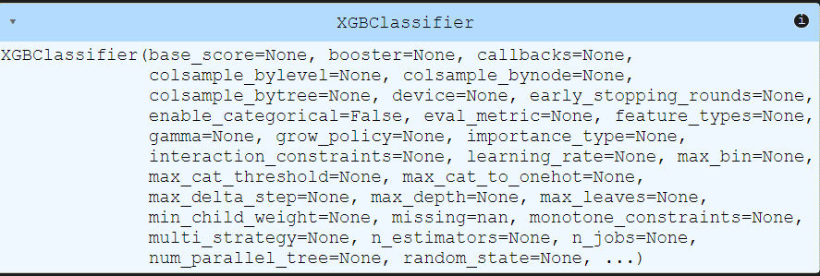
#Making the Confusion Matrix
from sklearn.metrics import confusion_matrix, accuracy_score
y_pred = classifier.predict(X_test)
cm = confusion_matrix(y_test, y_pred)
print(cm)
accuracy_score(y_test, y_pred)
#Output
[[ 0 0 0 0]
[ 0 0 0 0]
[85 2 0 0]
[ 1 49 0 0]]
0.0
# Applying k-Fold Cross Validation
from sklearn.model_selection import cross_val_score
accuracies = cross_val_score(estimator = classifier, X = X_train, y = y_train, cv = 10)
print("Accuracy: {:.2f} %".format(accuracies.mean()*100))
print("Standard Deviation: {:.2f} %".format(accuracies.std()*100))
#Output
Accuracy: 96.71 %
Standard Deviation: 2.28 %
Experiment -17
RANDOM FOREST MODEL

Description :

Random Forest is a supervised machine learning algorithm that uses multiple decision trees to make predictions. It is an ensemble learning method, meaning it combines the outputs of many trees to improve accuracy and reduce overfitting.
- For classification, Random Forest uses majority voting from multiple trees to decide the final class.
- For regression, it takes the average of all tree predictions.

Data Set:
The dataset contains three columns:
- Age: Represents the age of individuals, ranging from 18 to 60 years.
- EstimatedSalary: Represents the estimated salary of individuals, ranging from 15,000 to 150,000.
- Purchased: A binary variable (0 or 1) indicating whether the individual made a purchase (1) or not (0).
The dataset consists of 400 observations, with no missing values.
Social_Network_Ads.csv:
Age | EstimatedSalary | Purchased
19 | 19000 | 0
35 | 20000 | 0
26 | 43000 | 0
27 | 57000 | 0
19 | 76000 | 0
27 | 58000 | 0
27 | 84000 | 0
32 | 150000 | 1
25 | 33000 | 0
35 | 65000 | 0
… | … | ...
… | ... | …
36 | 33000 | 0
49 | 36000 | 1

Code:
# Importing the libraries
import numpy as np
import matplotlib.pyplot as plt
import pandas as pd
# Importing the dataset
dataset = pd.read_csv('Social_Network_Ads.csv')
X = dataset.iloc[:, :-1].values
y = dataset.iloc[:, -1].values
# Splitting the dataset into the Training set and Test set
from sklearn.model_selection import train_test_split
X_train, X_test, y_train, y_test = train_test_split(X, y, test_size = 0.25, random_state = 0)

print(X_train)
#Ouput:
[[ 44 39000]
[ 32 120000]
[ 38 50000]
[ 32 135000]
...
[ 29 43000]
[ 36 52000]
[ 27 54000]
[ 26 118000]]
print(y_train)
#Output
[0 1 0 1 1 1 0 0 0 0 0 0 1 1 1 0 1 0 0 1 0 1 0 1 0 0 1 1 1 1 0 1 0 1 0 0 1
0 0 1 0 0 0 0 0 1 1 1 1 0 0 0 1 0 1 0 1 0 0 1 0 0 0 1 0 0 0 1 1 0 0 1 0 1
1 1 0 0 1 1 0 0 1 1 0 1 0 0 1 1 0 1 1 1 0 0 0 0 0 1 0 0 1 1 1 1 1 0 1 1 0
1 0 0 0 0 0 0 0 1 1 0 0 1 0 0 1 0 0 0 1 0 1 1 0 1 0 0 0 0 1 0 0 0 1 1 0 0
0 0 1 0 1 0 0 0 1 0 0 0 0 1 1 1 0 0 0 0 0 0 1 1 1 1 1 0 1 0 0 0 0 0 1 0 0
0 0 0 0 1 1 0 1 0 1 0 0 1 0 0 0 1 0 0 0 0 0 1 0 0 0 0 0 1 0 1 1 0 0 0 0 0
0 1 1 0 0 0 0 1 0 0 0 0 1 0 1 0 1 0 0 0 1 0 0 0 1 0 1 0 0 0 0 0 1 1 0 0 0
0 0 1 0 1 1 0 0 0 0 0 1 0 1 0 0 1 0 0 1 0 1 0 0 0 0 0 0 1 1 1 1 0 0 0 0 1
0 0 0 0]
print(X_test)
#Output:
[[ 30 87000]
[ 38 50000]
[ 35 75000]
…..
[ 23 63000]
[ 48 33000]
[ 48 90000]
[ 42 104000]]

print(y_test)
#OutPut:
[0 0 0 0 0 0 0 1 0 0 0 0 0 0 0 0 0 0 1 0 0 1 0 1 0 1 0 0 0 0 0 1 1 0 0 0 0
0 0 1 0 0 0 0 1 0 0 1 0 1 1 0 0 0 1 1 0 0 1 0 0 1 0 1 0 1 0 0 0 0 1 0 0 1
0 0 0 0 1 1 1 0 0 0 1 1 0 1 1 0 0 1 0 0 0 1 0 1 1 1]
# Feature Scaling
from sklearn.preprocessing import StandardScaler
sc = StandardScaler()
X_train = sc.fit_transform(X_train)
X_test = sc.transform(X_test)

print(X_train)
#Output:
[[ 0.58164944 -0.88670699]
[-0.60673761 1.46173768]
[-0.01254409 -0.5677824 ]
...
[-0.90383437 -0.77073441]
[-0.21060859 -0.50979612]
[-1.10189888 -0.45180983]
[-1.20093113 1.40375139]]

print(X_test)
#Output
[[-0.80480212 0.50496393]
[-0.01254409 -0.5677824 ]
[-0.30964085 0.1570462 ]
...
[-1.49802789 -0.19087153]
[ 0.97777845 -1.06066585]
[ 0.97777845 0.59194336]
[ 0.38358493 0.99784738]]
# Training the Random Forest Classification model on the Training set
from sklearn.ensemble import RandomForestClassifier
classifier = RandomForestClassifier(n_estimators = 10, criterion = 'entropy', random_state = 0)
classifier.fit(X_train, y_train)
#Output:

# Predicting a new result
print(classifier.predict(sc.transform([[30,87000]])))
#Output:
[ 0 ]

# Predicting the Test set results
y_pred = classifier.predict(X_test)
print(np.concatenate((y_pred.reshape(len(y_pred),1), y_test.reshape(len(y_test),1)),1))
#OutPut
[[0 0]
[0 0]
[0 0]
….
[0 0]
[1 1]
[1 1]
[1 1]]
# Making the Confusion Matrix
from sklearn.metrics import confusion_matrix, accuracy_score
cm = confusion_matrix(y_test, y_pred)
print(cm)
accuracy_score(y_test, y_pred)
#Output
[[63 5]
[ 4 28]]
0.91

# Visualising the Training set results
from matplotlib.colors import ListedColormap
import numpy as np
import matplotlib.pyplot as plt
import matplotlib
# Ensure `X_train` and `y_train` are available and `sc` is defined (e.g., StandardScaler, MinMaxScaler)
X_set, y_set = sc.inverse_transform(X_train), y_train
# Create a mesh grid for the plot
X1, X2 = np.meshgrid(
np.arange(start=X_set[:, 0].min() - 10, stop=X_set[:, 0].max() + 10, step=0.25),
np.arange(start=X_set[:, 1].min() - 1000, stop=X_set[:, 1].max() + 1000, step=0.25)
)

# Predict on the grid using the classifier and reshape to fit the mesh grid
Z = classifier.predict(sc.transform(np.array([X1.ravel(), X2.ravel()]).T))
Z = Z.reshape(X1.shape)

# Create a dynamic colormap based on the number of unique classes by sampling from 'coolwarm'
cmap = ListedColormap(plt.cm.coolwarm(np.linspace(0, 1, len(np.unique(y_set)))))

# Plot the decision boundary
plt.contourf(X1, X2, Z, alpha=0.75, cmap='viridis')
plt.xlim(X1.min(), X1.max())
plt.ylim(X2.min(), X2.max())

# Plot the data points with distinct colors for each class
for i, j in enumerate(np.unique(y_set)):
plt.scatter(X_set[y_set == j, 0], X_set[y_set == j, 1],
c=cmap(i), label=f'Class {j}')
# Add titles and labels
plt.title('Random Forest Classification (Training set) - 22B01A4655')
plt.xlabel('Age')
plt.ylabel('Estimated Salary')
plt.legend()
plt.show()

#Output
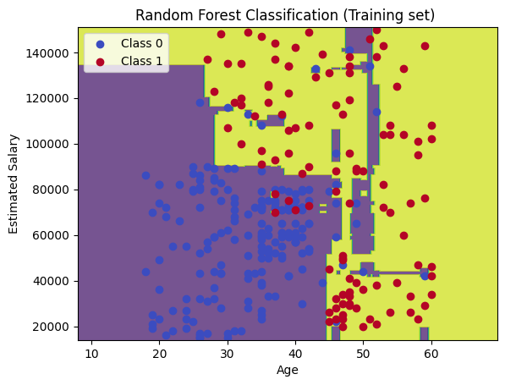
# Visualising the Test set results
from matplotlib.colors import ListedColormap
import numpy as np
import matplotlib.pyplot as plt

# Ensure `X_test` and `y_test` are available and `sc` is defined (e.g., StandardScaler, MinMaxScaler)
X_set, y_set = sc.inverse_transform(X_test), y_test

# Create a mesh grid for the plot
X1, X2 = np.meshgrid(
np.arange(start=X_set[:, 0].min() - 10, stop=X_set[:, 0].max() + 10, step=0.25),
np.arange(start=X_set[:, 1].min() - 1000, stop=X_set[:, 1].max() + 1000, step=0.25)
)
# Predict on the grid using the classifier and reshape to fit the mesh grid
Z = classifier.predict(sc.transform(np.array([X1.ravel(), X2.ravel()]).T))
Z = Z.reshape(X1.shape)
# Create a dynamic colormap based on the number of unique classes by sampling from 'coolwarm'
cmap = ListedColormap(plt.cm.coolwarm(np.linspace(0, 1, len(np.unique(y_set)))))
# Plot the decision boundary
plt.contourf(X1, X2, Z, alpha=0.75, cmap='plasma')
plt.xlim(X1.min(), X1.max())
plt.ylim(X2.min(), X2.max())
# Plot the data points with distinct colors for each class
for i, j in enumerate(np.unique(y_set)):
plt.scatter(X_set[y_set == j, 0], X_set[y_set == j, 1],
c=cmap(i), label=f'Class {j}')
# Add titles and labels
plt.title('Random Forest Classification (Test set) 22B01A4655')
plt.xlabel('Age')
plt.ylabel('Estimated Salary')
plt.legend()
plt.show()
#Output
