DSA06 - Data Handling and Visualization | Activity 5: Normality Detection using Q-Q Plots | Slot D
R.No: 26 Reg. No: 192424308 Name: MUNGAMURU TEJA KUMAR
Each chart is a normal Q-Q plot made in R (stat_qq and stat_qq_line; red line = perfect normal fit). Part A (16 marks): for every chart decide whether the data are normal and name the shape from this list: Normal, Right-skewed, Left-skewed, Heavy-tailed, Light-tailed, Bimodal, Normal with outlier(s); then cite the evidence you see.
Chart 1: typing speed (words per minute), n = 40
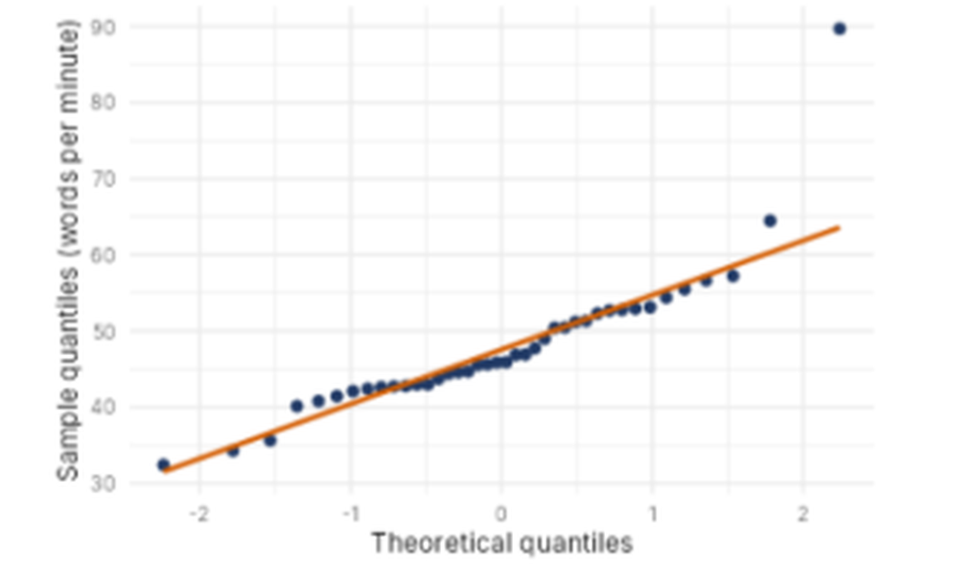
Normal? (Yes / No) | No (approximately normal, but not perfectly because of outliers)
Shape (from the list) | Normal with outlier(s)
Evidence in the plot | Most points lie close to the red line from about -2.2 to +1.5 theoretical quantiles (about 32 to 57 words per minute), so the bulk of the data is normal. At the top right, one point (about 90 wpm) lies far above the line, whose value there is about 63, and a second point (about 64 wpm) sits slightly above it. These extreme upper values are outliers.
Chart 2: plant height (cm), n = 80
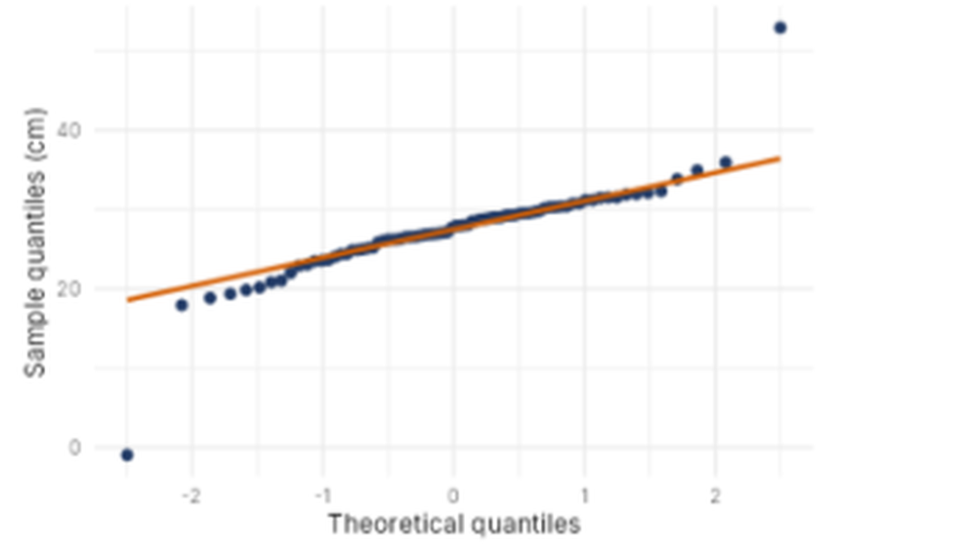
Normal? (Yes / No) | No (approximately normal, but not perfectly because of two outliers)
Shape (from the list) | Normal with outlier(s)
Evidence in the plot | The points between about -1.3 and +1.6 theoretical quantiles (about 22 to 32 cm) hug the red line. Two isolated points break the pattern: one at the bottom left (about -1 cm, far below the line value of about 18 cm) and one at the top right (about 53 cm, far above the line value of about 36 cm). Both are outliers, one at each end.
Chart 3: battery drain per hour (percent), n = 50
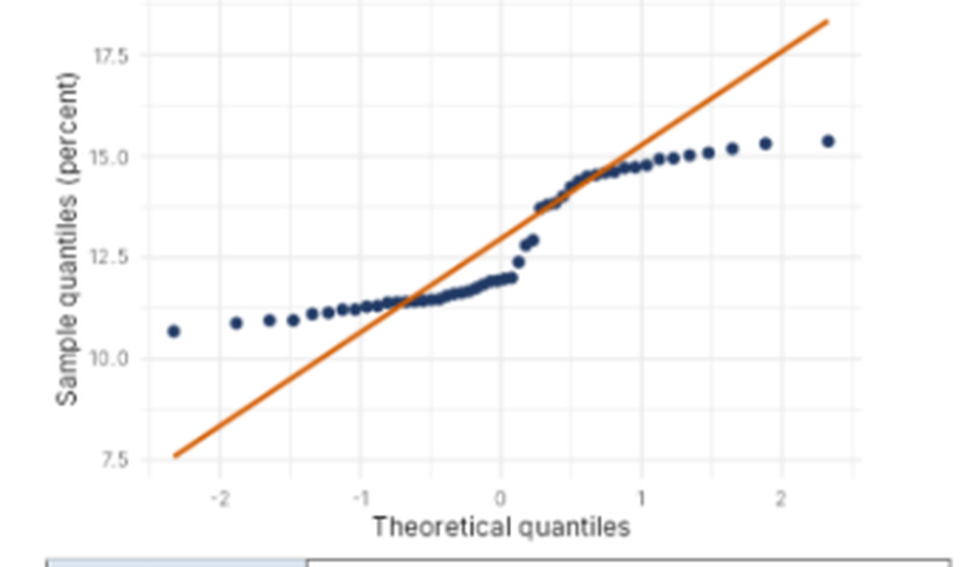
Normal? (Yes / No) | No
Shape (from the list) | Bimodal
Evidence in the plot | The points form a staircase instead of following the line. There is a flat run at about 11 to 12 percent on the left and another flat run at about 14.5 to 15.4 percent on the right, joined by a steep jump from about 12 to 14.5 near theoretical quantile 0 to 0.5. This means two clusters with a gap between them. All values stay within about 10.7 to 15.4, much narrower than the red line (about 7.6 to 18.3), so the tails are also shorter than normal.
Chart 4: commute time (minutes), n = 60
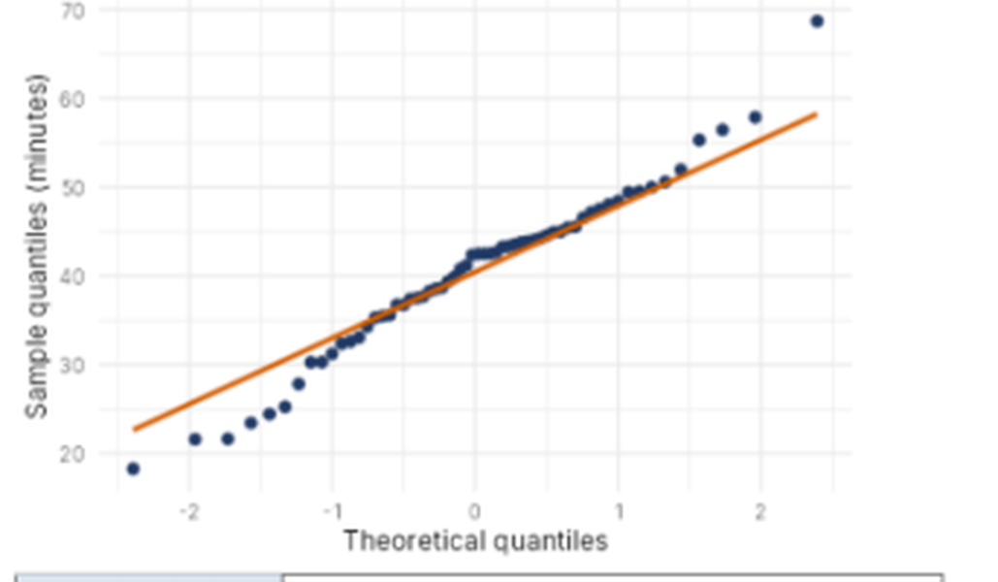
Normal? (Yes / No) | No
Shape (from the list) | Heavy-tailed
Evidence in the plot | The middle points (about -1 to +1.4, roughly 33 to 50 minutes) follow the red line closely, but the tails bend away from it in both directions. At the lower left, the points (about 18, 22, 22 minutes) fall below the line (about 23 to 27). At the upper right, the points (about 55 to 58 minutes) lie above the line, and the largest point (about 68 minutes) is far above the line value of about 58. The extremes are more spread out than a normal distribution would give.
Part B (4 marks)
B1. Chart 3 departs from normality. Name the departure and state the remedy you would try before using mean-and-SD methods (for example log transform, square, split the data, robust methods). [2]
Chart 3 is bimodal: the Q-Q plot is a staircase with two flat runs (about 11 to 12 percent and about 14.5 to 15.4 percent) and a gap between them, which means the data come from two clusters mixed together. The remedy I would try is to split the data into the two groups (finding what separates them, such as two battery types or two usage modes) and analyse each group separately, then re-check the Q-Q plot of each group. A log or square transformation would not fix two separate humps, so it is not suitable here. If the groups cannot be identified, I would use robust methods (median and IQR) instead of the mean and SD.
B2. Fill the blanks to draw a Q-Q plot with its reference line for a data frame df with a column value: ggplot(df, aes(sample = value)) + ________ + ________ [2]
ggplot(df, aes(sample = value)) +
stat_qq() +
stat_qq_line()

