DSA06 - Data Handling and Visualization | Activity 6: Website Flow Sankey Design | Slot D
R.No: 26 Reg. No: 192424308 Name: MUNGAMURU TEJA KUMAR
Scenario: The analytics team of an online bookstore tracked 4,000 sessions last month through four stages: traffic source, landing page, next action and outcome. The Sankey diagram below shows the number of sessions on every flow. Three flows are hidden and marked "?".
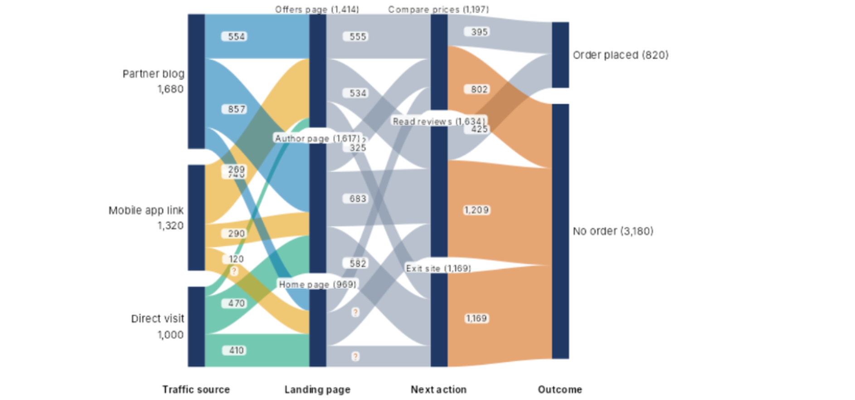
(a) Using conservation of flow (what enters a node equals what leaves it) find the three hidden flows, showing working: Mobile app link to Home page; Home page to Exit site; Home page to Read reviews. State the rule you used. [4]
Rule: Conservation of flow. For every node, the total of the flows entering it equals the total of the flows leaving it, and that equals the node total shown on the diagram (every stage adds up to 4,000 sessions).
1. Mobile app link → Home page: Mobile app link sends out 1,320 sessions in total. The other two flows leaving it are to Offers page (740) and Author page (290). So 1,320 − 740 − 290 = 290 sessions. Check: Home page inflow = 269 + 290 + 410 = 969 ✓.
2. Home page → Exit site: Exit site receives 1,169 sessions in total. The other two flows entering it are from Offers page (325) and Author page (582). So 1,169 − 325 − 582 = 262 sessions.
3. Home page → Read reviews: Read reviews receives 1,634 sessions in total. The other two flows entering it are from Offers page (534) and Author page (683). So 1,634 − 534 − 683 = 417 sessions.
Check: The three flows leaving Home page must add up to its total of 969. The remaining flow, Home page → Compare prices, is 969 − 417 − 262 = 290, and Compare prices inflow = 555 + 352 + 290 = 1,197 ✓ (where Author page → Compare prices = 1,617 − 683 − 582 = 352). Flows leaving Home page: 290 + 417 + 262 = 969 ✓.
Hidden flow | Working | Answer
Mobile app link → Home page | 1,320 − 740 − 290 | 290
Home page → Exit site | 1,169 − 325 − 582 | 262
Home page → Read reviews | 1,634 − 534 − 683 | 417

(b) Compute: (i) the overall conversion rate, i.e. Order placed as a percentage of all sessions; (ii) the largest single flow into "No order" or "Exit site"; (iii) the percentage of "Author page" sessions that go on to "Compare prices". [4]
(i) Overall conversion rate: 820 / 4,000 × 100 = 20.5%.
(ii) Largest single flow into "No order" or "Exit site": The flows into No order are Compare prices 802, Read reviews 1,209 and Exit site 1,169. The flows into Exit site are 325, 582 and 262. The largest is Read reviews → No order = 1,209 sessions (30.2% of all 4,000 sessions).
(iii) Author page sessions that go on to Compare prices: 352 / 1,617 × 100 = 21.77% ≈ 21.8%.
(c) Design the final Sankey: give four design decisions (node order to reduce crossings, colour rule, labels, what to highlight) and justify each in one line using this data. [4]
1. Node order: Order the nodes in each column by size and by their biggest feeder. Put Author page next to Partner blog (857) and Offers page next to Mobile app link (740), and keep Offers → Compare prices (555) and Author → Read reviews (683) as nearly straight flows. The biggest flows then run almost straight and only thin flows such as 120 and 269 cross.
2. Colour rule: Colour the first set of flows by traffic source (three colour-blind-safe colours for Partner blog, Mobile app link and Direct visit), use neutral grey for landing page → next action, and use one strong colour for flows into Order placed against a muted colour for No order. The data give only stage-to-stage flows, not full paths, so carrying the source colour further would invent information, and only 820 of 4,000 sessions (20.5%) order, so those flows need the strong colour.
3. Labels: Label each node with its name, count and percentage of 4,000 (for example "Order placed 820 (20.5%)"), and label only flows of about 300 sessions or more. In the current diagram the 23 flows overlap labels (for example 269 sits on 740, and the Author page label hides the 352 flow), and thin flows add little.
4. What to highlight: Highlight the biggest leak, Read reviews → No order (1,209 sessions, 30.2% of all sessions), and the two paths into Order placed (Compare prices 395 and Read reviews 425), and grey out the rest. This shows that Compare prices converts 395 / 1,197 = 33.0% while Read reviews converts only 425 / 1,634 = 26.0%, and that 3,180 of 4,000 sessions (79.5%) end with no order.
(d) The Sankey is to be printed with 1 cm of node height = 200 sessions. Compute the height in cm of each landing-page node (Home page, Author page, Offers page). [2]
Landing page node | Working | Height
Home page | 969 / 200 | 4.85 cm (4.845)
Author page | 1,617 / 200 | 8.09 cm (8.085)
Offers page | 1,414 / 200 | 7.07 cm

Check: 4.845 + 8.085 + 7.07 = 20 cm = 4,000 / 200 ✓
(e) Write R code: a links data frame for the first four flows leaving "Mobile app link" and "Direct visit" in the table order of the diagram, a nodes data frame, and the networkD3::sankeyNetwork() call (or plotly) that draws the whole diagram. [4]
library(networkD3)

# links: first four flows leaving Mobile app link and Direct visit
# (table order of the diagram: Offers, Author, Home)
first4 <- data.frame(
source = c("Mobile app link", "Mobile app link", "Mobile app link",
"Direct visit"),
target = c("Offers page", "Author page", "Home page", "Offers page"),
value = c(740, 290, 290, 120),
stringsAsFactors = FALSE
)

# links: all 23 flows of the diagram (including the three hidden ones)
links <- data.frame(
source = c(rep("Partner blog", 3), rep("Mobile app link", 3),
rep("Direct visit", 3), rep("Offers page", 3),
rep("Author page", 3), rep("Home page", 3),
rep("Compare prices", 2), rep("Read reviews", 2), "Exit site"),
target = c(rep(c("Offers page", "Author page", "Home page"), 3),
rep(c("Compare prices", "Read reviews", "Exit site"), 3),
rep(c("Order placed", "No order"), 2), "No order"),
value = c(554, 857, 269, 740, 290, 290, 120, 470, 410,
555, 534, 325, 352, 683, 582, 290, 417, 262,
395, 802, 425, 1209, 1169),
stringsAsFactors = FALSE
)

# nodes: every name used in links (sankeyNetwork needs 0-based ids)
nodes <- data.frame(
name = c("Partner blog", "Mobile app link", "Direct visit",
"Offers page", "Author page", "Home page",
"Compare prices", "Read reviews", "Exit site",
"Order placed", "No order")
)
links$source <- match(links$source, nodes$name) - 1
links$target <- match(links$target, nodes$name) - 1

sankeyNetwork(Links = links, Nodes = nodes,
Source = "source", Target = "target",
Value = "value", NodeID = "name",
fontSize = 12, nodeWidth = 30)
Note: first4 holds the four flows asked for (Mobile app link → Offers page 740, Author page 290, Home page 290, then Direct visit → Offers page 120). The links data frame has all 23 flows, so the sankeyNetwork() call draws the whole diagram.
(f) State two situations in which a Sankey diagram misleads or becomes unreadable, and name one alternative chart for each. [2]
1. Too many nodes and links: When there are many stages or categories, the flows cross like spaghetti, small flows become invisible and labels overlap. This diagram already has 23 flows and overlapping labels. Alternative: a heatmap (for example a traffic source × landing page matrix of session counts).
2. Comparing exact values or trends over time: Band thickness is hard to compare exactly (for example 555 and 534 look almost identical), and a Sankey shows only one period, so it cannot show change from month to month. Alternative: a bar chart for exact comparisons, or a line chart for a trend over time.

