DSA06 - Data Handling and Visualization | Activity: Identify Skewness using Violin Plots | Slot D
R.No: 26 Reg. No: 192424308 Name: MUNGAMURU TEJA KUMAR
Part A (18 marks). Each chart is a violin plot (white dot = median) made in R with ggplot2. For every violin circle the skew (1 mark) and the relation of the mean to the median (0.5 mark).
Chart 1: Daily steps (thousand steps)
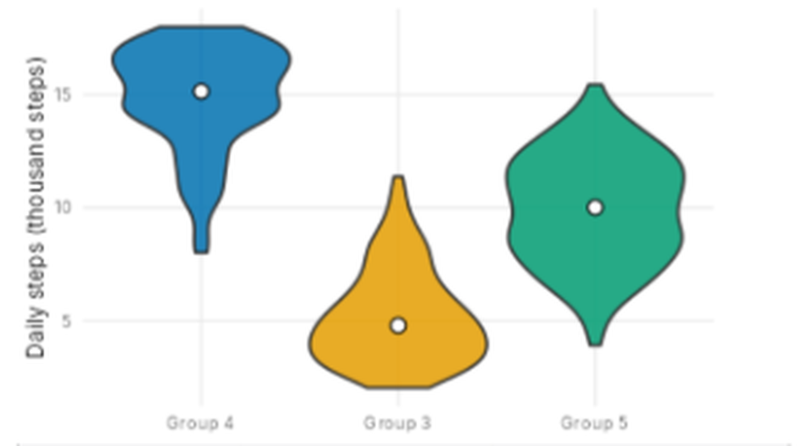
Violin | Skew | Mean vs Median
Group 4 | Left skew | Mean < Median
Group 3 | Right skew | Mean > Median
Group 5 | Symmetric | Mean ≈ Median

Chart 2: Battery life (hours)
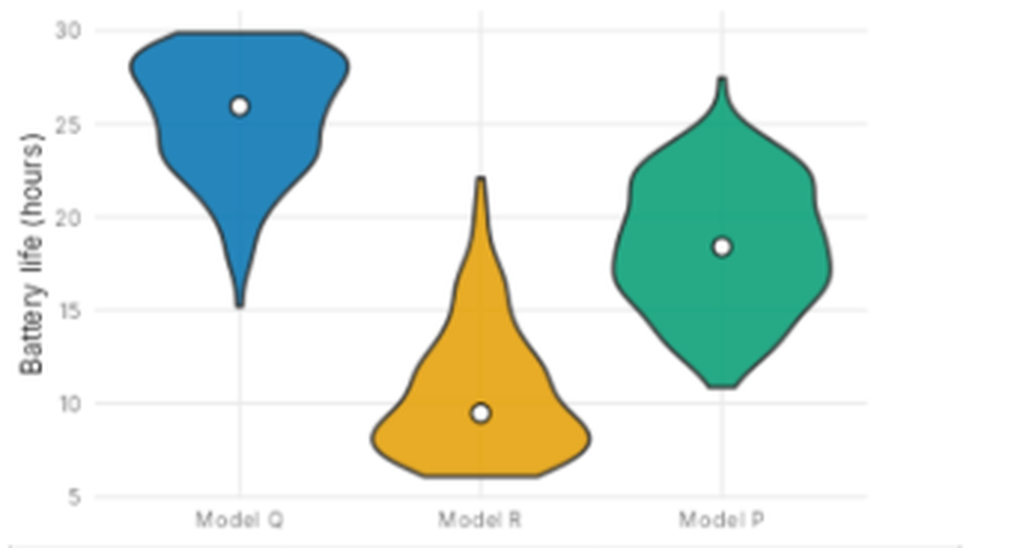
Violin | Skew | Mean vs Median
Model Q | Left skew | Mean < Median
Model R | Right skew | Mean > Median
Model P | Symmetric | Mean ≈ Median

Chart 3: Resting heart rate (beats per min)
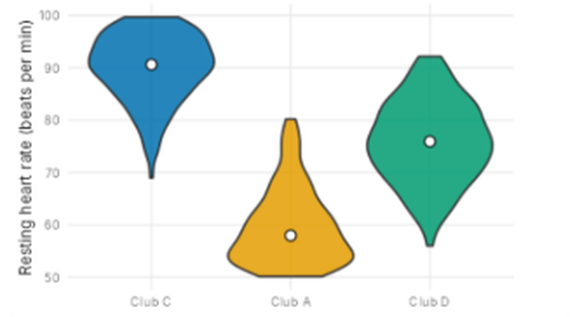
Violin | Skew | Mean vs Median
Club C | Left skew | Mean < Median
Club A | Right skew | Mean > Median
Club D | Symmetric | Mean ≈ Median

Chart 4: Delivery time (minutes)
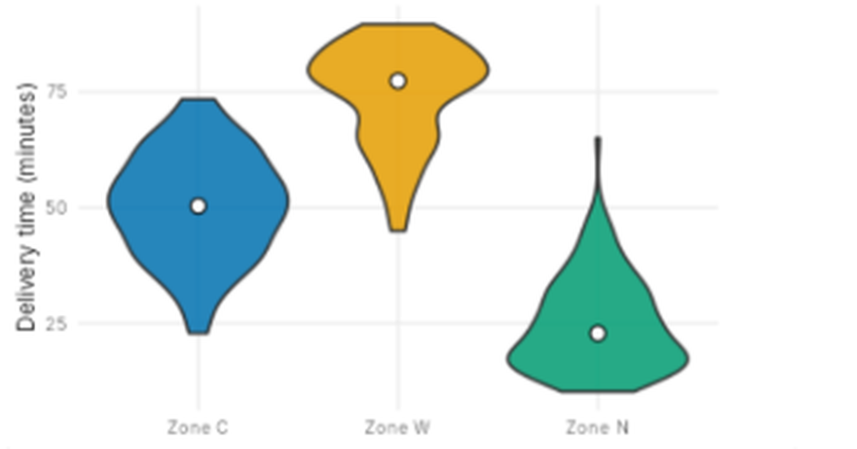
Violin | Skew | Mean vs Median
Zone C | Symmetric | Mean ≈ Median
Zone W | Left skew | Mean < Median
Zone N | Right skew | Mean > Median

Part B (2 marks)
B1. In Chart 1, violin "Group 4" is not symmetric. Towards which side is its tail, and which is the better measure of a typical daily steps here: mean or median? Give one reason. [1]
Answer: The tail of Group 4 is on the left (towards the lower step counts, about 8 to 12 thousand steps), so it is left-skewed. The median (about 15 thousand) is the better measure of typical daily steps, because the long left tail of low values pulls the mean down below where most of the group lies (the wide part of the violin at about 15 to 18 thousand), whereas the median is not affected by these extreme low values.
B2. Write one ggplot2 line that draws violins of value for each group from a data frame df (columns group, value), with the median shown. [1]
Answer:
ggplot(df, aes(x = group, y = value)) + geom_violin() + stat_summary(fun = median, geom = "point", colour = "white", size = 3)

