Every day, mobile applications are being developed, and they are used to solve many real-world problems and make human life easy. With the help of millions of mobile applications, these problems have been addressed, and solutions have been helping humankind. This roadmap paper addresses the problem which we face in everyday life when we move to a new home address and updating the address in several locations like banks, insurances, government organisations, clubs, employment organisation, and many more. As the problem increases, the need for a mobile application to solve this problem has been identified. Users can use this application and update their new address location through a centralised repository, and it saves time for the users. As people migrate to new places, this application will become handy in updating their address. The following sections demonstrate the mobile application and how it solves the problem and saves time for the users to update their new address in multiple locations.

Abstract

Teja Kumar Reddy Kovvuri

Email :- ktkr9013@live.com

Towards Designing a Novel Android Application for Updating Address and Seamless Moves

# Introduction

Domicile is a mobile application which will help the users to update their addresses when they move to a new house. It is a centralized location to change the user’s address in all the required locations like banks, education institutions, Government locations like VicRoads, clubs, gyms, Telecommunication companies, Local Libraries, Car Insurance Companies, Health Insurance Companies and many more. Whenever a user moves to a new house, he must change his/her address in so many locations. It is a repetitive process for him/her to update by going to all the websites and change the address. This will application reduce the burden of the repetitive process by providing all the links at one location (in the application).

## Market Research and Motivation

Through my market analysis, I did not find an app which is solving this problem. There are no similar apps which accommodates to solve this problem.

The motivation came from me when I moved to a new house and the hassle I to go through to update my address in multiple locations like banks, educational institution, and Government locations.

## Overview

This app was named as “domicile” which is synonym for address which is related to our problem. For now, this application will retrieve and provide the list of all applications which the user needs to change his new home address. The applications are like CommBank, ANZ, and Optus.

## Background and Summary of the intended product

The user to create an account and supply his new address in the mobile application. The application will then provide the list of locations where the user needs to update his address in. In this way, the user can directly click on the links and go to the website location and update his address easily. This application will save time for the user from traditional approach where the user must do the same process separately.

## Competitor Analysis

Currently, there are no similar applications which deal with this problem. The user currently updates his address by manually visiting all the sites where he needs to update the address.

# Features

## Asset list

As part of the prototype development from project proposal to project delivery, several tools and technologies are used for the prototype implementation. The following assets will be utilized:

* Figma:

Figma is useful for design of the prototype. It gives the initial look and feel of the application where it covers the UX/UI of the application.

* GitHub:

GitHub is used as a repository for maintaining the code and can be shared with anyone easily. I will create a repository for my project and commit the changes regularly to the repository so that I will not lose the code/project if anything goes wrong with local machine.

* Android Studio:

Android studio is used to build the mobile application. It has many built-in functions, and pallet with different components which makes it easy for me to design and develop the application.

* Android Studio Emulator:

The emulator is used to run the application once it was developed. I will perform thorough testing to see my changes in the mobile device.

* MySQL:

I will useMySQL as my database to save the informationby connecting it with the front-end.

### Java:

For this project, I will use Java programming to implement the components, Intents, Fragments, and necessary elements for my mobile application.

### Microsoft Teams:

I will use Microsoft Teams to communicate with other students, and unit chair and seek help from them and share ideas with them for my project. I will also give suggestions to other students

### Android device:

After implementation of a big factor/element, I will test that using my Android device to observer the behavior of the application and apply changes as well.

## Product Purpose

The target audience for this mobile app are people who use the Utilities and Travel apps. The below chart shows that the usage of these apps is 6.12% for Utilities and 3.8% for Travel. This app will target these users and shows creativity by reducing the time and makes it as a centralized repository to update their address.

This is a simple and easy to use application for users and they will get benefitted by using this application.

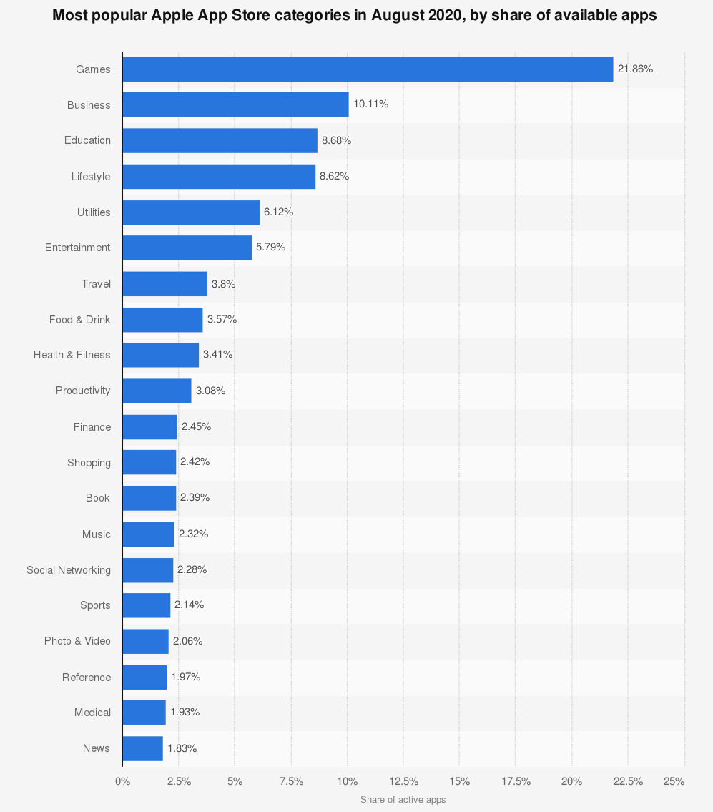

Figure 1Most Popular App Categories [1]

## Complex components

### Login functionality

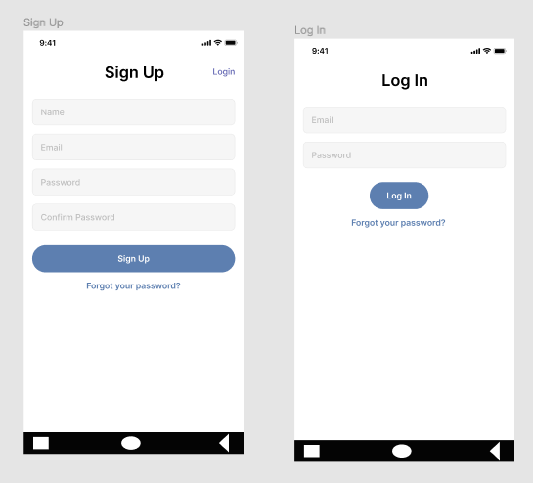

The user will be provided the facility to register in the application and then he/she will be asked to login to the application. If the user already gets registered, then he/she can click on the “Login” link on top right of the screen or he/she can also click on the “Forgot your password?” link to reset his/her password.

### User Story 1:

|  |  |  |  |
| --- | --- | --- | --- |
| Statement | Acceptance Criteria | Estimation | Priority |
| As a new user on the Domicile app, I want to Register in the application and login to it. | 1. User friendly design of login and register screens. 2. When the user starts the application, the signup screen will be presented. 3. By supplying the details and clicking on Sign Up, the user will register into the application. 4. Once the user registers, the user will be taken to the login screen. 5. The user can then supply the login details to login to the application. 6. The user can click on the “Forgot your password?” Link to reset his password if he forgets his password. | By using the planning poker technique to estimate the story points.  **Story Points: 8** | **Priority: 1**  High Priority |

### 2) Entering the user’s updated address

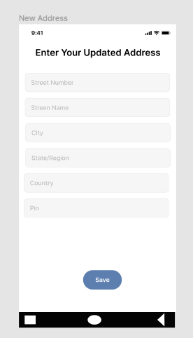

Once the user login to the application, he/she will be prompted to provide his updated address and save that in the database. The user will then be provided these details in the next fragment.

### User Story 2:

|  |  |  |  |
| --- | --- | --- | --- |
| Statement | Acceptance Criteria | Estimation | Priority |
| As a user, after logging in to the application I want to supply my updated address. | 1. User friendly design of Update address screen. 2. The user will enter his Street Number, Street Name, City, State/Region, Country, and Pin. 3. The user will click on the Save button to save the updated address. | By using the planning poker technique to estimate the story points.  **Story Points: 8** | **Priority: 1**  High Priority |

### Locations

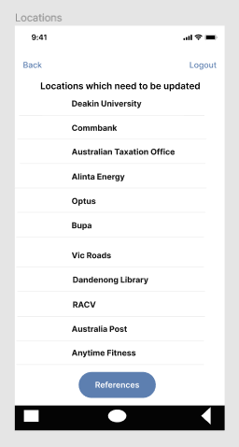

The Locations Screen provides the list of locations where the user needs to update his address in each of the provided locations.

### User Story 3:

|  |  |  |  |
| --- | --- | --- | --- |
| Statement | Acceptance Criteria | Estimation | Priority |
| As a user, I want to click on the links to navigate to the desired location to update my address. | 1. The user will click on the desired link to update his address. 2. The user can continue this process to update his/her address. | By using the planning poker technique to estimate the story points.  **Story Points: 8** | **Priority: 1**  High Priority |

### Website location to change the address (Ex: Deakin University)

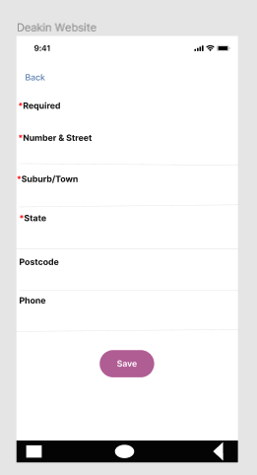

Once the user clicks on the Deakin University link, he/she will be taken to the Deakin University website. The app will supply the details to the relevant fields. The user will click on Save to save his details.

### User Story 4:

|  |  |  |  |
| --- | --- | --- | --- |
| Statement | Acceptance Criteria | Estimation | Priority |
| As a user, I want to use the application’s capability to insert the address details on the website and Save it. | 1. The application will fill the relevant fields with details. 2. The user will click on the Save button to save the details. | By using the planning poker technique to estimate the story points.  **Story Points: 8** | **Priority: 1**  High Priority |

### References

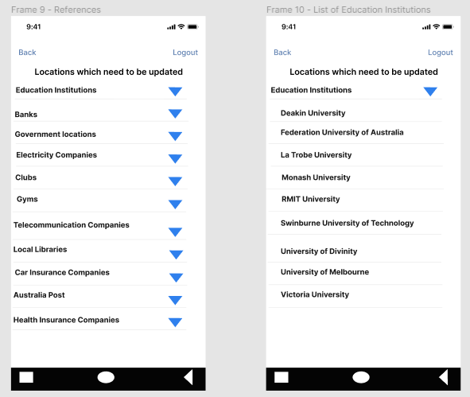

The user can navigate to References to see the different companies which are categorized based on their operations. The user has the flexibility to refer to this to remember any locations that he/she has his/her address details stored in the relevant company’s database.

### User Story 5:

|  |  |  |  |
| --- | --- | --- | --- |
| Statement | Acceptance Criteria | Estimation | Priority |
| As a user, I want to use the references screen to check for any companies that I registered my details in. | 1. The application provides all the categories to the user for reference. 2. The user can click on any category to see the list of companies in that category and that might help him/her to remember saving his details in those companies. 3. He/she could go and change their details in those sites with the help of the list. | By using the planning poker technique to estimate the story points.  **Story Points: 8** | **Priority: 1**  High Priority |

## Summary of how the system will function

The system will store the user’s login details, updated address, and supply them to the relevant fields when the user visits the location of the website. The user can then simply click the Save/Update button to Save the details.

# Milestones of the project plan

|  |  |  |
| --- | --- | --- |
| Description | Actual Man hours | Estimated Hours |
| User Interface   * The signup and login pages * Presenting the updated address to user * Presenting the user with list of locations * Forgot password page * Reference page   Database Creation   * Saving user address details * Make a connection between Database and interface   Logic   * Retrieving the list of locations with links * Accessing the link which navigates to the website * Providing the list of companies/institutions for each category | 70 hours | 80 hours |

# Detailed UX/UI Design: user Stories, Use Cases, URL to UX/UI Design etc.

## URL to UX/UI Design:

<https://www.figma.com/file/20gHl7I4hw3fFmHkubQ2I1/Domicile?node-id=0%3A1>

## User Stories:

|  |  |  |  |
| --- | --- | --- | --- |
| User Stories | Acceptance Criteria | Estimation | Priority |
| 1. As a user, I want to Register and login to the application. | 1. By supplying the data, the user will register and login to the application. | Story Point: 8 | High Priority: 1 |
| 1. As a user, I want to see the details I have entered. | 1. The user will be presented the details he entered in the application. | Story Point: 4 | Low Priority: 3 |
| 1. As a user, I want to select the desired location to update the details | 1. The user will be given the details he/she has entered, and user can use them. | Story Point: 5 | Low Priority: 3 |
| 1. As a user, I want to see the list of companies based on categories. | 1. The user will be given the list of companies according to categories which will help the user remember any more locations where he needs to change the location. | Story Point: 6 | Low Priority: 3 |

## Use Cases:

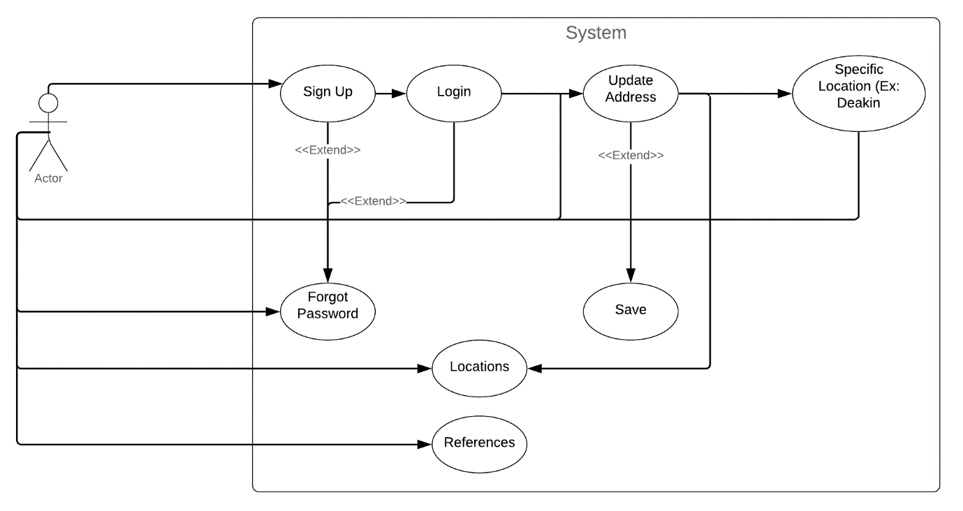

Figure Use Case Diagram

# High Level Wireframes

With the help of Figma I have designed the Wireframes which will demonstrate how my mobile application “Domicile” works.

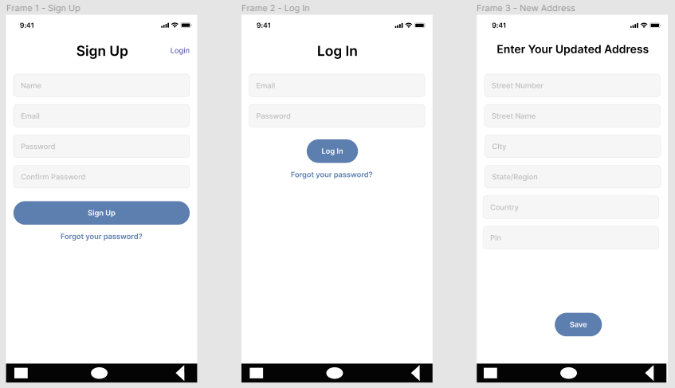

In the above screenshot, the first three screens (Sign Up, Log in, and Enter Your Updated Address) are presented.

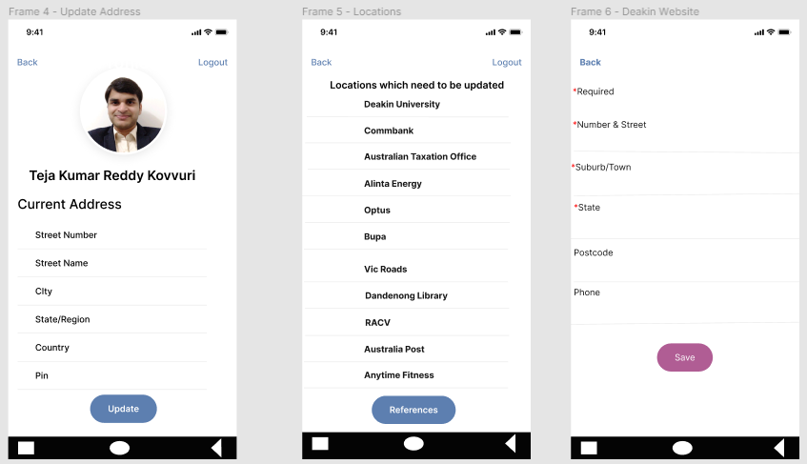

In the above screenshot, the next three screenshots (Update Address, Locations, and Deakin Website) are presented.

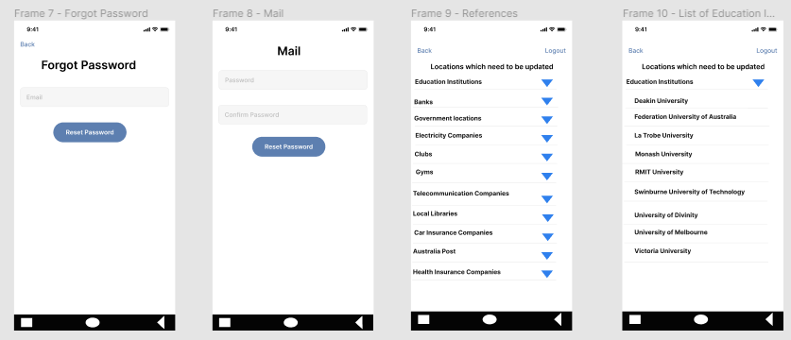

In the above screenshot, the last four screenshots (Forgot Password, Mail, References, and List of Educational Institutions) are presented.

# Resources required (Optional)

The following resources are required for my project:

1. Android java courses: These courses are required for me to upskill in different components which I use in my application.
2. Android studio: Gaining familiarity with Android Studio is highly essential for me to develop my mobile application. I will gain this through the courses.
3. Figma: To update the prototype design and wireframes, I will use Figma to make the modifications before implementing them.

# 7. Minimum Viable Product (MVP) functionality

The following process describes how a user can navigate in the application:

1. The user clicks and opens the app.
2. The user can signup to register by supplying his email address.
3. The user will then be redirected to Login to login to the application.
4. He/She then supply his/her updated address which will be used later in the locations for address update purposes.
5. The user will be presented with details he entered in the next screen.
6. In the next screen, the user will be presented the locations where he/she has to update his/her address.
7. If a user clicks on a specific location, the user will be taken to that location and he/she can update his/her address in that location. The app will show provide the address (data) the user has entered at the beginning.
8. Once the user is happy for updating the details, he/she can save the changes.
9. If the user wants to see the list of companies to remember any other places where his/her details reside.
10. If the user forgets his/her password, he can use the Forgot Your Password? Link to reset his/her password.
11. Finally, the user can logout using the logout link.

# 8. Performance analysis and Future Directions

Rigorous testing will be conducted on the application over the Transport layer protocols including TCP [2] and multipath TCP [3], among others over widely used WiFi and Cellular networks [4]. The ways to plug and play our apps for advances in distributed computing such as federated learning [5] and distributed ledger [6] will be sought for the future enhancements.

# References:

[1] fullestop. "Mobile App Usage Statistics 2021 for Growth & Success." <https://www.fullestop.com/blog/mobile-app-usage-stats-2021/> (accessed 03 April 2021.

[2] S. R. Pokhrel and C. Williamson, "Modeling compound TCP over WiFi for IoT," *IEEE/ACM transactions on networking,* vol. 26, no. 2, pp. 864-878, 2018.

[3] S. R. Pokhrel, M. Panda, and H. L. Vu, "Analytical modeling of multipath TCP over last-mile wireless," *IEEE/ACM transactions on networking,* vol. 25, no. 3, pp. 1876-1891, 2017.

[4] S. R. Pokhrel and M. Mandjes, "Improving multipath TCP performance over WiFi and cellular networks: An analytical approach," *IEEE Transactions on Mobile Computing,* vol. 18, no. 11, pp. 2562-2576, 2018.

[5] S. R. Pokhrel and J. Choi, "Federated learning with blockchain for autonomous vehicles: Analysis and design challenges," *IEEE Transactions on Communications,* vol. 68, no. 8, pp. 4734-4746, 2020.

[6] S. R. Pokhrel, "Blockchain Brings Trust to Collaborative Drones and LEO Satellites: An Intelligent Decentralized Learning in the Space," *IEEE Sensors Journal,* pp. 1-1, 2021, doi: 10.1109/JSEN.2021.3060185.