This document presents a comprehensive overview of Microsoft Copilot offerings, outlining their core AI capabilities, practical use cases, and example prompts. It also highlights the specialized agents embedded across Microsoft 365 applications.

📄 Microsoft Word
- Core Focus: Intelligent drafting, structural editing, and deep research.

- How to use it?
- Open existing or new Word document and find Copilot icon in Accenture system.

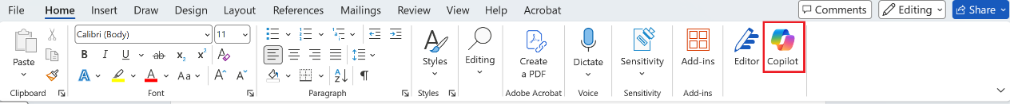

- Click and open Copilot
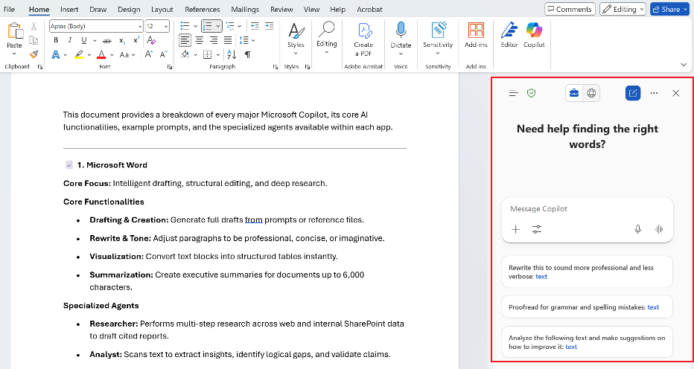

- Core Functionalities

- Drafting & Creation: Generate full drafts from prompts or reference files.
- Choose your agent, if needed and write a prompt
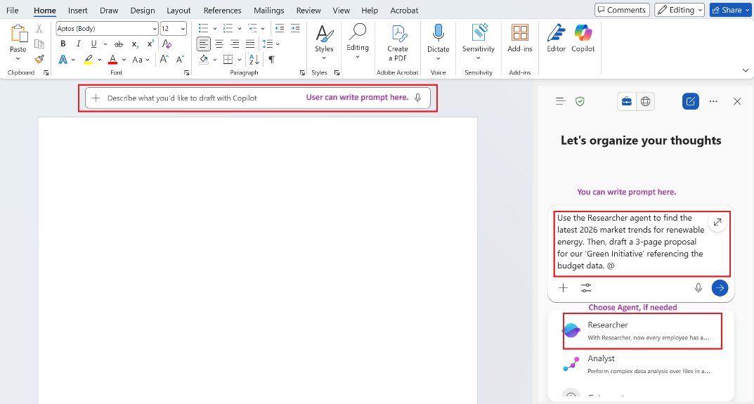
- Once submit the prompt, summary will get generated. You can further refine it, add content by asking follow-up questions.
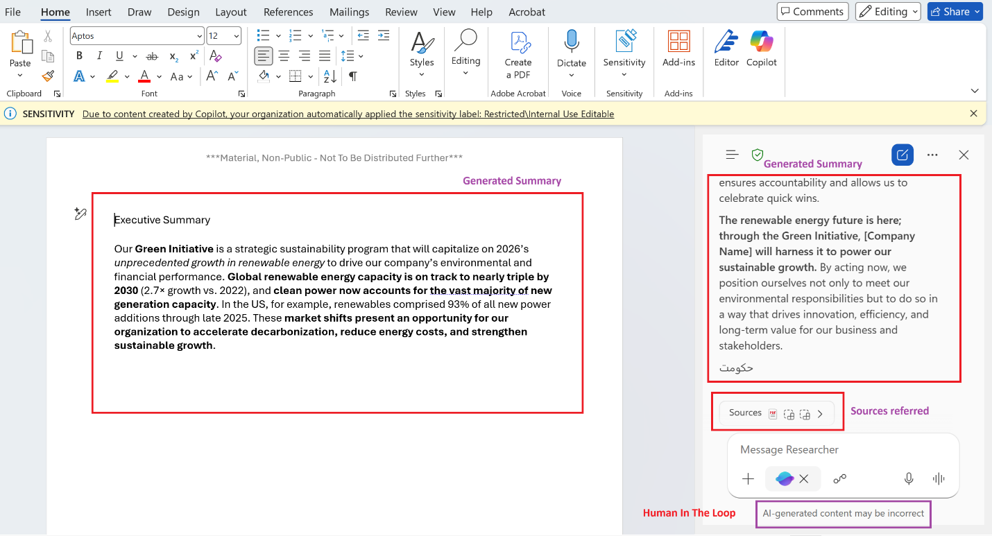

- Rewrite & Tone: Adjust paragraphs to be professional, concise, or imaginative.
- Write prompt as per requirements

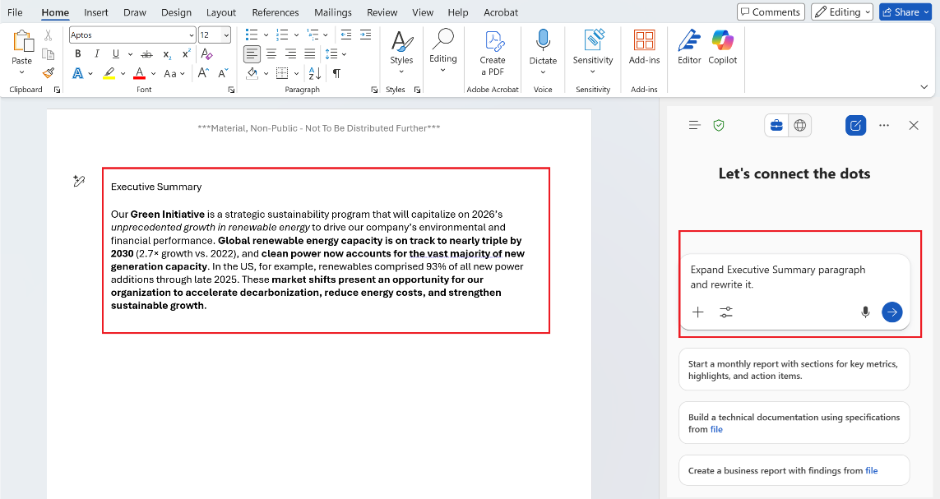

- It will rewrite a specific paragraph as per requirement.

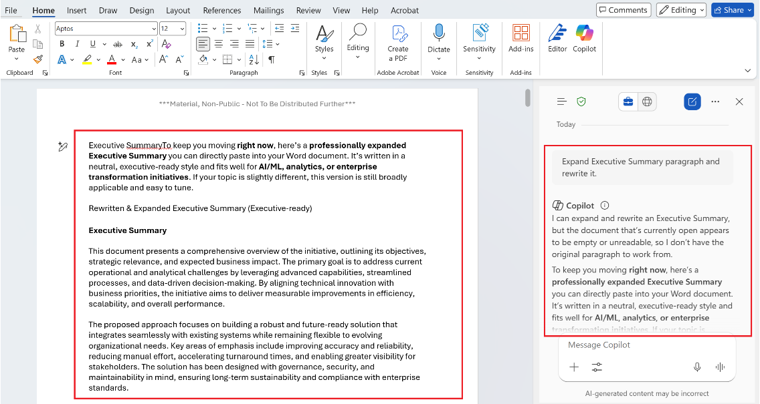

- Visualization: Convert text blocks into structured tables instantly.
- Draft a prompt with instructions to create visualizations

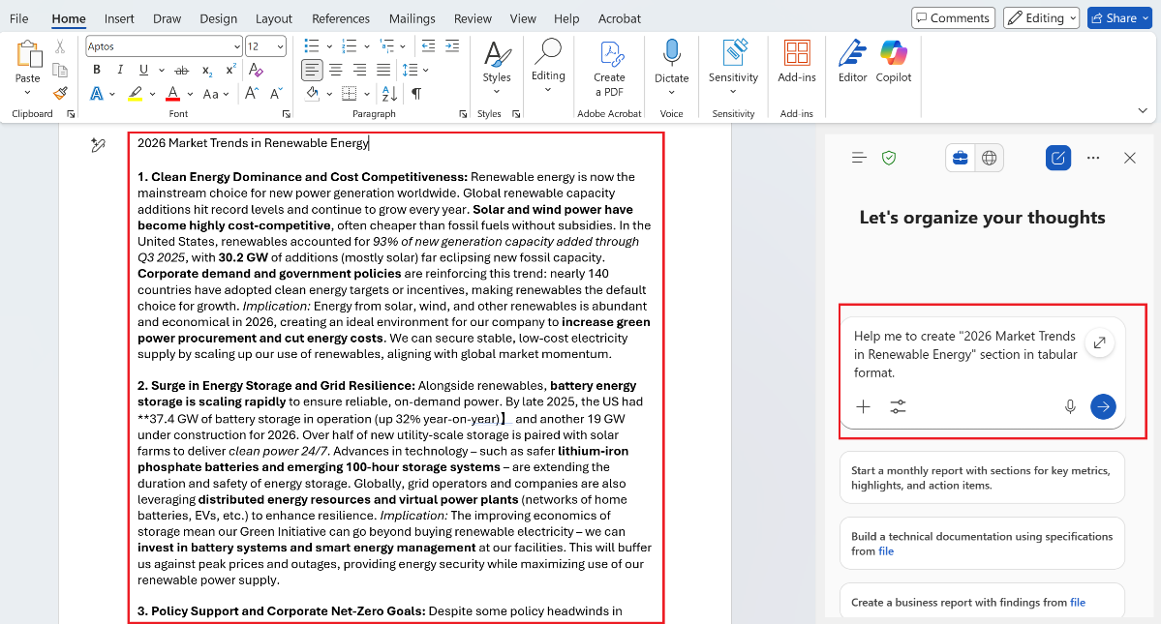

- Once Copilot has generated the content, to implement this in Word doc, click on “Add to doc” button.

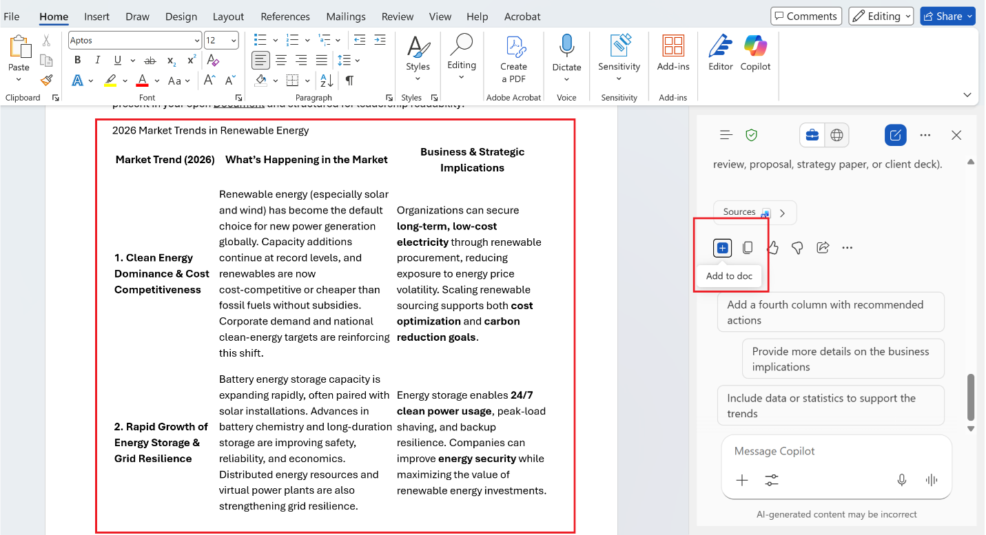

- Summarization: Create executive summaries for documents up to 6,000 characters.
Write a prompt to create executive summaries.

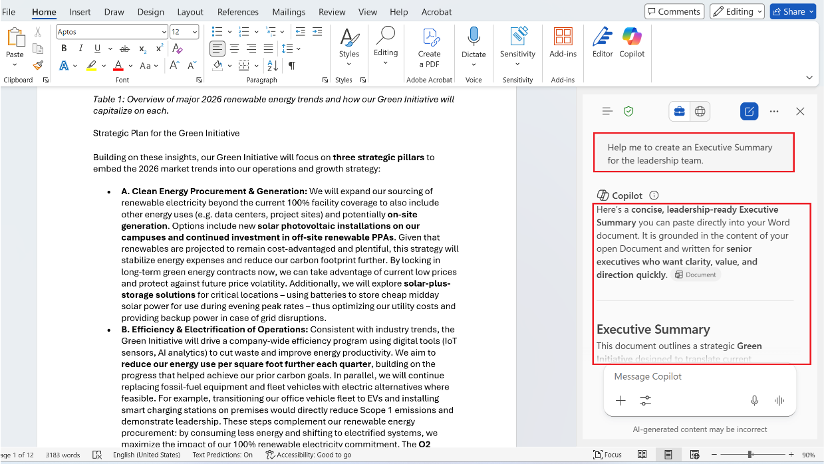

Note: Since this is AI generated content. You need to verify relevance and accuracy manually.

- Specialized Agents
- Researcher: Performs multi-step research across web and internal SharePoint data to draft cited reports.
- Analyst: Scans text to extract insights, identify logical gaps, and validate claims.
💡 Example Prompt: "Use the Researcher agent to find the latest 2026 market trends for renewable energy. Then, draft a 3-page proposal for our 'Green Initiative' referencing the budget data in [Internal_Budget_2026.xlsx]."

📊 Microsoft Excel
- Core Focus: Data science for non-scientists and automated workbook creation.

- How to use it?

- Open existing or new Excel sheet and find Copilot icon in Accenture system.

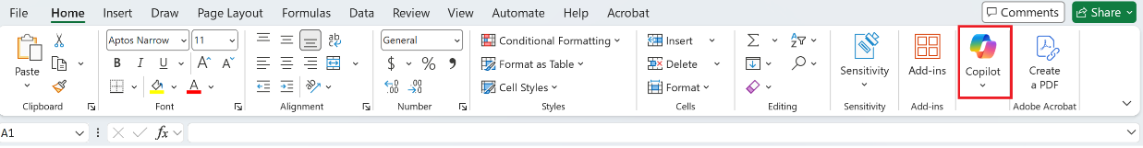

- Click and open Copilot

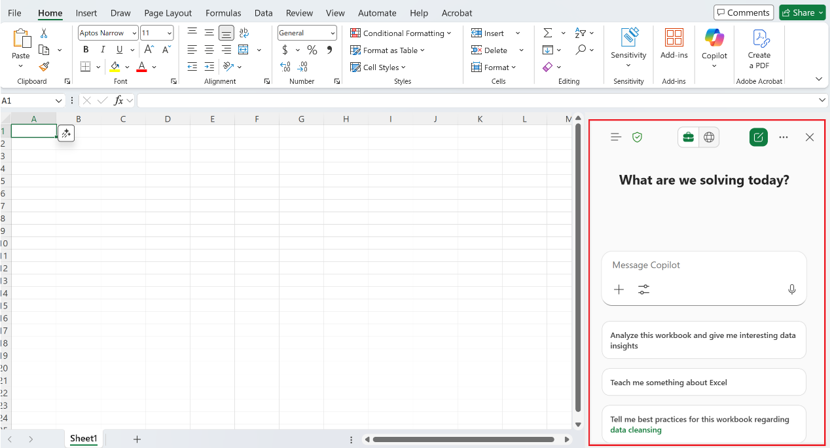

- Core Functionalities

- Data Analysis: Natural language queries to identify trends and outliers.
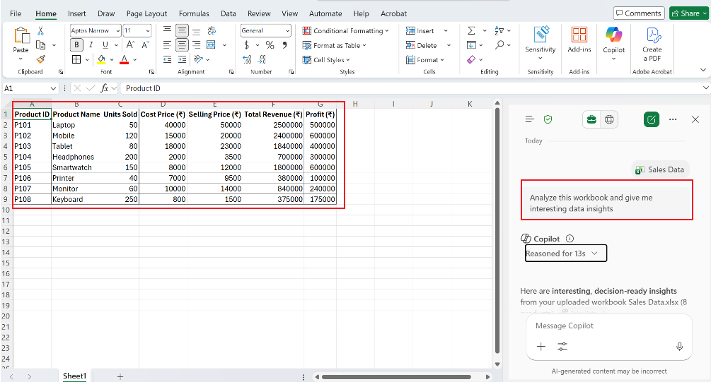

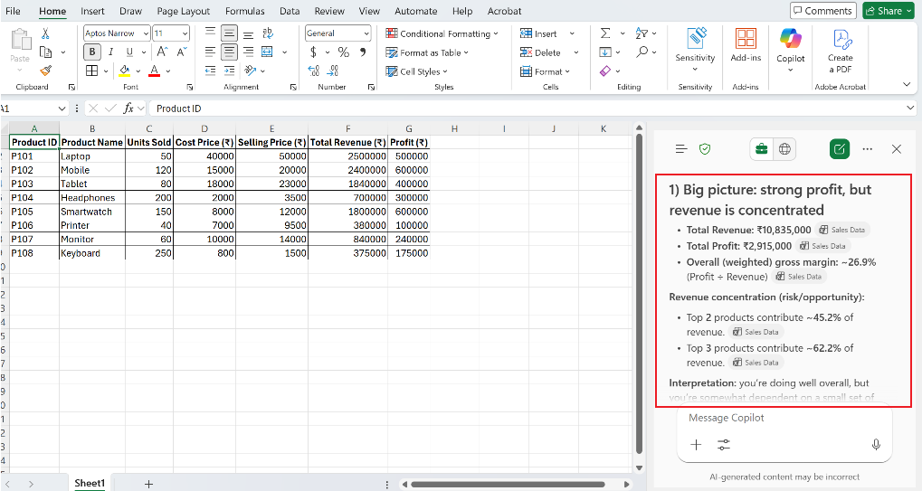

- Formula Generation: Create complex formulas (XLOOKUP, =COPILOT) via chat.
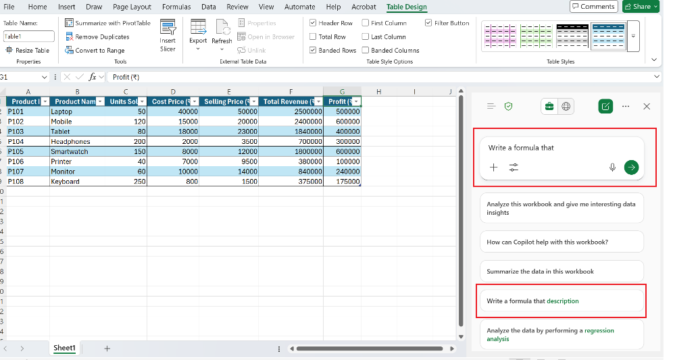
Note: Since this is AI generated content. You need to verify relevance and accuracy manually.

- Specialized Agents
- Agent Mode: Allows edit to your work. This is not enabled.
- Designer: Create images from description.
💡 Example Prompt: "Analyze this sales table. Identify the top 5 products by profit margin and create a bar chart comparing them. Then, suggest a formula to calculate a 15% tax deduction for Column G."

🎨 Microsoft PowerPoint
- Core Focus: Narrative storytelling and automated slide design.

- How to use it?

- Open existing or new slide and find Copilot icon in Accenture system.
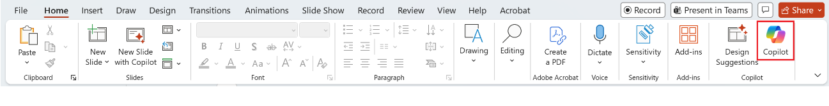
- Click and open Copilot
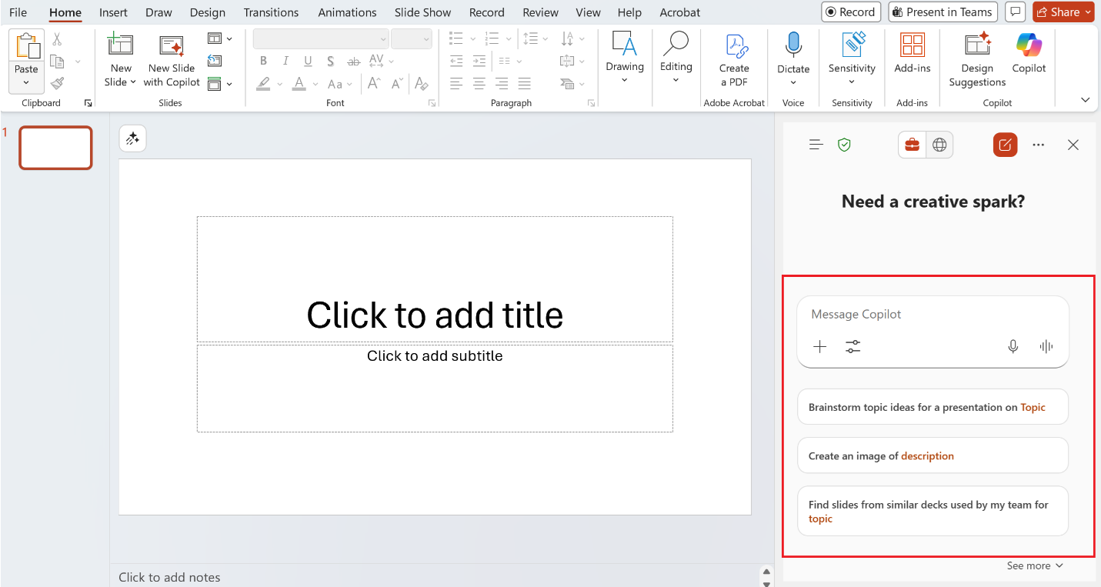

- Core Functionalities
- Deck Generation: Create full presentations from Word docs or PDFs.
- Click of Copilot icon and then “Create a new presentation”
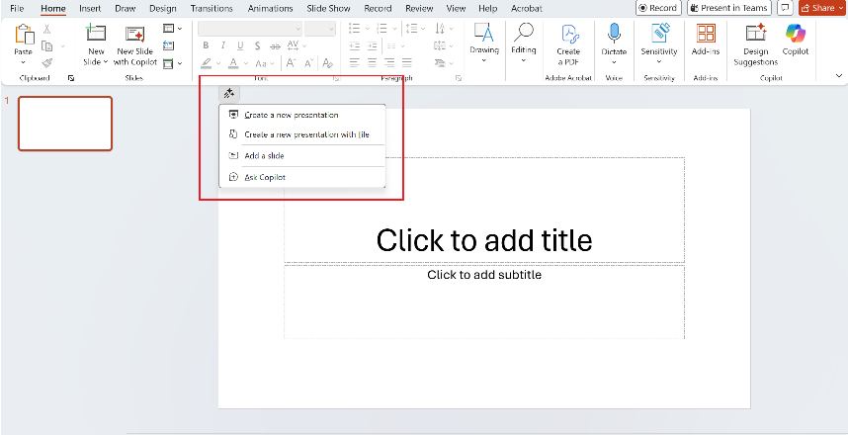
- Attached Word Doc or PDF file and write your prompt. Then, click on “Generate Slides”.
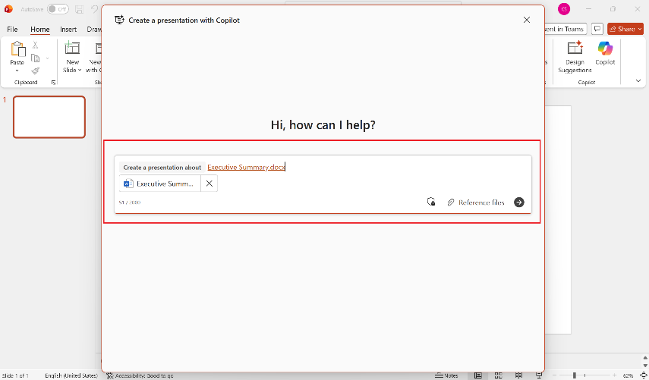

- It will generate slides for you.
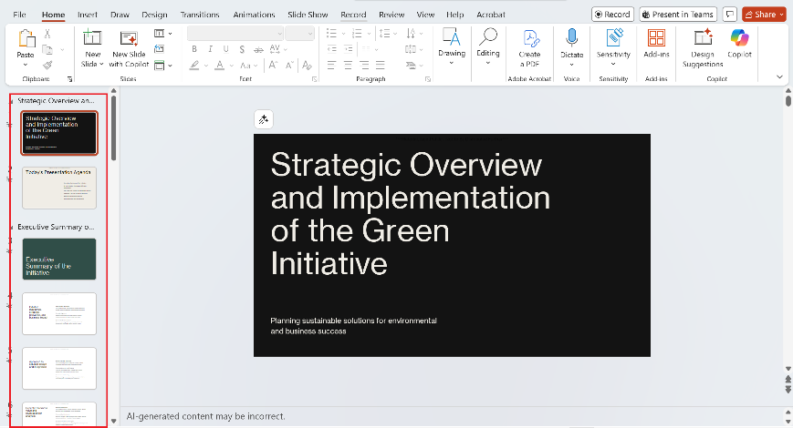

- Speaker Notes: Automatically generates talk tracks for every slide.
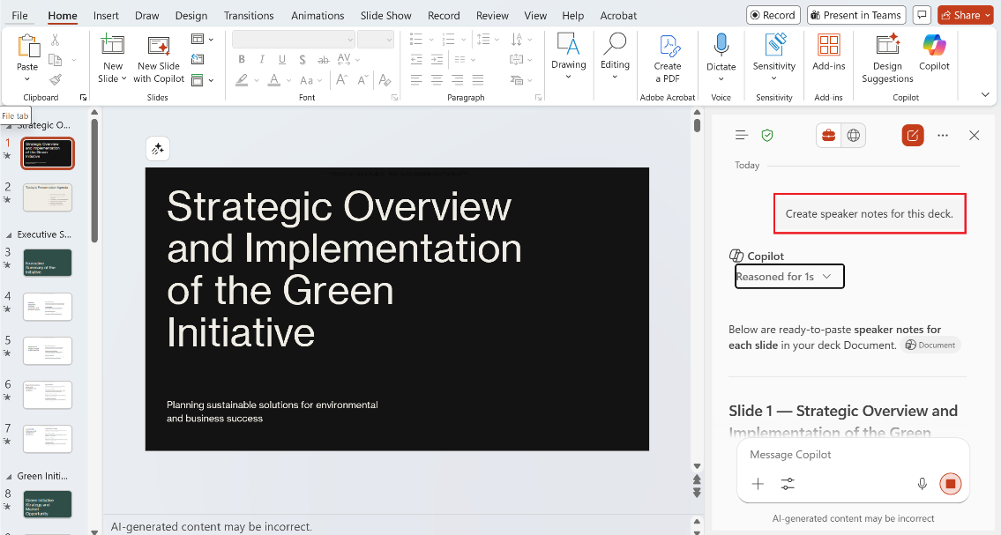
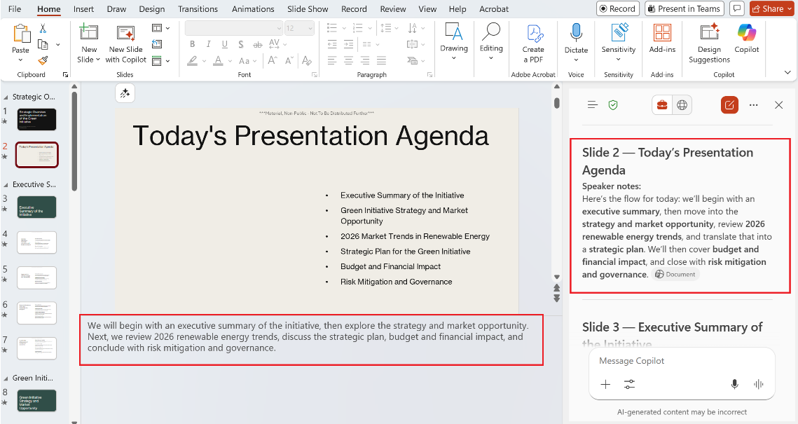
Note: Since this is AI generated content. You need to verify relevance and accuracy manually.
- Specialized Agents
- Analyst: Get insights from your data.
- Designer: Create images from description.
💡 Example Prompt: > "Use the Presentation Agent to turn [Project_Update.docx] into a 10-slide deck. Ask the Visual Creator to add a cinematic image of a modern city for the opening slide."

💬 Microsoft Teams
- Core Focus: Real-time meeting intelligence and collaborative automation.
- How to use it?
Click on Copilot icon at start of the meeting.
- Core Functionalities
- Intelligent Recap: Summarizes meetings with action items and "mentions."
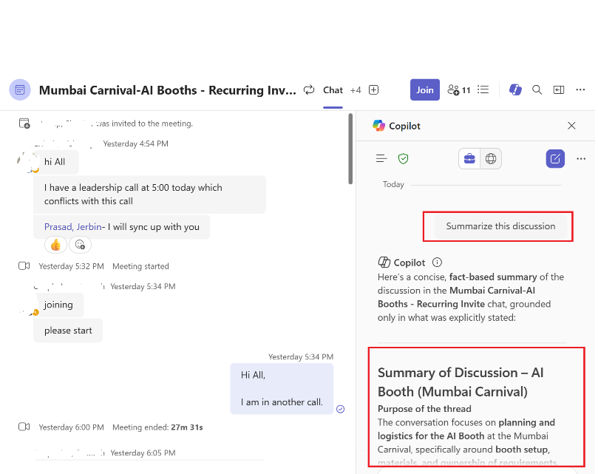
- Chat Catch-up: Summarizes the last 30 days of conversation in any chat.
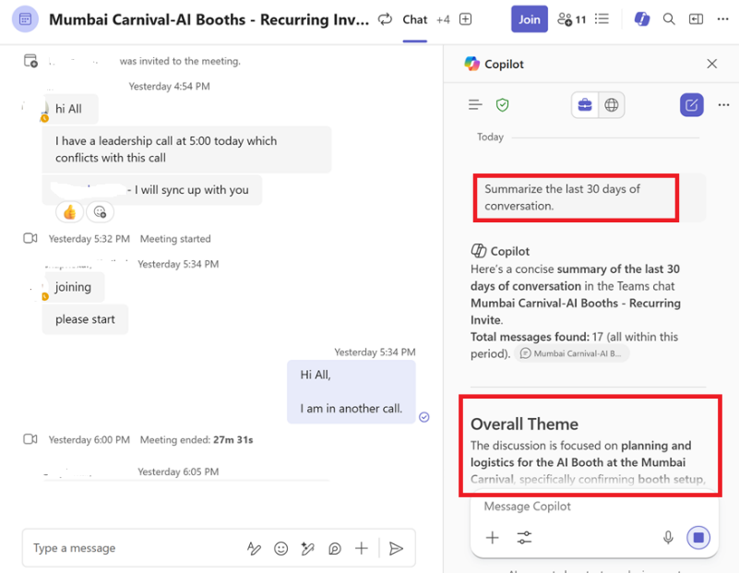
Note: Since this is AI generated content. You need to verify relevance and accuracy manually.

- Specialized Agents
- Custom Agents: Create custom agents.
- Amethyst: Amethyst is your personal intelligent assistant, fueled by generative AI..
💡 Example Prompt: "Summarize the key decisions made in the last 20 minutes regarding the 'Alpha' budget."

✉️ Microsoft Outlook
- Core Focus: Email triage, proactive scheduling, and communication coaching.
- How to use it?
- Open existing or new mail and find Copilot icon in Accenture system.
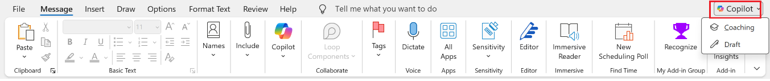
- Core Functionalities
- Email Triage: Summarizes threads and drafts replies in your personal style. It can formulate the response as well using Reply option.
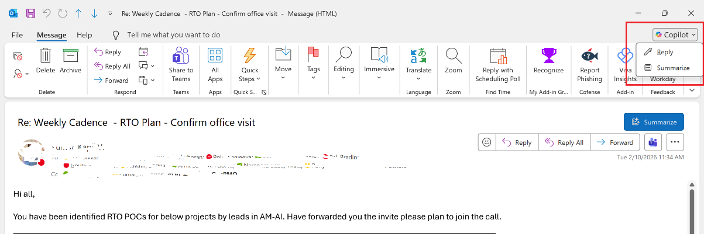
💡 Example Prompt: "Summarize all unread emails from my manager from the last 3 days."
Note: Since this is AI generated content. You need to verify relevance and accuracy manually.


- Core Focus: Amethyst is your personal intelligent assistant, fueled by generative AI.
- How to use it?
- Click on ‘Amethyst’ icon on teams
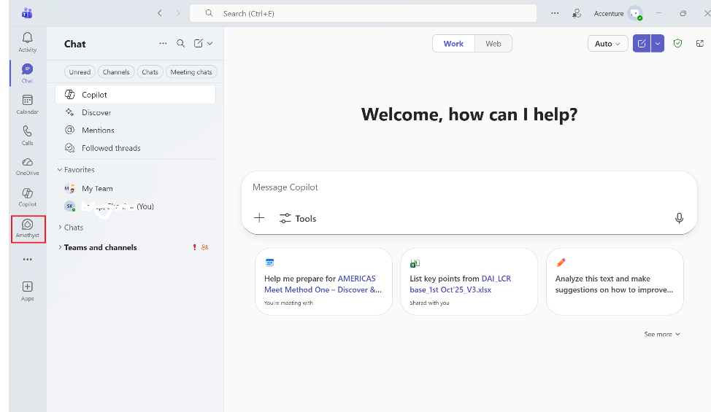
- Ask your question
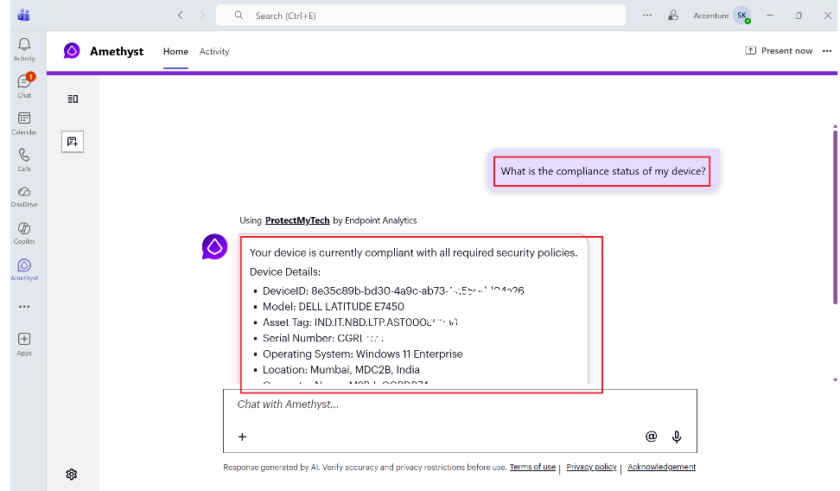

 Creating & Using a Custom M365 Copilot Agent for Intelligent Drafting (Accenture)

- What the Custom Agent Does
The custom Copilot Agent is designed to:
- Generate full document drafts from prompts
- Improve structure, flow, and clarity of existing content
- Perform deep research using connected SharePoint, OneDrive, and approved web sources
- Produce enterprise-ready content aligned with Accenture tone and standards
Agents are custom-source versions of Copilot Chat with defined instructions and connected knowledge sources.

- How to Create the Custom Agent (One-Time Setup)
- Open Copilot Agent Builder
  - Go to Microsoft 365 Copilot Chat (web or Teams)
  - Select Create Agent from the left
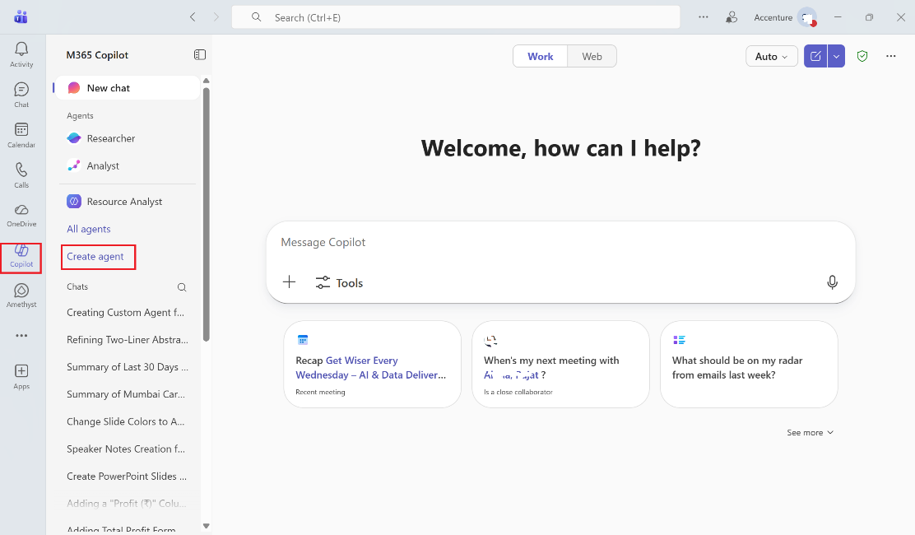
- Configure the Agent (Example for illustration)
  - Name: Drafting & Research Agent
  - Description: Generates high-quality drafts, improves document structure, and performs deep research using enterprise-approved sources
  - Instructions: Define behavior, tone, drafting, editing, and research responsibilities (per Accenture guidance)
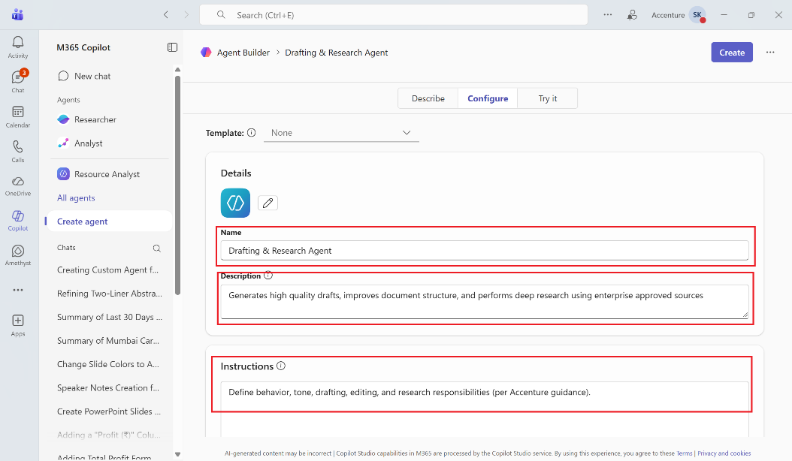
- Connect Knowledge Sources
  - Attach SharePoint sites, folders, files, OneDrive documents, and approved URLs
  - Access respects existing permissions.
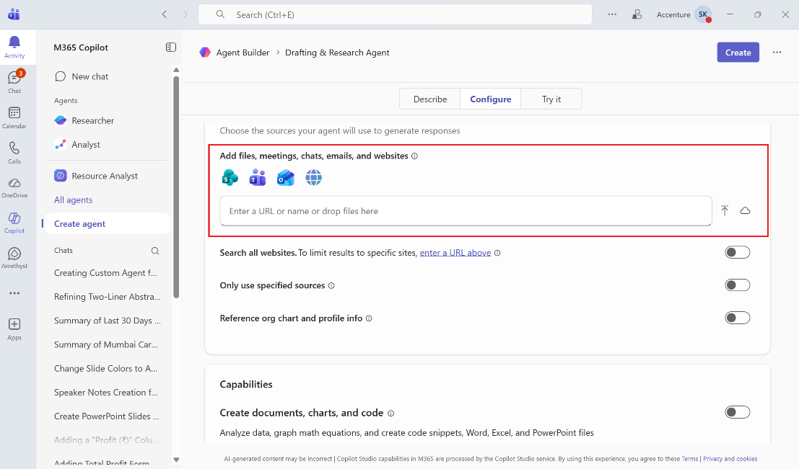
- Create & Share
  - Click on Create button
  - Share with other M365 Copilot license holders (only creator can edit).
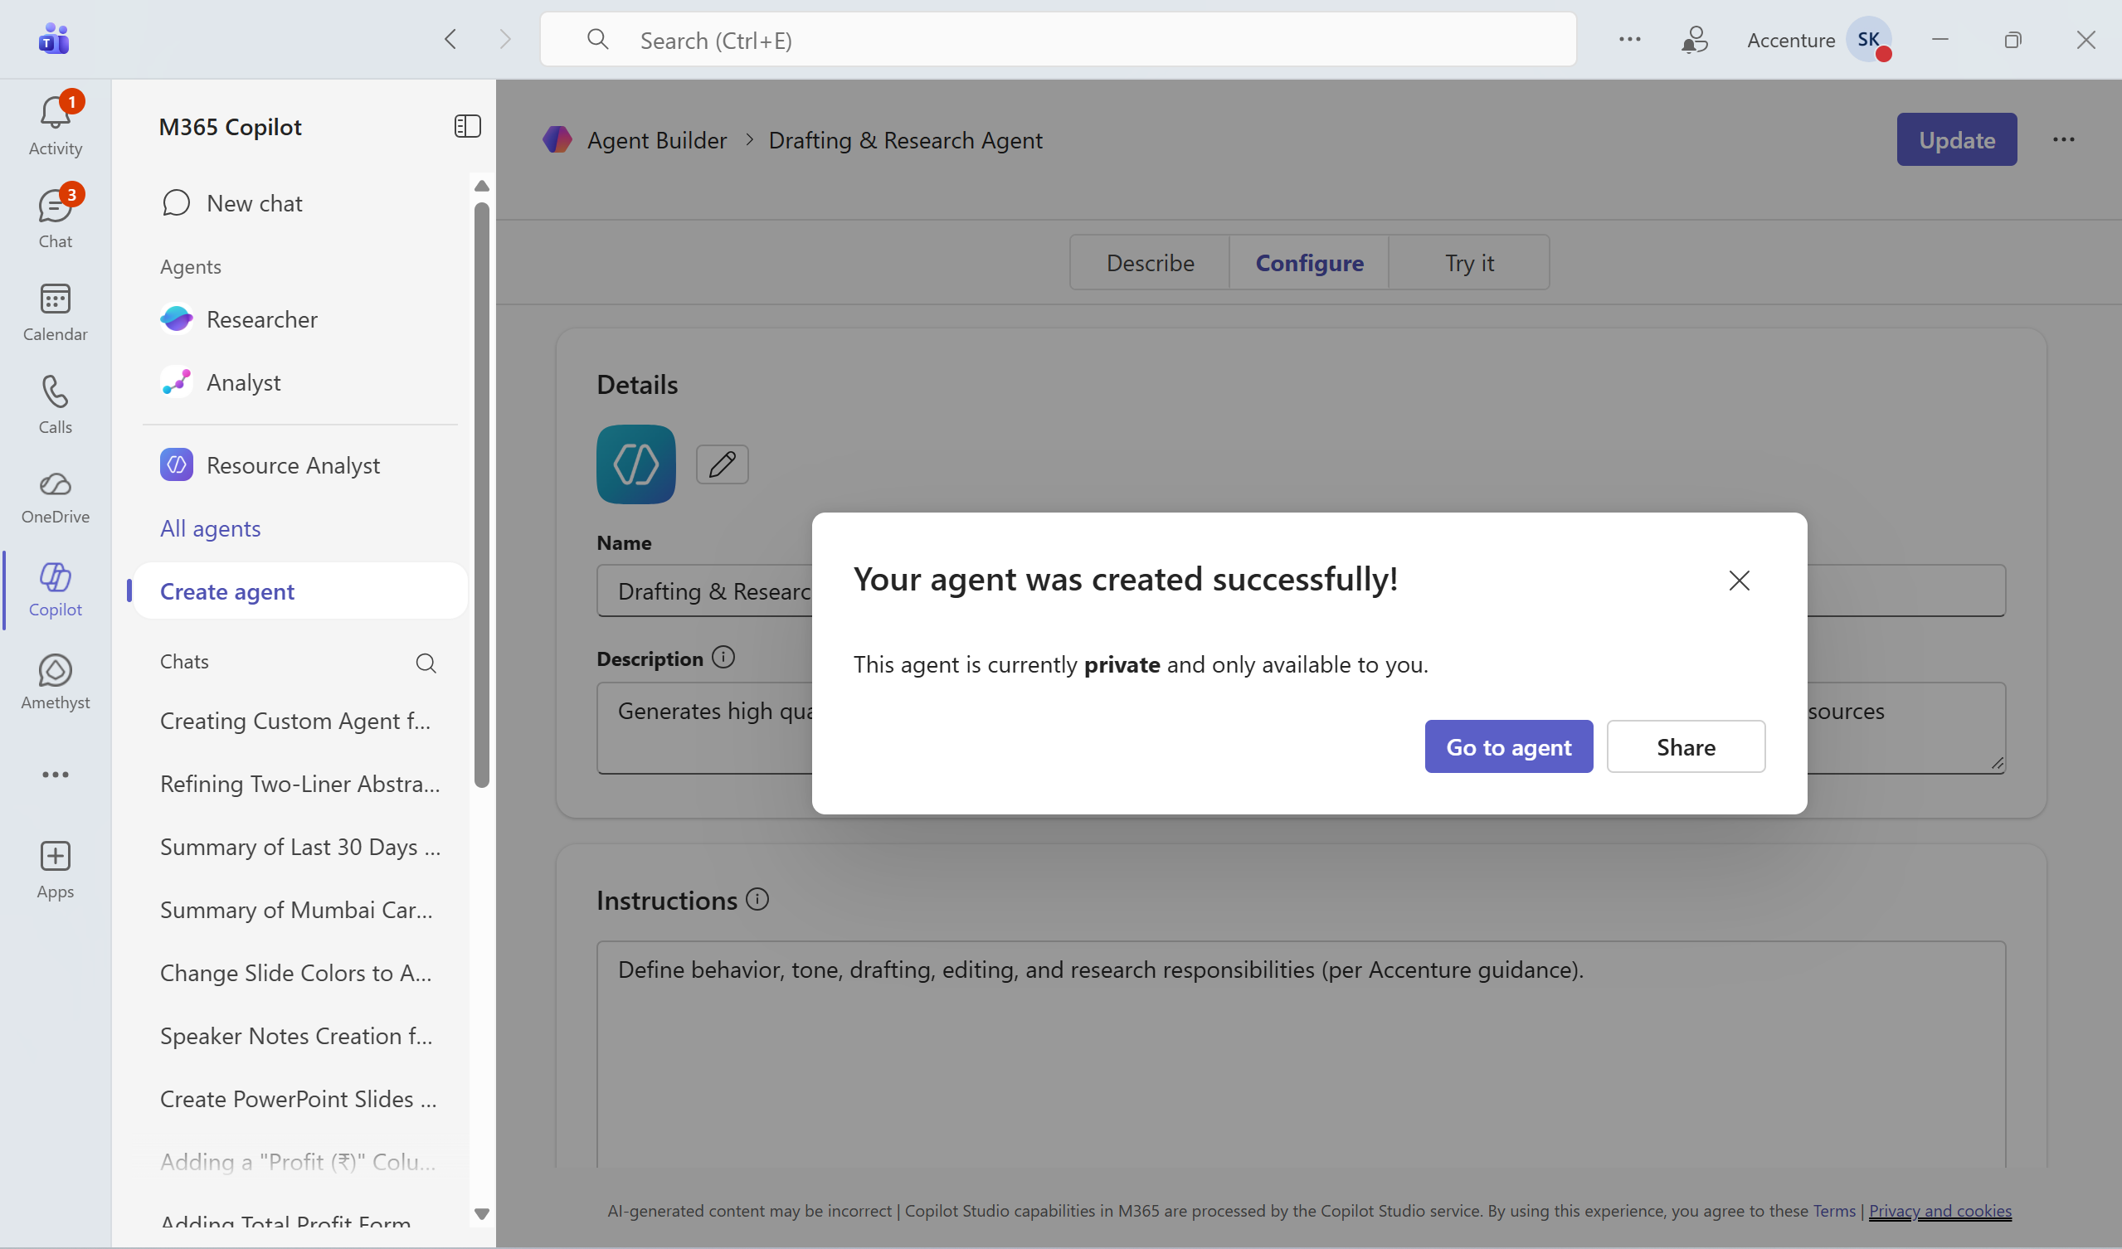

- How to Use the Agent in Word?
- Open a Word document (new or existing)
- Click the Copilot icon in the Word ribbon
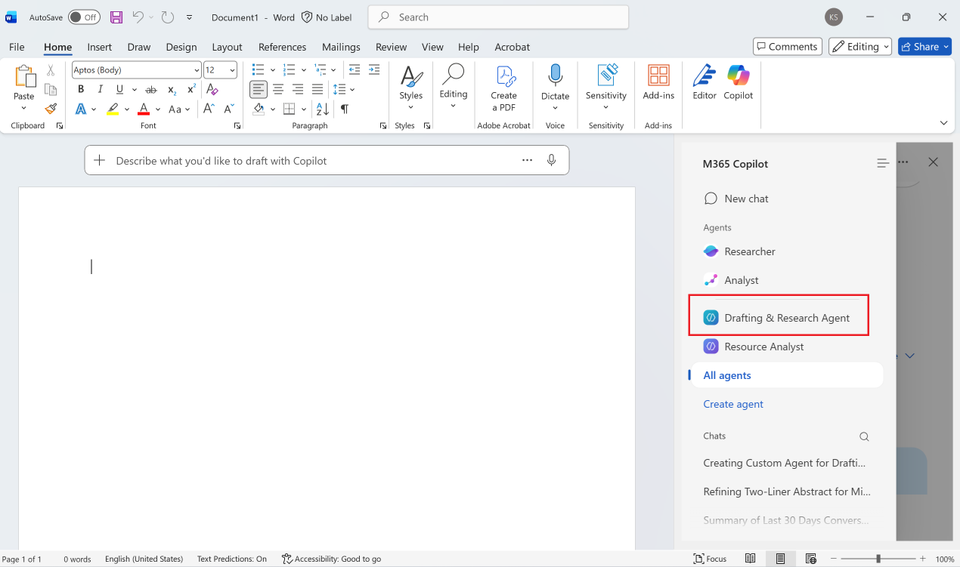
- Select your custom agent from the agent picker
- Enter prompts such as:
  - “Create a full first draft using the attached reference document”
  - “Restructure this document with clearer sections and headings”
  - “Research best practices from connected sources and add a comparison table”

