 | Hope Foundation's  International Institute of Information Technology, Pune-57  DEPARTMENT OF COMPUTER ENGINEERING

Mini Project Report

Academic Year: 2021-2022 Semester: I Year: B.E Date: / /2021

Mini Project Title: TESTING GMAIL AND AMAZON WEBSITE USING SELENIUM TOOL
Mini Project Domain: Software Testing

Team Members:
Sr. No. | Name | Mail-id | Contact No. | Signature
1 | Sejal Kalyankar | sejalkalyankar121@gmail.com | 90759 90997 | Sejal
2 | Tejal Jadhav | tejaljadhav798@gmail.com | 93702 19259 | Tejal
3 | Shraddha Jagtap | shrddhajagtap@gmail.com | 9370502876 | Shraddha

INDEX

1. Project Details
2. Abstract
3. Introduction
4. Technical Details
5. Algorithm: SELELNIUM TOOL
6. Output Snapshot
7. Conclusion

(Name and Sign of Students) (Name and signature of Project Guide)

- Project Details
  - Project Title:
TESTING GMAIL AND AMAZON WEBSITE USING SELENIUM TOOL
  - Group Members:
- Sejal Kalyankar (BC042)
- Tejal Jadhav(BC064)
- Shraddha Jagtap (BC072)

  - Problem Statement:
Gmail Website Random Testing with Selenium Tool And Amazon Website Testing with using Selenium Tool.

- Abstract
Software testing is but an art of investigating software to ensure that
its quality under test is in line with the requirement of the client. Software testing
is carried out in a systematic manner with the intent of finding defects in a system.
It is required for evaluating the system. As the technology is advancing we see
that everything is getting digitized.
Selenium is used to automate tests on websites to monitor their performance. It is a browser automation framework that accepts commands and sends them to a browser. It is implemented through a browser-specific driver. It controls the browser by directly communicating with it.
In the Gmail website testing Done with selenium Alternatively we can test the Amazon Website also with Selenium Test.
Execution of automation testing requires a comprehensive understanding of numerous automation tools and frameworks. Among all these tools, Selenium is the most popular due to its ease of use and relevant features. Selenium WebDriver is a web framework that permits you to execute cross-browser tests. This tool is used for automating web-based application testing to verify that it performs expectedly. Selenium WebDriver allows you to choose a programming language to create test scripts.

- Introduction
As we know the Unit testing having different types. Here is one of the Testing that is Hybrid Testing with Selenium. Execution of automation testing requires a comprehensive understanding of numerous automation tools and frameworks. Selenium is the most popular due to its ease of use and relevant features.
Unit Testing is a type of testing which is done by software developers. The goal of unit testing is to break each part of source code and check that each part works properly. Unit testing is done before integration testing. Unit Testing of software product is carried out during the development of an application.
What is Software testing?
Software testing is nothing but an art of investigating software to ensure that
its quality under test is in line with the requirement of the client. Software testing
is carried out in a systematic manner with the intent of finding defects in a system.
It is required for evaluating the system. As the technology is advancing we see
that everything is getting digitized. You can access your bank online, you can
shop from the comfort of your home, and the options are endless. Have you ever
wondered what would happen if these systems turn out to be defective? One small
defect can cause a lot of financial loss. It is for this reason that software testing is
now emerging as a very powerful field in IT.

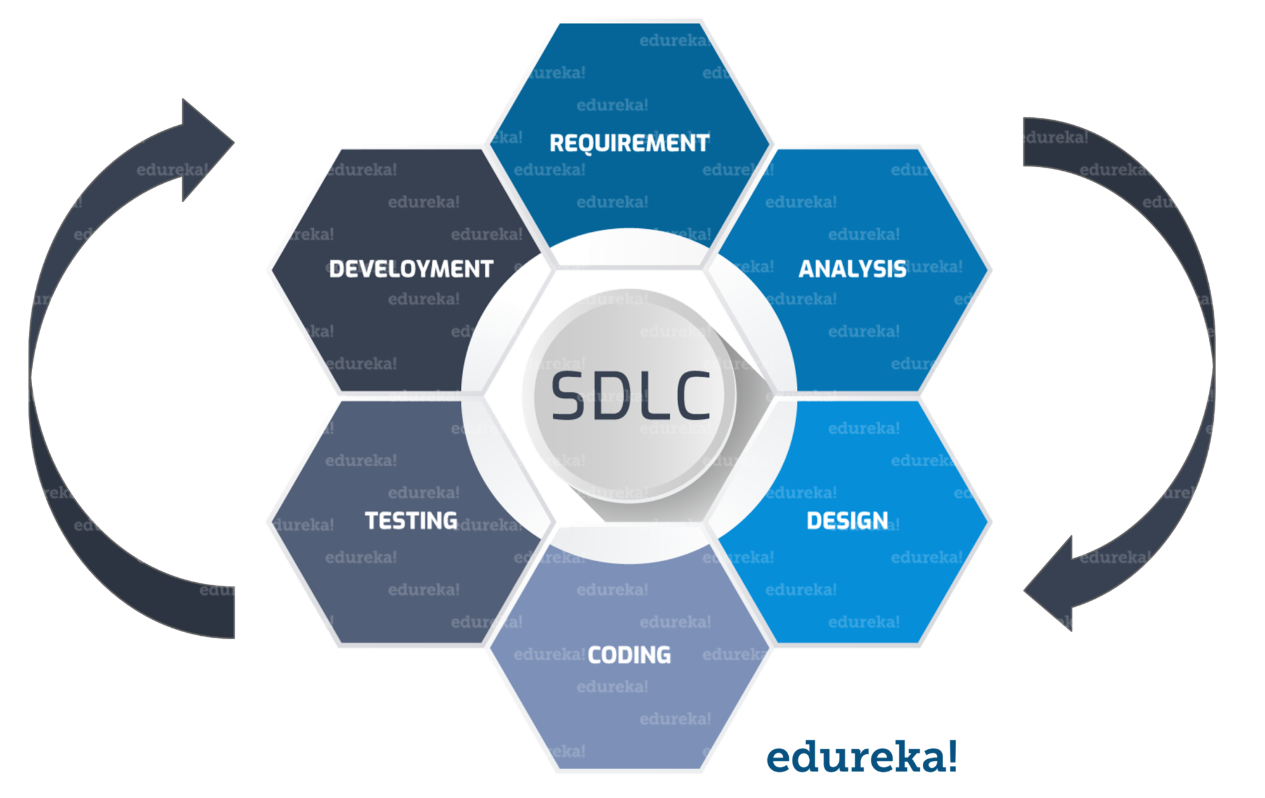

Selenium WebDriver is a web framework that permits you to execute cross-browser tests. This tool is used for automating web-based application testing to verify that it performs expectedly. Selenium WebDriver allows you to choose a programming language to create test scripts.
Selenium is used to automate tests on websites to monitor their performance.
It is a browser automation framework that accepts commands and sends them to a browser. It is implemented through a browser-specific driver. It controls the browser by directly communicating with it.

Type Of Testing
There are two main type of testing:-
1) Manual Testing.
2) Automated Testing.
1) Manual Testing :-
Manual Testing is a process of finding out the defects or bugs in a software
program. In this method the tester plays an important role of end user and verifies
that all the features of the application are working correctly. The tester manually
executes test cases without using any automation tools. The tester prepares a test
plan document which describes the detailed and systematic approach to testing of
software applications. Test cases are planned to cover almost 100% of the
software application. As manual testing involves complete test cases it is a time
consuming test.
The differences between actual and desired results are treated as defects. The
defects are then fixed by the developer of software application. The tester retests
the defects to ensure that defects are fixed. The goal of Manual testing is to ensure
that application is defect & error free and is working fine to provide good quality
work to customers.
Procedure of Manual Testing
1. Requirement Analysis
2. Test Plan Creation
3. Test case Creation
4. Test case Execution
5. Defect Logging
6. Defect Fix & Re-Verification
2 Automation Testing:-
Test automation has grown in popularity over the years because teams do
not have the time or money to invest in large test teams to make sure that
applications work as they are expected to. Developers also want to make sure that
the code they have created works as they expect it to.
Developers use a multitude of different testing frameworks to test different
aspects of the system. Selenium is one of the most well-known testing
frameworks in the world that is in use. It is an open source project that allows
testers and developers alike to develop functional tests to drive the browser. It can
be used to record workflows so that developers can prevent future regressions of
code. Selenium can work on any browser that supports JavaScript since Selenium
has been built using JavaScript. Software applications today are written as webbased applications to be run in an Internet browser. The effectiveness of testing
these applications varies widely among companies and organizations. In an era of
highly interactive and responsive software processes where many organizations
are using some form of Agile methodology, test automation is frequently
becoming a requirement for software projects. Test automation is often the
answer. Test automation means using a software tool to run repeatable tests
against the application to be tested. For regression testing this provides that
responsiveness.

- Technical Details
Software Requirements:
- Eclipse
- Java
- selenium.jar file
- Cromedriver.exe

Hardware Requirements:
- PIV (Personal Identification Verification)
- 2GB RAM
- 500 GB HDD (Hard Disk Drive)

5. SELENIUM TOOL:
Automation Tool-Selenium
Selenium:-
Selenium is a suite of tools to automate web app testing across many
platforms. Selenium...runs in many browsers and operating systems. Can be
controlled by many programming languages and testing frameworks.
• Create by developers at ThoughtWorks
• Released publically as an Open Source project on OpenQA
• Selenium is a test tool for web applications.
• Selenium tests run directly in a browser.
• Runs on Windows, Linux, and Macintosh.
• Runs in Internet Explorer, Mozilla and Firefox.
• Enables Browser Compatibility Testing.
• Enables System Functional Testing.
•
How it works:-
• Uses JavaScript and Iframes in the browser
• Core runs the tests and interrogates the DOM
• RC server and Core communicate via AJAX
• Language hooks communicate with the RC server.

Advantages of Selenium:-
• Open source, Free software
• Easy Installation
• Easy Record and Play back
• Supports Multiple operating systems
• Supports Multiple Browser Testing
• Can convert scripts in to other languages (Java, C#, Python)
• Easy to learn
• Script once, Run on multiple browsers
• Testing tool for browser-based testing of web applications. It can be used
both for functional, compatibility (it has extensive cross-browser support)
and regression testing

- Output Snapshot
Gmail testing :

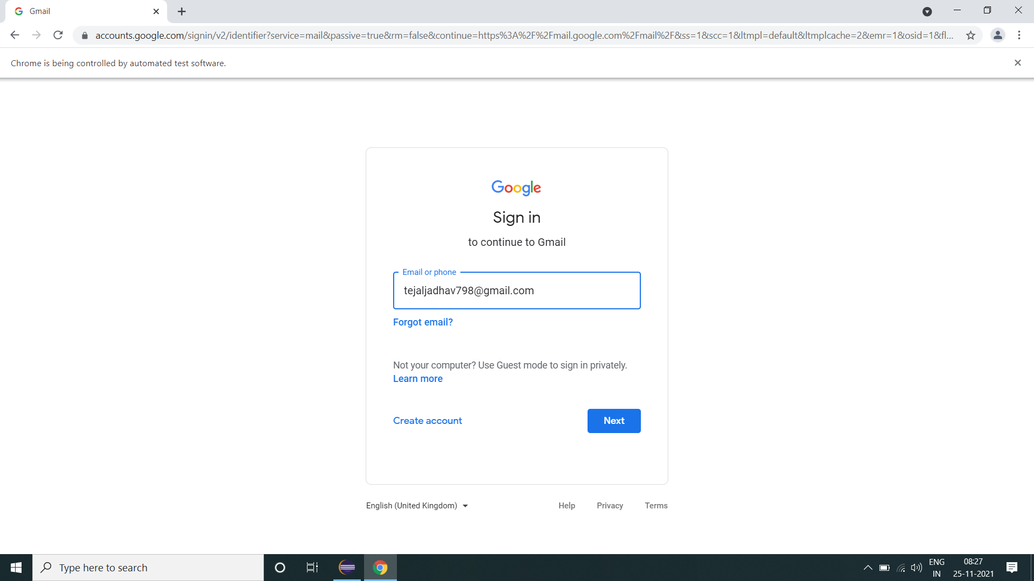

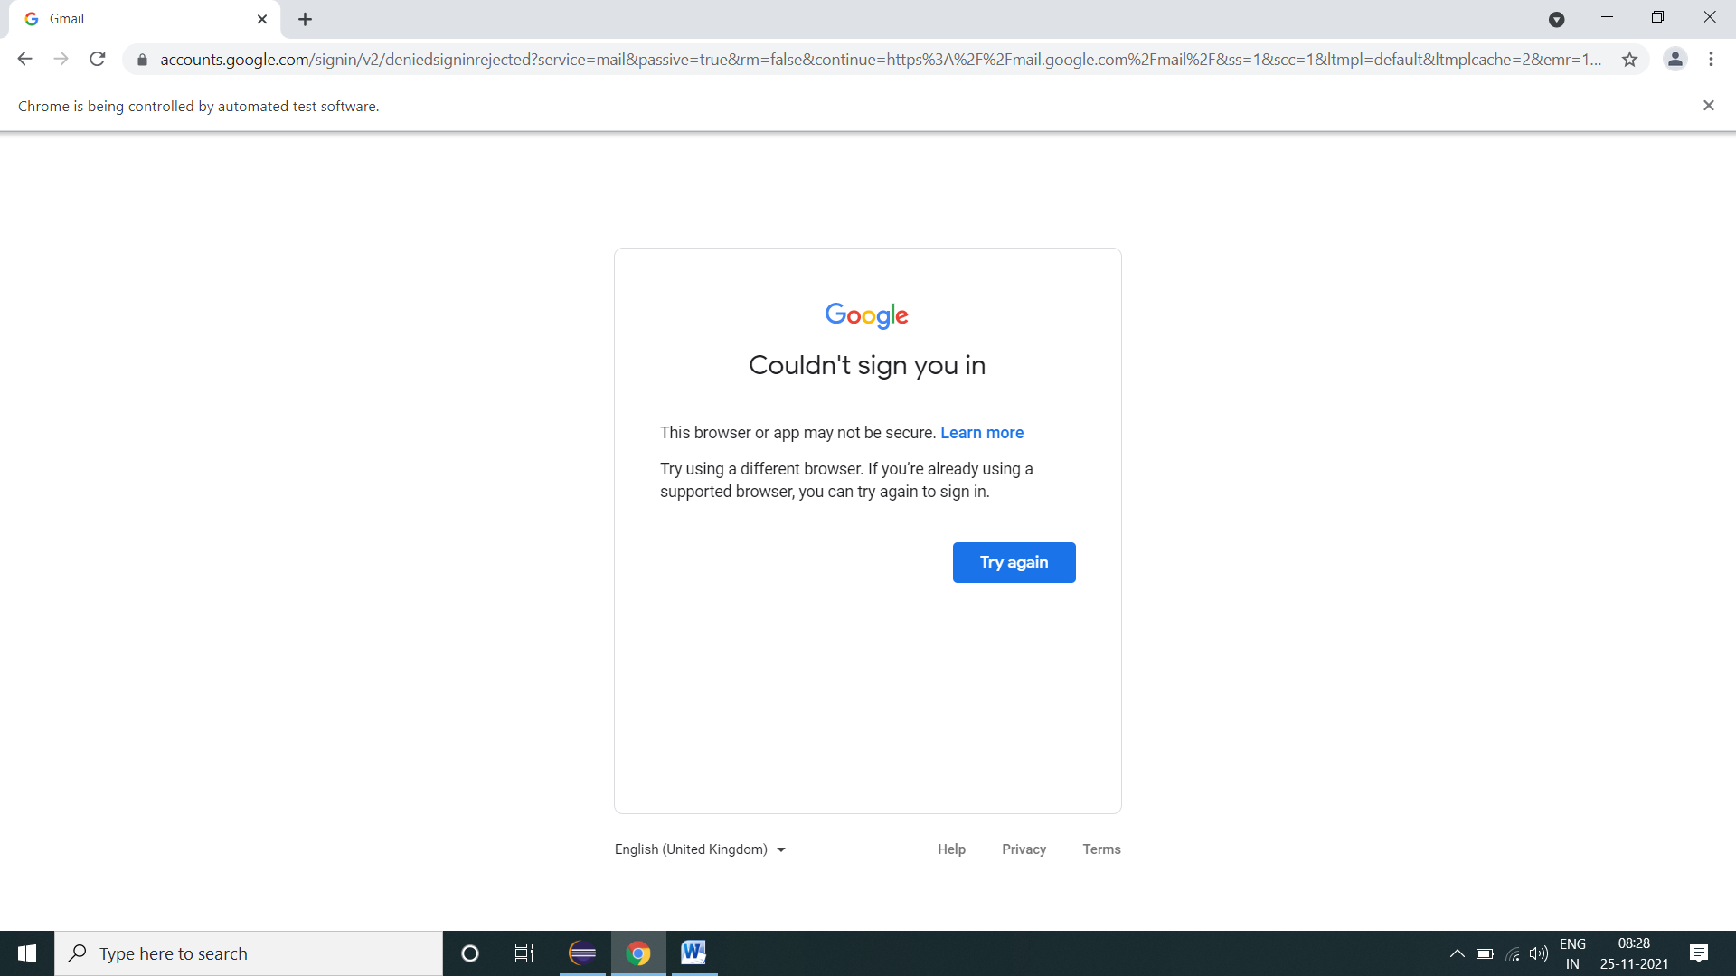

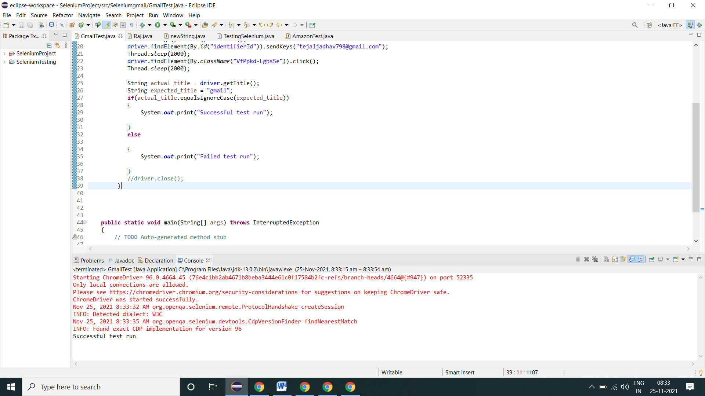
Amazon

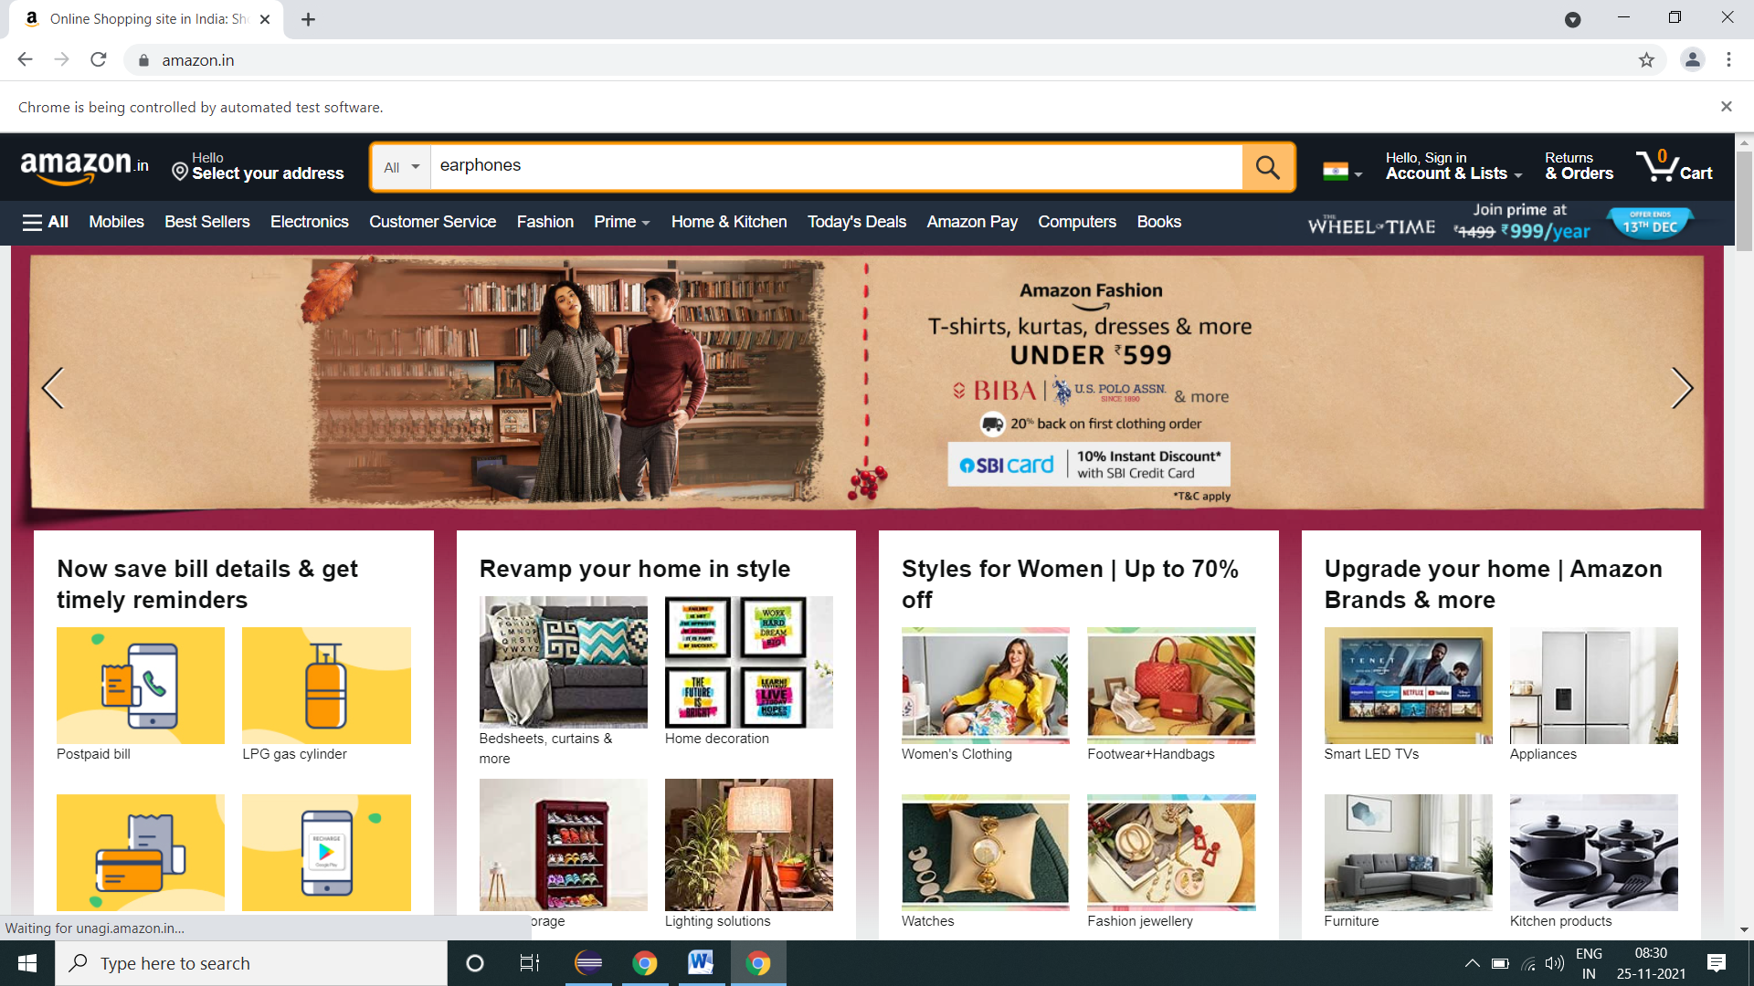



7. Conclusion
Software testing is an important part of the software development process. It is not a single activity that takes place after code implementation, but is part of each stage of the lifecycle. A successful test strategy will begin with consideration during requirements specification. Testing details will be fleshed through high and low level system designs, and testing will be carried out by developers and separate test groups after code implementation.

As with the other activities in the software lifecycle, testing has its own unique challenges. As software systems become more and more complex, the importance of effective, well planned testing efforts will only increase.

