Task

Hosting 3-tier studentapp via docker image

Name – tejal pawar

1. Create EC2 instance with ubuntu image and connect it.
2. Install docker in the instance terminal using root user (sudo -i) and after installing docker start the docker using

systemctl start docker

Link - https://docs.docker.com/engine/install/ubuntu/

1. Firstly create data base in MySQL for this use command. docker run -d -p 3306:3306 -e MYSQL_ROOT_PASSWORD=1234 mysql:latest

docker ps

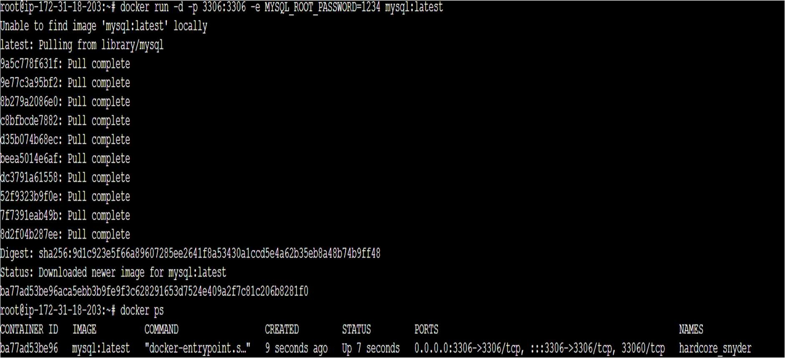

docker exec -it <container-id> mysql -u root -p1234

1. After entering this command you enter into the mysql use commands to create database.

create database studentapp; use studentapp;

CREATE TABLE if not exists students(student_id INT NOT NULL AUTO_INCREMENT,

student_name VARCHAR(100) NOT NULL, student_addr VARCHAR(100) NOT NULL,

student_age VARCHAR(3) NOT NULL, student_qual VARCHAR(20) NOT NULL, student_percent VARCHAR(10) NOT NULL, student_year_passed VARCHAR(10) NOT NULL, PRIMARY KEY (student_id)

);

desc students; exit

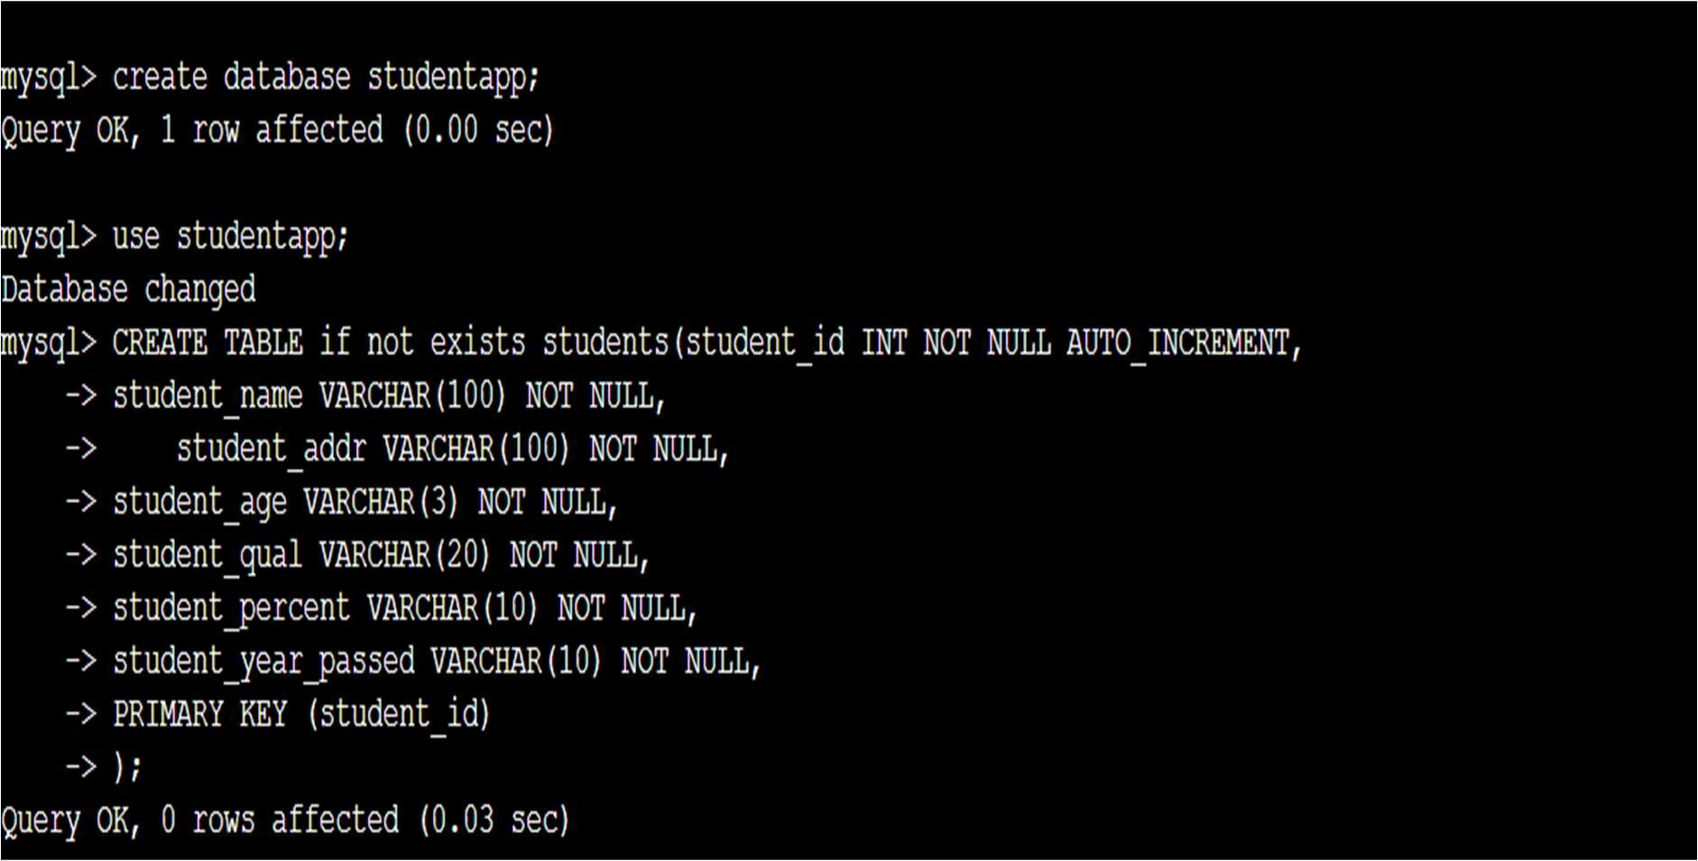

1. To see image ip. (mysql ip)

docker inspect <container-id> |grep “IP”

1. Copy mysql ip for the further use.

* Backend

1. Create repo in git or use existing and make two folder in the repo. 1.frontend
2. backend
3. In backend create three files. 1.Dockerfile -> your image 2.context.xml -> add mysql ip 3.studnet.war ->
4. Make git clone and build docker image. docker build .

docker images

Assign ip to image -> docker run -d -p 8080:8080 <image-id> docker ps

1. Hit ip to see hosting.
   * Frontend
2. Create two files in frontend folder. 1.Dockerfile -> your image
3. index.html -> paste your EC2 instance ip
4. Git push or pull
5. Build docker image -> docker build .
6. Docker images
7. Assign ip -> docker run -d -p 80:80 <image-id>
8. docker ps

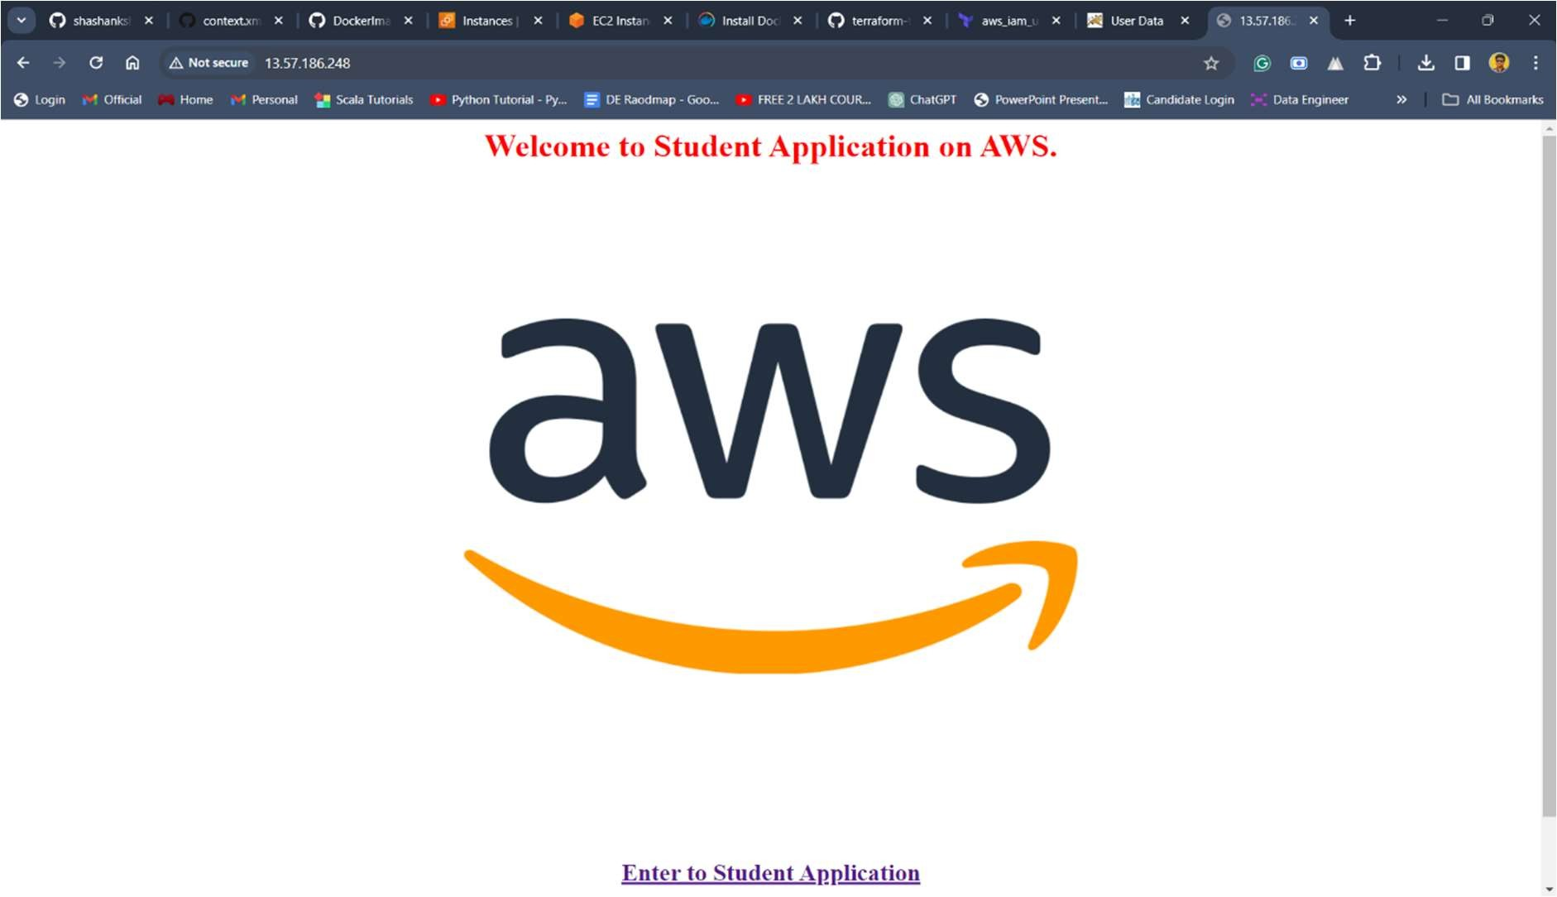

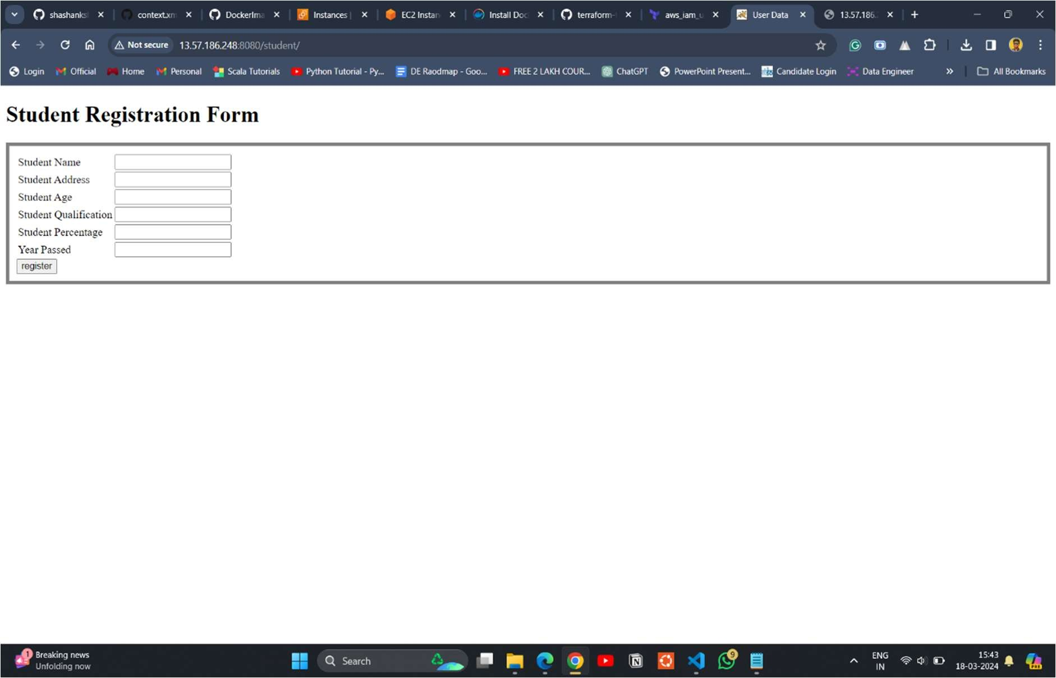

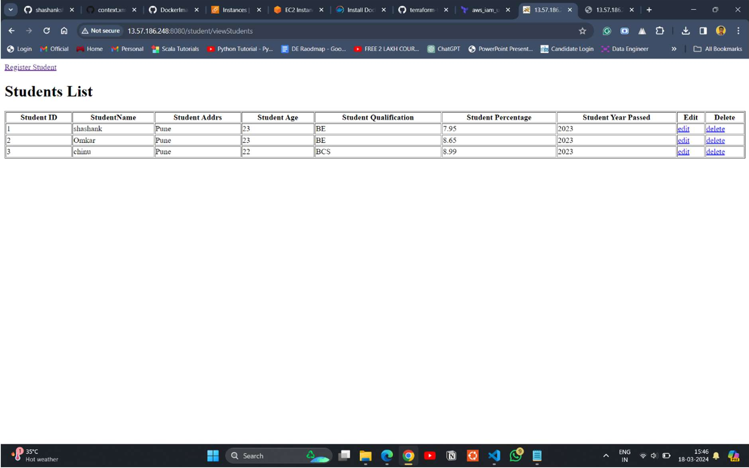

* + If you want to push files to the dockerhub provide tags to your images and then login into the dockerhub using command.

docker login

docker push <dockerhub-usrname>/<dockerhub-repo>:<tag>

