**Name: Tejal Bala Dalvi.**

**Roll no : MCA2024121**

**Seat no.: 2012087**

**Subject : devops**

**Q A) write a playbook(ping_playbook.yml)that uses the ping module to test connectivity for all nodes in your inventory file.Run the playbook and confirm that all nodes respond successfully.**

Ans:

1. Create a repo

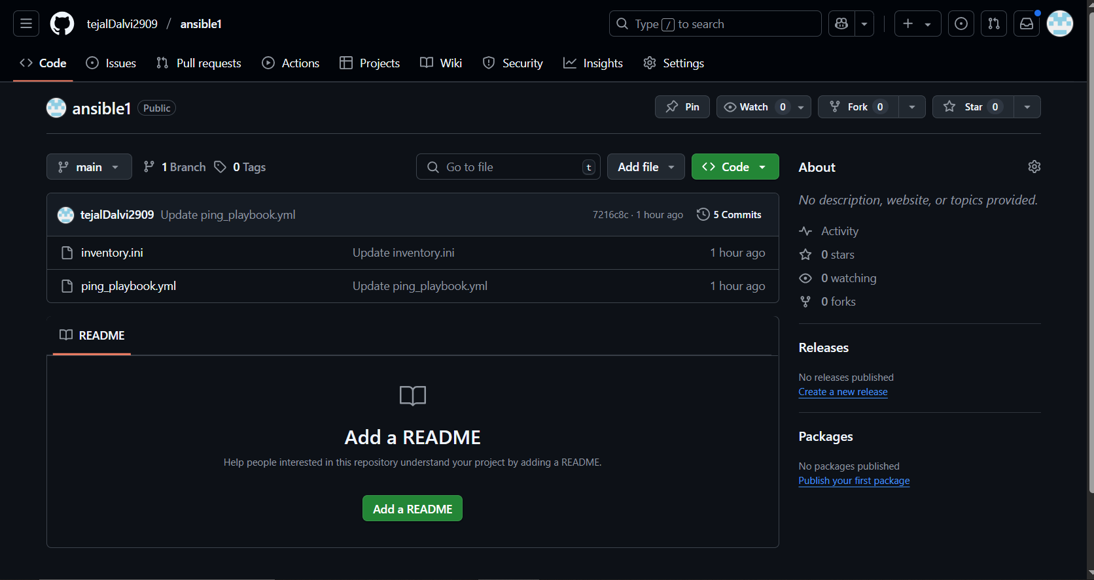

1. Create file ‘inventory.ini’

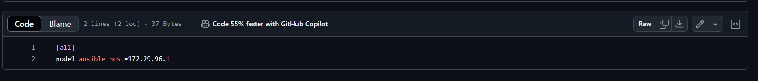

1. Create file ‘play_playbaook.yml”

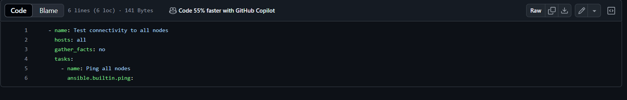

1. Clone github to ubuntu

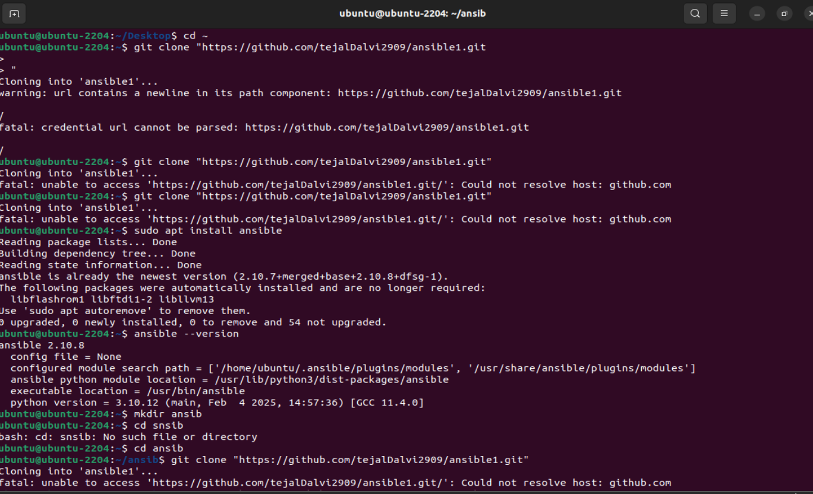

**Q B) Deploy an HTML Page Using Gitlab CI/CD**

Ans:

1.create project

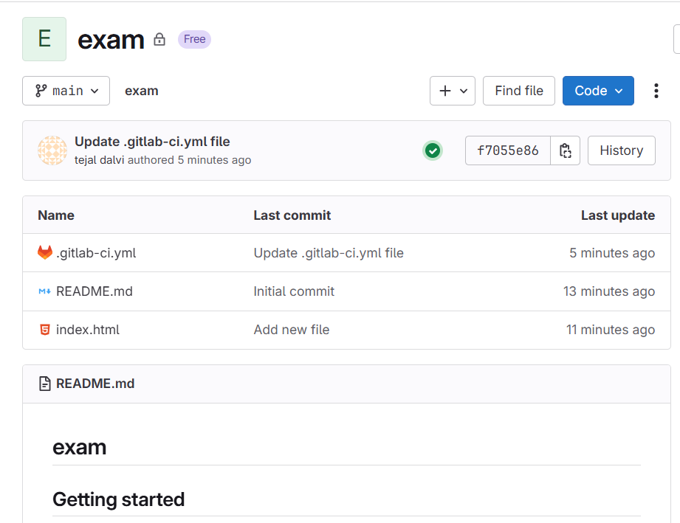

2.create index.html

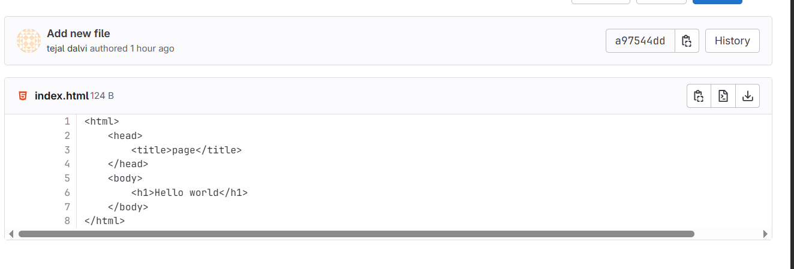

3. create ‘.gitlab-ci.yml’ file

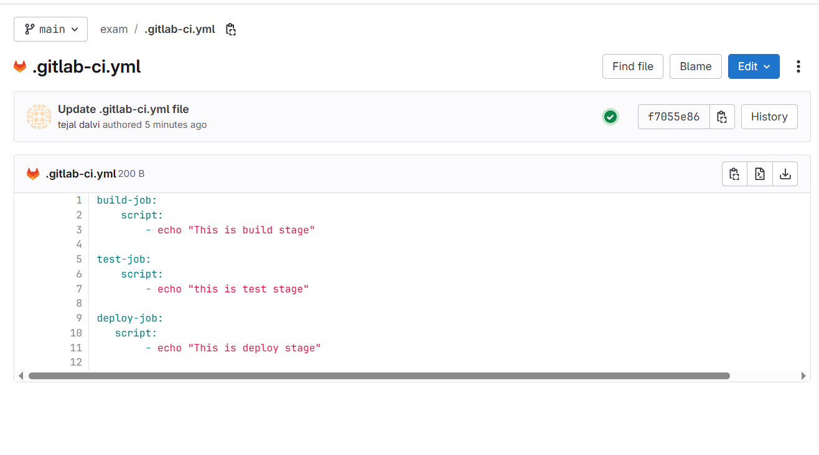

4.Pipeline

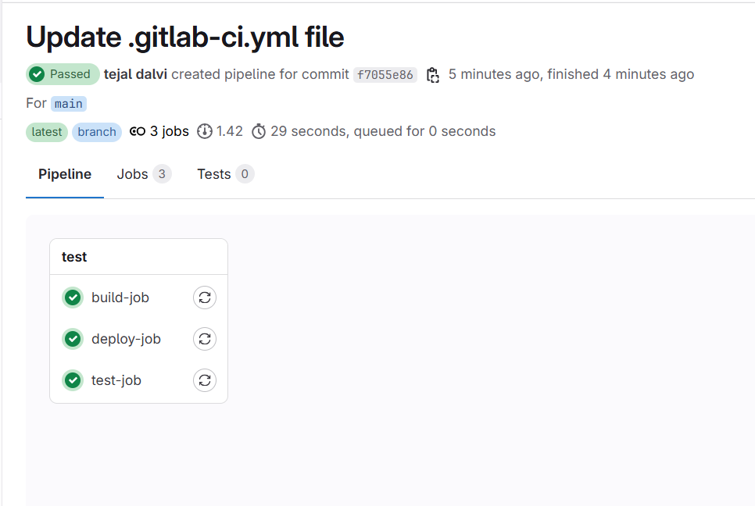

5.build

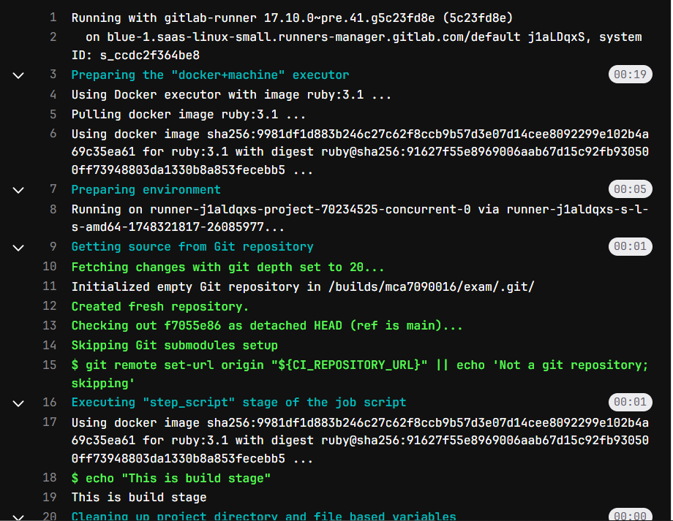

6.deploy

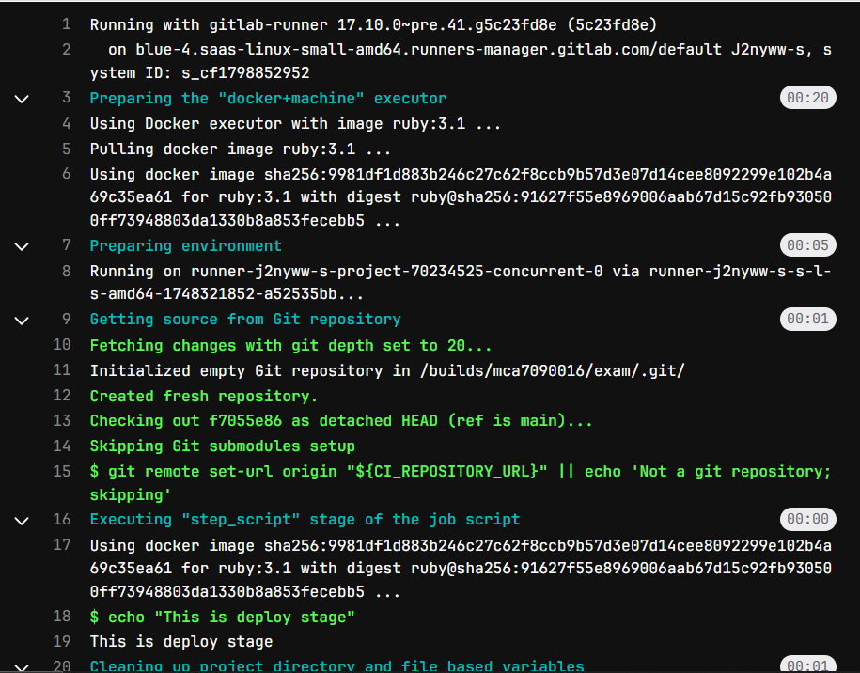

7.test

