

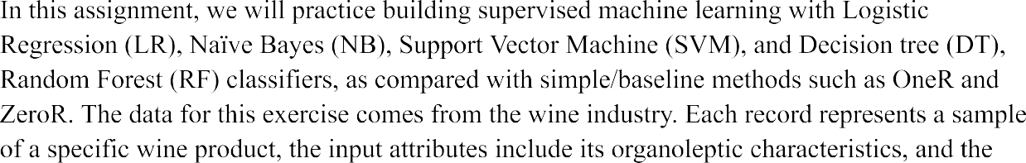

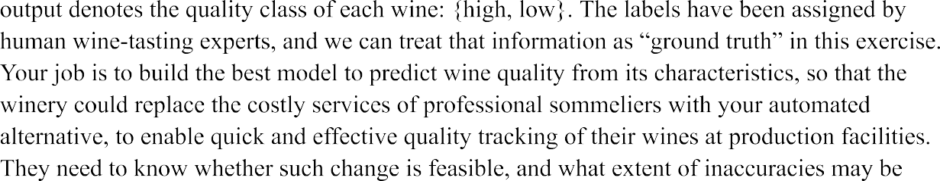



**WEKA Task**

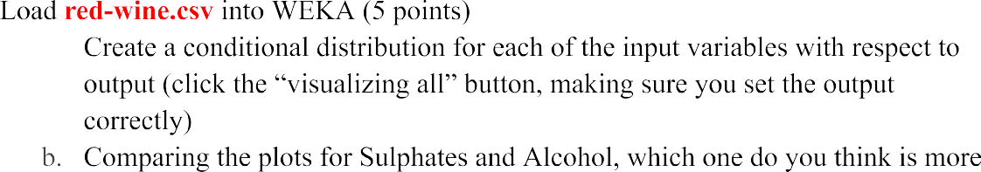

 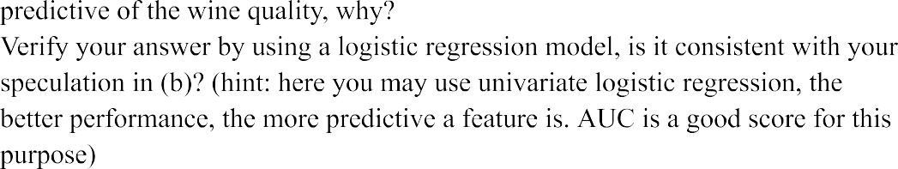



 

|  |  |  |  |  |  |  |  |
| --- | --- | --- | --- | --- | --- | --- | --- |
|  |  |  |  |  |  |  |  |
|  |  |  |  |  |  |  |  |
|  |  |  |  |  |  |  |  |



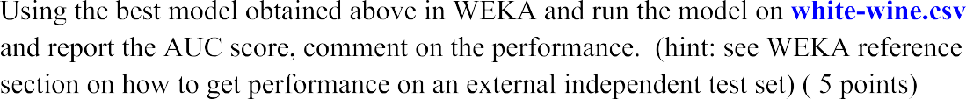

**Python Task**



