Report-2

Diabetic Retinopathy (DR) is the fastest growing cause of preventable blindness. All people with diabetes are at risk. They need to be screened once a year.

This screening involves taking a picture of the back of the eye. The picture is called a fundus photo. It's taken using a special camera. An eye doctor then diagnoses this image. In many parts of the world there's a shortage of eye doctors. As a result, in India about 45% of people suffer some form of vision loss before the disease is detected.

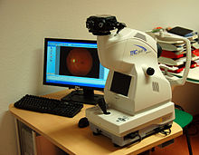

Fundus Camera

Methodology

1) The Aptos Dataset rated each image according to the levels of severity of the diabetes on a scale of 0 to 4. Here 0 - No DR, 1 - Mild, 2 - Moderate,3 - Severe, 4 - Proliferative DR. These images are processed and targeted into binary labels as shown in figure

2)The dataset contains 3662 images out of that 650 images were used for validation of the system. We have taken image size as 224 X 224X 3.

3)First dataset divides the dataset of 5 classes of grade [0,1,2,3,4] into a binary dataset. This is done to make the dataset unbiased, i.e. to equal the number of images having and not having the disease.

4)As for preprocessing the dataset images are shrunk to (224,224,3) pixels and passed to the preprocessing method specially designed for MobileNet architecture.

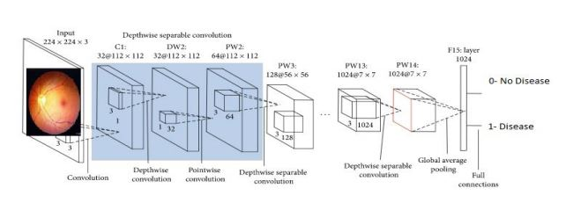

Mobilenet is a lightweight architecture. It uses depth wise separable convolutions which basically means it performs a single convolution on each color channel rather than combining all three and flattening it. This has the effect of filtering the input channels. It is very low maintenance thus performs very good with high speed. Mobilenet Architecture used to train APTOS dataset.