**Assignment 4 – Geo Location Message**

UML diagram for Android assignment 4 has been provided below:

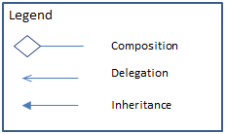

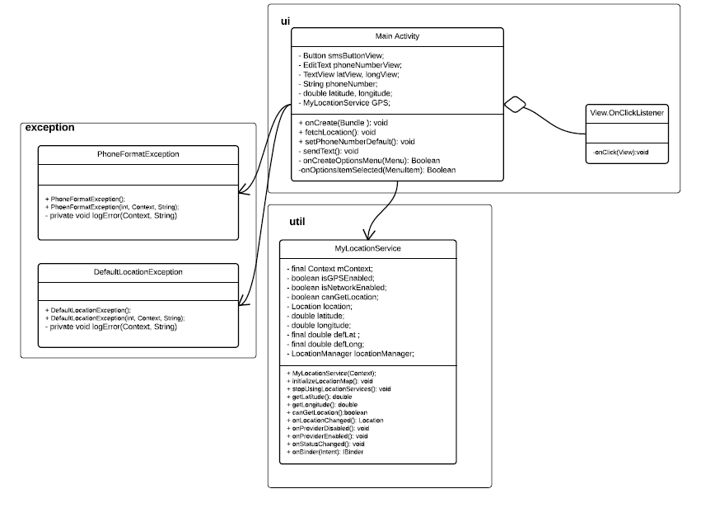

In mini-2, assignment 4 I have built a simple app that fetches the current location of the user (on application start and when user tries refreshing) and sends the location details as SMS text message.

Step 1: Start Application

Step 2: Update default phone number (if desired)

Step 3: Refresh location by clicking on action menu or use existing default location

Step 4: Press send button to send the location details to the provided phone number.

This app has been developed with the following files:

**Presentation Layer:**

* The res/layout folder contains the activity_main. xml layout file, which draws the editext box for phone number and location details on the screen.
* The menu_main.xml file is used to inflate the location coordinates refresh icon on the toolbar.

To make the xml file more maintainable common code has been extracted and can be maintained through the following files in the values folder: string.xml, dimen.xml, styles.xml, colors.xml.

**Logic Layer:** All the logic for the Geo Location Messaging app has been split into three clearly segregated packages:

* Ui package – This package contains the MainActivity.class file that loads the page with the activity_main.xml and menu_main.xml files and updates the UI as required.
* Util package – MyLocationService.class handles all the background logic of instantiating a location manager, requesting location updates, etc. It is responsible for interacting with androids location API. The main activity instantiates this class and calls methods in it to obtain the location coordinates.
* exception package –
  + The PhoneFormatException.class is thrown and self-healed by alerting user if the phone input string does not have the correct US number format. The errors are logged in a local cache log file.
  + The DefaultLocationException is thrown and self-healed by alerting user that location has been set as default location when a user refreshes the location by clicking on the action bar item. The exception is logged in an error file.

**Program Output**

Output has been demonstrated in the output file provided in the folder. The program should be executed in Android Studio using Marshmallow. The local error log output is printed in the android studio console.

**References:**

<http://techlovejump.com/android-gps-location-manager-tutorial/>

<http://www.tutorialspoint.com/android/android_location_based_services.htm>

<https://www.javacodegeeks.com/2010/09/android-location-based-services.html>

<http://wptrafficanalyzer.in/blog/android-gps-with-locationmanager-to-get-current-location-example/>

<http://www.tutorialspoint.com/android/android_sending_sms.htm>

<http://x-team.com/2016/01/android-runtime-permissions/>