**Assignment 4 – Geo Location Message**

The output of the Geo Location Messaging app has been shown here. The following options are available on the homepage:

* Replace Default Phone Number (Incorrect format throws exception)
* Refresh location coordinates (click on refresh button icon in the toolbar)
* Send SMS (click on pink button to send location coordinates to specified phone number

**Update Phone Number:**

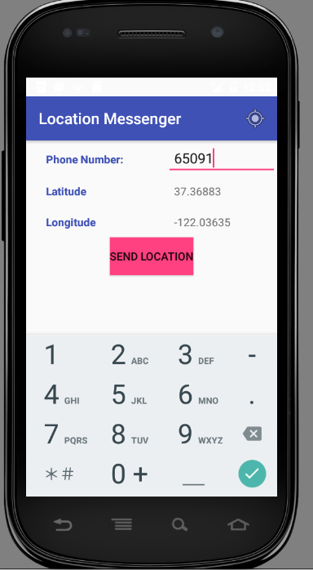

**Refresh Coordinates:**

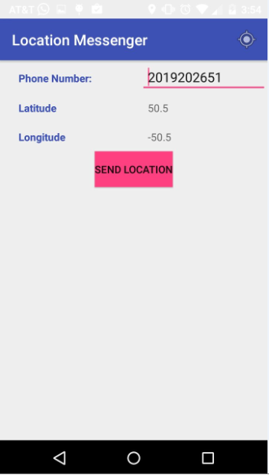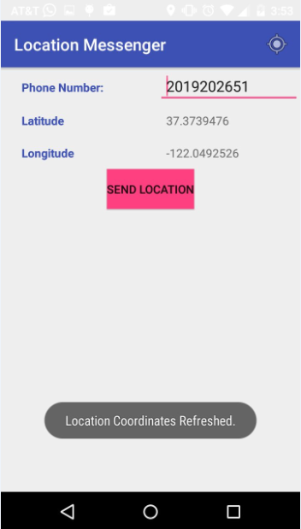

**Send SMS** (Default location: 50, -50 changed to real Sunnyvale location after refresh**):**

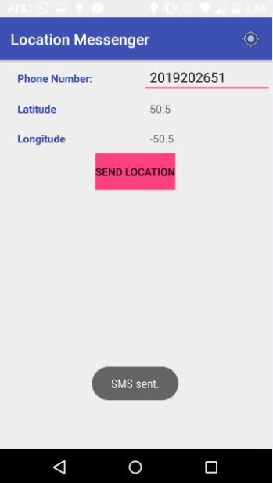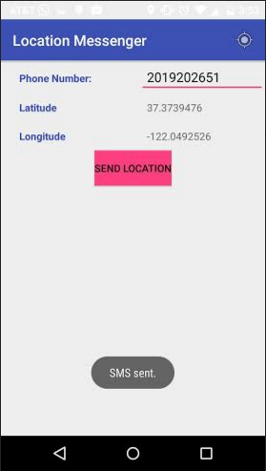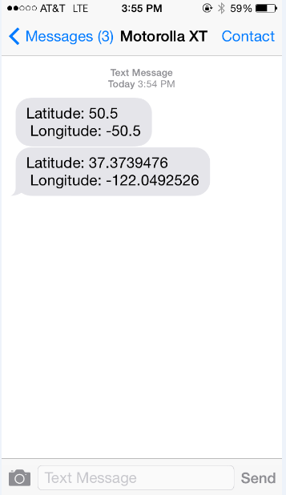

**Exception Handling:**

1. Incorrect phone number format exception

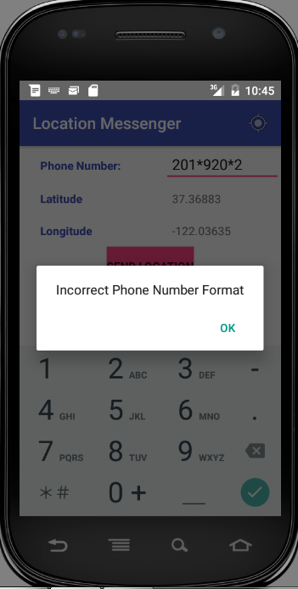

1. Location Coordinates Set to default value exception:

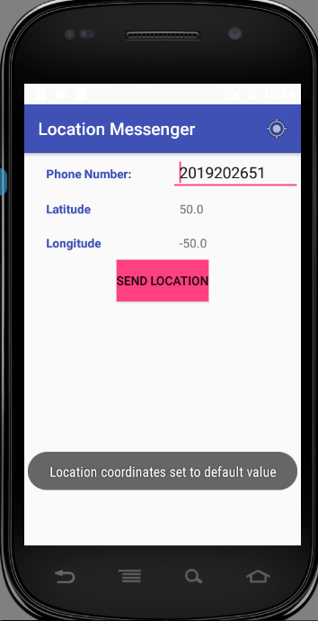

**Exception Handling Log Output:**

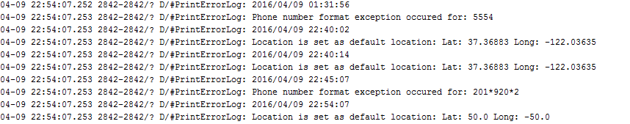

Note: Default value was previously set to 37.36883, -122.03635 but then later set to 50, -50 to indicate the phone was detecting real location which is around the same Sunnyvale value. Hence, the log file indicates two different default values.