**Assignment 3 Part B – Music Artist**

UML diagram for Android assignment 3 part B has been provided below:

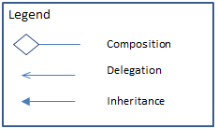

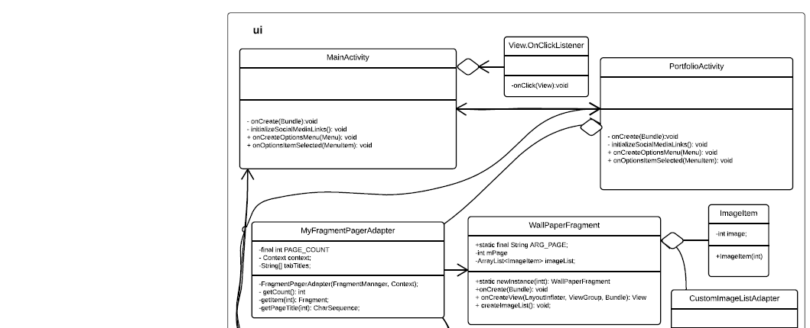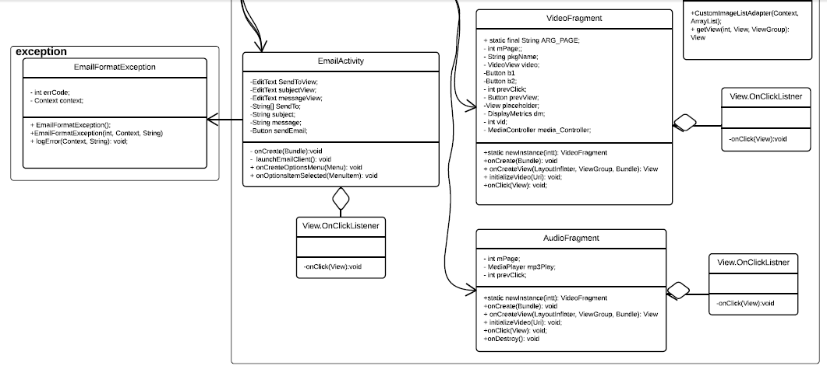

In mini-2, assignment 3 part B I have built a vocal artist’s homepage that provides the following:

* Basic Demographics and contact info (including social media links) (Activity)
* Songs (Fragment)
* Music Videos (Fragment)
* Wall papers (Fragment)
* Join mailing list request option (Activity)

This app has been developed with the following files:

**UI:**

* The res/layout folder contains all the xml layout files for each screen. The files have been given the post_fix main, page or item.
  + _main: correspond to a activity’s layout
  + _page: correspond to a sub component of main or a fragments’s content layout.
  + _item: correspond to a list item’s layout
* The res/drawable folder contains all the images
* The res/raw folder contains all the video and audio files
* The rest of the folders are standard

To make the xml file more maintainable common code has been extracted and can be maintained through the following files in the values folder: string.xml, dimen.xml, styles.xml, colors.xml.

**Logic Layer:** All the logic for the vocal artist app has been split into two clearly segregated packages:

* Ui package – This package contains three Activity files and three fragment files that each load the corresponding xml files.
  + MainActivity.class: Loads activity_main.xml and info_page.xml
  + PortfolioActivity.class: Loads portfolio_main.xml and fragments as necessary.
    - AudioFragment – audio_page.xml
    - Video Fragment – video_page.xml
    - WallPaperFragment – wallpaper_page.xml,wallpaper_item.xml
  + EmailActivity.class: Loads email_main.xml
* exception package – The EmailFormatException.class throws an exception and self-heals by alerting user if the email input string does not contain ‘@’ or ‘.’. The errors are logged in a local cache log file.

**Program Output**

Output has been demonstrated in the output file provided in the folder. The program should be executed in Android Studio using Marshmallow. The local error log output is printed in the android studio console.

**References:**

<http://developer.android.com/training/basics/intents/sending.html>

[http://www.tutorialspoint.com/android/android_sending_email.htm](http://www.google.com/url?q=http%3A%2F%2Fwww.tutorialspoint.com%2Fandroid%2Fandroid_sending_email.htm&sa=D&sntz=1&usg=AFQjCNFCl7T_HeryJ_gWLBvE51vhjhTtOQ)

[http://www.compiletimeerror.com/2013/10/playing-video-in-android-application.html#.Vv7y2BMrLVp](http://www.google.com/url?q=http%3A%2F%2Fwww.compiletimeerror.com%2F2013%2F10%2Fplaying-video-in-android-application.html%23.Vv7y2BMrLVp&sa=D&sntz=1&usg=AFQjCNFtSbD2ZOg9RGM3PcFjlbycmJHMeA)

[http://www.compiletimeerror.com/2013/10/playing-audio-in-android-application.html#.Vv7zPxMrLVo](http://www.google.com/url?q=http%3A%2F%2Fwww.compiletimeerror.com%2F2013%2F10%2Fplaying-audio-in-android-application.html%23.Vv7zPxMrLVo&sa=D&sntz=1&usg=AFQjCNHNZk2rgz6xy3HLKhtZ6l5oiVDT0A)

[http://www.androidhive.info/2015/09/android-material-design-working-with-tabs/](http://www.google.com/url?q=http%3A%2F%2Fwww.androidhive.info%2F2015%2F09%2Fandroid-material-design-working-with-tabs%2F&sa=D&sntz=1&usg=AFQjCNFFWuIir5QOGMiezpOsy1mgp4KGfQ)

[https://guides.codepath.com/android/google-play-style-tabs-using-tablayou](https://www.google.com/url?q=https%3A%2F%2Fguides.codepath.com%2Fandroid%2Fgoogle-play-style-tabs-using-tablayout&sa=D&sntz=1&usg=AFQjCNGByBhFDLQO-Zn_gkY6V7DTLVmuOQ)

<http://stackoverflow.com/>