**Assignment 3, Part B – Music Artist Output**

The output of the music artist app has been shown here. The following menu items are available in the toolbar:

* Homepage (i)
  + Link to Social Media, Homepage, Email, Phone
* Gallery
  + Audio Songs tab
  + Music Videos tab
  + Wallpaper tab
* Mail List – Auto populates email client to send mail

**Artist Home Page:**

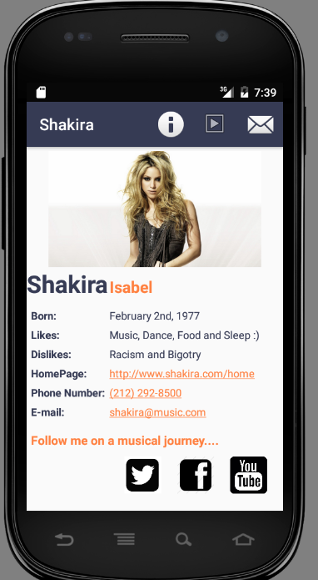 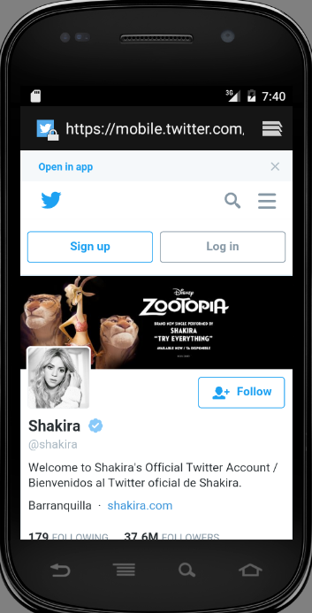

**Gallery – Songs:**

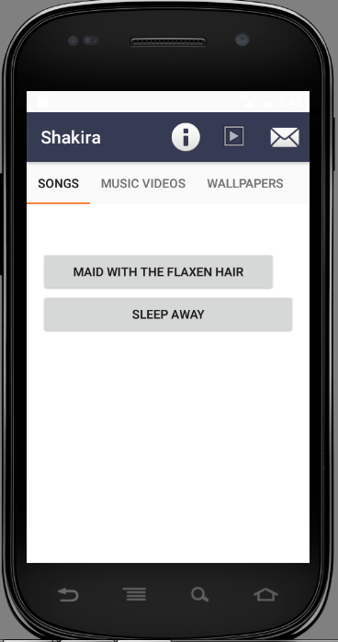

**Gallery – Videos:**

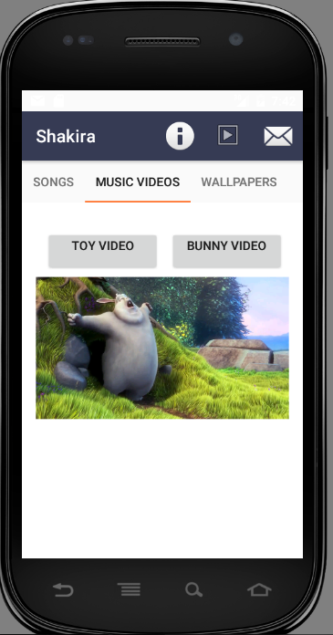

**Gallery – Wallpaper (Scroll):**

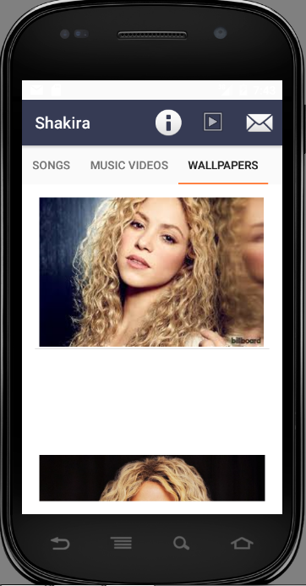

**Join Mail List:**

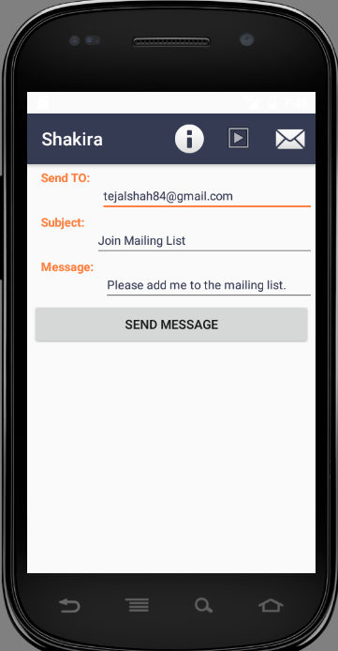 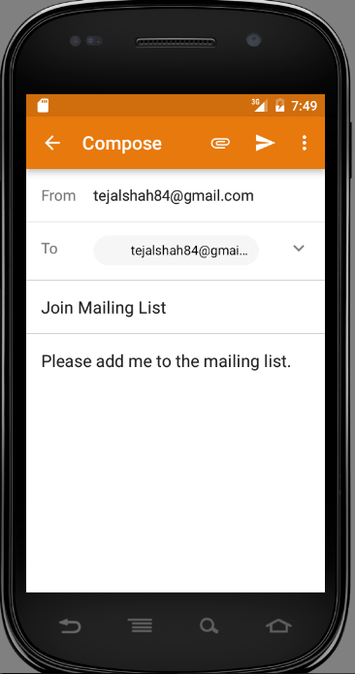

**Exception Handling:**

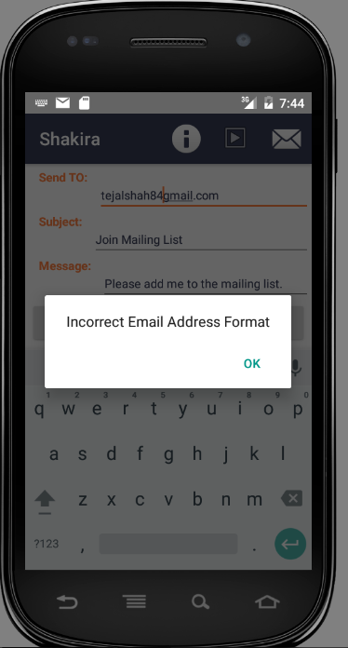

**Exception Handling Log Output:**

