**Assignment 3 Part A - QuizScores**

UML diagram for Android assignment 3 part A has been provided below:

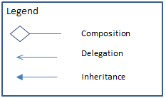

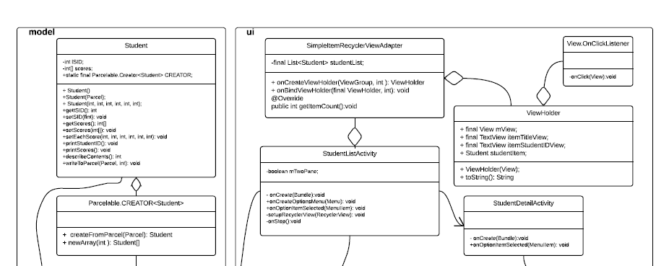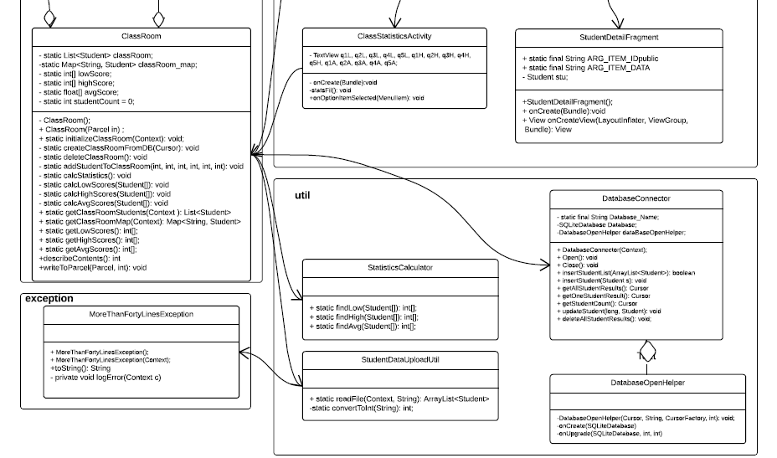

In mini-2, assignment 3 part A I have built an app that displays and calculates statistics for a classroom of students with five quiz scores.

**Input Values:**

* Studentdata2.txt – an input file with 41 student scores stored in assets folder. It should throw an exception and self-heal by reading only 40 entries and continuing.

**Output Screens:**

* Student List
* Student Score
* Class Statistics

This app has been developed by using the following files in the software:

**Presentation Layer:**

* activity_student_list.xml – corresponds to StudentListActivity.class
  + student_list.xml -
    - student_list_content.xml
* activity_student_detail.xml – corresponds to StudentDetailActivity.class
  + student_detail.xml – corresponds to StudentDetailFragment.class
* activity_class_stats.xml – corresponds to ClassStatisticsActivity.class

To make the xml file more maintainable common code has been extracted and can be maintained through the following files in the values folder: string.xml, dimen.xml, styles.xml, colors.xml.

**Logical Layer:** All the logic for the calculator has been split into four clearly segregated packages:

* Ui package – This package contains three Activity files and one Fragment file that each load the corresponding xml files and invoke other classes to help with calculation and db interaction.
  + StudentListActivity.class – invokes ClassRoom to load studentDatafile and get database results.
  + StudentDetailActivity.class – invoked by StudentListActivity and uses intent extras to display data.
  + StudentDetailFragment.class – invoked by StudentDetailActivity.class and uses fragment arguments passed.
  + ClassStatisticsActivity.class – invokes methods in ClassRoom to get calculations
* model package – This package contains the following model classes:
  + Student.class - models student object with student id and quiz scores
  + ClassRoom.class - ClassRoom acts a repository of student details and is a singleton.
* Util package – This package contains the following files:
  + StudentDataUploadUtil.class – This class invoked from ClassRoom reads inputfile and returns the data.
  + StatisticsCalculator.class – This class is invoked from ClassRoom and which passes an arraylist of students and receives class summary back.
  + DatabaseConnector.class – This class is invoked from ClassRoom and handles all the database CRUD operations.
* exception package – This package has the MoreThanFortyLinesException.class which is invoked by the StudentDataUploadUtil.class file when a file with more than 40 students is encountered and then self-heals the issue by only reading forty lines and logging the exception in local cache file.

**Database Layer:** The local SQLite DB in Android is used and one table is created storing the following details:

* RowID, StudentID, Q1, Q2, Q3, Q4, Q5

**Program Output**

Output has been demonstrated in the output file provided in the folder. The program should be executed in Android Studio using either Lollipop or Marshmallow. The exception error log is printed in the android studio log. The DB state is reflected on the UI screens (DB is source of student data).