**Assignment 3, Part A – Quiz Scores Output**

The output of the Quiz Scores app and the database has been shown here. The student list is read from a file and populates the database. The database is subsequently accessed to display this list view of students. Clicking on each student item, takes user to the second screen with the score details of each student. The (i) icon in the menu takes user to the class statistics summary page.

**Student List:**

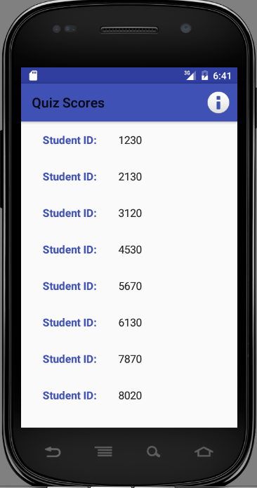

**Student Score:**

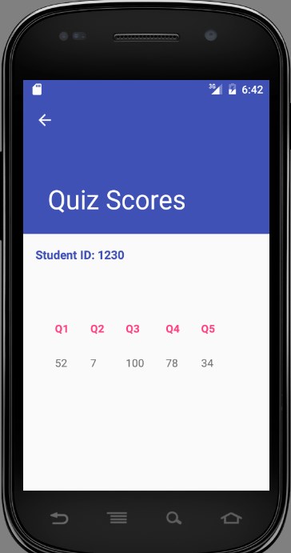

**Another Student Score:**

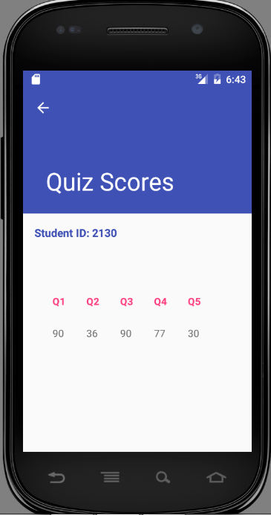

**Class Summary:**

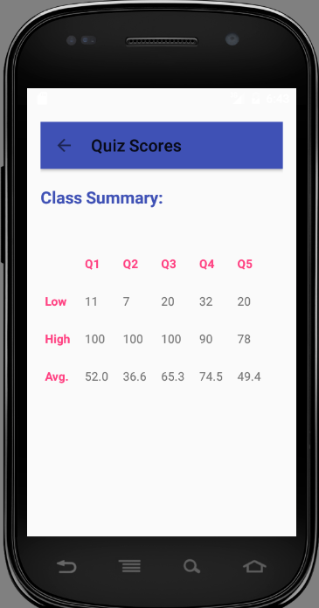

**Exception Log output (read from local error log):**

