Iterations 5 - UI Mock Up

**Use Case Name:** Finding Missing People

**Use Case Brief Description:**

The use case allows the Citizen to find missing people in the community. The Citizen can files a missing person report or report any missing people that are found in the community. The Citizen can upload an image of the missing person to the report and other information that will help to describe the missing person. Other citizens will be able to view the missing people list and report people that are found back to the community. Once a missing person is found, the Citizen who files that particular report will be notified.

**Link to the UI mockups with dynamic flows on POP.COM:** [**Click Here!!!**](https://popapp.in/w/projects/56412a8e0ddf6b4075874adb/mockups)

* **Click on “Preview” button to interact with the mock up with dynamic flows**

**1. UI Mock Up:** Browsing people who are reported as missing as a deck of cards

* **PASS button:** Go to the next card in the deck
* **FOUND button:** Report back to the system that the missing person is found(See the next mock up)

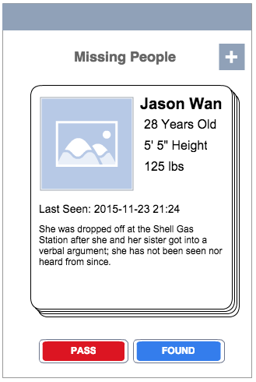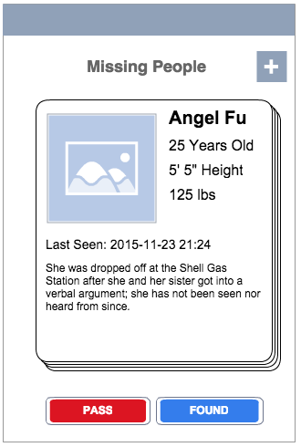

=>

**2. UI Mock Up:** Report back to the system that the missing person is found

* **FOUND PERSON button:** Submit the report and redirect the user back to browse all missing people

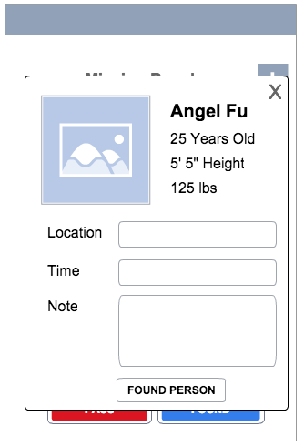

**3. UI Mock Up:** The user who file the entry of the missing person will be notified by the system when another user files the found person report (previous mock up)

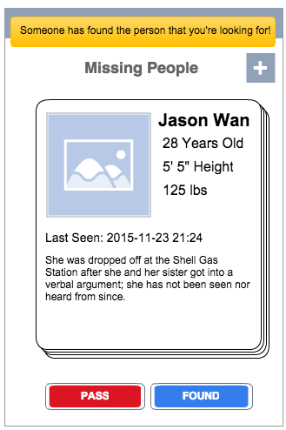

**4. UI Mock Up:** Add an new entry to report a missing person

* **File The Report button:** After the report is submitted, the user will be redirected back to browse all the missing people

