SSNoC: Use-Case OOAD

### Analysis Model

### Administer User Profile Use Case Analysis

* + 1. Update User Profile- Analysis Classes

Entity Classes: Admin

Boundary Classes: ProfileForm

Control Classes: ProfileController

* + 1. Join Community - Basic Flow (Sequence Diagram)

Update User Profile

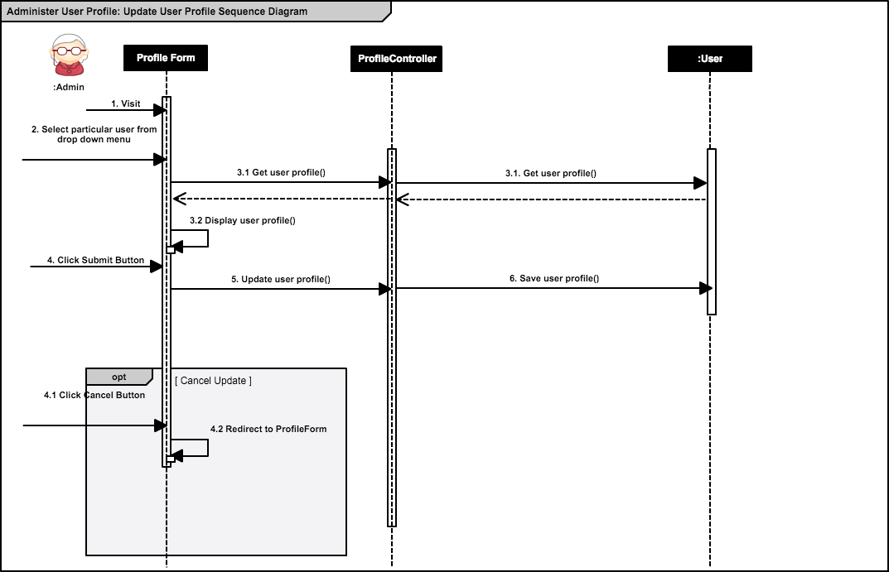

* + 1. Update User Profile - Class Diagram

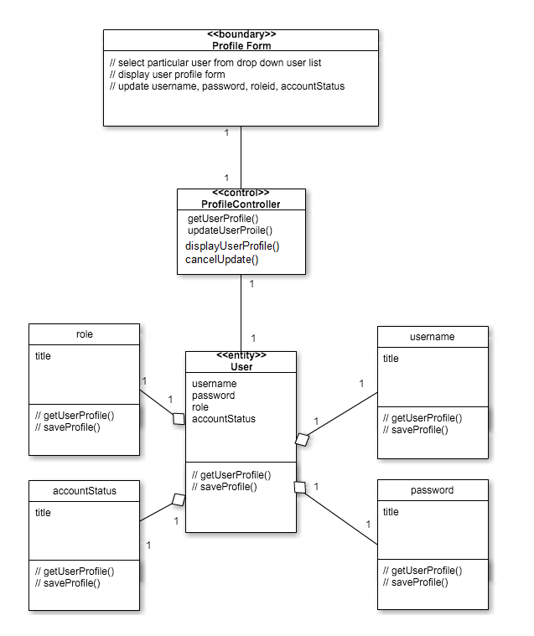

### Design Model

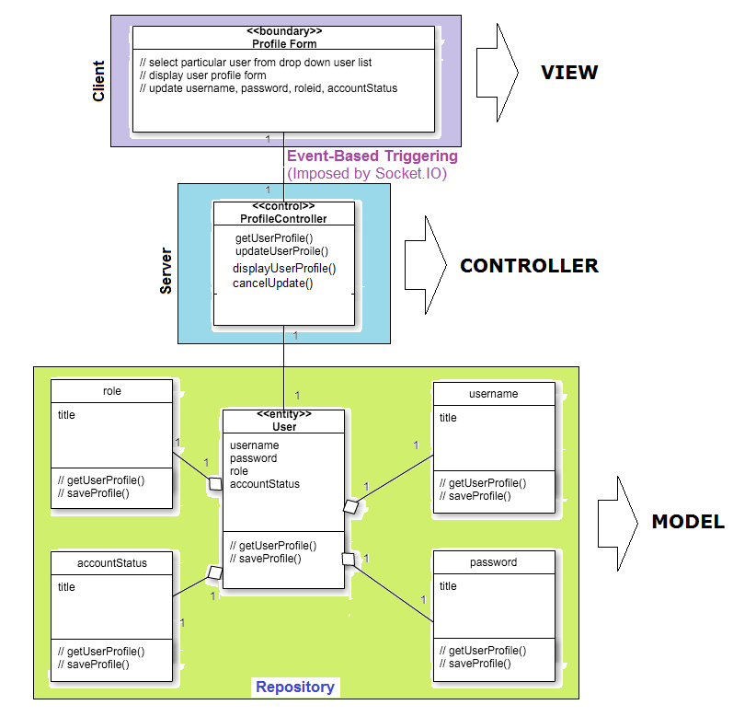

**Class diagrams for access distribution as per Privilege assigned to Users :**

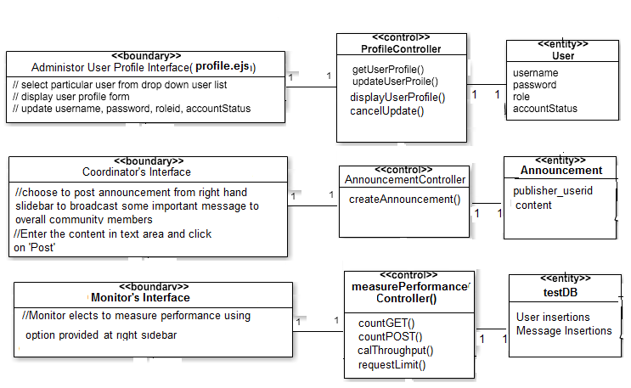

### Mapping

|  |  |  |  |
| --- | --- | --- | --- |
| **Analysis classes** | **Design elements** | **Implementation elements** | **Files** |
| User: Administrator | User.id, Privilege | User.id, Privilege | models/user.js |
| Profile Form  (Boundary) | Profile Form | Profile Form   * username * password * roleid * accountStatus | view/profile.ejs (view) |
| ProfileController  (Controller) | ProfileController | ProfileController   * getUserProfile() * updateUserProfile() * displayUserProfile() * cancelUpdate() | controller/profileController.js |
| User:  Coordinator, Administrator | User.id, Privilege | User.id, Privilege | models/user.js |
| Announcement Form  (Boundary) | Announcement Form | Announcement Form   * publisher_userid * content | view/partials/announceMsg.ejs (view) |
| AnnouncementController  (Controller) | AnnouncementController | AnnouncementController   * createAnnouncement() | controller/announcementController.js |
| User: Monitor | User.id, Privilege | User.id, Privilege | models/user.js |
| Monitor Interface  (Boundary) | Monitor Interface | Monitor Interface   * duration | view/monitor.ejs (view) |
| measurePerformanceController  (Controller) | measurePerformanceController | measurePerformanceController   * countGET() * countPOST() * calThroughput() * requestLimit() | controller/measurePerformanceController.js |