

International Journal of Research Publication and Reviews

Journal homepage:
www.ijrpr.co
m

ISSN 2582
-
7421

Waste Collection and Waste Segregation Robot with Dustbin
Sumithra N V*¹, Kavitha C A*², Dr. Divakara S S*³

A B S T R A C T :

The proposed project aims to develop an autonomous waste collection and segregation system that efficiently collects waste from homes and segregates it into dry and wet categories. The robot uses an IR array for detecting tracks and identifying home stops, and an ultrasonic sensor to prevent accidents. Upon reaching a home, a buzzer alerts the residents for waste dumping, and a button press signals the robot to move to the next home. If no user is present, the robot waits for 1 minute before proceeding. The waste segregation mechanism differentiates between dry and wet waste and deposits them accordingly.

Keywords: Smartwastemanagement, Automated garbage sorter, Robotic trash collector, intelligent waste segregation, Sensor based waste disposal, Recycling assistant robot.

INTRODUCTION
The rapid urbanization and growth of populations in cities around the world, waste management has become a critical challenge. Improper waste disposal and inefficient segregation of waste contribute to environmental pollution, increased landfill usage, and the loss of valuable resources that could otherwise be recycled. Traditional waste collection systems often rely on manual labor for sorting and transportation, which can be error-prone, inefficient, and costly. As such, there is an increasing need for innovative, automated solutions to streamline waste management processes, reduce human intervention, and improve the overall efficiency of waste collection, segregation, and disposal.
The Autonomous Waste Collection and Segregation System is a proposed solution that aims to address these issues by developing an intelligent robot capable of autonomously collecting waste from homes, sorting it into dry and wet categories, and ensuring efficient disposal. This system combines several technologies, including infrared (IR) tracking, ultrasonic sensing, waste segregation mechanisms, and real-time user interaction to create a fully autonomous waste management robot.

EXISTING SYSTEM
The existing system for waste collection and segregation using robots with dustbins is still in early stages of development and implementation. These systems are designed to reduce human effort and exposure to harmful waste by automating the collection and sorting process. Most current robots are semi-autonomous or remotely controlled and are equipped with compartments or dustbins to hold the collected waste. They use basic sensors like infrared (IR) for material detection, metal detectors for identifying metallic objects, and moisture sensors to distinguish biodegradable waste. Some advanced prototypes use image processing and artificial intelligence to classify waste visually and sort it into categories such as biodegradable, non- biodegradable, and recyclable.Smart bins are also used in these systems, which can alert authorities when full. However, the accuracy of waste segregation is still a challenge, especially when waste is mixed or contaminated. These robots often require human supervision, are costly to build and maintain, and are not widely deployed due to their limited scalability and reliability in real-world conditions. Most existing systems remain in the research or pilot testing phase.

PROPOSED SYSTEM
Most of the times, the garbage bins are overflowing with excess waste and are scattered out in the street. These scattered wastes get either decayed or burnt in that place or overflows all over which leads to serious health issues to humans. The wastes which are dumped are segregated by Humans which leads to health problems to them. To overcome this problem a well organised waste segregation and monitoring system has been designed.
The foremost goal of this project is to automatically segregate the wastes and to perceive the level of the dustbins which is delivered through wireless mesh network. With such information, litter bin providers and cleaning contractors are able to make better decision for the efficient disposal. IR sensor identifies the objects, Moisture and metal sensors detects the wet and metal waste. Ultrasonic sensor observes the levels of bin. The waste is dropped inside the bin where the sensor identifies the type of the waste. The Bin consists of three partitions inside were each bin collects each waste respectively. The motor then rotates and respective partitions gets opened and respective wastes are collected. The status of the bin is displayed in Thing speak server.

METHODOLOGY
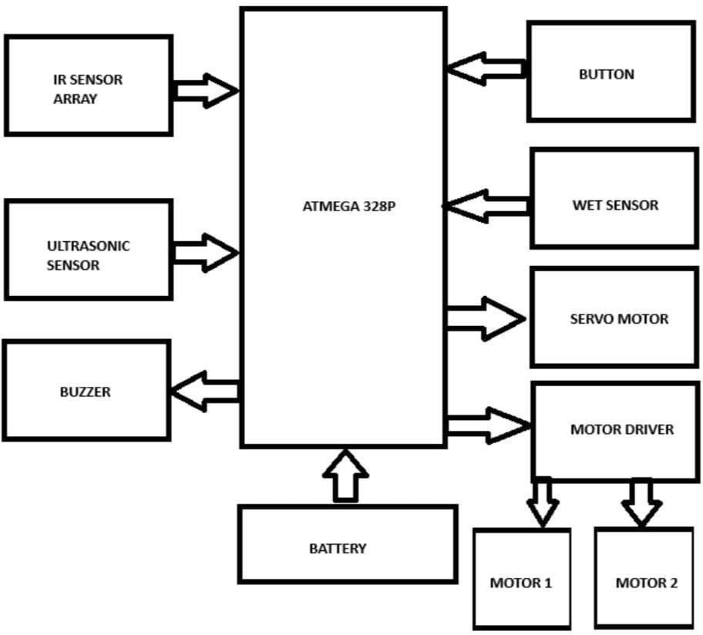

Fig 1. Block diagram
The Autonomous Waste Collection and Segregation System is engineered to integrate modern technologies for efficient, self-reliant waste management. Its core focus is to minimize human involvement while ensuring environmentally sustainable operations through automated processes that are both cost- effective and scalable. The system is built around a mobile robotic unit that navigates using an infrared (IR) sensor array. This technology enables the robot to follow pre-established routes in residential neighborhoods, stopping at specific points for garbage collection. To avoid obstacles like pedestrians or parked vehicles, ultrasonic sensors are used, helping the robot to maneuver safely and smoothly. When the robot reaches a house, it sounds a buzzer to notify residents of its arrival. A confirmation button allows individuals to indicate their intention to dispose of waste. If no response is received within a minute, the robot moves on to the next location, maintaining efficiency in its operations. A key feature of the system is its ability to automatically separate waste. Using dedicated sensors, the robot distinguishes between dry waste—such as metal, paper, and plastic—and wet waste like food scraps. This waste is then directed into separate containers within the robot, ensuring proper sorting at the point of collection. After completing its scheduled route, the robot returns to its charging dock. Powered by rechargeable batteries, the robot ensures continuous functionality by automatically charging itself when necessary. Overall, the system’s operation is centered on autonomous travel, resident interaction for waste collection, and the accurate division of waste into dry and wet categories. This approach delivers a smart, sustainable, and automated solution to everyday waste management needs.

IR ARRAY NAVIGATION: An IR array is commonly used in navigation systems for autonomous robots, including waste collection robots. It consists of multiple infrared sensors arranged in a line that emit and detect IR light reflected from surfaces. This setup allows the robot to detect contrasts in colour, such as a black line on a white surface, which it can then follow as a guided path. The sensors continuously read the surface beneath them, and based on which sensors detect the line, the robot adjusts its movement to stay on course.

ULTRASONIC SENSOR FOR ACCIDENT PREVENTION: An ultrasonic sensor is widely used in robots for accident prevention due to its ability to detect obstacles and measure distance using sound waves. It works by emitting high-frequency sound pulses and measuring the time it takes for the echo to return after bouncing off an object. In waste collection robots, ultrasonic sensors are mounted on the front or sides to detect nearby obstacles like walls, people, or objects. When an obstacle is detected within a certain range, the robot can slow down, stop, or change direction to avoid a collision. This real- time detection capability helps prevent accidents, especially in crowded or unpredictable environments.

BUZZER NOTIFICATION: A buzzer notification is a simple yet effective alert system used in waste collection and segregation robots. It emits an audible sound to notify users or operators of specific events or statuses. In such robots, the buzzer can be triggered in various situations—such as when the dustbin is full, when the robot detects an error, when it encounters an obstacle, or when it successfully completes a task like segregating waste. The buzzer ensures quick awareness without requiring visual attention, making it especially useful in noisy or busy environments. It's a low-cost component that adds a practical layer of communication between the robot and its users.

BUTTON BASED CONTROL: Button-based control is a manual input method used in waste collection and segregation robots to perform basic operations. It involves using physical push buttons connected to the robot’s control system, allowing users to start, stop, or reset the robot’s functions easily.

DRY AND WET WASTE SEGREGATION: Dry and wet waste segregation is a crucial process in effective waste management, especially in automated systems like waste collection robots. Wet waste typically includes biodegradable materials such as food scraps, vegetable peels, and garden waste, while dry waste consists of recyclable items like plastic, paper, metal, and glass.
SERVO MOTOR: A servo motor is a precision-controlled motor widely used in robotics for tasks that require accurate movement and positioning. In a waste collection and segregation robot, servo motors are typically used to operate mechanical components like sorting arms, bin lids, or conveyor flaps.
MOTOR DRIVER: A motor driver is an essential electronic component used to control the operation of motors in a robot. It acts as an interface between the microcontroller (like an Arduino or Raspberry Pi) and the motors, allowing the low-power control signals from the microcontroller to drive high-power.
BATTERY: A battery is the primary power source for a mobile waste collection and segregation robot, enabling it to operate independently without a direct power supply. Commonly used batteries include Li-ion (Lithium-ion) or Li-Po (Lithium Polymer) due to their high energy density, lightweight, and rechargeable nature.

RESULT AND CONCLUSION
During testing, the waste collection and segregation robot demonstrated consistent performance across various tasks. The IR sensor array effectively enabled the robot to follow a predefined path with minimal deviation, ensuring smooth navigation. The ultrasonic sensor provided real-time obstacle detection, allowing the robot to halt or redirect itself when necessary, thus preventing collisions. The moisture sensor showed high accuracy in differentiating between wet and dry waste based on conductivity, enabling the servo motor to rotate the sorting mechanism accordingly.
The DC motors, controlled via the motor driver, provided sufficient torque and stability for indoor mobility, while the servo motor performed precise angular movements to segregate waste. The buzzer system gave prompt notifications for events such as full bins and errors in sorting, enhancing user awareness. Button-based controls allowed manual overrides and simple user interaction with the robot, which proved useful in supervised environments.

The robot was powered by a rechargeable battery, which offered a working time suitable for showcase collection cycles without significant voltage drops. Tests confirmed reliable performance under normal conditions, with all components interacting seamlessly through the microcontroller.

In conclusion, the project successfully met its objectives of automated waste collection, dry/wet waste segregation, and basic path-following capability. This solution can reduce manual handling of waste, lower human exposure to unsanitary conditions, and promote source-level segregation. With further development—such as AI-based image recognition for complex waste types, cloud connectivity for monitoring, or solar charging for energy efficiency— this prototype can evolve into a practical solution for smart cities, educational campuses, and eco-friendly buildings.

FUTURE SCOPE
Integration of Artificial Intelligence and Machine Learning: Future versions of the robot can incorporate AI-based algorithms for advanced waste classification. Using image recognition and machine learning models, the system could identify various materials such as plastic, metal, paper, and organic matter, increasing segregation accuracy.

Use of Computer Vision for Enhanced Waste Identification: A camera module combined with computer vision can replace basic sensors to visually analyze and sort waste based on shape, color, and texture, providing more reliable and flexible segregation.

Incorporation of IoT for Remote Monitoring and Data Management: By connecting the system to the Internet of Things (IoT), data such as bin fill levels, route efficiency, and operational status can be monitored remotely. This enables efficient scheduling of collection and maintenance.

Solar-Powered Operation for Environmental Sustainability: The inclusion of solar panels can provide a renewable energy source for charging the robot, reducing dependence on traditional power supplies and supporting eco-friendly practices.
Development of Mobile Application or Voice-Control Features: User interaction can be improved through a dedicated smartphone application or integration of voice commands, allowing users to control or monitor the robot conveniently.

Expansion of Waste Categories and Smart Compaction: Future designs can handle more diverse waste types and include a compacting mechanism to reduce waste volume, increasing the capacity of the dustbin and minimizing the need for frequent disposal.

GPS Navigation for Dynamic Path Planning: The addition of GPS can allow the robot to navigate larger or more complex environments, optimizing routes for efficient waste collection in both indoor and outdoor settings.

Integration with Smart City Infrastructure: The system can be synchronized with municipal waste tracking networks, supporting urban planning goals and enabling data-driven waste management decisions.

Increased Storage and Modular Design: Modular bins or swappable waste containers can be added to accommodate different zones or waste types, enabling adaptability across various use cases.

Scalability for Public and Industrial Use: With further testing and robustness, the robot can be scaled for deployment in public spaces, industrial facilities, or housing societies to assist with mass waste segregation and collection.

REFERENCES

- Rajput and Prasad (2019) presented a model for smart waste management using Internet of Things (IoT), published in IJAREEIE, highlighting how automation can enhance urban waste systems.

- Kumar, Sharma, and Joshi (2021) proposed a low-cost, sensor-based waste segregation robot in IJERT, aimed at improving sorting efficiency in household and municipal settings.
- Shukla, Verma, and Singh (2020) introduced an Arduino-powered smart bin capable of basic waste detection and sorting, as detailed in IJISET

- Banerjee and Dey (2018) discussed integrating IoT for automated waste management in IJSER, providing insight into networkbased bin monitoring systems.

- Al-Ghusain and Arshad (2017) demonstrated a robotic approach for detecting and sorting waste using sensors, published in IEEE conference proceedings.

- The Arduino team offers detailed hardware and software guides for building microcontroller- based projects at www.arduino.cc.

- Upton and Halfacree’s Raspberry Pi User Guide (Wiley, 2021) serves as a comprehensive introduction to Raspberry Pi hardware for embedded systems.

- STMicroelectronics provides technical specifications for the L298N motor driver, commonly used to control motors in robotics systems.

