Counting no of oranges in a video using DeepSORT algorithm

Object Tracking implemented with DeepSORT, YOLOv4 and TensorFlow. A video containing the Instances of the fruits are carried on Detection.

1.Object Detection with YOLOV4:

For purpose of Detecting the instances of Oranges, I have used YOLOv4 (You Look Only Once) model along with pretrained weights on coco dataset. This pre-trained YOLOv4 model can detect around 80 classes like person, car, apple, traffic signs etc. So for the given problem I have selected only class ‘orange’ in the dataset. This YoloV4 model can take 480*480 input size and returns bounding box for detected instances of the class orange.

2.Object Tracking with DeepSORT:

After the bounding box is returned from yolov4 model, the detection results are then passed to DeepSORT tracker. DeepSORT uses COSINE distance to identify the instance throughout the frames. DeepSORT uses the bounding box along with a tracking ID for the instances. This tracking ID is used for counting the no. of oranges.

DEMO:

* Parameters:

1. Object Detection is done through YOLOv4 for the input size 480*480 is based on DarkNet weights for around 64,429,405 parameters.
2. Object tracking by DeepSORT is based on maximum Cosine distance=0.4, IOU threshold= 0.4.
3. At first the Darknet weights for YOLOv4 model is saved to TensorFlow using save_model.py with the following syntax:

python save_model.py --weights ./data/yolov4-tiny.weights --output . /checkpoints/yolov4-tiny-416 --model yolov4 –tiny

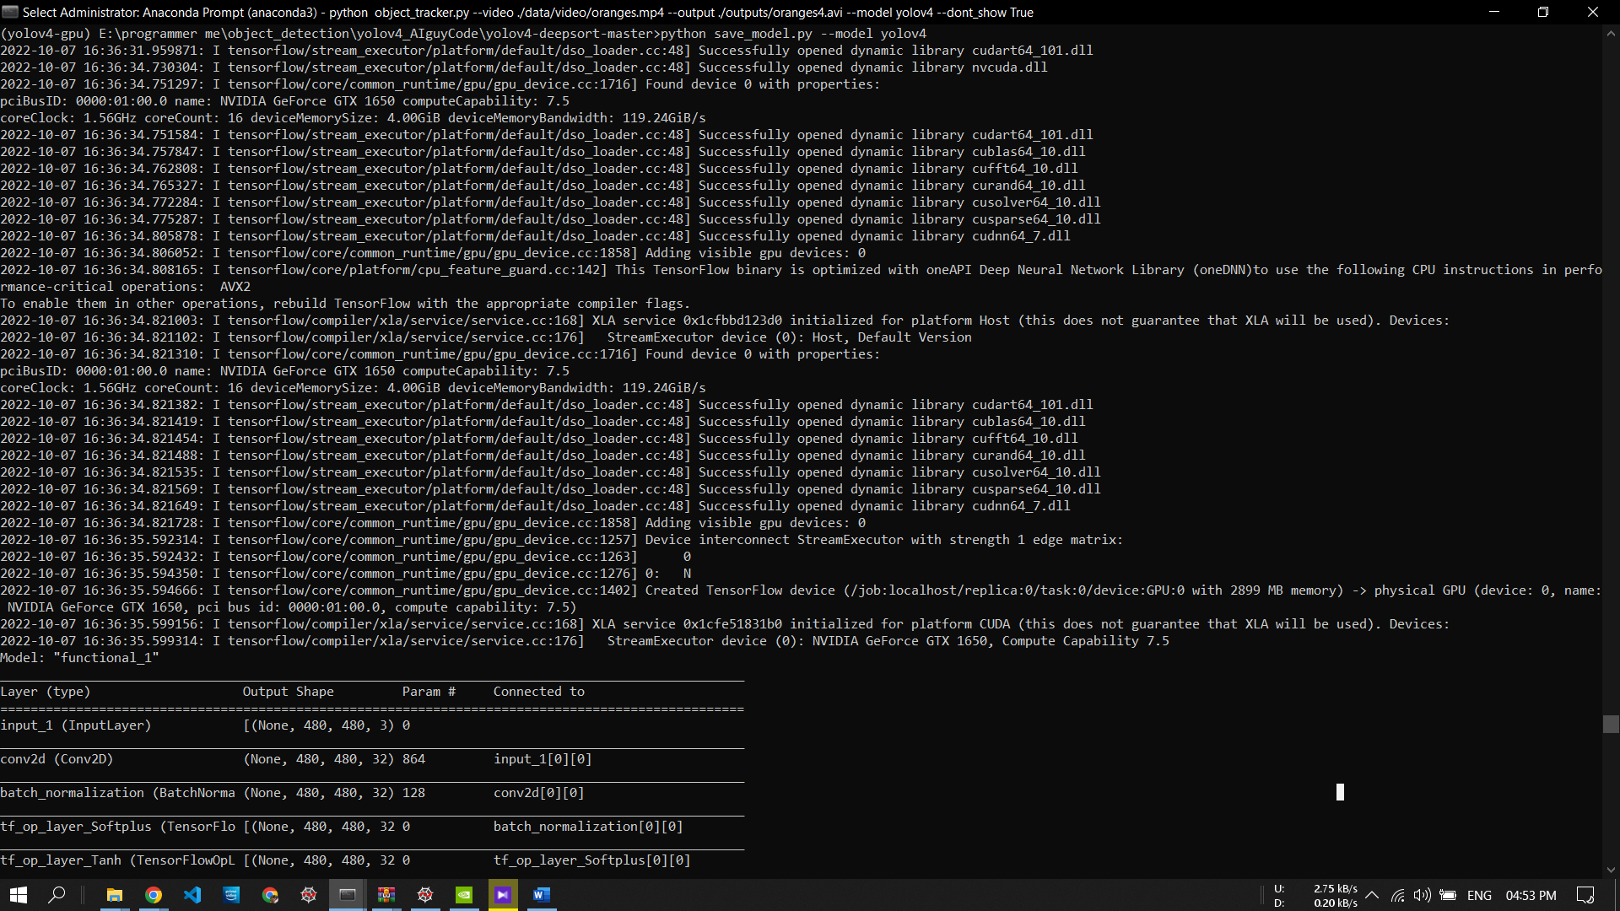

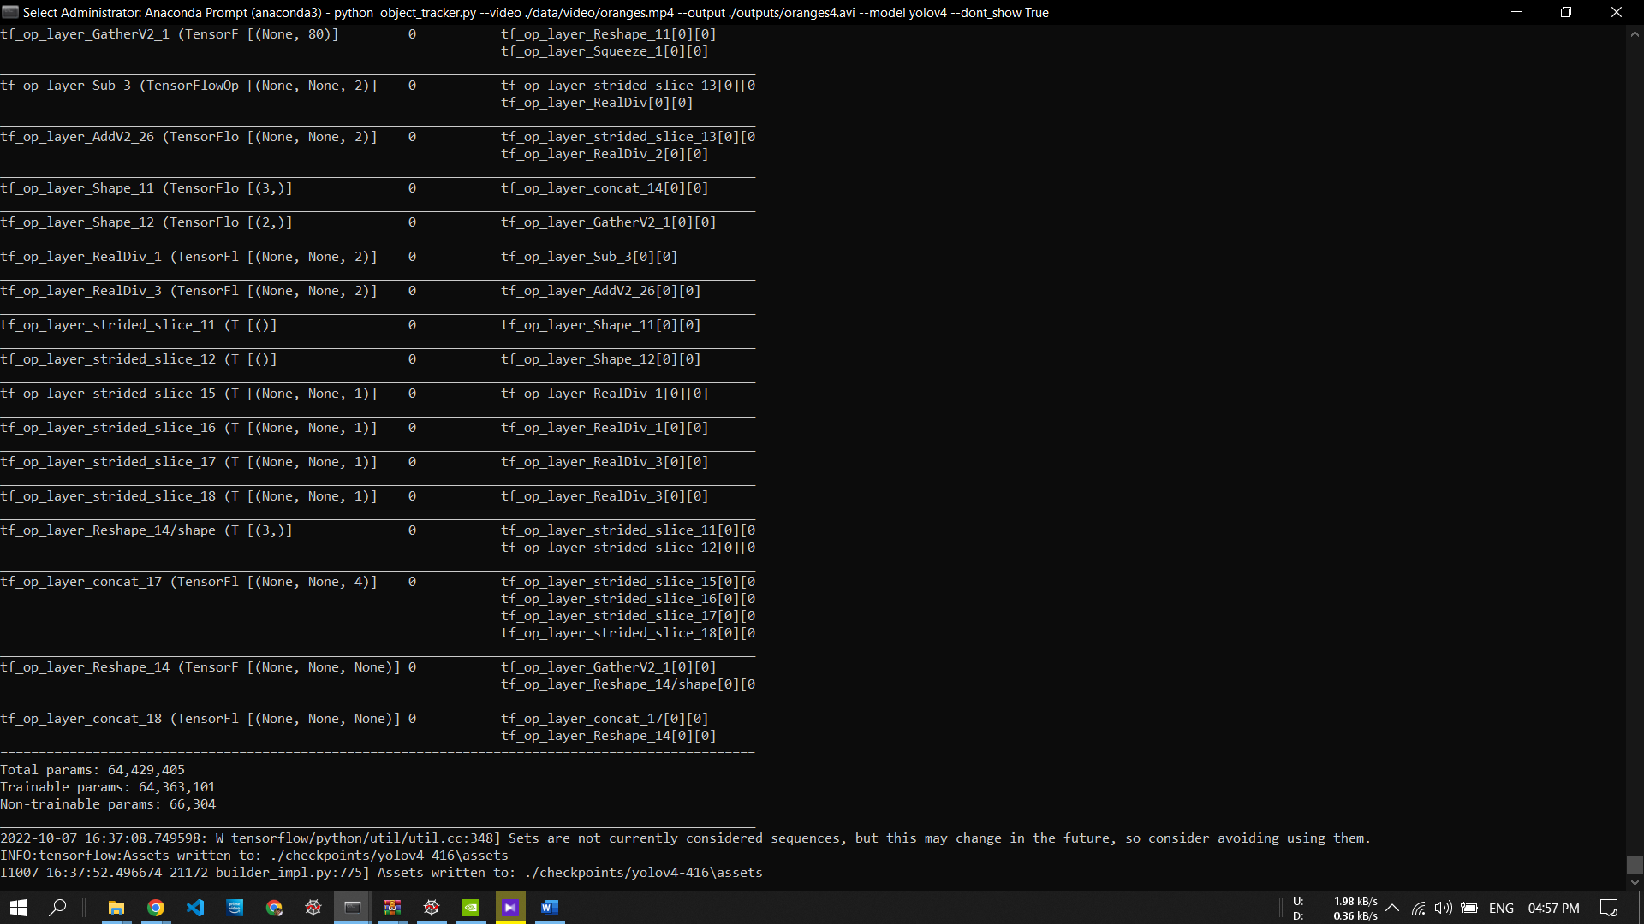

* Running the Algorithm:

DeepSort dependencies and yoloV4 dependencies are loaded and object detection is done by running the object_tracker.py with the following syntax:

python object_tracker.py --video ./data/video/test.mp4 --output ./outputs/demo.avi --model yolov4

arguments:

--video: for input video

--output: for output video containing the detected objects and final count

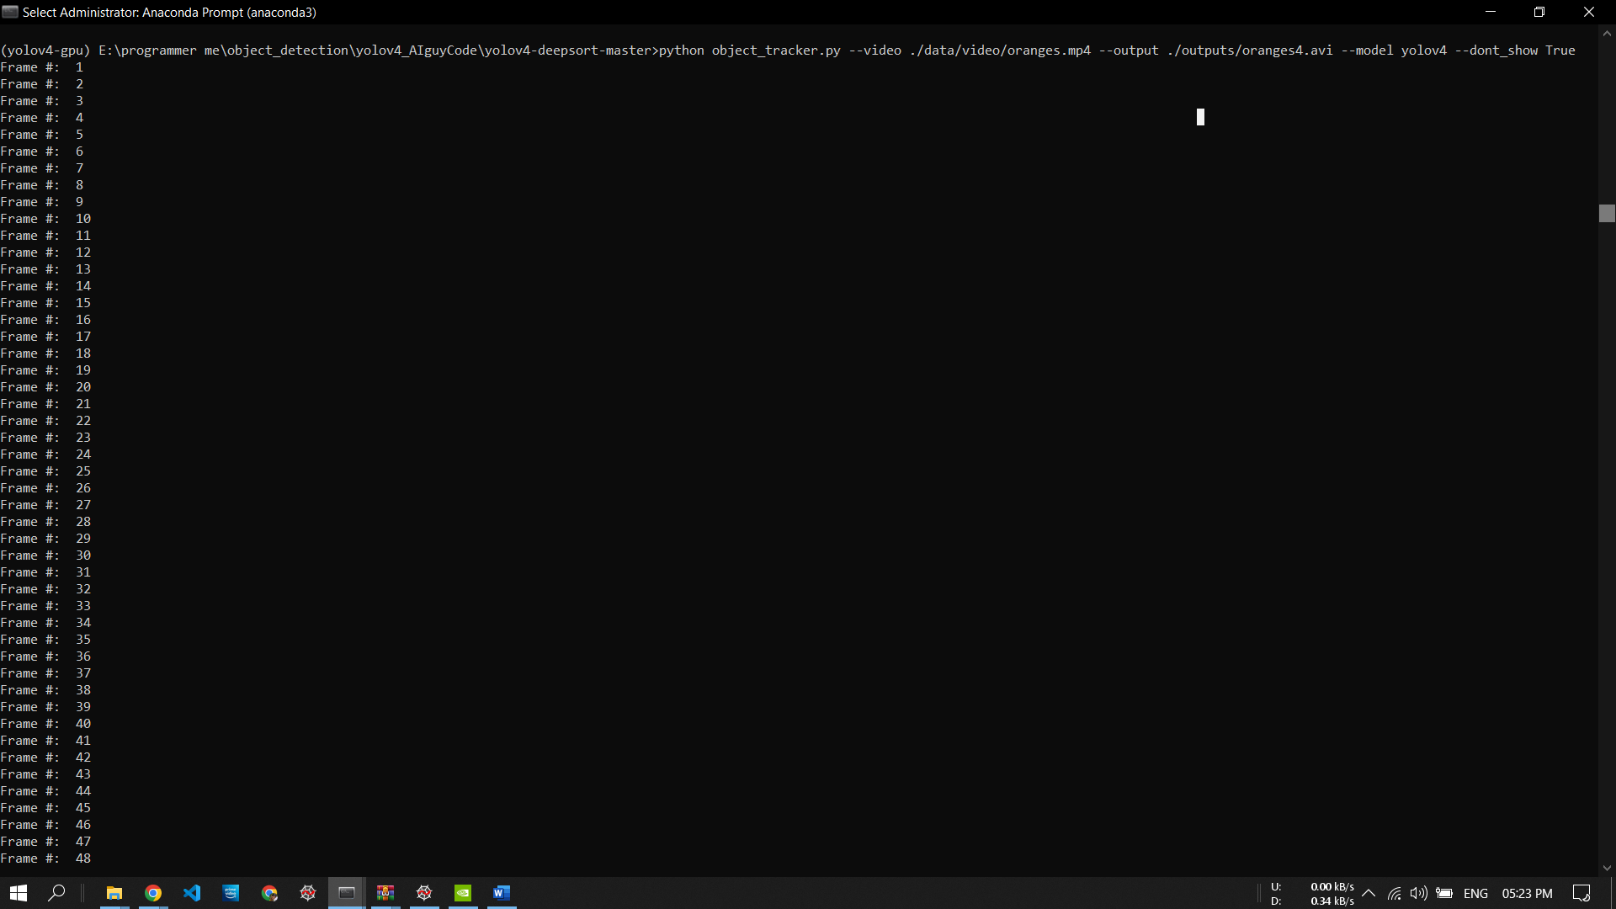

Performance Results:

All the tasks have been carried with GPU processing on NVIDIA RTX 1650 Ti mobile GPU with an average 20 FPS as processing speed. Requirements and libraries for GPU processing are installed accordingly.

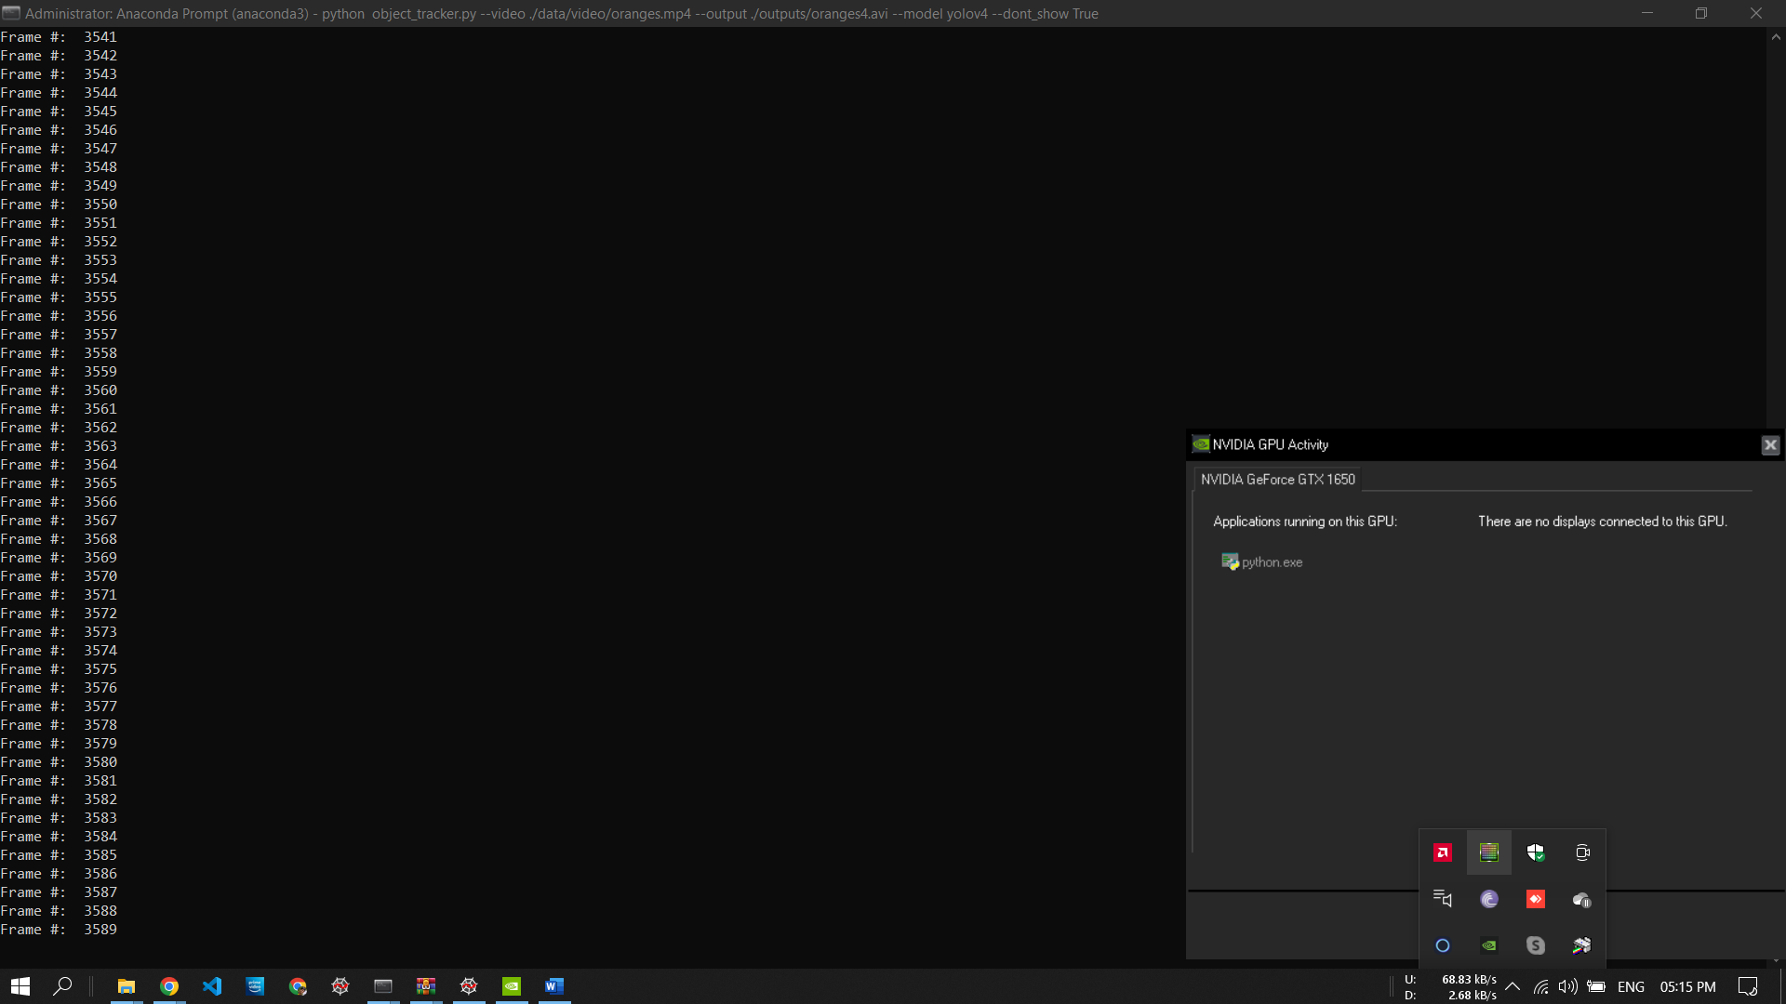

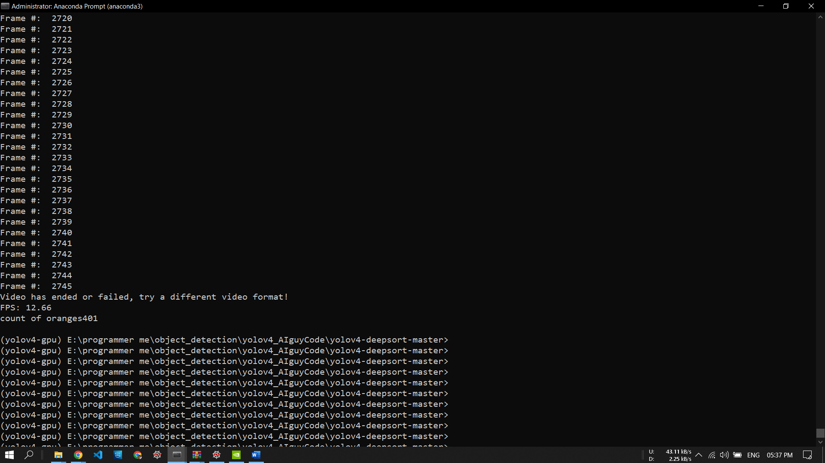

References:

https://github.com/theAIGuysCode/yolov4-deepsort