Project on

Contact_book

Description

• Contactbook is a easy console software designed to illustrate the realistic use of C programming language and its functions as wells as to generate an software which may be utilized in any cellular and different programs that want touch list.

• You can use this software to keep the record such name, address, cellular number, se. E mail etc. of your everyday costumer. Moreover, when you have a brand new customer, you may upload and edit the brand new contact at any time.

• This contactbook may be deployed in a actual world situation. For example, it may be carried out for a telecommunication corporation to have powerful touch listing of the purchaser and it may additionally be deployed as contractor to already present networks.

Requirements

High level requirement:

* It can keep any wide variety of contacts and call may be delivered to this system at any time.
* This challenge in C offers you the power of seek the contact by name of the customer.
* And you may view your contact listing and delete your contacts.
* If you've got got not anything to do with this system, you may at once go out from the main menu.

Low level requirement:

* First we have to pick out what we need to add contact, search, delete and view all contact list.
* Then you need to insert the value like contact name It will display all of the info of unique contact.

5W AND 1H

WHAT—

• Contactbook

• It keeps a record of contacts and its modification details.

• It shows all personal details of the contact.

WHY—

• To maintain contact of a persons.

• To keep the records such as name, address, mobile number, Email and all other personal details of a contact.

• It can be used by any shops or companies and all other people to access to their contacts in future.

WHEN—

• It is required to maintain contact list for future use.

• It act as a record for contacts.

WHERE—

• It can be used in any shops. companies and personal use of a person to save contacts for future use.

WHO—

• This Contactbook can be used by all people around the world.

HOW—

• Using C programming language.

• Using software like visual studio code.

• It takes contact details as input and keeps a record of their personal information.

SWOT ANALYSIS

STRENGTH--

• Easy to use.

• Keep good contact list with instant access.

• Helps people to remain more number of contacts and it is flexible.

• It can be accessible from anywhere.

• It also have enhanced security.

WEAKNESS--

• There may be some confusion if we have same name contacts.

OPPURTUNITIES

• So many companies people and all other need phonebook to save there records for future use we could say all around the world.

THREAT

• More advanced softwares are building to save contacts including AI than this are used in today's outside world.

• There may be chance we could be saved with fake records.

output

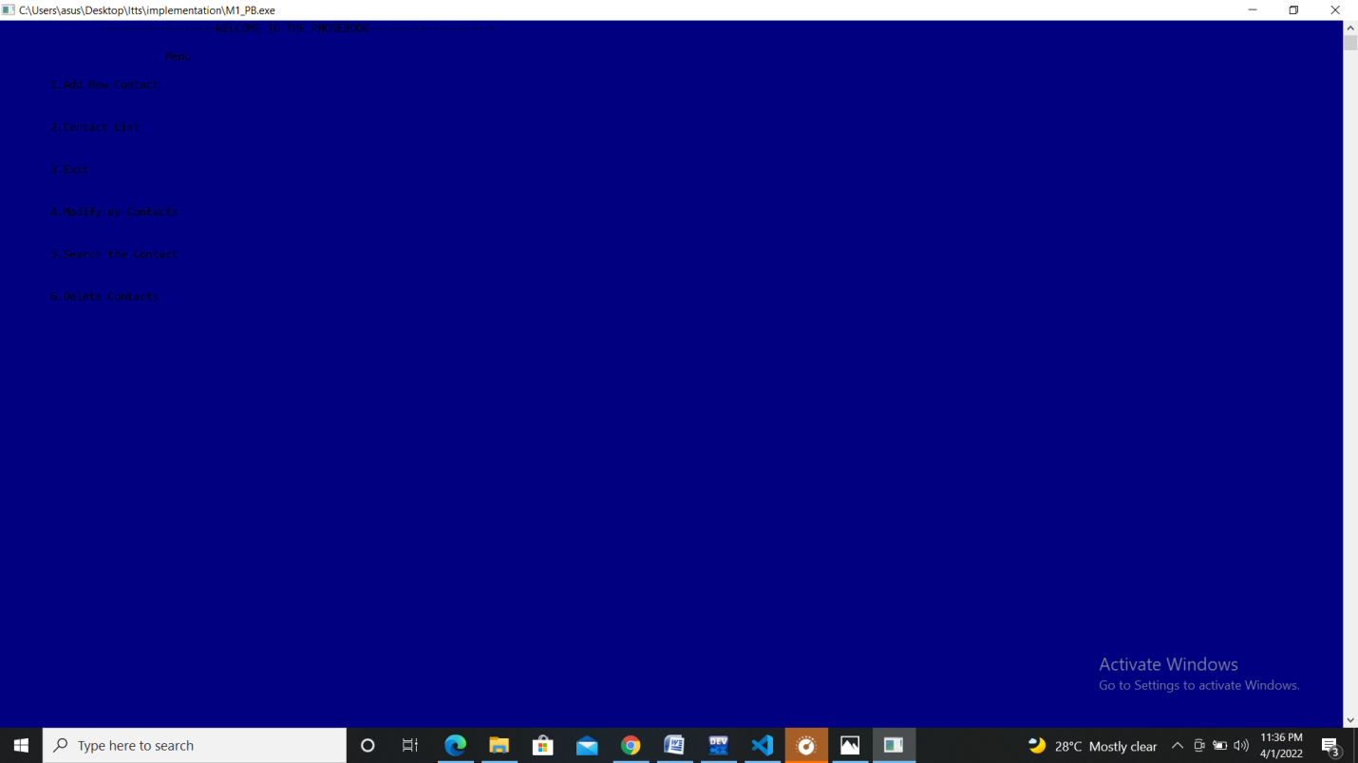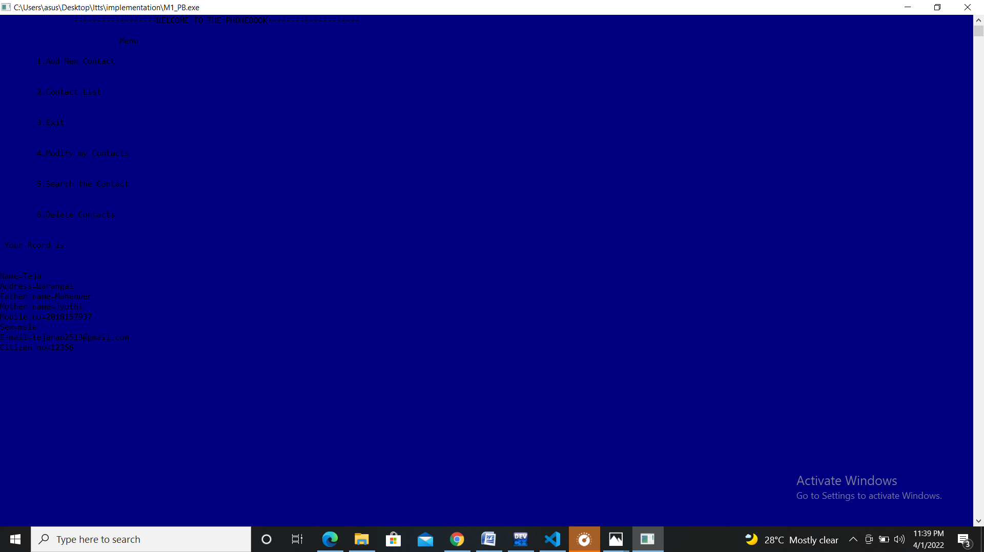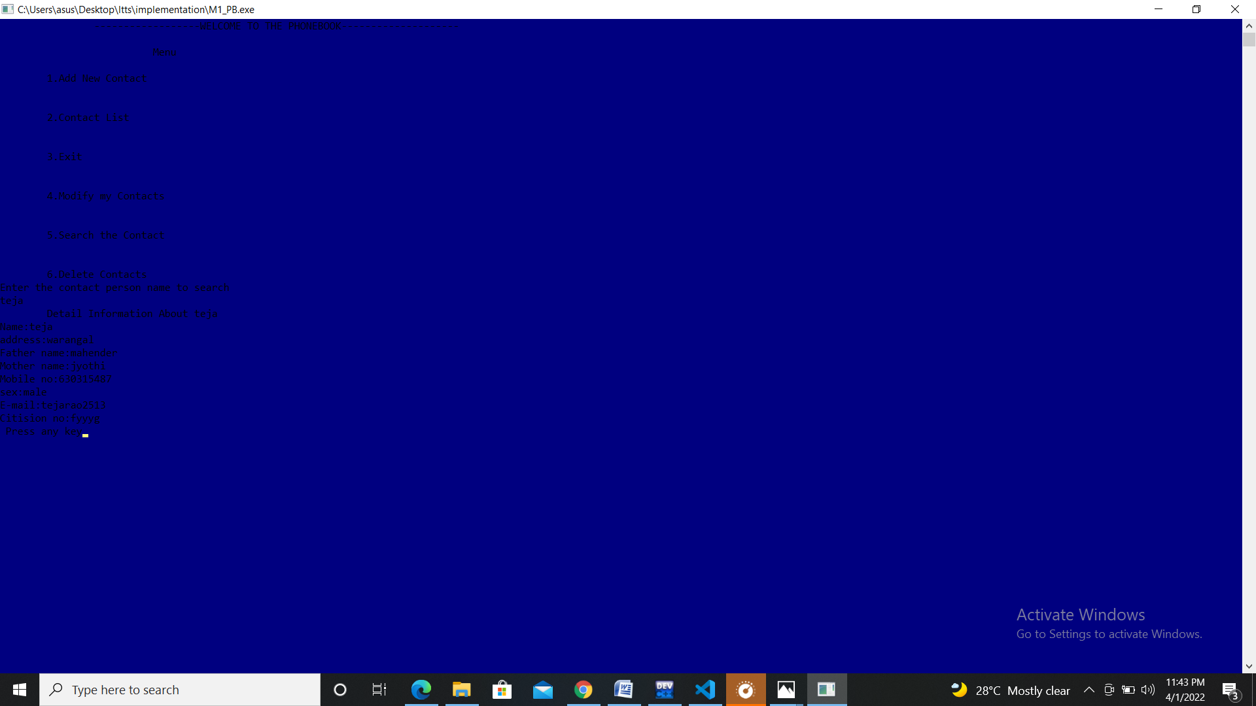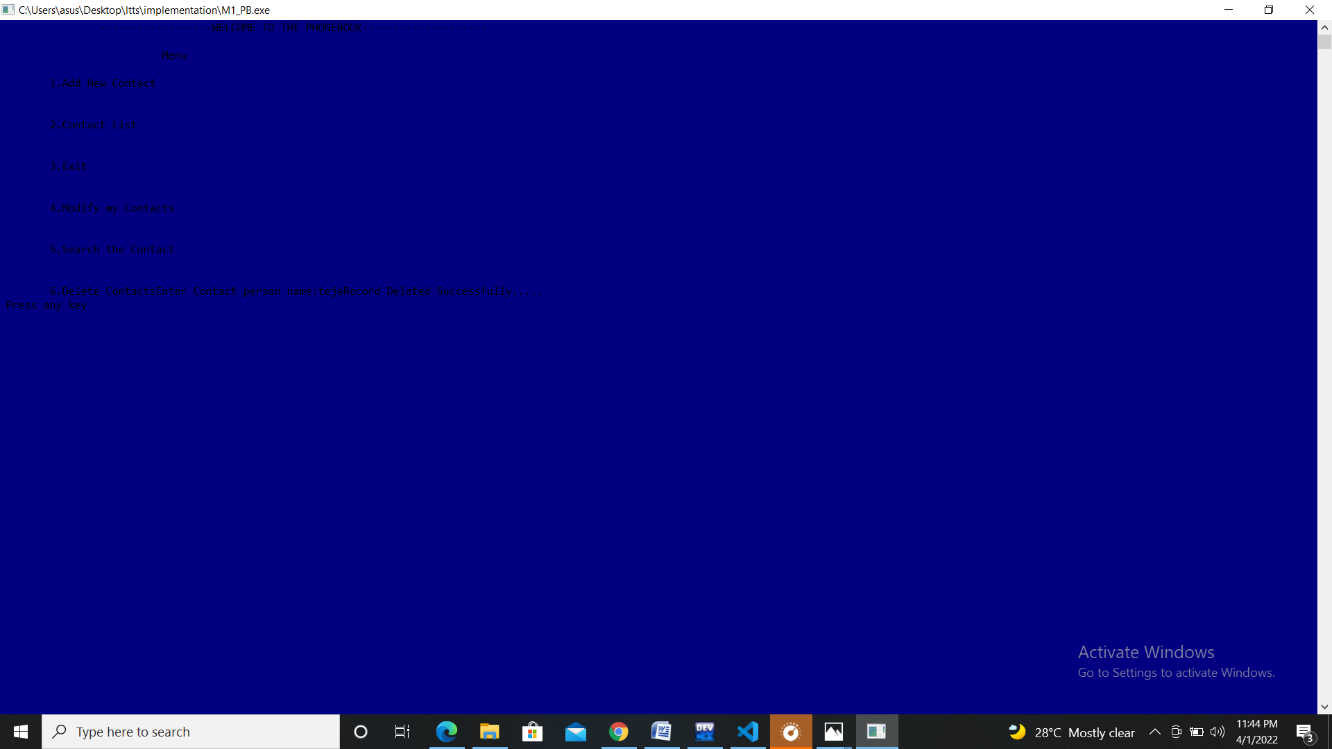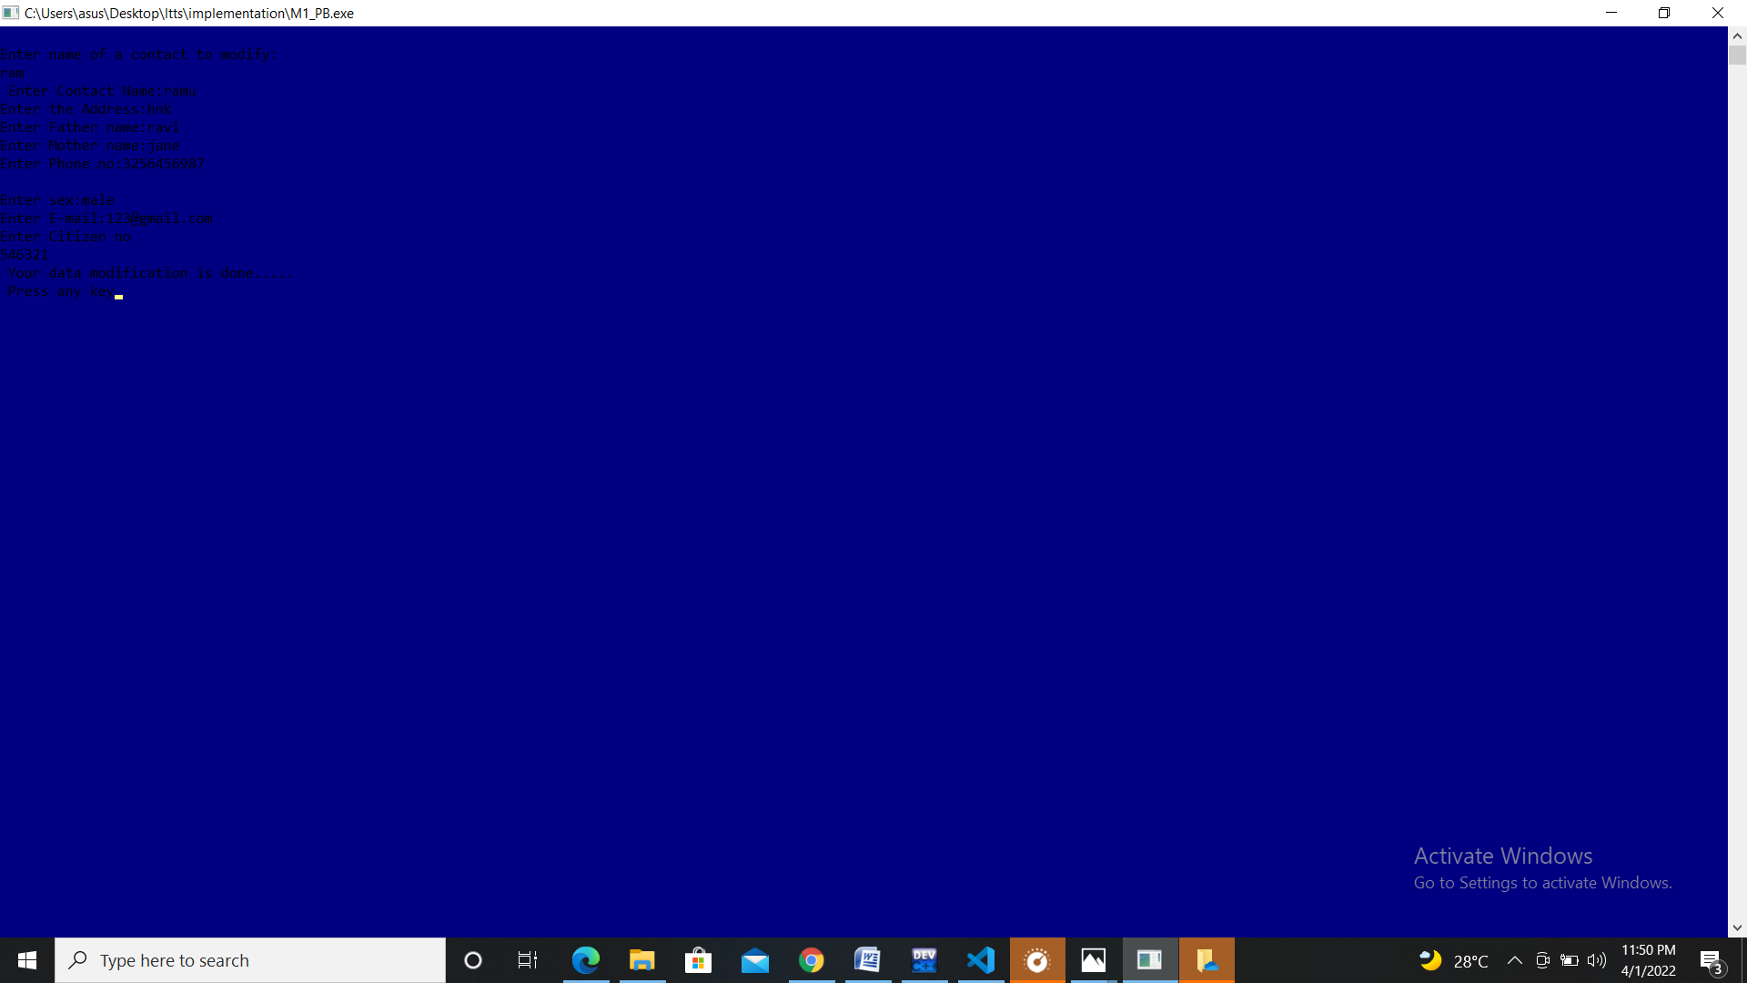

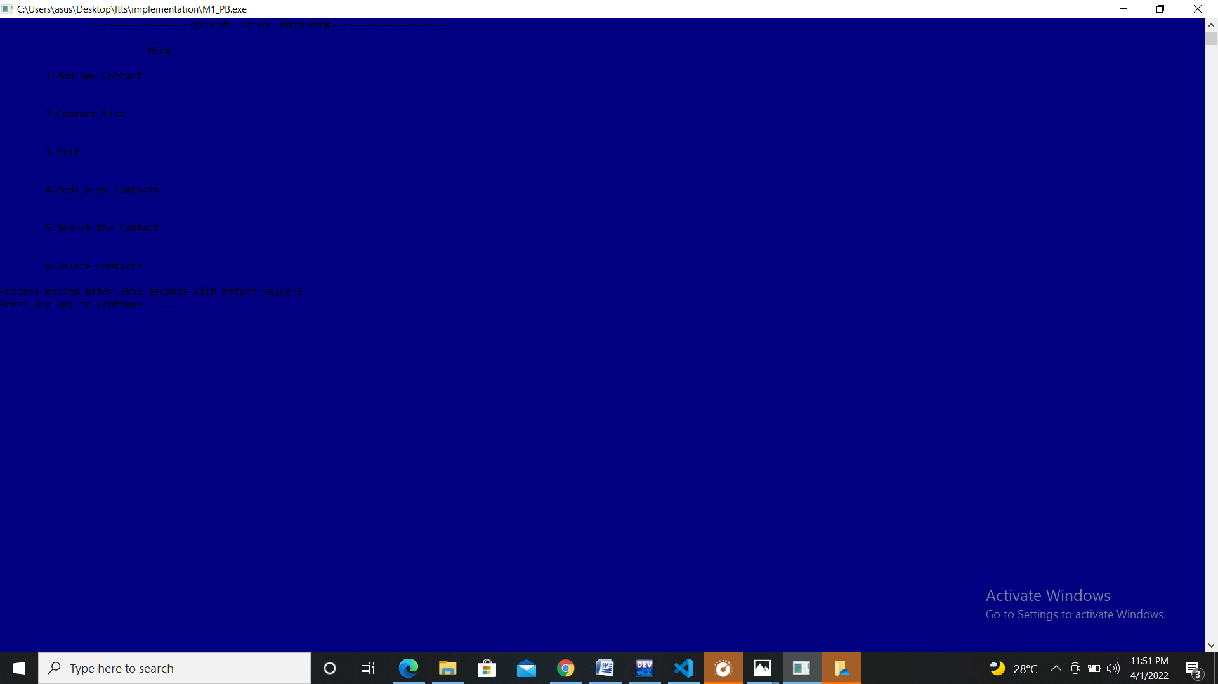

Flowchart

