**Section 1: Introduction to MongoDB (10 points)**

1. **Define MongoDB and explain its significance in modern** **database management.**

MongoDB stands out as a pivotal player in the realm of database management due to its innovative approach and array of features tailored for modern data needs.

**1. Adaptive Schema**: MongoDB's unique document-oriented model liberates developers from the constraints of rigid schemas, offering a dynamic environment where data structures can evolve organically as applications grow.

**2.Scalability at its Core**: The architecture of MongoDB is engineered to scale horizontally across multiple servers, empowering it to effortlessly handle massive datasets and surges in user traffic. Its sharding capabilities guarantee efficient distribution of data, maximizing performance potential.

**3.Performance Redefined**: MongoDB's focus on speed is shown through its suite of tools, encompassing indexing, query optimization, and in-memory operation support. Moreover, functionalities like replica sets bolster data availability and resilience, further enhancing its performance.

4.**Robust Querying Abilities**: MongoDB's query language is both powerful and versatile, catering to a wide spectrum of operations ranging from basic CRUD tasks to advanced aggregation, text search, and geospatial queries. This empowers developers to extract insights from data with unparalleled efficiency.

**5.Embracing Big Data Challenges**: MongoDB's agility and scalability make it an ideal choice for managing big data, where traditional relational databases often falter. Its ability to seamlessly handle diverse data types and adapt to changing demands positions it as a frontrunner in the big data landscape.

**6.Developer-Friendly Environment**: MongoDB's alignment with modern development paradigms, coupled with its intuitive document-based structure, streamlines the development process. This translates to faster iterations and smoother deployments, driving innovation and productivity.

**7.Thriving Community Ecosystem**: The vibrant MongoDB community fosters collaboration and innovation, giving rise to an extensive array of tools, libraries, and resources. From official drivers for various programming languages to robust documentation and support, the ecosystem surrounding MongoDB is rich and diverse.

In essence, MongoDB's blend of adaptability, scalability, performance, and developer-centric design makes it an indispensable asset in modern database management. Its ability to tackle the complexities of today's data landscape with finesse positions it as a cornerstone technology for organizations striving to stay ahead in a data-driven world.

**Section 2: Getting Started with MongoDB Atlas (10 points)**

**2. Discuss the advantages of using MongoDB Atlas over traditional self-hosted MongoDB installations**

**MongoDB Atlas, the managed database service provided by MongoDB, presents many advantages over conventional self-hosted MongoDB installations:**

1.**Streamlined Management:** MongoDB Atlas streamlines the setup, configuration, and maintenance of database infrastructure. Developers can effortlessly provision, scale, and oversee MongoDB clusters across their preferred cloud platform with minimal effort, allowing teams to prioritize application development over infrastructure management.

2.A**utomated Backup and Recovery:** MongoDB Atlas integrates automated backup and disaster recovery features. Regular data backups and point-in-time recovery options ensure data integrity and minimize the risk of data loss due to hardware failures or human errors. This automated process drops the need for manual backup tasks and simplifies disaster recovery strategies.

3.**Enhanced Availability and Resilience:** MongoDB Atlas offers high availability configurations using replica sets and automatic failover mechanisms. Even in the face of node failures or network disruptions, databases stay accessible. By swiftly detecting and addressing failures, MongoDB Atlas minimizes downtime, bolstering application reliability.

4.**Seamless Scalability:** MongoDB Atlas helps seamless scalability, enabling users to adjust their database clusters' size based on evolving workload demands. Horizontal scaling via sharding allows for distributed data storage across multiple nodes, enhancing performance and accommodating increasing data volumes and user traffic without downtime.

**5.Robust Security Measures:** MongoDB Atlas boasts robust security features to safeguard data against unauthorized access and cyber threats. These include encryption at rest and in transit, role-based access control, IP whitelisting, and network isolation. These built-in security measures aid compliance with regulatory standards and uphold data privacy and integrity.

**6.Comprehensive Monitoring and Optimization:** MongoDB Atlas provides extensive monitoring and performance optimization tools to proactively find and address performance bottlenecks. Real-time metrics, customizable alerts, and performance recommendations ensure best database performance and resource use, enhancing application reliability and user experience.

**7.Global Deployment Flexibility**: MongoDB Atlas offers flexible deployment options across various cloud providers and regions. This enables users to deploy database clusters closer to their end-users, reducing latency and improving performance. Multi-region replication and data locality features support complian**ce with data residency requirements, easing a seamless global user experience.**

**8.Automatic Software Updates and Patch Management**: MongoDB Atlas takes care of software updates and patch management automatically, ensuring that users always have access to the latest features, performance enhancements, and security fixes without the need for manual intervention. This cuts the overhead of monitoring for updates, scheduling maintenance windows, and applying patches, allowing development teams to stay focused on building and improving their applications. By keeping the database infrastructure up-to-date and secure, MongoDB Atlas helps mitigate the risk of vulnerabilities and ensures that applications stay resilient to appearing threats and challenges in the evolving landscape of technology and security.

In summary, MongoDB Atlas offers a comprehensive array of benefits compared to traditional self-hosted MongoDB installations, including simplified management, automated processes, enhanced availability, scalability, robust security, comprehensive monitoring, and global deployment flexibility. Leveraging MongoDB Atlas empowers organizations to accelerate development, reduce operational complexity, and deliver highly available, scalable, and secure applications to their users.

**Section 3: MongoDB and the Document Model (10 points)**

3.Explain the document model used in MongoDB. How does it differ from the relational model used in traditional databases? Can provide examples

The document model in MongoDB is like organizing data into flexible documents, like how you might organize information in a text file or a JSON object. Here's a simple example:

Document Model in MongoDB:

Think of MongoDB documents as structured pieces of information, like small files holding data.

Each document can have different fields and structures, allowing flexibility within a collection.

You can have nested fields and arrays, making it easy to stand for complex data.

Example of a Document in MongoDB:

{  
 "name": "Teja",  
 "age": 25,  
 "email": "teja.pn42@.com",  
 "address": {  
 "street": "252 Goffe Ter",  
 "city": "New Haven",  
 "zip": "06511"  
 },  
 "interests": ["dancing", "reading", "swimming"]  
}

Relational Model in Traditional Databases:

In contrast, relational databases organize data into tables with rows and columns.

Each table has a fixed structure defined by columns and data types.

Relationships between tables are set up using keys, ensuring data consistency.

Example of Tables in a Relational Database:

Table: Users  
| id | name | age | email |  
|----|-----------|-----|-------------------|  
| 1 | Teja | 25 | teja.pn42@gmail.com |  
  
Table: Addresses  
| id | userid | street | city | zip |  
|----|---------|-------------|----------|-------|  
| 1 | 1 | 252 Goffe Ter | new haven | 06511 |  
  
Table: Interests  
| id | userid | interest |  
|----|---------|----------|  
| 1 | 1 |dancing |  
| 2 | 1 | reading |  
| 3 | 1 | swimming|

**Key Differences:**

**Flexibility**: MongoDB allows for dynamic structures within documents, while relational databases have fixed table schemas.

**Data Relationships**: MongoDB can embed related data within documents or reference it, while relational databases use keys to link tables.

**Query Language**: MongoDB uses a JavaScript-like query language, while relational databases use SQL for querying.

**Scalability**: MongoDB's flexible model can be more scalable for certain types of data compared to the structured nature of relational databases.

In short, MongoDB's document model offers flexibility and simplicity, making it great for storing diverse and evolving data, while relational databases are well-suited for structured data with established relationships.

**Section 4: MongoDB Data Modelling Intro (10 points)**

**4. Describe the process of data modelling in MongoDB. How does it differ from data modelling in relational databases? Can provide examples**.

In MongoDB, data modeling involves designing flexible document structures within collections. Documents can have varying fields and structures, allowing for schema flexibility. Relationships between data can be represented through embedding or referencing.

Example:

// User Document

{

"_id": ObjectId("6011a0f3a4a9f49ec43d9bf2"),

"name": "Teja",

"email": "teja.pn42@gmail.com”

}

// Order Document

{

"_id": ObjectId("603011a82b3ff81f75fdcb9b"),

"user_id": ObjectId("6011a0f3a4a9f49ec43d9bf2"),

"total_price": 1996.96

}

In relational databases, data modeling involves designing normalized tables and defining relationships using foreign keys. Tables have fixed schemas, and relationships are set up through primary and foreign keys.

Example:

-- Users Table

CREATE TABLE Users (

user_id INT PRIMARY KEY,

name VARCHAR (255),

email VARCHAR (255)

);

-- Orders Table

CREATE TABLE Orders (

order_id INT PRIMARY KEY,

user_id INT,

total_price DECIMAL (10, 2),

FOREIGN KEY (user_id) REFERENCES Users(user_id)

);

Key Difference:

MongoDB offers flexibility in document structure and relationships, while relational databases have fixed schemas and rely on foreign keys for relationships.

**Section 5: Connecting to a MongoDB Database (10 points)**

**5. Explain the steps involved in connecting to a MongoDB database using the MongoDB shell. Can provide screenshots**

**Open Command Prompt**: Open your terminal or command prompt window.

**Navigate to MongoDB**: If MongoDB is not in your system's PATH environment variable, navigate to the bin directory of your MongoDB installation.

**open MongoDB Shell**: Enter the command to launch the MongoDB shell. On Windows, this command is mongo. On Unix-based systems like macOS and Linux, you may need to specify the hostname and port of the MongoDB server if it's not running locally. For example:

**Enter Connection Details**: Once the MongoDB shell is launched, enter the connection details such as hostname, port, username, password (if authentication is enabled), and authentication database (if applicable). For a local MongoDB instance without authentication, simply enter:

**Verify Connection**: After entering the connection details, press Enter to connect to the MongoDB database. If the connection is successful, you will see a message showing a successful connection, and the MongoDB shell prompt (>) will appear.

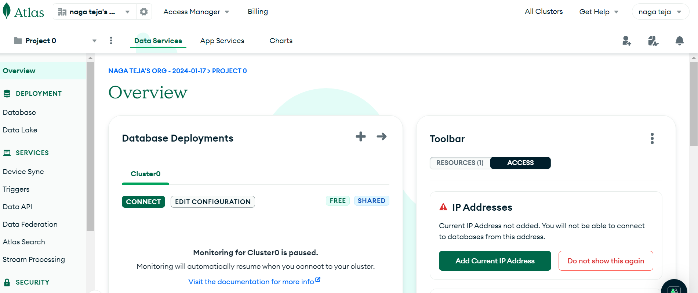

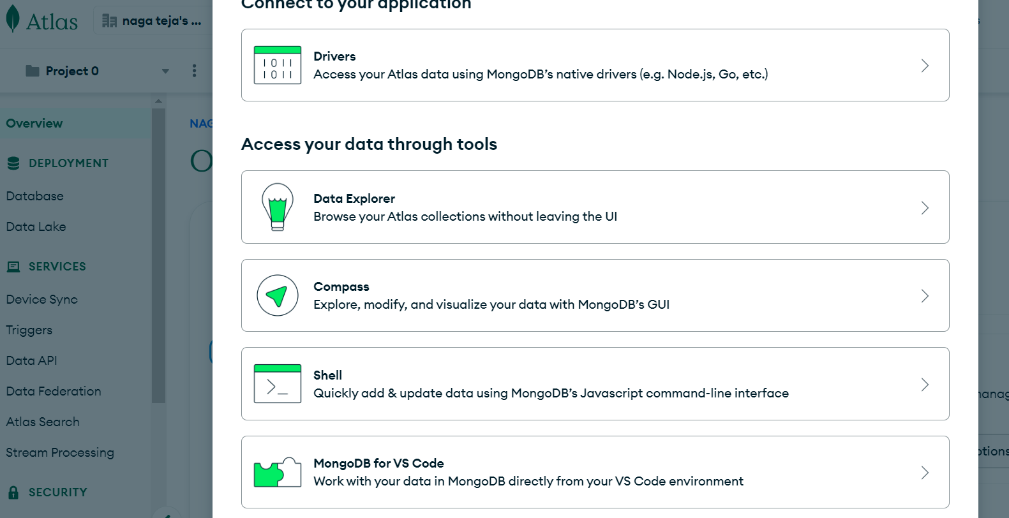

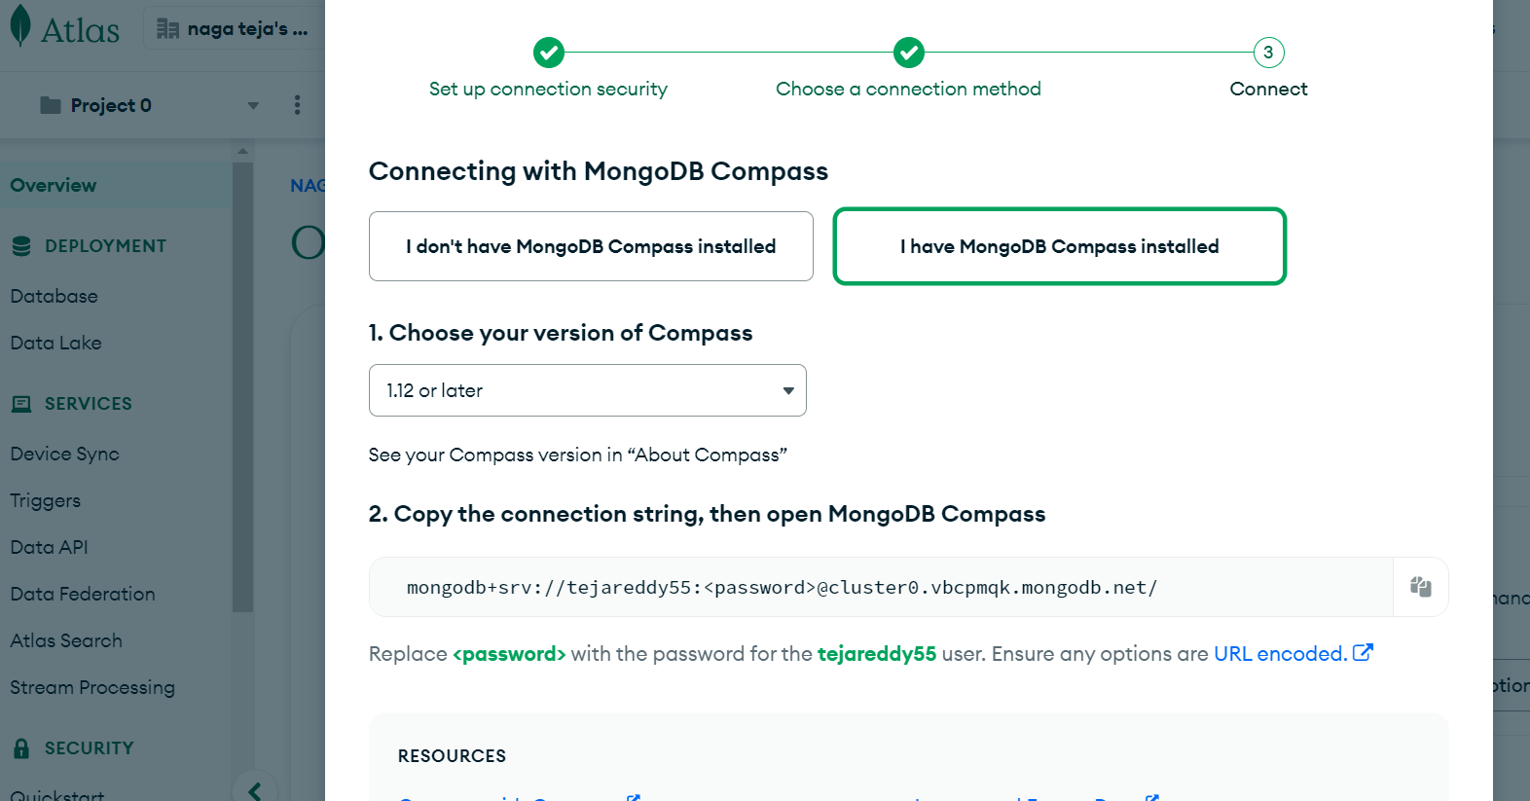

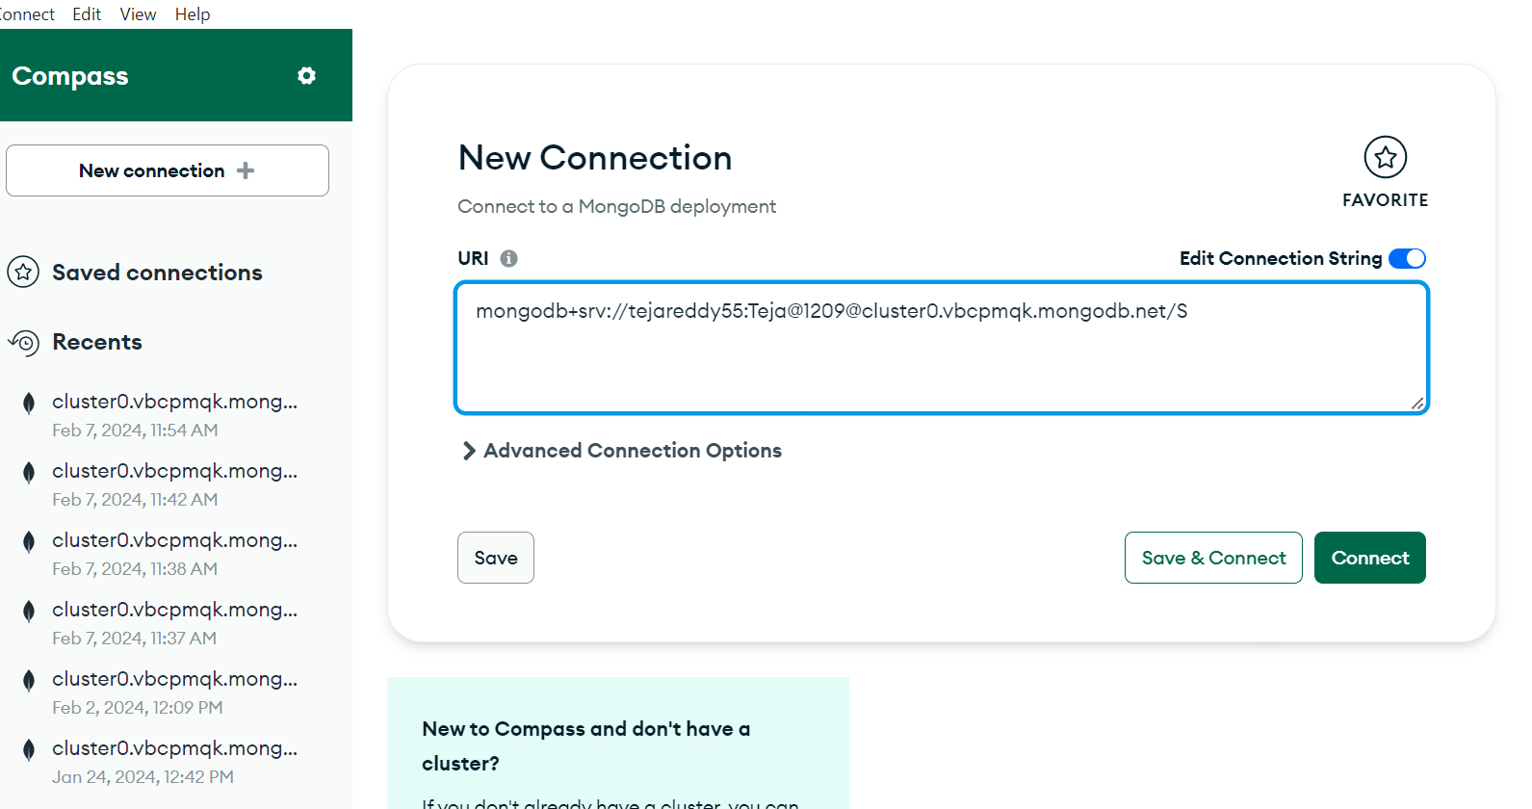

**Section 6: Connecting to MongoDB in Python (10 points)**

6. Discuss the methods available for connecting to MongoDB databases usingPython. Provide code examples to illustrate your points.

1. **Using PyMongo**:

PyMongo is a Python library that lets you connect to MongoDB databases.

Here's how to use it:

import pymongo

# Connect to MongoDB

client = pymongo.MongoClient("mongodb://localhost:27017/")

# Access a specific database

db = client["mydatabase"]

# Access a specific collection

collection = db["mycollection"]

# Insert a document

document = {"name": "Teja", "age": 25}

result = collection.insert_one(document)

print("Inserted document ID:", result.inserted_id)

# Find documents

query = {"name": "Teja"}

result = collection.find(query)

for doc in result:

print(doc)

2**. Using MongoDB Atlas with PyMongo:**

MongoDB Atlas is a cloud-based service for hosting MongoDB databases. Here's how to connect to it with PyMongo:

import pymongo

# Connect to MongoDB Atlas

client = pymongo.MongoClient("your_mongodb_atlas_connection_string")

# Access a specific database

db = client["mydatabase"]

# Access a specific collection

collection = db["mycollection"]

# Insert a document

document = {"name": "teja", "age": 25}

result = collection.insert_one(document)

print ("Inserted document ID:", result.inserted_id)

# Find documents

query = {"name": "teja"}

result = collection.find(query)

for doc in result:

print(doc)

**Section 7: MongoDB CRUD Operations: Insert and Find Documents (10points)**

**7. Explain the CRUD operations in MongoDB, focusing on the insertion and retrieval of documents. Provide examples to prove each operation.**

In MongoDB, CRUD operations stand for Create, Read, Update, and Delete. These operations are fundamental for interacting with data stored in MongoDB databases. Below is an explanation of each CRUD operation:

**Create (Insert):**

This operation is used to add new data to a MongoDB database.

In MongoDB, data is stored in collections. To create a new document (similar to a row in a relational database), you insert it into a collection.

You can insert a single document or multiple documents at once.

Example of inserting a single document:

import pymongo

# Connect to MongoDB

client = pymongo.MongoClient("mongodb://localhost:27017/")

db = client["mydatabase"]

collection = db["mycollection"]

# Insert a single document

document = {"name": "Teja", "age": 25}

result = collection.insert_one(document)

print ("Inserted document ID:", result.inserted_id)

Example of inserting multiple documents:

# Insert multiple documents

documents = [

{"name": "teja", "age": 25},

{"name": "reddy", "age": 35}

]

result = collection.insert_many(documents)

print ("Inserted documents IDs:", result.inserted_ids)

Retrieval (Read):

To retrieve data from MongoDB, we use the find () method, which returns a cursor to iterate over the documents. We can specify criteria for filtering data.

Example of retrieving all documents:

# Retrieve all documents

cursor = collection.find()

# Iterate over the documents

for document in cursor:

print(document)

Example of retrieving documents based on a query:

# Retrieve documents matching a query

query = {"age": {"$gt": 30}} # Find documents where age is greater than 30

cursor = collection.find(query)

# Iterate over the documents

for document in cursor:

print(document)

Example of retrieving a single document:

# Retrieve a single document

document = collection.find_one({"name": "John"})

print(document)

These examples show how to perform insertion and retrieval operations in MongoDB using PyMongo, providing flexibility and ease of use for interacting with the database.

**Section 8: MongoDB CRUD Operations: Replace and Delete Documents(10 points)**

8. Discuss the replace and delete operations in MongoDB. How do theseoperations differ from traditional update and delete operations in relationaldatabases? Can provide examples

**Replace Operation in MongoDB**: In MongoDB, the "replace" operation involves substituting an entire document with a new one. This action completely overrides the existing document with the new data provided, including all fields except for the _id field, which is still unchanged unless specified.

D**elete Operation in MongoDB**: The "delete" operation in MongoDB removes documents from a collection based on specified criteria. It allows for the deletion of one or multiple documents that match the given criteria.

Differences from Relational Databases:

Replace vs. Update:

MongoDB's "replace" operation substitutes the entire document, akin to performing a "DELETE" followed by an "INSERT" in relational databases. In contrast, an "update" in relational databases typically changes specific fields within a row.

Delete Operation:

MongoDB's "delete" operation shares similarities with the "DELETE" operation in relational databases.

However, MongoDB offers greater flexibility in deletion criteria using its expressive query language.

Atomicity:

MongoDB ensures atomicity at the document level for write operations, including replace and delete. This guarantees that either the entire operation succeeds or fails, ensuring data consistency.

In relational databases, atomicity is usually managed through transactions, but the level of granularity can vary.

Schema Flexibility:

MongoDB's document-oriented structure allows for more flexible schema design. Replace operations can introduce entirely new fields without strict constraints, unlike relational databases, where altering table structures might be necessary for schema changes.

from pymongo import MongoClient

# Connect to MongoDB

client = MongoClient('mongodb://localhost:27017/')

db = client['your_database'] # Replace 'your_database' with your actual database name

users_collection = db['users']

# Replace Operation

users_collection.replace_one(

{"name": “teja"}, # Criteria to find the document to replace

{"name": "teja", "age": 25, "city": "New Haven"} # New document with updated information

)

# Delete Operation

users_collection.delete_many(

{"age": {"$gt": 50}} # Criteria to match documents for deletion

)

**Section 9: MongoDB CRUD Operations: Modifying Query Results (10points)**

9. Describe how to modify query results in MongoDB using projection, sorting,and limiting techniques. Can provide examples.

In MongoDB, you can change query results using projection, sorting, and limiting techniques to tailor the output according to your needs. Let's dive into each technique with examples:

Certainly, here's another way to describe modifying query results in MongoDB using projection, sorting, and limiting techniques:

**Projection**:

Projection gives you the chance to shape the documents returned by a query by specifying which fields to include or exclude.

For instance, you can use projection to fetch only specific fields such as names, ages, or any other relevant data from your documents.

**Sorting**:

Sorting enables you to arrange query results in either ascending or descending order based on one or more fields.

By applying sorting, you can organize the retrieved documents in a meaningful sequence, such as sorting by age, creation date, or any other relevant criteria.

**Limiting:**

Limiting restricts the number of documents returned by a query, which can be helpful when dealing with large collections or when you only need a subset of the data.

This technique allows you to control the volume of data returned, enhancing query performance and perfecting resource use.

from pymongo import MongoClient

# Connect to MongoDB

client = MongoClient('mongodb://localhost:27017/')

db = client['your_database'] # Replace 'your_database' with your actual database name

collection = db['your_collection'] # Replace 'your_collection' with your actual collection name

# Example query: Retrieve names and ages of the five oldest individuals, sorted by age in descending order

projection = {'name': 1, 'age': 1, '_id': 0}

sort_order = [('age', -1)]

limit = 5

result = collection.find({}, projection). sort(sort_order). limit(limit)

# Print the results

for doc in result:

print(doc)

**Section 10: MongoDB CRUD Operations in Python (10 points)10.**

Write Python code to perform CRUD operations in MongoDB. Provideexplanations for each operation and any challenges you encountered duringimplementation. Can provide examples.

from pymongo import MongoClient

# Connect to MongoDB

client = MongoClient('mongodb://localhost:27017/')

db = client['test_database'] # Replace 'test_database' with your actual database name

collection = db['test_collection'] # Replace 'test_collection' with your actual collection name

# CREATE operation: Insert a document into the collection

def create_document(document):

collection.insert_one(document)

print ("Document inserted successfully!")

# READ operation: Retrieve all documents from the collection

def read_all_documents():

documents = collection.find()

for doc in documents:

print(doc)

# UPDATE operation: Update a document in the collection

def update_document(query, update):

collection.update_one(query, {'$set': update})

print ("Document updated successfully!")

# DELETE operation: Delete a document from the collection

def delete_document(query):

collection.delete_one(query)

print ("Document deleted successfully!")

# Example usage:

# Create operation

document = {"name": "John", "age": 30, "city": "New York"}

create_document(document)

# Read operation

print ("All documents in the collection:")

read_all_documents()

# Update operation

query = {"name": "Teja"}

update = {"age": 25}

update_document(query, update)

# Verify update

print ("After update, all documents in the collection:")

read_all_documents()

# Delete operation

delete_query = {"name": "Teja"}

delete_document(delete_query)

# Verify deletion

print("After deletion, all documents in the collection:")

read_all_documents()

Explanation:

**Create:** The create_document function inserts a new document into the collection using insert_one. It takes a dictionary being the document to be inserted as input.

**Read**: The read_all_documents function retrieves all documents from the collection using find and iterates over the result set to print each document.

**Update**: The update_document function updates a document in the collection matching a given query using update_one. It takes a query to match the document and an update operation to perform.

**Delete**: The delete_document function removes a document from the collection using delete_one. It takes a query to match the document to be removed.

**Bonus Question: Application of MongoDB (10 points)**

11. Choose a real-world scenario where MongoDB could be beneficially applied.Describe the scenario and explain how MongoDB's features align with therequirements of the scenario. Can provide examples

Im taking Mobile App Backend for a Large Financial Services Company aa real world scenario

Background:

A financial services company wants to build a mobile app for its customers.

The app needs to handle millions of users, provide real-time information, and allow users to manage their accounts, transactions, and investments.

The company needs a scalable, flexible, and cost-effective solution to handle the app’s data.

How MongoDB Aligns with the Requirements:

Flexible Data Model:

MongoDB’s document-oriented data model allows the company to stand for complex financial data (accounts, transactions, user profiles) as JSON-like documents.

The flexible schema accommodates changes and additions without disrupting existing data.

Scalability:

MongoDB’s horizontal scaling capabilities allow the company to handle large simultaneous transactions from millions of users.

As the user base grows, MongoDB can distribute data across multiple servers, ensuring high availability and performance.

Rich Query Functionality:

MongoDB’s powerful query language enables complex searches, filtering, and aggregation.

Users can retrieve account balances, transaction history, and investment details efficiently.

Real-Time Analytics:

MongoDB’s MapReduce and aggregation framework allow the company to perform real-time analytics on financial data.

For example, the app can calculate portfolio performance, generate investment recommendations, and track spending patterns.

Low Downtime:

MongoDB’s minimal downtime during maintenance or upgrades ensures uninterrupted service for users.

The company can deploy updates without affecting app availability.

Examples:

Automatic Data Processing, Inc. (ADP):

ADP manages employee finances, health, and benefits.

Their mobile app, serving over a million users in 17 countries, relies on MongoDB for low cost and minimal downtime1.

The Weather Channel:

The Weather Channel’s website faced issues serving many clients using a traditional RDBMS.

MongoDB helped them build a mobile app serving over 40 million users (about twice the population of New York) with real-time weather data and live analytics.