IRONCORE: GYM MANAGEMENT SYSTEM

WEB TECHNOLOGY PROJECT REPORT, V SEM. BTech (Program Name).
FLEXICORE-3131

SUBMITTED TO
SCHOOL OF COMPUTER ENGINEERING, M.I.T., MANIPAL


By
Avaneeth Gowda L (Reg. No: __________)
Adhyan Mahajan (Reg. No: __________)

Under the guidance of: <Faculty Name>
October 2026


Team Details and Work Split

Sl. | Name | Reg. No. | Modules / Pages designed (2 per student) | Signature
1 | Avaneeth Gowda L | __________ | 1. Login & Authentication  2. Members Management | Digital-sign…
2 | Adhyan Mahajan | __________ | 1. Attendance Tracking  2. Payments & Revenue

1. Project Overview
IronCore is a full-stack gym management web application that brings the day-to-day work of a fitness centre into one browser-based dashboard: member registration, membership plans and subscriptions, attendance, payments, trainers, class schedules, equipment and supplement inventory. The front end is a single-page application built with React 19, Vite and Tailwind CSS [1]–[3]. It talks to a RESTful API written in Node.js with Express 5 [4], which stores its data in a MySQL 8.0 database [5]. Every request except login is protected by JSON Web Token (JWT) authentication [6], with role-based authorisation for administrators, trainers and members.
The database layer does more than store rows. Views, stored procedures, user-defined functions and triggers validate input and compute derived values such as a member's age, subscription status and lifetime revenue. The interface offers a dark and a light theme, adapts to desktop, tablet and phone screens, and was built against the WCAG 2.1 Level AA checklist [7].
1.1 Purpose of the Website
Many small and mid-sized gyms still track members, fees and attendance in paper registers or spreadsheets. Renewals get missed, payment records go missing, and the owner has no clear picture of how the business is doing. IronCore replaces these with a single secure system. Front-desk staff can register a member and assign a plan in a few clicks, check members in and out by ID, and see who is inside the gym right now. Owners get live revenue figures, monthly trends and attendance statistics, so decisions rest on data rather than guesswork.
1.2 Objectives
The website provides the following features:
• Secure login: JWT tokens, bcrypt-hashed passwords and role-based access for Admin, Trainer and Member accounts.
• Dashboard: KPI cards (active members, today's check-ins, monthly revenue, classes today), a six-month revenue chart and a membership split chart.
• Member management: register, search, filter and edit members, and assign subscriptions; registration runs through a validating stored procedure.
• Attendance: quick check-in and check-out by member ID, live occupancy, average session length, peak hour, today's activity log and CSV export.
• Payments: this month's revenue, monthly and daily trend charts, a searchable and paginated transaction history, and CSV export.
• Operations: trainer directory, class schedules, plan assignment, equipment inventory with maintenance records, and a supplement shop with automatic stock updates.
• Reports and database features: a metrics page and a page that demonstrates the views, stored procedures, functions and triggers used by the system.
• Themes and layout: dark/light theme toggle remembered in localStorage, and a responsive layout with an off-canvas sidebar on small screens.
1.3 Target Users
The primary users are gym owners and administrators, who manage members, plans, payments and reports, and front-desk staff and trainers, who register members, record attendance and manage classes. The following groups with special needs were kept in mind:
• Keyboard-only users: a "Skip to main content" link, a logical tab order, a visible focus ring, and modal dialogs that trap focus, close with Esc and return focus to the button that opened them.
• Screen reader users: semantic landmarks (header, nav, main), labels tied to every input, aria-label on icon-only buttons, and role="alert" / role="status" on error and success messages so they are announced.
• Users with low vision: text colours chosen for at least 4.5:1 contrast in both themes, a light theme for glare-sensitive users, and layouts that reflow when text is enlarged.
• Users sensitive to motion: animations are switched off when the operating system requests reduced motion (prefers-reduced-motion).
• Tablet and mobile users: staff at the front desk can use the app on a tablet or phone; the sidebar collapses into a menu button and tables scroll within their cards.
1.4 Site Map
The application is a single-page app with client-side routing (React Router). All pages except Login are protected and share the same sidebar, so every page links to every other page.
• Login (/login) → Dashboard on successful sign-in. Any protected URL redirects here when there is no token.
• Dashboard (/) → Members, Attendance, Payments, Trainers, Classes (/plans), Equipment, Supplements, Assign Plans (/assign), Metrics (/reports), DB Features (/db), Logout → Login. These links appear in the sidebar on every page.
• Members → Register Member dialog, Edit Member dialog, Assign Subscription dialog.
• Attendance → Quick Scan (check-in / check-out), Today's Activity Log, CSV export.
• Payments → Revenue Overview, Revenue Trend (daily / monthly), Transaction History, CSV export.
• Pages by student: Login and Members by Avaneeth Gowda L; Attendance and Payments by Adhyan Mahajan; the remaining pages were developed jointly.
1.5 Tools and Technologies
Item | Details
HTML version | HTML5 (single index.html; pages rendered from React JSX components using semantic elements)
CSS framework and version | Tailwind CSS 4.2 (via @tailwindcss/vite) with custom design tokens defined in index.css; Google Fonts: Space Grotesk and Manrope
JavaScript (if any) | React 19.2 with React Router 7, Axios 1.13, Recharts 3 (charts) and Lucide React (icons); built with Vite 8. Back end: Node.js with Express 5, jsonwebtoken, bcryptjs, mysql2
Data source (static / JSON / API) | REST API returning JSON (Express 5), backed by a MySQL 8.0 database (gym_db: 17 tables plus views, stored procedures, functions and triggers)
IDE and Environment used | IDE name on Windows 11; Node.js 20+, npm, Vite dev server, MySQL Server 8.0 / MySQL Workbench, Git and GitHub
Accessibility Guidelines for Users with Disabilities. | WCAG 2.1 Level AA: skip link, semantic landmarks, labelled form controls, accessible modal dialogs (focus trap, Esc to close), live status/alert messages, visible focus ring, 4.5:1 text contrast, prefers-reduced-motion support, responsive layout
Testing tools (Lighthouse, WAVE etc.) | ESLint 9 (react-hooks, react-refresh plugins), browser DevTools, manual keyboard-only navigation testing; add Lighthouse / WAVE results if run

1.6 Common Design Followed by the Team
All protected pages share one layout, defined once in App.jsx inside a ProtectedRoute wrapper, so every page looks and behaves the same:
• Skip link: the first focusable element, which jumps to the main content.
• Sidebar (<aside> with <nav aria-label="Main">): brand logo, eleven navigation links with icons, the current page marked with aria-current, and a <footer> that holds the Logout button. On small screens it slides in from the left.
• Top bar (<header>): the page title (looked up from a TITLES map by URL), the theme toggle and the signed-in user badge.
• Main content (<main id="main-content">): each page is loaded lazily with React.lazy and Suspense to keep the first load small.
Colours are defined once as design tokens in the Tailwind @theme block of index.css and overridden under a .light class, so pages never hard-code colours. The dark theme uses a near-black background (#0A0A0E), dark cards (#111116) and a lime accent (#DFFF00). The light theme uses a pale grey background (#F0F0F5), white cards and a blue accent (#1D4ED8). Headings use the Space Grotesk font and body text uses Manrope, both from Google Fonts. Shared building blocks (rounded cards, KPI stat cards, data tables, modal dialogs via the useDialog hook, and a ConfirmDialog for deletions) make the pages read as one project.
2. Student 1: Avaneeth Gowda L (Reg. No: __________)
Modules / Pages: Login & Authentication, Members Management
2.1 Module Description
Module 1: Login & Authentication
The Login page is the entry point of the system. It shows the IronCore brand, a short instruction ("Both fields are required.") and a card with an email field, a password field and a Sign in button. A user cannot reach any other page without a valid token: the ProtectedRoute wrapper redirects to /login when no token is stored.
• Input: email and password typed by the user.
• Processing: the server looks the email up in the Admin, Trainer and Member tables in turn, compares the password with the stored bcrypt hash [8], and on success signs a JWT containing the user's id and role, valid for 8 hours.
• Output: on success the token and role are saved in localStorage and the user is sent to the Dashboard; on failure an error message is shown in an alert box.
• Components used: centred card, labelled form inputs with icons, submit button with a loading spinner, alert banner.
Module 2: Members Management
The Members page lists every member with their contact details, age, current plan and subscription status, lifetime revenue and number of visits. The header shows the total and active counts. Staff can search by name or email, filter by status, register a new member, edit an existing one, and assign a membership plan.
• Input: member details (full name, email, phone, date of birth, gender, and on edit, join date and status); for subscriptions, a plan and a payment method.
• Processing: listing reads the vw_member_dashboard view and calls three SQL functions per member (fn_member_age, fn_subscription_status_label, fn_total_revenue_by_member). Registration calls the sp_register_member stored procedure, which rejects an empty name, an invalid gender or a duplicate email.
• Output: the refreshed member table, and a success or error message inside the dialog.
• Components used: page header with action button, search bar and status filter, data table with avatar initials and status badges, Register/Edit modal form, Assign Subscription modal with selectable plan cards.
2.2 Design of the Module
Both modules use the same pattern: the React front end sends an HTTP request with Axios [9], the Express back end processes it and queries MySQL through a mysql2 connection pool, and the result comes back as JSON. All data is sent as JSON (Content-Type: application/json); no HTML is rendered on the server.
Login flow
• The user submits the form. The browser checks that both fields are filled and that the email is well formed (required and type="email").
• React calls POST /api/auth/login with the JSON body { email, password }.
• The auth controller queries SELECT * FROM Admin|Trainer|Member WHERE email = ? using a parameterised query, which prevents SQL injection, and checks the password with bcrypt.compare.
• On success it returns { token, role, name } with status 200; on failure it returns 401 with { message: "Invalid credentials" }.
• For every later request the front end sends Authorization: Bearer <token>. The auth middleware verifies the token and checks that the role is allowed on that route, otherwise it answers 401 or 403.
Members flow
Action | Request | Back-end processing
Load list | GET /api/members | SELECT from view vw_member_dashboard plus three SQL functions; falls back to the Member table if the view is not installed.
Register | POST /api/members JSON: name, email, phone, gender, date_of_birth | CALL sp_register_member(…, @new_id, @msg); returns 201 with the new id, or 400 with the procedure's error message.
Edit | PUT /api/members/:id | UPDATE Member SET … WHERE member_id = ?
Assign plan | POST /api/db/procedures/renew-subscription JSON: member_id, plan_id, payment_method | CALL sp_renew_subscription(…) inserts the Subscription row and its Payment row in one step and returns the new subscription id and a message.

Client-side validation: required attributes on name and email, type="email" and type="date" inputs, a check that a plan is selected before assigning a subscription, and disabled buttons while a request is in progress to stop double submission.
Server-side validation: the JWT middleware allows only admin and trainer roles on member routes; sp_register_member validates name, gender and email uniqueness; the database enforces NOT NULL, UNIQUE (email), ENUM (gender, status) and foreign-key constraints; all queries are parameterised.
2.3 Development of the Module
Listing 2.1: Login request in Login.jsx (front end)
const handleLogin = async (e) => {
e.preventDefault();
setLoading(true);
setError('');
try {
const res = await axios.post(`${API_BASE}/auth/login`, { email, password });
localStorage.setItem('token', res.data.token);
localStorage.setItem('role', res.data.role);
navigate('/');
} catch (err) {
setError(err.response?.data?.message || 'Login failed! Check server connection.');
} finally {
setLoading(false);
}
};
Listing 2.2: Login handler in authController.js (back end)
for (const r of roles) {
const target = tableMap[r];
const [rows] = await db.query(
`SELECT * FROM ${target.table} WHERE email = ?`, [email]
);
const user = rows[0];
if (!user || !user.password || !(await bcrypt.compare(password, user.password))) continue;

const token = jwt.sign(
{ id: user[target.idCol], role: r },
process.env.JWT_SECRET,
{ expiresIn: '8h' }
);
return res.json({ token, role: r, name: user.name });
}
res.status(401).json({ message: 'Invalid credentials' });
Listing 2.3: Role-based JWT middleware (authMiddleware.js)
module.exports = (roles = []) => (req, res, next) => {
const token = req.headers.authorization?.split(' ')[1];
if (!token) return res.status(401).json({ message: 'No token provided' });
try {
const decoded = jwt.verify(token, process.env.JWT_SECRET);
req.user = decoded; // { id, role }
if (roles.length && !roles.includes(decoded.role))
return res.status(403).json({ message: 'Access denied' });
next();
} catch {
return res.status(401).json({ message: 'Invalid token' });
}
};
Listing 2.4: Member routes and registration through a stored procedure
router.get('/', auth(['admin', 'trainer']), memberController.getAllMembers);
router.post('/', auth(['admin', 'trainer']), memberController.createMember);
router.put('/:id', auth(['admin', 'trainer']), memberController.updateMember);

// memberController.createMember
await db.query(
'CALL sp_register_member(?, ?, ?, ?, ?, @new_id, @msg)',
[name, gender || 'Male', phone, email, date_of_birth || null]
);
const [[result]] = await db.query('SELECT @new_id AS member_id, @msg AS message');
if (result.member_id > 0)
return res.status(201).json({ id: result.member_id, message: result.message });
return res.status(400).json({ message: result.message });
Listing 2.5: Validation inside sp_register_member (MySQL)
IF p_name IS NULL OR TRIM(p_name) = '' THEN
SET p_new_id = -1;
SET p_message = 'ERROR: Member name cannot be empty.';
ELSEIF p_gender NOT IN ('Male', 'Female', 'Other') THEN
SET p_new_id = -1;
SET p_message = 'ERROR: Gender must be Male, Female, or Other.';
ELSE
SELECT COUNT(*) INTO v_email_count FROM Member WHERE email = p_email;
IF v_email_count > 0 THEN
SET p_new_id = -1;
SET p_message = 'ERROR: A member with this email already exists.';
ELSE
INSERT INTO Member (name, gender, phone, email, date_of_birth, join_date, status)
VALUES (p_name, p_gender, p_phone, p_email, p_date_of_birth, CURDATE(), 'Active');
SET p_new_id = LAST_INSERT_ID();
END IF;
END IF;
2.4 Results
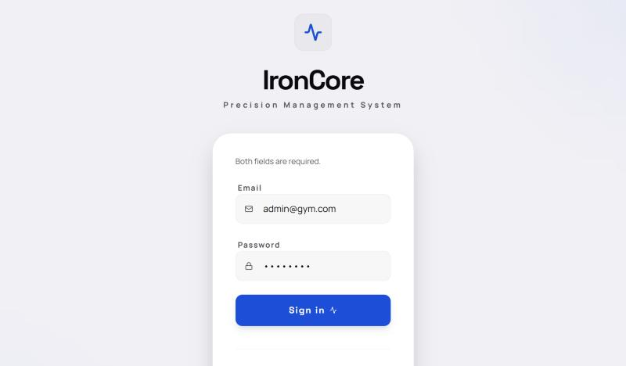
Figure 2.1: Login page
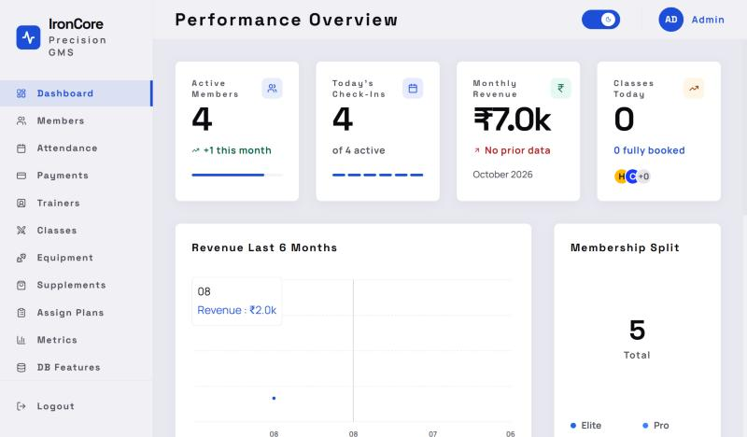
Figure 2.2: Dashboard shown after a successful login
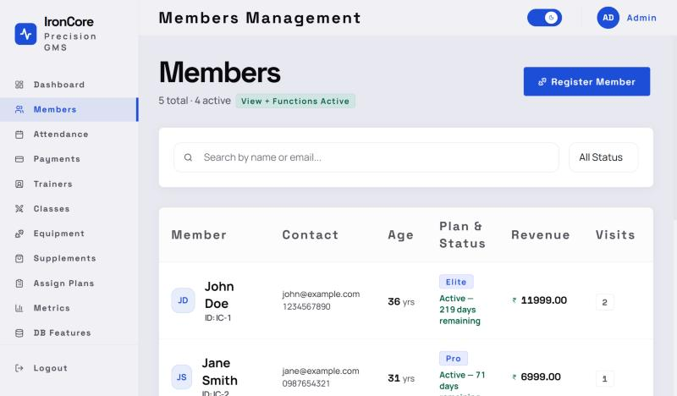
Figure 2.3: Members page with search, status filter and member table
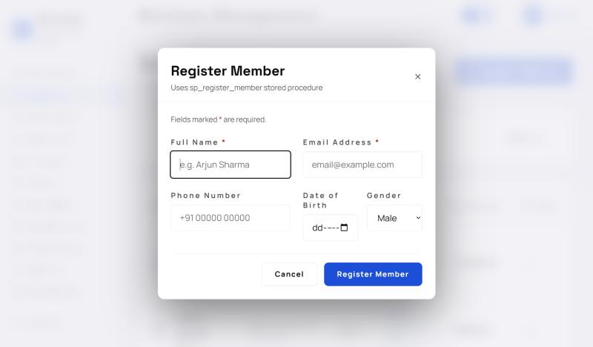
Figure 2.4: Register Member dialog with labelled, required fields
3. Student 2: Adhyan Mahajan (Reg. No: __________)
Modules / Pages: Attendance Tracking, Payments & Revenue
3.1 Module Description
Module 1: Attendance Tracking
The Attendance page records when members enter and leave the gym. A Quick Scan card lets staff type a member ID and press Check In or Check Out (Enter also works). Four live statistic cards show how many members are inside now, how many checked in today, the average session length and the peak hour. Below them, Today's Activity Log lists each visit with in-time, out-time, duration and status, and can be filtered (inside now / completed), extended with more rows on demand, and exported to CSV.
• Input: a member ID and the chosen action (check in or check out).
• Processing: the server confirms the member exists, prevents a second open check-in on the same day, inserts or closes an Attendance row, and recomputes the statistics with aggregate SQL (COUNT, AVG, TIMESTAMPDIFF, GROUP BY HOUR).
• Output: a success message with the member's name and time, or an error such as "Member not found"; the statistic cards and log refresh automatically.
• Components used: input card with two action buttons, KPI stat cards with a "Live" badge, data table with status badges, export and filter buttons, load-more paging.
Module 2: Payments & Revenue
The Payments page gives the owner a financial view of the gym. It shows this month's revenue and the transaction success rate, a revenue trend chart that switches between daily and monthly views, and a transaction history table with member name, plan, amount, method, date and status. The table supports search and pagination (8 rows per page), and all records can be exported as CSV.
• Input: a search term, the page number and the trend mode (daily / monthly).
• Processing: the server joins Payment, Subscription, Member and Membership_Plan, filters with LIKE on member name, plan name and payment method, and pages the result with LIMIT/OFFSET. Statistics compare this month's revenue with last month's and count active subscriptions without a payment this month. The trend endpoint groups revenue by month and fills missing months with zero.
• Output: KPI cards, an area chart drawn with Recharts [10], and the paginated table.
• Components used: KPI cards, chart card with a segmented toggle, search form, data table with avatar initials and status badges, Previous/Next pagination, Export CSV button.
3.2 Design of the Module
Both pages call the Express API with Axios and receive JSON. Each request carries the JWT in the Authorization header. Attendance routes are open to admin, trainer and member roles; payment routes are restricted to admin.
Action | Request | Back-end processing / response
Check in | POST /api/attendance/checkin JSON: { member_id } | Validates the member, blocks a duplicate open check-in, INSERTs into Attendance. Returns 201 { message, member_name, time } or 400/404 { message }.
Check out | POST /api/attendance/checkout JSON: { member_id } | Finds today's open visit and UPDATEs check_out_time. Returns 200 or 400 "not currently checked in".
Statistics | GET /api/attendance/stats | COUNT of open and total visits, AVG session minutes, busiest hour. Returns { currently_inside, checked_in_today, avg_session, peak_hour }.
Activity log | GET /api/attendance/today?limit=&offset= | JOIN Attendance with Member for today, with TIMESTAMPDIFF for duration. Returns { records, total }.
Payment list | GET /api/payments?search=&limit=&offset= | Four-table LEFT JOIN with LIKE search and LIMIT/OFFSET. Returns { records, total }.
Payment stats | GET /api/payments/stats | This and last month's revenue, percentage change, pending and expired counts, success rate.
Trend | GET /api/payments/trend/monthly|daily | SUM(amount) grouped by month or day, missing periods filled with 0. Returns [{ name, revenue }].

Client-side validation: the check-in buttons do nothing when the ID field is empty and are disabled while a request is running; the search form resets to page 1 on each new search; numeric display values are formatted safely when data is missing.
Server-side validation: the controller rejects a missing member_id (400), an unknown member (404) and a duplicate check-in or check-out without check-in (400). The BEFORE INSERT trigger trg_attendance_validate_member stops a check-in for a non-existent or inactive member even if the API is bypassed. On the payment side, the ENUM on payment_method and NOT NULL on amount and date guard the data, and the AFTER INSERT trigger trg_payment_audit_log writes every new payment to Audit_Log as JSON.
3.3 Development of the Module
Listing 3.1: Check-in / check-out request in Attendance.jsx (front end)
const handleAction = async (mode = actionMode) => {
const memberId = memberIdInput.trim();
if (!memberId) return;
setActionLoading(true);
try {
const endpoint = mode === 'checkin' ? `${API}/checkin` : `${API}/checkout`;
const { data } = await axios.post(endpoint, { member_id: memberId }, { headers: getHeaders() });
setActionFeedback({ type: 'success', message: data.message, member_name: data.member_name, time: data.time, mode });
setMemberIdInput('');
fetchStats();
fetchToday(true);
} catch (err) {
setActionFeedback({ type: 'error', message: err.response?.data?.message || 'Something went wrong. Please check the ID.' });
} finally {
setActionLoading(false);
}
};
Listing 3.2: Check-in handler in attendanceController.js (back end)
const { member_id } = req.body;
if (!member_id) return res.status(400).json({ message: 'Member ID is required' });

const [members] = await db.query('SELECT * FROM Member WHERE member_id = ?', [member_id]);
if (members.length === 0) return res.status(404).json({ message: 'Member not found' });

const [existing] = await db.query(
'SELECT * FROM Attendance WHERE member_id = ? AND DATE(check_in_time) = ? AND check_out_time IS NULL',
[member_id, today]
);
if (existing.length > 0)
return res.status(400).json({ message: `${members[0].name} is already checked in today` });

await db.query('INSERT INTO Attendance (member_id, check_in_time) VALUES (?, ?)', [member_id, checkInTime]);
res.status(201).json({ message: 'Check-in successful', member_name: members[0].name, time: timeStr });
Listing 3.3: Trigger that validates attendance in the database
CREATE TRIGGER trg_attendance_validate_member
BEFORE INSERT ON Attendance
FOR EACH ROW
BEGIN
DECLARE v_status VARCHAR(10);
SELECT status INTO v_status FROM Member WHERE member_id = NEW.member_id;
IF v_status IS NULL THEN
SIGNAL SQLSTATE '45000' SET MESSAGE_TEXT = 'Cannot check in: Member does not exist.';
ELSEIF v_status = 'Inactive' THEN
SIGNAL SQLSTATE '45000' SET MESSAGE_TEXT = 'Cannot check in: Member is Inactive. Renew subscription first.';
END IF;
END
Listing 3.4: Searchable, paginated payment history (paymentController.js)
const [rows] = await db.query(
`SELECT p.payment_id, p.amount, p.payment_date, p.payment_method,
m.name AS member_name, m.member_id, mp.plan_name, s.status AS subscription_status
FROM Payment p
LEFT JOIN Subscription s ON p.subscription_id = s.subscription_id
LEFT JOIN Member m ON s.member_id = m.member_id
LEFT JOIN Membership_Plan mp ON s.plan_id = mp.plan_id
WHERE (m.name LIKE ? OR mp.plan_name LIKE ? OR p.payment_method LIKE ?)
ORDER BY p.payment_date DESC, p.payment_id DESC
LIMIT ? OFFSET ?`,
[searchParam, searchParam, searchParam, limit, offset]
);
// Cancelled subscription -> Refunded, otherwise Paid
const records = rows.map(r => ({ ...r, status: r.subscription_status === 'Cancelled' ? 'Refunded' : 'Paid' }));
res.json({ records, total });
Listing 3.5: Fetching a page of payments in Payments.jsx (front end)
const fetchTable = useCallback(async (pg, q) => {
setLoadingTable(true);
try {
const { data } = await axios.get(API, {
headers: getHeaders(),
params: { limit: PAGE_SIZE, offset: pg * PAGE_SIZE, search: q }
});
setRecords(Array.isArray(data.records) ? data.records : []);
setTotal(data.total ?? 0);
} finally { setLoadingTable(false); }
}, []);
3.4 Results
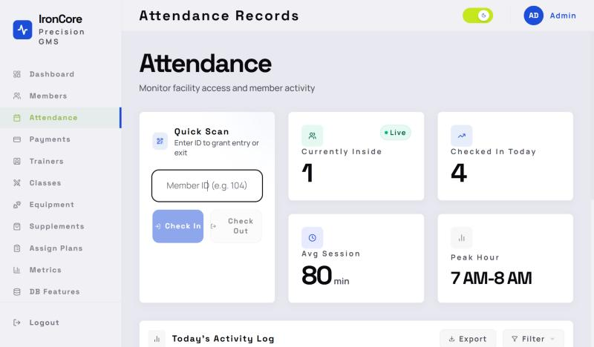
Figure 3.1: Attendance page with Quick Scan and live statistics
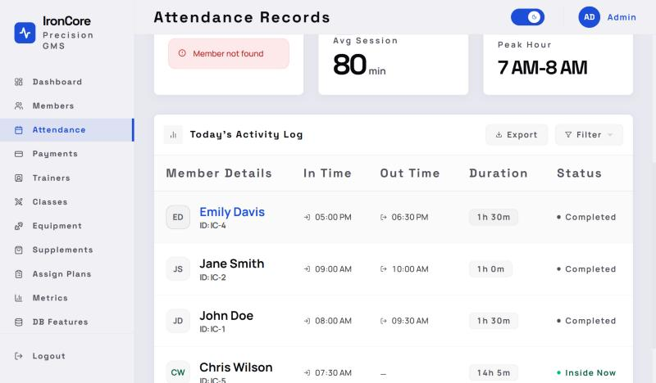
Figure 3.2: Server-side validation message for an unknown member ID, and Today's Activity Log
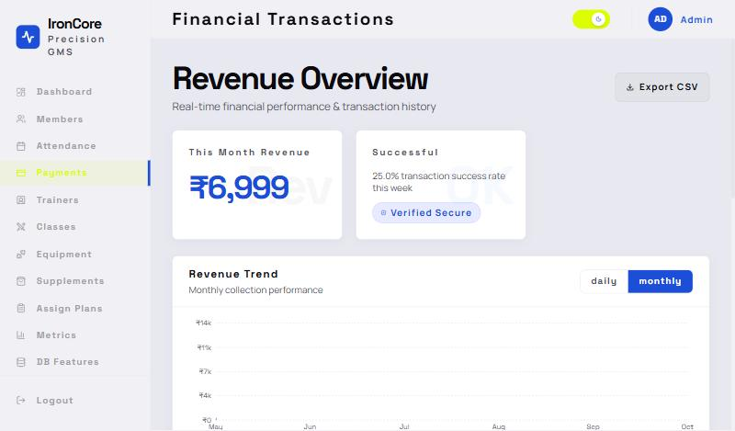
Figure 3.3: Payments page with revenue overview and trend chart
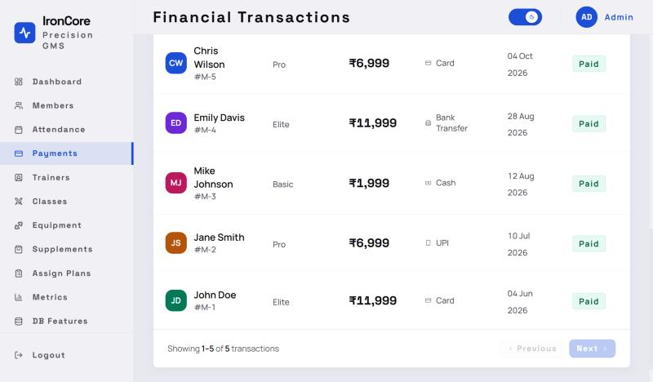
Figure 3.4: Paginated transaction history
4. Conclusion and Future Scope
The team built IronCore, a working full-stack gym management system with a React single-page front end, an Express REST API and a MySQL database. Through it we learnt how a front end and back end communicate over JSON, how to secure an API with JWT and role-based middleware, and how to move validation into the database with stored procedures and triggers so that bad data is rejected even if the interface is bypassed. We also learnt to build a consistent design from shared layout components and design tokens, to make an interface accessible to keyboard and screen reader users, and to make it responsive across screen sizes.
Possible future additions:
• A member-facing portal and mobile app where members can view their plan, attendance history and pay renewals online through a payment gateway.
• QR-code or RFID check-in at the gym entrance instead of typing the member ID.
• Email and SMS reminders for expiring subscriptions and upcoming classes.
• Online class booking with waiting lists, and trainer schedules.
• Automated unit and end-to-end tests, and deployment to a cloud host with HTTPS.
5. References
[1] React, "React Documentation," Meta Open Source. https://react.dev/
[2] Vite, "Vite Guide." https://vite.dev/guide/
[3] Tailwind Labs, "Tailwind CSS Documentation (v4)." https://tailwindcss.com/docs
[4] OpenJS Foundation, "Express 5.x API Reference." https://expressjs.com/en/5x/api.html
[5] Oracle, "MySQL 8.0 Reference Manual: Stored Objects (procedures, functions, triggers, views)." https://dev.mysql.com/doc/refman/8.0/en/stored-objects.html
[6] M. Jones, J. Bradley and N. Sakimura, "JSON Web Token (JWT)," RFC 7519, IETF, 2015. https://www.rfc-editor.org/rfc/rfc7519
[7] W3C, "Web Content Accessibility Guidelines (WCAG) 2.1." https://www.w3.org/TR/WCAG21/
[8] bcryptjs, "bcrypt.js: Optimized bcrypt in JavaScript," npm. https://www.npmjs.com/package/bcryptjs
[9] Axios, "Axios Documentation." https://axios-http.com/docs/intro
[10] Recharts, "Recharts API." https://recharts.org/en-US/api
[11] W3C WAI, "ARIA Authoring Practices Guide: Dialog (Modal) Pattern." https://www.w3.org/WAI/ARIA/apg/patterns/dialog-modal/
[12] MDN Web Docs, "HTTP authentication and the Authorization header." https://developer.mozilla.org/en-US/docs/Web/HTTP/Headers/Authorization
[13] React Router, "React Router Documentation." https://reactrouter.com/

