Linux Command Practice – AWS EC2
Name: Tejas Firke
Objective: Practice basic Linux commands on an AWS EC2 instance and document the commands, explanations, and screenshots.

1. Creating and Renaming Files/Directories
Command: mkdir test_dir
Explanation: Creates a new directory named test_dir.
Command: cd test_dir
Explanation: Changes the current directory to test_dir.
Command: touch example.txt
Explanation: Creates an empty file named example.txt.
Command: mv example.txt renamed_example.txt
Explanation: Renames example.txt to renamed_example.txt.
Screenshot: 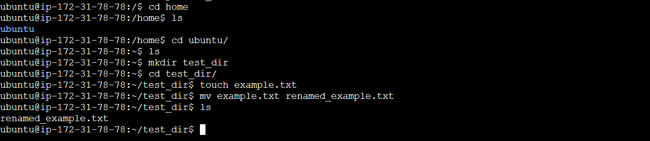

2. Viewing File Contents
Command: cat /etc/passwd
Explanation: Displays the full content of the /etc/passwd file.
Command: head -n 5 /etc/passwd
Explanation: Displays the first 5 lines of the file.
Command: tail -n 5 /etc/passwd
Explanation: Displays the last 5 lines of the file.
Screenshot: 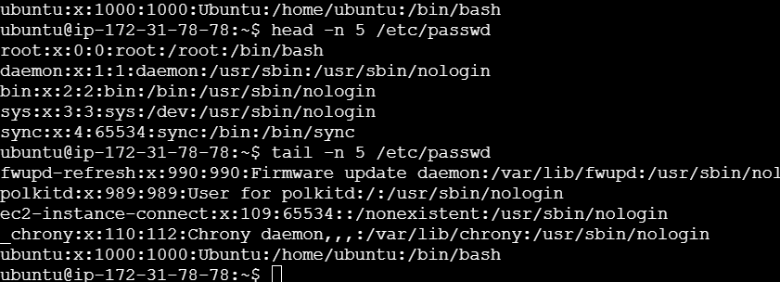

3. Searching for Patterns
Command: grep root /etc/passwd
Explanation: Searches for lines containing the word 'root' in /etc/passwd.
Screenshot: 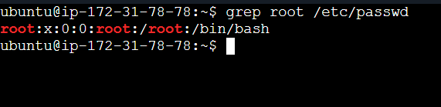

4. Zipping and Unzipping
Command: zip -r test_dir.zip test_dir
Explanation: Compresses the test_dir directory into test_dir.zip.
Command: mkdir unzipped_dir
Explanation: Creates a new directory named unzipped_dir.
Command: unzip test_dir.zip -d unzipped_dir
Explanation: Extracts the zip file contents into unzipped_dir.
Screenshot: 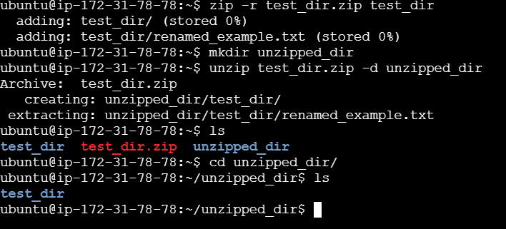

5. Downloading Files
Command: wget https://example.com/sample.txt
Explanation: Downloads a file from the internet into the current directory.
Screenshot: 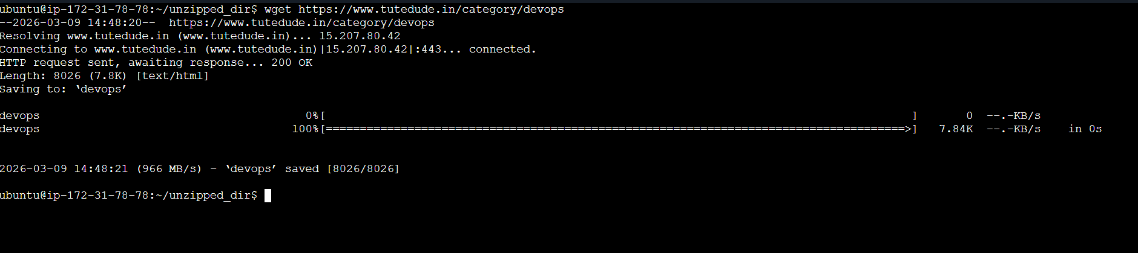

6. Changing Permissions
Command: touch secure.txt
Explanation: Creates a file named secure.txt.
Command: chmod 444 secure.txt
Explanation: Changes permissions to read-only for everyone.
Command: ls -l secure.txt
Explanation: Displays file permissions.
Screenshot: 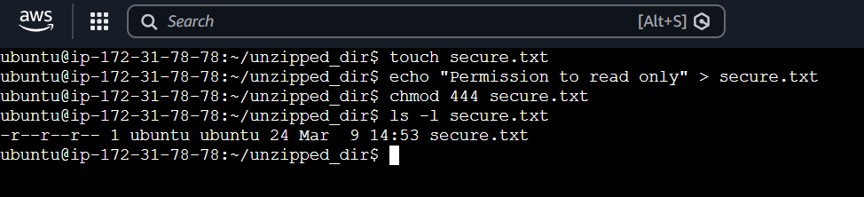

7. Working with Environment Variables
Command: export MY_VAR='Hello, Linux!'
Explanation: Creates a new environment variable named MY_VAR.
Command: echo $MY_VAR
Explanation: Displays the value of the environment variable.
Screenshot: 