Python Library

The python libraries which were used in the model building are:

import numpy as np
import tensorflow as tf
from keras.callbacks import ModelCheckpoint
from keras.models import Sequential
from keras.layers import LSTM,Conv1D,Conv2D,MaxPooling2D,MaxPooling1D,Flatten
from keras.layers import Dense, Dropout
import pandas as pd
# from keras.optimizers import Adam
from matplotlib import pyplot as plt
from sklearn.preprocessing import StandardScaler,MinMaxScaler
import seaborn as sns
#from datetime import datetime

from tensorflow.compat.v1.keras.layers import CuDNNLSTM,Bidirectional

7.3 Data Visualization
Visualizing the data gives more understanding of the problem and the type of solution to be built. The distribution of classes, the number of instances under each category, the spread of the data, and the correlation between the features and clustering are a few methods to visualize the data. Python and R provide statistical functions for data visualization.

7.4 Feature Analysis

Primarily, we are importing the required modules for the model to work,

import seaborn as sns
plt.figure(figsize=(25,7));
sns.lineplot(x=df["date"],y=df["Adj Close"])
df['sentiment_analysis']=df['P_mean']
df['sentiment_analysis']=df['sentiment_analysis'].apply(lambda x: 'pos' if x>0 else 'nue' if x==0 else 'neg')
sns.scatterplot(x=df["date"],y=df['Adj Close'],hue=df['sentiment_analysis'],palette=['y','r','g'])
plt.xticks(rotation=45);
plt.title("Stock market of Netfilx from Jan-2018 to Jul-2022",fontsize=16);

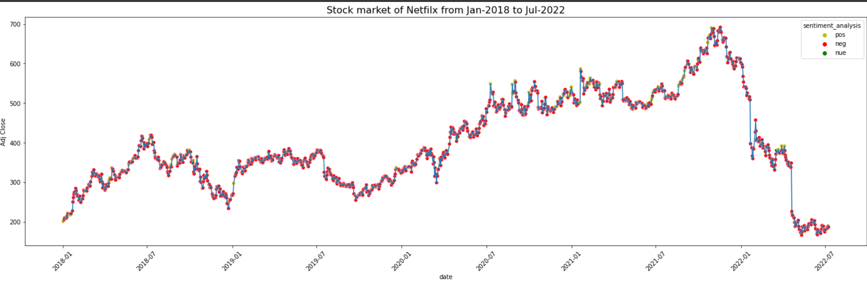

And the result is in the Table 1.1
Table 1.1

Algorithm | Accuracy
LSTM(without twitter data) | 45.52%
LSTM(with twitter data) | 67.16%

7.5 TESTING

Once training of the model is done,it is important to test the model’s accuracy of the data which is not used while training.This broad purpose of this exercise has been to arrive at trading strategies which could help in the real-world application of the models developed. The study could not approach to those levels due to several constraints and limitations as described above. Two Regressor that were used viz LSTM and Random Forest have been used to predict the next day value and the RMSEs are considered as the evaluation metrics. Since this was a regression exercise prediction with certain confidence levels couldn’t be achieved. Thus, a simple intuitive analysis of RMSE values was carried out to gauge the appropriateness of the values predicted by our models. The results as achieved from the models are indicated below

Algorithm for different scenario | MSE error
LSTM-open(without tweets) | 162.333
LSTM-open(with tweets) | 87.6900
LSTM-close(without tweets) | 175.9912
LSTM-close(with tweets) | 122.3798

CHAPTER 8. SNAPSHOTS

Feature Scaling: 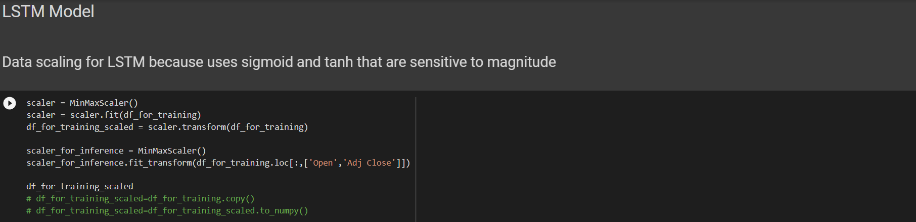

Model building: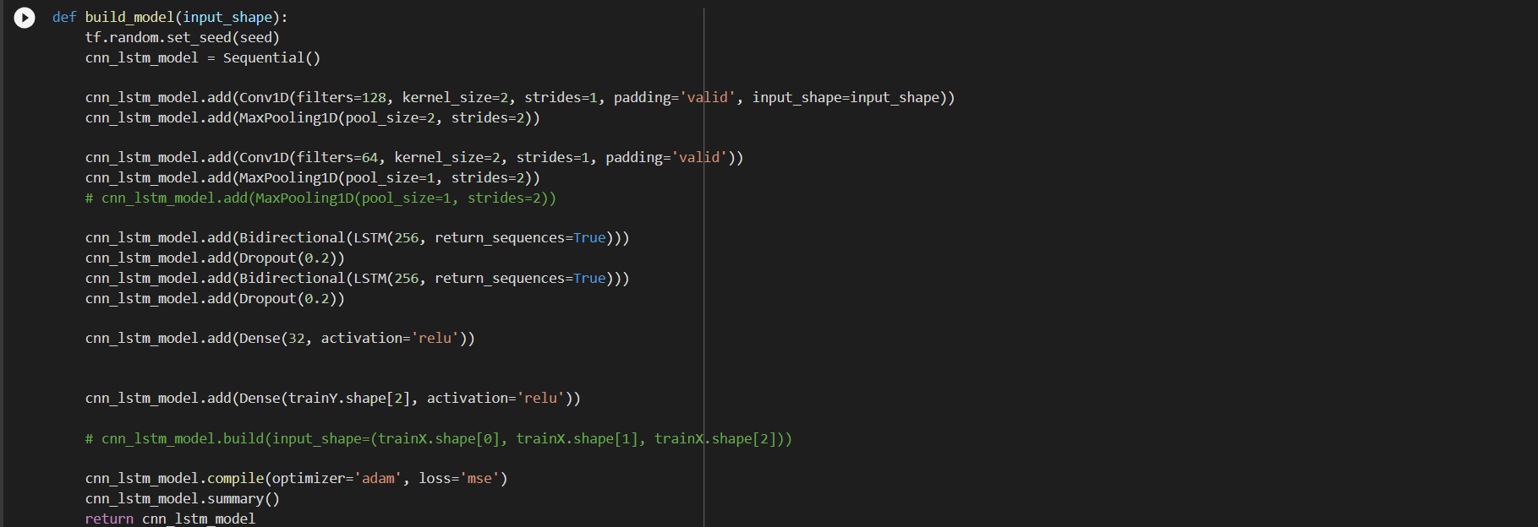

Validating the error on training data without twitter data :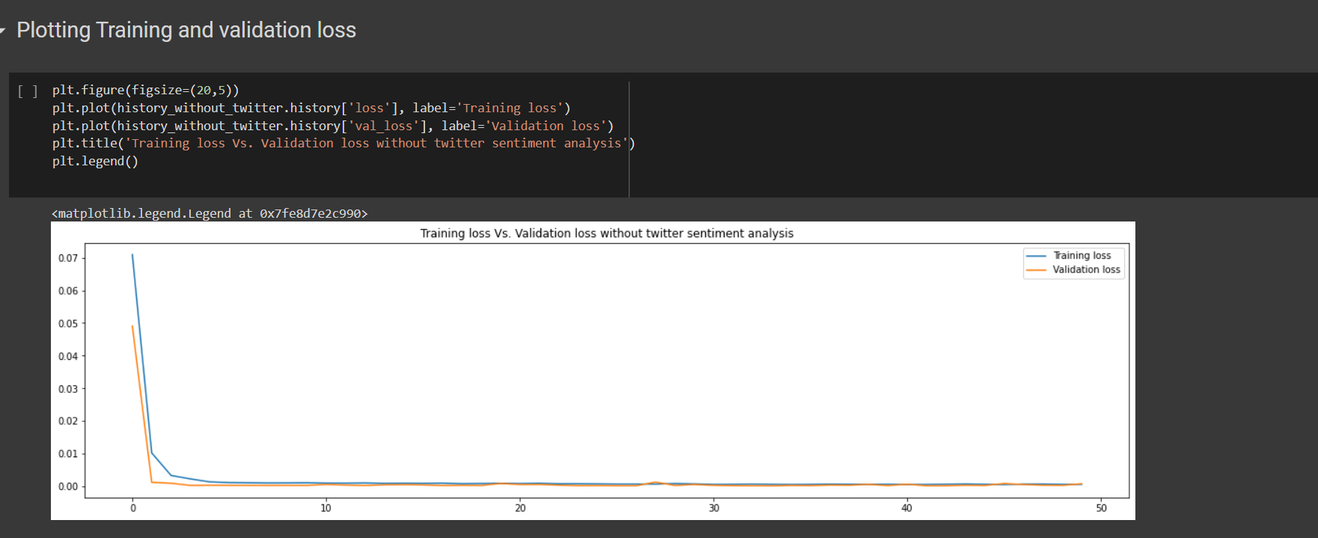
Validating the error on training data with twitter data :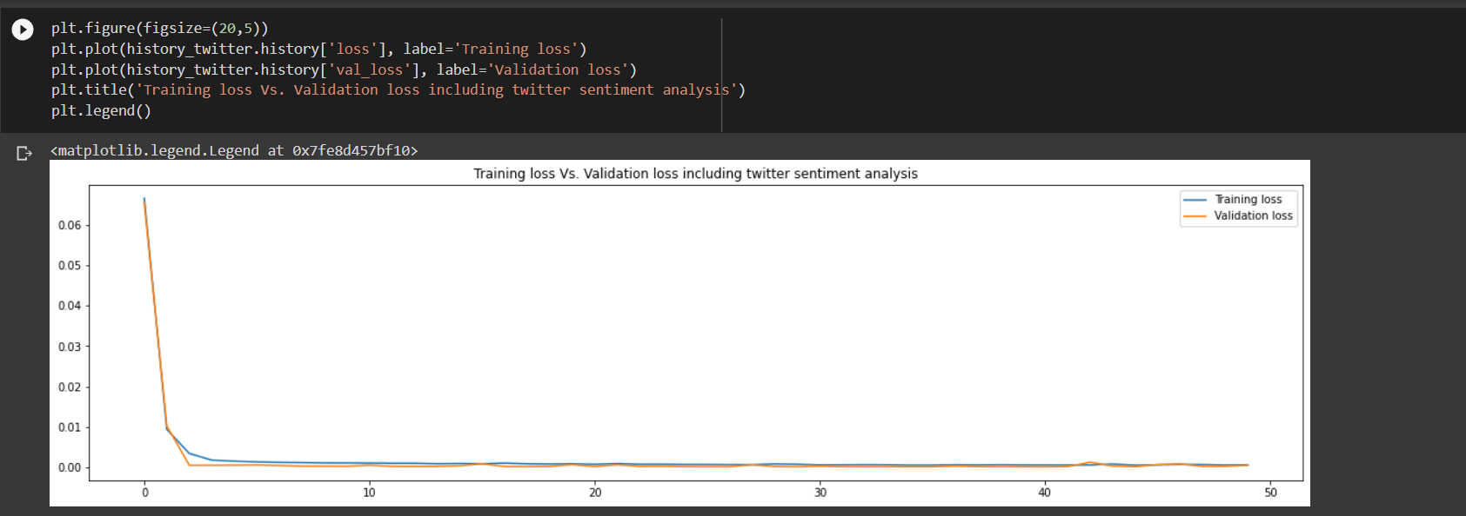Computing Accuracy: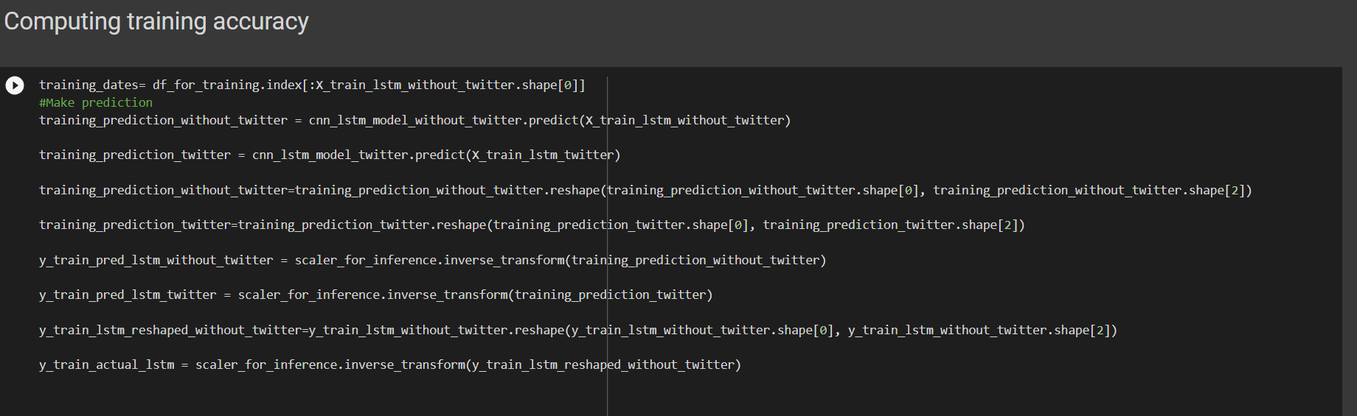
Final Outputs:
- Open without twitter data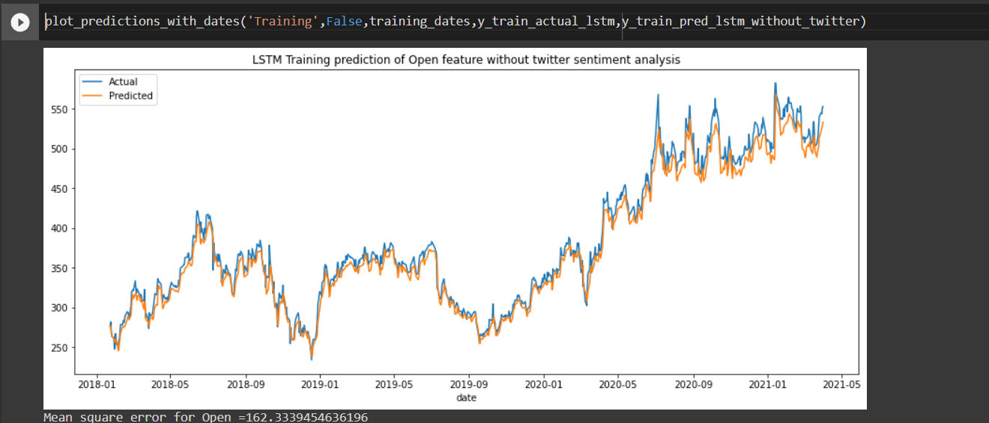
- Open with twitter data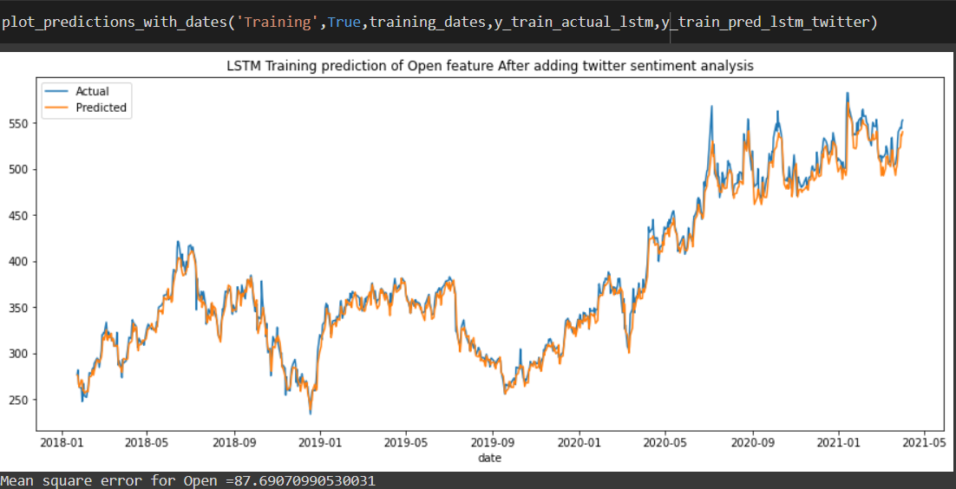

- Close without twitter data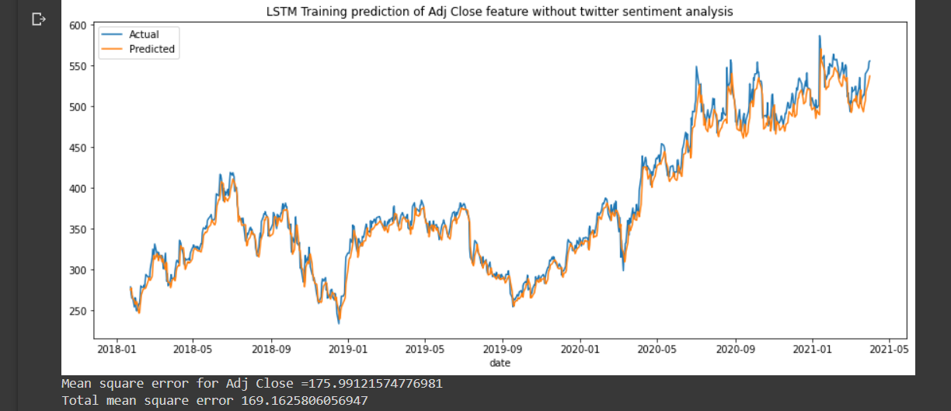

- Close with twitter data