***Netmeds (Pharmaco)***

* **Pages:**

Login Page(Signup Page)/ Home Page / Product Page/ Detail Page / buying option (address, etc.) /payment gateway

* **Structure:**

1. **Login Page:** Contains normal details (username,password etc.)

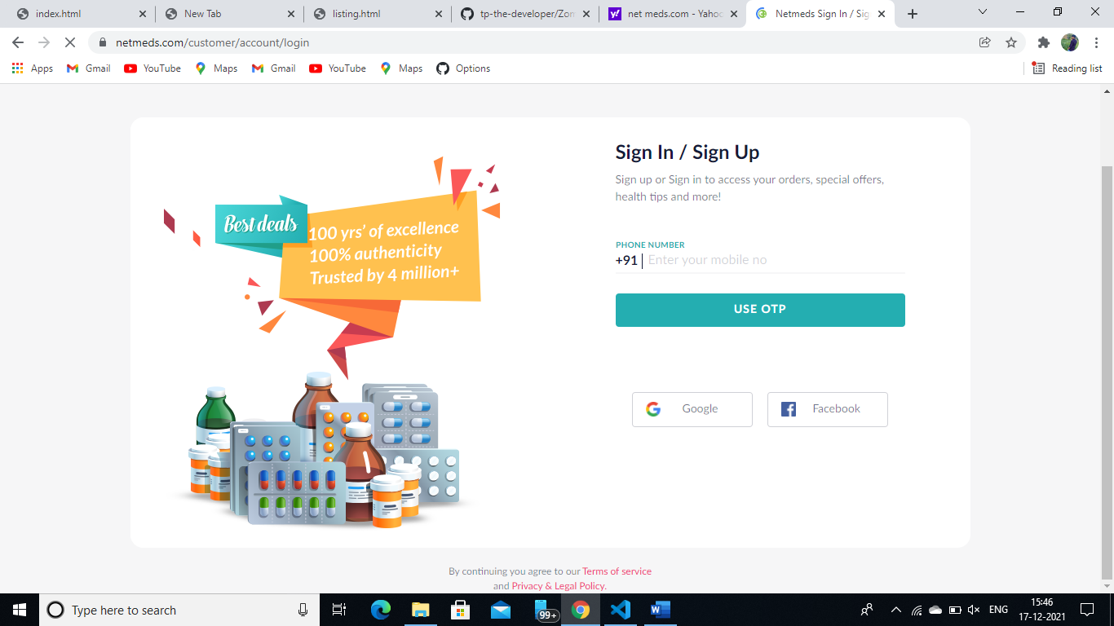

1. **Home page:** 
   * + Menu Button (Home, Orders, My cart, Customer, My account, Contact us)
     + Add to cart option
     + Offers Option (Optional)
     + Trending (Optional)
     + Search Bar Option
     + Pin code Option
     + Explore by categories(Filter)

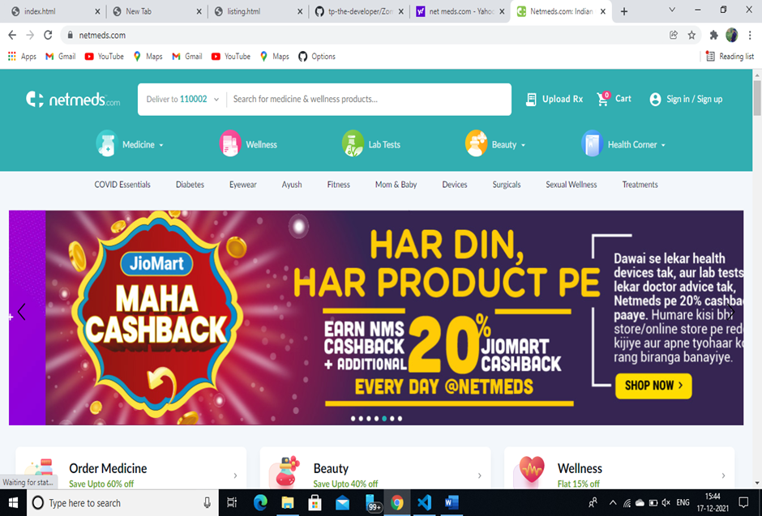

1. **Product Page:**

* Buy NoW
* Add to cart
* Details of the selected page
* Filter
* Item Count or Add more product option

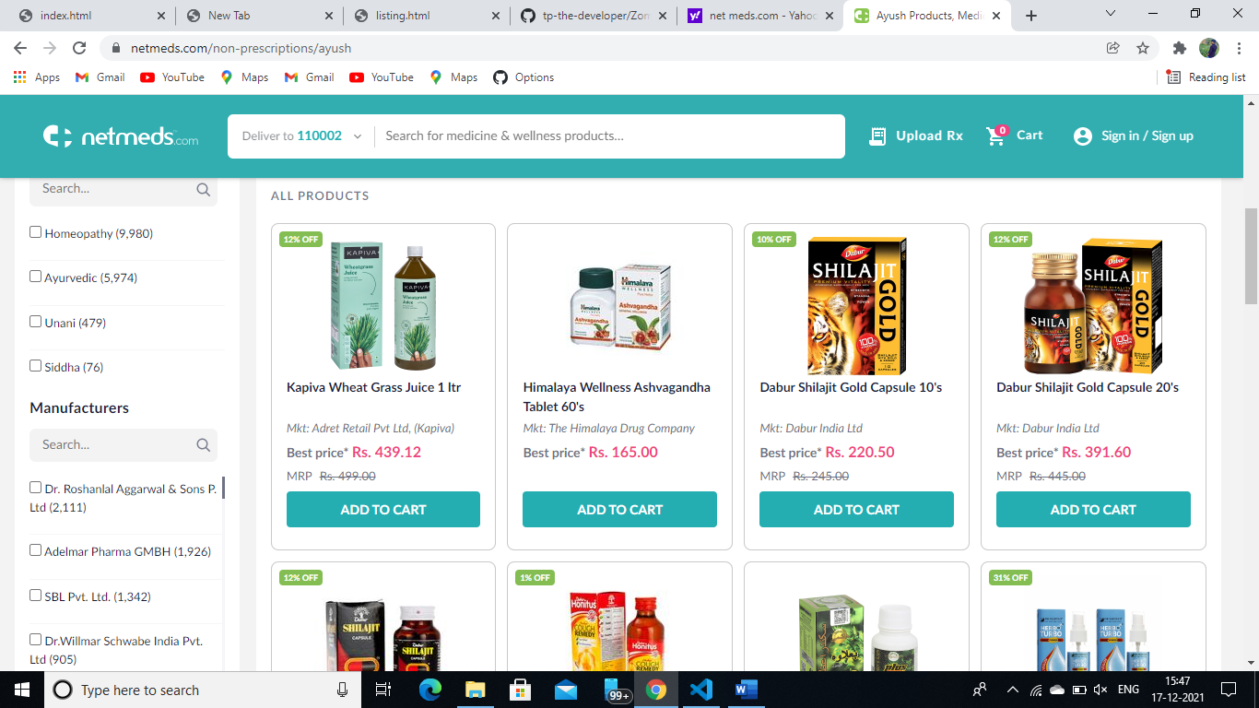

1. **Buying Page:**

* Payment Option (COD, Internet Banking, Etc.)
* Address Pincode

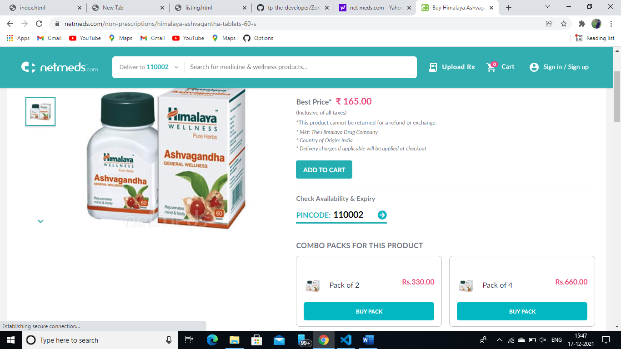

1. **Payment:** Enter details of payment method like gpay(contact info etc.)