Project Report

**On**

# “Sign Detection and Recognition”



### SRI BALAJI UNIVERSITY PUNE SCHOOL OF COMPUTER STUDIES

**Program: Master of Computer Application 2023 Batch**

#### SUBMITTED BY: -

Aditya Patel (MCA2302114) Khushi Sahita (MCA2302073**)** Shivangi Bhosle (MCA2302067) Tejas Patil (MCA2302080)

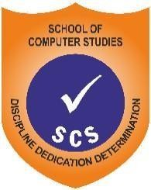**Sri Balaji University Pune School of Computer Application MCA- 2023 Semester-3**

**As part of Mini Project (MCA109)**

**CERTIFICATE**

Certified that the Project Report entitled **“Sign Detection and Detection”,** submitted by **Aditya Patel, Khushi Sahita, Shivangi Bhosle, Tejas Patil** of MCA, is their own work and has been carried out under my supervision. It is recommended that the candidates may now be evaluated for their work by the University.

|  |  |
| --- | --- |
| **Name 1 : Aditya Patel** | **Roll no. :** MCA2302114 |
| **Name 2 : Khushi Sahita** | **Roll no. :** MCA2302073 |
| **Name 3 : Shivangi Bhosle** | **Roll no. :** MCA2302067 |
| **Name 4 : Tejas Patil** | **Roll no. :** MCA2302080 |

**Date: 09/10/2024**

#### Remark:

Asst. Prof. Punam Nikam (Project Guide)

**ACKNOWLEDGEMENT**

We feel immense pleasure to introduce “**SIGN DETECTION AND RECOGNITION**” as our major project. I express my sincere thanks to our instructor **Dr. Richa Purohit** and **Asst. Prof. Punam Nikam** who guided us to the successful completion of this project report. We take this opportunity to express our deep sense of gratitude for their individual guidance, constant encouragement and immense motivation which have sustained our efforts at all stages of this project report. We are grateful and appreciate all the staff members of the School of Computer Application for their cooperation and support. I extend my sincere thanks to our principal **Dr.G.Y.Shitole** for his support and for all the facilities provided for the preparation of this project report. Also, we wish to thank our parents & friends who helped us a lot in collecting data, pictures and continuous help and support. Finally, we would wish to thank everyone involved in this project time.

# INDEX

|  |  |  |
| --- | --- | --- |
| **SR.NO** | **CONTENT** | PAGE NO |
| 1. | **Abstract** | 5 |
| 2. | **Introduction-**   * 1. Motivation   2. Problem Statement   3. Purpose /Objective and goals   4. Literature Survey   5. Project Scope and Limitations | 6-12 |
| 3. | **System Analysis-**   * 1. Existing systems   2. Scope and Limitations of System   3. Project perspective, Features   4. Stakeholders   5. Requirement Analysis | 13-19 |
| 4. | **System Design-**   * 1. Design constraints   2. System Model: Using OOSE   3. Data Model   4. User interfaces | 20-31 |
| 5. | **Implementation Details-**   * 1. Software/hardware specifications | 32-44 |
| 6. | **Output and Reports Testing-**   * 1. Test cases and results | 45-54 |
| 7. | **Conclusion and Recommendation** | 55 |
| 8. | **Future Scope** | 56-57 |
| 9. | **Bibliography and Reference** |  |

## ABSTRACT

The aims to raise awareness about the importance and beauty of sign language, highlighting its role as a vital mode of communication for the Deaf and hard-of- hearing community. A real time sign language detector is a significant step forward in improving communication between the deaf and the general population. We are pleased to showcase the creation and implementation of sign language recognition model based on a Convolutional Neural Network(CNN).We utilized a Trained on our own dataset in order to apply Transfer learning to the task. We developed a robust model that consistently classifies Sign language in majority of cases. Additionally, this strategy will be extremely beneficial to sign language learners in terms of practising sign language. Various human-computer interface methodologies for posture recognition were explored and assessed during the project. A series of image processing techniques with Human movement classification was identified as the best approach. The system is able to recognize selected Sign Language signs with the accuracy of 90% without a controlled background with small light.

### INTRODUCTION

**Sign Language** is mainly used by deaf (hard hearing) and dumb people to exchange information between their own community and with other people. It is a language where people use their hand gestures to communicate as they can’t speak or hear. **Sign Language Recognition (SLR)** deals with recognizing the hand gestures acquisition and continues till text or speech is generated for corresponding hand gestures. Sign language uses visual hand and body gestures to convey meaningful messages. Using, Deep Learning algorithms and Image Processing we can able to classify these hand gestures and able to produce corresponding text. An example of “A” alphabet in sign language notion to English “A” text or speech. Sign language is a visual language that uses hand signs, facial expressions, and body language to communicate. It is primarily used by Deaf and hard-of-hearing individuals but can be learned by anyone interested in expanding their communication skills. Sign languages are fully developed languages with their own grammar and syntax, distinct from spoken languages. Each country or region may have its own version of sign language—like American Sign Language (ASL), British Sign Language (BSL), or International Sign (IS)—each with unique signs and cultural contexts.

### MOTIVATION

Our motivation to create the **Sign Detection and Recognition System** comes from the challenges faced by deaf and hard-of-hearing individuals who rely on sign language for communication. Traditional translation methods can be slow, limited, or unavailable, making communication difficult and frustrating. We believe that using AI and machine learning can help bridge this gap by offering a faster and more accurate way to translate sign language into text or speech.

This system is important because it will make communication easier for sign language users, helping them interact more smoothly in everyday situations like work, school, and social events. By breaking down communication barriers, the system can improve accessibility and inclusion for deaf and hard-of-hearing people, allowing them to connect more easily with the world around them.

## PROBLEM STATEMENT

Sign language uses lots of gestures so that it looks like movement language which of a series of hands and arms motions. For different countries, there are different sign languages and hand gestures. Also, it is noted that some unknown words are translated by simply showing gestures for each in the word. In addition, sign language also includes specific gestures to each alphabet in the English dictionary. Based on these sign languages are made up of two groups, namely static gesture, and dynamic gesture. The static gesture is used for alphabet and number representation, whereas the dynamic gesture is used for specific concepts. Dynamic also includes words, sentences, etc. The static gesture consists of hand gestures, whereas the latter includes motion of hands, head, or both. Sign language is a visual language and consists of 3 major components, such as finger-spelling, word-level sign vocabulary, and non-manual features. Finger-spelling is used to spell words letter by letter and convey the message whereas the latter is keyword-based. But the design of a sign language translator is quite challenging despite many research efforts during the last few decades. Also, even the same signs have significantly different appearances for different signers and different viewpoints. This work focuses on the creation of a static sign language translator by using a Convolutional Neural Network. We created a lightweight network that can be used with embedded devices/standalone applications/web applications having fewer resources.

## LITERATURE SURVEY

Real-time sign language fingerspelling recognition using convolutional neural networks from depth map. This works focuses on static fingerspelling in American Sign Language A method for implementing a sign language to text/voice conversion system without using handheld gloves and sensors, by capturing the gesture continuously and converting them to voice. In this method, only a few images were captured for recognition. The design of a communication aid for the physically challenged. Design of a communication aid for physically challenged. The system was developed under the MATLAB environment. It consists of mainly two phases via training phase and the testing phase. In the training phase, the author used feed-forward neural networks. The problem here is MATLAB is not that efficient and also integrating the concurrent attributes as a whole is difficult.American Sign Language Interpreter System for Deaf and Dumb Individuals . The discussed procedures could recognize 20 out of 24 static ASL alphabets. We have used only a limited number of images.

## SCOPE & LIMITATIONS

The **Sign Detection and Recognition** System will include features such as gesture capture, real-time recognition, and text or speech translation. However, it is essential to acknowledge certain limitations, including:

* Limited availability of comprehensive datasets for sign language gestures across different regions and languages.
* Constraints in terms of budget, time, and resources for developing and refining the system.
* Potential challenges in user adoption, especially in ensuring the system is user-friendly and accessible to a wide audience.
* As we goes on increasing the number of alphabets the prediction is not much accurate.

## SYSTEM ANALYSIS

The current landscape of **Sign detection and recognition** systems often relies on manual processes, such as human interpreters or physical reference materials. While some technologies exist for automatic sign language recognition, they frequently lack the precision, accessibility, and real-time capabilities needed for practical use.

Scope and limitations of existing systems– The limitations of existing sign detection and recognition systems include:

* Lack of comprehensive, real-time recognition for various sign languages and gestures.
* Inefficient recognition processes leading to delayed or inaccurate communication.
* Difficulty in adapting to different users' signing styles, environments, and regional sign language variations

## PROJECT PERSPECTIVE

The primary purpose of the Sign Detection and Recognition System is to provide a user-friendly, efficient, and accessible platform for translating sign language into text or speech. Our objectives include:

* Streamlining communication for sign language users through real-time recognition.
* Providing accurate and immediate translation of hand gestures into corresponding text or speech.
* Simplifying the process of recognizing and interpreting sign language for individuals and organizations.
* Enhancing user satisfaction by offering a seamless and inclusive solution for communication.

1. The Sign Detection and Recognition System aims to reduce the reliance on manual translation methods, making communication faster and more convenient.
2. The system will enable the detection and recognition of hand gestures for translating sign language to text or speech, bridging the communication gap.
3. Users can perform sign gestures, and the system will interpret these signs, allowing for efficient communication in real-time.
4. The system will also allow users to access previously stored gesture data and retrieve corresponding translations, providing a personalized experience.
5. The system can notify users of successful recognition through multiple formats (e.g., text or speech) and can integrate with external platforms for communication assistance.

## REQUIREMENT ANALYSIS

#### Functional Requirements –

* 1. **Gesture Input:** Users should be able to input hand gestures via a live camera feed allowing the system to detect and recognize sign language.
  2. **Gesture Recognition and Translation:** The system should translate recognized sign language gestures into corresponding text or speech in real-time, providing instant feedback to the user.

#### Non Functional Requirements –

The non-functional requirements are tailored to enhance usability, reliability, and performance for users, including those with disabilities. The system must have an intuitive interface, ensure real-time and accurate gesture recognition, and provide fast, reliable responses. It should be scalable, secure, and accessible, complying with accessibility standards. Comprehensive documentation for users and developers is essential, along with 24/7 support to address any technical or usability issues. These adjustments ensure the system remains functional, scalable, and user- friendly for a wide audience.

## PERFORMANCE REQUIREMENT

1. Response Time: The system should recognize and respond to hand gestures within a specified time frame (e.g., less than 1 second) to ensure real-time interaction.
2. Throughput: The system should handle a high number of gesture recognitions per second (e.g., more than 50 recognitions/second) to maintain smooth operation, even with multiple users or complex gestures.
3. Scalability: The system should scale horizontally, allowing the addition of servers or resources to handle increased numbers of users or gesture inputs without slowing down recognition speed or accuracy.

## SYSTEM DESIGN

**System Flow**

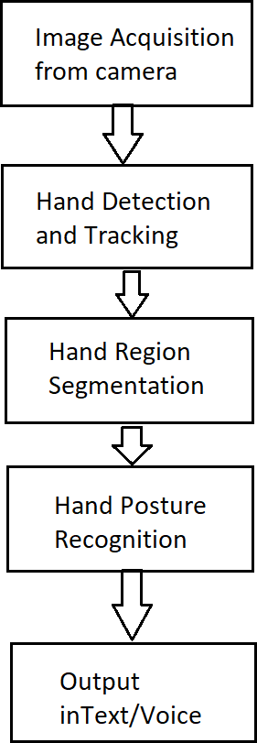

# Data Flow Diagram

**LEVEL-0**

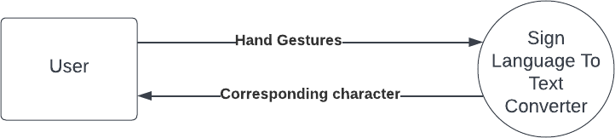

**Level-2**

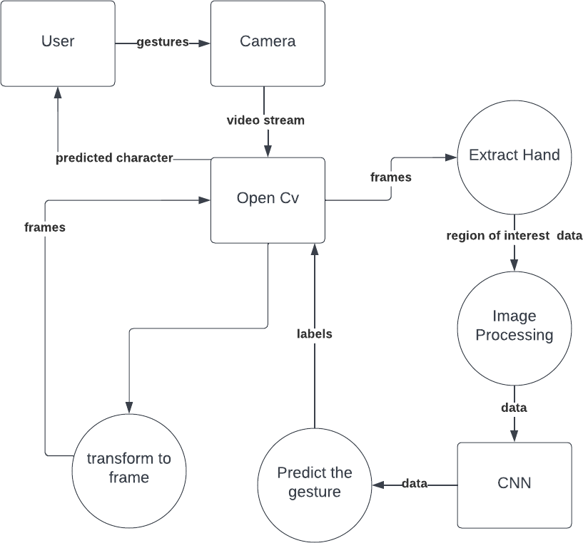

## FLOWCHART

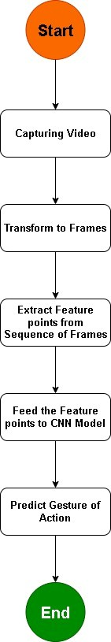

**SYSTEM MODEL: USING OOSE**

**Sequence Diagram**

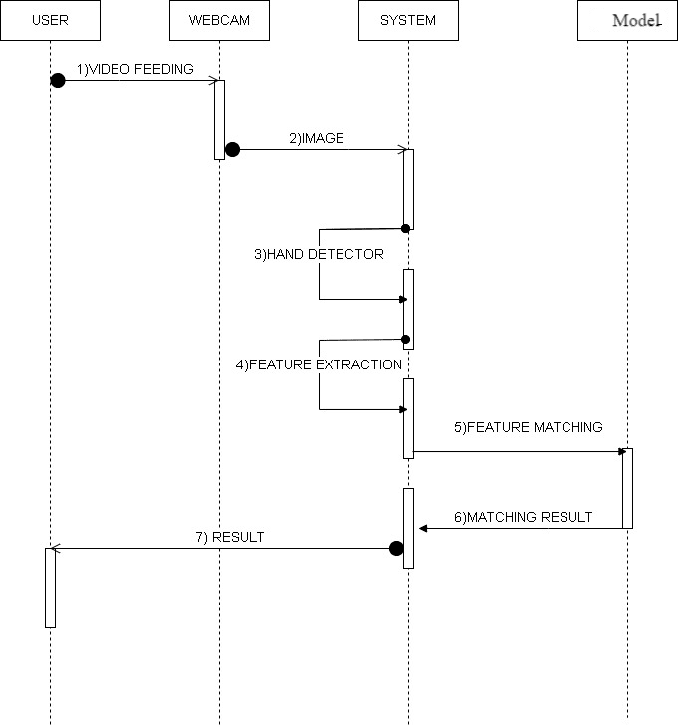

**Activity Diagram**

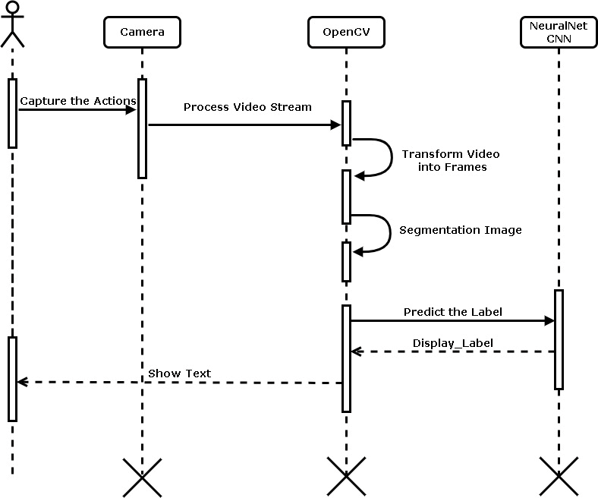

# Usecase

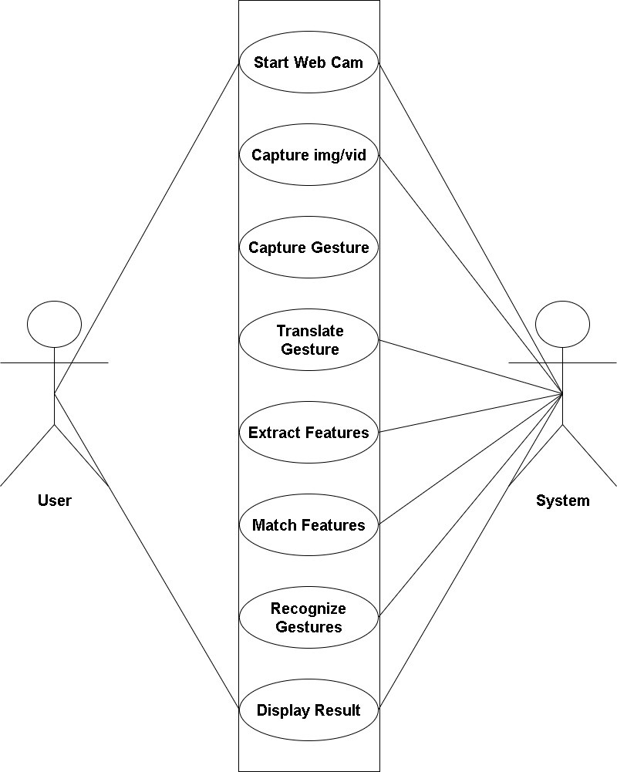

**Methodology**

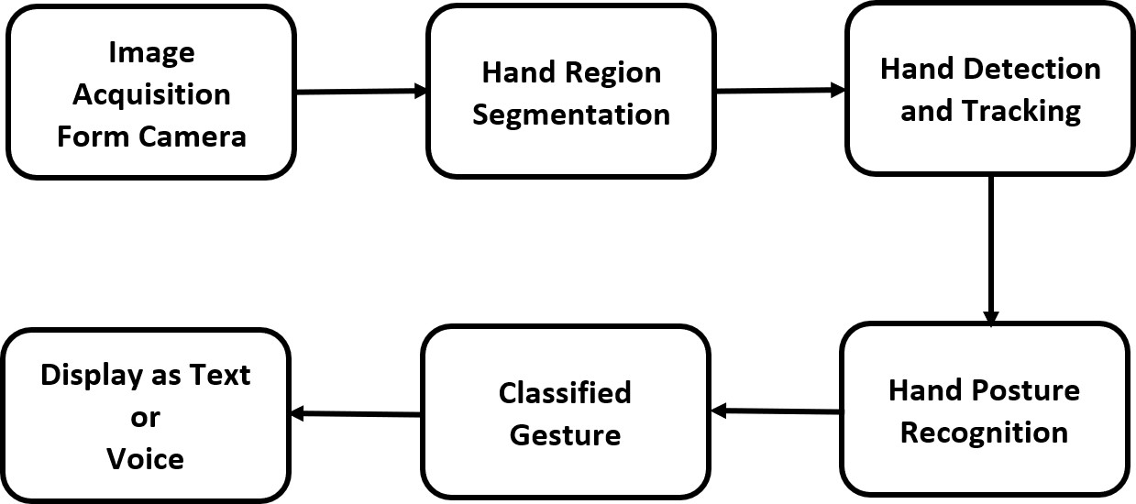

**DATA SET**

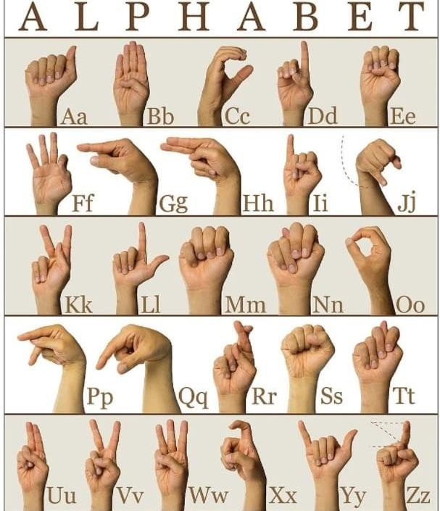

**USER INTERFACE**

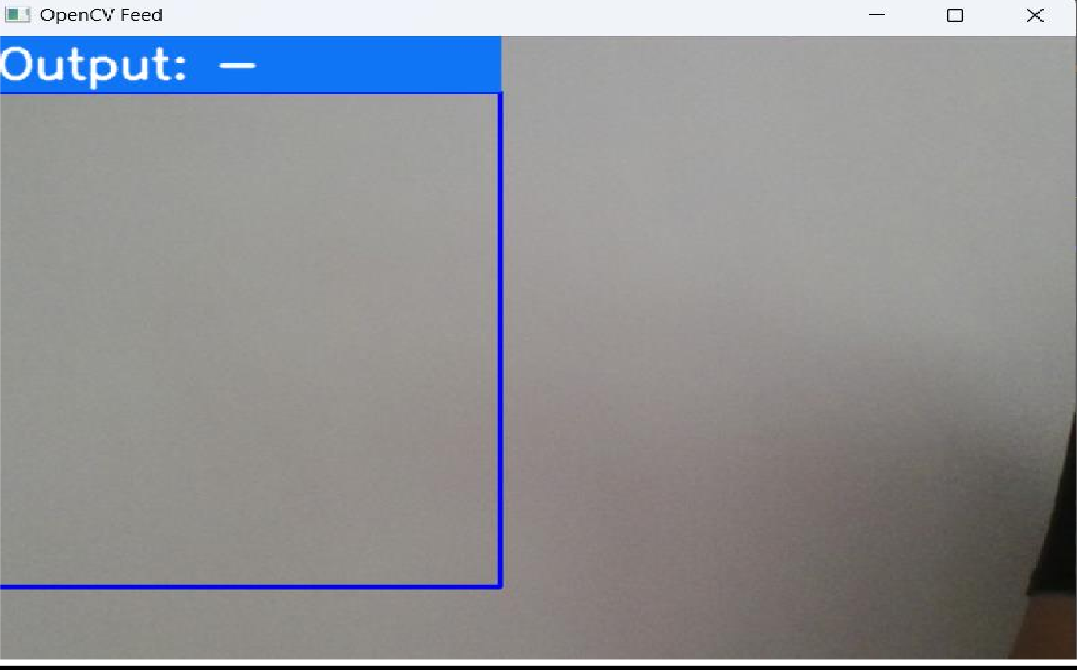

**IMPLEMENTATION DETAILS**

**Hardware/Software Specification**

**Hardware**

1. Processor – Intel i5 onwards
2. RAM – Min 8 GB
3. Hard disk – Min 256 GB

# Software

1. Operating System : Windows 7 onwards.
2. IDE Application - Visual Studio 16.11
3. Programming Language- Python
4. Python Libraries- Tensorflow, OpenCV, Keras, Mediapipe

## INPUT SCREEN

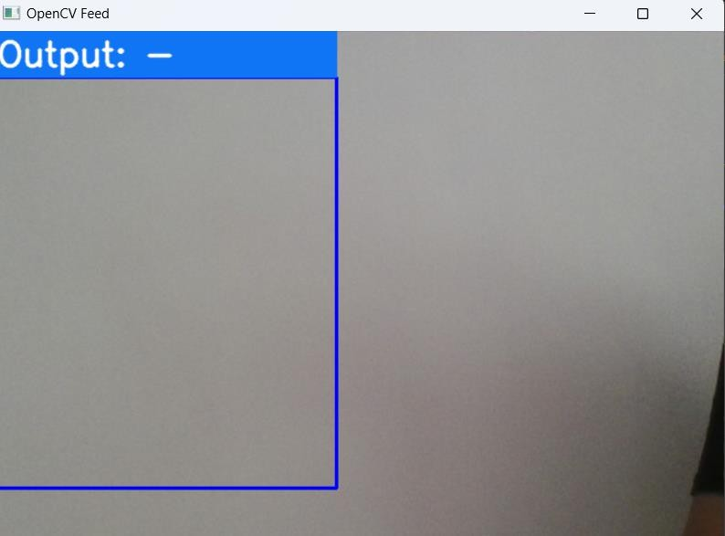

**OUTPUT SCREENS**

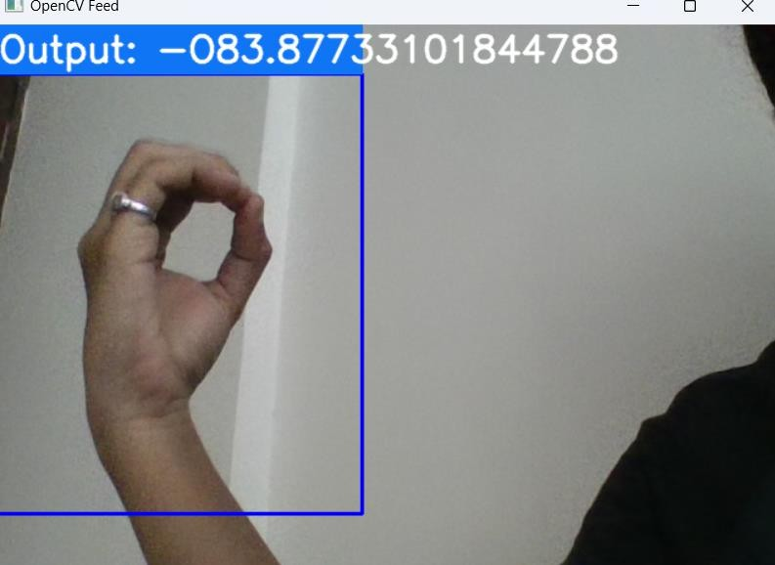

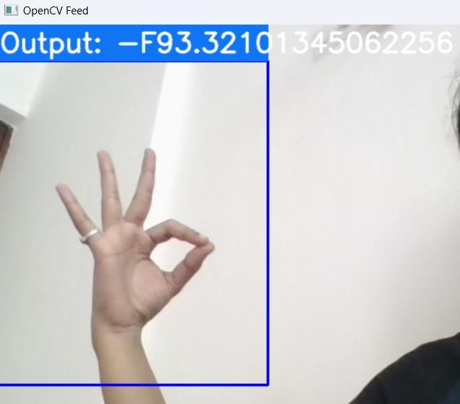

### TEST CASE:1

1. **Input Data** :

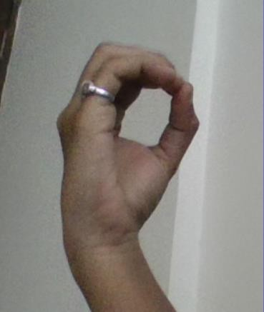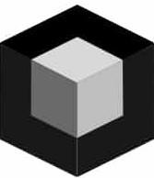

1. **Black Box** :

Black Box Testing



1. **Actual Output** :
2. **Expected Output** : Expeccted output is same as actual result.
3. **Status** : Pass

### TEST CASE:2

1. **Input Data**:

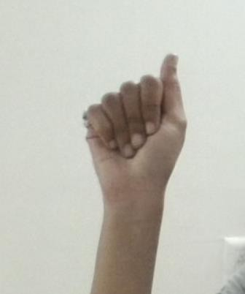

1. **Black Box**:

Black Box testing



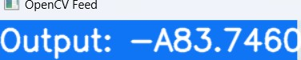

1. **Actual Output**:
2. **Expected Output** : Expected output is same as the actual output.
3. **Status** : PASS
4. **Input Data**:





1. **Black Box**

### TEST CASE:3

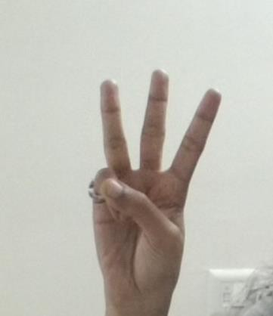Black Box testing



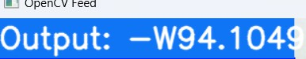

1. **Output**:
2. **Expected output** : Expected output is same as actual output
3. **Status** : PASS

## FUTURE SCOPE

* 1. Expanding the Dataset-
     + More gestures: Expanding the gesture set to include signs from various sign languages
  2. Multilingual Support
     + Supporting multiple sign languages and speech translation for global use.
  3. Enhanced Machine Learning Models
     + Improving accuracy using deep learning to understand inputs in sentence-level contexts.
  4. Real-time Feedback
     + Providing real-time feedback and corrections for visually impaired users.
  5. Mobile App Development
     + Developing a mobile app for on-the-go access to gesture recognition, optimized for real-time processing.

## CONCLUSION AND RECOMMENDATION

In conclusion, this project focuses on the development of a Sign Detection and Recognition System, designed to assist individuals, including those with disabilities, in communicating through hand gestures. The system features several core modules, including hand gesture detection. It enables users to capture and recognize hand gestures, translate them into text and provide an accessible interface for seamless interaction.

Future enhancements for the system include expanding the dataset by giving more inputs, improving the accuracy of recognition with machine learning advancements, developing mobile app versions for wider accessibility, incorporating real-time feedback. These improvements will enhance both the system's functionality and its usability, ensuring it continues to evolve with user needs.

## BIBLIOGRAPHY

**References used:**

1. https:/[/www.rese](http://www.researchgate.net/publication/353141966_Sign_Language_Recognition)a[rchgate.net/publication/353141966_Sign_Language_Recognition](http://www.researchgate.net/publication/353141966_Sign_Language_Recognition)
2. https:/[/www.studo](http://www.studocu.com/in/z/34171637?sid=01701663833)c[u.com/in/z/34171637?sid=01701663833](http://www.studocu.com/in/z/34171637?sid=01701663833)
3. https://youtu.be/Ui85SVJsRf8?si=S06eO_2y8a5upZBT
4. P signing and the emergence of new signs in American Sign Language. (1998). *Language and Speech,* 41(2), 191-220.
5. Goldin-Meadow, Susan. (2003). "The Resilience of Language." *Nature,* 423, 43-44.