**DAYANANDA SAGAR COLLEGE OF ENGINEERING**

(An Autonomous Institute affiliated to VTU, Belagavi, Approved by AICTE & ISO 9001:2008 Certified)

Accredited by National Assessment & Accreditation Council (NAAC) with ‘A’ grade,

Shavige Malleshwara Hills, Kumaraswamy Layout, Bengaluru-111



**Seminar Report**

**on**

**“StudySpaces”**

Submitted by

**Tejas R (1DS20CS227)**

**Tushar Pathak (1DS20CS228)**

**Vishnu Shedole (1DS20CS246)**

**Sixth Semester B.E (CSE)**

**2022-2023**

Under the guidance of-

**Mr. K. Sai Prabanjan Kumar**

**Assistant Professor**

**Dept. of CSE**

**DSCE, Bangalore**

**Department of Computer Science and Engineering**

**Dayananda Sagar College of Engineering**

**Bangalore-78**

**VISVESVARAYA TECHNOLOGICAL UNIVERSITY**

DAYANANDA SAGAR COLLEGE OF ENGINEERING

Shavige Malleshwara Hills, Kumaraswamy Layout, Bangalore - 560078

**Department of Computer Science & Engineering**



**CERTIFICATE**

This is to certify that the project entitled **STUDYSPACES** is a bonafide work carried out by **TEJAS R [1DS20CS227], TUSHAR PATHAK [1DS20CS228], VISHNU SHEDOLE [1DS20CS246]** in partial fulfilment of 6th semester, Bachelor of Engineering in Computer Science and Engineering under Visvesvaraya Technological University, Belgaum during the year 2022-23.

**Prof. K Sai Prabanjan Kumar Dr.Ramesh Babu Dr.B G Prasad**

(Internal Guide) Vice principal & Head Principal

Assistant Professor Department of CSE DSCE

Department of CSE, DSCE

DSCE

Signature.................... Signature.................... Signature.................

Name of the Examiners: Signature with date:

1. .................................... ………………………………
2. .................................... ……………………………….

**ACKNOWLEDGEMENT**

We are pleased to have successfully completed the Mini project **“StudySpaces”**. We thoroughly enjoyed the process of working on this project and gained a lot of knowledge doing so.

We would like to take this opportunity to express our gratitude to **Dr. B G Prasad**, Principal of DSCE, for permitting us to utilize all the necessary facilities of the institution.

We also thank our respected Vice Principal, HOD of Computer Science & Engineering, DSCE, Bangalore, **Dr. Ramesh Babu D R**, for his support and encouragement throughout the process.

We are immensely grateful to our respected and learned guide, **Prof. K Sai Prabanjan Kumar**, Assistant Professor CSE, DSCE for his/her valuable help and guidance. We are indebted to them for their invaluable guidance throughout the process and their useful inputs at all stages of the process.

We also thank all the faculty and support staff of Department of Computer Science, DSCE. Without their support over the years, this work would not have been possible.

Lastly, we would like to express our deep appreciation towards our classmates and our family for providing us with constant moral support and encouragement. They have stood by us in the most difficult of times.

TEJAS R , 1DS20S227

TUSHAR PATHAK , 1DS20S228

VISHNU SHEDOLE , 1DS20S246

**CONTENTS**

| **SL. NO** | **CONTENT** | **PG. NO** |
| --- | --- | --- |
|  | Abstract |  |
|  | Introduction |  |
|  | Literature Survey |  |
|  | System design & Methodology |  |
|  | Snapshots and Results |  |
|  | Conclusion & Future Enhancements |  |
|  | References |  |
|  | Appendix |  |

**ABSTRACT**

StudySpaces is a comprehensive classroom platform designed to enhance online learning process for students. With StudySpaces, teachers can effortlessly create virtual study environments known as a Study Space, where students can join and participate in interactive learning activities.

The platform's primary objective is to simplify online learning by providing an all-in-one solution for teachers and students. Teachers can leverage StudySpaces to create engaging quizzes and host assignments, facilitating seamless assessment and feedback. Additionally, StudySpaces introduces TaskStack, an intuitive task management feature that enables both teachers and students to stay organized and keep track of their upcoming assignments, deadlines, and priorities.

One of the standout features of StudySpaces is its real-time interaction option, which promotes effective communication between students and teachers within the platform itself. This eliminates the need for external applications, enabling direct and efficient doubt clarification, class announcements, and circulars.

The platform empowers both teachers and students by providing a centralized hub for educational activities, promoting collaboration, and offering streamlined tools for assessment and communication.

**Chapter 1**

**INTRODUCTION**

**Chapter 2**

**LITERATURE SURVEY**

* For the project, StudySpaces, the following 10 research papers were referred before the implementation process. These research papers are studied and tabulated as follows having the title, algorithm/technique used, as well as their performance and the dataset used in the implementation.

| **Title** | **Algorithms/Technique** | **Performance** | **Datasets/Database** |
| --- | --- | --- | --- |
| 1. Student Smart Attendance Through Face Recognition Using Machine Learning Algorithm | Face Recognition Algorithm (PCA,Single vector Decomposition(SVD),fisher face),Haarcascade classifier and MTCNN Model | Leave-out method, Hold-out method using SVD expected outcome rate is 88.89% on combining SVD with PCA and fisher face accuracy rate is 92.89%, 93.12%, 92.87% for AT&T, Yale&Facepix. | AT&T database, Yale database Facepix dataset |
| 2. Automated Attendance System and voice assistance using Face Recognition | SVM,CNN and K-Nearest Neighbor(KNN) SVM & MLP(extraction using PCA and LDA-Linear Discriminant Analysis),Histogram Oriented Gradients(HOG) | Viola Jones algorithm SVM accuracy 88%,CNN testing accuracy 95%,KNN testing accuracy 97%,Fast-RCNN yield than HOG | Self-generated database(creating datasets) |
| 3. Automated Attendance System using image processing | Violas Jones framework Algorithm,Haarfeatures,Adaboost learning algorithm,cascade,GLCM | The system provides 80% recognition rate and 90% detection rate | Self-generated database or datasets |
| 4. Automated Attendance System by Face Recognition | Histogram of Oriented Gradient(face detection),opencv(cv2 face recognition)CLAHE(contrast limited adaptive histogram equation)is used to enhance contrast of image | The model has an accuracy of 99.38% on labeled wild, pair-matching | Self-generated dataset |
| 5. Automatic Attendance System using face Recognition Technique | Haar cascade, adaboost ,SVM(face detector Viola-Jones face detector, histogram of oriented gradient ,line edge map and Eigen faces(extract features) | It is able to capture images from 60-80cm distance very accurately and less time required,haar cascade provides highest accuracy among all | Self-generated dataset or creating dataset using GUI |
| 6. Automated Attendance System by Face Recognition | Face geometry based methods, feature invariant methods, Viola-Jones detection algorithm, Adaboost learning & integral. | The system developed only recognizes face up to 30 degree angle. PCA uses better recognition rate and low false positive rate. | Biometric base system is required ,It contains of image capture. |
| 7. Efficient Attendance management based on face Recognition | Histogram normalization, Noise removal, FFT and low pass filter for noise removal. | Face detection: 40% of veil, 95% of unveils, 75% of beard.  Face recognition:2% of veil,85% of unveil,63% of beard | Face database: from input image(self generated database) |
| 8. Automatic Attendance System using face Recognition | Viola-Jones, Integral images, Ada-boost and attentional cascade. | If training set consists of m images, principal component, analysis could form a basis set of N images where N<M | Eigen –picture compared with original training set. |
| 9. Face Recognition Based Attendance System Using Machine Learning | Skin classification technique, LBPH, SVM for classification. | Rotation at 90 degree and at finer angle. For SVM is 77-78% v/s 54% fd PCA | Biometric base system, lighting condition |
| 10. Face Recognition Smart Attendance System using Deep Transfer Learning. | This approach consists of data collection, data formatting and augmentation. | Squeeze net gives accuracy of 98.33%,googlenet gives accuracy of 93.33% alexnet gives accuracy of 100% | Self-generated database |

**Chapter 3**

**SYSTEM DESIGN & METHODOLOGY**

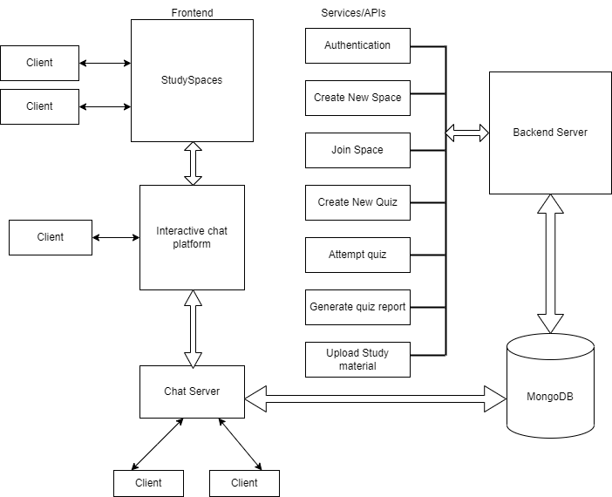

**User specific services-**

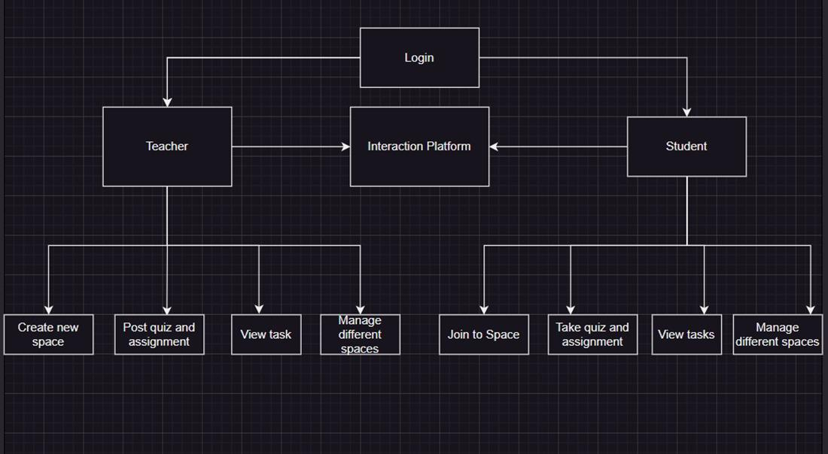

**Chapter 4**

**SNAPSHOTS AND RESULTS**

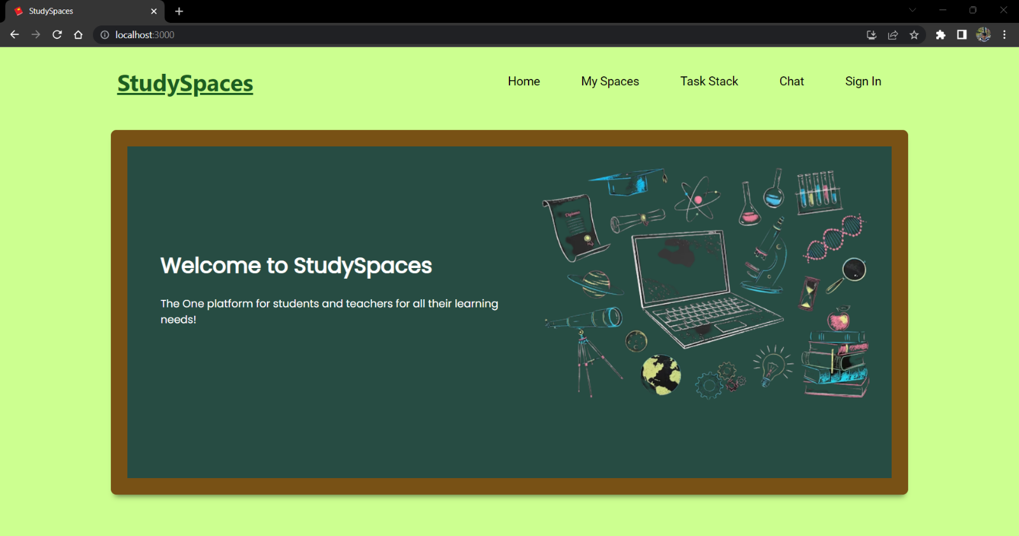

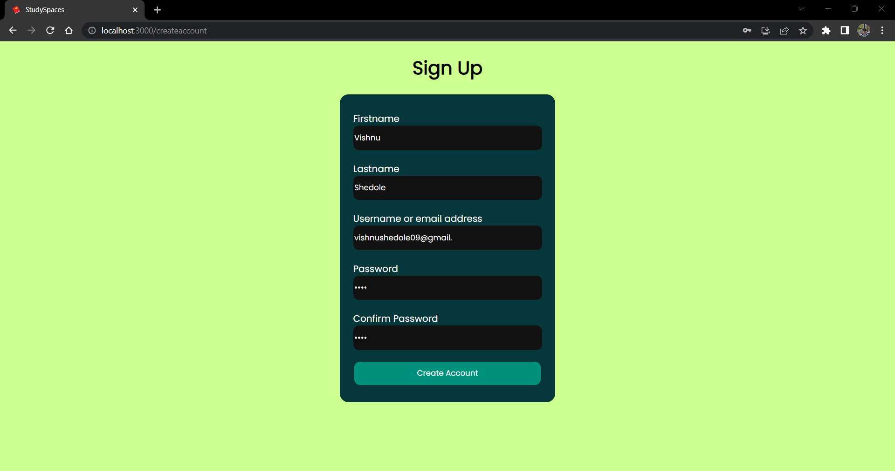

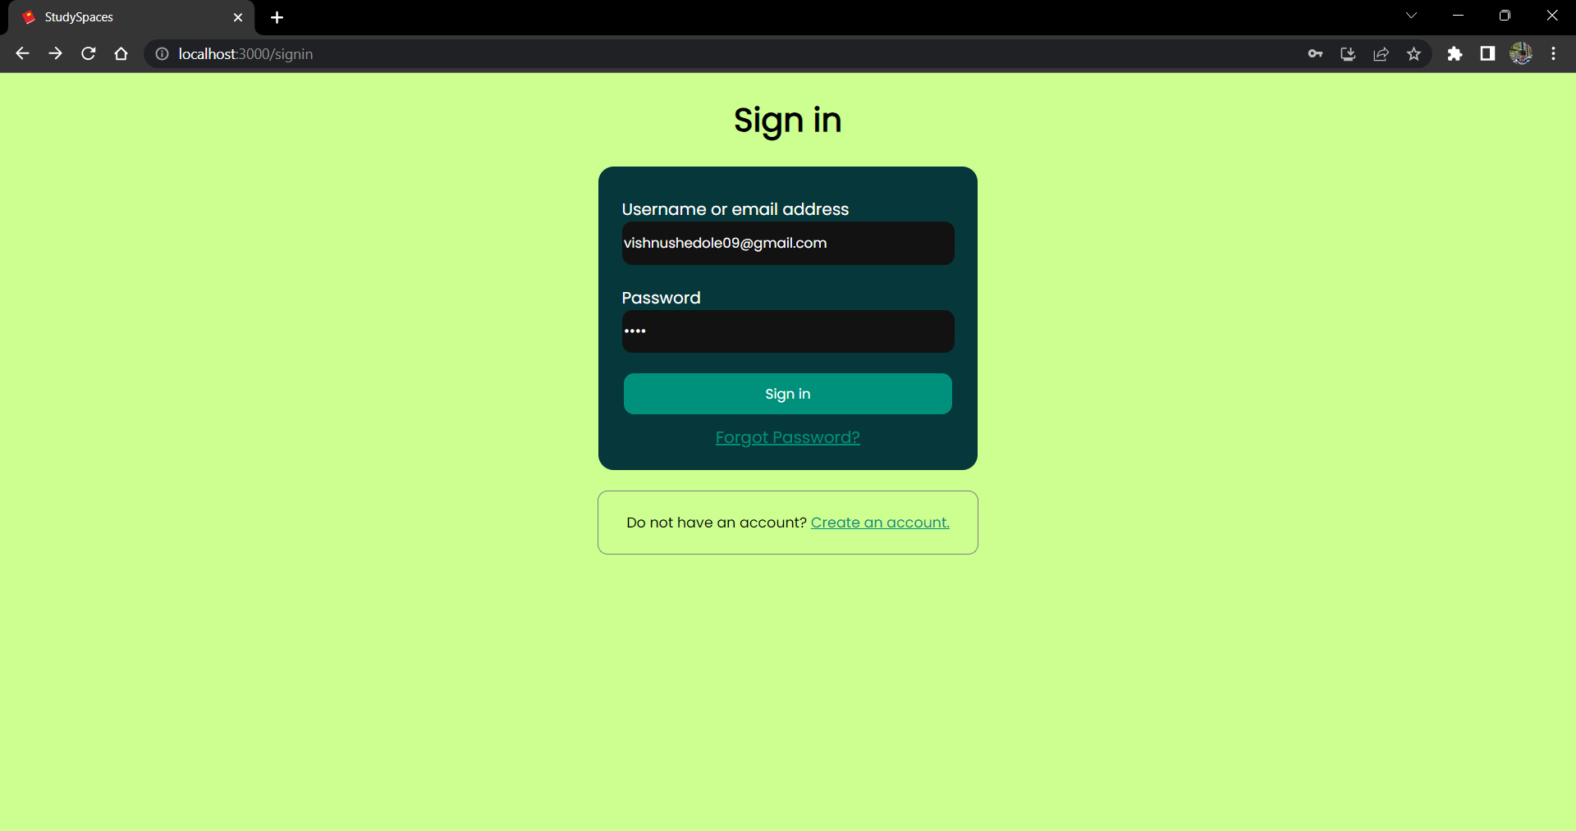

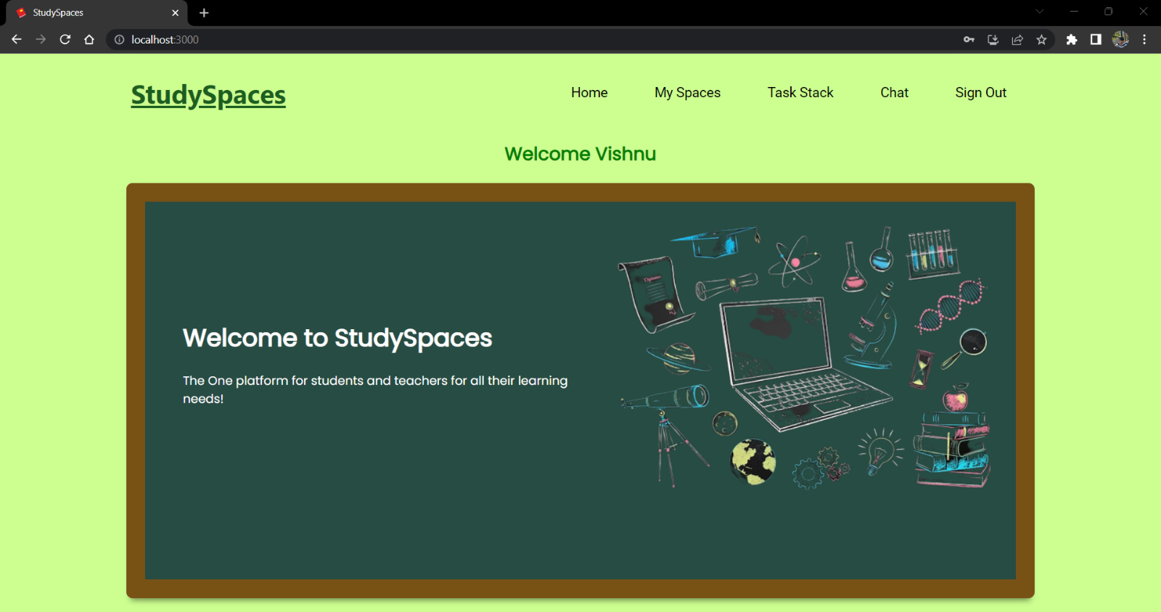

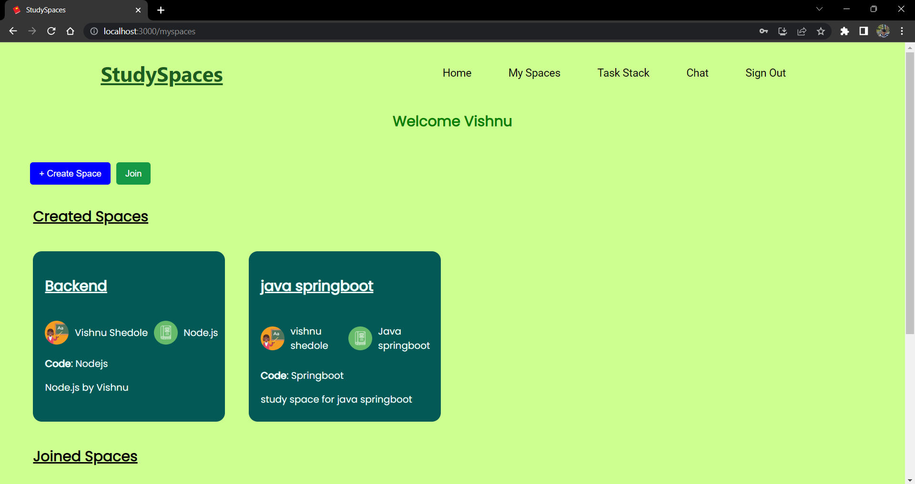

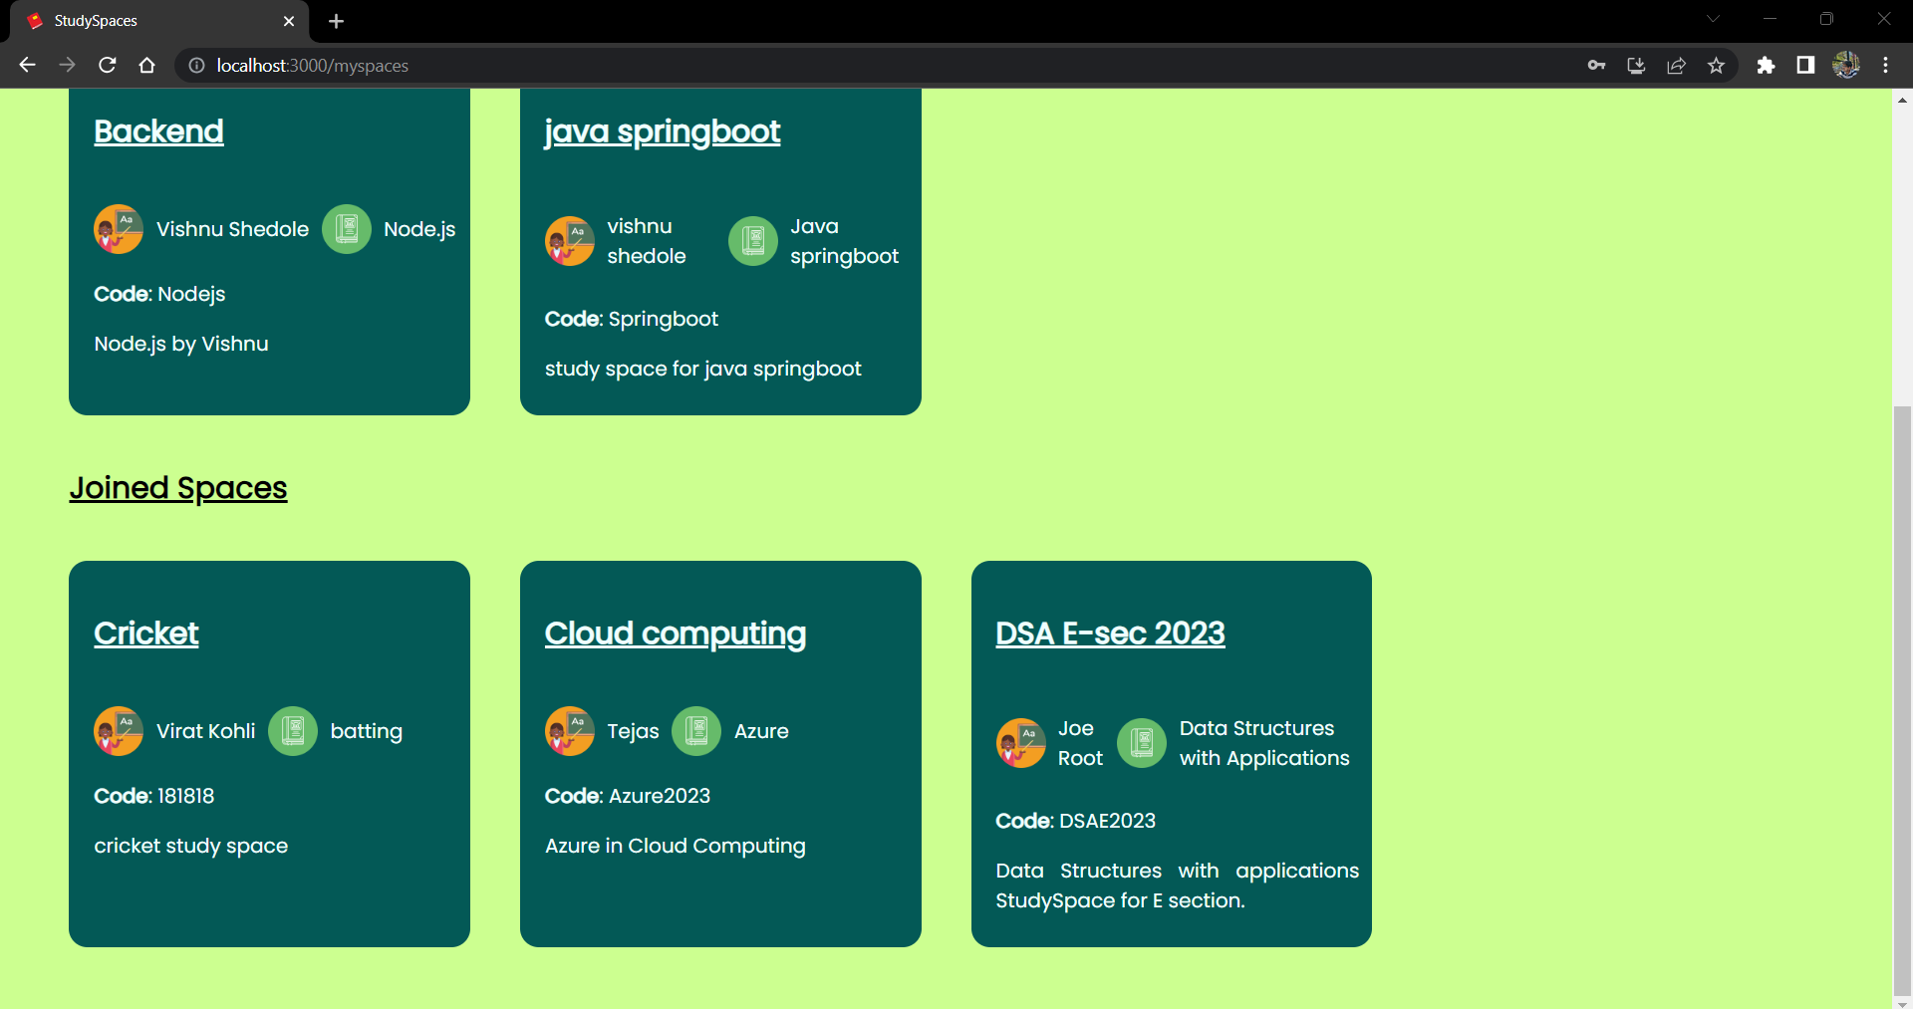

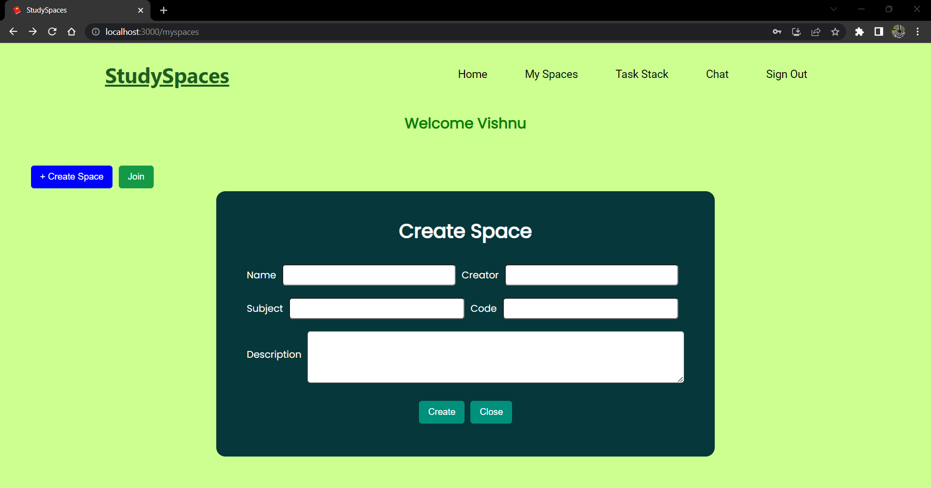

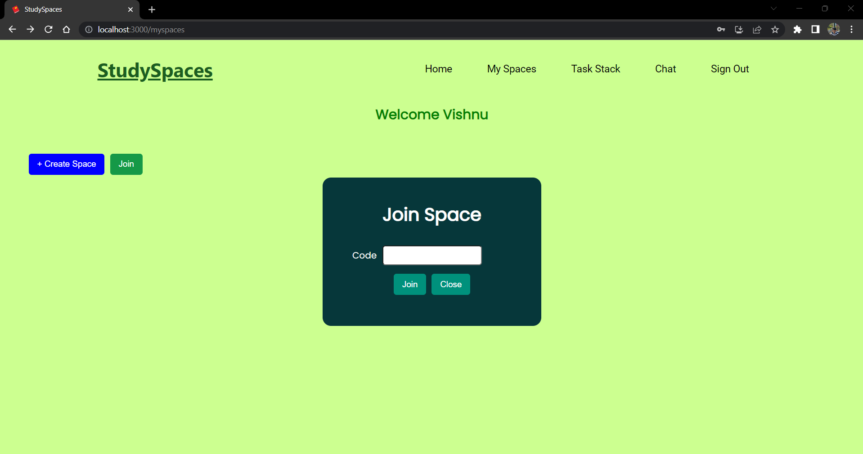

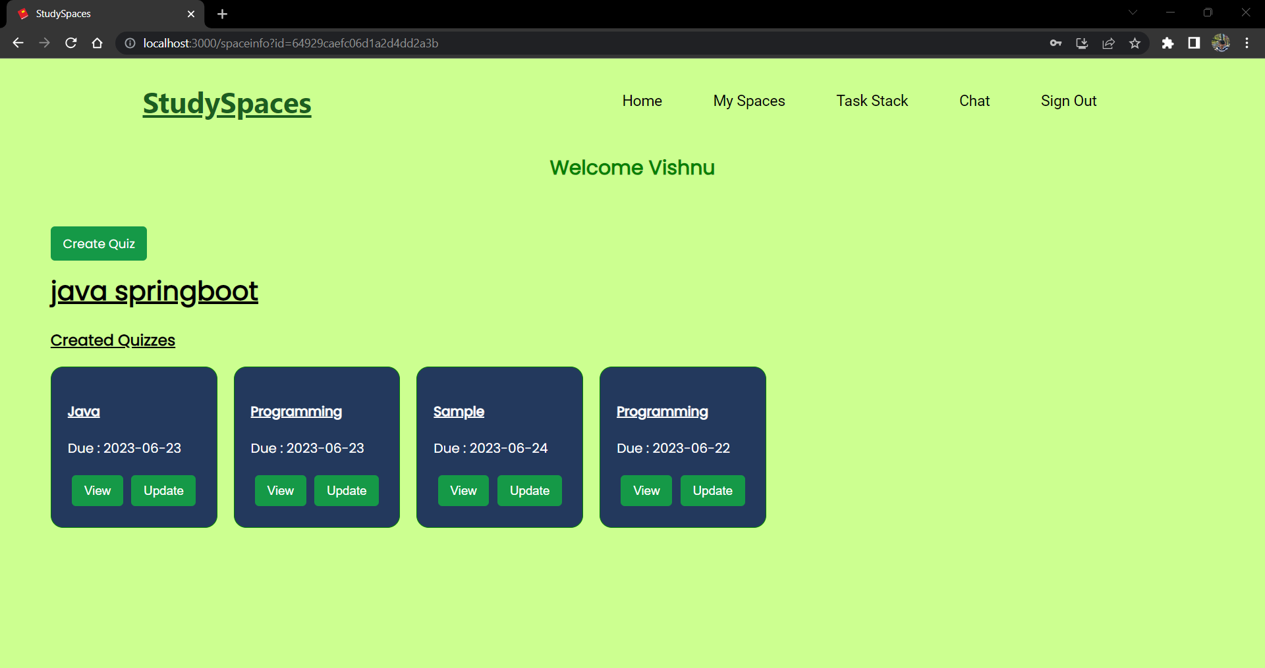

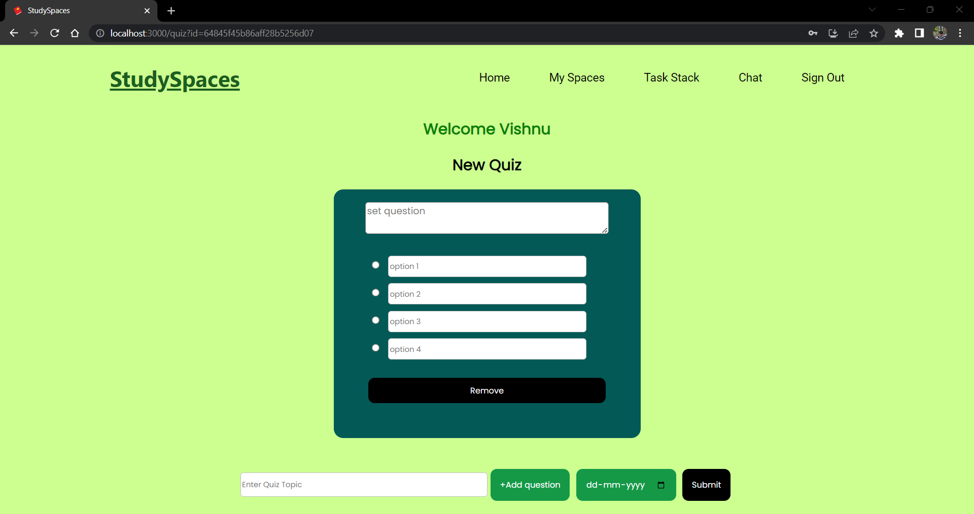

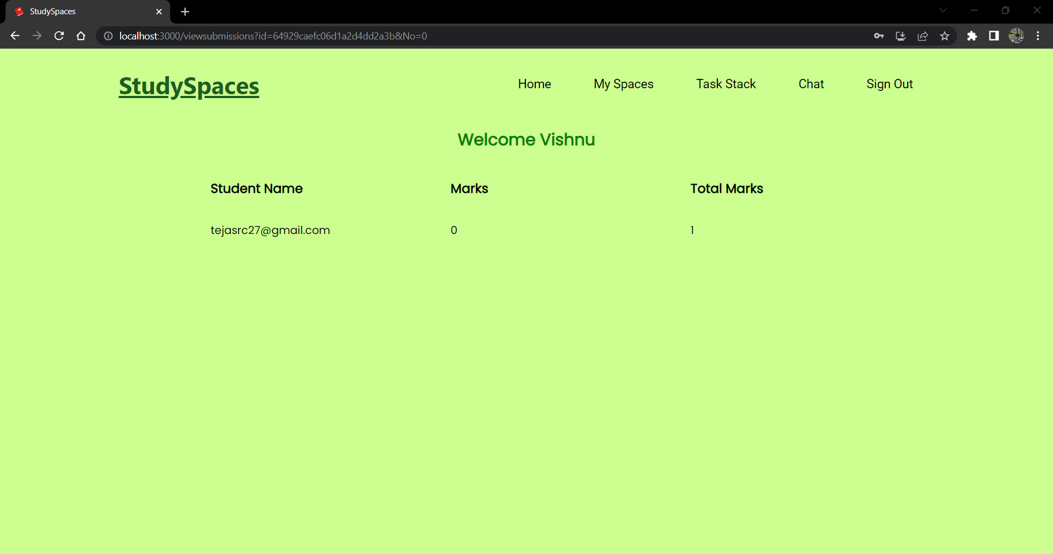

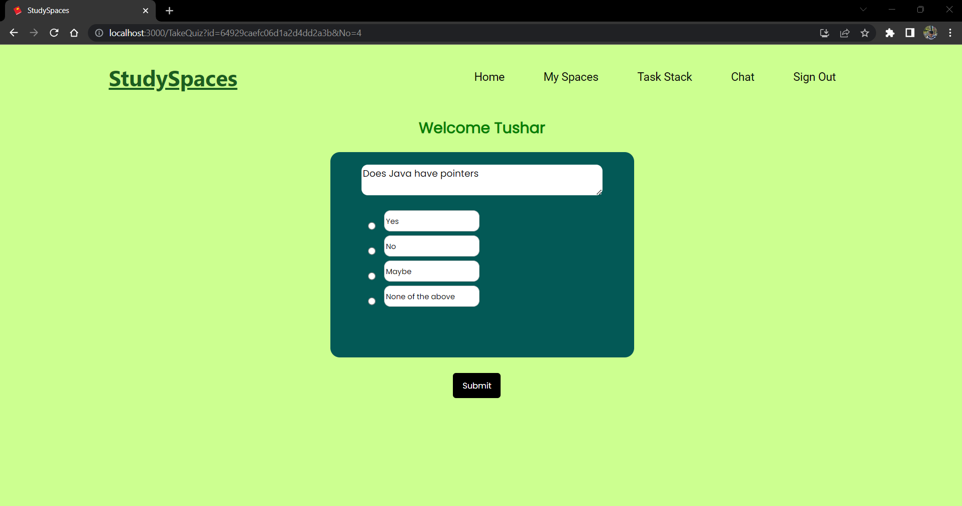

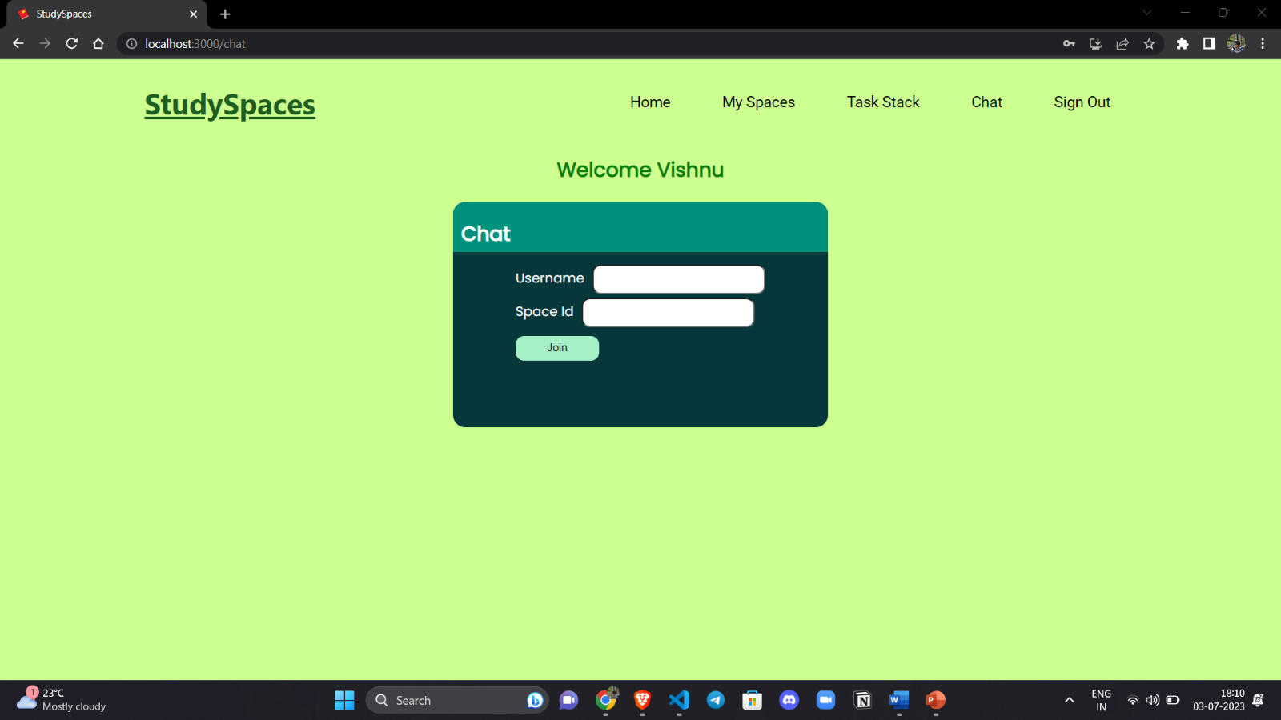

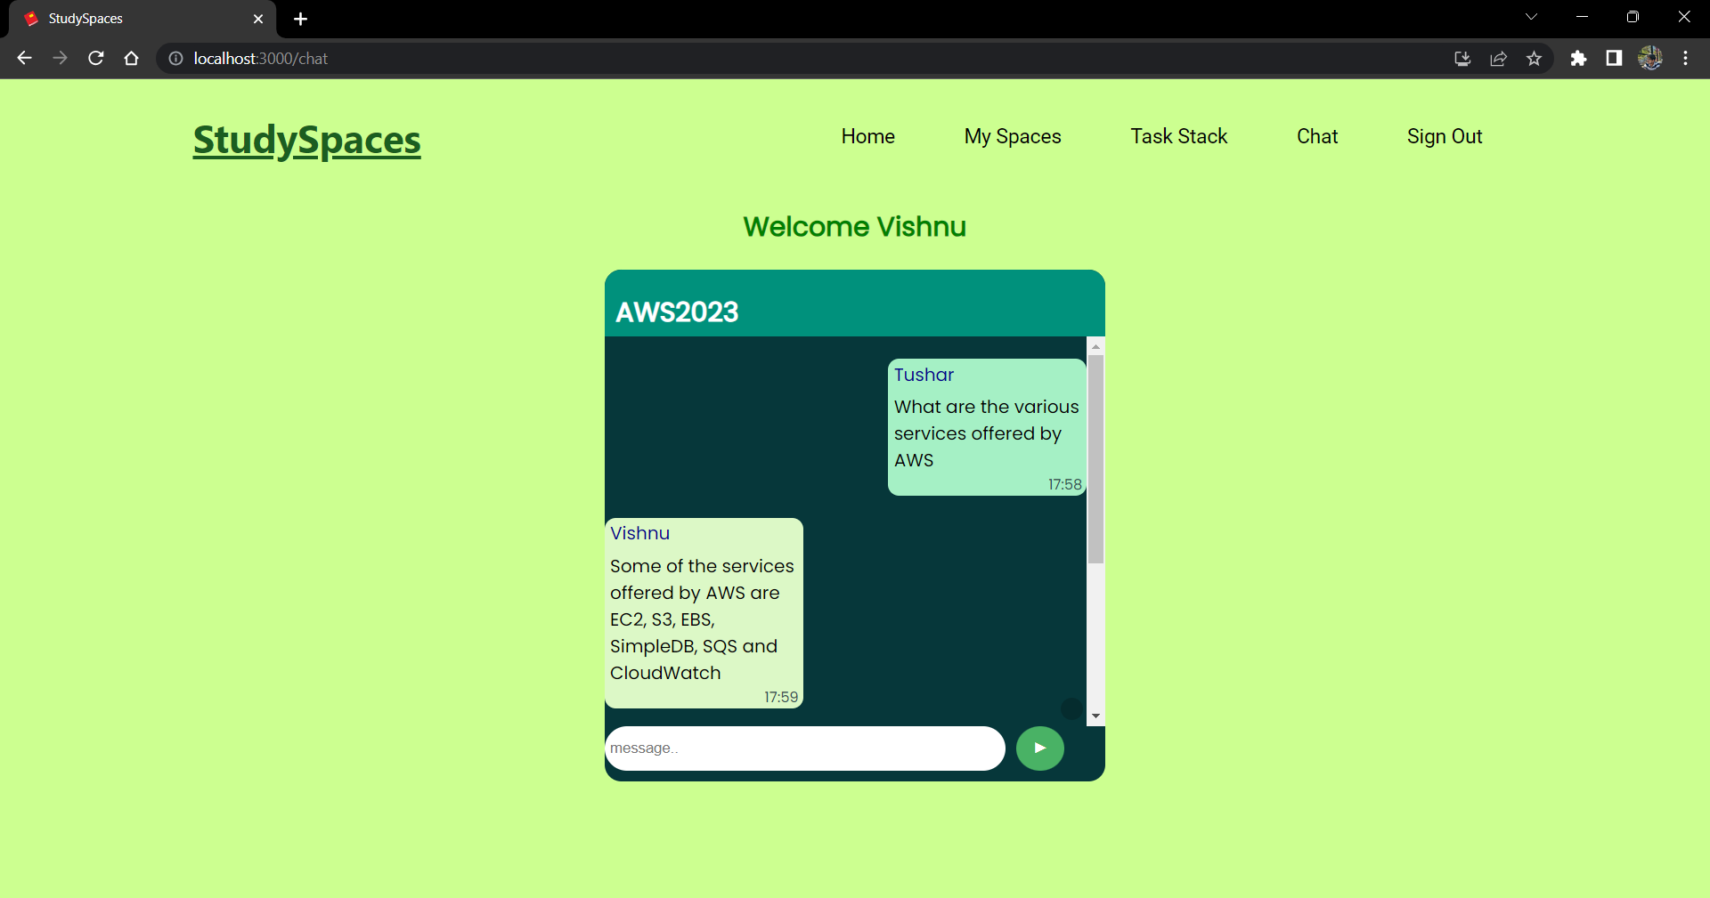

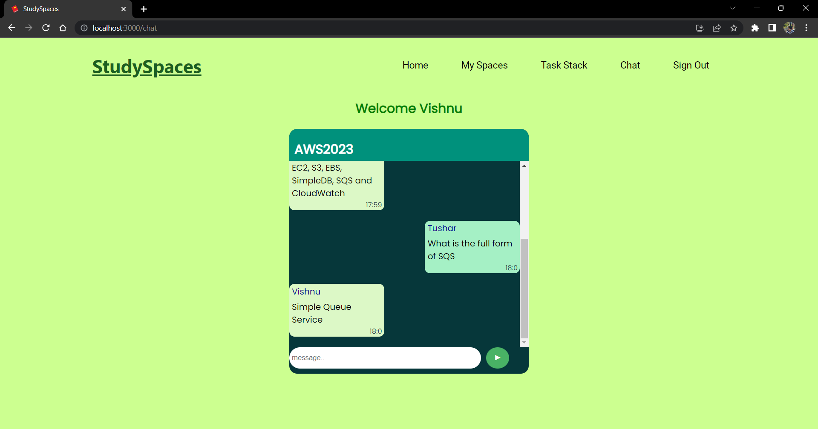

**CONCLUSION**

StudySpaces is a comprehensive classroom platform that revolutionizes the online learning experience for students and teachers alike. By offering a range of powerful features and intuitive tools, StudySpaces simplifies the process of online education and creates an interactive virtual environment for effective learning.

With StudySpaces, teachers can effortlessly create Study Spaces, virtual classrooms where students can join and engage in various interactive learning activities. This feature promotes collaboration and encourages active participation, enhancing student engagement and comprehension. Furthermore, teachers can leverage StudySpaces to create quizzes and assignments, facilitating seamless assessment and providing timely feedback to students.

The introduction of TaskStack, an intuitive task management feature, helps both teachers and students stay organized by keeping track of assignments, deadlines, and priorities. One of the standout features of StudySpaces is its real-time interaction option. This built-in communication tool eliminates the need for external applications, enabling direct and efficient communication between students and teachers within the platform itself.

Students can clarify doubts, receive announcements, and access circulars in real-time, fostering effective and timely communication. StudySpaces serves as a centralized hub for educational activities, empowering both teachers and students. By providing a comprehensive set of tools and features, it streamlines the online learning process, making it more efficient and enjoyable for all users. The platform's focus on collaboration and interaction enhances the overall learning experience and encourages student participation.

In a rapidly evolving educational landscape, StudySpaces stands as a solution that addresses the challenges faced in online learning. It not only provides a seamless learning environment but also promotes effective communication, organization, and assessment.

With StudySpaces, the potential for enhanced educational outcomes becomes a reality, creating a platform that is truly beneficial for both teachers and students. In conclusion, StudySpaces offers a comprehensive and user-friendly platform that caters to the needs of modern education, making online learning a more engaging and efficient experience for all involved.

StudySpaces represents a powerful solution that enhances the online learning process. By fostering engagement, streamlining assessment, promoting collaboration, and offering a range of features for teachers, StudySpaces contributes to an enriched educational experience. As the world continues to embrace digital learning, StudySpaces stands at the forefront, empowering educators and students in their pursuit of knowledge and academic success.

**FUTURE ENHANCEMENTS**

* Integration with Learning Management Systems (LMS): To further streamline the online learning process, StudySpaces can consider integrating with popular LMS platforms. This integration would allow seamless synchronization of course materials, grades, and student information, providing a more holistic learning experience for both teachers and students.
* Advanced Analytics and Reporting: Implementing advanced analytics capabilities would enable teachers to gain insights into student performance, engagement, and progress. By analyzing data such as quiz results, assignment completion rates, and participation levels, teachers can identify areas for improvement and tailor their teaching methods accordingly.
* Virtual Reality (VR) Integration: Introducing VR capabilities within StudySpaces could take online learning to the next level. VR technology can create immersive virtual environments, allowing students to experience hands-on learning, virtual field trips, and interactive simulations. This enhancement would enhance engagement and foster a deeper understanding of complex concepts.
* Gamification Elements: Incorporating gamification elements into StudySpaces can make the learning experience more enjoyable and motivating. By introducing badges, leaderboards, and rewards for achievements and milestones, students can be incentivized to actively participate and excel in their studies.
* Enhanced Collaboration Tools: StudySpaces can enhance its collaboration features by introducing virtual whiteboards, real-time document editing, and group project management tools. These additions would facilitate seamless group work and foster effective teamwork among students, promoting a more interactive and collaborative learning environment.
* Integration with Video Conferencing Platforms: While StudySpaces already offers real-time interaction, integrating with popular video conferencing platforms such as Zoom or Microsoft Teams would provide additional flexibility for live lectures, virtual classrooms, and interactive discussions. This integration would allow teachers and students to leverage familiar video conferencing tools within the StudySpaces platform.
* Mobile Application: Developing a mobile application for StudySpaces would enable students and teachers to access the platform on-the-go. This would allow for greater flexibility in completing assignments, engaging in discussions, and receiving notifications, making online learning more accessible and convenient

**REFERENCES**

1. Node.js documentation : <https://nodejs.org/en/docs>
2. Express.js documentation : <https://expressjs.com/>
3. React.js documentation : <https://react.dev/>
4. Mongodb documentation : <https://www.mongodb.com/docs/>
5. Socket.io documentation : <https://socket.io/docs/v4/>
6. NodeJS - The Complete Guide (udemy course) : <https://www.udemy.com/course/nodejs-the-complete-guide/>
7. ReactJS codevolution youtube playlist : <https://www.youtube.com/playlist?list=PLC3y8-rFHvwgg3vaYJgHGnModB54rxOk3>
8. Socket.io Tutorial (PerdoTech youtube channel) : <https://www.youtube.com/watch?v=NU-HfZY3ATQ>
9. Mongoose documentation : <https://mongoosejs.com/docs/>
10. Material ui colors : <https://mui.com/material-ui/customization/color/>
11. Session cookie based authentication : <https://www.youtube.com/watch?v=TDe7DRYK8vU>
12. Asynchronous javascript : <https://www.youtube.com/watch?v=ZYb_ZU8LNxs>

**APPENDIX**

**PROJECT SOURCE CODE :**

https://github.com/tejas0123/StudySpaces