ADDS AI LLP -CONFIDENTIAL DOCUMENT
Concept and functionality Description of Legal AI- the Project
CONFIDENTIAL AND HIGHLY RESTRICTED DISTRIBUTION – THE PROJECT OWNER SHOULD EXERCISE CONTROL AND EXTRACT AND PROVIDE LIMITED AND RELEVANT SECTION TO KEY DEVELOPMENT LEAD. THIS DOCUMENT CONTAINS SENSITIVE IPR AND COPYRIGHT MATERIAL OF ADDS LEGAL AI LLP.

RECEIPIENTS OF THIS DOCUMENT ARE ADVISED CAUTION FOR USE OF THE CONTENTS (PART OR FULL). ONLY USERS WHO HAVE SIGNED CONFIDENTIALITY AGREEMENT (CA) HAVE A RIGHT TO VIEW THIS DOCUMENT.

IN CASE OF DISCONTINUATION WITH THE PROJECT THE USER MUST DESTROY ALL HARD COPIES AND DIGITAL COPIES IN AN UNRETRIEVABLE FORM AND NOT USE THE INFORMATION MADE AVAILABLE TO HIM/HER FOR ANY PURPOSE WHATSOEVER

Legal AI –
Conceptual and Functional Requirements

Owned by ADDS Legal AI LLP

Table of Contents

1. Arbitration and reconciliation/ mediation portal functionalities: 1
2. AI based Arbitration assistant 3
3. Additional Services 3
4. Arbitration Functionality 6
4.1. Arbitration/Mediation/Advisory Request by Claimant 6
4.2. Arbitration Response by Respondent 7
4.3. Evidence of the Claimant and Respondents (To be filed by Day 14): 8
4.4. Arguments of the Claimant and Respondents 9
4.5. Rendering of award 10
4.6. Arbitration Requests worklist by Claimant/Respondent/Arbitrator 10
4.6.1. Workflow Stages and Actions 10
4.6.2. Case Status 12
4.6.3. Case Category and Nature of Dispute 13
4.6.4. Case Category and Sub-Category 14
4.7. Case Detail View 15
4.8. Document Type 16
4.9. Common Functionality 17
4.10. Portal Pages 18
4.11. Technology Considerations 19
4.11.1. API First Approach 20
4.11.2. Configuration Management 20
4.11.3. Portal specification 20
4.11.4. Security specification 21
5. Appendix 1 : Sample Arbitration questions to be addressed by the system 22

Arbitration Functionality (Arbitration/ reconciliation / mediation portal judgements)

This is the conceptual and functional requirements of the Arbitration Functionality through AI/ML/NLP functionality – a sub component of legal AI platform to assist users to resolve disputes outside of traditional court proceedings through the intervention of an arbitrator or a panel of arbitrators as per Arbitration and Conciliation Act, 1996. The functional requirements of the other items of the platform will be provided later. The conceptual level descriptions of requirements are provided herein.

Arbitration and reconciliation/ mediation portal functionalities:
- User registers on the portal to avail arbitration related services. Individuals, organizations/firms/companies - parties, advocates, consultants, arbitrators can all register on the portal and initiate/participate in arbitration process for a basic fee – say Rs. 100 per registration.
- User selects Service - arbitration/mediation/advisory and the Acts applicable to the case)
- The user fills up a form Refer “Arbitration/Mediation/Advisory Request by Claimant” - giving all the details - the reason for filing and the clauses which merit this filing
- User uploads the contract and other relevant documents and supporting documents in a structure
- User keys in his prayers viz. reliefs that he is seeking.
- User also has to select location (if he desires to get the arbitration/mediation done in person. This is not required if it is agreed for a virtual case outcome).
- User to select name of arbitrators/mediators if requiring a physical arbitrator/mediator (from the panel on our portal). Against each name profile of arbitrators/mediators, history of past experience, his rates and availability etc will be visible to the user)
- Users pay registration fees as per a schedule, including advance for a physical arbitrator/ mediator and submits the case.
- User gets a sms/ email giving details of his filing and the system generated unique id for future references.
- System will also inform the respondent/s and other agencies as may be desired / required viz the Indian arbitration council, or other relevant body.
- System will notify the selected arbitrator/s/ mediator about the case. he will also get a link to the case request and respond to the same, refer “Arbitration/Mediation/Advisory Request by Claimant”
- The arbitrator/mediator gets an option to accept or reject the appointment citing reasons if he/she wants to declare them. Rejection will let the user select another arbitrator/mediator. And the above cycle of acceptance by arbitrator/mediator shall continue till it gets accepted (for convenience - the user shall get the contact details of all the arbitrators/mediators on the panel).
- After the arbitrator/mediator is willing to accept the appointment, the respondent gets an option to agree to the arbitrator/mediator selected by claimant or else can select another arbitrator/mediator. He also would be required to pay registration fees before he could submit his response.
- The claimant will get the response of the respondent and accordingly finalise the appointment of his/her/its nominated arbitrator/mediator or by accepting the respondents arbitrator/mediator respondent.
- The cycle repeats till the sole arbitrator/mediator is appointed.
- Once the above process is over, all stake holders to the case viz. the claimant, respondent, arbitrator will receive a system generated editable draft schedule, which the arbitrator will finalise and issue to the parties. If no physical arbitrator/mediator is to be appointed the parties will accept the system generated draft schedule, incorporating changes agreed to by the parties.
- System will notify all the stakeholders at regular intervals of all the proceedings and alert on next scheduled date, demand submissions from respondents or petitioners as may be required.
- System will provide the video and audio link to all stake holders for all the hearings (if any) well in advance. It will record the sessions, transcript the sessions, create summaries of the processes and issue (optional).
- Each party will submit a summarised statement of facts with the key points of evidence (documents for which will be separately scanned and submitted with the statement as Exhibits or witness statements), submissions and prayers not exceeding 15 pages with a pre-decided font and number of words. This will be in the sequence of claimant first, respondent second and claimant in rejoinder (if required) third.
- If a physical arbitrator/mediator is involved, witnesses can be cross-examined by the opposing party.
- System will let the parties login in to the portal and make any filings/ submission of additional documents as they may deem fit any time until the arbitration/mediation is closed for orders/draft agreement in case of mediation)
- The hearing begins with each party presenting its opening statement, outlining its case and the key points of evidence it plans to present.
- Both parties present their evidence, which can include documents, witnesses, expert testimony, and any other relevant material. Witnesses are usually cross-examined by the opposing party.
- The arbitrator will often decide which evidence is admissible. While the rules of evidence in arbitration may be more relaxed than in court, fairness is still a priority.
- The arbitrator may ask for further documents or evidence and reschedule the hearing, this might be iterative process and hearing can be conducted for multiple sessions.
- System also let's all stake holders to login in to the portal and make any filings/ submission of additional documents as they may deem fit any time ( till the final order is pronounced to be reserved )
- Once all evidence has been presented, both parties provide closing arguments, summarizing their case and why they believe they should prevail.
- After the hearing, the arbitrator deliberate and issue a written decision that outlines the facts, legal reasoning, and the specific outcome, including any damages or remedies ordered. Claimant and respondent may appeal for the same in Indian courts under Section 34 of the Act if they want to set aside the award on following grounds:
  - The tribunal was not properly constituted.
  - The tribunal has committed a serious procedural error.
  - The award is in conflict with the public policy of India.
- After the hearing, the arbitrator/mediator will use the system to obtain recommended outcomes based on prevailing law and the arbitrator will issue a written award/mediator will recommend settlement terms.
- The entire transaction viz communication, the documentations and the proceedings will be indexed and stored by date in the e file of the case for future referrals (based on access rights).
- Once an arbitral award is passed, it can be enforced as a decree of a court. If a party refuses to comply with the award, the other party can approach the relevant court for enforcement.
- Arbitration and Conciliation Act, 1996, The Arbitration and Conciliation (Amendment) Act, 2019 and the Arbitration and Conciliation (Amendment) Act, 2021 introduced several important reforms, including the establishment of an Arbitration Council of India (ACI) for promoting institutional arbitration, time-bound completion of arbitration proceedings, and provisions for enforcing interim measures. The system should implement the relevant rules while governing the process.
- Arbitration Act (Section 29A) mandates that the award must be made within 12 months from the date of the appointment of the arbitrator(s), which can be extended by an additional 6 months with the consent of the parties.

AI based Arbitration assistant
Claimant desirous of settling a dispute uploads the facts of the case and the desired pleas. Our system will pass these through a filter to weed out those have a prima facie case. It will also sieve through the relevant case law in doing this.

A majority of applications are expected to be resolved at this stage itself. For those that don’t, the platform facilitates the resolution process.

Once the registration and uploading of documents is completed by the client, the system will generate

- various extracts from the agreement ( the issues preconditions , obligations etc ),
- Associate relevant paragraphs from judgements on appeals of similar arbitration matters if available in repository.
- It will also give draft response to the claims and prayers made by the petitioners along with relevant supporting references.
- This will let user amend his petition / seek advice or withdraw his claim. Else he proceeds as per the process.
- The process automation maybe a value addition if acceptable as an easy way to proceed and close arbitrations in time.
- before the petition is registered or arbitrators are appointed. The process of reconciliation / mediation will be similar except that the parties to the dispute will seek advice of reconciliator.
- can also give probability of winning the case though we can discuss and try to evolve and algorithm to it.
- system will do some basic checks on the data in the form filled by petitioner and the base agreement to give advice of this kind. Viz. Limitations of liability , time barred claims, not an obligation, the pre condition was not met etc. Will take inputs and design this part of the system.
- Integration with other systems will be a necessary condition for each module delivery ( technically they integrate through APIs and exchange protocols after system verifications

Additional Services
- Arbitrator Management
- Registration of arbitrators : System should allow any individual who desirous of being on the panel/admin. Any retired judges, legal practitioners (lawyers, advocates), chartered accountant, retired bureaucrats and professionals/Industry experts with expertise in the subject matter of the dispute etc. can register as an arbitrators. This request will go to respective authority in system to be validated and approved. Once approved arbitrator can be selected by both parties for the arbitration process.
- Profile of arbitrator : Arbitrator will update his profile with relevant experience and past arbitration experience. This profile will be automatically updated based on cases being handled in the system.
- Performance of arbitrators : System will automatically calculate performance of arbitrator based on the registration data and outcomes of arbitration and ratings/feedback provided by all parties.
- Rules and regulations: Searchable Arbitration and Conciliation Acts and amendments
- The Arbitration and Conciliation Act, 1996
- the Arbitration and Conciliation (Amendment) Act, 2015
- The Arbitration and Conciliation (Amendment) Act, 2019
- The Arbitration and Conciliation (Amendment) Act, 2021
- Repository of Arbitration appeals in database for search
- Advisory services: This should allow users to seek other commercial services that the portal may publish from time to time, e.g. drafting arbitration matters. System can provide templates for the same.
- Subscription services: System will offer paid services to various users. System will offer various packages for individuals/firms and users will be able to subscribe for the same. System will generate bill and have online payment option to pay the amount.
- Case Management Functionality: Case management functionality should have capability to manage and track arbitration cases through various stages of resolution.
It should have
  - Case Creation and tracking : captures relevant information for arbitration case and automatically assign the case to respective stakeholders. It tracks the progress of each case and records the actions and events and respective timeline of the same. It sends periodic reminders and alerts as per configured rules to respective stakeholders for the follow up actions and tasks to be completed. All the case stages needs to be captured and managed up to closure of case and relevant information.
  - Document management: All communication and documents are stored and needs to be properly versioned and history should be maintained for each information.
  - Workflow: Workflow should be configured to process various arbitration processes. Users and tasks needs to be defined while based on predefined rules it should automatically triggers tasks/actions. As per configured rules for escalation matrix system should trigger it to next level if action is not taken as per specific timeframe.
  - Team Collaboration: The case details can be shared with other users of same team/party to collaborate, share updates and managing information.
  - Security: Arbitration process is a sensitive matter so all information needs to be stored and transmitted in secure way. It should also ensure that all the sensitive documents, evidence, and proceedings are kept confidential. Audit trail needs to be maintained for each action, including who updated it, when and from which machine/IP address.
  - Notifications: System should notify all stakeholders through email/SMS for importation events, appointments, information, reminders, drafts and outcome.
- Appointment Scheduler: It should schedule, manage, and track appointments, hearing, and events. User also has to select location (if he desires to get the arbitration done in person and not required if he agrees for a virtual case).
  - In case of virtual case System will provide the video and audio link to all stake holders for all the hearings well in advance. It will record the sessions and transcript the sessions. This will stored against each hearing. User should be able to reschedule or schedule a next hearing until closure of case. Using AI system should be able to extract minutes of meetings, actions and proceedings from session transcript.
  - In case of personal hearing, Minutes of meeting and actions needs to be keyed in by respective users.
System should send automatically reminders and notifications at specific interval and should capture the delivery of notification to respective stakeholders. It should also notify in case of changes in schedule, appointment details, cancellation or rescheduling. Appointment history needs to be maintained for future references all relevant information related to hearing against each appointment needs to be linked and tracked

Arbitration Functionality

Arbitration/Mediation/Advisory Request by Claimant
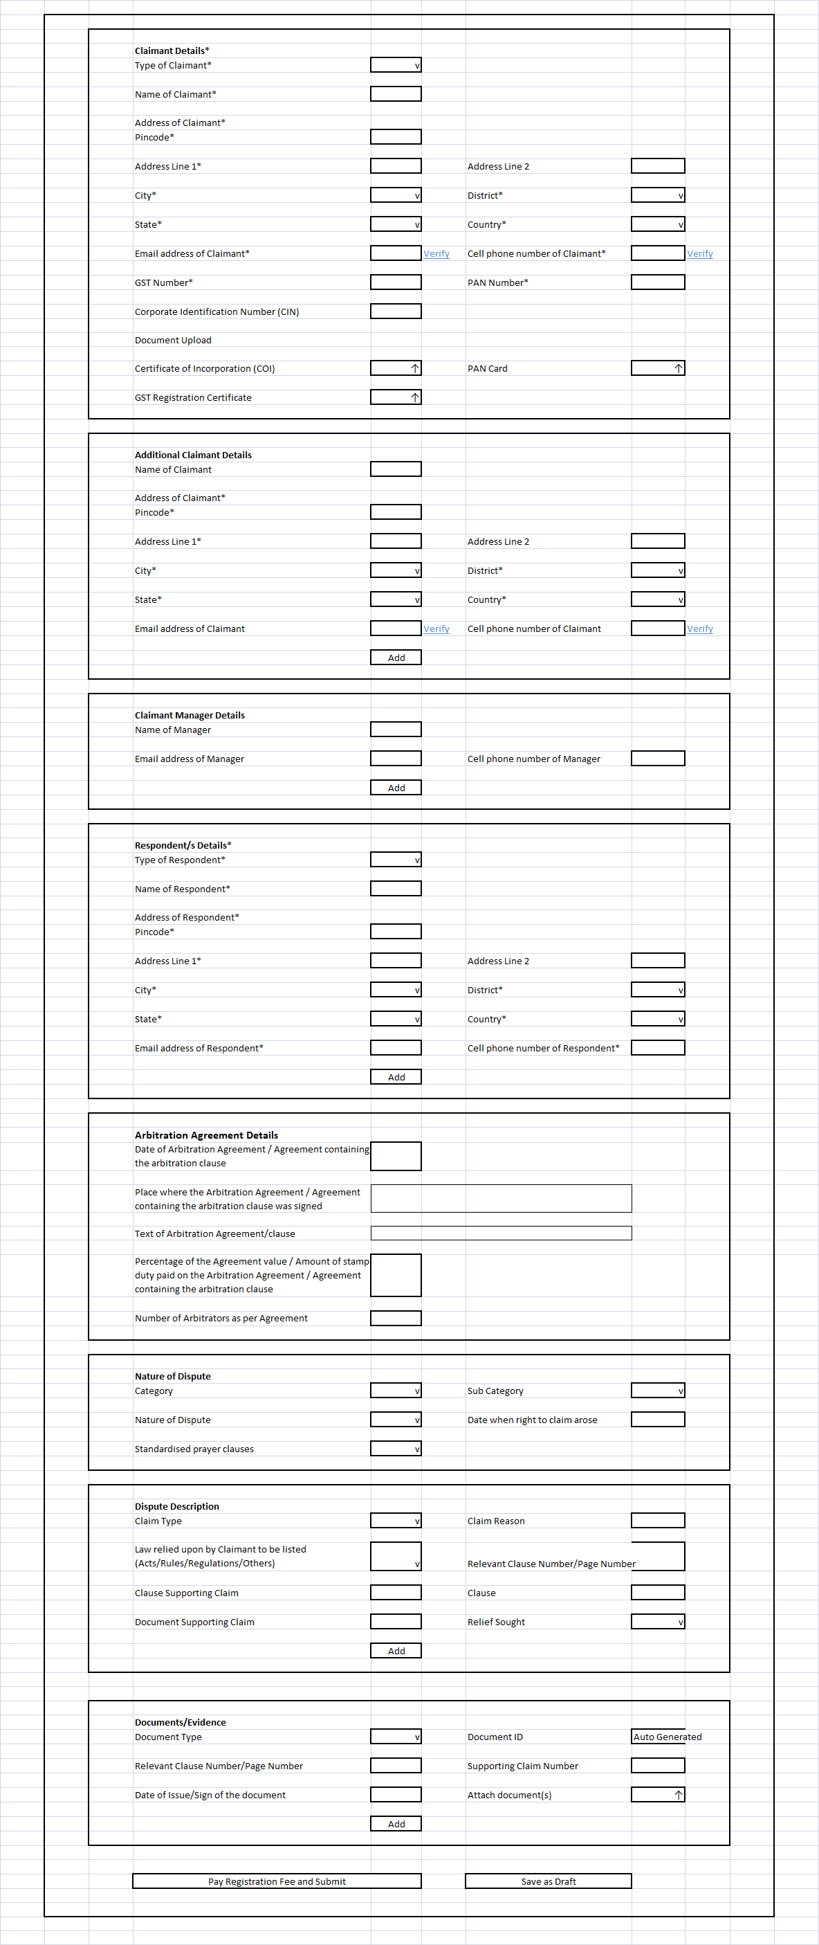
Based on category/sub-category and dispute type system will ask specific questions (checklist). List will be shared later on. User need to answer the questions, based on questions system will decide if arbitration can be filed.
Payment page will option to choose payment for advisory services or proceed with arbitration. Payment page will provide different payment heads for payment.
If claimant chooses Advisory services, AI system will suggest probable outcome and user can decide not to proceed with arbitration. If user wants to pursue arbitration he will again pay for arbitration charges and proceed further. On Submission after payment, an acknowledgement sent to main claimant and additional claimants, and notice to all defendants.
The copies should be stored in respective inboxes and e file of the same.

Letter format (To be shared later)
Agreement details
Signed on

At -----( place)

( taluka city /town/
Dist, state, )

Seat of arbitration as per agreement.

Agreement between
--------( name of party ) and -----( name of party ) Note : Default should be first claimant name and first defendant name. But give a button of change to change the same.

Arbitration Response by Respondent
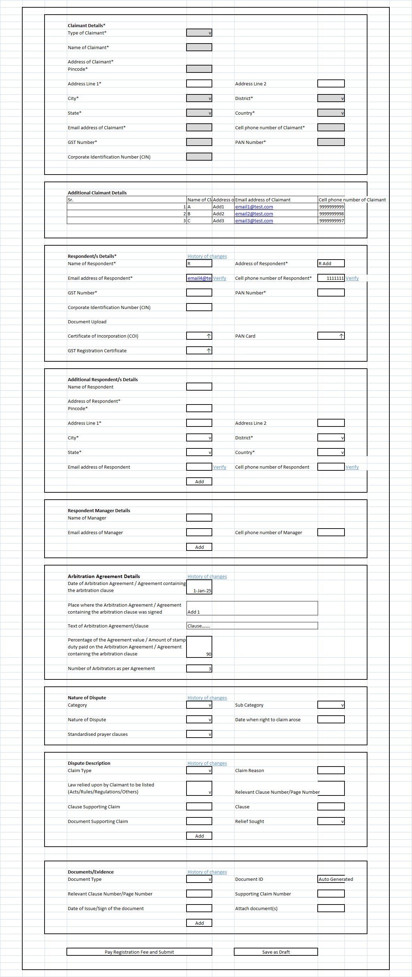
History of Arbitrator Acceptance by Claimant and Respondent needs to be maintained and displayed
Respondent can reply to notice through email reply, system will read the email and map it with the case. Respondent need to keep the same subject (having case id) while replying to email.
Three notices will be sent to respondent if respondent doesn’t respond to notice, after X days of third notice system will issue the order from the system and deliver to respondent.
Respondent has the option to register in the portal and he/she will be able to see all details entered by Claimant in read only mode and he can add the details of respective field. This updated details will be visible to Claimant in read only mode, this will be two times iterations
- Claimant add details,
- Respondent respond with details,
- Claimant again review respondent details and respond with details,
- Respondent review Claimant details and respond with details
History of updated details should be also visible to all parties.

Based on contractual obligation Claimant will select the Arbitrator, and email will be sent to Respondent to accept/reject or propose new arbitrator, he/she can also do the same through system. If Respondent doesn’t revert with arbitrator, reminder emails will be sent to respondent.
Claimant and Respondent also agrees to arbitration location in person or virtual.
Claimant and Respondent can propose/accept/reject arbitrator. Once arbitrator(s) are agreed, Arbitrator get the email notification and request will also go to arbitrator inbox, where he/she can accept/reject request.
Claimant propose Arbitrator
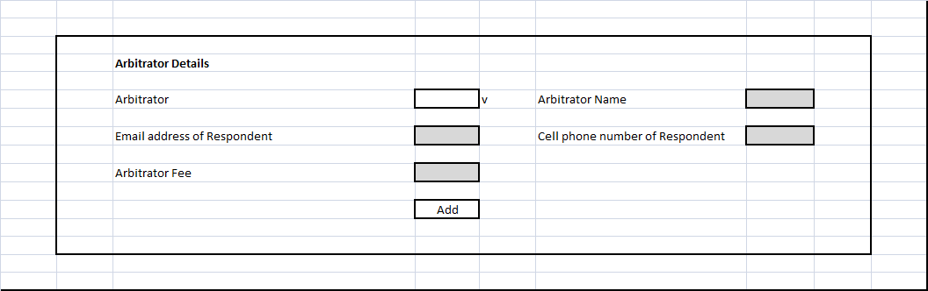

Respondent accept/propose Arbitrator

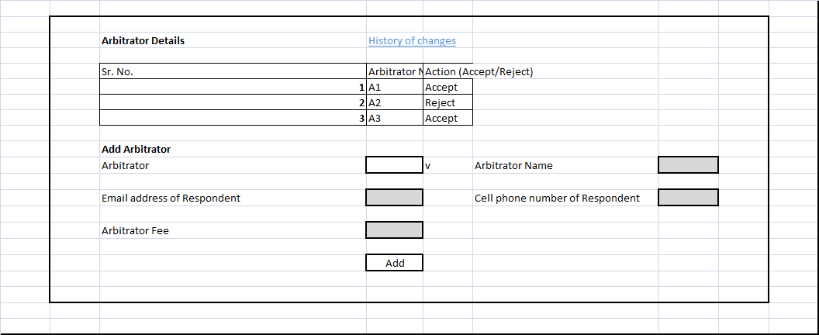
Arbitrator will have read only option for all information.
Track notices and reply to respective notices.
Manager details will be visible to respective party only
Arbitrator or case manager can schedule the hearing
Arbitrator can seek additional details from all parties and respective parties will respond

(a) The system will generate a password and share it with the parties to ensure privacy of the process.

(b) If the claim / counterclaim (if any), are admitted/not disputed in whole, then the system will throw up a result saying the dispute is resolved.

(c) If the claim/ counterclaim (if any), are admitted/not disputed in part, then the system can throw up a result saying the dispute is resolved in part, and Parties can identify the areas where the dispute continues in a list, to be confirmed by the parties.

(d) If the claim / counterclaim if any, are disputed without any part being admitted/not disputed, then the system can throw up the areas of dispute viz. the Issues in dispute between the parties, in a list, to be confirmed by the parties. If the parties have comments on the Issues, they can seek to resolve them mutually by an email exchange within a defined timeframe. If they are unable to resolve them, the Issues created by the program shall be applicable.

Evidence of the Claimant and Respondents (To be filed by Day 14):

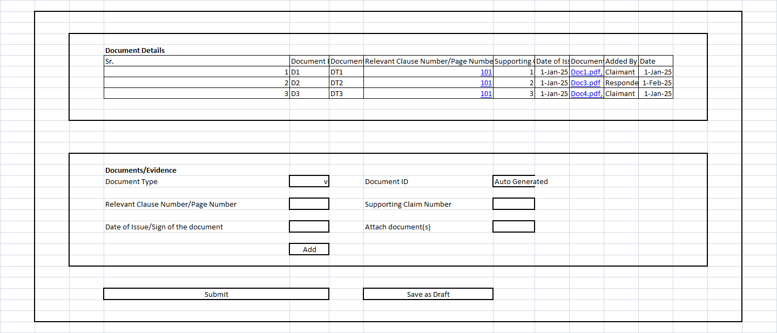

Sr. No. |  | Evidence | Scanned copies of documents [to be read by OCR]
 | Affidavit of Claimant/ Officer of Claimant | Sworn affidavit to be submitted containing particulars relevant to each Issue in the format:  Date Place Event  with a standardised verification clause | Documents proved by the affidavit to be submitted
 | Affidavits of witnesses for Claimant | Sworn affidavits to be submitted containing particulars relevant to each Issue in the format:  Date Place Event  with a standardised verification clause | Documents proved by each affidavit to be submitted
 | Certificate for electronic evidence tendered by Claimant | Signed certificate to be submitted with a tabulated list of electronic records relevant to each Issue | Documents proved by the certificate to be submitted
 | Law relied upon by Claimant to be listed | Acts  Rules/Regulations  Case citations mentioning relevant paragraph numbers  - as relevant to each Issue
 | Affidavit of Respondent/ Officer of Respondent | Sworn affidavit to be submitted containing particulars relevant to each Issue in the format:  Date Place Event  with a standardised verification clause | Documents proved by the affidavit to be submitted
 | Affidavits of witnesses for Respondent | Sworn affidavits to be submitted containing particulars relevant to each Issue in the format:  Date Place Event  with a standardised verification clause | Documents proved by each affidavit to be submitted
 | Certificate for electronic evidence tendered by Respondent | Signed certificate to be submitted with a tabulated list of electronic records relevant to each Issue | Documents proved by the certificate to be submitted
 | Law relied upon by Respondent to be listed | Acts  Rules/Regulations  Case citations mentioning relevant paragraph numbers  - relevant to each Issue

Arguments of the Claimant and Respondents

Arguments of the Claimant and Respondents not exceeding one A4 size page per Issue in font Times New Roman 12, which must include reference to (i) the paragraph in the affidavit of evidence, (ii) the document/s relied upon and (iii) the law relied upon, (To be filed by Day 30):

Rendering of award
The program will apply the law from statutes and judgements to the facts of the case presented by the parties and render its Award which will be emailed to the parties, and the successful party can affix stamp duty to the same.

[If parties wish, the Award can be endorsed as an Award by an advocate who peruses the documents and draft Award.]

Clarifications and Additional Information

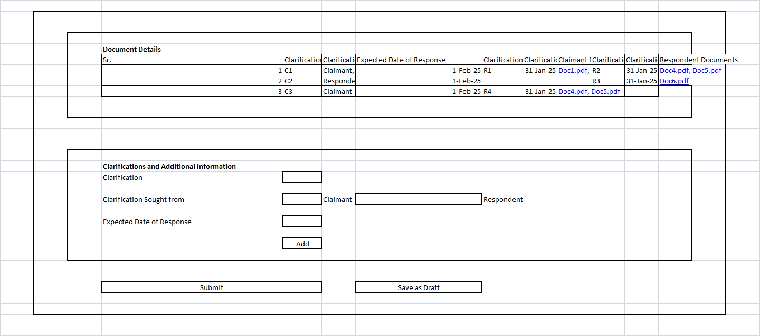

Arbitration Requests worklist by Claimant/Respondent/Arbitrator
All arbitration requests will be listed in individual stakeholder (Arbitration Requests by Claimant/Respondent/Arbitrator) and they will be able to act on specific request. It will have provision to search the requests, check current status and assign it to team members for further actions.

Sr.No. | Columns | Details
1 | Case ID | Unique Number of Case in format  ADDS/ARB/Year/Six Digit Running Number e.g. ADDS/ARB/2025/0000001
2 | Claimant | Name of Claimant
3 | Respondent | Name of Respondent
4 | Category | Category of Case, Refer LOVs
5 | Sub-Category | Sub-Category of Case, Refer LOVs
6 | Nature of Dispute | Nature of Dispute, Refer LOVs
7 | Arbitrator Name | Name of Arbitrator
8 | Arbitrator Assigned | Assigned, Not Assigned
9 | Case Status | Case Status, Refer LOVs
10 | Actions | Refer Actions in Workflow Stage & Actions
11 | Additional Columns in Worklist
12 | Location | Online/Physical
13 | Last Updated Date | Date when case was last updated
14 | Next Hearing Date | Next Scheduled Hearing Date

Workflow Stages and Actions
Sr. No. | Workflow Stage | Action | Roles to Perform Action
1 | Case Initiation | Submit arbitration request | Claimant
2 |  | Upload supporting documents | Claimant
3 |  | Prayers viz. reliefs | Claimant
4 |  | Add Arbitration Agreement Details | Claimant
5 |  | Respondent Comments against Arbitration Agreement Details | Respondent
6 |  | Review case submission | Admin, Case Manager
7 |  | Verify party details | Admin, Case Manager
8 |  | Assign Arbitrator | Claimant, Respondent, Admin, Case Manager
9 |  | Set timeline / due dates | Admin, Case Manager
10 | Arbitrator Assignment | Accept or reject case assignment | Arbitrator
11 |  | Request additional info | Arbitrator
12 |  | Reassign Arbitrator if rejected | Claimant, Respondent, Admin, Case Manager
13 | Hearing | Schedule/Reschedule hearing | Arbitrator, Case Manager
14 |  | Notify parties | System, Case Manager
15 |  | Submit evidence / responses /Counterclaims | Claimant, Respondent
16 |  | Upload case documents | Arbitrator, Parties
17 |  | Conduct hearing (virtual/in-person) | Arbitrator
18 |  | Submit statements / witness records | Claimant, Respondent
19 |  | Record hearing notes | Arbitrator
20 | Deliberation & Award | Draft arbitration award | Arbitrator
21 |  | Upload final decision document | Arbitrator
22 |  | Notify parties of decision | System
23 | Make Payment |  | Claimant, Respondent
24 | View/Download | Case Details | Arbitrator, Claimant, Respondent
25 |  | Case Summary | Arbitrator, Claimant, Respondent
26 |  | Facts | Arbitrator, Claimant, Respondent
27 |  | System recommended outcomes | Arbitrator, Claimant, Respondent
28 |  | Extracts from the agreement | Arbitrator, Claimant, Respondent
29 |  | Decision | Arbitrator, Claimant, Respondent
30 |  | Notices | Arbitrator, Claimant, Respondent
31 |  | Evidence/Counterclaim | Arbitrator, Claimant, Respondent
32 |  | Hearing Details | Arbitrator, Claimant, Respondent
33 |  | Invoices | Arbitrator, Claimant, Respondent
34 |  | Payment History | Arbitrator, Claimant, Respondent
35 |  | List of Arbitrator | Claimant, Respondent
36 |  | Arbitrator Score | Claimant, Respondent
37 | Assign to Team | Assign to Team | Claimant, Respondent
38 | Share (email or Whatsapp) | Share (email or Whatsapp) | Claimant, Respondent
39 | Save Arbitration Request | Save as Draft | Claimant, Respondent
40 | Withdraw Arbitration Request | Withdraw Arbitration Request | Claimant
41 | Case Closure | Mark case as resolved / closed | Arbitrator, Admin
42 |  | Archive case and documents | System, Admin
43 |  | Generate final summary/report | System, Case Manager
44 | Feedback | Submit rating or feedback | Claimant, Respondent
45 |  | Review feedback | Admin
46 | Arbitrator Availability/Calendar | Manage Arbitrator Availability/Calendar | Arbitrator/Admin

Case Status
Sr. No. | Case Status | Description
1 | Request Submitted | When Arbitrator request is submitted by Claimant
2 | Draft Arbitration Request | When Claimant saves Arbitration request as draft.
3 | Payment Pending for Claimant | When Claimant payment is pending
4 | Payment Pending for Respondent | When Claimant payment is pending
5 | Arbitrator Assigned | When Arbitrator assigned by Claimant/Respondent and accepted by all Parties
6 | Arbitrator Assignment Pending | When Arbitrator assignment is pending
7 | Arbitrator Acknowledgement | When Arbitrator accept the mediation
8 | Hearing Scheduled | When Hearing is Scheduled
9 | Hearing Re-Scheduled | When Hearing is Re-Scheduled
10 | Evidence Awaited | When Arbitrator ask for additional evidence and Claimant/Respondent need to Submit Evidence / Counterclaims
11 | Evidence Submitted | When Evidence submitted
12 | Counterclaims Submitted | When Counterclaims Submitted
13 | Notices to Parties | Notices to Parties
14 | Deliberate and draft award | Deliberate and draft award
15 | Final Decision | Final decision of Arbitration Request
16 | Resolved / Closed | Final Status of Case
17 | Appealed in Indian courts | When Claimant/Respondent appeal against Arbitration Judgment
18 | Withdraw Arbitration Request | When Claimant withdraw request
19 | Out of Court Settlement

Case Category and Nature of Dispute
Sr. No. | Category | Nature of Dispute | Applicable Law / Act | Jurisdiction | Complexity Level
1 | Commercial & Contractual | Breach of Contract
2 |  | Business Partnership Dispute
3 |  | Franchise Agreement Dispute
4 |  | Joint Venture Conflict
5 |  | Supplier/Vendor Dispute
6 |  | Payment or Invoice Dispute
7 |  | Sale of Goods Dispute
8 |  | Distribution Agreement Conflict
9 | Corporate & Shareholder | Shareholder Agreement Dispute
10 |  | Company Governance Issues
11 |  | Director Misconduct
12 |  | Minority Oppression Claim
13 |  | Valuation Dispute in Buyouts
14 | Employment | Unfair Dismissal
15 |  | Wage & Compensation Claims
16 |  | Workplace Harassment
17 |  | Non-Compete Clause Violation
18 |  | Employment Contract Breach
19 | Property & Real Estate | Lease Agreement Dispute
20 |  | Property Sale Agreement Dispute
21 |  | Boundary / Land Encroachment
22 |  | Construction Agreement Dispute
23 |  | Builder vs. Buyer Dispute
24 |  | Rent Recovery
25 | Intellectual Property | Trademark Infringement
26 |  | Copyright Violation
27 |  | Patent Dispute
28 |  | Trade Secret Breach
29 |  | Licensing Agreement Dispute
30 | Banking & Finance | Loan Default / Recovery
31 |  | Mortgage Dispute
32 |  | Guarantee Enforcement
33 |  | Investor vs. Fund Dispute
34 |  | Insurance Claim Dispute
35 | Consumer | Product or Service Deficiency
36 |  | Warranty Breach
37 |  | E-commerce Dispute
38 |  | Refund or Return Conflicts
39 | Technology & Data | Software Development Dispute
40 |  | SaaS/IT Service Agreement Breach
41 |  | Data Privacy or Security Dispute
42 |  | Technology Licensing Dispute
43 | Logistics & Transport | Freight Claim
44 |  | Shipping Delay Penalty Dispute
45 |  | Transportation Contract Conflict
46 |  | Loss/Damage of Goods in Transit
47 | Government & Regulatory | Public Procurement Dispute
48 |  | PPP (Public Private Partnership) Conflict
49 |  | License or Permit-related Conflict
50 |  | Regulatory Non-compliance
51 | Family & Personal | Divorce Settlement
52 |  | Alimony / Maintenance Dispute
53 |  | Property Division
54 |  | Guardianship Conflict
55 |  | Inheritance Dispute

Case Category and Sub-Category
Sr. No. | Category | Sub Category
1 | Price of goods sold and delivered refused to be paid | invoice raised and given to Respondent, and delivery challan/proof of delivery available
2 |  | invoice raised and given to Respondent, delivery challan/proof of delivery not available
3 |  | invoice not raised as dispute raised on price/ certification of invoice not done although required under the agreement
4 |  | invoice not raised as dispute on quantity and/or quality of goods delivered
5 | Price of goods refused to be paid although the goods were agreed to be sold, but delivery not taken | invoice raised and given to Respondent, and written intimation to take delivery available
6 |  | invoice raised and given to Respondent, and written intimation to take delivery challan/proof of delivery not available
7 |  | invoice not raised as dispute raised on price/ certification of invoice not done although required under the agreement
8 | Price of services rendered refused to be paid | invoice raised and given to Respondent, and document/s showing proof of services having been rendered available
9 |  | invoice raised and given to Respondent, and document/s showing proof of services having been rendered not available
10 |  | invoice not raised as dispute raised on price/ certification of invoice not done although required under the agreement
11 |  | invoice not raised as dispute on quantity and/or quality of services
12 | Dispute between partners/ shareholders regarding accounts of the partnership/ LLP/ company | Dispute between partners/ shareholders regarding accounts of the partnership/ LLP/ company
13 | Indemnity amount not paid/ reimbursement not made | Indemnity amount not paid/ reimbursement not made
14 | Others

Document Type

Sr. No. | Name | Description
1 | Contract
2 | Invoice
3 | Delivery Challen
4 | Photo
5 | eMail
6 | Letter
6 | MoM
7 | Material Corresspondence
8 | Proof of Payment of prescribed fee
9 | Affidavit of Claimant/ Officer of Claimant | Sworn affidavit to be submitted containing particulars relevant to each Issue in the format:  Date Place Event  with a standardised verification clause
10 | Affidavits of witnesses for Claimant | Sworn affidavits to be submitted containing particulars relevant to each Issue in the format:  Date Place Event  with a standardised verification clause
11 | Certificate for electronic evidence tendered by Claimant | Signed certificate to be submitted with a tabulated list of electronic records relevant to each Issue
13 | Affidavit of Respondent/ Officer of Respondent | Sworn affidavit to be submitted containing particulars relevant to each Issue in the format:  Date Place Event  with a standardised verification clause
14 | Affidavits of witnesses for Respondent | Sworn affidavits to be submitted containing particulars relevant to each Issue in the format:  Date Place Event  with a standardised verification clause
15 | Certificate for electronic evidence tendered by Respondent | Signed certificate to be submitted with a tabulated list of electronic records relevant to each Issue

Case Detail View

Sr. No. | Sections | Description
1 | Case Overview | Basic summary: Case ID, Title, Type, Status, Date Created, Last Updated
2 | Parties Involved | Name, contact info, roles (Claimant/Respondent), legal representatives
3 | Arbitrator(s) | Assigned arbitrator(s) with profile, status (Assigned/Pending/Withdrawn)
4 | Nature of Dispute | Category, Subcategory, Short Description, Amount Involved
5 | Arbitration Agreement Details | Arbitration Agreement Details
6 | Documents & Evidence | Upload/view/download supporting docs, contracts, statements, etc.
6 | Case Timeline | Chronological event log: submission, review, hearing, award, etc.
7 | Communication Log | Internal messages, notes, and party notifications
8 | Hearings | Hearing schedule, type (virtual/in-person), link, and outcome summary
9 | Awards / Decisions | Arbitrator’s award file(s), interim orders, date issued
10 | Status Tracker | Visual tracker or stepper showing current phase/Status
11 | Case Actions / Workflow Toolbar | Actions based on workflow Stage and Roles, Refer “Workflow Stages and Actions”
12 | Comments & Notes | Private notes by Individuals and visible to team members  Case Notes/Comments added by Arbitrator/Case Manager
13 | Activity Log | System-generated audit trail of who did what and when
14 | Related Cases | Display linked or precedent cases
15 | Feedback / Ratings | User feedback on experience or arbitrator

Common Functionality

Sr. No. | Functionalities Name | Roles Allowed to Perform Action | Details
1 | Login Functionalities | Claimant, Respondent, Arbitrator, Admin, Case Manager, Team Members | User Log in
2 | Forgot Password Functionalities | Claimant, Respondent, Arbitrator, Admin, Case Manager, Team Members | Forgot Password Functionalities
3 | Change Password | Claimant, Respondent, Arbitrator, Admin, Case Manager, Team Members | Change Password
4 | Logout | Claimant, Respondent, Arbitrator, Admin, Case Manager, Team Members | Logout
5 | Registration | Claimant, Respondent, Arbitrator | User Registration for Individuals, organizations/firms/companies - parties, advocates, consultants, arbitrators
6 | Registration Payment | Claimant, Respondent | Registration Payments by Users
7 | Hyperlinks | Claimant, Respondent, Arbitrator | To View details of Acts/Rules/Sections, Hearing Details, Arbitrator Details
8 | Inbox | Claimant, Respondent, Arbitrator | System mail communication with Claimant, Respondent, Arbitrators with Systems, and list all Notifications
9 | Recycle Bin | Claimant, Respondent, Arbitrator | Deleted communications
10 | Feedback & Rating | Claimant, Respondent | Feedback & Rating provided by Claimant, Respondent for Arbitrator
11 | Scoring Engine - Calculate Arbitrator Score | Claimant, Respondent | System calculates Arbitrator score based on Arbitrator previous cases, User feedback & Ranking, number of cases etc.
12 | Analytics – MIS | Claimant, Respondent, Arbitrator, Admin, Case Manager, Team Members | Various reports for respective stakeholders
13 | Help Desk | Claimant, Respondent, Arbitrator, Admin, Case Manager, Team Members | To manage support request raised by Claimant, Respondent, Arbitrator
14 | Manage User Profile | Claimant, Respondent, Arbitrator | To View/Update user profile
15 | Manage Subscription | Admin | Manage Arbitration Subscription packages
16 | Arbitrator Master | Admin | To Manage Arbitrator
17 | Landing Page (Dashboard After Login) |  | Case Worklist, Upcoming hearings, Messages or alerts

Portal Pages

Sr. No. | Static Page | Description
1 | Main Portal Landing Page | Overview of the System, Key Images and Important sections
2 | About Us | Overview of the organization and services offered
3 | Contact Us | Contact form, support email, phone number, address, and map
4 | FAQs | Common questions, on boarding guides, dispute resolution process, and technical help
5 | Subscription Page | Overview of all Subscription Packages and Features
6 | Arbitration Process Key Features | Static walkthrough of how arbitration works on the portal
7 | User Guidelines | Behavior expectations, communication rules, and platform usage norms  Info page for interested arbitrators, mediators, or partners
8 | Customer Testimonials | Endorsements from satisfied customers that showcase the positive experiences they've had with the system
9 | Feedback / Suggestions | Page or form for users to share ideas, rate experience, or report bugs
10 | Sitemap | A human-readable version of the site structure for easy navigation and SEO
11 | News/Blog | Articles, updates, case studies, legal insights, and announcements
12 | Terms & Conditions | Legal agreement outlining the rules for using the portal
13 | Privacy Policy | How user data is collected, stored, processed, and protected
14 | Cookie Policy | Notification and consent regarding the use of cookies on the site
15 | Disclaimer | Legal disclaimers about the nature of advice or content provided

Technology Considerations

The overall solution should address following architectural design principals

- Address the needs of ease of navigation.
- Accessible from multiple channels/OS/ device independent
- Customization / Value additions and training of the available free wares and open source will be the preferred route to choose the technology. Care needs to be taken that we do not create dependencies or lock-ins with any specific technology or product.
- Selection of appropriate technologies shall be guided by the ability and sufficiency to meet the requirements. The focus shall be on the quality of outcomes as benchmarked against the best and also in meeting the emerging expectations in India and in international market and feedback.
- Setting up of evaluating metrics, validations and testing, iterative refinement, quality assurance will be required to monitor quality, key word and semantic search, user interface design and feedback loop
- Design of consistent visual elements and architecture that is scalable and expandable.
- The solution architecture should be able to address the future scalability requirements, in terms of both application (to add new services) and infrastructure and backend (adding more users).
- The solution architecture should be highly available and in harmony with the existing backend systems.
- The solution should be Browser/platform independent and dynamic in nature.
- The solution architecture should be platform and vendor independent.
- The solution should facilitate centralized deployment of the application.
- The solution should be interoperable in nature and design and development should be based on Service Oriented Architecture (SOA)/Microservices.
- The solution should have the ability to scale up as and when the new business applications and services are added without compromising the performance of the overall solution. The architecture should be proven to be highly scalable and capable of delivering high performance as and when the transaction volumes increase.
- The system should be developed to be deployed in a n-tier datacentre Architecture.
- The Solution should be capable of delivering the services through intranet and internet both.
- Ability to provide a solution with database level, module and operating system which is Platform independent and can be deployed on most of the database.
- Ability to connect to other systems in the distributed environment.
- Ability to provide data as a web service to other applications.
- Standard Reports configuration.
- Ability to provide Multi-tired Architecture which can be installed on different servers for logical or functional load sharing.
- Mobile platform access – either application support the mobile platform or html 5 standard. All features should be accessible from mobile device as well
- All dropdowns should have Others value and on selection of Others Details (User enterable) should be captured.

API First Approach

- The Platform would be based on an Open API approach. The Platform would be accessible from multiple touch points like a web portal, mobile application and other interfaces.
- All components must be loosely coupled using open interfaces (APls) ensuring interoperability across components and subsystems. Also, in the future it is critical for third party applications to interoperate with the platform
- The API based architecture would enable consumption across technologies and platforms (mobile, tablets, desktops, etc.)
- This architecture would also be adaptable of changing business needs and end user requirements and expectations.
- Ability to provide API to build web-based applications and provide data to other applications
- Ability to provide APIs to update, search and create data from custom applications

Configuration Management

Ability to manage system changes by the system admin for
- User management
- Roles management
- Template configuration for SMS/Email
- LOVs configurations
- Business Rules configurations
- Fees/Discount configuration
- Invoice/Billing parameters configuration

Portal specification

- Portal should be web responsive in design so that it adapts to the size and resolution of the screen it is accessed on either desktop or mobile.
- Portal shall be developed in English but should be configurable to support other languages in future. This should be achieved through language configuration only.
- Search Engine Optimization (SEO) should be implemented so that portal content is searchable through any search engine and website come in top 3 searches.
- Web portal must be compatible and accessible with all major browsers and site must be compatible with Safari, Firefox, Chrome, Edge browsers.
- The website should be able to adapt to the size and resolution of the screen it is accessed on.
- Web site must not require plug-ins as a default.
- Site must be built in accordance to the Web Content Accessibility Guidelines 1.0, provided by the W3C and should also be easily accessible to the novice as well as the experienced Internet user.
- Fast Loading Pages – The web site must be designed with a balance of text and graphics such that each page loads in 4 seconds or less on the average computer.
- Supports standard views to provide access to data over a portal.
- The portal should provide search engines with advanced full text search capabilities.
- The portal should provide support for comprehensive audit trail.

Security specification

- Portal should be secure, and all security measures should be considered.
- Portal should be free from any OWASP top 10 vulnerabilities.
- Should encrypt the password / other sensitive data during data transmission
- Validations should be kept at frontend and server level to prevent any data modification by end user or hackers.
- Ability to provide role-based access.
- Ability to provide Role based views that provide data level access control based on predefined search criteria
- Supports Secure data formats and wire protocols like SSL
- The solution should enforce network level security, traffic to be encrypted using secured connectivity.
- The solution should employ a common user access and authentication service to ensure Single-Sign on for the end-user. Department will provide the single sign on facilities, if required.
- The solution should support multi-tier authentication wherever and whenever required.
- The solution should have a capability to assign activities to roles, and map roles to users.
- The solution should restrict users from unauthorized access by allowing only the authorized users with valid profile/password to access only the allowed transaction
- The framework should support plugging in of other authentication methods in the future.
- The system should ensure high standards of security and access control.
- The portal should not allow concurrent sessions for same user.
- Login guesstimate should be addressed during implementation
- Email flooding should be addressed during implementation

Appendix 1 : Sample Arbitration questions to be addressed by the system

Sr. No. | Questions
1 | What is the limitation period for filing an application under section 11 of the arbitration and conciliation act 1996 in India?
2 | Does the court and arbitration tribunal have concurrent jurisdiction under section 9 and section 17 of the arbitration and conciliation act 1996 in India?
3 | Can an anti-suit injunction be granted restraining an arbitral tribunal from proceeding with an arbitration in India?
4 | In which court should an application to execute a foreign arbitral award be filed in India?
5 | What duty do arbitrators have to disclose their relationship with the parties and advocates involved in the arbitration in India?
6 | Do courts award exemplary damages in India?
7 | How do courts interpret clauses in contracts providing for liquidated damages in India?
8 | Are liquidated damages the same as a penalty in India?
9 | What is the effect under Indian law of a party not giving his own evidence in a suit?
10 | What is the period of limitation for filing a suit to avoid a contract brought about by fraud in India?
11 | In India, Is the “seat” of arbitration the same as “place” or “venue” of arbitration?
12 | In India, can a court or arbitrator act upon an arbitration agreement which is not properly stamped?
13 | In India, can an arbitrator decide an issue of limitation?
14 | Can an Indian court reassess the evidence if an arbitrator commits an error?
15 | Can an Indian court examine the reasonableness of reasons given in an award by an arbitrator?
16 | In India, can an arbitrator ignore the principles of natural justice?
17 | In India, what are the principles of public policy that apply to an arbitral award?
18 | In India, can an arbitral tribunal join a third party who is not a party to the arbitration agreement as a respondent in the arbitration?
19 | In India, can an unproved document be considered by an arbitrator in deciding the conclusion in an award, or will that be violative of principles of natural justice and hence, make the award liable to be set aside?
20 | How is the word “proof’ to be understood under the law of evidence in India?
21 | What is the definition of a “prudent man” under the law of evidence in India?
22 | What is the definition of a “reasonable man” under the law of evidence in India?
23 | When should a court draw an inference of the existence of a fact under the law of evidence in India?
24 | Is circumstantial evidence the same as inferential or presumptive evidence under the law of evidence in India?
25 | How have Indian courts drawn a distinction between witnesses who are (i) wholly reliable; (ii) wholly unreliable, and; (iii) neither wholly reliable nor wholly unreliable?
26 | In India, what is the value of the testimony of a sole witness who is also an interested witness?
27 | In India, can a registered gift be revoked in law?
28 | In India, how will a court or arbitral tribunal interpret conflicting clauses in a trust deed?
29 | In India, how will a court or arbitral tribunal interpret conflicting clauses in a contract?
30 | In India, what is the law on an arbitrator awarding interest on a contractual claim?
31 | In India, what is the law on an arbitrator awarding interest on a claim in damages?
32 | In India, is an arbitration maintainable when either party has made serious allegations of fraud against the other?
33 | In India, can an arbitrator lift the corporate veil in case of a group of companies?
34 | In India, what is the group of companies doctrine in arbitration?
35 | In India, can an interim order passed by an arbitral tribunal be challenged in a court?
36 | What is the procedure in India for execution of a foreign award?
37 | Can a court in India executing an arbitration award attach properties of the respondent which are situated outside India?
38 | In India, can an arbitrator decide whether a guarantor to a loan agreement can be made a party to the arbitration?
39 | In India, can there be a single arbitration despite there being multiple agreements each containing an arbitration clause?
40 | In India, does an arbitrator cease to have powers as an arbitrator after issuing a final award?
41 | In India, what happens if one of three arbitrators dies in the midst of the arbitration?
42 | In India, Can a final arbitral award be set aside by a court and the dispute sent back to the arbitral tribunal to re-hear the matter?
43 | In India, do the principles of res judicata apply to an arbitration award?
44 | In India, can a court try a suit arising from a contract which does not provide for the disputes clause being subject to the arbitration clause?
45 | In India, in case the contract contains a vague reference to arbitration, will the parties have to be referred to arbitration?
46 | In India, can an arbitral tribunal order the winding up of a company?
47 | In India, how can a party prove bias against an arbitrator?
48 | In India, is it better to go to arbitration or to the commercial court when a dispute arises under a contract?
49 | In India, what happens if an arbitration is not completed in 18 months and the court does not grant an extension of time?
50 | In India, if an arbitration claim is rejected by the arbitrator, under section 34 of the arbitration act can a court allow the claim?
51 | In India, can a court increase or decrease costs awarded by an arbitrator?
52 | In India, Which laws apply to an arbitration?

