/\***author:#Tejas1106#**

**date: Jan 15,2016**\*/

//Program for addition of two 4-bit numbers

#include<stdio.h>

#include<conio.h>

#include<string.h>

void addition(char x,char y,char z,int i);

char c[6]; //result array......take required_size+1 for null

void main()

{

char a[5],b[5]; //array for two 4-bit numbers

int i;

clrscr();

printf("Enter first 4-bit number : ");

gets(a); //input first number

printf("Enter second 4-bit number : ");

gets(b); //input second number

for(i=0;i<5;i++) //initialize result array

{

c[i]='0';

}

c[i]='\0';

//Loop for Logic addition of 4-bit numbers

for(i=3;i>=0;i--)

{

addition(a[i],b[i],c[i+1],i+1);

}

printf("\n4-bit addition : ");

puts(c); //result addition

printf("where Sum : %s",c+1);

printf(" & Final Carry: %c",c[0]);

getch();

}

void addition(char x,char y,char z,int i) //Logic for addition

{

c[i-1]=(x+y+z-3*'0')/2+'0'; //manual char to int to char conversion

c[i]=(x+y+z-3*'0')%2+'0';

}

/*OUTPUT :

1.

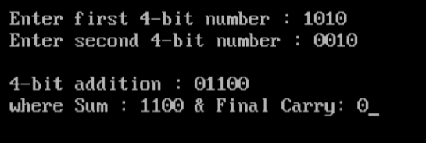

2.

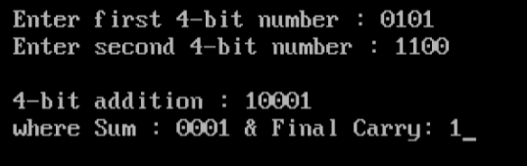

*/

/\***author:#Tejas1106#**

**date: Jan 15,2016**\*/

//Program for subtraction of 4 bit numbers using 2’s complement

#include<stdio.h>

#include<conio.h>

#include<string.h>

#include<stdlib.h>

void one_s_complement(char t[]);

void add_one(char t[]);

void addition(char x,char y,char z,int i);

char c[6]; //result array....required_array size+1 for null

void main()

{

char a[5],b[5]; //arrays for two 4-bit numbers

int i;

clrscr();

printf("Enter first 4-bit number : ");

gets(a); //input first number

printf("Enter second 4-bit number : ");

gets(b); //input second number

for(i=0;i<5;i++) //initialize result array

{

c[i]='0';

}

c[i]=’\0’;

//One's complement of second number

one_s_complement(b);

printf("\nOne's complement of second number : ");

puts(b);

//Two's complement of second number

add_one(b);

printf("Two's complement of second number : ");

puts(b);

//Loop for Logic Addtion

for(i=3;i>=0;i--)

{

addition(a[i],b[i],c[i+1],i+1);

}

//carry condition check

printf("\n4-bit subtraction : ");

if(c[0]=='1')

{

puts(c+1);

}

else

{

strcpy(c,c+1);

one_s_complement(c);

add_one(c);

printf("-");

puts(c);

}

getch();

}

void one_s_complement(char t[]) //function for one_s_complement

{

int i;

for(i=0;i<strlen(t);i++)

{

if(t[i]=='0')

t[i]='1';

else

t[i]='0';

}

}

void add_one(char t[]) //function to add one

{

int i=3,temp,temp1=0,m=1;

do

{

temp=t[i];

t[i]=(temp+m+temp1)%2+'0';

temp1=(temp+m+temp1)/2+'0';

m=0;

i--;

}while(i>=0);

}

void addition(char x,char y,char z,int i) //Logic for Addition

{

c[i-1]=(x+y+z-3*'0')/2+'0'; //manual char to int to char conversion

c[i]=(x+y+z-3*'0')%2+'0';

}

/*OUTPUT:

1.

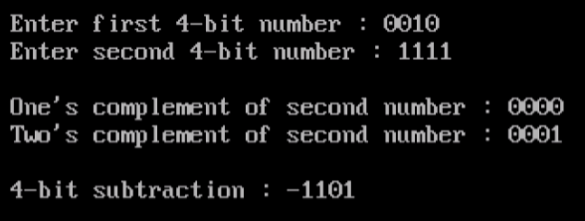

2.



