Student Name: Tejas Bhatt UID: 24BAI70851
Branch: AIT-CSE (AIML) Section/Group: 24AIT_KRG-1A
Semester: 5
Subject Name: Database Management System Subject Code: 24CSH-298

Q1) A website maintains records of users who have registered on the platform and the status of confirmation requests sent to them. A confirmation request can either be successfully completed or may expire without completion.
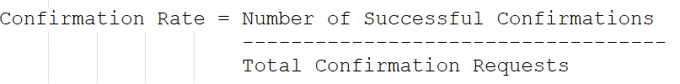
For each registered user, calculate the confirmation rate, which is defined as:
If a user has never received any confirmation request, their confirmation rate should be considered 0.
Display the user ID along with the confirmation rate rounded to 2 decimal places. The result can be returned in any order.

SOFTWARE REQUIREMENTS:
Database Management System:
Oracle Database Express Edition (Oracle XE)
PostgreSQL Database
Database Administration Tool / Client Tool:
Oracle SQL Developer (for Oracle XE)
pgAdmin (for PostgreSQL)

CODE SCREENSHOTS:

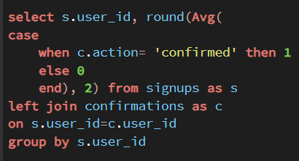

OUTPUT SCREENSHOTS:
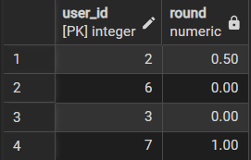

LEARNING OUTCOMES:
After completing this experiment, I was able to:
- Understand how to calculate a confirmation rate for each registered user.
- Calculate the number of successful confirmations based on confirmation status.
- Determine the total number of confirmation requests for each user.
- Handle users with no confirmation requests by assigning a confirmation rate of 0.
- Use SQL aggregation functions such as COUNT() and conditional counting.
CONCLUSION:
In conclusion, calculating the confirmation rate provides a clear measure of how successfully users complete their confirmation requests. By comparing successful confirmations with the total number of requests and handling users with no requests appropriately, we can accurately determine each user’s confirmation rate. Rounding the result to two decimal places ensures a clear and consistent presentation of the data.

Q2) A ride-booking company maintains information about trip requests and the users involved in those trips. Some users may be restricted from using the platform, while others are active participants. Each trip can either be completed successfully or cancelled by one of the participants.
For each day between 2013-10-01 and 2013-10-03, determine the proportion of canceled trips among all valid trips. A trip should be considered valid only when both the customer and the driver associated with that trip are active users. The final result should display the date and the calculated cancellation rate rounded to two decimal places.
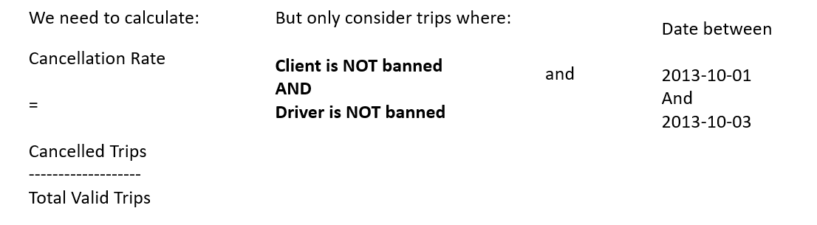

SOFTWARE REQUIREMENTS:
Database Management System:
Oracle Database Express Edition (Oracle XE)
PostgreSQL Database
Database Administration Tool / Client Tool:
Oracle SQL Developer (for Oracle XE)
pgAdmin (for PostgreSQL)

CODE SCREENSHOTS:
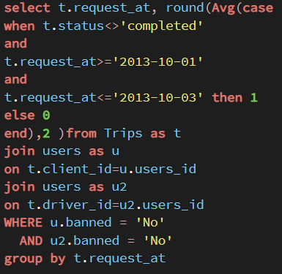

OUTPUT SCREENSHOTS:
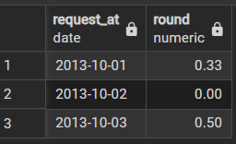

LEARNING OUTCOMES:
After completing this experiment, I was able to:
- Understand how to calculate the daily cancellation rate for trips.
- Identify valid trips by checking whether both the client and driver are not banned.
- Apply date-based filtering to analyze trips within a specific time period.
- Use conditional counting to determine the number of cancelled and total valid trips.
- Round the calculated cancellation rate to two decimal places for clear presentation.

CONCLUSION:
In conclusion, this task demonstrates how to calculate the daily cancellation rate by considering only valid trips where both the client and driver are active users. By comparing cancelled trips with the total number of valid trips for each date and rounding the result to two decimal places, we can accurately measure the cancellation rate over the given period.

