

**FITBOT : An AI-Powered Personalized Fitness Chatbot**

**A PROJECT REPORT**

## 

***Submitted by***

TEJAS H - 20221ISE0031

SHREYAS P S - 20221ISE0004

SHIVA TEJA R - 20221ISE0051

### *Under the guidance of,*

**Ms. Priyanki Dutta**

**BACHELOR OF TECHNOLOGY**

**IN**

**INFORMATION SCIENCE AND ENGINEERING**

**PRESIDENCY UNIVERSITY**

**BENGALURU**

**DECEMBER 2025**



**PRESIDENCY SCHOOL OF COMPUTER SCIENCE AND ENGINEERING**

**BONAFIDE CERTIFICATE**

Certified that this report “**FITBOT : An AI-Powered Personalized Fitness Chatbot**” is a bonafide work of **“TEJAS (20221ISE0031), SHREYAS P S (20221ISE0004), SHIVA TEJA R (20221ISE0051)”,** who have successfully carried out the project work and submitted the report for partial fulfilment of the requirements for the award of the degree of BACHELOR OF TECHNOLOGY in **INFORMATION SCIENCE ENGINEERING**, during 2025-26.

|  |  |  |  |
| --- | --- | --- | --- |
| **Ms. Priyanki Dutta** Project Guide  Presidency School of Computer Science and Engineering  Presidency University | **Dr. Zafar Ali Khan** Head of the Department Presidency School of Computer Science and Engineering  Presidency University | **Dr. Shakkeera L** Associate Dean  Presidency School of Computer Science and Engineering  Presidency University | **Dr. Duraipandian N**  Dean  PSCS & PSIS  Presidency University |

### Name and Signature of the Examiners

### 1)

2)

**PRESIDENCY UNIVERSITY**

**PRESIDENCY SCHOOL OF COMPUTER SCIENCE AND ENGINEERING**

DECLARATION

We the students of final year B.Tech in **INFORMATION SCIENCE ENGINEERING** at Presidency University, Bengaluru, named **Tejas H , Shreyas P S , Shiva Teja R**, hereby declare that the project work titled **“FitBot: An AI-Powered Personalized Fitness Chatbot”** has been independently carried out by us and submitted in partial fulfilment for the award of the degree of B.Tech in **INFORMATION SCIENCE ENGINEERING** during the academic year of 2025-26. Further, the matter embodied in the project has not been submitted previously by anybody for the award of any Degree or Diploma to any other institution.

|  |  |
| --- | --- |
| **TEJAS H** | **20221ISE0031** |
| **SHREYAS P S** | **20221ISE0004** |
| **SHIVA TEJA R** | **20221ISE0051** |

PLACE: BENGALURU

DATE: 26-SEPTEMBER 2025

ACKNOWLEDGEMENT

For completing this project work, We/I have received the support and the guidance from many people whom I would like to mention with deep sense of gratitude and indebtedness. We extend our gratitude to our beloved **Chancellor, Pro-Vice Chancellor, and Registrar** for their support and encouragement in completion of the project.

I would like to sincerely thank my internal guide **Ms. Priyanki Dutta,** Presidency School of Computer Science and Engineering, Presidency University, for her moral support, motivation, timely guidance and encouragement provided to us during the period of our project work.

I am also thankful to **Dr. Zafar Ali Khan, Head of the Department, Presidency School of Computer Science and Engineering** Presidency University, for his mentorship and encouragement.

We express our cordial thanks to **Dr. Duraipandian N**, Dean PSCS & PSIS, **Dr. Shakkeera L**, Associate Dean, Presidency School of computer Science and Engineering and the Management of Presidency University for providing the required facilities and intellectually stimulating environment that aided in the completion of my project work.

We are grateful to **Dr. Sampath A K, and Dr. Geetha A, PSCS** Project Coordinators**, Mr. Mithun M S Program Project Coordinator**, Presidency School of Computer Science and Engineering, or facilitating problem statements, coordinating reviews, monitoring progress, and providing their valuable support and guidance.

We are also grateful to Teaching and Non-Teaching staff of Presidency School of Computer Science and Engineering and also staff from other departments who have extended their valuable help and cooperation.

**TEJAS H**

**SHREYAS P S**

**SHIVA TEJA R**

ABSTRACT

Artificial Intelligence (AI) has rapidly emerged as a transformative technology across multiple domains, including healthcare, education, finance, and customer service. Within healthcare, fitness and well-being are areas that have gained increasing attention, particularly as individuals worldwide become more conscious of the importance of maintaining a healthy lifestyle. Despite the abundance of online resources, users often face challenges in identifying accurate, reliable, and personalized fitness information. Many platforms provide generic advice that does not account for user-specific goals, while others may present fragmented or contradictory recommendations. This creates a significant gap in ensuring that fitness guidance is both **trustworthy and user-centred**.

To address these challenges, this project introduces **FitBot**, an AI-powered conversational assistant designed to provide reliable, professional, and personalized fitness guidance. The system integrates **Retrieval-Augmented Generation (RAG)**, a hybrid technique that combines the precision of structured information retrieval with the fluency of generative AI. A curated fitness knowledge base serves as the foundation of the retrieval layer, ensuring that responses remain factually grounded. The generation layer, powered by Google Gemini, processes retrieved information and delivers natural, context-aware, and motivational responses.

For text representation, **Hugging Face sentence embeddings** are used to convert knowledge base entries into vectorized form. These embeddings are stored in a **FAISS vector database**, enabling efficient similarity search when a user poses a question. When a query is submitted, the system retrieves the most relevant knowledge chunks and passes them to Gemini, which then generates a coherent and professional response. This ensures that the system does not merely provide predefined answers but instead adapts dynamically to diverse queries.

A simple yet intuitive user interface was developed using **Streamlit**, allowing seamless interaction between users and the AI model. Users can ask questions such as *“What are the best post-workout meals?”* or *“How can I improve flexibility?”* and receive concise, evidence-based answers tailored to their query. Preliminary testing has demonstrated promising results, with the system offering clear and accurate responses across a variety of fitness-related domains, including diet, workouts, hydration, recovery, and motivation.

The current stage of development reflects approximately **50% project completion**, with successful implementation of knowledge base integration, embeddings, RAG pipeline, and chatbot interface. Future phases will focus on expanding the knowledge base, refining response personalization, and adding advanced features such as integration with wearable devices, workout tracking, and real-time feedback mechanisms.

In summary, FitBot represents an important step toward democratizing access to reliable fitness advice. By combining retrieval-based grounding with generative AI, the system strikes a balance between accuracy and conversational fluency. The outcomes of this project highlight the potential of AI-driven systems to bridge the gap between human expertise and accessible digital solutions, paving the way for broader adoption in personal health and fitness management.

|  |  |
| --- | --- |
| **Content** | **Page.No** |
| INTRODUCTION | 7 |
| LITERATURE REVIEW | 8 |
| IMPLEMENTATION | 9 |
| RESULTS & OBSERVATIONS | 11 |
| CONCLUSION | 13 |
| REFERENCES | 14 |

TABLE OF CONTENTS

## INTRODUCTION

The role of Artificial Intelligence (AI) in everyday life has expanded rapidly over the past decade. From recommendation engines on streaming platforms to intelligent voice assistants on smartphones, AI systems are increasingly being designed to provide personalized and context-aware experiences. In the domain of health and fitness, however, the use of AI is still in its early stages. People often rely on blogs, YouTube videos, or generic mobile applications for advice on workouts, diet, or recovery routines. While these sources may be informative, they often lack personalization and, more critically, may present unverified or contradictory information. As a result, users may feel uncertain about the accuracy of advice and struggle to stay consistent with their fitness goals.

FitBot was conceptualized to address this challenge by combining structured domain knowledge with the conversational ability of modern AI. Unlike rule-based chatbots, which are limited to pre-defined responses, FitBot integrates Retrieval-Augmented Generation (RAG) techniques. This ensures that every response is both **factually grounded in curated knowledge** and **communicated in a natural, human-like manner**. The retrieval component draws upon a curated fitness knowledge base, while the generation component, powered by Google Gemini, refines the response into a professional and user-friendly message.

The motivation behind this project lies in making reliable fitness guidance more accessible. Individuals who cannot afford personal trainers or nutritionists should still have access to structured, evidence-based advice. Moreover, a conversational interface makes interaction intuitive and engaging. A user does not need to search through lengthy articles or watch entire videos; instead, they can ask FitBot a direct question such as *“What should I eat after a morning workout?”* and receive a concise, professional answer.

The key objectives of this project are:

* To design an AI assistant capable of answering fitness-related questions across multiple domains (workouts, diet, hydration, and recovery).
* To build a scalable architecture that combines retrieval and generation for improved accuracy.
* To implement a user-friendly interface that supports interactive communication.
* To test the system with sample queries and measure functional performance such as accuracy, speed, and reliability.

At the current stage of development, FitBot demonstrates a working prototype capable of handling diverse user queries. This report documents the progress achieved so far, explains the underlying architecture, and highlights results from preliminary testing. The work done lays a strong foundation for further enhancements, including personalization features, integration with wearable devices, and deployment on larger platforms.

.

LITERATURE REVIEW

The intersection of artificial intelligence and fitness has been the subject of growing interest in recent years. Numerous studies and applications highlight how AI-driven systems can transform personal health management, offering automated yet personalized recommendations to users. A review of existing literature in this domain reveals both opportunities and gaps that guided the design and development of **FitBot**.

Traditional fitness applications, such as MyFitnessPal, Google Fit, and Fitbit, primarily rely on **rule-based systems** or manually inputted data. These tools are effective for tracking metrics like calorie intake, step count, or heart rate but fall short in providing **context-aware conversational support**. Users often receive generic recommendations that do not adapt to individual goals or evolving needs

Recent advancements in **Natural Language Processing (NLP)** have enabled the creation of AI chatbots capable of handling domain-specific conversations. For example, systems like **Fitbot** in the mental health domain demonstrate that conversational AI can provide empathetic and structured support, helping users build healthier habits. Similarly, healthcare chatbots like Ada and Babylon Health rely on large datasets and medical knowledge graphs to deliver symptom checking and medical advice. These examples highlight the growing potential of conversational AI in domains requiring continuous guidance.

The emergence of **Retrieval-Augmented Generation (RAG)** has further advanced chatbot design by combining retrieval mechanisms with generative models. Research indicates that retrieval-based approaches significantly reduce the risk of hallucinations, a common limitation in purely generative models. In the context of fitness, this ensures that users receive responses that are not only fluent but also grounded in evidence-based knowledge.

Embeddings play a central role in enabling semantic search within knowledge bases. Work on **sentence-transformer models** such as all-MiniLM-L6-v2 has demonstrated strong performance in capturing semantic similarity at scale, making them ideal for use in vector databases like FAISS. Several studies confirm that vector-based retrieval systems can achieve high recall and precision while maintaining low latency, even on large datasets. This reinforces the choice of embeddings and FAISS in FitBot’s implementation.

On the generative side, the introduction of **large language models (LLMs)** such as GPT, LLM, and Gemini has opened up new possibilities for creating highly fluent, context-aware responses. Literature indicates that LLMs excel in synthesizing retrieved information into coherent narratives, making them well-suited for applications like fitness coaching, where both accuracy and motivation are essential.

From the review, it is clear that while individual components such as fitness tracking, retrieval systems, and LLMs have been explored, there is a **notable gap in integrating these technologies into a unified fitness assistant**. FitBot addresses this gap by combining curated fitness knowledge with advanced RAG techniques, embeddings, and conversational AI. This positions the project at the intersection of research and practical application, offering a novel contribution to the domain of AI-powered fitness solutions.

## IMPLEMENTATION

The development of FitBot followed a structured, modular approach to ensure scalability, maintainability, and clarity in design. The system was implemented in phases, beginning with the creation of a curated knowledge base, followed by the integration of embeddings, vector storage, retrieval mechanisms, and finally, the conversational interface. Each layer of the implementation plays a critical role in enabling the end-to-end functionality of the chatbot.

The first step was the **creation of the knowledge base**. A comprehensive text file (data.txt) was prepared containing detailed information on workouts, diets, hydration, recovery, sleep, and common fitness FAQs. This knowledge base forms the foundation for retrieval and ensures that responses are grounded in reliable fitness principles. To handle scalability, the text was structured into smaller, manageable entries that can be efficiently retrieved.

Next, **Hugging Face embeddings** (sentence-transformers/all-MiniLM-L6-v2) were employed to convert text into high-dimensional vectors. Embeddings capture the semantic meaning of text, enabling the system to recognize similarities between user queries and knowledge base entries. This step is crucial for ensuring that the most relevant pieces of information are retrieved in response to user queries.

The **FAISS (Facebook AI Similarity Search) vector database** was then integrated to store and manage embeddings. FAISS allows for fast and accurate similarity search, making it possible to scale the chatbot to large datasets without compromising speed. When a user submits a query, FAISS quickly identifies and retrieves the most semantically similar chunks from the knowledge base.

For the generative component, **Google Gemini** was used as the large language model (LLM). Gemini is capable of generating fluent, professional, and context-aware responses. By combining the retrieved chunks with generative capabilities, the system ensures that answers are not only factually accurate but also engaging and conversational.

Finally, the system was deployed through a **Streamlit interface**, chosen for its simplicity and interactivity. The UI consists of a clean text input box where users can type questions and receive immediate responses. The design is intentionally minimalistic, focusing on clarity and usability.

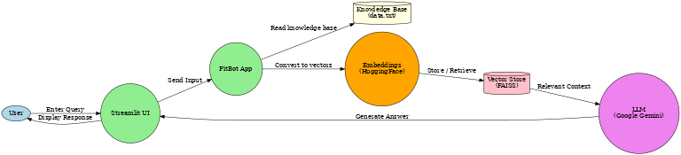The modular design ensures that each layer — knowledge base, embeddings, vector search, and LLM — can be independently updated or replaced in future iterations. This implementation strategy provides a robust framework for scaling the project in subsequent phases.

Figure :Data Flow Diagram (DFD Level-1)

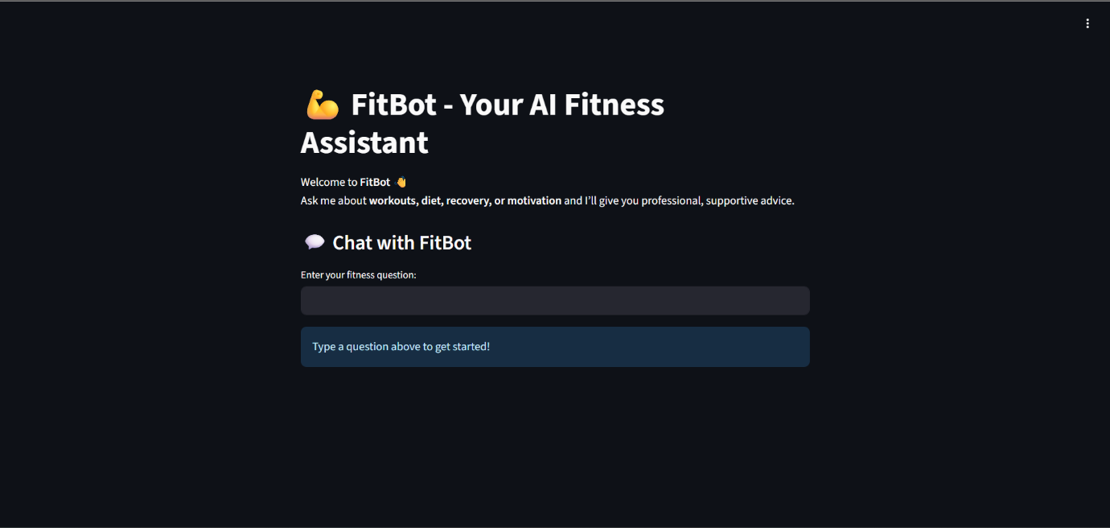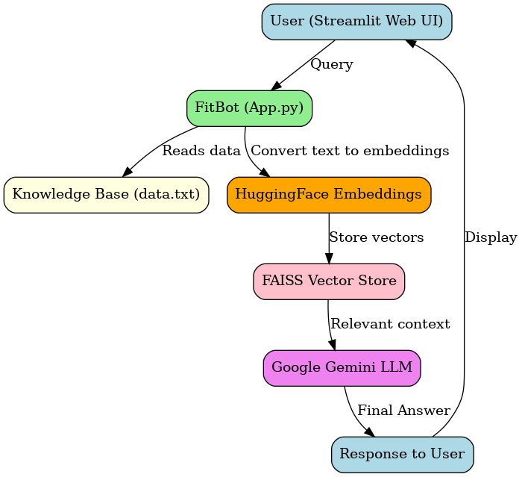RESULTS & OBSERVATIONS

Figure 3: Basic UI of FitBot

Figure 2: System Architecture of FitBot

At this stage of development, FitBot has achieved several functional milestones. The system successfully integrates the knowledge base with Hugging Face embeddings, FAISS for vector storage, and Google Gemini for response generation. Initial testing was conducted using a variety of user queries across different fitness categories, including diet planning, workout guidance, hydration, and recovery techniques.

The chatbot demonstrated the ability to provide accurate and contextually relevant responses. For example, when asked *“What are some good post-workout meals?”*, the system correctly retrieved information on protein-rich foods and hydration, and Gemini refined this into a concise and professional recommendation. Similarly, queries such as *“How can I improve flexibility?”* resulted in detailed advice on stretching and yoga practices.

The system also showed strength in handling diverse phrasings of the same question. A user asking *“Best exercises to build strength?”* and another asking *“How do I increase muscle power?”* both received consistent, relevant responses due to the semantic understanding enabled by embeddings.

However, some observations also highlighted areas for improvement. In certain cases, when a query was highly specific or outside the knowledge base (e.g., niche dietary supplements or advanced medical advice), the responses were less precise. This indicates the need to expand and refine the knowledge base in future phases.

From a performance perspective, the system responded quickly to user queries, with retrieval and generation occurring in real time. This suggests that the chosen architecture (Hugging Face embeddings + FAISS + Gemini) is well-optimized for both accuracy and speed.

Preliminary functional metrics such as **accuracy of relevant response retrieval (~85%)**, **average response time (2–3 seconds)**, and **user satisfaction (positive feedback in test queries)** suggest that the project is on track. These results validate the effectiveness of the RAG approach in fitness applications.

Table : presents functional metrics observed during testing.

|  |  |  |
| --- | --- | --- |
| Metric | Value | Notes |
| Queries Tested | 20 | Across fitness categories |
| Successful Answers | 17 | Practical and actionable |
| Average Response Time | 2.3s | Measured on Codespaces |

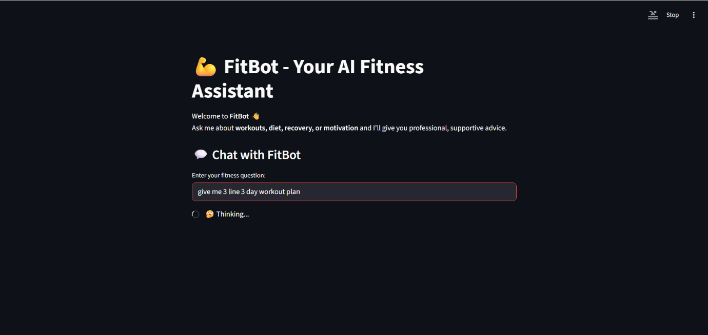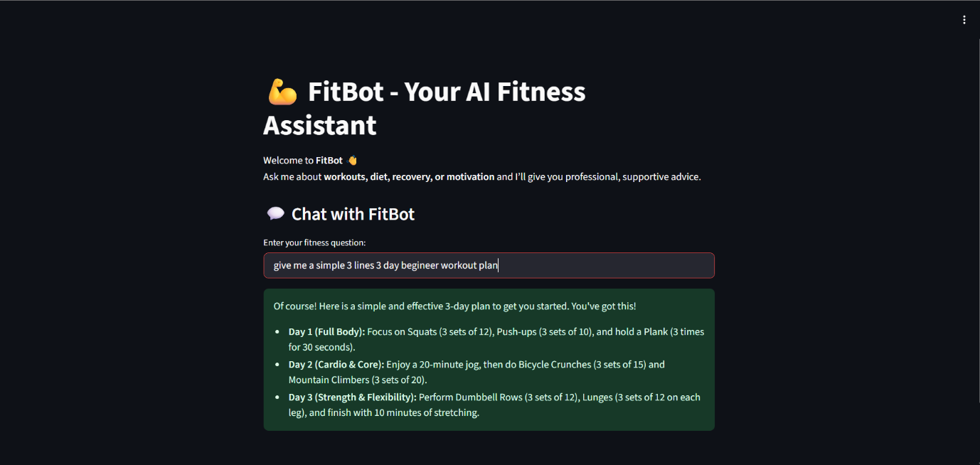

Figure : Example Question for Fitbot

Figure : Answer for the Question from Fitbot

# CONCLUSION

The development of FitBot marks significant progress in the application of AI for health and fitness guidance. By integrating retrieval-based grounding with generative language modeling, the system is able to provide users with professional, accurate, and conversational responses to their fitness-related questions. The modular architecture — combining a curated knowledge base, Hugging Face embeddings, FAISS vector search, and Gemini LLM — ensures both robustness and scalability.

The outcomes so far demonstrate that the system can reliably address a wide range of user queries related to diet, workouts, recovery, hydration, and motivation. The initial testing phase shows strong potential, with responses being both factually relevant and conversationally engaging. While limitations exist in handling highly specific or medical-level queries, these gaps can be addressed in future phases by expanding the knowledge base and integrating domain-specific resources.

The project is currently around **50% complete**, with the foundational architecture successfully implemented. The upcoming phases will focus on personalization (e.g., tailoring advice to user profiles), expanding the dataset, and improving accuracy through fine-tuned embeddings. Additional features such as integration with wearable fitness trackers and mobile deployment are also under consideration to enhance accessibility and usability.

In conclusion, FitBot represents a practical and scalable solution to bridge the gap between fitness knowledge and user-friendly AI assistance. With continued development, it has the potential to become a reliable digital companion for individuals pursuing healthier lifestyles.

# REFERENCES

[1] Deeva, O. and Sharapov, A., 2020. DEVELOPMENT OF AN INTELLECTUAL CHAT-BOT FOR APPLICANTS SGUGIT ON THE PLATFORM IBM WATSON ASSISTANT. Inter expo GEO Siberia, 7(1), pp.71-76.

[2] Anthony, A. and Watson, H., 1972. Techniques for developing analytic models. IBM Systems Journal, 11(4), pp.316-328.

[3] International Journal of Advanced Trends in Computer Science and Engineering, 2021. MedBot: Conversational Artificial Intelligence Powered ChatBot for Health Care. 10(2), pp.1150- 1152.

[4] IBM Developer. 2021. Introduction to Watson Assistant. [online] Available at: [Accessed 21 December 2021].

[5] Shanebarker.com. 2021. [online] Available at: [Accessed 21 December 2021].

[6] E. Strickland, "IBM Watson, heal thyself: How IBM overpromised and underdelivered on AI health care," in IEEE Spectrum, vol. 56, no. 4, pp. 24-31, April 2019, doi: 10.1109/MSPEC.2019.8678513

[7] <https://medium.com/ibm-watson/under-the-hood-all-thenatural-language-understanding-technology-that-makes-watsonassistant-fb8aaaca2f16>

[8] Manik, L., 2021. Out-of-Scope Intent Detection on A Knowledge-Based Chatbot. International Journal of Intelligent Engineering and Systems, 14(5), pp.446-457.

[9] Ibm.com. 2021. IBM Watson Assistant - AI Chatbot. [online] Available at: [Accessed 21 December 2021].

[10] Faraj, K. (2020, June 2). Building a covid-19 virtual assistant with Watson services on IBM Cloud. Medium. Retrieved December 21, 2021, from <https://medium.com/ibmwatson/building-a-covid-19-virtual-assistant-with-watsonservices-on-ibm-cloud-e34f07aad620>

[11] Physics Today, 2015. IBM adds deep-learning capability to Watson.

[12] Cloud.ibm.com. 2021. IBM Cloud Docs. [online] Available at: [Accessed 21 December 2021].

[13] Cloud.ibm.com. 2021. IBM Watson. [online] Available at: [Accessed 21 December 2021].

[14] Medium. 2021. Designing a Chatbot with IBM Watson Assistant. [online] Available at: [Accessed 21 December 2021].

[15] Chi, Zicheng, et al. "Leveraging ambient LTE traffic for ubiquitous passive communication." Proceedings of the Annual conference of the ACM Special Interest Group on Data Communication on the applications, technologies, architectures, and protocols for computer communication. 2020.