VISHWAKARMA INSTITUTE OF INFORMATION TECHNOLOGY,PUNE

**Mini Project Report**

On

**Stock Market Prediction Using AI**

**Under the Guidance of**

**Professor: Mrs. F.M.Inamdar**

SUBMITTED BY

|  |  |  |
| --- | --- | --- |
| **GR.NO** | **ROLL.NO** | **NAME** |
| 22010134 | 332044 | Siddhant Patil |
| 22010332 | 332046 | Rakshit Bhat |
| 22010863 | 332047 | Prithviraj Amol Raut |
| 22010583 | 332048 | Tejas Raut |

**Stock Market Prediction Using AI**

**Abstract :**

In Stock Market Prediction, the **aim** is to predict the future value of the financial stocks of a company. The recent trend in stock market prediction technologies is the use of machine learning which makes predictions based on the values of current stock market indices by training on their previous values. Machine learning itself employs different models to make prediction easier and authentic. The paper focuses on the use of Regression and LSTM based Machine learning to predict stock values. Factors considered are open, close, low, high and volume.

**Keywords :**

Days moving average(DMA), Linear regression(LR), Amazon Stock Ticker(AMZN), Apple Stock Ticker(AAPL)

**Introduction :**

In the world of finance, stock trading is one of the most important activities. Professional traders have developed a variety of analysis methods such as fundamental analysis, technical analysis, quantitative analysis, and so on. Such analytically methods make use of different sources ranging from news to price data, but they all aim at predicting the company’s future stock prices so they can make educated decisions on their trading. In recent years, the increasing prominence of machine learning in various industries have enlightened many traders to apply machine learning techniques to the field, and some of them have produced quite promising results. In this paper, we will focus on short-term price prediction on general stock using time series data of stock price.

**Literature Survey :**

|  |  |  |  |  |  |
| --- | --- | --- | --- | --- | --- |
| **Author** | **Title of paper** | **Problem or gap addressed** | **Findings and conclusions** | **Limitations or weaknesses** | **Implications or suggestions future research** |
| Aditya Sharma - [URL](https://www.ijeat.org/wp-content/uploads/papers/v8i4/D6321048419.pdf) | Stock market prediction using machine learning algorithmsa | stock market prediction is a very complex task, and different factors should be considered for predicting the future of the market more accurately and efficiently. | Exponential Smoothing predictions results are best rather than Linear Regression(LR) and Three Months Moving Average(3MMA) | Present system test and train on dataset from yahoo finance | capable to predict one-month forward stock market trend using time sharing forecasting |
| Lokesh Chauhan-[URL](https://www.researchgate.net/publication/331345883_Stock_Market_Prediction_Using_Machine_Learning) | Stock market prediction using the machine learning | Correct prediction of stock rather than using ML | It is possible to predict stock market more accurectly and efficiently using machine learning technique . | Present system test and train on dataset from yahoo finance | In future we can impove the stock market prediction by using much bigger dataset than currently . |
| Sohrab Mokhtari -[UR](https://www.researchgate.net/publication/353053940_Effectiveness_of_Artificial_Intelligence_in_Stock_Market_Prediction_based_on_Machine_Learning#:~:text=The%20stock%20market%20prediction%20can,on%20the%20historical%20price%20data.)L | Effectiveness of Artificial Intelligence in Stock Market Prediction Based on Machine Learning | stock market prediction leveraging artificial intelligence (AI) strategies | Based on this study, it seems that AI is not close to the prediction of the stock market with reliable accuracy. Maybe in the future, with AI development and especially computation power, a more precise model of stock market prediction can be available | The results imply that although AI can predict the stock price trends or public sentiment about the stock markets, its accuracy is not good enough | Iincrease the accuracy in the prediction process that implies an exciting topic for future studies |

**Proposed Methodology : System Architecture**

**Linear Regression (LR) :**

These algorithms can be understood easily and can be implemented easily. This algorithm runs into risky and over fitting environment easily. In some cases these algorithms are considered very much simple to solve complex problems. Linear regression runs under the relationship of two variables as one variable considered and dependent variable and other is considered as explanatory variable. A linear regression line has an equation of the form equation Y = a + bX, where X is the explanatory variable and Y is the dependent variable. The slope of the line is b, and a is the intercept.

*Table 1 : Linear regression classification for the Stock Market Prediction*

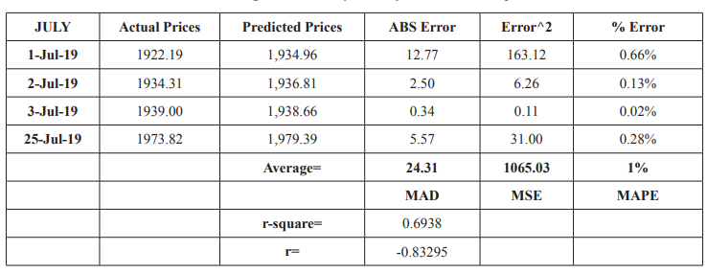

There can be different types of error present in our predictions that are explained by Table 1.

1. **Absolute Error**: If we want to calculate absolute error in our prediction we can perform calculations by predicted values-actual close prices. In MS Excel it can be calculated by following formula

**ABS Error(Fx) =abs(forcast-actual)**

1. **Square Error**: It can be defined as square of absolute error=(Abs Err)^2
2. **%age Error**: When absolute error is divided by actual close then we obtain percentage error

**% Error=ABS Error/Actual Close price**

1. **Average absolute error** = Mean absolute deviation=MAD
2. **Average square error** = Mean of square error=MSE
3. **Average percentage error** = Mean absolute %age error=MAPE

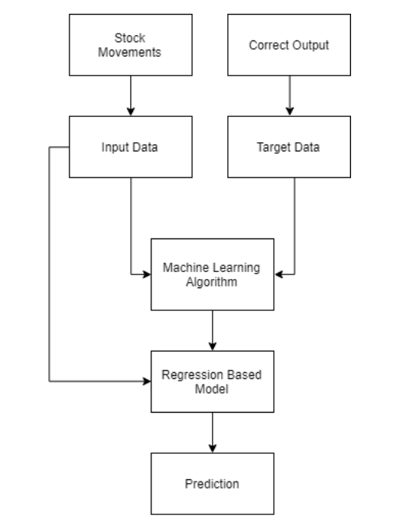

***Figure 1 : Flow for Regression Based Model***

Regression is used for predicting continuous values through some given independent values . The project is based upon the use of linear regression algorithm for predicting correct values by minimizing the error function as given in *Figure1*. Regression uses a given linear function for predicting continuous values:

***V = a + bK + error***

*V* : is a continuous value

*K* : represents known independent values and,

*a, b* : are coefficients.

**Conclusion :**

Stock market prediction is actual demand for beneficial business. Predictions always helpful to decrease risk factor in any business environment. Risk factor can be analyzed on the basis of historical data and previous business trends. This research based on several results and we used machine learning algorithm (ML) as Linear Regression (LR) with respect relations to business priority. Linear regression applied on different data sets that were obtained from stock market place. In our research we used Amazon (AMZN) and Apple (AAPL) datasets for our practical approaches. Before applying ML on datasets, we analyzed stock market trends for both products. Trend analysis also provide predictions about future business plan. In next step first we used AMZN dataset and after analysis of stock market trend we applied linear regression with the help of Excel statistical graphs. Secondly, we applied three month moving average(3MMA) method to predict stock market prices of AMZN products.

**Result and Decisions :**

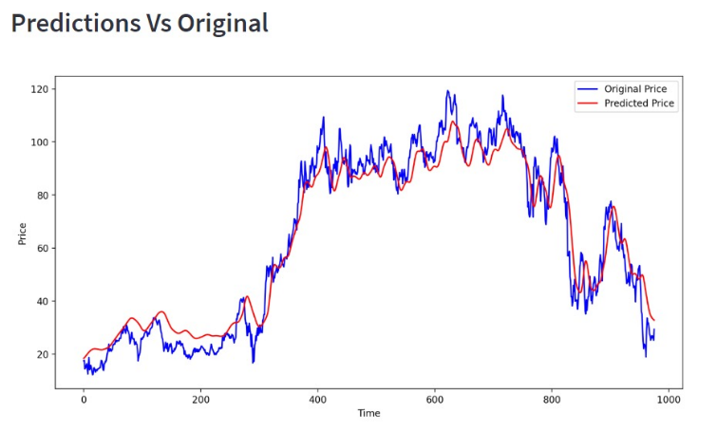

***Figure 2 : Plot between actual and predicted trend***

Here in the *figure 2,* the plot shows price vs time. The blue line represents, the original price of AMZN, while the red line represents the predicted price by the regression model.

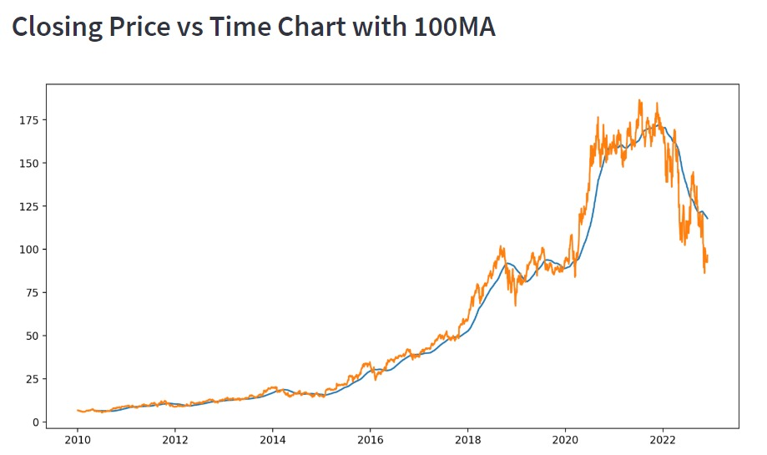

***Figure 3 : Closing Price vs Time Chart with 100 DMA***

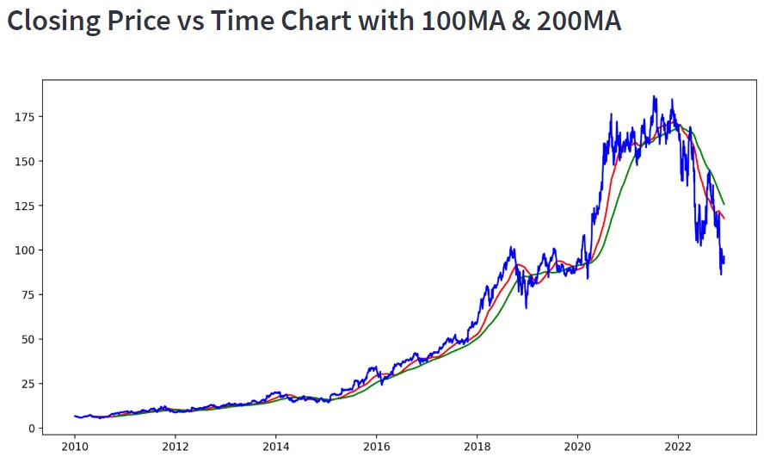

***Figure 4 : Price vs Time chart using 100 & 200 DMA***

The above plots shown in *figure 3* and *figure 4* shows the comparison between the actual and predicted price with the help of 100DMA and 100 & 200 DMA, respectively. In the *figure 4*, the red running line indicates 100DMA while the green represents 200 DMA.

**Future Scope :**

In the future, the stock market prediction system can be further improved by utilizing a much bigger dataset than the one being utilized currently. This would help to increase the accuracy of our prediction models. Furthermore, other models of Machine Learning could also be studied to check for the accuracy rate resulted by them. Thus, the increased accuracy would be of great benefit and we, as investers would be able to predict the future stock performance and invest smartly, and not blindly.

**References :**

Tae Kyun Lee et al. “Global stock market investment strategies based on financial network indicators usingmachine learning tech niques”, Expert Systems with Applications, 117(2019):228-242.

Bruno et al. “Literature review: Machine learning techniques applied to financial market prediction”, ExpertSystems with Applications, 124(2019): 226-251.

Thomas Fischer et al. “Deep learning with long short-term memory networks for financial market predictions”, European Journal of Operational Research, 270.2(2018): 654-669.

Kang Zhang et al. “Stock Market Prediction Based on Generative Adversarial Network”, Procardia Computer Science, 147(2019):400-406

Ben Moews et at. “Lagged correlation-based deep learning for directional trend change prediction in financial time series”. Expert Systems with Applications, 120(2019):197-206.

Fische Mospel et al. “Deep learning with machine learning algorithms for financial market predictions”, European Journal of scientific Research, 220.2(2019):654-669.