**CSE 3045: Mathematical Modelling for Data Science**

**Digital Assignment 2**

**Name: Tejas Rahul Rokade**

**Reg. No.: 20BDS0033**

**Faculty: Dr. Ilanthenral K P S K**

**Lab Slot: L49 & L50**

**Eigen Decomposition and Cholesky Decomposition**

1. Perform Eigen and Cholesky Decomposition using Python NumPy package linalg, explore all the possible routines along with different possible scenarios.
2. Using R, perform the Eigen Decomposition and Cholesky Decomposition.

**Eigen Decomposition in Python:**

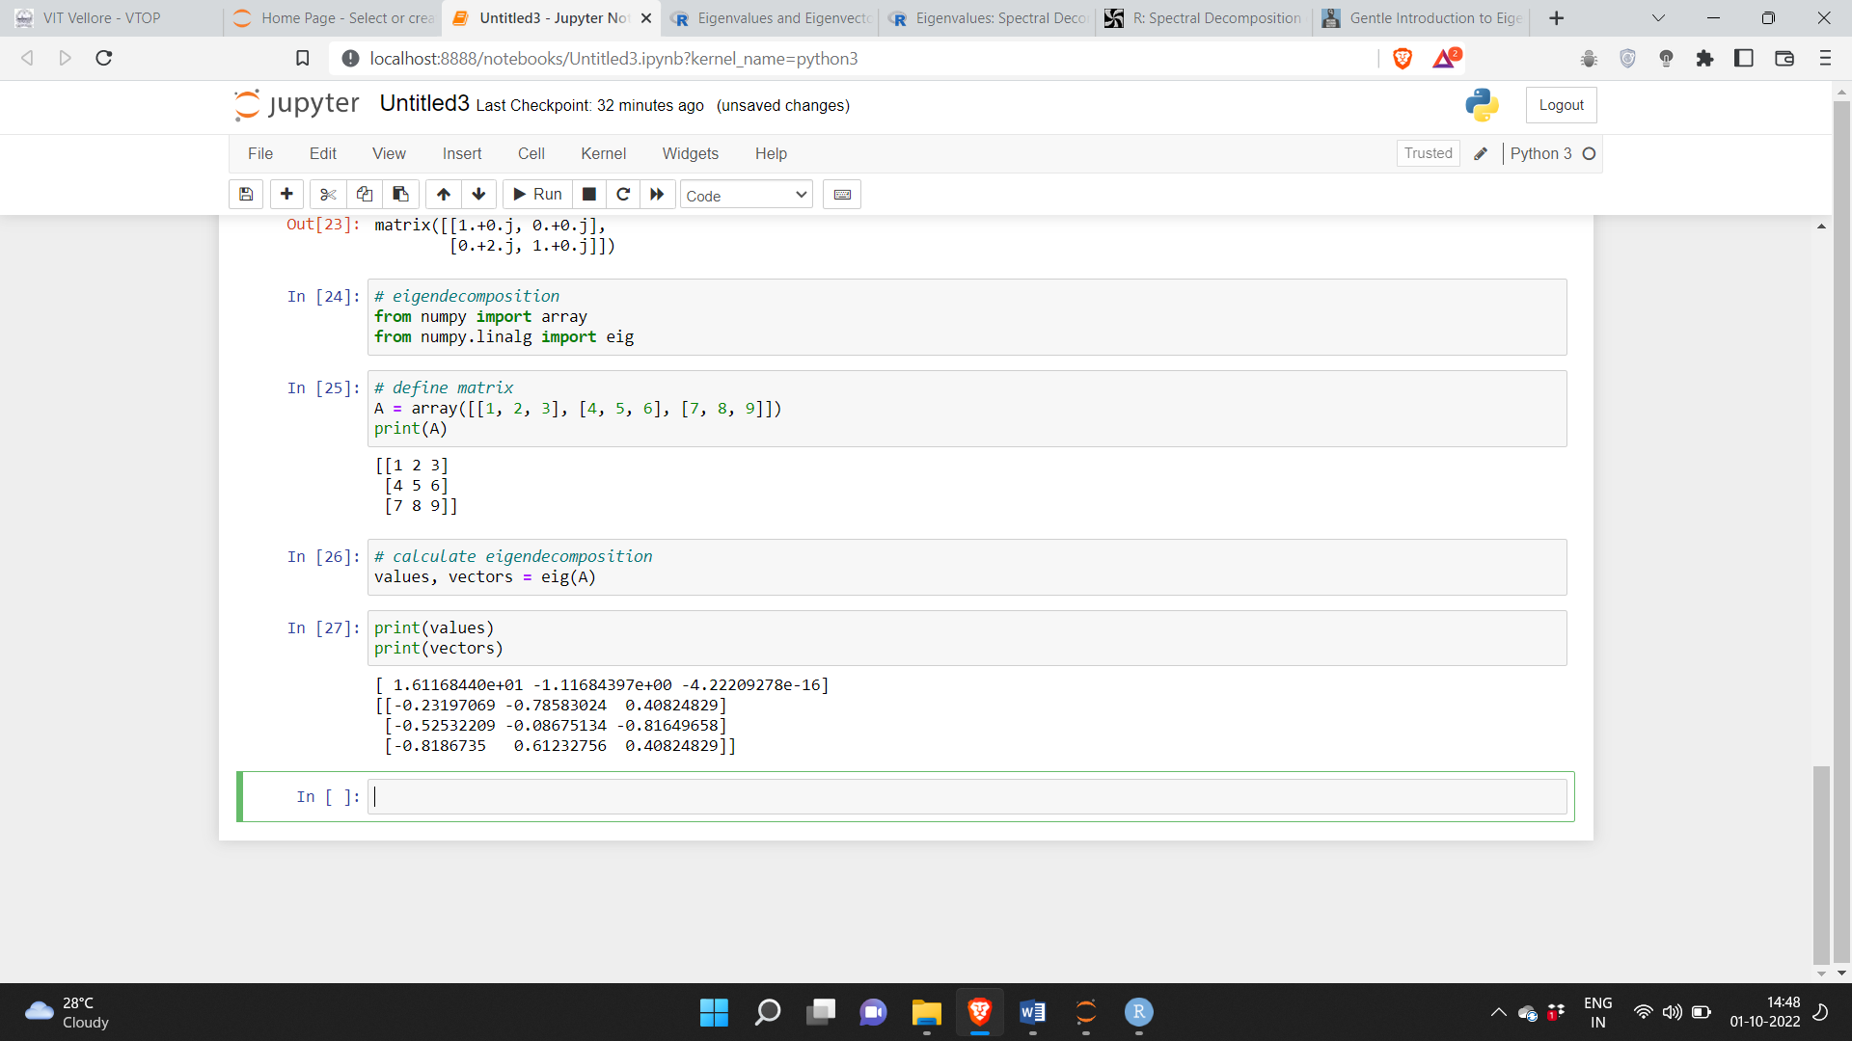

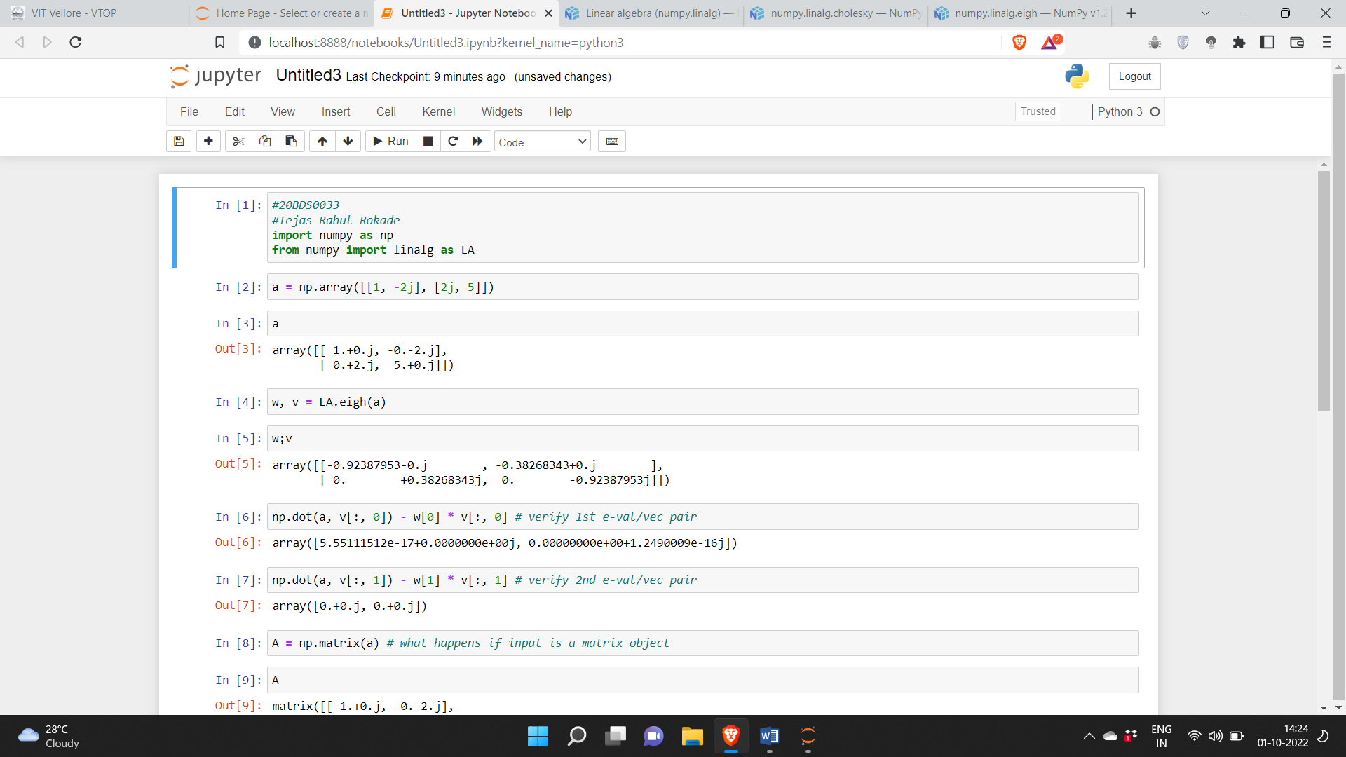

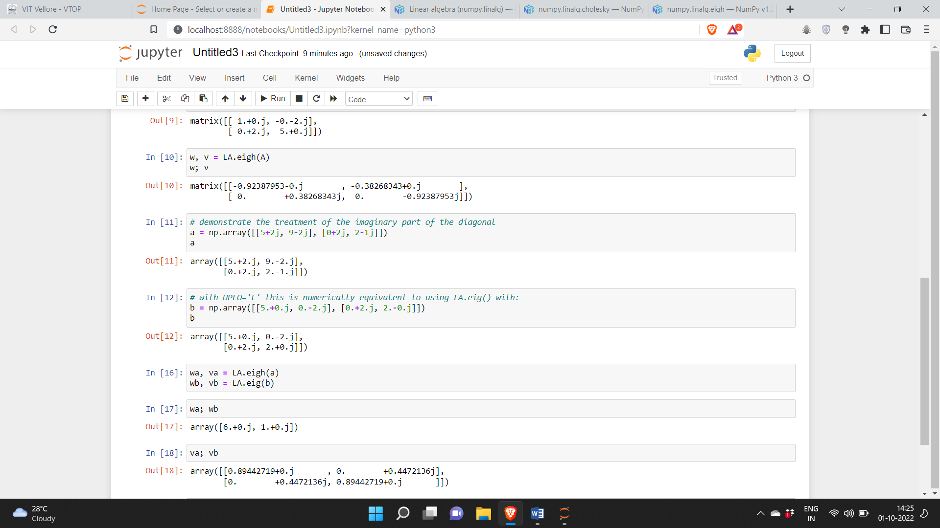

**Cholesky Decomposition in Python:**

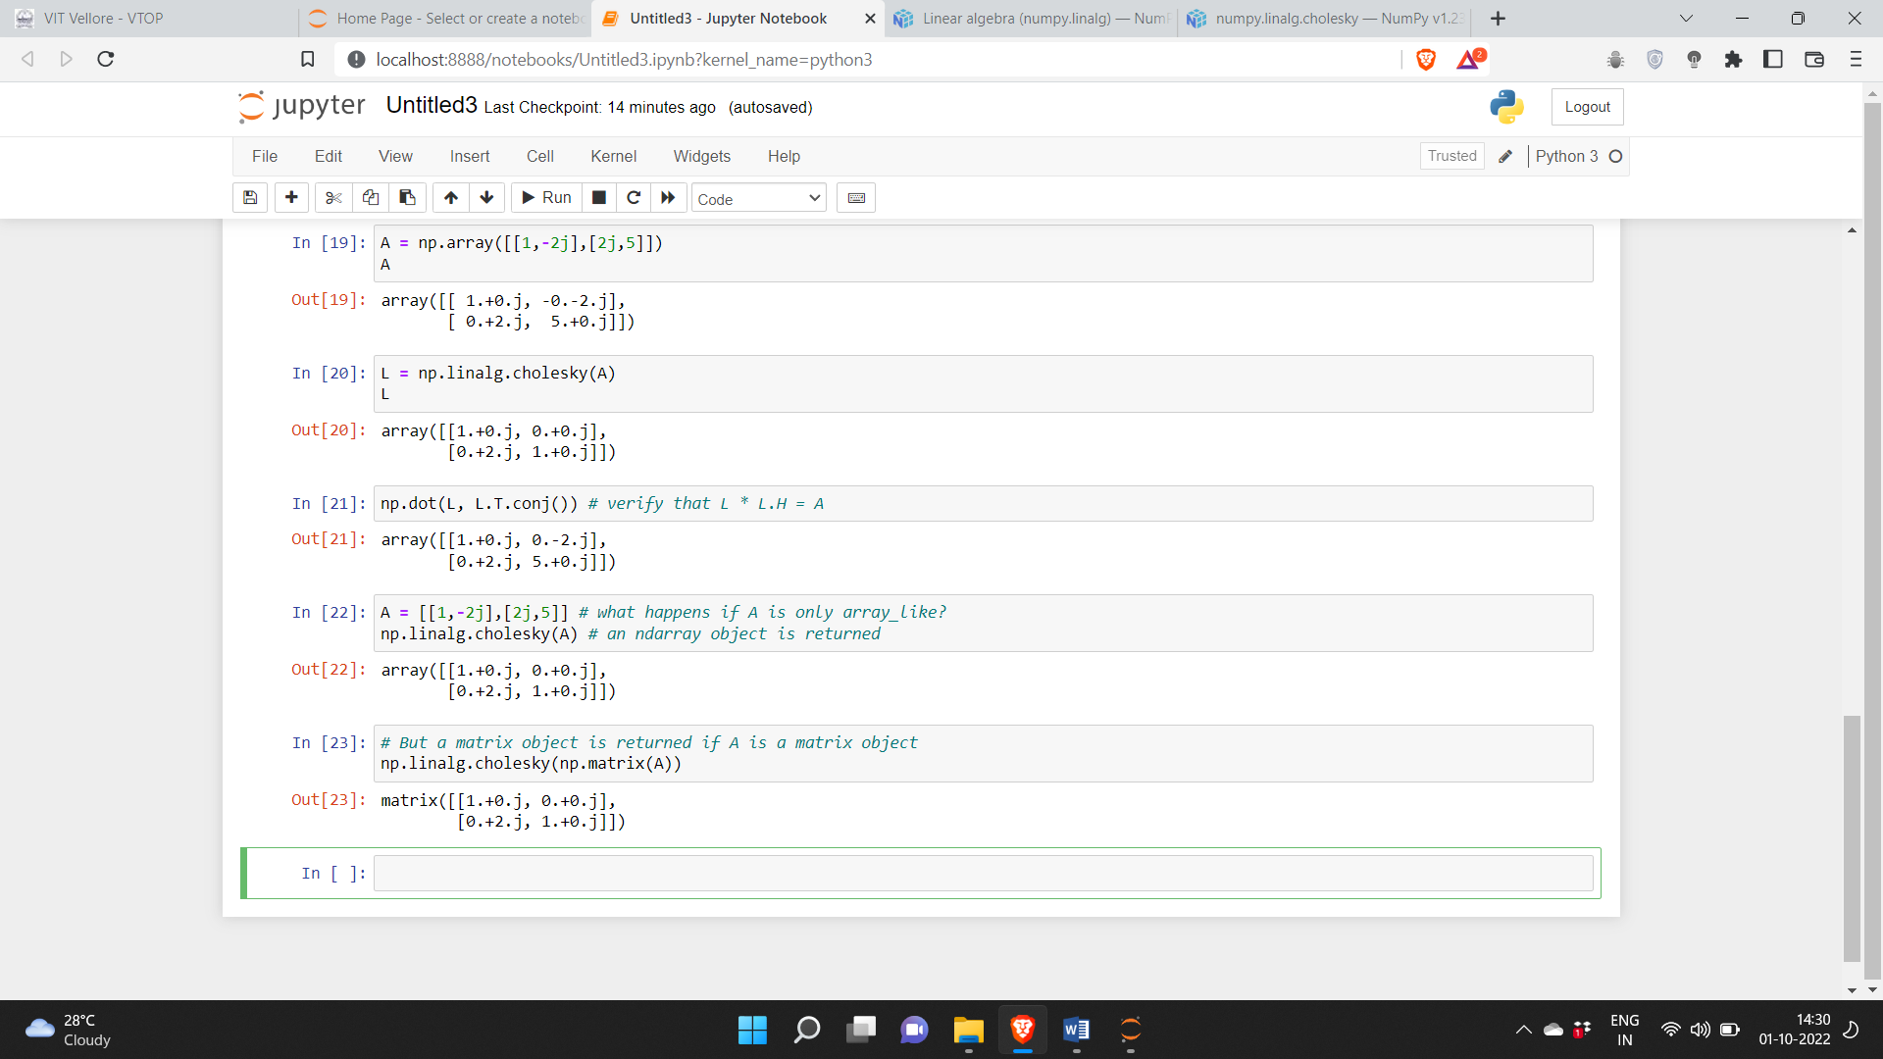

**Eigen Decomposition in R**

**Code:**

A <- matrix(c(13, -4, 2, -4, 11, -2, 2, -2, 8), 3, 3, byrow=TRUE)

A

#Get the eigenvalues and eigenvectors using eigen();

#this returns a named list, with eigenvalues named values and eigenvectors named vectors.

ev <- eigen(A)

# extract components

(values <- ev$values)

(vectors <- ev$vectors)

crossprod(vectors)

zapsmall(crossprod(vectors))

library(matlib) # use the matlib package

tr(A)

sum(values)

sum(A^2)

sum(values^2)

det(A)

prod(values)

#Rank

R(A)

sum(values != 0)

AI <- solve(A)

AI

eigen(AI)$values

eigen(AI)$vectors

eigen(A %*% A)

eigen(A %*% A %*% A)$values

eigen(mpower(A, 4))$values

**Output:**

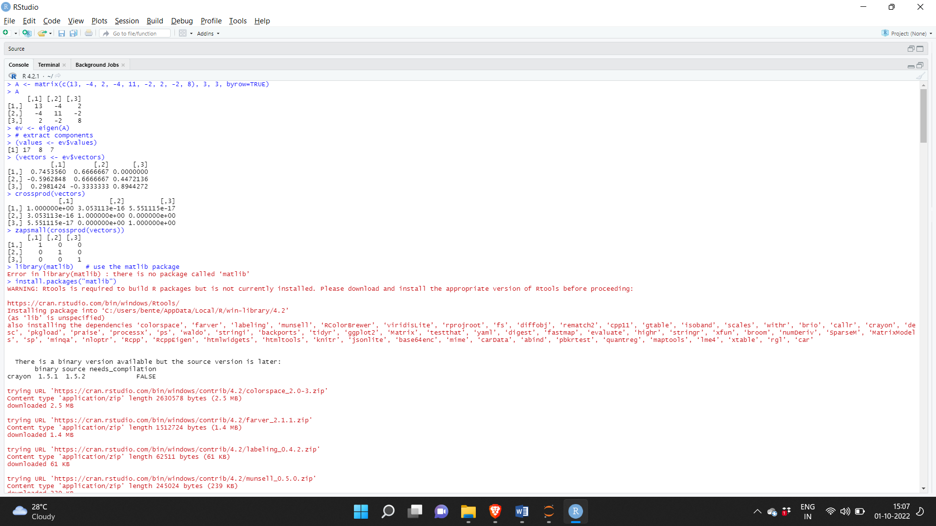

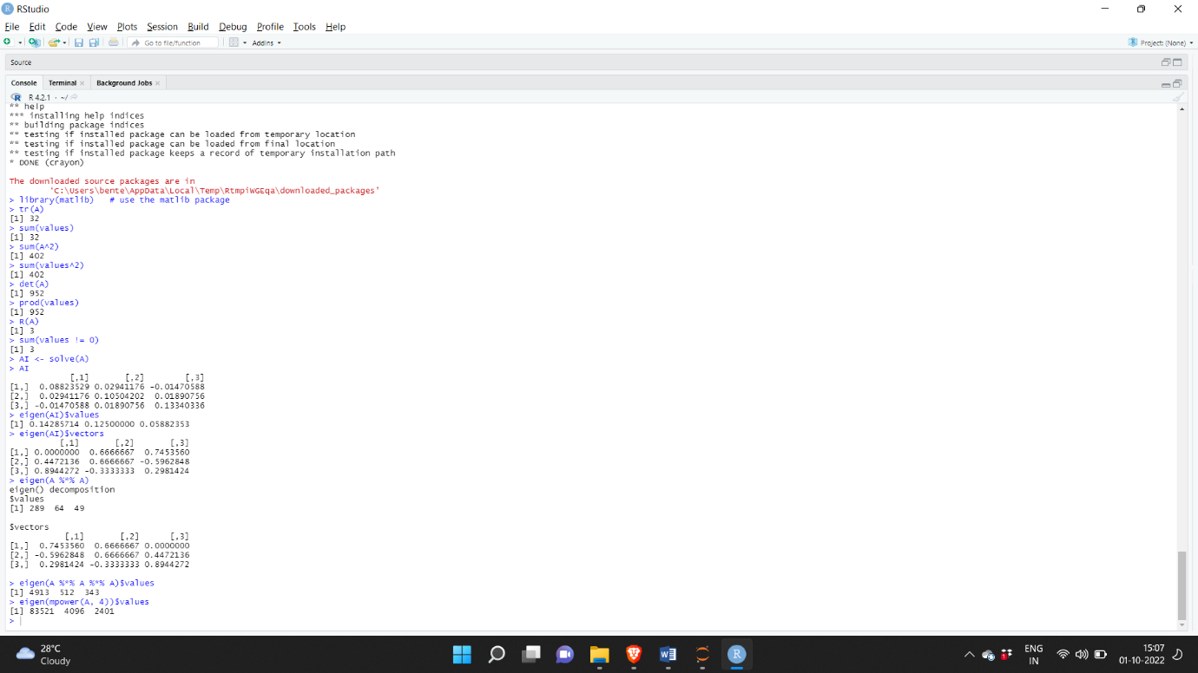

**Cholesky Decomposition in R:**

Cholesky Decomposition is for Positive Definite Symmetric Matrix.

**Code:**

m <- matrix(c(1,2,1,2,8,10,1,10,18), 3, 3)

chol(m)

n = t(chol(m))

m == (n %*% chol(m))

**Output:**

